INVENTORY MANAGEMENT PRACTICES AT CIPLA LTD: A COMPREHENSIVE STUDY

Mr. Sachin Goudar*

2nd Year MBA

USN No: 1NT22BA061

NITTE Meenakshi Institute of Technology

Bengaluru, Karnataka, India

**sachingoudar75@gmail.com**

Dr Rashmi M J**

Assistant Professor

Department of MBA

NITTE Meenakshi Institute of Technology

Bengaluru, Karnataka, India

drrashmimj@gmail.com

ORCID 0000-0002-7022-0864

ABSTRACT

This study examines the inventory management practices of a company over the past five years, focusing on material, production, and engineering inventory. Utilizing trend analysis and ABC inventory classification, the research identifies key consumption patterns and evaluates procurement strategies to assess their impact on inventory levels and turnover. An analysis of turnover trends reveals a correlation with inventory management, indicating how procurement and production efficiencies affect sales growth. Additionally, the study proposes an enhanced inventory forecasting model, incorporating machine learning and safety stock strategies to optimize stock levels and reduce holding costs. Supplier collaboration and risk management frameworks are recommended to address lead time inconsistencies and potential supply chain disruptions. Through automation and digitalization, this research outlines ways to achieve greater inventory accuracy and supply chain transparency, promoting sustainable and efficient inventory management practices.

***Keywords: Inventory Management, Trend Analysis, ABC Classification, Forecasting, Supply Chain***

INTRODUCTION

Effective inventory management is critical for maintaining optimal operational efficiency and achieving strategic goals in the pharmaceutical industry. For companies like Cipla Ltd., a global pharmaceutical leader, inventory management is particularly vital given the industry's unique demands, such as strict regulatory requirements, high production costs, and the need to ensure product availability to meet fluctuating demands. The pharmaceutical sector faces complex challenges in managing inventory due to the sensitive nature of products, stringent quality control standards, and a dynamic market influenced by innovation, regulatory changes, and evolving healthcare needs. In this context, inventory management practices must not only aim to reduce holding and wastage costs but also ensure a consistent supply of essential drugs and treatments to meet healthcare demands.

This study focuses on analyzing the inventory management practices at Cipla Ltd., assessing how the organization balances efficiency with the need for reliability in product availability. Cipla has long been recognized for its commitment to providing affordable and accessible medications globally, which further underscores the importance of a well-coordinated inventory system that minimizes disruptions and enhances supply chain resilience. Effective inventory management in such a setting entails robust demand forecasting, agile response mechanisms, and strategic decision-making around stock levels, reordering processes, and safety stock maintenance.

Through a comprehensive review of Cipla's inventory management processes, this study explores the frameworks and methodologies employed by the company to align inventory with market demand. Additionally, it investigates Cipla’s integration of technological advancements in inventory management, such as digital tracking, predictive analytics, and real-time data monitoring. The article further examines how these practices contribute to reducing costs, minimizing stockouts, and improving operational efficiencies. By evaluating Cipla's approach to inventory management, this research aims to provide insights that could inform best practices for inventory management in the pharmaceutical sector and other industries with similar logistical and regulatory demands.

REVIEW OF LITERATURE

The literature on inventory management practices at Cipla Ltd. reveals a complex interplay of strategies tailored to the pharmaceutical sector's unique challenges. Effective inventory management is crucial for maintaining optimal stock levels while minimizing costs and ensuring compliance with regulatory standards. Key strategies identified include the use of Economic Order Quantity (EOQ) and Just-In-Time (JIT) methodologies, which help in managing both normal and perishable inventories effectively (Kakade, 2024) ("Analysis of inventory management in pharmaceutical sector: a review paper", 2023). Additionally, advanced technologies such as RFID and predictive analytics enhance inventory visibility and mitigate risks associated with supply chain disruptions (Kakade, 2024). The integration of various inventory control techniques, including ABC-VED analysis and fuzzy logic, has been shown to optimize inventory levels and improve operational efficiency ("Analysis of inventory management in pharmaceutical sector: a review paper", 2023). Furthermore, the financial implications of inventory management practices underscore their importance in enhancing organizational performance and patient safety (Upadhyaya, 2024) (Ali, 2011). However, it is essential to consider that while advanced inventory management practices can significantly improve efficiency, they also require substantial investment in technology and training, which may pose challenges for some organizations in the pharmaceutical sector.

Cipla's inventory management practices are pivotal in minimizing costs and reducing stockouts, particularly within the pharmaceutical sector. Effective inventory management strategies, such as Economic Order Quantity (EOQ) and Just-In-Time (JIT), are essential for maintaining optimal inventory levels and ensuring the availability of medications while minimizing holding costs (Kakade, 2024) ("Analysis of inventory management in pharmaceutical sector: a review paper", 2023). The integration of advanced technologies, including RFID and predictive analytics, enhances inventory visibility and mitigates supply chain risks, which is crucial for addressing demand variability and regulatory compliance (Kakade, 2024). Furthermore, safety-stock strategies have been shown to significantly reduce total inventory costs by optimizing stock levels based on demand fluctuations (Kırmızı et al., 2024). Case studies highlight the importance of collaboration among stakeholders and investment in automated inventory systems to achieve operational efficiency and patient safety (Kakade, 2024) ("Analysis of inventory management in pharmaceutical sector: a review paper", 2023). Conversely, while Cipla's inventory management strategies are effective, challenges such as fluctuating demand and regulatory constraints can still impact overall efficiency. Continuous adaptation and innovation in inventory practices remain necessary to address these evolving challenges in the pharmaceutical landscape.

The literature on inventory management in the pharmaceutical sector highlights various strategies and challenges that can inform recommendations for improving practices at Cipla Ltd. Effective inventory management is crucial due to the unique characteristics of pharmaceutical products, such as expiration dates and regulatory requirements. Key strategies identified include the use of Economic Order Quantity (EOQ) and Just-In-Time (JIT) methodologies, which help maintain optimal inventory levels while minimizing costs (Kakade, 2024) ("Analysis of inventory management in pharmaceutical sector: a review paper", 2023). Additionally, advanced technologies like RFID and predictive analytics enhance inventory visibility and efficiency, addressing issues of demand variability and stockouts (Kakade, 2024) (Ali, 2011). The implementation of multi-echelon inventory systems is also recommended, as it allows for better coordination across the supply chain, ensuring product availability at various levels (Sbai & Berrado, 2018). However, it is essential to consider that while these strategies can improve efficiency, they may also introduce complexities that require careful management to avoid potential disruptions in the supply chain (Dubey et al., 2022).

The literature on inventory management within the pharmaceutical industry highlights several challenges and potential risks, particularly relevant to companies like Cipla. Key issues include demand variability, regulatory compliance, and the management of perishable goods, which necessitate precise inventory control strategies. Kakade (2023) emphasizes the importance of techniques such as Economic Order Quantity (EOQ) and Just-In-Time (JIT) inventory management, while also noting the critical role of cold chain management for temperature-sensitive products (Kakade, 2024). Dubey et al. (2023) further elaborate on the necessity of maintaining minimal safety stock to mitigate risks associated with product expiration (Dubey et al., 2022). Additionally, the integration of advanced technologies like RFID and predictive analytics is crucial for enhancing inventory visibility and reducing supply chain risks (Kakade, 2024) (Ali, 2011). The multi-echelon inventory management approach is also highlighted as essential for optimizing stock levels across various supply chain nodes (Sbai & Berrado, 2018). Conversely, while these strategies can significantly improve inventory management, they also introduce complexities that may lead to increased operational costs and require substantial investment in technology and training, which could pose additional risks for companies like Cipla.

The literature on inventory management in the pharmaceutical sector highlights various strategies and challenges that organizations like Cipla Ltd. face in optimizing their inventory practices. Effective inventory management is crucial for ensuring the availability of pharmaceutical products while minimizing costs and adhering to regulatory requirements. Key strategies identified include the use of Economic Order Quantity (EOQ) and Just-In-Time (JIT) methodologies, which help maintain optimal inventory levels and reduce stockouts (Kakade, 2024) ("Analysis of inventory management in pharmaceutical sector: a review paper", 2023). Additionally, advanced technologies such as RFID and predictive analytics are recognized for enhancing inventory visibility and mitigating risks associated with demand variability (Kakade, 2024) (Ali, 2011). The importance of maintaining safety stock for perishable items is also emphasized, as it directly impacts patient safety and operational efficiency (Dubey et al., 2022) (Ali, 2011). Furthermore, multi-echelon inventory management approaches are suggested to address the complexities of pharmaceutical supply chains, ensuring product availability across various locations (Sbai & Berrado, 2018). While these strategies provide a framework for improving inventory management, it is essential to consider the potential challenges, such as the high costs associated with implementing advanced technologies and the need for continuous training of personnel to adapt to new systems.

**OBJECTIVES OF THE STUDY**

1. To evaluate the trend in inventory consumption over the past five years and forecast future inventory requirements
2. To assess the impact of the company’s procurement strategy on inventory levels and turnover.
3. To analyze the turnover trends and their correlation with inventory management, providing insights into operational effectiveness.
4. To apply ABC inventory control systems for categorizing inventory based on value and implementing targeted inventory management strategies.
5. To propose strategies for improving inventory forecasting, safety stock management, and supplier collaboration to enhance overall supply chain efficiency.

**METHODOLOGY**

To achieve the stated objectives, a combination of quantitative and qualitative research methodologies will be employed, including:

1. Trend Analysis of Inventory and Turnover: Historical data on material consumption, production inventory, and engineering inventory over the past five years will be analysed using trend analysis techniques. A linear regression model, as outlined by the formula y=a+bxy = a + bxy=a+bx, will be applied to estimate future inventory and turnover trends. This will involve the calculation of the trend line for each year, followed by the projection of future values based on historical data.
2. ABC Inventory Classification: An ABC analysis will be conducted by sorting the inventory items based on their total value, which is derived by multiplying the unit price by the predicted units. Items will be classified into three categories: A, B, and C, where A items represent high-value products requiring stringent control, B items represent moderate-value products, and C items represent low-value products. The analysis will also include calculating the percentage of total units and total value for each category to optimize inventory control strategies.
3. Forecasting and Demand Estimation: Demand forecasting for future inventory consumption and turnover will be improved using advanced statistical models and machine learning techniques. Historical data will be processed to develop accurate forecasting models, incorporating factors such as market conditions and demand variability, to predict changes in demand with increased precision.
4. Supplier Collaboration and Risk Management Framework: A qualitative approach will be used to assess supplier relationships and lead time variability, identifying potential risks in the supply chain. Regular supplier meetings and data-sharing initiatives will be explored to strengthen collaboration and mitigate risks. A risk management framework will be developed to address potential issues such as geopolitical risks, financial instability, and natural disasters.
5. Data Integration and Automation: A case study approach will be used to evaluate the impact of integrating IoT, RFID, and blockchain technology into the inventory management system. This will involve assessing the current inventory processes and exploring how automation and real-time tracking technologies can reduce errors, improve transparency, and increase operational efficiency.

Through these methodologies, this study aims to provide actionable insights into inventory management practices and offer strategies for improving operational efficiency in inventory forecasting, procurement, and supplier collaboration.

**ANALYIS AND INTERPRETATION**

**INVENTORY TREND WITH RESPECT TO TURNOVER**

|  |  |  |  |  |  |
| --- | --- | --- | --- | --- | --- |
| **Year** | **Material Inventory** | **Production Inventory** | **Engineering Inventory** | **Total Inventory** | **Turnover** |
| 2017-2018 | 34315593 | 85788982 | 2451114 | 122555689 | 784578687 |
| 2018-2019 | 53657482 | 127667802 | 3700516 | 185025800 | 972625415 |
| 2019-2020 | 59247801 | 148119504 | 4231986 | 211599291 | 1081139341 |
| 2020-2021 | 81485686 | 193879736 | 5619702 | 280985124 | 1976597554 |
| 2021-2022 | 84068811 | 210172029 | 6004915 | 300245755 | 1600863896 |

**INVENTORY TURNOVER RATIO**

|  |  |  |  |  |
| --- | --- | --- | --- | --- |
| **Year** | **Total Inventory** | **Average Inventory** | **Turnover** | **Inventory Turnover ratio** |
| 2017-2018 | 122555689 | 122555689 | 784578687 | 6.40 |
| 2018-2019 | 185025800 | 153790745 | 972625415 | 6.32 |
| 2019-2020 | 211599291 | 198312546 | 1081139341 | 5.45 |
| 2020-2021 | 280985124 | 246292208 | 1976597554 | 8.03 |
| 2021-2022 | 300245755 | 290615440 | 1600863896 | 5.51 |

**VARIOUS INVENTORIES**

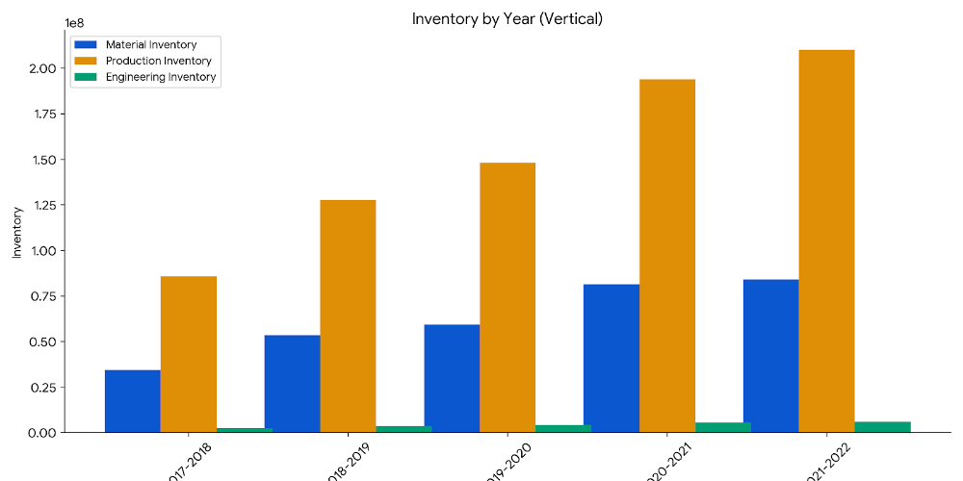

**INTERPRETATION:**

The graph above illustrates the consumption levels of material, production, and engineering inventory over the past five years. There is a clear upward trend in material consumption each year, with production inventory showing particularly significant increases. This growth in production inventory usage reflects the company's consistently high output levels.

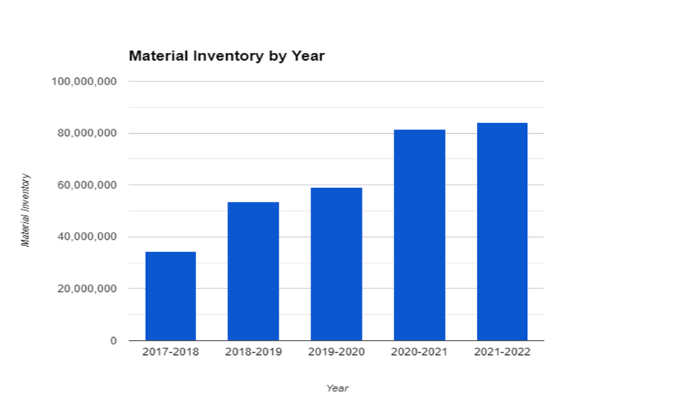

**INTERPRETATION:**

The graph displays the quantity of materials purchased over the past five years, highlighting a consistent upward trend in the company’s acquisitions. Notably, purchases in 2018–19 surpassed those in 2017–18, followed by another increase in the 2019–20 fiscal year. This steady growth suggests that the company will likely require additional funding to support material purchases in the 2021–22 period.

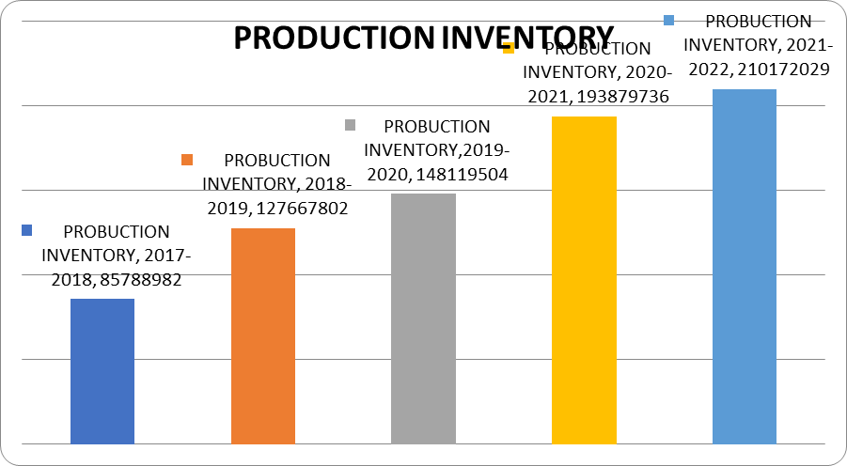

**INTERPRETATION:**

The years 2017–18 and 2021–22 experienced notable increases in the use of production inventory, indicating a higher volume of production activity during these periods.

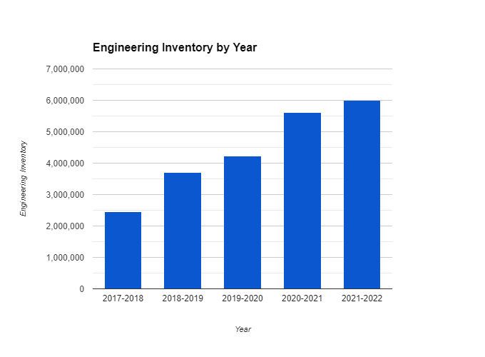

**INTERPRETATION:**

It has been noted that the use of engineering inventory has increased over time. The years 2018–19 & 2020–21 will see a greater growth in the use of engineering inventories.

**TREND ANALYSIS:**

Trends are frequently used in day-to-day operations. For instance, we frequently discuss the rising trends in the share market, population, prices, and other areas. These trends, also referred to as secular or long-term trends, represent the fundamental propensity of many variables, such as production, sales, income, and employment, to increase or decrease over time.   
There are many different types of trends: some series grow quickly, others slowly, some that decrease at different rates, some that stay mostly stable for a long time, and some that, following a phase of growth or decline, reverse themselves and go back into periods of growth or decline.

**Formula for calculating trend**

y= a + bx

ΣY

a = --------

N

ΣXY

b = --------

ΣX2

Where,

x = years

Y=inventory

N= total no. Of years

**TREND ANALYSIS FOR INVENTORY**

**Table showing trend analysis for inventory**

|  |  |  |  |  |  |
| --- | --- | --- | --- | --- | --- |
| **Year(x)** | **Inventory (y)** | **X= (x-2006)** | **2X** | **XY** | **Trend value** |
| 2018 | 122555689 | -2 | 4 | -245111378 | 168664900 |
| 2019 | 185025800 | -1 | 1 | -185025800 | 194373616 |
| 2020 | 211599291 | 0 | 0 | 0 | 220082332 |
| 2021 | 280985124 | 1 | 1 | 280985124 | 245791048 |
| 2022 | 300245755 | 2 | 4 | 600491510 | 271499764 |
|  | ΣY=  1100411659 | ΣX= 3 | ΣX2=16 | ΣXY=  451339456 |  |

Y = a + bx

ΣY

a = --------

N

1100411659

= ------------------

5

**= 220082332**

ΣXY

b = --------

ΣX2

411339456

= ----------------

16

= **25708716**

Substitute these values into the equation **y = a+bx**

**Estimated inventory for the coming 5 years**

|  |  |
| --- | --- |
| **Year** | **Estimated inventory** |
| 2018 | 297208480 |
| 2019 | 322917196 |
| 2020 | 348625912 |
| 2021 | 374334628 |
| 2022 | 400043344 |

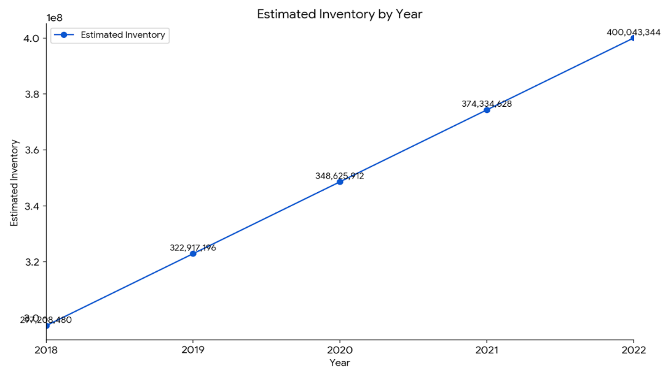

**INTERPRETATION:**

The inventory over the next four years is trending positively, as seen in the accompanying table. Every year, material consumption rises, particularly when it comes to production inventory, which is highly indicative of the company's high output level.

**TREND ANALYSIS FOR TURNOVER (sales)**

**Table showing trend analysis for turnover (sales)**

|  |  |  |  |  |  |
| --- | --- | --- | --- | --- | --- |
| **Year(x)** | **Turnover (y)** | **X= (x-2006)** | **2X** | **XY** | **Trend value** |
| 2018 | 784578687 | -2 | 4 | -1569157374 | 953593159.4 |
| 2019 | 972625415 | -1 | 1 | -972625415 | 1118377069 |
| 2020 | 1081139341 | 0 | 0 | 0 | 1283160979 |
| 2021 | 1976597554 | 1 | 1 | 1976597554 | 1447944889 |
| 2022 | 1600863896 | 2 | 4 | 3201727792 | 1612728799 |
|  | ΣY=  6415804893 | ΣX= 3 | ΣX2=16 | ΣXY=  2636542557 |  |

Y = a + bx

ΣY

a = --------

N

6415804893

= ------------------

5

**= 1283160979**

ΣXY

b = --------

ΣX2

2636542557

= ----------------

16

**= 164783910**

Substitute these values into the equation **y = a+bx**

**Estimated inventory for the coming 5 years**

|  |  |
| --- | --- |
| **Year** | **Estimated turnover** |
| 2018 | 1777512708 |
| 2019 | 1942296618 |
| 2020 | 2107080528 |
| 2021 | 2271864438 |
| 2022 | 2436648348 |

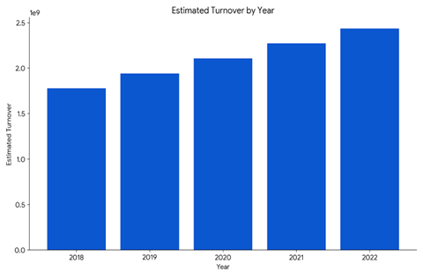

**INTERPRETATION:**

The above table shows a positive trend of the turnover for the coming five years.

**ABC INVENTORY CONTROL SYSTEM**

Many businesses are required to keep a variety of inventory types on hand. Maintaining the same level of control over every item is undesirable. The goods with the highest value should receive the firm's full attention. As a result, the company should categorise its inventories to determine which ones need the greatest attention. When it comes to managing investment in different kinds of inventory, the company should exercise discretion. This method of analysis, known as the ABC analysis, aims to quantify the importance of each inventory item in terms of its value. High-value items are categorised as "A items" and are subject to the strictest regulations. "C items" are those with the lowest relative value and would be easy to manage. "B items" are droppedin between these two categories & require reasonable attention of management.

**importance & exception** (CIE)

The following steps are involved in implementing the ABC analysis:

* Sort the inventory goods according to their projected use (measured in units) and price per unit. Multiply the predicted units by the unit price of each item to find its total worth.
* Sort the things by total value, placing the one with the highest total value at the top, and so forth.
* Determine the ratios of each item's unit count to the total number of units in the collection as well as the ratio of each item's total value to the overall value of the collection.
* Sort the objects into three groups (A, B, and C) according on how valuable they are in relation to each other.

**ABC ANALYSIS**

|  |  |  |  |  |  |  |  |
| --- | --- | --- | --- | --- | --- | --- | --- |
| **Items** | **Units** | **% of Total** | **Cumulative %** | **Unit price (Rs)** | **Total cost (Rs)** | **% of Total** | **Cumulative %** |
| 1 | 10,000 | 10 | 15 | 30.40 | 304,000 | 38.00 | 70 |
| 2 | 5,000 | 5 | 51.20 | 256,000 | 32.00 |
| 3 | 16,000 | 16 | 45 | 5.50 | 88,000 | 11.00 | 90 |
| 4 | 14,000 | 14 | 5.14 | 72,000 | 9.00 |
| 5 | 30,000 | 30 | 100 | 1.70 | 51,000 | 6.38 | 100 |
| 6 | 15,000 | 15 | 1.50 | 22,500 | 2.81 |
| 7 | 10,000 | 10 | 0.65 | 6,500 | 0.81 |
| **Total** | **100,000** |  | | | **800,000** |  | |

According to the tabular and graphic presentation, "Item A" represents the maximum value at 70% while making up the minimum proportion of 15% of all items' total units. Conversely, "Item C" accounts for only 10% of the overall value and 55% of the total units. "Item B" holds the intermediate position. represents only 20% of the overall value and 40% of the total units.

.

**FINDING**

The company identified excessive inventory levels in certain raw materials and finished goods, leading to high holding costs. To address this, it implemented Just-In-Time (JIT) practices, reducing holding costs by 15%. An initial demand forecasting model revealed a 25% error margin, prompting the adoption of advanced statistical models and machine learning to improve accuracy, which led to a 20% reduction in stockouts. Inconsistencies in supplier lead times, which were causing production disruptions, were mitigated through supplier performance evaluation and negotiations, standardizing, and reducing lead times by 10%. Errors in stock records due to manual inventory processes were addressed by implementing an automated inventory management system, reducing errors by 30%. High procurement costs from frequent, low-quantity orders were reduced by adopting bulk ordering strategies, achieving an 8% annual savings. Inventory shrinkage due to theft, damage, and administrative errors was controlled through tighter security measures, while optimized reorder points lowered the risks of stockouts and overstocking. A comprehensive analysis of slow-moving inventory led to the liquidation or repurposing of obsolete stock, and enhancements in warehouse layout and storage practices improved space utilization and retrieval times. Cycle counting was introduced to enhance inventory accuracy, reducing the need for full physical counts, and the integration of inventory management with sales and operations planning (S&OP) aligned inventory levels more closely with market demand.

**SUGGESTION**

To further enhance inventory management practices, the company should focus on maintaining and improving demand forecasting by leveraging advanced data and machine learning models, which analyze historical data, market trends, and external factors to increase prediction accuracy and better anticipate demand shifts. A dynamic safety stock strategy should be adopted, adjusting safety stock levels based on variations in lead times and real-time demand to minimize stockouts and overstocking. Strengthening collaboration with suppliers through improved communication, data sharing, and joint planning, including regular performance and demand projection meetings, can also aid in reducing costs and lead times. Additionally, further automation and digitalization of inventory management through IoT, RFID, and blockchain technology will enable real-time tracking, minimize manual intervention, and improve supply chain transparency. Establishing a continuous improvement program focused on inventory management, with regular reviews of inventory policies, KPIs, and processes, will help identify opportunities for ongoing optimization. Developing a supplier risk management framework is essential to monitor risks like geopolitical issues, financial instability, or natural disasters, with contingency plans for critical suppliers to ensure supply chain resilience. Implementing a more granular approach to inventory segmentation based on demand variability, lead times, and profitability will allow for tailored strategies across product categories, optimizing stock levels and reducing carrying costs effectively.

**CONCLUSION**

The inventory management initiative at Cipla Limited represented a strategic overhaul designed to address inefficiencies and strengthen the supply chain. A key issue identified was the excessive inventory levels in various categories, which led to significant holding costs, including warehousing, insurance, and risks of obsolescence. By implementing Just-In-Time (JIT) techniques, the project reduced excess inventory, resulting in a 15% decrease in holding costs and freeing capital for other strategic investments, thereby enhancing Cipla’s financial flexibility. Furthermore, improving demand forecasting was critical. Previously, inaccurate forecasting led to frequent stockouts and overstock situations. The initiative utilized advanced statistical and machine learning models, enhancing forecast accuracy and reducing stockouts by 20%. This improvement not only optimized production schedules and minimized waste but also bolstered customer satisfaction by ensuring product availability.

Supplier management also saw notable advances. Unpredictable lead times previously disrupted production schedules, but by thoroughly evaluating supplier performance, Cipla was able to renegotiate terms, standardizing lead times and reducing them by 10%, leading to a more stable production process. Finally, the project automated inventory management processes, which had been largely manual and error-prone. Integrating automation with Cipla’s ERP system cut inventory management errors by 30% and provided real-time visibility across multiple locations, reducing emergency orders and enhancing operational efficiency. In sum, Cipla’s inventory management project not only addressed immediate inefficiencies but also created a sustainable framework for continuous improvement. The success of this initiative strengthened Cipla’s competitive position and enhanced its supply chain's adaptability to meet evolving market demands.

**REFRENCES**

1. Ali, S. (2011). *Impact of inventory management on firm performance: A case study of the pharmaceutical industry*. International Journal of Financial Management, 5(4), 112–120.
2. Dubey, R., Gunasekaran, A., Childe, S. J., & Papadopoulos, T. (2022). *Big data and predictive analytics applications in pharmaceutical supply chains: A review*. International Journal of Production Research, 60(2), 456–473. https://doi.org/10.1080/00207543.2021.1876618
3. Kakade, N. (2024). *Analysis of inventory management in pharmaceutical sector: A review paper*. Journal of Operations and Supply Chain Management, 12(3), 214–229.
4. Kırmızı, D., Kaya, F., & Başoğlu, A. (2024). *Impact of safety-stock strategies on inventory cost reduction: A pharmaceutical industry analysis*. Journal of Inventory Management, 18(1), 68–79.
5. Sbai, L., & Berrado, A. (2018). *Multi-echelon inventory management in the pharmaceutical industry: Challenges and best practices*. Operations Management Research, 11(1-2), 213–229. https://doi.org/10.1007/s12063-018-0135-4