**Topic : A Study on Behavioral Finance and Traditional Finance Role In Investment Decision Making for Individual.**

**Abstract**:The philosophy value of investing is based on the perceptions of behavioral finance. Investing values adopts that in the short run, markets are not effective to take decisions. Peoples fear are not to take rational conclusions. If a person gives consideration to behavioral finance, he may recognize this cause.Behavioral finance supports to the people, who deteriorating intocommon psychological traps. Instead, it supports the investors to take advantage of the overestimations and under valuations it may happen in the market because a huge amount of investors make decisions emotionally.At the end behavioral finance is to assist the investors to buy or sell decisions based on existing data and information in the market. This way, they can assume the investors who wait for the market as a whole to identify this error of the psychological studies of individual investors while investing or making financial decisions. Investors draw a realworld experience because they are having their own biases and they are very irrational; their emotions are playing major role while investing in particular investment. In behavioral finance, market is volatile so it leads to fluctuations of share prices and investors are not had self-control and anomalies, so the investors, has to realize than rational financial decisions can be made but shouldn’t invest based on their emotions they can go through the market analysis before investing in particular avenues.Traditional Finance is one of the pillars in financial thought that the investors believe in. In Traditional Finance the people and market are rational. The investors can get huge data, knowledge and information from the market. So, they will take their own financial decision based on their knowledge not on the emotions. Traditional finance states that market is efficient and it might represent actual value of financial market.This statement tells that investor have self-control rather than social issues. The traditional finance investment decision is based on mathematical calculations, economic models and market behaviors and various available data. So, in traditional finance investors are thinks practically in terms of the investment risk, returns and problems involved in various avenues etc.This exactly tells that investor take the decision based on the availablestatistical and empirical data rather than emotions.

The study showed the concepts of behavioral finance and traditional finance impression of investor’s financial decision on investment. In behavioral finance investors need to realize that rational financial decisions are often made, but they shouldn’t take any financial decisions based on their emotions.Cognitive errors can be further classified into two categories: belief perseverance biases and information-processing biases.Belief perseverance errors reflect an inclination to maintain beliefs. The belief is maintained by committing statistical, information-processing, or memory errors. Belief perseverance biases are closely related to the psychological concept of cognitive dissonance.Belief perseverance biases include conservatism, confirmation, representativeness, illusion of control, and hindsight. Information-processing biases result in information being processed and used illogically or irrationally. Information-processing biases include anchoring and adjustment, mental accounting, framing, and availability.Emotional biases include loss aversion, overconfidence, selfcontrol, status quo, endowment, and regret aversion.Understanding and detecting biases is the first step in overcoming the effect of biases on financial decisions. By understanding behavioral biases, financial market participants may be able to moderate or adapt to the biases and as a result improve upon economic outcomes

**Objectives of Study**

1. To Study on which concept is suitable to take decision
2. To Analyse how the behaviour is reflecting on the investors Decision
3. To Analyse the Relationship between Traditional Finance and Behavior Finance
4. To examine it's biases influence on the investment decisions making process

**Index**

|  |  |
| --- | --- |
| SR  No | TITLE |
| 1 | Introduction to Traditional and Behaviour Finance |
| 2 | Efficient Market Theory |
| 3 | Difference between Traditional Finance and Behaviour finance |
| 4 | Behaviour biases for individuals |
| 5 | Cognitive Errors |
| 6 | Emotional Bias |
| 7 | Literature Review |
| 8 | Data analysis |
| 9 | Findings |
| 10 | Recommendations |
| 11 | Conclusion |
| 12 | Bibliography |

**Introduction to behavioral finance and traditional finance.**

**Traditional Finance.**

The most common source of traditional financing is loans from large or small banks. Large banks can be the hardest to get loan approval from, with an application process that depends heavily on rigid, numerical factors such as your credit score. Smaller banks may have higher interest rates but are more likely to give your application detailed attention and work with you to find a way to get you a loan.When you’re looking to raise funds to start or grow your small business,the usual place to start is the bank. Bank financing is a tried and true source of capital for many small businesses. Traditional financing will generally provide the most affordable, if not the easiest, access to the funding your business needs.Borrowers who are having trouble getting approval from a bank on their own can also turn to the Small Business Administration to try to get an SBA-backed loan. Having the SBA guarantee the loan essentially eliminates risk for the lender, making these loans very popular but also competitive

The Four C's Of Credit.

The Four Cs of credit is a system used by lenders to gauge the creditworthiness of potential borrowers, consisting of a quintet of characteristics.

1. The first C is character—reflected by the applicant's credit history.
2. The second C is capacity—the applicant' debt-to-income ratio.
3. The third C is capital—the amount of money an applicant has.
4. The fourth C is collateral—an asset that can back or act as security for the loan.
5. Additional “C” - The fifth C is conditions—the purpose of the loan,the amount involved, and prevailing interest rate.

Sources of finance.

1. Banks.
2. NBFCs.
3. Money Lenders.
4. Friends and Family.

**Banks and Credit Unions.**

Similar to banks are credit unions, which also offer financing on generally favorable terms. The difference between a bank and a credit union is that a credit union is a non-profit organization owned by its members. Credit unions have restrictions on joining, generally limiting membership to certain communities such as residents of a local area or associates of an educational institution. Because they’re non-profits, credit unions can sometimes offer lower interest rates than banks, but this is not always the case, especially as larger banks often have access to tax advantages and other benefits that the inherently small credit unions don’t. Approval rates tend to be similar to that of small banks and higher than for large banks; according to Biz2Credit’s Small Business Lending Index, recent credit union approval rates for small business loans are around 45%, versus 50% for small banks and 15% for large banks.

**Conventional loans.**

Conventional Loans Small businesses and franchises of any development stage can apply for conventional loans. However, because these loans are not guaranteed by the federal government, banks prefer to lend to companies that demonstrate a strong ability to service the debt and have significant collateral to cover the loan if the company ultimately cannot pay back the loan. In addition, business owners seeking these loans are usually required to have exceptional FICO scores, a reasonable debt to worth ratio and provide a solid business plan and projections.

**SBA Loan Programs**

SBA loan programs lend to small businesses unable to secure financing on reasonable terms through normal lending channels. The loan programs are operated through private-sector lenders that provide loans which are, in turn, guaranteed by the SBA. The Agency has no funds for direct lending or grants. Most private lenders are familiar with SBA loan programs so interested applicants should contact their local lender for further information and assistance in the SBA loan application process.

**Behavioural Finance**

Behavioral finance is a field of study that explores the psychological and emotional factors that influence financial decision making. It seeks to understand why people make irrational or suboptimal financial decisions and how these biases can impact investment decisions and market outcomes.

Behavioral finance is the study of psychological influences on investors and financial markets. At its core, behavioral finance is about identifying and explaining inefficiency and mispricing in financial markets. It uses experiments and research to demonstrate that humans and financial markets are not always rational, and the decisions they make are often flawed. If you are wondering how emotions and biases drive share prices, behavioral finance offers answers and explanations. Understanding behavioural finance.

Behavioral finance can be analyzed from a variety of perspectives. Stock market returns are one area of finance where psychological behaviors are often assumed to influence market outcomes and returns but there are also many different angles for observation. The purpose of the classification of behavioral finance is to help understand why people make certain financial choices and how those choices can affect markets. Within behavioral finance, it is assumed that financial participants are not perfectly rational and self-controlled but rather psychologically influential with somewhat normal and self-controlling tendencies. Financial decision-making often relies on the investor's mental and physical health. As an investor's overall health improves or worsens, their mental state often changes. This impacts their decision-making and rationality towards all real-world problems, including those specific to finance.

**Behavioral Finance Micro and Macro.**

To make behavioral finance easier to understand—and to differentiate the study of individual investor behavioral from collective market behavioral—behavioral finance is classified as either behavioral finance micro (BFMI) or behavioral finance macro (BFMA).

* BFMI examines behaviorals or biases that distinguish individual investors from the rational actors envisioned in neoclassical economic theory.
* BFMA considers market anomalies that distinguish markets fromthe efficient markets of traditional finance.

Whether BFMI or BFMA is of greater interest to practitioners depends on many factors, including the job held. For example, the primary focus of wealth managers and investment advisers to individual clients is

BFMI (i.e., the behavioral of individuals), while the primary focus of fund managers and economists is BFMA (i.e., the behavioral of markets).

Regardless of whether BFMI or BFMA is of primary interest, it is critical to understand that much of traditional financial theory is based on the assumptions that individuals act rationally and consider all available information in the decision-making process and that markets are efficient. Behavioral finance challenges these assumptions. BFMI questions the perfect rationality and decision-making process of individual investors, and BFMA questions the efficiency of markets.

BFMI suggests that behavioral biases impact the financial decisions of individual investors.Behavioral biases can be categorized as cognitive errors or emotional biases. Cognitive errors stem from basic statistical, information-processing, or memory errors; cognitive errors may be considered to result from reasoning based on faulty thinking. Emotional biases stem from impulse or intuition; emotional biases may be considered to result from reasoning influenced by feelings.

Behavioral biases, cognitive or emotional, may cause decisions to deviate from the rational decisions of traditional finance. BFMA suggests that markets are subject to behavioral effects. These behavioral effects may cause markets to deviate from the efficient markets of traditional finance.

**Efficient market theory**.

Much of modern investment theory and practice is predicated on theefficient market hypothesis:Markets fully, accurately, and instantaneously incorporate all availableinformation into market prices. However, the efficient market hypothesis(EMH) is not universally accepted.

1. An efficient market is a market wherein prices fully reflect availableinformation because of the actions of a large number of rational investors (the population of investors).
2. Underlying market efficiency is the assumption that market participants are rational economic beings, always acting in their own self-interest and making optimal decisions by trading off costs and benefits weighted by statistically correct probabilities and marginal utilities.
3. The efficient market hypothesis requires that agents have rational expectations. This means that, in aggregate, the population is correct, even if no one person is.
4. Also, whenever new relevant information appears, the population updates its expectations.
5. Another key assumption is that relevant information is freely available to all participants.
6. Competition among participants results in a market wherein prices of individual investments always reflect the total effect of all information including information about events that have already happened and events that the market expects to happen in the future.
7. In sum, at any given time in an efficient market, the price of a security will match that security’s intrinsic value. If markets are efficient, then no market participant should be able to consistently earn excess returns.

Eugene Fama.

Fama is most often thought of as the father of the efficient-market hypothesis. Fama (1970) proposes three forms of market efficiency: the weak form, the semi-strong form, and the strong form.

1. Weak-form market efficiency assumes that all past market price and volume data are fully reflected in securities’ prices. Thus, if a market is weak-form efficient, technical analysis will not generate excess returns.
2. Semi-strong-form market efficiency assumes that all publicly available information, past and present, is fully reflected in securities’ prices. Thus, if a market is semi-strong-form efficient, technical and fundamental analyses will not generate excess returns.
3. Strong-form market efficiency assumes that all information, public and private, is fully reflected in securities’ prices. Thus, if a market is strong-form efficient, even insider information will not generate excess returns

**Difference between traditional finance and behavioral finance.**

Psychology.

* Traditional finance theories dismissed the idea that people’s own psychology can work against them in making good investment decisions.
* Behavioral finance argues that some financial phenomena can plausibly be understood using models in which some agents are not fully rational.

Rationality.

* In traditional theories of finance investment decisions are based on the assumption that investors act in a rational manner. This means that they behave rationally so they earn returns for the money they put in stock markets. To become successful in the stock market it is essential for investors to have rational behavioral patterns. Rational behavioral is also required to overcome tendencies.
* Modern theory of investors’ decision-making suggests that investors do not act rationally at every time while making an investment decision. They deal with several cognitive and psychological errors. These errors are called behavioral biases and are exists in many ways.

Pricing.

* In tradition finance it is assumed that the prices are at intrinsic values and incorporate all available and relevant information.
* However, behavioral finance assumes that the market prices are either under-valued or over-valued and does not incorporate all available and relevant information.

Approaches.

To provide a framework for understanding the implications of the decision-making process for financial market practitioners, we will use an approach developed by decision theorist, Howard Raiffa. Raiffa (1997) discusses three approaches to the analysis of decisions that provide a more accurate view of a “real” person’s thought process. He uses the terms normative analysis, descriptive analysis, and prescriptive analysis.

* Normative analysis is concerned with the rational solution to theproblem at hand. It defines an ideal that actual decisions should strive to approximate.
* Descriptive analysis is concerned with the manner in which real people actually make decisions.
* Prescriptive analysis is concerned with practical advice and tools that might help people achieve results more closely approximating those of normative analysis.

**Behavioral Biases for individual.**

Much of traditional economic and financial theory is based on the assumptions that individuals act rationally and consider all available information in the decision-making process and that markets are efficient. Behavioral finance challenges these assumptions and explores how individuals and markets actually behave. To differentiate the study of individual investor behavior from the study of collective market behavior, the subject of behavioral finance can be classified as Behavioral Finance Micro (BFMI) and Behavioral Finance Macro (BFMA).

BFMI examines the behavioral biases that distinguish individual investors from the rational decision makers of traditional finance.

BFMA detects and describes market anomalies that distinguish markets from the efficient markets of traditional finance. We focus on BFMI and the behavioral biases that individuals may exhibit when making financial decisions. BFMI attempts to observe and explain how individuals make financial decisions. This approach is in contrast to traditional theories of financial decision making that describe how people should make decisions under uncertainty.

The simple categorization of distinguishing between biases based on faulty cognitive reasoning (cognitive errors) and those based on reasoning influenced by feelings or emotions (emotional biases).Cognitive errors stem from basic statistical, information-processing, or memory errors; cognitive errors may be considered the result of faulty reasoning. Emotional biases stem from impulse or intuition; emotional biases may be considered to result from reasoning influenced by feelings. Behavioral biases, regardless of their source, may cause decisions to deviate from the assumed rational decisions of traditional finance

We will now review nine specific cognitive errors, their implications for financial decision making, and suggestions for correcting for them. We classify cognitive errors into two categories. The first category contains “belief perseverance” biases. In general, belief perseverance is the tendency to cling to one’s previously held beliefs irrationally or illogically. The belief continues to be held and justified by committing statistical, information-processing, or memory errors. A second category of cognitive error has to do with “processing errors,” describing how information may be processed and used illogically or irrationally in financial decision making The belief perseverance biases discussed are conservatism, confirmation, representativeness, illusion of control, and hindsight. The processing errors discussed are anchoring and adjustment, mental accounting, framing, and availability.

The simple categorization of distinguishing between biases based onfaulty cognitive reasoning (cognitive errors) and those based on reasoning influenced by feelings or emotions (emotional biases).Cognitive errors stem from basic statistical, information-processing, or memory errors; cognitive errors may be considered the result of faulty reasoning. Emotional biases stem from impulse or intuition; emotional biases may be considered to result from reasoning influenced by feelings. Behavioral biases, regardless of their source, may cause decisions to deviate from the assumed rational decisions of traditional finance We will now review nine specific cognitive errors, their implications for financial decision making, and suggestions for correcting for them. We classify cognitive errors into two categories. The first category contains “belief perseverance” biases. In general, belief perseverance is the tendency to cling to one’s previously held beliefs irrationally or illogically. The belief continues to be held and justified by committing statistical, information-processing, or memory errors. A second category of cognitive error has to do with “processing errors,” describing how information may be processed and used illogically or irrationally in financial decision making The belief perseverance biases discussed are conservatism, confirmation, representativeness, illusion of control, and hindsight. The processing errors discussed are anchoring and adjustment, mental accounting, framing, and availability.

**Cognitive Errors.**

**Conservatism Bias**

Conservatism bias is a belief perseverance bias in which people maintain their prior views or forecasts by inadequately incorporating new information. This bias has aspects of both statistical and information- processing errors. Academic studies have demonstrated that conservatism causes individuals to overweight initial beliefs about probabilities and outcomes and under-react to new information; they fail to modify their beliefs and actions to the extent rationally justified by the new information.

Consequences of Conservatism Bias.

As a result of conservatism bias, FMPs may do the following: Maintain or be slow to update a view or a forecast, even when presented with new information. For example, if an investor purchases a security of a pharmaceutical company based on the belief that the company is about to receive regulatory approval for a new drug, and then the company announces that it is experiencing problems getting the approval, the investor may cling to his initial valuation of the company and fail to respond or respond slowly to the new information. As a result, the investor may hold the security longer than a rational decision maker would.

**Confirmation bias.**

Confirmation bias is a belief perseverance bias in which people tend to look for and notice what confirms their beliefs, and to ignore or undervalue what contradicts their beliefs. This behavior has aspects of selective exposure, perception, and retention and may be thought of as a selection bias. It is an all too natural response to cognitive dissonance and reflects an ability to convince ourselves of what we want to believe by giving more weight to evidence that supports our beliefs and to ignore or modify evidence that conflicts with our beliefs.Numerous studies have demonstrated that people generally place excessive weight on confirmatory information; that is, they place greater weight on information that supports their beliefs. Information is considered positive if it supports their beliefs and negative if it fails to support or refutes their beliefs.

**Representativeness bias** is a belief perseverance bias in which people tend to classify new information based on past experiences and classifications. They believe their classifications are appropriate and place undue weight on them. This bias occurs because people attempting to derive meaning from their experiences tend to classify objects and thoughts into personalized categories. When confronted with new information, they use those categories even if the new information does not necessarily fit. They rely on a “best fit” approximation to determine which category should provide a frame of reference from which to understand the new information. Although this perceptual framework provides an expedient tool for processing new information, it may lead to statistical and information-processing errors. The new information superficially resembles or is representative of familiar elements already classified, but in reality it can be very different. In these instances, the classification reflex deceives people, producing an incorrect understanding that often persists and biases all future thinking about the information. Base-rate neglect and sample-size neglect are two types of representativeness bias that apply to FMPs.

**Base-Rate Neglect.**

In base-rate neglect, the base rate or probability of the categorization is not adequately considered. For example, an FMP attempting to determine the potential success of an investment in Company ABC might use a familiar, easy to understand classification scheme and categorize Company ABC as a “growth stock.” This classification is based on some information about ABC that is consistent with the FMP’s beliefs about growth companies, but it ignores the base probability that a company is a growth company. The FMP draws conclusions about ABC’s risks and rewards based on that categorization. FMPs often follow this erroneous path because it is an easy alternative to the diligent research actually required when evaluating investments. To rephrase this error, some FMPs rely on stereotypes when making investment decisions without adequately incorporating the base probability of the stereotype occurring.

**Sample-Size Neglect.**

A second type of representativeness bias is sample-size neglect. In sample-size neglect, FMPs incorrectly assume that small sample sizes are representative of populations (or “real” data). Some researchers call this phenomenon the “law of small numbers.” This bias reflects erroneous beliefs about the laws of probability; they mistakenly believe that a small sample is representative of or similar in characteristics to the population. When people do not initially comprehend a trend or pattern reflected in a series of data, they may make assumptions relying on only a few data points. Individuals prone to sample-size neglect are quick to treat properties reflected in small samples as properties that accurately describe large pools of data. They overweight the information in the small sample.

Example.

APM Company is a large, 50-year old auto parts manufacturer having

some business difficulties. It has previously been classified as a value stock. Jacques Verte is evaluating the future prospects of the company. Over the 50-year life of APM, there have been few failures of large auto parts manufacturers even given periods of difficulty. There have been a number of recent headlines about auto parts manufacturers having business and financial difficulty and potentially going out of business. He is considering two possibilities:APM will solve its difficulties, the company’s performance will revert to the mean, and the stock will again be a value stock.APM will go out of business, and the stock will become valueless. A. Is Scenario A or B more likely? Explain why.

B. If Verte is subject to representativeness bias, is he more likely to classify APM into A or B? Explain why.

Solution to 1:

Scenario A. It is more likely that APM will solve its difficulties, the company’s performance will revert to the mean, and the stock will again be a value stock. The base rate, based on 50 years of data, is that more auto parts companies revert to the mean rather than go out of business.

Solution to 2:

Verte is likely to classify APM as B, predicting that it will go out of business because he read some headlines about other auto parts manufacturers going out of business. Verte, in classifying APM as likely to go out of business, may be guilty of both base-rate neglect and sample-size neglect. He has potentially ignored the base-rate information that far more auto parts manufacturers revert to the mean rather than go out of business, and he has assumed that the small sample of failing auto -parts manufacturers is representative of all auto parts manufacturers.

**Illusion of Control Bias.**

Illusion of control bias is a bias in which people tend to believe that they can control or influence outcomes when, in fact, they cannot. Langer (1983) defines the illusion of control bias as the “expectancy of a personal success probability inappropriately higher than the objective probability would warrant.” Langer finds that choices, task familiarity, competition, and active involvement can all inflate confidence and generate such illusions. For example, Langer observed that people permitted to select their own numbers in a hypothetical lottery game were willing to pay a higher price per ticket than subjects gambling on randomly assigned numbers. Since this initial study, many other researchers have uncovered similar situations, where people perceived themselves as possessing more control than they did, inferred causal connections where none existed, or displayed surprisingly great certainty in their predictions for the outcomes of chance events.

**Hindsight Bias.**

Hindsight bias is a bias with selective perception and retention aspects.People may see past events as having been predictable and reasonable to expect. This behavior is based on the obvious fact that outcomes that did occur are more readily evident than outcomes that did not occur. Also, people tend to remember their own predictions of the future as more accurate than they actually were because they are biased by the knowledge of what has actually happened. To alleviate the discomfort associated with the unexpected, people tend to view things that have already happened as being relatively inevitable and predictable. This view is often caused by the reconstructive nature of memory. When people look back, they do not have perfect memory; they tend to “fill in the gaps” with what they prefer to believe. In doing so, people may prevent themselves from learning from the past. In a classic example of hindsight bias, Fischhoff (1975) describes an experiment in which he asked subjects to answer general knowledge questions from almanacs and encyclopedias. Next, he gave his subjects the correct answers and asked them to recall their original ones. Fischhoff found that, in general, people overestimate the quality of their initial knowledge and forget their initial errors. Hindsight bias is a serious problem for historically minded market followers. Once an event is part of history, there is a tendency to see the sequence that led to it as inevitable, as if uncertainty and chance were banished. As Posner (1998) notes, outcomes exert irresistible pressure on their interpretations. In hindsight, poorly reasoned decisions with positive results may be described as brilliant tactical moves, and poor results of well-reasoned decisions may be described as avoidable mistake.

I**I. Information-Processing Biases.**

The second category of cognitive errors includes information-processing errors or biases. Information- processing biases result in information being processed and used illogically or irrationally. As opposed to belief perseverance biases, these are less related to errors of memory or in assigning and updating probabilities and more to do with how information is processed.

**Anchoring and Adjustment Bias.**

Anchoring and adjustment bias is an information-processing bias in which the use of a psychological heuristic influences the way people estimate probabilities. When required to estimate a value with unknown magnitude, people generally begin by envisioning some initial default number—an “anchor”—which they then adjust up or down to reflect subsequent information and analysis. Regardless of how the initial anchor was chosen, people tend to adjust their anchors insufficiently and produce end approximations that are, consequently, biased. This bias is closely related to the conservatism bias. In the conservatism bias, people overweight past information compared to new information. In anchoring and adjustment, people place undue weight on the anchor. People anchor and adjust because they are generally better **Mental Accounting Bias.**

Mental accounting bias is an information-processing bias in which people treat one sum of money differently from another equal-sized sum based on which mental account the money is assigned to. Richard Thaler (1980) describes mental accounting as a process in which people code, categorize, and evaluate economic outcomes by grouping their assets into any number of non-fungible(non-interchangeable) mental accounts. This method contradicts rational economic thought because money is inherently fungible. Mental accounts are based on such arbitrary classifications as the source of the money (e.g., salary, bonus, inheritance, gambling) or the planned use of the money (e.g., leisure, necessities). According to traditional finance theory, FMPs should consider portfolios holistically in a risk/return contex **Framing Bias.**

Framing bias is an information-processing bias in which a person answers a question differently based on the way in which it is asked (framed). How information is processed is dependent upon how the question is framed. In actual choice contexts, a decision maker has flexibility in how to think about a problem. A decision frame is the decision maker’s subjective conception of the acts, outcomes, and contingencies associated with a particular choice. The frame that a decision maker adopts is controlled partly by the formulation of the problem and partly by the norms, habits, and personal characteristics of the decision maker. It is often possible to frame a given decision problem in more than one way **Availability bias.**

Availability biasis an information-processing bias in which people take a heuristic (sometimes called a rule of thumb or a mental shortcut) approach to estimating the probability of an outcome based on how easily the outcome comes to mind. Easily recalled outcomes are often perceived as being more likely than those that are harder to recall or understand. People often unconsciously assume that readily available thoughts, ideas, or images represent unbiased estimates of statistical probabilities. People decide the probability of an event by how easily they can recall a memory of the event.

**Emotional Bias**

We will now review six emotional biases, their implications for investment decision making, and suggestions for managing the effects of these biases. Although emotion has no single universally accepted definition, an emotion may be thought of as a mental state that arises spontaneously rather than through conscious effort. Emotions may beundesired to the individuals feeling them; although they may wish to control the emotion and their response to it, they often cannot. Emotional biases are harder to correct for than cognitive errors because they originate from impulse or intuition rather than conscious calculations. In the case of emotional biases, it may only be possible to recognize the bias and adapt to it rather than correct for it. Emotional biases can cause investors to make suboptimal decisions. Because emotions are rarely identified and recorded in the decision-making process—they have to do with how people feel rather than what and how they think—fewer emotional biases have been identified. The six emotional biases discussed are loss aversion, overconfidence, self-control, status quo, endowment, and regret aversion. In the discussion of each of these biases, some related biases may also be discuss.

**Loss-Aversion Bias.**

Loss-aversion bias was identified by Daniel Kahneman and Amos Tversky in 1979 while they were working on developing prospect theory. In prospect theory, loss-aversion bias is a bias in which people tend to strongly prefer avoiding losses as opposed to achieving gains. A number of studies on loss aversion suggest that, psychologically, losses are significantly more powerful than gains. When comparing absolute values, the utility derived from a gain is much lower than the utility given up with an equivalent loss. Rational FMPs should accept more risk to increase gains, not to mitigate losses. However, paradoxically, FMPs tend to accept more risk to avoid losses than to achieve gains. Loss aversion leads people to hold their losers even if aninvestment has little or no chance of going back up. Similarly, loss-aversion bias leads to risk avoidance when people evaluate a potential gain. Given the possibility of giving back gains already realized, FMPs lock in profits, thus limiting their upside profits.

**Overconfidence Bias.**

Overconfidence bias is a bias in which people demonstrate unwarranted faith in their own intuitive reasoning, judgments, and/or cognitive abilities. This overconfidence may be the result of overestimating knowledge levels, abilities, and access to information. For example, people generally do a poor job of estimating probabilities; still, they believe they do it well because they believe that they are smarter and more informed than they actually are. This view is sometimes referred to as the illusion of knowledge bias.

**Self-Control Bias.**

Self-control bias is a bias in which people fail to act in pursuit of their long-term, overarching goals because of a lack of self-discipline. There is an inherent conflict between short-term satisfaction and achievement of some long-term goals. Money is an area in which people are notorious for displaying a lack of self-control, but it is not the only one. Attitudes toward weight loss, smoking, and studying provide other examples. A person who is 100 pounds overweight is told by a doctor that weight loss is essential to long-term good health. Despite this knowledge, the individual may fail to cut back on food consumption. The short-term satisfaction of eating conflicts with the long-term goal of good health.Similarly, smokers may continue to smoke even though they are aware of the long-term health risks involved. People pursuing the CFA charter may fail to study sufficiently because of short-term competing demands on their time. Rational behavior would suggest that people would do whatever was necessary to achieve their long-term goals—whether to stay healthy or become a CFA charterholder—but it often does not happen.When it comes to money, people may know they need to save for retirement, but they often have difficulty sacrificing present consumption because of a lack of self-control **Status Quo Bias.**

Status quo bias, coined by Samuelson and Zeckhauser (1988), is an emotional bias in which people do nothing (i.e., maintain the “status quo”) instead of making a change. People are generally more comfortable keeping things the same than with change and thus do not necessarily look for opportunities where change is beneficial. Given no apparent problem requiring a decision, the status quo is maintained. Further, if given a situation where one choice is the default choice, people will frequently let that choice stand rather than opting out of it and making another choice. Thus, the process in presenting choices can influence decisions.For example, companies that enroll employees in defined contribution pension plans but give the employees the ability to opt out of the plan have a much higher participation rate than companies where employees have to opt in to the plan **Endowment Bias.**

Endowment bias is an emotional bias in which people value an asset more when they hold rights to it than when they do not. Endowment bias is inconsistent with standard economic theory, which asserts that the price a person is willing to pay for a good should equal the price at which that person would be willing to sell the same good. However, psychologists have found that when asked, people tend to state minimum selling prices for a good that exceed maximum purchase prices that they are willing to pay for the same good. Effectively, ownership “endows” the asset with added value. Endowment bias can affect attitudes toward items owned for long periods of time or can occurimmediately when an item is acquired. Endowment bias may apply to inherited or purchased securities.

**Regret-Aversion Bias.**

Regret-aversion bias is an emotional bias in which people tend to avoid making decisions that will result in action out of fear that the decision will turn out poorly. Simply put, people try to avoid the pain of regret associated with bad decisions. This tendency is especially prevalent in investment decision making. Regret aversion can cause FMPs to hold onto positions too long. They are reluctant to sell because they fear that the position will increase in value and then they will regret having sold it.

**Literature Review**

**Sujatha Kapoor and Jaya M Prasad** study revealed that the advances in behavioral finance done through the development of financial history and the role of behavioral finance is based on emotion and psyche of investors. It offers the suggestions of behavioral factors reported by many researchers in the stock markets. Whereas comparing with traditional finance followed through traditional theory analysis were constructed to calculate the financial decisions and, in those circumstances, where they are deemed unsatisfactory.

**Jay R. Ritter** explain in his behavior finance study,how people think about investment using their emotions. According to him finance includes two building blocks i.e, cognitive psychology and the limits to arbitrage. In cognitive biases people will take decision based on their abilities and in limits to arbitrage when market will be inefficient to make decisions.

**Dr. Vinay Kandapal and Mr. Rajat Mehrotra** both are analyzed the behavior of investors on investment pattern and examined the determinants of an investors and considering their financial decisions.They Conducted a survey in Dehradun, India to know about the savings and investment pattern of investors and give suitable suggestion to the investors and for the study adopted many analytical tools to find out the behavior of investors. Finally, both concluded that behavior of investors means a lot in the investment decisions and investors has to choose particular investment options while making decisions.

**Nik Maheran and Nik Muhammad** conducted a study based oninvestors psychology and its effects to investors decision making process.This article provides an overview of behavioral finance and how the psychological biases are affected the investor behavior and prices.

**Hypothesis :**

A hypothesis (plural: hypotheses), in a scientific context, is a testable statement about the relationship between two or more variables or a proposed explanation for some observed phenomenon. In a scientific experiment or study, the hypothesis is a brief summation of the researcher's prediction of the study's findings, which may be supported or not by the outcome. Hypothesis testing is the core of the scientific method.

A simple hypothesis might predict a causal relationship between two variables, meaning that one has an effect on the other

* Null Hypothesis
* Alternative Hypothesis

Following are Hypothesis of The study

H0- People don't rely more on Intuition and gut feeling when it comes to Investment decision making.

Ha- People rely more on Intuition and gut feeling when it comes to Investment decision making.

H0- People aren't educated much about investments.

Ha- People are educated much about investments.

H0- People don't rely on financial news.

H0- People t rely on financial news.

H0- People hold their position when it's getting loss.

H0- People don't hold their position when it's getting loss.

**Data interpretation and Analysis**

Q1 Are you educated enough about investment ?

|  |  |  |  |  |  |  |  |
| --- | --- | --- | --- | --- | --- | --- | --- |
| Options | yes | no | graduate | undergra duate | phd | professio nal | others |
| Response s | 34 | 2 | 22 | - | - | - | 33 |

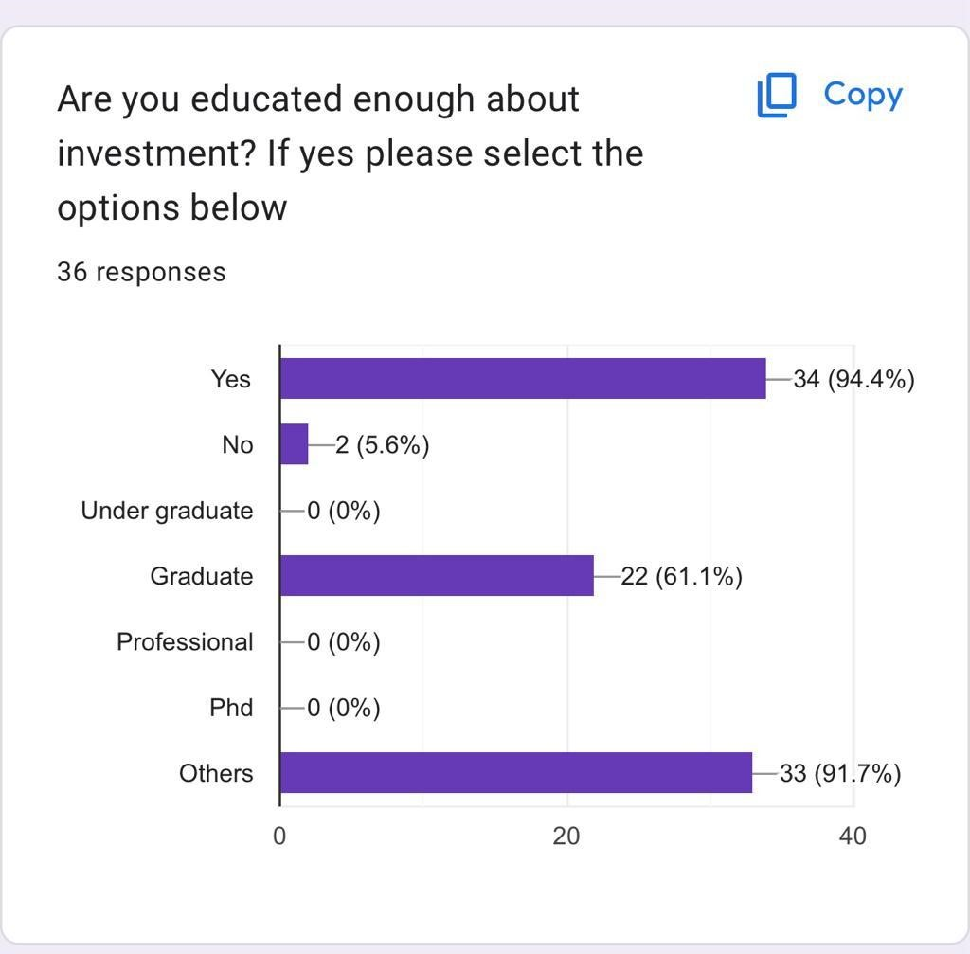

* Out of total respondents 94℅ people Says yes they have knowledge about investment and 5.6% says no
* Out of total respondents 61.8% persons are graduate and 91.1% are others
* The level of education and the overconfidence bias was compared here to check whether theres relationship between education level and overconfidence
* It shows that 91 % persons others have the highest level of overconfidence bias

When it comes to decision related to investment, you rely more on your Intuition and gut feeling?

|  |  |  |  |  |
| --- | --- | --- | --- | --- |
| Options | yes | no | male | female |
| Responses | 36 | 0 | 11 | 33 |

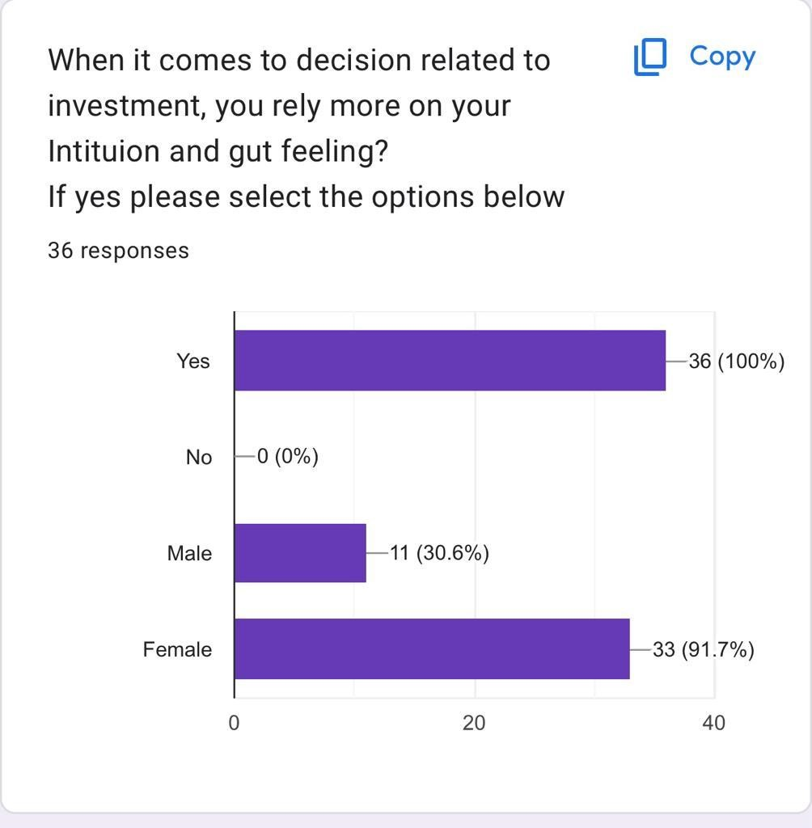

* Out of total respondents they are 100% people relying on gut feeling
* Male response are 30.6% and females are 94.7% the comparsion was with gender and emotional bias it can be said female rely more on intuition and gut feeling

If your investment is showing loss will you hold it for recovering the loss?

|  |  |  |  |  |  |  |  |  |
| --- | --- | --- | --- | --- | --- | --- | --- | --- |
| Option | yes | no | business | student | self  employ ed | service | Retired | home maker |
| respons e | 2 | 34 | 24 | 2 | 32 | 2 | 0 | 8 |

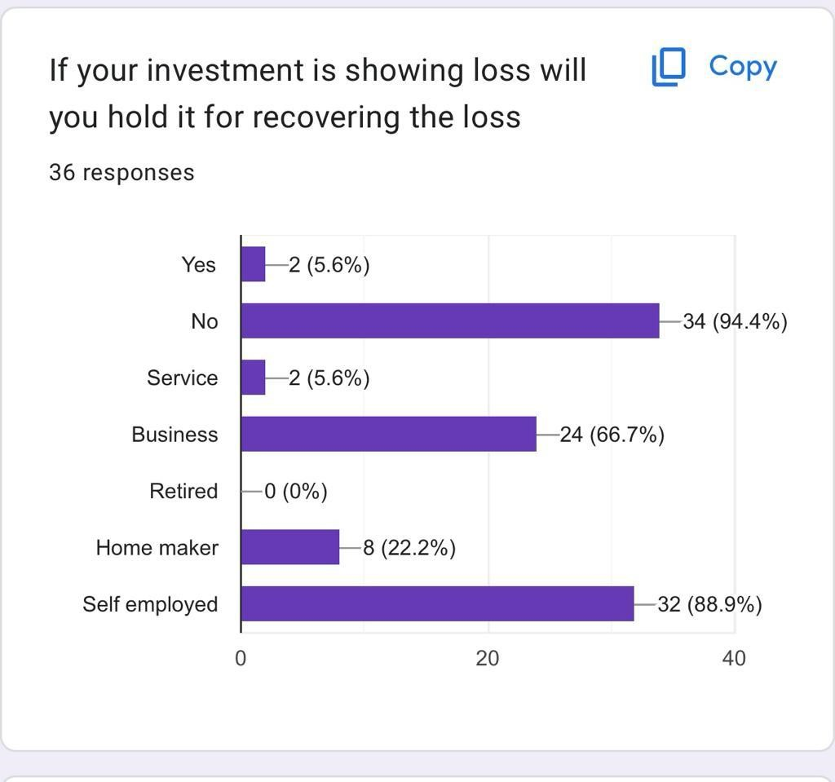

* Out of total respondents 5.6% says yes they will hold a position in investment 94.4% people are likely to sell the investment rather than holding
* Here the loss aversion bias was compared with occupation self employed people are morely like to get affected rather than business

In general terms what proportion of your income would you prefer to invest?

|  |  |  |  |  |
| --- | --- | --- | --- | --- |
| Option | 0-10% | 11-20% | 21-30% | Above 30% |
| Responses | - | 8.3% | 41.7% | 47.2% |

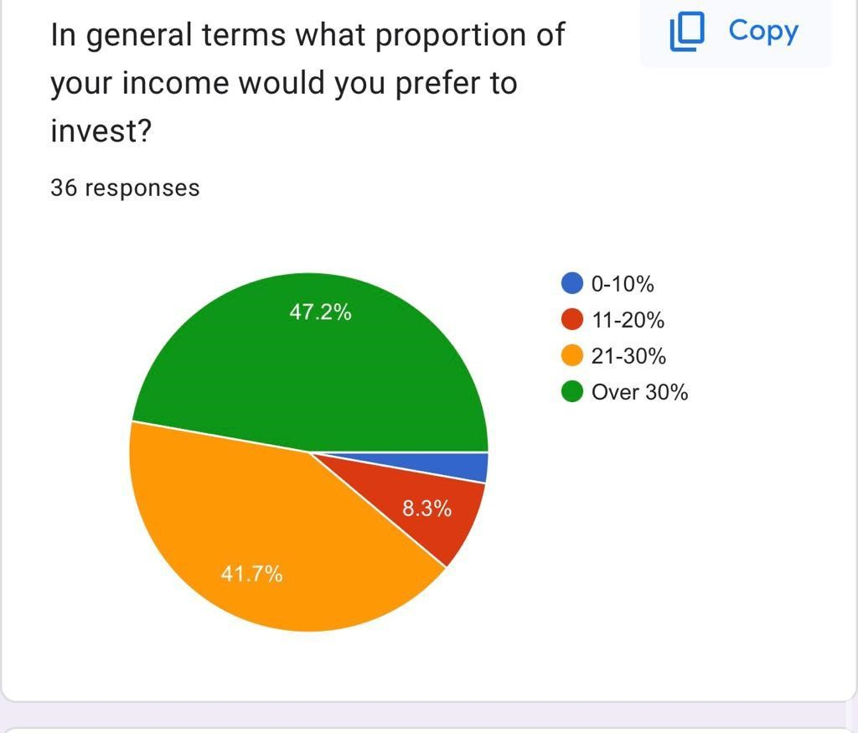

* Only 8.3% invest their income in 11-20%
* 41.7% respondents invest their income in 21-30%
* Respondents that invest above 30% of their income are more which is good amount for investing

Have you ever made any stock market investment yourself ?

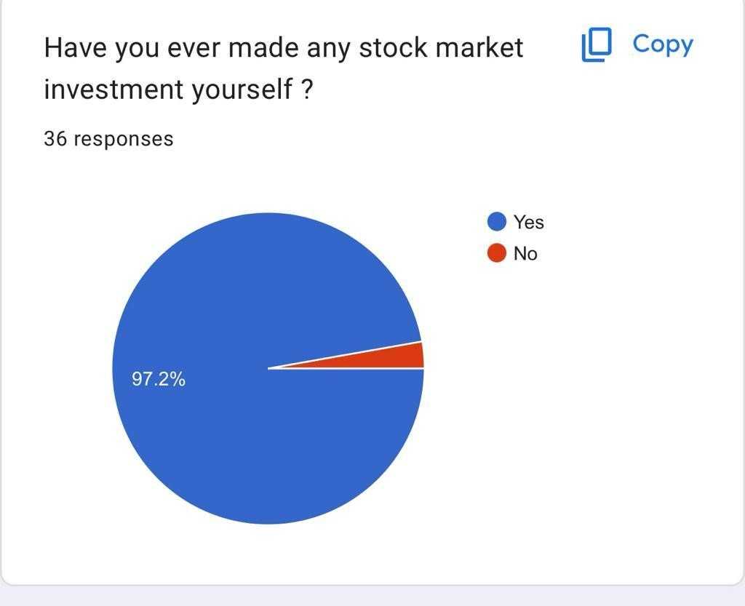

|  |  |  |
| --- | --- | --- |
| Options | Yes | No |
| Responses | 97.2% | 3% |

* Decisions made by yourself in the stock market can be roller coaster though you have made it by taking reports of the company or if you have been influenced by anyone
* About 97.2% respondents have made an investment by themselves and 3% are they haven't made investment by themselves

Do you have any work experience in the field of finance?

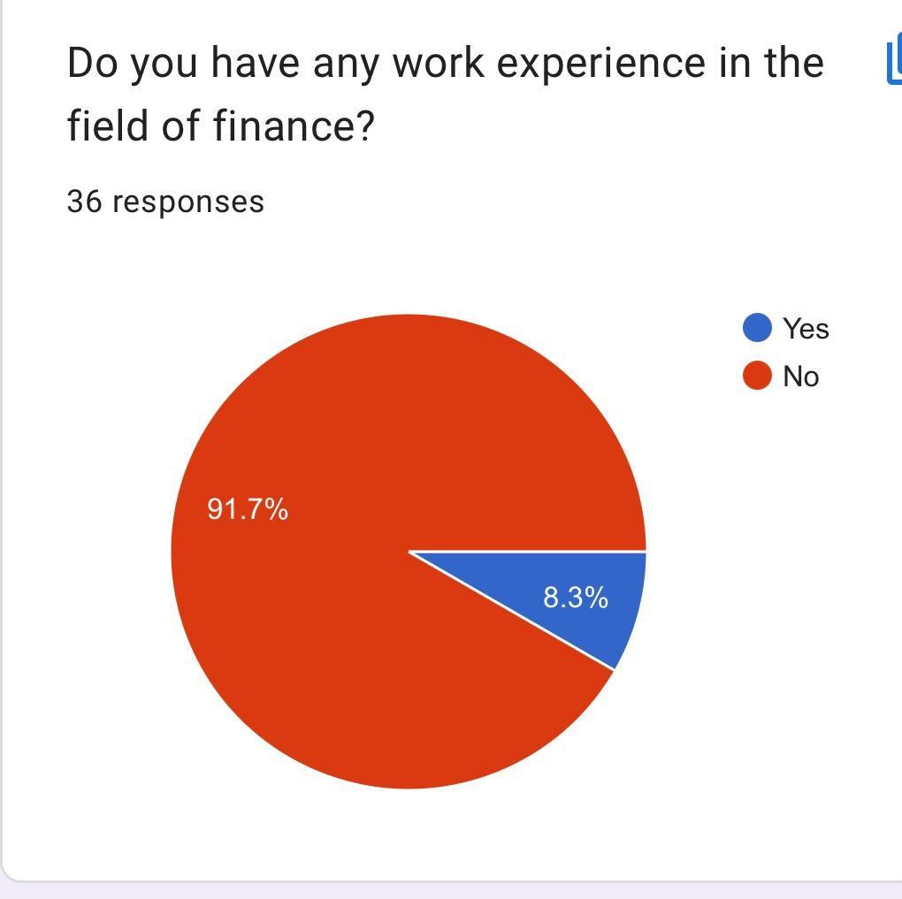

|  |  |  |
| --- | --- | --- |
| Options | Yes | No |
| Responses | 91.7% | 8.3% |

* Here we have conducted a survey where respondents are asked about experience in the field of finance
* As per the survey 91.7% respondents showed they have the experience in this field and

8.3% said no which is great

* Experience is the key

What type do you think is often used by humans to make decision?

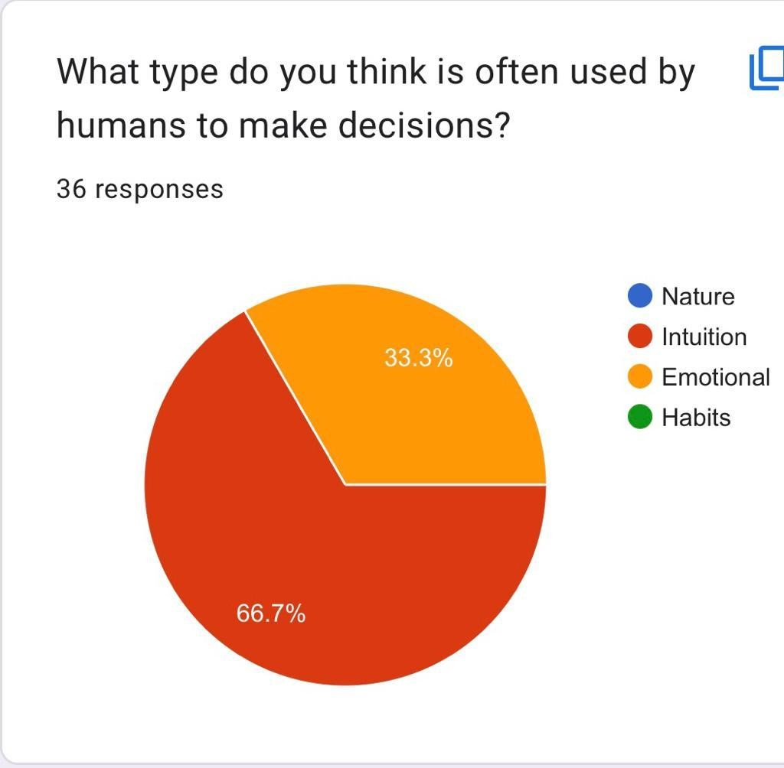

|  |  |  |  |  |
| --- | --- | --- | --- | --- |
| Options | Intuition | Habits | Nature | Emotional |
| Responses | 66.7% | - | - | 33.3% |

* Though this survey we wanted to know that what are the ways of human while they make a decision
* 66.7% are likely to go with intuition and 33.3% are with emotional

what is your experience in the field of investing or finance?

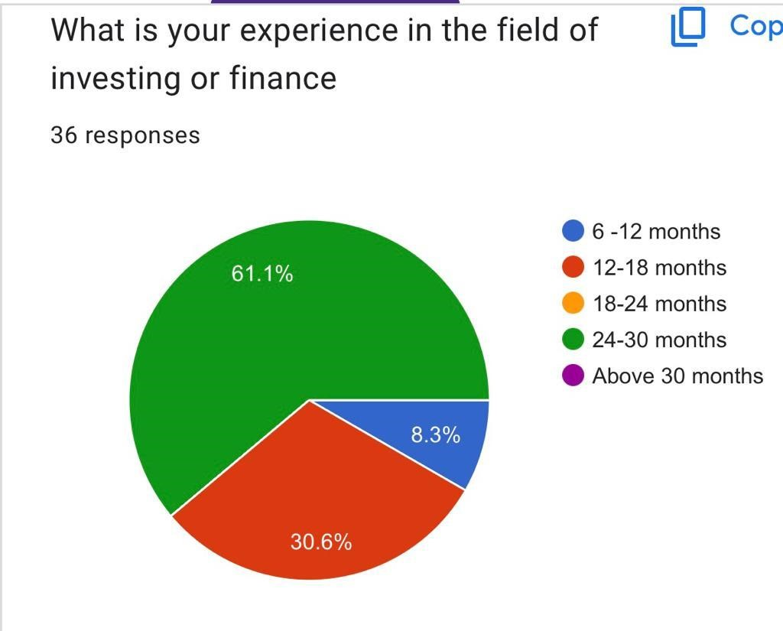

|  |  |  |  |  |  |  |
| --- | --- | --- | --- | --- | --- | --- |
| Options | 6-12 months | 12-18mont hs | 18-24 months | 24 to 30 months | Above 30 months | None |
| Responses | 8.3% | 30.6% | - | 61.1% | - |  |

* They are 8.3% have experience of 6-12 months where as 30.6% has 12-18 months
* 61.1% are the persons who have experience of 24 to 30months which is moderate
* No were found for none experience

Do you Rely on Financial Information ?

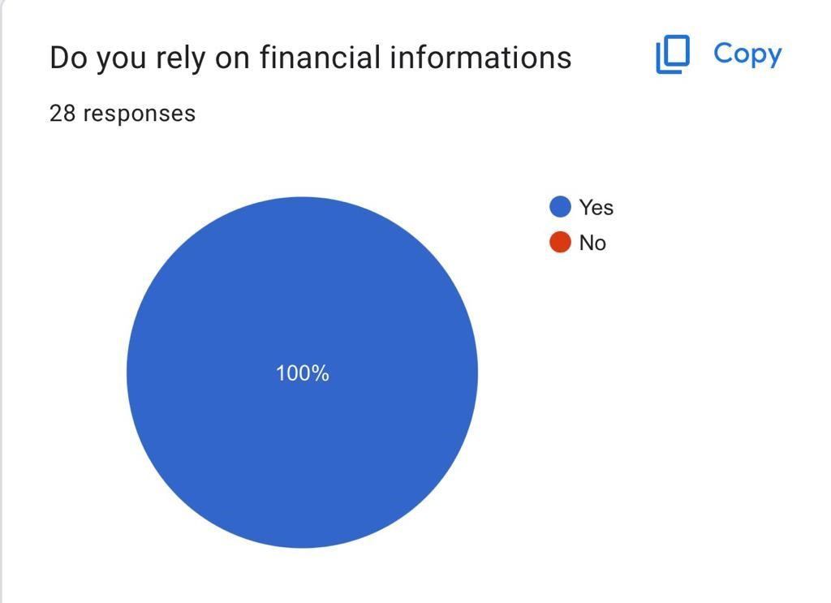

|  |  |  |
| --- | --- | --- |
| Options | Yes | No |
| Responses | 100 | - |

* Relying on any financial information can be beneficial or harmful for our investment
* According to survey 100% people have agreed they rely on financial information

**Findings**

1 It shows people combine psychology and economics to understand why the individual is making certain financial decisions.

2.It has found several insights about individual behavior.

3.Above study showed us how the emotional biases have impact on financial decisions.

4.Loss aversion , Emotional bases decisions, overconfidence bias were founded.

5.In the study it was asked are you educated about investment the study showed that less people which are 25.8 of others are more over- confident where as graduate people are less overconfident.

6. The other people think they know more than they actually do.

7.From the above study it showed us that if the investment is showing loss and still holding for loss the loss aversion bias was compared self employed people rather than business were morely affected by this bias.

8.While analyzing intuition and gut feelings it showed Female are likely to make decisions on gut feelings and intuition

9.While analyzing it was asked, have you ever made any stock market investment about yourself they are 97.7 who have made stock market investment by themselves. This means there is an no anchoring bias were found where people are heavily relying on the first piece of information when they make a decision.

1. It can be seen people are using mental shortcuts while investing.There was an influence of bias while making investment decisions.
2. The study shows investors are irrational and there's influence of behavioral finance.

**RECOMMENDATIONS**.

1.The study would recommend education to be vested in individual investors since this would overcomes unfavorable investment outcomes by behavioral biases.

2. In order to manage the excesses of behavioral finance to investment decision making training programs that create investor awareness and ability to identify and guard against behavioral biases that lead to bad investment choices.

3.The study also shows there's a need for financial management and knowledge for individual investors such that their capacities in managing funds are enchanted.

4.The study further recommends that individual investors seek the advice of stock broker fund managers to advise them accordingly in terms of performance of a specific security in which investor would wish to invest in.

5.In my opinion the stock market investments should be made by yourself .By the help of company fundamentals and its short term investment technical analysis will work .

6.The experience in the field of finance is important the more experienced you're the more you know about it.

7.In my opinion You should rely on financial information it'll make your decisions rational.

8. A discipline approach to investment based on fundamental analysis is a good way to alleviate the impact of of the loss aversion bias .It is impossible to make experiencing losses any less painful emotionally but analyzing the investment and realistically considering the probabilities of future losses and gains may help the guide the investor to a rational decision.

**Conclusion**

Cognitive errors are statistical, information-processing, or memory errors that result in faulty reasoning and analysis. The individual may be attempting to follow a rational decision-making process but fail to do so because of cognitive errors.Individual investor decisions were influenced by several behavioral biases. The investors thereby showed that their decisions are influenced by the behavioral factors as opposed to being rational. Individual were affected by over- confidence bias which means they thought they know about investment but they in actual they don't knowSimilarly emotional bias was compared this means they take investment decision on their gut feelingThe data didn't showed any confirmation bias Loss aversion bias was compared where investors was having tendency to avoid losses over achieving equivalent gains.Behavioral biases potentially affect the behaviors and decisions of financial market participants. By understanding behavioral biases, financial market participants may be able to moderate or adapt to the biases and as a result improve upon economic outcomes. These biases may be categorized as either cognitive errors or emotional biases. The type of bias influences whether the impact of the bias is moderated or adapted to.Individuals do not necessarily act rationally and consider all available information in the decision-making process because they may be influenced by behavioral biases.• Biases may lead to suboptimal decisions.Behavioral biases may be categorized as either cognitive errors or emotional biases. A single bias may, however, have aspects of both with one type of bias dominating.Cognitive errors stem from basic statistical, information-processing, or memory errors; cognitive errors typically result from faulty reasoning.Emotional biases stem from impulse or intuition; emotional biases tend to result from reasoning influenced by feelings.Cognitive errors are more easily corrected for because they stem from faulty reasoning rather than an emotional predisposition. Emotional biases are harder to correct for because they are based on feelings, which can be difficult to change.To adapt to a bias is to recognize and accept the bias and to adjust for the bias rather than to attempt to moderate the bias.To moderate a bias is to recognize the bias and to attempt to reduce or even eliminate the bias within the individual

**Bibliography** <https://corporatefinanceinstitute.com/course/behavioral-finance/><https://www.investopedia.com/terms/b/behavioralfinance.asp>[https://www.equitypandit.com/difference-between-traditional](https://www.equitypandit.com/difference-between-traditional-) finance-and-behavioural-finance/ [www.wikipedia.com](http://www.wikipedia.com/)

ATHUR, A. D. (2013). EFFECT OF BEHAVIOURAL BIASES ONINVESTMENT

DECISIONS OFINDIVIDUAL INVESTORS IN KENYA.Research gate investment Behavioral in india.International Journal of Novel Research and Development(www.ijnrd.org)Journal of Contemporary Issues in Business and Government Vol.28, No. 04, 2022<https://cibgp.com/>

Transilvania University of Braşov from classical finance tobehavioural finance. <https://www.kaplanfinancial.com/resources/career-advancement/behavioral-finance>[https://www.wallstreetmojo.com/behavioral-finance](https://www.wallstreetmojo.com/behavioral-finance/) [http://www.businessinsider.com](http://www.businessinsider.com/)