**A RESEARCH PAPER ON**

**“A COMPARATIVE STUDY OF MUTUAL FUNDS WITH RESPECT TO INVESTING”**

**SUBMITTED TO**

**HSNC UNIVERSITY, MUMBAI FOR**

**THIRD SEMESTER: MASTER OF COMMERCE (BANKING AND FINANCE)**

**SUBMITTED BY: ABHISHEK PREMCHAND GUPTA**

**ROLL NO. 18**

**SY MCOM (BANKING & FINANCE)**

**MUMBAI**

**NOVEMBER 2024**

Abstract

This paper explores the role of mutual funds as an investment vehicle, focusing on their benefits, types, market trends, and regulatory framework in India. Mutual funds offer diversification, professional management, and accessibility, making them attractive to a wide range of investors. The study examines the growing popularity of mutual funds in India, driven by investor awareness and regulatory support from SEBI. It also investigates recent industry developments, such as the shift in investment preferences post-COVID-19. A case study of SBI Mutual Fund and Kotak Mahindra Mutual Fund provides insights into their growth and strategies in the Indian market.

### **Introduction**

A mutual fund is a financial instrument that pools together money from multiple investors to invest in a diversified portfolio of assets such as stocks, bonds, or other securities. Managed by professional fund managers, mutual funds offer individual investors the opportunity to participate in the financial markets with a relatively low initial investment. This makes mutual funds an ideal choice for those who may not have the time, expertise, or resources to manage individual investments on their own. The fund manager’s role is to allocate the fund’s capital strategically, aiming to generate returns in line with the fund’s investment objectives.

In India, mutual funds have gained popularity as an investment vehicle due to their inherent advantages, including diversification, professional management, liquidity, and affordability. They cater to a wide range of investors, from conservative individuals seeking steady income to those with higher risk appetites looking for capital appreciation. As the market evolves, mutual funds are available in various types, such as equity, debt, hybrid, index, and tax-saving schemes, each designed to meet specific financial goals.

The mutual fund industry in India is regulated by the Securities and Exchange Board of India (SEBI), which ensures investor protection, transparency, and fair practices. Over the years, mutual funds have become a preferred choice for investors, given their ability to provide access to a broad array of asset classes, minimize risk through diversification, and offer professional expertise at a relatively low cost. This paper aims to provide an overview of the benefits, types, market trends, and regulations of mutual funds, with a particular focus on recent developments in the Indian mutual fund sector.

# OBJECTIVE

➢ To give a brief idea about the benefits available from Mutual Fund investment.

➢ To give an idea of the types of schemes available.

➢ To discuss about the market trends of Mutual Fund investment.

➢ To study some of the mutual fund schemes.

➢ To study some mutual fund companies and their funds.

➢ Observe the fund management process of mutual funds.

➢ Explore the recent developments in the mutual funds in India.

➢ To give an idea about the regulations of mutual funds.

# HYPOTHESIS

Null Hypothesis (H0): The source of information about mutual funds has no impact on the level of understanding.

Alternative Hypothesis (H1): The source of information about mutual funds has a significant impact on the level of understanding.

Null Hypothesis (H0): There is no significant shift in investment preferences after COVID-19.

Alternative Hypothesis (H2): There is a significant shift in investment preferences after COVID-19.

# REVIEW OF LITERATURE

A mutual fund is a financial vehicle that pools assets from shareholders to invest in securities like stocks, bonds, money market instruments, and other assets.

Mutual funds are operated by professional money managers, who allocate the fund's assets and attempt to produce capital gains or income for the fund's

investors. A mutual fund's portfolio is structured and maintained to match Review of researchers on the study

**Jana Hali, Desmond Pace and Simon Grima ,** (2016)8, are they focused on two important things first providing significant contributions to the literature and second was the practical perspective of the research.

Needless to say, that researchers and academia have centered their efforts on appraising the behavior of fund managers domiciled primarily in developed and more efficient economics, leaving the emerging region highly uncovered in this respect.

**Priyan, (2018)9** in his study it is very pivotal for the performance evaluation as in that study they check investment style of large cap equity mutual funds using styleexposure analysis proposed by Sharpe (1992). The study uses the constrained quadratic optimization factor model over the period January 2011–April 2015. To assess the dynamic drift in the style of a fund, a rolling-period exposure style analysis of the funds has been carried out by using a 36-month rolling-period window. The results of the study show that the fund managers exhibit some level of active management and a good selection capability.

**M. Jayalakshmi and V. Palanichamy (2020)10** has evaluated the performance of selected Kotak Mahindra mutual fund undergrowth scheme and compare the schemes return and risk with benchmark index within o the help of various measures like Sharpe, Treynor, and Jenson’s investment portfolio and concluded that the Sharpe and Treynor give a positive response to the decision-making process whereas Jenson’s measure gives the negative response to the same.

# DATA COLLECTION

To find out suitable data for research mainly two kinds of data was gathered namely primary and secondary data as explained below:

1. Secondary data
2. Primary data

# Secondary data

Secondary Data: The secondary data was collected from the different websites, reference books, magazines, journals, daily newspapers and various articles.

Introduction about Mutual Funds

A Mutual Fund is a trust that pools the savings of a number of investors who share a common financial goal. The money thus collected is invested by the fund manager in different types of securities depending upon the objective of the scheme. These could range from shares to debentures to money market instruments. The income earned through these investments and the capital appreciations realized by the scheme are shared by its unit holders in proportion to the number of units owned by them (pro rata). Thus, a Mutual Fund is the most suitable investment for the common man as it offers an opportunity to invest in a diversified, professionally managed portfolio at a relatively low cost. Anybody with an investible surplus of as little as a few thousand rupees can invest in Mutual Funds. Each Mutual Fund scheme has a defined investment objective and strategy.

A mutual fund is the ideal investment vehicle for today's complex and modern financial scenario. Markets for equity shares, bonds and other fixed income instruments, real estate, derivatives and other assets have become mature and information driven. Price changes in these assets are driven by global events occurring in faraway places. A typical individual is unlikely to have the knowledge, skills, inclination and time to keep track of events, understand their

implications and act speedily. An individual also finds it difficult to keep track of ownership of his assets, investments, brokerage dues and bank transactions etc.

A mutual fund is the answer to all these situations. It appoints professionally qualified and experienced staff that manages each of these functions on a full- time basis. The large pool of money collected in the fund allows it to hire such staff at a very low cost to each investor. In effect, the mutual fund vehicle exploits economies of scale in all three areas research, investments and transaction processing. While the concept of individuals coming together to invest money collectively is not new, the mutual fund in its present form is a 20th century phenomenon. In fact, mutual funds gained popularity only after the Second World War. Globally, there are thousands of firms offering tens of thousands of mutual funds with different investment objectives. Today, mutual funds collectively manage almost as much as or more money as compared to banks.

Mutual funds are investment products that operate on the principal of Strength in numbers. They collect money from large group of investments, pool it together, and invest it various securities, in line with their objective. They are an alternative to investing directly investments in securities are spread across a wide cross- section of industries and sectors and thus the risk is reduced. Diversification reduces the risk because all stocks may not move in the same direction in the same proportion at the same time. Mutual fund issues units to the investors in accordance with quantum of money invested by them. Investors of mutual funds. are known as unit holders.

The investors in proportion to their investments share the profits or losses. The mutual funds normally come out with a number of schemes with different investment objectives, which are launched from time to time: A mutual fund is required to be registered with Securities and Exchange Board of India (SEBI), which regulates securities markets before it can collect funds from the public.

"Mutual Fund is a trust that pools the savings of a number of Investors who share a common Financial Goal. The Money thus collected is invested by the fund manager in different types of securities depending upon the objective of the scheme. These could range from shares to debentures to money market instruments. The income earned through these Investments and the capital appreciation realized by the scheme is shared by its unit holders in proportion to the number of units owned by them."

"A Mutual Fund is nothing more than a collection of stocks and/or bonds. You can think of Mutual Fund as a company that brings together a group of people and invests their money in stocks, bonds and their securities. Each investor owns units, which represent a portion of the holdings of the Fund."

General Purpose:

The investment objectives of general-purpose equity schemes do not restrict them to invest in specific industries or sectors. They thus have a diversified portfolio of companies across a large spectrum of industries. While they are exposed to equity price risks, diversified general-purpose equity funds seek to reduce the sector or stock specific risks through diversification. They mainly have market risk exposure. HDFC Growth Fund is a general-purpose equity scheme.

Sector Specific:

These schemes restrict their investing to one or more pre-defined sectors, e.g., technology sector. Since they depend upon the performance of select sectors only, these schemes are inherently more risky than general-purpose schemes. They are suited for informed investors who wish to take a view and risk on the concerned sector.

Index Schemes

The primary purpose of an Index is to serve as a measure of the performance of the market as a whole, or a specific sector of the market. An Index also serves as a relevant benchmark to evaluate the performance of mutual funds. Some investors are interested in investing in the market in general rather than investing in any specific fund. Such investors are happy to receive the returns posted by the markets. As it is not practical to invest in each and every stock in the market in proportion to its size, these investors are comfortable investing in a fund that they believe is a good representative of the entire market. Index Funds are launched and managed for such investors. An example to such a fund is the HDFC Index Fund.

Tax saving schemes

Investors (individuals and Hindu Undivided Families ("HUFS")) are being encouraged to invest in equity markets through Equity Linked Savings Scheme ("ELSS") by offering them a tax rebate. Units purchased cannot be assigned / transferred/ pledged / redeemed/ switched-out until completion of 3 years from the date of allotment of the respective Units. The Scheme is subject to Securities & Exchange Board of India (Mutual Funds) Regulations, 1996 and the notifications issued by the Ministry of Finance (Department of Economic Affairs), Government of India regarding ELSS.

Subject to such conditions and limitations, as prescribed under Section 88 of the Income-tax Act, 1961, subscriptions to the Units not exceeding Rs. 10, 000 would be eligible to a deduction, from income tax, of an amount equal to 20% of the amount subscribed. HDFC Tax Plan 2000 is such a fund.

Real Estate Funds:

Specialized real estate funds would invest in real estate’s directly, or may fund real estate developers or lend to them directly or buy shares of housing finance companies or may even buy their securitized assets.

Debt Based Schemes:

These schemes, also commonly called Income Schemes, invest in debt securities such as corporate bonds, debentures and government securities. The prices of these schemes tend to be more stable compared with equity schemes and most of the returns to the investors are generated through dividends or steady capital appreciation. These schemes are ideal for conservative investors or those not in a position to take higher equity risks, such as retired individuals. However, as compared to the money market schemes, they do have a higher price fluctuation risk and compared to a Gilt fund they have a higher credit risk.

Income Schemes

These schemes invest in money markets, bonds and debentures of corporate with medium and long-term maturities. These schemes primarily target current income instead of capital appreciation. They therefore distribute a substantial part of their distributable surplus to the investor by way of dividend distribution. Such schemes usually declare quarterly dividends and are suitable for conservative investors who have medium to long term investment horizon and are looking for regular income through dividend or steady capital appreciation. HDFC Income Fund, HDFC Short Term Plan and HDFC Fixed Investment Plans are examples of bond schemes.

Gilt Funds

This scheme primarily invests in Government Debt. Hence the investor usually does not have to worry about credit risk since Government Debt is generally

credit risk free. HDFC Gilt Fund is an example of such a scheme. Hybrid Schemes:

These schemes are commonly known as balanced schemes. These schemes invest in both equities as well as debt. By investing in a mix of this nature,

balanced schemes seek to attain the objective of income and moderate capital appreciation and are ideal for investors with a conservative, long-term

orientation. HDFC Balanced Fund and HDFC Children's Gift Fund are examples of hybrid schemes.

Constitution:

Schemes can be classified as Closed-ended or Open-ended depending upon whether they give the investor the option to redeem at any time (open-ended) or whether

the investor has to wait till maturity of the scheme. Open ended Schemes:

The units offered by these schemes are available for sale and repurchase on any business day at NAV based prices. Hence, the unit capital of the schemes keeps

changing each day. Such schemes thus offer very high liquidity to investors and are becoming increasingly popular in India. Please note that an open-ended fund is NOT obliged to keep selling/issuing new units at all times, and may stop

issuing further subscription to new investors. On the other hand, an open-ended fund rarely denies to its investor the facility to redeem existing units.

Closed ended Schemes:

The unit capital of a close-ended product is fixed as it makes a one-time sale of fixed number of units. These schemes are launched with an initial public offer (IPO) with a stated maturity period after which the units are fully redeemed at NAV linked prices. In the interim, investors can buy or sell units on the stock

exchanges where they are listed. Unlike open-ended schemes, the unit capital in closed-ended schemes usually remains unchanged. After an initial closed period, the scheme may offer direct repurchase facility to the investors. Closed- ended schemes are usually more illiquid as compared to open-ended schemes

and hence trade at a discount to the NAV. This discount tends towards the NAV closer to the maturity date of the scheme.

Interval Schemes:

These schemes combine the features of open-ended and closed-ended schemes.

They may be traded on the stock exchange or may be open for sale or redemption during pre- determined intervals at NAV based prices.

CASE STUDY OF SBI MUTUAL FUND V/S KOTAK MAHINDRA MUTUAL FUND (as on 2022)

* SBI Mutual Fund

SBI Mutual Fund is a payment system introduced by State Bank of India (SBI) and incorporated in 1987 with its corporate head office located in Mumbai, India. SBIFMPL is a joint venture between the State Bank of India, an Indian public sector bank, and Amund, a European asset management company. The chairman of state bank of India mutual fund is Mr. Vinay M Tones. As of September, 2019, the fund house claims to serve 5,809,315 unique investors through approximately 212 branches PAN India. As of September 2021, the total AUM stands at Rs.579318.29 crores. In 1991 the SBI mutual fund Company launches the SBI magnum equity fund, and in 1999 they launch the first contra fund. In 2013 SBI do acquisition with Daiwa mutual funds, part of Tokyo. Employees provident fund organization decides to invest 5000 crores in the nifty and Sensex EFTs (exchange traded fund) of SBI mutual fund.

* Kotak Mahindra Mutual Fund

Kotak group was recognized in 1985 by Mr. Uday Kotak. It is the first Indian non- banking financial corporation to be given Certificate by reserve bank of

India. It got certify in February 2003. Kotak Mahindra Asset Management Company Limited, a Company incorporated under the Companies Act,1956, selected to act as the Investment Manager to Kotak Mahindra Mutual Fund vide Investment Management Agreement dated 20the May, 1996, as amend up to date. It is a completely owned secondary of The Sponsor, Kotak Bank. The Investment Manager is entitled to chargea management fee as prearranged by the Regulations for the services render by it to the Fund. An approval by the Division of Funds, Investment Management Department under the SEBI (Portfolio Manager) Regulations, 1993 and Mutual Funds Division of SEBI under the SEBI (‘Mutual Funds’) Regulations 1996, has been granted to the Company for undertaking Portfolio Management Service (PMS). There is no disagreement of interest between the Mutual Fund and the PMS movement

# Primary data

Primary Data: Individual respondents were the main source of primary data.

The method of collecting primary data was through a structured questionnaire. The sample size of the survey is 35 respondents residing in Mumbai.

# DATA ANALYSIS AND INTERPRETATION

DEMOGRAPHIC PROFILE

# Age

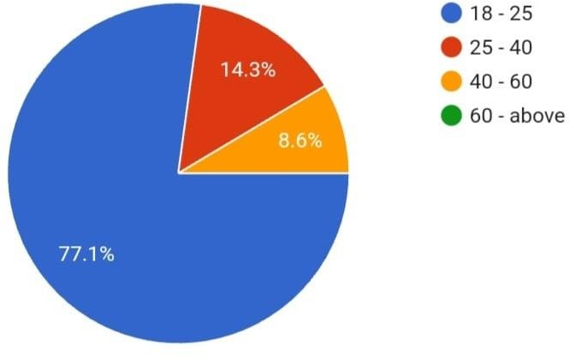

Interpretation :

This research shows that out of 35 responses there are 77.1 % are 18 – 25 years old ,14.3 % are 25 – 40 years old , 8.6 % 40 – 60 years old.

# Gender

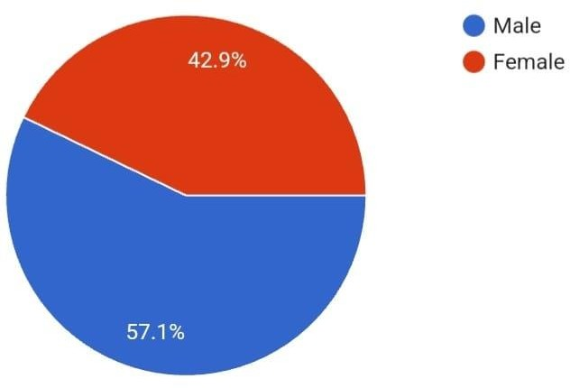

Interpretation:

This research shows that out of 35 responses there are 57.1 % are Male ,42.9 % are Female.

# Occupation

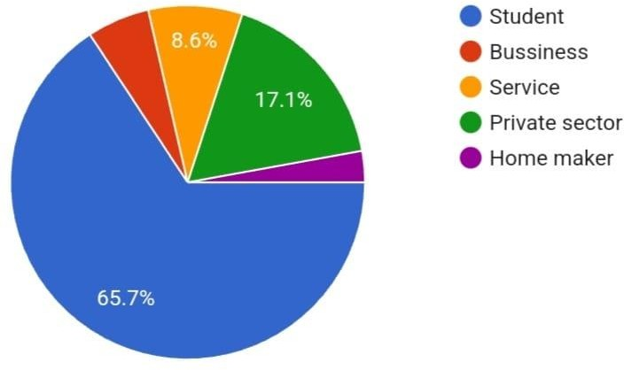

Interpretation:

This research shows that out of 35 responses 65.70 % are Student , 5.7 % are from business, 8.6 % are from service sector, 17.10% are from private sector, 2.9% are home maker.

# Monthly income

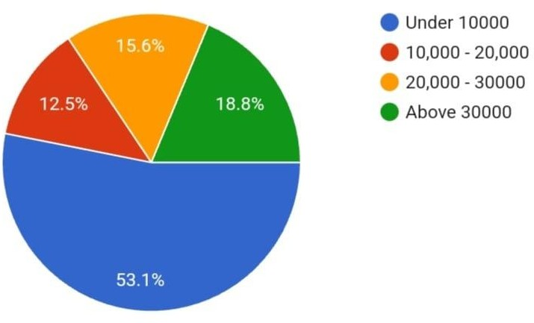

Interpretation :

This research shows that out of 32 responses 53.1% have monthly income below 10000 , 12.5% are between 10000-20000 rupees, 15.36% are between

20000 – 30000 and 18.8 % are above 30000.

# While investing your money, which factor you prefer the most?

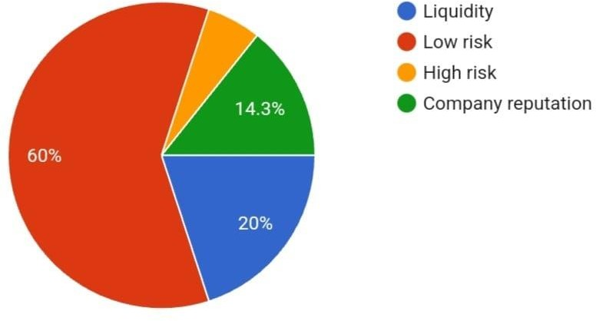

Interpretation :

This research shows that out of 35 responses their investment preference is 20% liquidity,60% low risk, 5.7% high risk and 14.3% company reputation.

# What is your investment horizon?

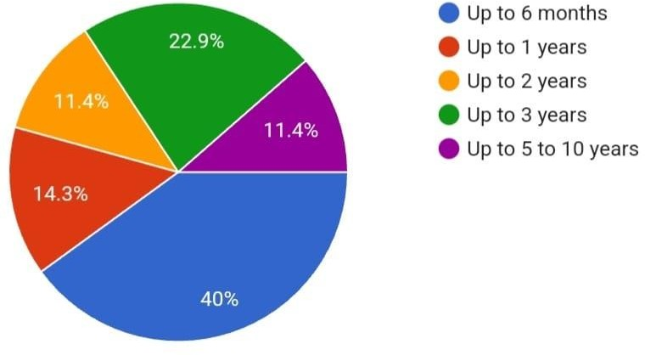

Interpretation :

This research shows that out of 35 responses 40% of the respondent’s

investment horizon is up to 6 months, 14.3% of the respondent’s investment horizon is up to 1 year, 11.4% of the respondent’s investment horizon is up to 2 years, 22.9% of the respondent’s investment horizon is up to 3 years and 11.4% of the respondent’s investment horizon is up to 5-10 years

# What are your Investment Preferences?

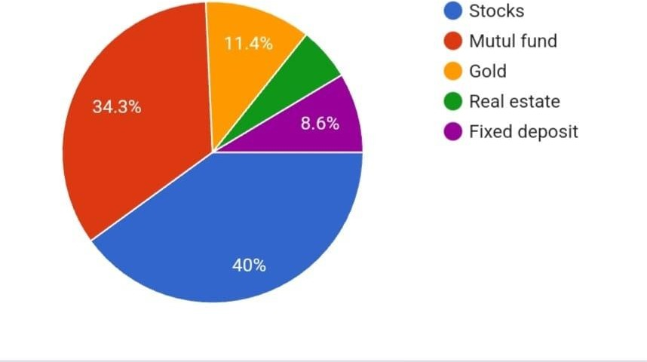

Interpretation :

This research shows that out of 35 responses 40% of the respondent’s investment preference is stocks, 34.3% of the respondent’s investment

preference is Mutual funds, 11.4% of the respondent’s investment preference is Gold, 5.7% of the respondent’s investment preference is Real-Estate, 8.6% of

the respondent’s investment preference is Fixed Deposit, 10.8% of the respondent’s investment preference is Others.

# How do you come to know about Mutual Fund ?

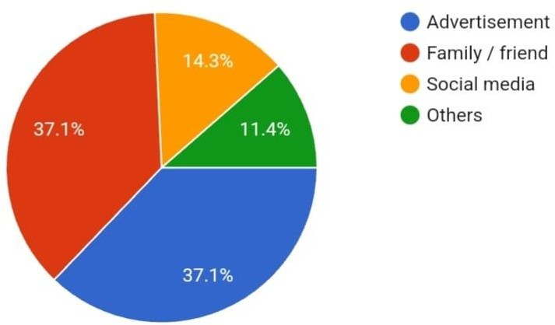

INTERPRETATION:

As per this research, it shows out of 35 respondents majorly know by family/ friend 37.1%, 37.1% were also know by advertisements and rest 14.3% and 11.4% by social media and from other sources

1. Have you ever invested your money Mutual fund?

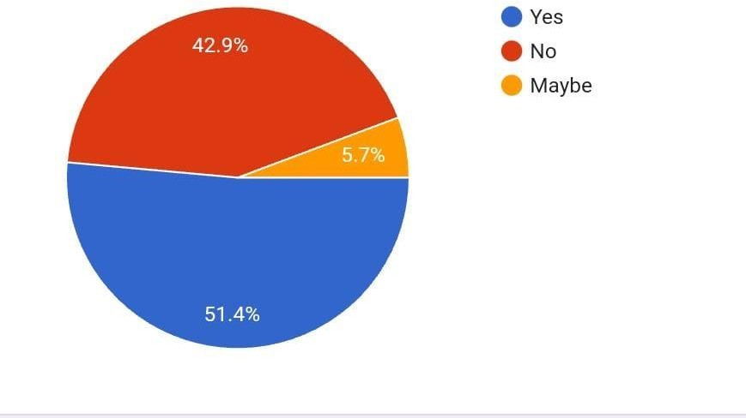

Interpretation :

This research shows that out of 35 responses 51.4% of the respondents have

invested in mutual funds, 42.9% of the respondents have not invested in mutual funds and 5.7 % of the respondents do not know whether they have invested in mutual funds or not.

# Your Risk capacity?

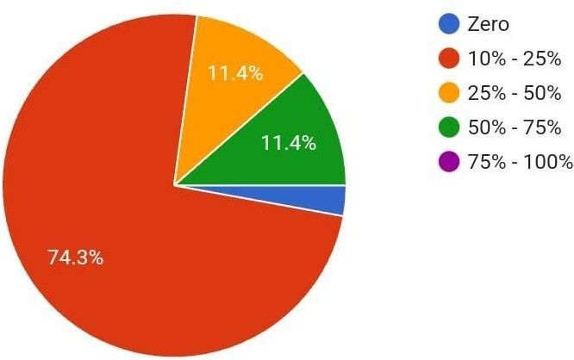

INTERPRETATION:

According to this research, it shows that out of 35 responses 2.9% of the respondents have zero risk capacity, 74.3% of them have around 10% - 25% of risk capacity and 11.4%, 11.4 % & 2.9 % of them have risk capacity of 25% - 50% ,1%- 75% and 100% respectively.

# Would you like more public or more private mutual funds?

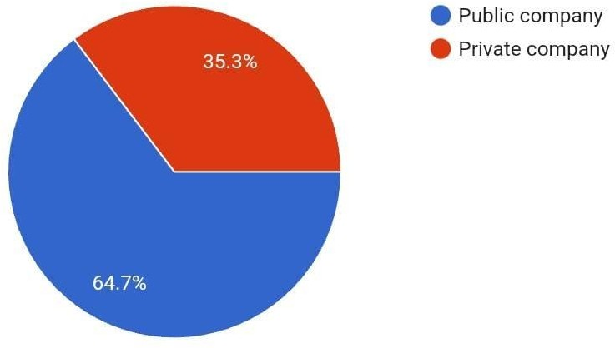

INTERPRETATION:

As per this research, it shows out of 35 respondents 64.7% of them like to invest in sovereign company’s mutual fund and 35.3% of them in private company’s mutual fund.

# When you invest in mutual funds which mode of investment will you prefer?

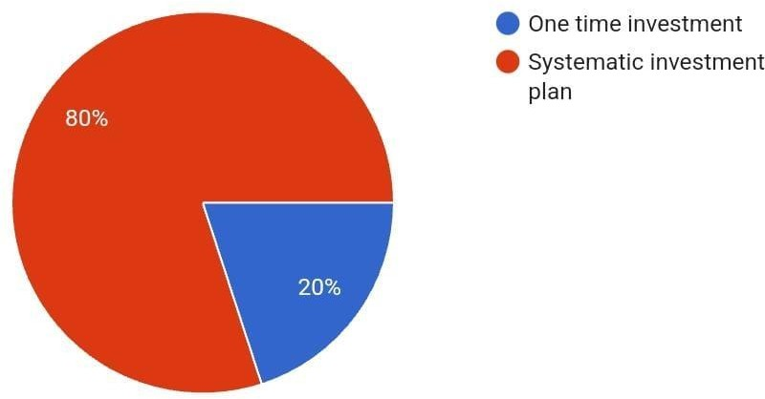

INTERPRETATION:

As per this research, it shows that out of 35 responses 20% and 80 % of the respondent are interested towards one time investment and systematic

investment plan respectively.

# What's the shift in your investment preference after covid ?

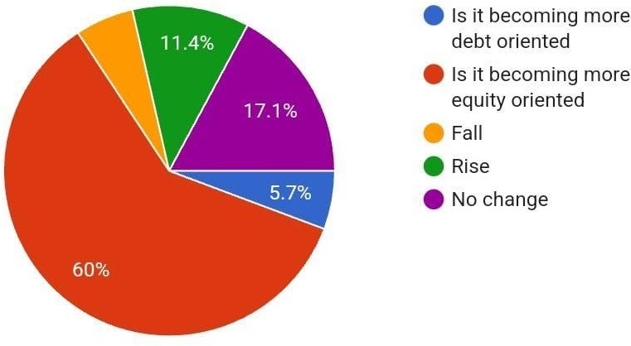

INTERPRETATION:

As per this research, it shows out of 35 respondents 5.7% & 60% of the respondent’s preference has become more debt oriented and become more

equity oriented respectively and 5.7% of fall in the investment preference and 11.4% of rise in the investment preference. 17.1% there is no change in the preference.

# Would you Recommend MF to Others

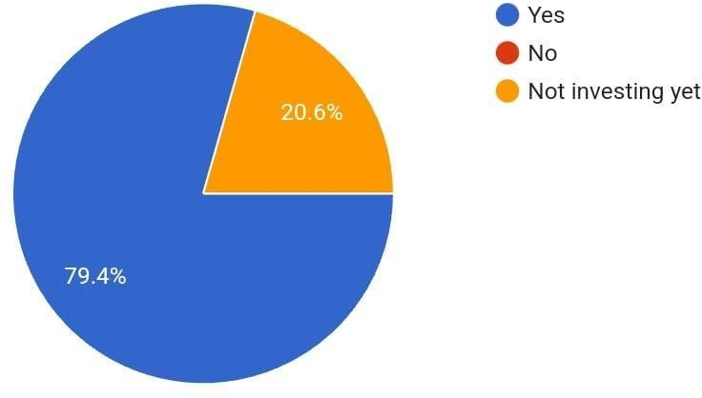

INTERPRETATION:

As per this research, it shows out of 35 respondents 79.4 % recommend For mutual fund and 20.6% not Investing Yet

# Findings

The following findings are based on the observations during the period of study.

* + It is seen that majority 77.1% of respondent were between age 18-25 years old.
  + Major were student with 65.7% with next 17.10% were from private Sector.
  + 18.8 % respondents were earning more then 30000 rupees a month and majority were below 10000 rupees per month.
  + 60% for respondent where low risk taking and highest were 5.7 %
  + As per study majority invest their money for short period of time with a 40 % in total.
  + 11.4 % were long term investor.
  + 40% are high interested in stocks , followed by mutual fund at 34.3 % only
  + Major people recommend to invest in Mutual fund at 79.4 %

•

•

Suggestions

The mutual funds industry should focus on managing investor money and other function such as accounting and other allied services can be outsourced. This will save both money and energy to concentrate in other profitable ventures.

* The rate of attrition is very high amongst the fund manager of various schemes as they are frequently changing their job to get higher package. This is cause of major concern as it is impacting the profitability and long-term objectives of the schemes Mutual funds industry at present having minuscule share of house hold savings as majority of people still prefer to park their savings in banks and other safer avenue of investments. To overcome this customer education programme should be under taken by AMFI in collaboration with other fund houses.
* To increase the pace of growth of the industry use of information technology should be promoted at a larger scale. This will reduce the time of transaction.
* The broker often engages in unethical practices of false projection about funds’ performance in order to generate brokerage on mobilized investment This create negative image about the mutual funds industry and dissuade investors from

investments.

* Mutual funds can be offered online to the investors through the stock

exchange. This can in one hand lower the cost of servicing the fund holder and on the other increase the penetration of mutual funds.

* The investors should have through knowledge about the funds before they

make any investment. Therefore, investment should be preceded by tracking the performance of the funds over a period of time and different business cycles.

# Conclusion

We can infer from the analysis that the concept of mutual fund in the place like Mumbai in its growing phase. With the growing importance of mutual fund in other areas in the country, this place is witnessing the same rate of growth in mutual funds. Apart from these facts the following are some other important facts which can easily be inferred from the paper---Huge opportunities of Mutual funds exist in all the country. In short, the market in this city is a growing market as because many companies exist in this market, competition is cut to throat. Mindsets of the investors are not towards mutual funds. They still think of investing in traditional investment alternatives. Customers are not properly educated about the mutual funds. Emerging youth are the scope for the mutual fund as they are being updated by lasted investment option available in the market.

# BIBLIOGRAPHY

* + Sib Mutual Fund PDF | PDF | Mutual Funds | Securities (Finance) (scribd.com)
  + https://[www.indmoney.com/articles/personalfinance/advanta](http://www.indmoney.com/articles/personalfinance/advantages-and-) [ges-and-](http://www.indmoney.com/articles/personalfinance/advantages-and-) disadvantages-of-mutual-funds-key-things-to-keep- in-mind
  + https://[www.financestrategists.com/wealth-](http://www.financestrategists.com/wealth-management/investments/mutual-) [management/investments/mutual-](http://www.financestrategists.com/wealth-management/investments/mutual-) fund/
  + https://[www.amfiindia.com/investor-corner/knowledge-](http://www.amfiindia.com/investor-corner/knowledge-center/advantages-of-) [center/advantages-of-](http://www.amfiindia.com/investor-corner/knowledge-center/advantages-of-) investing-in-mutual-funds.html
  + SEBI | Securities and Exchange Board of India (Mutual Funds) Regulations, 1996 [Lastamended on January 25, 2022]

**APPENDIX:- Google form link :** [**https://forms.gle/3hZtZr3TUF8zhnuE8**](https://forms.gle/3hZtZr3TUF8zhnuE8)

**Excel Link :A COMPARATIVE STUDY OF MUTUAL FUNDS WITH RESPECT TO INVESTING CRITERIA (Responses).xlsx**



A COMPARATIVE STUDY OF MUTUAL F