**TOPIC - A STUDY ON CONSUMER PREFERENCE TOWARDS FROZEN FOOD**

**AUTHOR – MOHIT SOBHANI**

**COLLEGE – HR COLLEGE OF COMMERCE AND ECONOMICS**

# SUMMARY

The purpose of the current study is to identify the buying behaviour of purchasing frozen food with reference to Ulhasnagar people. The research used descriptive research design with a quantitative and qualitative approach to get an in-depth understanding of the subject matter. The random sampling technique has been used to collect the data. The primary data is collected through questionnaires and the secondary data is collected through research articles .The sampling size of the study is 75.The targeted people in the study are the people who buy and utilise the frozen food products from both physical and online mode.

# OBJECTIVES

**PRIMARY OBJECTIVES:**

1. To study the buying behaviour of frozen food products.

**SECONDARY OBJECTIVES:**

1. To analyse how much money they spend while buying frozen food products.
2. To find the importance of brand value among the buyers.
3. To analyse the most important factor that the buyers look at while buying frozen food products.

# HYPOTHESIS

**Hypothesis 1: Brand Awareness and Purchase Frequency Correlation:** Null Hypothesis (H0): There is no significant correlation between sources of brand awareness (e.g., television, friends/relatives, shopkeepers/salespersons) and the frequency of frozen packaged food purchases.

Alternative Hypothesis (H1): Certain sources of brand awareness significantly impact the frequency of frozen packaged food purchases among consumers.

**Hypothesis 2: Demographic Impact on Likeness Ratings:**

Null Hypothesis (H0): There is no significant difference in likeness ratings for frozen packaged food products across different demographic segments such as age groups, occupations, and dietary preferences.

Alternative Hypothesis (H1): Likeness ratings for frozen packaged food products significantly differ among various demographic segments.

# LITERATURE REVIEW

**Nitya (2021):** Has conducted a study on consumer perception towards instant food products. The objective of the study was to study the awareness of effective utilisation of instant food products among youngsters of Delhi/NCR.

**Nazrul (2021):** Conducted a study on Factors Influencing the Consumers' towards RTC (Ready-to-Cook) Foods in Bangladesh. The main objective of the study was to identify the factors that influence customers to buy ready-to-cook food products in Bangladesh.

**Malavika (2019):** Has published an article on a customer perception on frozen foods in Chennai. This article mainly focuses on the understanding of the customer’s perception towards frozen food with reference to Chennai people and to find the factors influencing to buy frozen foods.

**Muhammad Ahid (2017):** Has conducted a study on determinants of frozen food products. This study was conducted to know the role of knowledge about frozen foods and it also analyses consumer attitudes toward frozen food products.

# SECONDARY DATA

Frozen foods are the foods that are prepared by freezing the food and the growth of frozen foods is growing significantly because it is very easy to cook, food taste and odour does not change by freezing the foods and also it is used as food storage due to which the buyers are more attracted to it. The frozen food is the best option for the people who run on a busy schedule and who don’t want to spend more time in the kitchen. The market consists of frozen vegetables, frozen fruits, frozen chicken related products, frozen mutton related products, and frozen sea foods.

Frozen foods encompass a diverse range of items, offering convenience, extended shelf life, and varying nutritional profiles.

**Fruits and Vegetables:** These are typically flash-frozen or individually quick frozen (IQF) at peak ripeness, locking in nutrients. From berries and mango chunks to broccoli and peas, these retain much of their original nutritional value and are versatile for use in smoothies, stir-fries, or as side dishes.

**Meats and Seafood:** Frozen meats like chicken breasts, beef cuts, and pork chops, as well as seafood such as shrimp, fish fillets, and scallops, are vacuum-sealed or frozen in individual portions. Properly frozen, they maintain quality and are convenient for meal planning.

**Ready-to-Eat Meals:** These include a wide array of options, from frozen pizzas and lasagnas to ethnic cuisines and healthy bowls. They're pre-cooked and frozen for reheating, ideal for quick, satisfying meals.

**Baked Goods:** Frozen bread, rolls, pastries, and desserts are partially or fully baked before freezing, allowing for easy storage and quick finishing in the oven. They offer convenience without compromising on taste.

Each category caters to different culinary needs and preferences, providing consumers with a broad selection of options for quick, nutritious, and flavorful meals.

The frozen food market in India is estimated to grow at a **CAGR of 14.12%** between 2022 and 2027. The size of the market is forecast to increase by **USD 1,478.91 million**. The growth of the market depends on several factors, including the growing desire for convenience, rapid e-commerce penetration boosting market growth, and the rising demand from QSRs.

This report extensively covers **market segmentation by product (ready to cook and ready to eat) and distribution channel (online and offline).** It also includes an in-depth analysis of drivers, trends, and challenges. Furthermore, the report includes historic market data from 2017 to 2021.

What will be the Size of the Frozen Food Market in India During the Forecast Period?

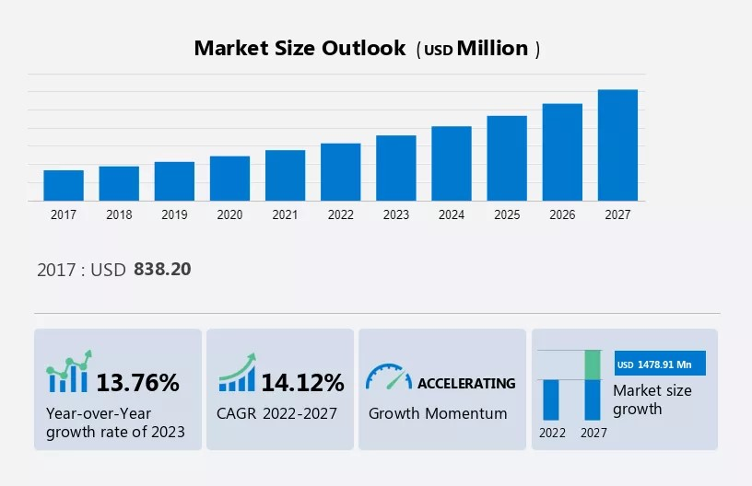

**The growing desire for convenience is notably driving the market growth, although distribution challenges may impede the Indian Frozen Food Market growth.** Our researchers analysed the data with 2022 as the base year, along with the key drivers, trends, and challenges. A holistic analysis of drivers will help companies refine their marketing strategies to gain a competitive advantage.

# Key Frozen Food Market Driver in India

**The growing desire for convenience is notably driving the Indian Frozen Food Market growth.** Consumers' increasingly hectic lifestyles make them prefer ready-to-eat foods, which saves cooking and cleanup time. Convenience is often a key factor that frozen food suppliers consider to increase consumer relevance, as the majority of consumers look for convenience while choosing a packaged product. Advances in refrigeration technology, an increase in single-person and small-person households, and an increase in the number of working women have increased the demand for ready-made foods such as frozen foods. In addition, frozen food suppliers offer convenient handling and preparation, offering a variety of flavours and recipes in desired portion sizes. Although the Indian food market has traditionally been dominated by fresh produce, the above factors provide opportunities for frozen food suppliers to grow. However, sellers should communicate the positive benefits of the long shelf life of frozen food to customers. Due to all these factors, the Indian frozen food market is expected to witness high growth during the forecast period.

Along with all this, the increasing internet penetration worldwide has led to the global growth of e-commerce companies. Moreover, the demand for online shopping is increasing all over the world due to convenient shopping, easy searching of products, and increased demand for attractive and customised offers on products. Online retail has created new opportunities for suppliers in the frozen food industry to increase sales, expand their geographic footprint, and improve customer relationships and profitability. The Indian frozen food market is expected to grow during the forecast period owing to increasing online penetration of frozen food. E-commerce and fast online grocery delivery services are sweeping the Indian startup ecosystem. Hence, the rapid growth of e-commerce will have a positive impact on the Indian frozen food market during the forecast period.

# Significant Frozen Food Market Trend in India

**The expanding organised retail landscape is a key trend influencing the Indian Frozen Food Market growth.** The growing retail environment and increased availability of frozen products through various distribution formats are emerging trends in the Indian frozen products market. Organised retail is experiencing significant expansion, as evident by the growing presence of supermarkets, hypermarkets, and specialty stores around the world. Large, organised retailers primarily sell different frozen products such as frozen prepared meals, frozen foods, frozen meats and poultry, and frozen fruits and vegetables. Therefore, Indian frozen food market players rely heavily on these retailers and compete for limited shelf space in these large organised retail outlets.

Convenience and value for money are key metrics for consumers, largely due to their busy lifestyles and work schedules, and organised retailers are pushing for a wide range of products under one roof. Thus, the shift in consumer shopping behaviour towards supermarkets and hypermarkets is further increasing the importance of organised retailers for market players, which will positively impact the growth of the Indian frozen food market during the forecast period.

# Major Frozen Food Market Challenge in India

**The distribution challenges are impeding the growth of the Indian Frozen Food Market.** Frozen product distribution and cold storage are key challenges that may hamper the growth of the Indian frozen food market during the forecast period. The lack of suitable refrigerated transportation and cold storage facilities across India is likely to hamper market growth during the forecast period. Market vendors rely on cold chain logistics providers to ensure proper distribution and storage of frozen products. Frozen foods should be stored at 0 degrees Fahrenheit to ensure product quality. The lack of adequate refrigeration facilities in some regions will pose a challenge for market participants during the forecast period. Fruits and vegetables are among the most delicate foods and can easily spoil if not kept at recommended or constant temperatures.

Exposure to high temperatures can be a serious factor in the deterioration of frozen foods. Short-term exposure is generally not serious unless it is repeated frequently, but long-term exposure can be harmful. Even short-term exposure to excessive temperatures can lead to significant deterioration that is only noticeable after further storage. Temperature fluctuations should be avoided as they cause migration of moisture out of the product or within the package, leading to the formation of ice crystals and partial dehydration of the product. The product temperature is generally more important than the air temperature. Therefore, refrigerated and refrigerated transportation facilities are required to ensure the quality of frozen foods. The lack of these facilities could impede the growth of the featured market during the forecast period.

# Key Frozen Food Market Customer Landscape in India

The report includes the adoption lifecycle of the market, covering from the innovator’s stage to the laggard’s stage. It focuses on adoption rates in different regions based on penetration. Furthermore, the report also includes key purchase criteria and drivers of price sensitivity to help companies evaluate and develop their growth strategies.

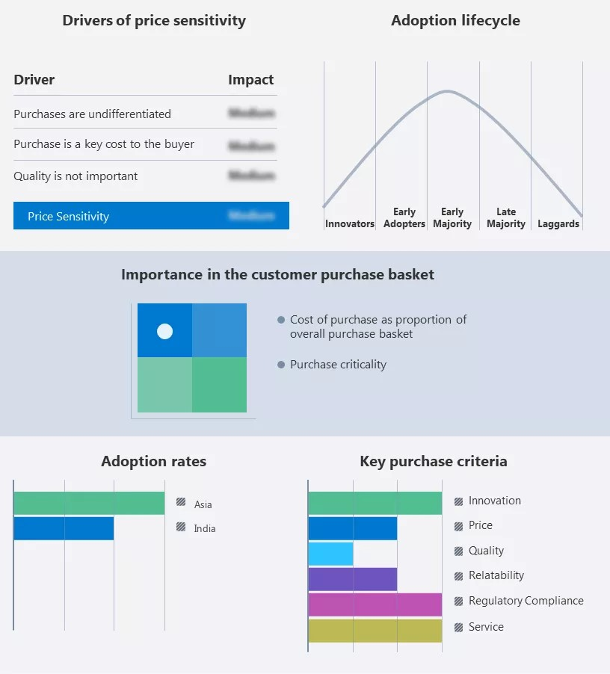

# Global Frozen Food Market in India Customer Landscape

**Who are the Major Frozen Food Market Vendors in India?**

Vendors are implementing various strategies, such as strategic alliances, partnerships, mergers and acquisitions, geographical expansion, and product/service launches, to enhance their presence in the market.

**Ajinomoto Co. Inc:** The company offers different varieties of frozen foods such as fruits, mixed vegetables, and others. It also provides ready-to-eat meals, healthy meals, and integrated food solutions.

The report also includes detailed analyses of the competitive landscape of the market and information about 15 market vendors, including:

* Apex Frozen Foods Ltd.
* Associated British Foods Plc ● Capricorn Food Products India Ltd.
* Conagra Brands Inc.
* Corporativo Bimbo SA de CV ● DARSHAN FOODS PVT. LTD.
* Frozen Tropicals Pvt. Ltd.
* General Mills Inc.
* Godrej Agrovet Ltd.
* HyFunFoods Pvt. Ltd.
* Innovative Foods Ltd.
* ITC Ltd.
* McCain Foods Ltd.
* Mother Dairy Fruit and Vegetable Pvt. Ltd.
* Nestle SA

Qualitative and quantitative analysis of vendors has been conducted to help clients understand the wider business environment as well as the strengths and weaknesses of key market players. Data is qualitatively analysed to categorise vendors as pure play, category-focused, industry-focused, and diversified; it is quantitatively analysed to categorise vendors as dominant, leading, strong, tentative, and weak.

# What are the Fastest-Growing Segments in the Frozen Food Market in

**India?**

The market share growth by the **ready-to-cook segment** will be significant during the forecast period. This segment includes Frozen Pizza, Frozen Pasta, Frozen Croissant, Frozen Asian Food, Frozen Rice Bowl, Frozen Noodle Bowls, Frozen Crispy Pancakes, Frozen Tarts, and others. Frozen foods are gaining popularity due to their ease of preparation and short cooking times.

However, this segment faces certain challenges. Frozen foods are often high in sulphur, and eating them can raise your blood pressure. Frozen prepared foods are reheated. The frozen ready-to-eat segment is affected by consumer shifts towards healthier eating options.

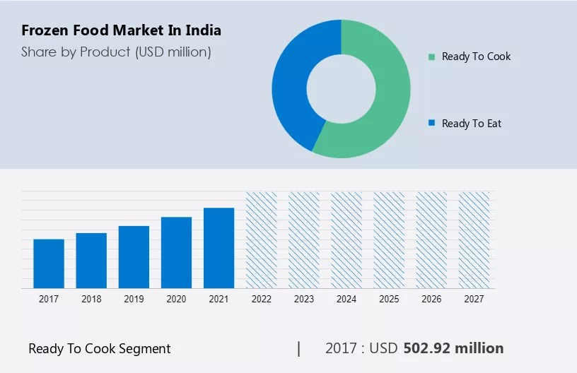

The ready to cook segment was valued at **USD 502.92 million** in 2017 and continued to grow until 2021. Suppliers are looking to add healthier options to their range of frozen prepared meals. The increasing availability of nutrient-dense varieties of frozen prepared meals will impact the growth of this segment during the forecast period. Prominent suppliers of frozen-ready meals in India include Conagra, Nestle, and McCain. The Indian frozen food market is expected to witness high growth during the forecast period, owing to the increasing consumption of ready-to-eat meals.

# Segment Overview

The report forecasts market growth by revenue at global, regional & country levels and provides an analysis of the latest trends and growth opportunities from 2017 to 2027.

* Product Outlook (USD Million, 2017 - 2027)
  1. Ready to cook

○ Ready to eat

* Distribution Channel Outlook (USD Million, 2017 - 2027)
  1. Online

○ Offline

# Parent Market Analysis

Technavio categorises the Indian frozen food market as part of the global packaged foods and meats products market, under the global food segment of the global food, beverage, and tobacco market. The global packaged foods and meats products market includes food processing manufacturers or suppliers involved in food processing to eliminate microorganisms and extend shelf life. Technavio calculates the global packaged foods and meat market size based on the total revenue of the vendors operating in the market. The market does not include manufacturers of food processing equipment. Manufacturers of packaged alcoholic and non-alcoholic beverages, including bottled water, have also been removed from the market.

# Frozen Food Market Scope in India

|  |  |
| --- | --- |
| Report Coverage | Details |
| Page number | 122 |
| Base year | 2022 |
| Historic period | 2017-2021 |
| Forecast period | 2023-2027 |
| Growth momentum & CAGR | Accelerate at a CAGR of 14.12% |
| Market growth 2023-2027 | USD 1,478.91 million |
| Market structure | Fragmented |
| YoY growth 2022-2023(%) | 13.76 |

|  |  |
| --- | --- |
| Competitive landscape | Leading Vendors, Market Positioning of  Vendors, Competitive Strategies, and  Industry Risks |
| Key companies profiled | Ajinomoto Co. Inc., Apex Frozen Foods  Ltd., Associated British Foods Plc, Capricorn  Food Products India Ltd., Conagra Brands Inc., Corporativo Bimbo SA de CV, DARSHAN FOODS PVT. LTD., Frozen  Tropicals Pvt. Ltd., General Mills Inc., Godrej Agrovet Ltd., HyFunFoods Pvt. Ltd.,  Innovative Foods Ltd., ITC Ltd., McCain Foods Ltd., Mother Dairy Fruit and Vegetable Pvt. Ltd., Nestle SA, Savola  Group, Top Fresh International Pvt. Ltd.,  Unilever PLC, and VH Group |
| Market dynamics | Parent market analysis, Market growth inducers and obstacles, Fast-growing and slow-growing segment analysis, COVID 19 impact and recovery analysis and future consumer dynamics, Market condition  analysis for forecast period |
| Customization purview | If our report has not included the data that you are looking for, you can reach out to our analysts and get segments customised. |

**What is the Key Data Covered in this Frozen Food Market in India Report?**

* CAGR of the market during the forecast period
* Detailed information on factors that will drive the growth of the frozen food market in India between 2023 and 2027
* Precise estimation of the size of the frozen food market size in India and its contribution to the parent market
* Accurate predictions about upcoming trends and changes in consumer behaviour
* Growth of the market across India
* Thorough analysis of the market’s competitive landscape and detailed information about vendors
* Comprehensive analysis of factors that will challenge the growth of the frozen food market vendors in India

# PRIMARY DATA

AGE

GROUP

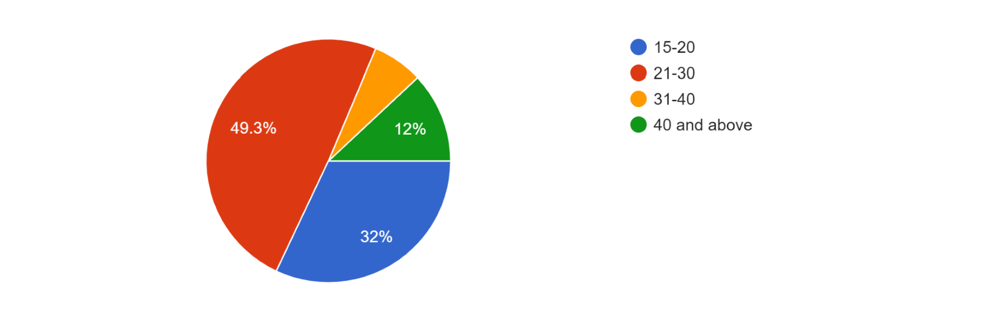

**Age Distribution:** There's a mix of age groups represented, with a significant number falling within the 21-30 range. There's also a notable presence of individuals aged 15-20 and a considerable representation of respondents aged 40 and above.

**Dominant Age Groups:** From the provided snippet, the 21-30 age group seems to have the highest frequency of selections, followed by 15-20 and 40 and above.

**Lack of Middle-Aged Responses:** There's a comparatively smaller number of respondents in the 31-40 age range.

OCCUPATION

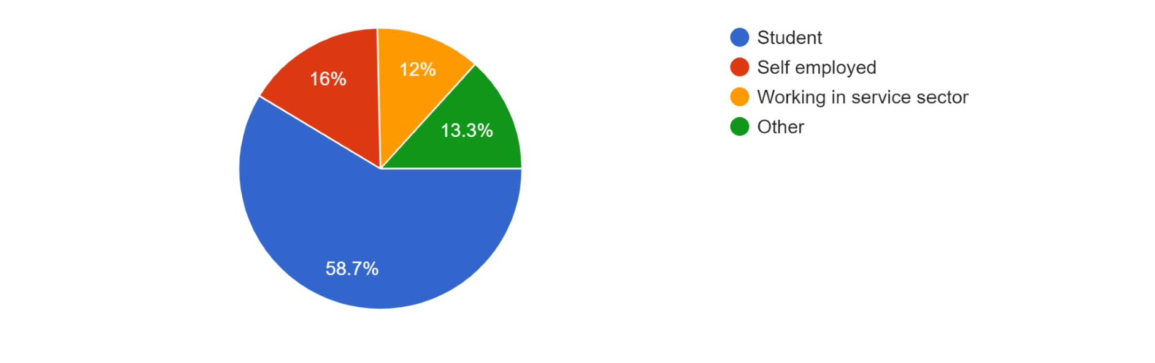

**Student Majority:** The majority of respondents seem to identify as students, indicating a prevalent student demographic within the dataset.

**Service Sector Workers:** There's a notable presence of individuals working in the service sector, indicating some diversity in occupations beyond the student category.

**Self-Employment:** There are a few respondents who mentioned being self-employed, indicating a small representation of individuals running their own businesses or ventures.

**Other Categories:** Some respondents indicated 'Other' as their occupation, which might include various roles not explicitly mentioned in the provided options. It could be valuable to further explore and understand these diverse roles.

# PREFERENCE

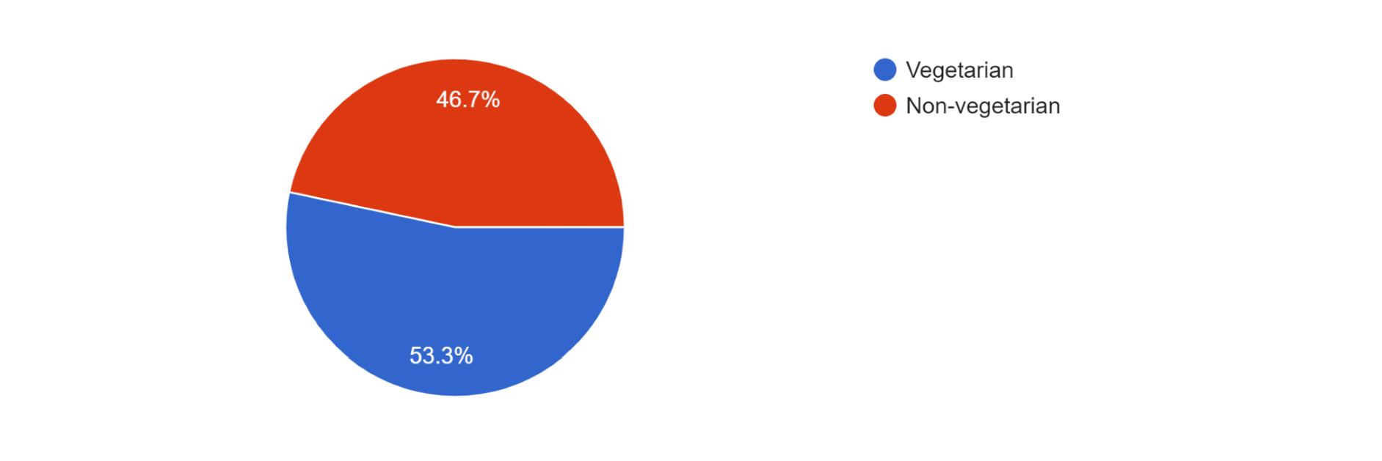

**Vegetarian Preference:** There's a noticeable majority leaning towards a vegetarian diet among the respondents. The number of individuals preferring a vegetarian diet seems notably higher than those favouring a non-vegetarian diet.

**Non-Vegetarian Preference:** While there's a presence of respondents who prefer a non-vegetarian diet, it seems to be a smaller proportion compared to those choosing a vegetarian diet.

DO YOU PURCHASE FROZEN PACKAGED FOOD?

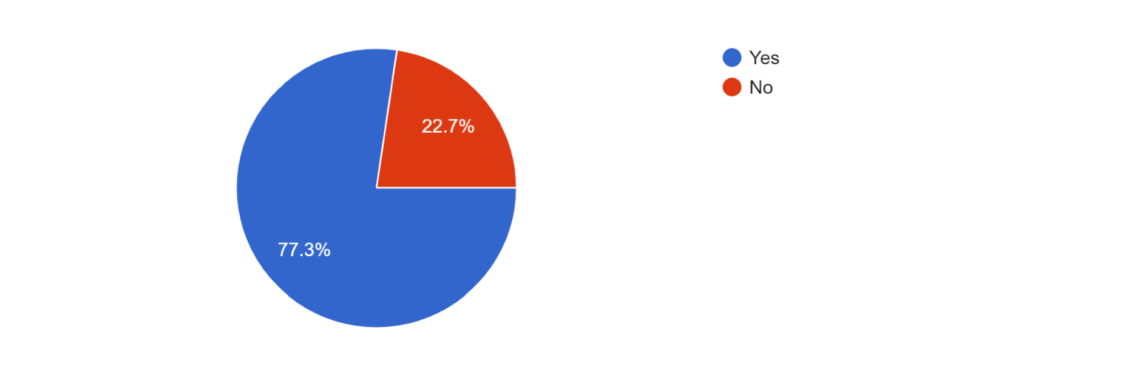

**High Percentage of Purchasers:** A significant majority, constituting 75% of the respondents, reported purchasing frozen packaged food products.

**Minority Avoiding Purchase:** Around 25% of respondents mentioned they do not purchase these items, signifying a smaller but noticeable proportion who opt not to buy frozen packaged food products.

IS YOUR MONTHLY EXPENDITURE ON FROZEN FOOD ITEMS?

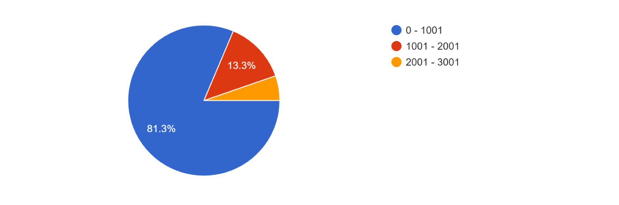

**Majority in Lower Expenditure Bracket:** The vast majority (about 85%) spend between 0 and 1001 units (currency) on frozen food items per month.

**Minority in Higher Expenditure Brackets:** A smaller percentage of respondents (12%) fall into the ranges of 1001 - 2001 units, while an even smaller proportion (3%) spend between 2001 - 3001 units.

ARE THE REASONS FOR PURCHASING FROZEN PACKAGED FOOD PRODUCTS?

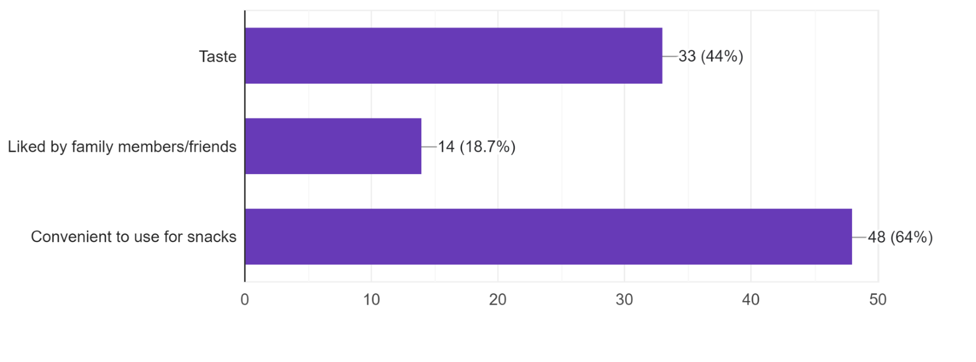

**Convenience as a Strong Factor:** The most prevalent reason for purchasing frozen packaged food products, mentioned by approximately 93% of respondents, is the convenience of using these items for snacks.

**Taste as a Significant Factor:** Taste is also a significant influencing factor, with around 61% of respondents citing it as a reason for their purchase of frozen packaged foods.

**Social Influence:** A smaller but notable proportion of respondents (24%) mentioned that the preference or liking of family members or friends influences their decision to purchase these products.

ARE THE REASONS FOR NOT PURCHASING FROZEN PACKAGED FOOD PRODUCTS?

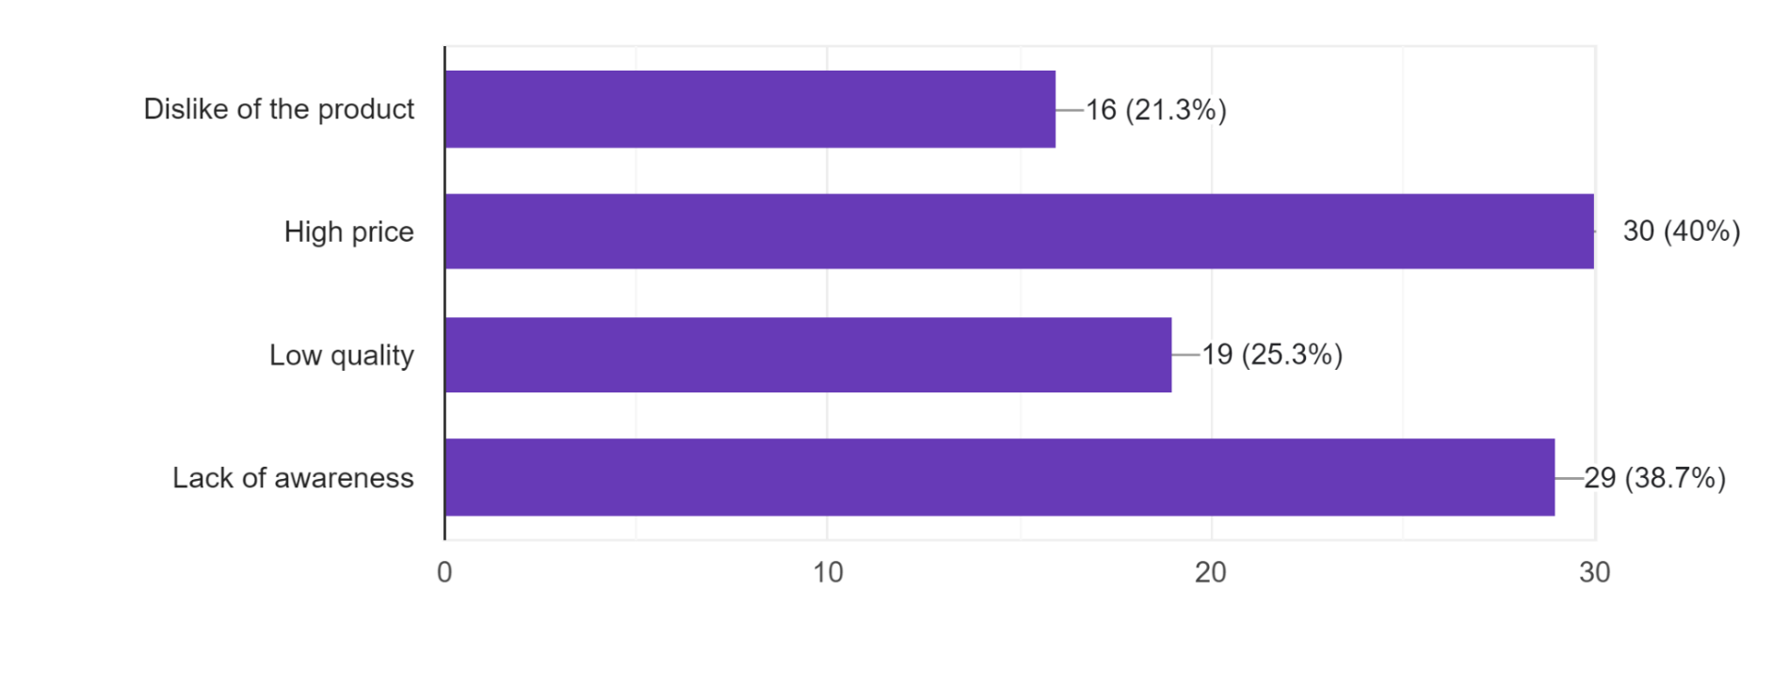

**High Price as a Primary Concern:** The most common reason cited for not purchasing frozen packaged food products is the perceived high price, mentioned by around 71% of respondents.

**Lack of Awareness as a Factor:** A significant proportion, approximately 55% of respondents, cited lack of awareness as a reason for not purchasing these products, indicating a potential need for better marketing or information dissemination.

**Quality and Product Preference Concerns:** Roughly 39% mentioned concerns about low quality, and 41% cited a dislike of the product as reasons for not making purchases.

IS YOUR PREFERRED BRAND?

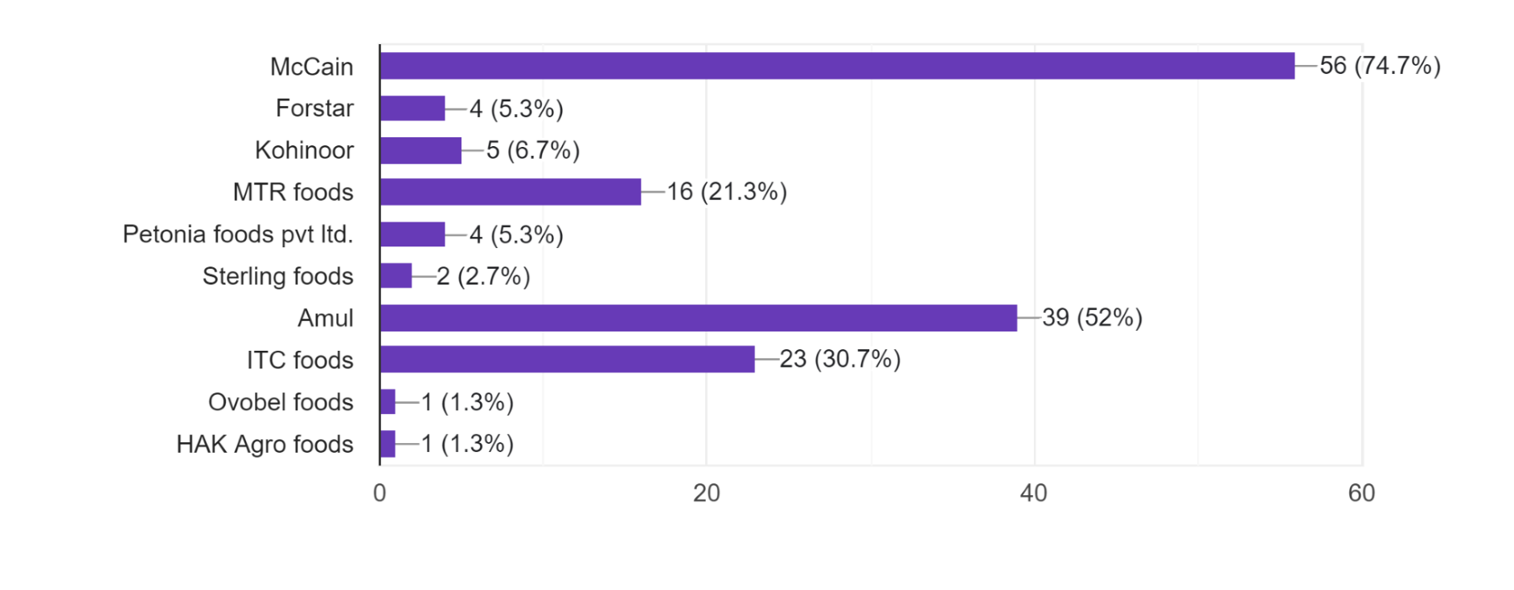

**McCain Dominance:** The most prevalent preferred brand among respondents is McCain, mentioned by approximately 85% of respondents.

**Amul as a Close Second:** Amul emerges as the second most popular brand, with around 60% of respondents mentioning it as their preferred brand.

**Presence of Other Brands:** While McCain and Amul are the prominent choices, several other brands are also mentioned, albeit with lower frequencies, indicating a diverse range of preferences among respondents.

REASONS FOR CHOOSING FROZEN PRODUCTS?

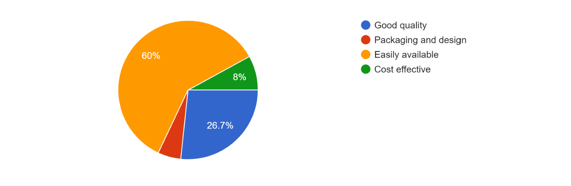

**Accessibility is a Key Factor:** The most prevalent reason for choosing frozen foods, cited by approximately 87% of respondents, is their easy availability.

**Emphasis on Quality:** Around 60% of respondents mentioned good quality as a significant factor influencing their choice of frozen foods.

**Minor Influence of Cost and Packaging:** Cost-effectiveness and packaging/design seem to have a lower impact, with fewer respondents citing these as reasons for choosing frozen foods.

WHAT ARE YOUR SOURCES OF INFORMATION FOR BRAND

AWARENESS?

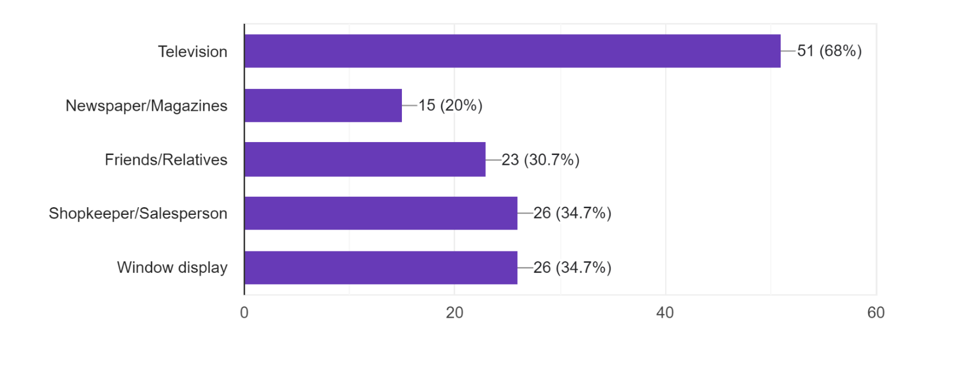

**Television as the Primary Source:** The most prevalent source of brand awareness, cited by approximately 87% of respondents, is television.

**Significant Influence of Personal Contacts:** Friends/Relatives and Shopkeeper/Salesperson follow closely, indicating the substantial impact of personal recommendations and interactions in building brand awareness.

**Window Display and Print Media as Secondary Sources:** Window displays and newspaper/magazines are mentioned by fewer respondents but still play a role in brand awareness, with around 44% and 24% of respondents, respectively, acknowledging these as sources of information.

HOW FREQUENTLY DO YOU PURCHASE FROZEN PACKAGED

FOODS?

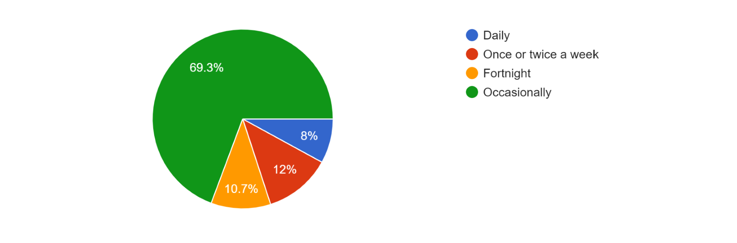

**Occasional Purchases Dominate:** The most prevalent frequency of purchasing frozen packaged food products, mentioned by approximately 75% of respondents, is occasional purchases.

**Weekly Purchases as Secondary:** About 19% of respondents indicated buying these products once or twice a week, showing a regular but not predominant pattern.

**Less Frequent Purchases:** A smaller proportion of respondents, approximately 13%, mentioned buying these products on a fortnightly basis.

**Daily Purchases are Minimal:** Daily purchases were the least frequent, mentioned by only around 7% of respondents, indicating a very small segment with a high-frequency consumption pattern.

ON A SCALE FROM 1-5 RATE YOUR LIKENESS TOWARDS FROZEN FOODS?

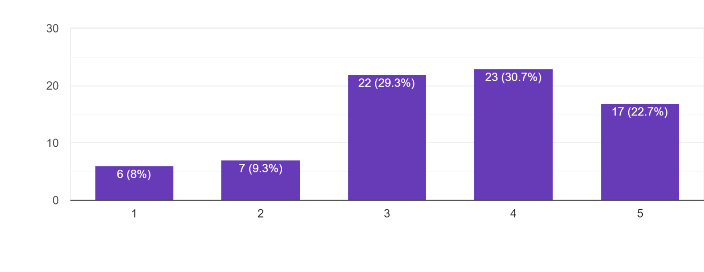

**Moderate Likeness Prevalent:** Ratings of 3 and 4 were the most common, with approximately 56% of respondents falling within these ratings, suggesting a moderate level of likeness towards frozen packaged food.

**Extreme Ratings:** Approximately 45% of respondents rated 5, showcasing a high likeness, while 21% rated 1 or 2, indicating a relatively lower preference or dissatisfaction.

# SUGGESTIONS

**Understanding Customer Preferences:**

**Variety of Choices:** There's a mix of reasons for purchasing frozen food, such as taste, convenience, and brand preference. It might be useful to offer a variety of flavours or types to cater to different tastes.

**Price Sensitivity:** Many respondents cite high prices as a reason for not purchasing. Consider offering occasional discounts or introducing more cost-effective options to attract customers.

**Quality Concerns:** Some respondents mention concerns about low quality. Improving the quality or highlighting the quality aspects of the products could attract more buyers.

**Awareness Campaigns:** Lack of awareness seems to be a barrier for some. Marketing campaigns or promotions could focus on educating customers about the products.

**Branding and Marketing:**

**Prominent Advertising Channels:** TV, friends/relatives, and window displays are noted sources of information. Invest more in these channels for brand visibility and awareness.

**Packaging Matters:** Packaging and design play a role in product selection.

Enhancing packaging to make it more appealing could attract potential buyers.

**In-store Promotion:** Shopkeepers and salespersons influence decisions.

Training or providing incentives to them could positively impact sales.

**Customer Retention and Expansion:**

**Customer Retention:** For those who purchase, ensure consistent quality and value for their money. This will retain existing customers.

**Expansion:** Targeting the younger age group might be beneficial, as they seem more open to purchasing frozen foods.

**Pricing Strategies:**

**Price Range:** Considering the varied monthly expenditure, offering products in different price ranges could cater to different budget categories.

**Frequency of Purchase:**

**Encourage Regular Purchases:** Encouraging occasional buyers to purchase more frequently might increase overall sales. This could be done through loyalty programs or discounts for regular customers.

**Product Improvement:**

**Feedback Integration:** Addressing concerns about low quality or taste can involve collecting customer feedback and making improvements accordingly.

**Education and Information:**

**Awareness Campaigns:** More educational campaigns about the benefits or cooking methods of frozen foods might attract hesitant buyers.

By focusing on these aspects—variety, price, quality, branding, marketing, customer retention, and education—you can potentially enhance the appeal and sales of frozen packaged food products.

# CONCLUSION

The study of consumer behaviour toward frozen packaged food products reveals nuanced insights crucial for businesses in this domain. It's evident that preferences and decisions regarding these products are influenced by various factors across different demographics.

Age groups ranging from 15-20, 21-30, and above 40 showcase distinct

inclinations. Younger age brackets, particularly students, prioritise convenience and taste, while older respondents, often self-employed or from other occupations, emphasise product quality and family preferences.

Occupation plays a role in shaping preferences, with students valuing convenience and taste due to their fast-paced lifestyles, while those in service sectors or self-employed individuals emphasise factors like quality, price, and family preferences.

Preferences for vegetarian versus non-vegetarian products also influence buying decisions. Vegetarians are driven by convenience and brand loyalty, whereas non-vegetarians are concerned about taste, quality, and sometimes price.

The preference for brands like McCain, Amul, and MTR foods is prominent, emphasising their market presence and perceived quality. Yet, despite brand loyalty, concerns about high prices, low quality, and lack of awareness among consumers persist.

Reasons for choosing frozen foods centre on convenience, taste, and sometimes brand loyalty, while reasons for not purchasing revolve around concerns like high prices, low quality, and lack of awareness about certain brands or products.

The sources of information influencing brand awareness are diverse, including television, friends/relatives, and shopkeepers/salespersons. This suggests that multiple channels play pivotal roles in shaping consumer perceptions and decisions.

Frequency of purchase varies widely, from occasional buyers to those purchasing once or twice a week or even daily, depending on lifestyle, occupation, and preferences. This indicates the importance of market segmentation and catering to diverse consumer needs.

Rating likeness on a scale of 1 to 5 generally falls between 3 and 5, reflecting moderate to high satisfaction with frozen packaged food products among respondents. However, concerns about quality and pricing persist, impacting these ratings.

In conclusion, to thrive in the frozen food market, businesses need to address concerns about pricing, quality, and awareness. Improving product quality, adjusting pricing strategies, enhancing brand visibility, and engaging diverse marketing channels can bridge these gaps. Tailoring offerings to meet varying consumer needs across age groups, occupations, and dietary preferences is key to sustained growth and increased consumer satisfaction in this competitive market landscape.

# BIBLIOGRAPHY

[https://www.technavio.com/image/20230321090203_abstract_2023_v2.jpg.web p?v4.1.14](https://www.technavio.com/image/20230321090203_abstract_2023_v2.jpg.webp?v4.1.14)

<https://ijcrt.org/papers/IJCRT2205039.pdf>