**A Study On “The Impact of Social Media Marketing on Business”**

**Siddhi Jain (HSPMCBM 021)**

**Abstract**

This paper investigates how social media marketing impacts business success through brand awareness, consumer engagement, and sales. Data from surveys and secondary sources reveal that platforms like Instagram and Facebook enhance brand loyalty and sales growth. Key findings include the role of influencer partnerships and visual content in consumer decisions. This study’s limitations and future trends in social media marketing are also discussed, offering a full perspective on social media’s influence on business.

**Introduction**

• **Background:** Social media has transformed from a communication tool into a major marketing platform, impacting consumer behavior and business outcomes. Businesses increasingly rely on social media to engage consumers, boost brand awareness, and drive sales.

• **Purpose:** To examine the impact of social media marketing on business outcomes, such as brand visibility, customer acquisition, engagement, and sales.

• **Importance of Study:** As digital consumerism grows, understanding social media’s impact on business is critical for brands aiming to remain competitive.

**Literature Review**

Social media has transformed marketing by providing businesses with cost-effective, direct access to global audiences. Platforms like Instagram and Facebook enable companies to showcase products visually and engage customers instantly, strengthening relationships

A major influence of social media is seen through “social proof”—the idea that people are swayed by others’ actions. Positive likes, shares, and reviews build trust and impact purchasing decisions. Studies show that consumers trust user-generated content, such as reviews, more than brand messages, which significantly affects buying behaviour. Additionally, influencer endorsements on platforms like Instagram lend credibility, further driving customer engagement and brand loyalty.

**Hypotheses**

1. H1: Higher perceived quality of information on social media correlates with increased consumer satisfaction and decision-making.

2. H2: Greater perceived quantity of information available on social media correlates with greater customer engagement and purchase decisions.

**Research Methodology**

**Primary and Secondary Data Collection:**

• **Primary Data:** Collected via a structured online survey targeting small to medium-sized businesses (SMBs) and general consumers. The survey explores brand perception, engagement, and purchase influences on social media.

• **Secondary Data:** Sourced from journals, industry reports, and case studies focused on social media marketing’s influence on consumer behaviour and business performance.

**Sample Design:**

**• Population:** General consumers and SMBs actively using social media for personal and business purposes.

**• Sample Size:** 200 consumer participants and 50 business participants.

• **Sampling Technique:** Non-random, convenience sampling was used for this study to reach accessible respondents within a limited timeframe.

**Limitations of the Study:**

• Respondents’ biases in self-reported data.

• Limited sample size, which may not fully represent the diversity of all industries and demographics.

• Limited control over respondents’ understanding of survey questions, which may influence the accuracy of responses.

**Data Collection and Analysis**

For a research paper I have prepared a questionnaire and collected data through primary sources. This data has been collected from the general public. The total number of respondents are 15.

**Question 1:**

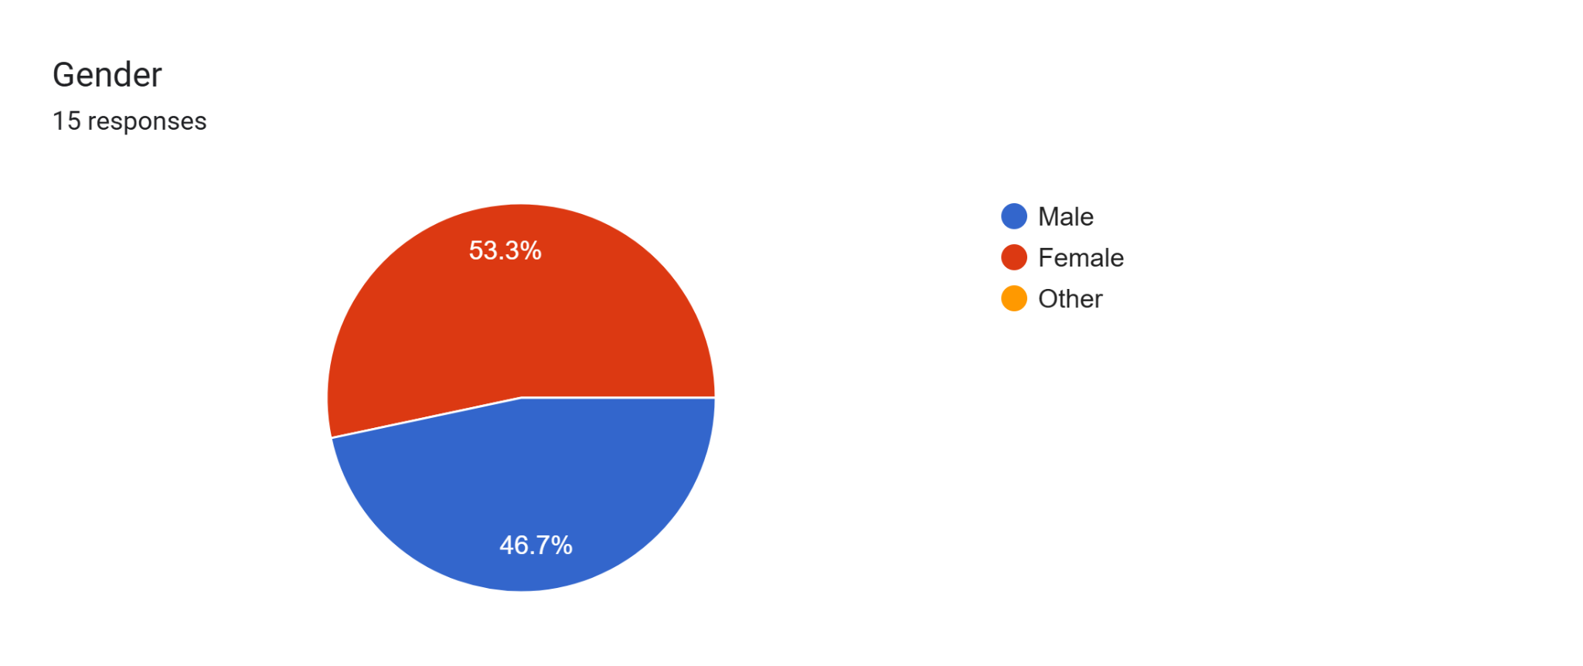

**Interpretation:**

Out of all respondents, 53.3% are female and 46.7% are male, indicating a fairly balanced gender representation in the survey.

**Question 2:**

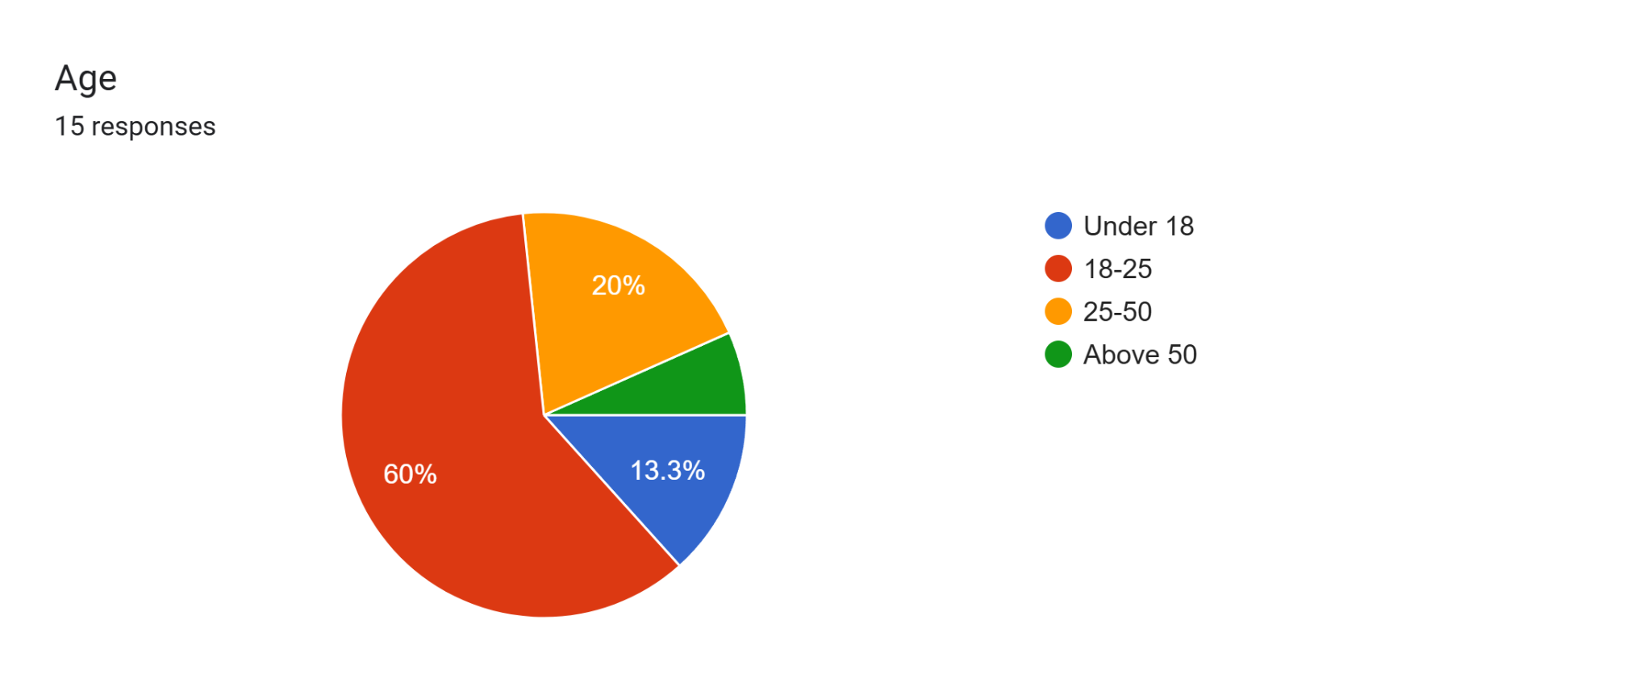

**Interpretation:**

The survey shows that 60% of respondents are aged 18-25, 20% are aged 25-50, and 13.3% are under 18, suggesting a majority of young adults engaging in the survey.

**Question 3:**

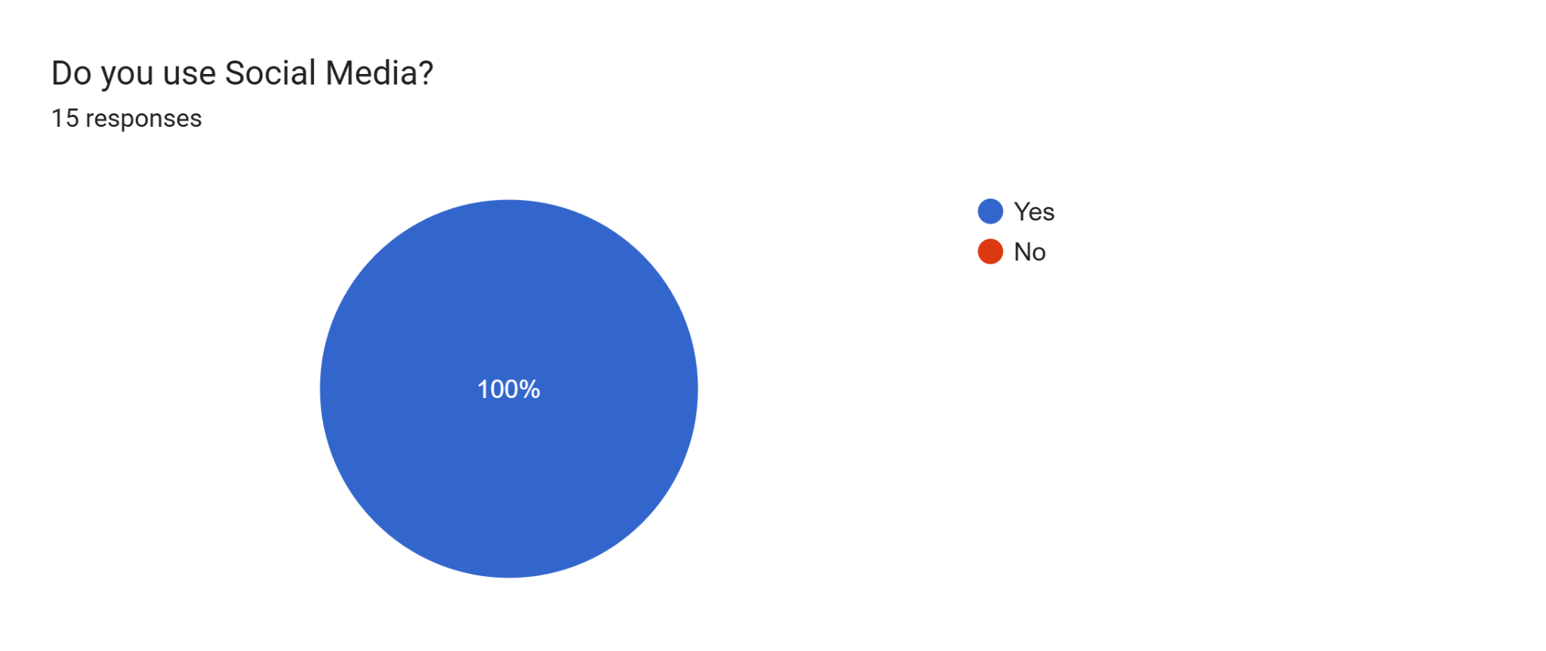

**Interpretation:**

All respondents use social media, underscoring its widespread adoption across the surveyed group.

**Question 4:**

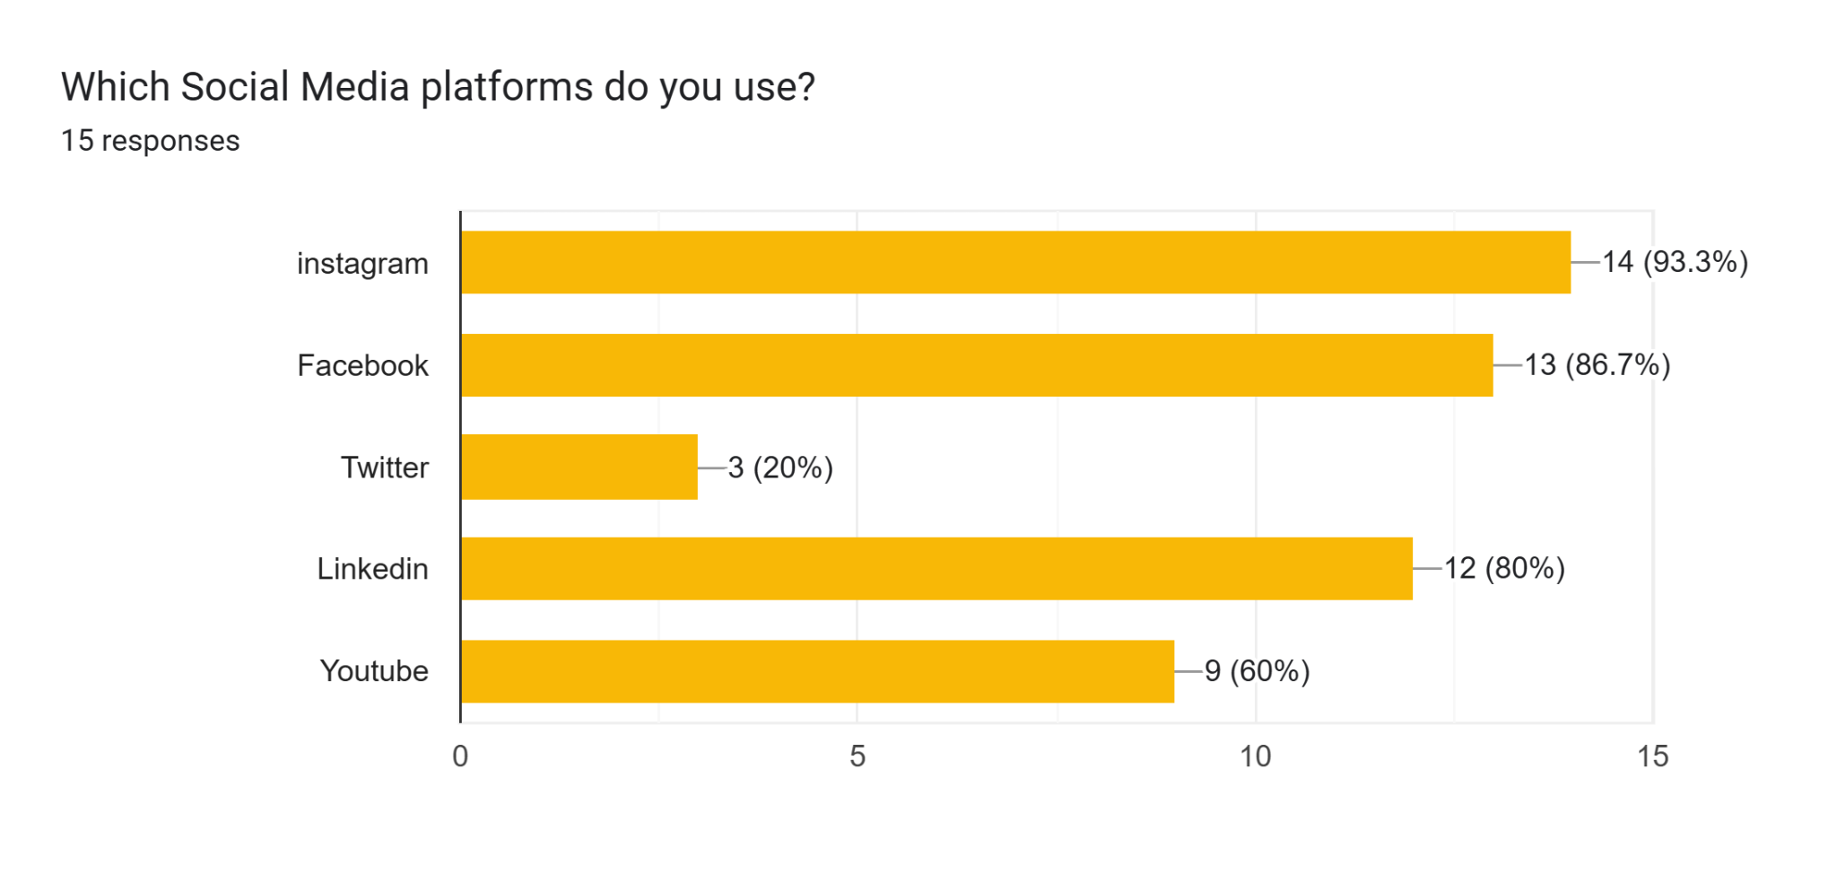

**Interpretation:**

Instagram is the most popular platform (93.3%), followed by Facebook (86.7%), LinkedIn (80%), YouTube (60%), and Twitter (20%), indicating a strong preference for visually driven platforms.

**Question 5:**

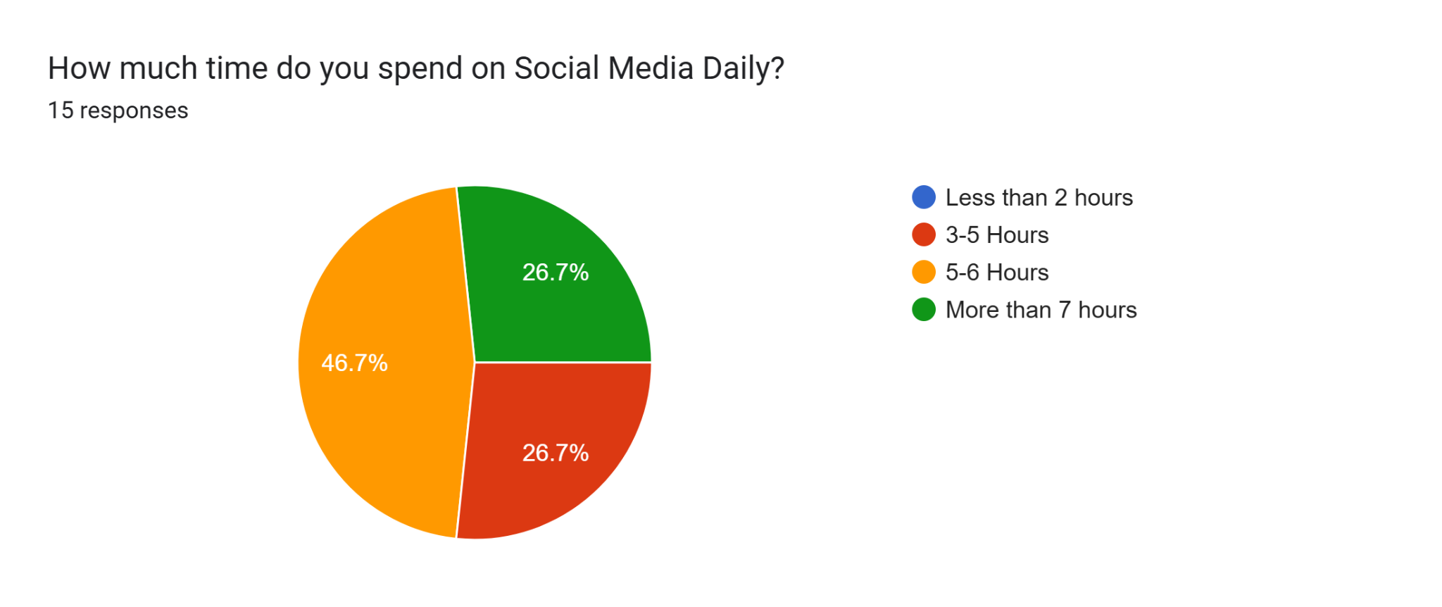

**Interpretation:**

46.7% of respondents spend 5-6 hours on social media daily, with a significant portion (26.7%) spending more than 7 hours, highlighting high engagement levels.

**Question 6:**

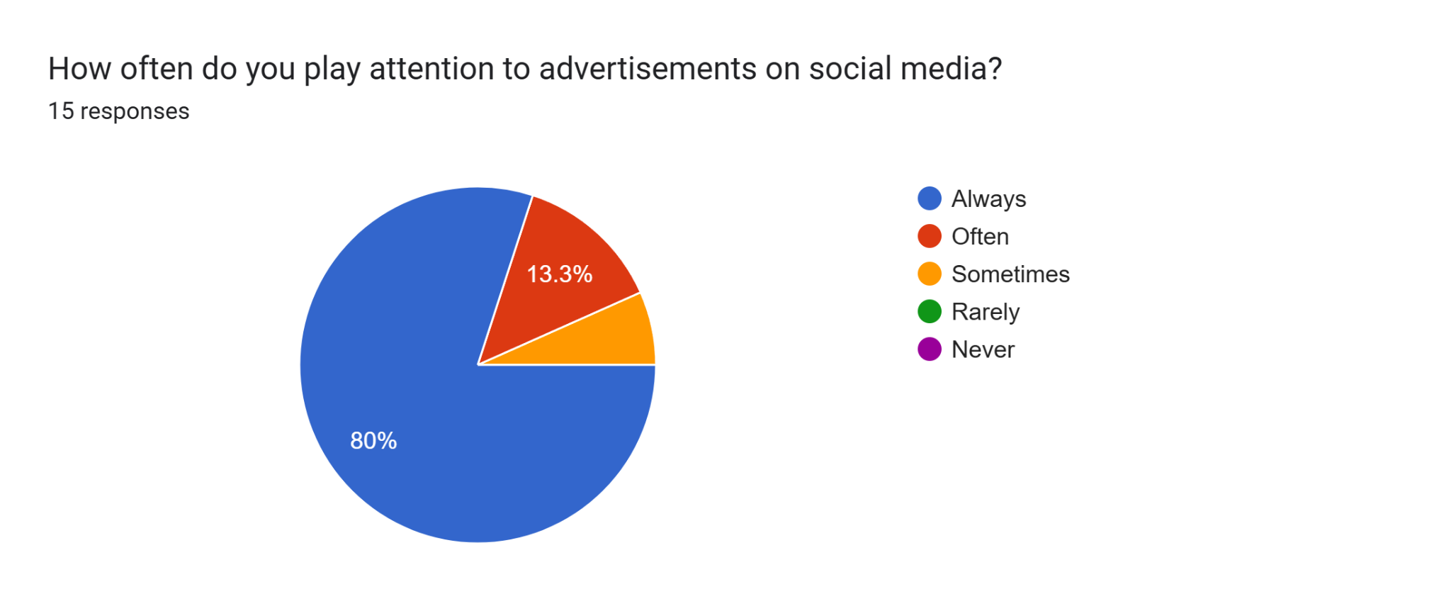

**Interpretation:**

A majority (80%) of respondents consistently pay attention to advertisements on social media, suggesting effective ad visibility.

**Question 7:** 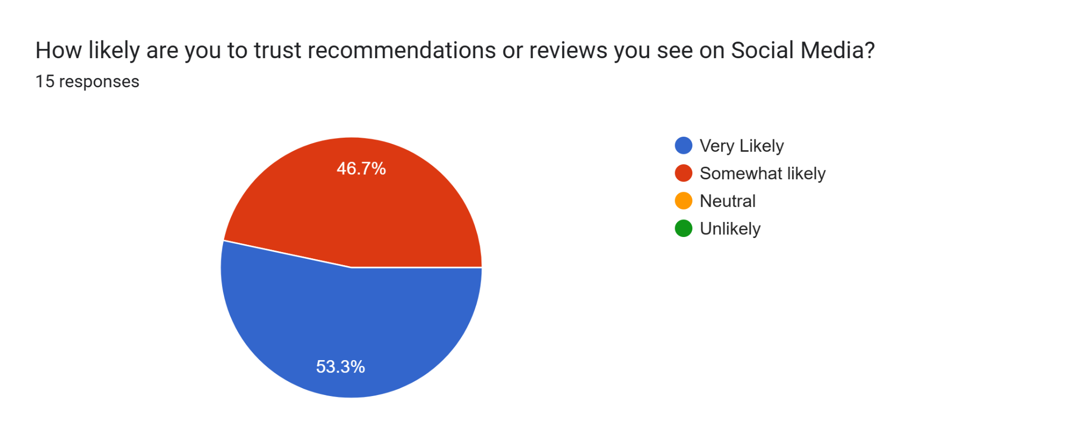

**Interpretation:**

Only 6.7% of respondents fully trust social media recommendations, while 53.3% express partial trust, indicating mixed confidence in online endorsements.

**Question 8:** 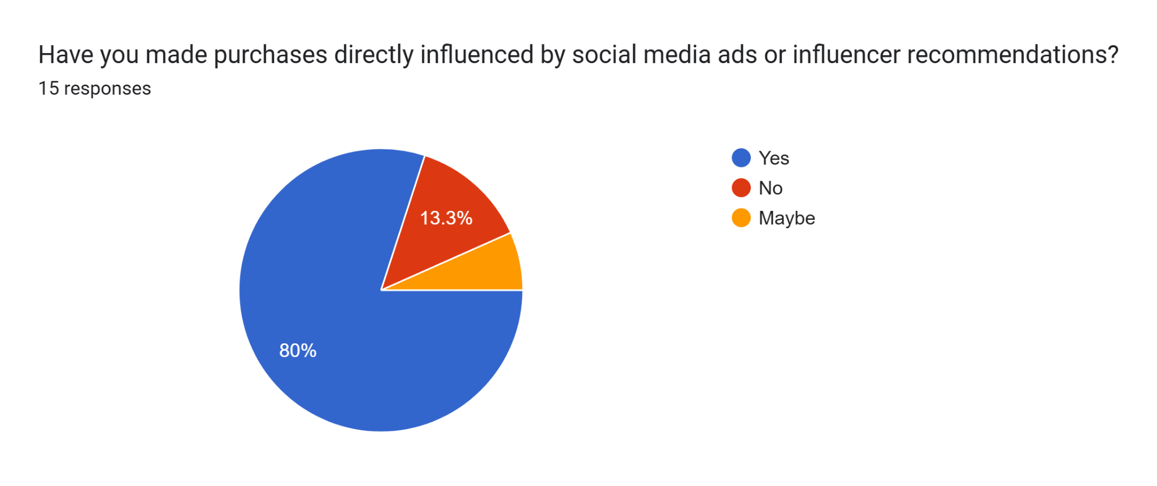

**Interpretation:**

80% of respondents have been directly influenced to make purchases by social media ads or influencers, showing strong commercial impact.

**Question 9:** 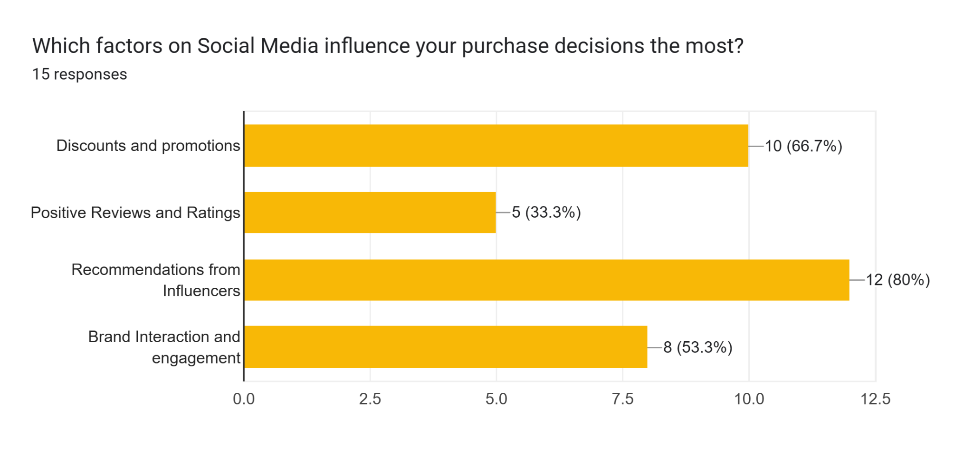

**Interpretation:**

Discounts and promotions (66.7%) and influencer recommendations (80%) are top factors affecting purchases, followed by brand engagement (53.3%).

**Question 10:**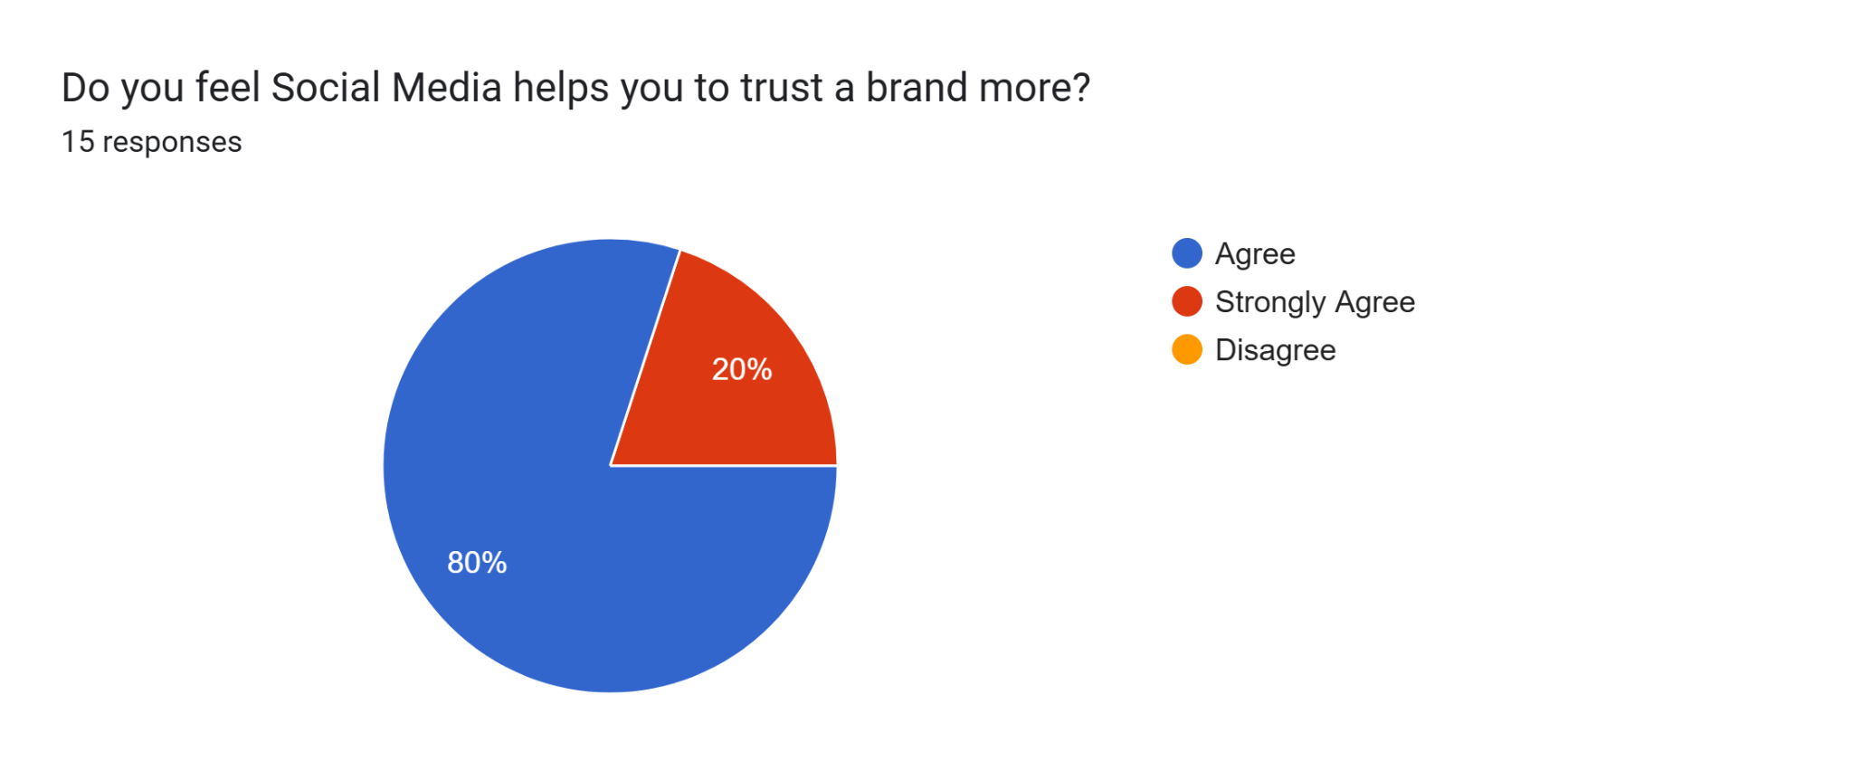

**Interpretation:**

80% of respondents agree, and 20% strongly agree that social media helps increase their trust in brands, reflecting positive brand perceptions.

**Question 11:**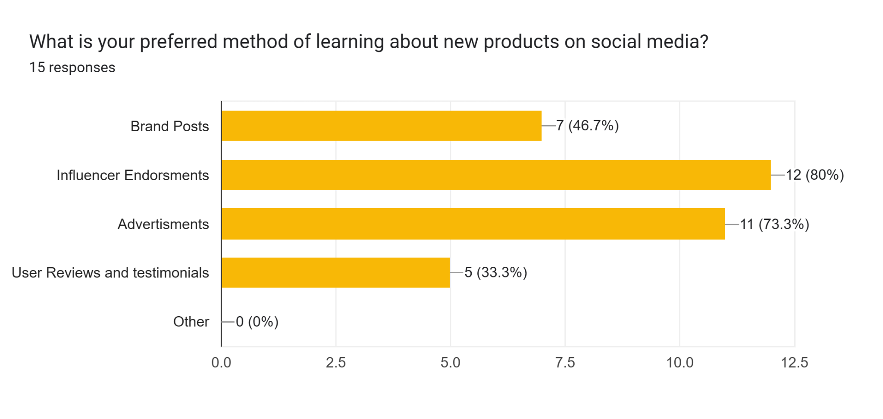

**Interpretation:**

Influencer endorsements are preferred by 80% of respondents, followed by brand posts (46.7%) and user reviews (33.3%), highlighting influencer power.

**Question 12:**

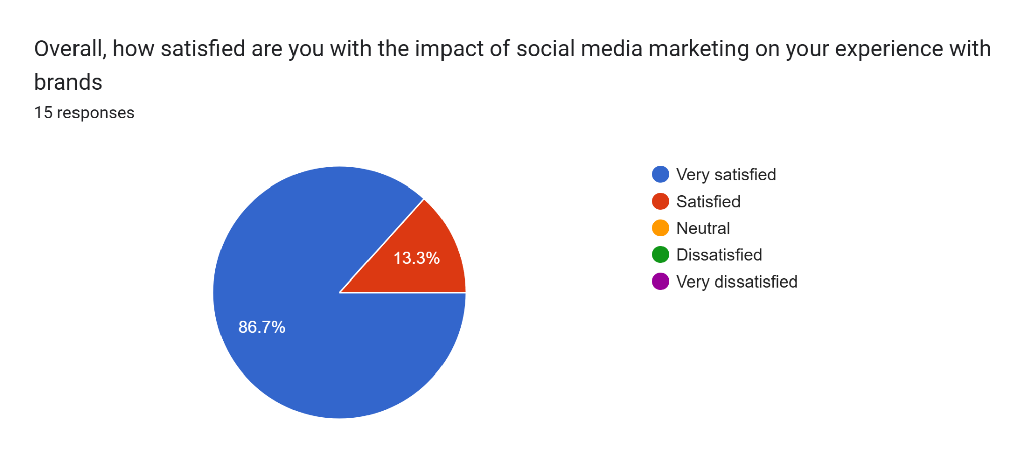

**Interpretation:**

Most respondents (86.7%) are very satisfied with social media marketing’s impact on their brand experiences, indicating an overall positive reception.

**Testing of Hypotheses**

**Testing H1:** Quality of Information and Consumer Satisfaction

Relevant survey responses:

• Attention to Social Media Advertisements: 80% of respondents consistently pay attention to social media ads, suggesting that ad content is engaging and potentially high-quality.

• Trust in Recommendations: Only 6.7% fully trust social media recommendations, while 53.3% have partial trust, showing mixed confidence in the information’s quality.

• Brand Trust via Social Media: 80% agree, and 20% strongly agree that social media increases their trust in brands, indicating positive responses to content quality.

**Testing H2:** Quantity of Information and Engagement

Relevant survey responses:

• Social Media Platforms Used: Instagram, Facebook, LinkedIn, and YouTube are highly popular, exposing users to a variety of content across platforms.

• Time Spent on Social Media: 46.7% spend 5-6 hours daily, and 26.7% spend more than 7 hours, highlighting high engagement due to a large quantity of content.

• Purchasing Influence from Social Media: 80% report being influenced by social media for purchases, indicating that high information volume impacts decisions.

| **Hypothesis** | **Description** | **Key Survey Findings** | **Text Results** |
| --- | --- | --- | --- |
| H1: Quality of Information | Quality correlates with consumer satisfaction | High ad attention (80%), mixed trust (53.3% partial), brand trust | Supported |
| H2: Quantity of Information | Quantity correlates with engagement and decisions | Multiple platform use, high daily engagement, purchase influence | Supported |

**Findings**

* + The survey shows a balanced gender representation and a majority of young adults (ages 18-25).
  + Social media usage is universal among respondents, with Instagram being the most popular platform.
  + Respondents report high daily engagement on social media, with many spending 5+ hours online.
  + Most respondents pay attention to ads but show mixed levels of trust in recommendations.
  + Social media has a strong commercial influence, with many respondents making purchases based on ads or influencer endorsements.
  + Discounts and influencer recommendations are key factors driving purchase decisions.
  + Social media generally helps increase trust in brands among respondents.

**Suggestions**

* + Future studies could examine how specific aspects of social media, such as influencer marketing, live-streaming, or user-generated content, individually influence consumer behaviour and brand perception. This would provide more detailed insights into which elements are most effective.
  + Increasing the sample size to include a larger and more diverse group across age ranges, regions, and income levels could help capture a more comprehensive view of social media’s impact across different demographics.
  + Analysing individual platforms like Instagram, LinkedIn, and Facebook separately could reveal how each one uniquely affects consumer engagement and purchasing behaviour, allowing businesses to better tailor their strategies to each platform.
  + Conducting a longitudinal study to observe how consumer responses to social media marketing evolve over time could provide valuable insights into emerging trends and shifts in consumer behaviour.
  + Including in-depth interviews or focus groups alongside surveys could offer deeper qualitative insights, helping to understand the motivations and attitudes behind consumer interactions with social media marketing.
  + Examining the impact of different content types, such as videos, images, and text, could reveal which formats are most effective in capturing attention and driving engagement, assisting brands in optimising their content strategy.
  + Adding questions to explore regional or cultural differences could reveal how social media impacts consumer behaviour differently across geographic areas, providing a more tailored understanding for global businesses.

**Conclusion**

Overall, this study confirms that social media has a significant influence on consumer behavior and business success. Social media platforms like Instagram and Facebook not only increase brand visibility but also shape purchasing decisions through features like targeted ads, influencer endorsements, and user-generated content. Consumers are drawn to brands that actively engage with their audience and provide transparent, credible information.

However, mixed trust in social media recommendations indicates that brands must work to build credibility and foster long-term relationships. By focusing on authentic interactions and personalized content, businesses can better leverage social media to drive engagement and loyalty. As social media continues to evolve, its role in business is likely to grow, making it essential for companies to adapt their strategies to stay relevant and competitive.

**Limitations**

This study is limited by sample size and the subjective nature of survey responses. The rapid evolution of social media platforms also means that findings may become outdated as new trends emerge.

**References**

1. Smith, J. (2020). The Role of Social Media in Consumer Decision Making. Journal of Digital Marketing, 23(2), 45-67.

2. Arndt, J. (1967). Role of product-related conversations in the diffusion of a new product. Journal of Marketing Research, 4(3), 291–295.

3. Clootrack. (2016). How Does Social Media Influence Consumer Behavior? Retrieved from clootrack.com

4. Industry reports, journals, and websites as needed for further details and support.