## **Review Paper on IoT Based Water Pipeline Leakage Detection System**

## 1Aryan Bijwe, 2Paras Tijare, 3 Vedansh Mulani, 4Atharva Gulhane, 5Jay Mawande.

6R.M. Gharat

## 1,2,3,4,5Students, Electronics Engineering.

6HOD, Electronics Engineering,

## Dr. Panjabrao Deshmukh Polytechnic, Amravati, Maharashtra, India.

### *Abstract: -*

### *In big cities, distribution pipe leaks cause waste of clean water, a finite resource for human livelihood. Water distribution authorities encounter challenges in identifying the source of leaks in their pipes, which is a major issue globally. Leakage can be caused by a number of things, including aging pipelines or ongoing construction in urban areas. As a result, it can be difficult for the distribution authorities to determine the cause and take appropriate action. Thus, the goal of this project was to create an IoT based water leak detection system. Two water flow sensors were used into the prototype to measure the water flow rate at the source and destination points. The outcome showed that if there is any leakage, the volume of water generated at the start point can be compared to the other end. Additional research on IoT monitoring systems could be justified by the intriguing results of a closer examination of distance calculation.*

***Keywords—Water leak detection system; Water flow sensor; Cloud system; ThinkSpeak; IoT; NodeMCU.***

# INTRODUCTION

Only 3% of the world's water is fresh, and shockingly, one-third of this is not accessible. The demand for fresh water has skyrocketed over the years due to a surge in population, rapid industrialization, and improved living standards. In an attempt to address this issue, dams, reservoirs, and underground water structures like wells have been constructed. However, by 2050, one-third of the world's population may face water shortage. As reported by a survey, 50 lakh households in major cities such as Delhi, Kolkata, Mumbai, Hyderabad, lack access to clean water. In line with the World Health Organization (WHO), a daily water consumption of 100-200 liters is recommended, which is beyond the average urban consumption of 90 liters. [1]

One possible solution is the installation of an underground water pipeline monitoring system to minimize water leaks. The age of the pipes used for it is also a crucial consideration. The material of the pipes is one of the most significant factors contributing to leaks in the water pipeline. The amount of water that leaks into networks due to aging pipes will eventually approach fifty percent. The network of the water supply system is mostly located beneath city streets. The pipes may get damaged by digging done by other companies that deal with gas, electricity, and communications.

If there is a water leak in the pipes, it will be challenging to locate where the leak originated. The concerned authorities may need several days to locate the leak's source and fix the pipe. A large amount of water is lost as a result of the delay. In order to minimize water loss and enable prompt repair or prevention of leaks, the conventional approach must be automated through the use of sensors-based technology to detect leaks and track their location. Water flow sensors and the Internet of Things make it simple to monitor pipelines. Here, a water flow sensor has been used to monitor the flow rate, and the amount of water flowing through the pipeline is also measured. IoT is used to transmit data to the cloud for additional processing, including the volume of water consumed and the water flow rate used in the pipeline.

An IoT-based water pipeline leakage detection system, sensors, microcontrollers, and cloud computing to monitor and detect water leaks in real-time. The system integrates various technologies, including sensors that can detect moisture, abnormal water flow, or pressure changes. These sensors are connected to an IoT platform. The IoT system proposed in this paper offers several advantages over traditional approaches. Firstly, its sensor-based technology enables the system to automatically detect and locate leaks in the pipeline network through the use of flow rate sensors attached at regular intervals along the pipeline. By continuously monitoring the flow rate and pressure of water within the pipelines, any abnormalities indicative of leaks can be promptly identified. This real-time monitoring capability allows for immediate repair, significantly reducing the time required to address leaks and minimize water loss.

# LITERATURE REVIEW

Recently, the development of IoT water leakage systems has been extensively studied by M. S. Mehta et al. [2]. This research presented a Leak Monitoring Device that builds a nodal network of systems that continuously monitor the flow of water and may deliver timely alerts. The study used two water flow sensors to monitor the water flow rate and it will be located at both ends of the pipe. According to the research, if there is a change in flow rate at the pipe's ends, this might indicate that the pipe is leaking.

A similar approach proposed by Arya Vijayan et al. [3] by developing a system that can detect pipe leakage by obtaining the inflow and outflow values. This study shows that if the differential between the two sensors exceeds 60 L/hr, a leak in the pipe has occurred. However, none of these researchers discusses the degree to which their various systems are accurate.

Another project was based on leakage detection using a flow liquid meter sensor by Kane SN, Mishra A et al. [4] whereby, they use an Arduino chip-based ATmega328P as a microcontroller and a flow liquid meter sensor to monitor the rate of water flow in a pipe with a maximum length of 2 meters, and when the leakage of the pipeline leakage has occurred it can detect but LCD doesn’t show the location of the leak. Furthermore, the data cannot be stored on a server.

Smart Pipeline Water Leakage Detection System by Suriya JV [5] in which the leakage of water can be detected by the flow rate sensors and the water flow can be obstructed by solenoid valves installed in various locations of the pipeline until the faulty component of the pipeline is fixed. The Hall Effect is utilized in the water flow sensor to determine the flow rate of a liquid. The water flow sensor can detect up to 30L/min and a pressure of 2. 0Mpa. The IoT solution employs an 8-bit microcontroller, ATmega328 (RISC), with a low power system for operation.

The work by Vijayakumar T et al. [6] proposed a water leakage detection system with SMS alert using the Node MCU, Water Flow Sensor, Ultrasonic Sensor, and Buzzer. In this project when the leak has occurred, the time taken by the system to deliver the SMS is reliant on the coverage area or range of the specified mobile network. In our project, we use the LCD screen to display the outputs immediately when the pipe leak.

Another study by B. Sithole et al. [7] proposed a leakage detection system using a similar water flow sensor and claimed that out of twelve iterations, the system has a 99.4% accuracy in measuring the correct value. Arduino Uno microcontroller had been used to analyze the data and publish it on the website for monitoring purposes. However, this system has a few drawbacks as it does not have easy access to monitor the data.

Meanwhile, Hafiz Kadar et al. [8] have conducted research that used an Arduino to monitor the water level and the volume and amount of water production utilizing mobile apps. The sensors in this system will detect any radical changes, and SMART2L will send an email alerting the user and controlling the pump automatically.

# METHODOLOGY

1. **System Architecture**

Architectural diagram refers to the conceptual model that defines the structure and behavior of a system. An architecture diagram is used to show the relationships between components. An architecture diagram displayed consists of three parts, first is the flow sensors that includes all the processes of detecting the water leakage and sending data process. The second is the internet part (Node MCU) in which the data is passed from the sensors into a cloud (ThingSpeak) which is the more reliable storage location, later the user receives the data about the detection of the water leakage through the LCD screen display or the web-based system.

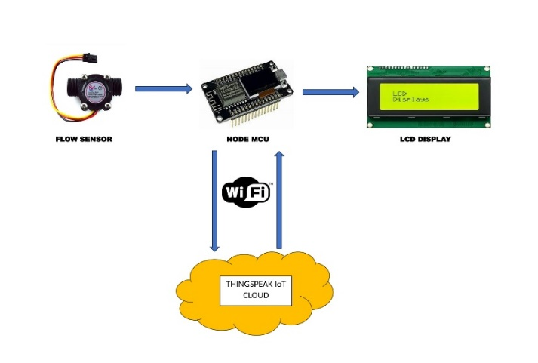Fig. (a) Block diagram of water leakage detection system

1. **Proposed System**

In Fig. (a), block diagram of the water pipeline leakage detection system. NodeMCU is a low-cost in-built Wi-Fi microcontroller. It has 8 digital pins and one analog read pin. YF-S201 water flow sensors are connected to digital I/O pins of NodeMCU. This water flow sensor consists of a rotor in it and also this sensor sits in line with your water line and contains a pinwheel sensor to measure how much liquid has moved through it. There’s an integrated magnetic hall effect sensor that outputs an electrical pulse with every revolution. The hall effect sensor is sealed from the water pipe and allows the sensor to stay safe and dry. Unlike motor, hall effect sensor produces pulse as an output when rotor rotates. So, when water flows through the flow sensor, with speed of rotation, pulses will be produced at the output. In microcontroller, this pulse signal is read as an interrupt signal. By counting the pulses from the output of the sensor, the water flow can be calculated. Each pulse is approximately 2.25 milliliters. ThingSpeak is a cloud server used for IoT. The data received from flow sensor and turbidity sensor is send to this cloud server for analyzing the outputs.

**Water Flow Sensor (YF-S201):**

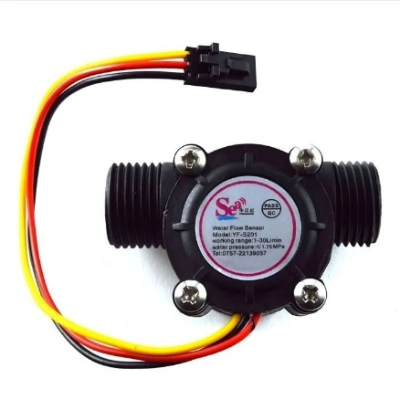

Fig. (b) Water flow sensor

The YF-S201 has a turbine rotor, a hall effect sensor, and a plastic valve body. When liquid flows through the sensor, the turbine rotor rotates, and the hall effect sensor outputs a pulse width signal. The number of pulses output is directly proportional to the amount of fluid flowing through the sensor.

**Node MCU:**

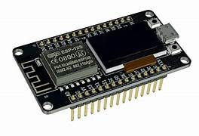

Fig. (c) Node MCU

NodeMCU is a low-cost, open-source platform designed for the Internet of Things (IoT). It initially focused on the ESP8266 Wi-Fi microcontroller but later expanded to support the more powerful ESP32. NodeMCU offers a user-friendly development environment, making it accessible to both beginners and experienced developers. Key features include its affordability, open-source nature, versatility in IoT applications, and a supportive community.

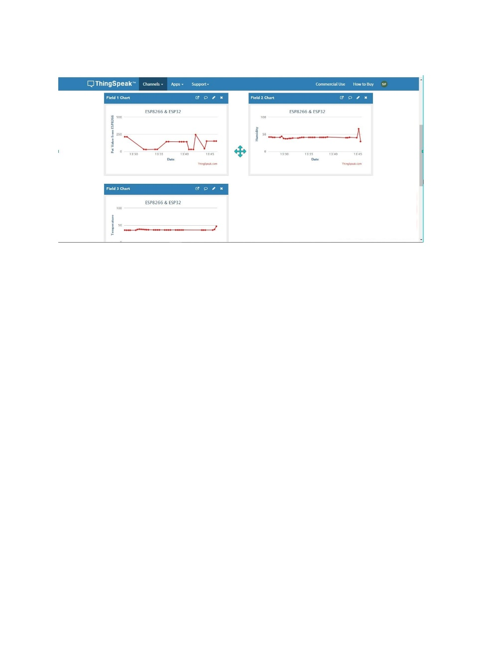**Cloud (ThingSpeak):**

Fig. (d) ThingSpeak

ThingSpeak is a free cloud-based platform designed for IoT data management and visualization. It provides a user-friendly interface for collecting, storing, and analyzing data from various IoT devices. Users can create channels to store their data, visualize it through charts and graphs, and set up alerts for specific data conditions. ThingSpeak integrates seamlessly with popular IoT devices and platforms, making it a versatile tool for a wide range of applications, from environmental monitoring to home automation and industrial IoT.

**LCD display:**

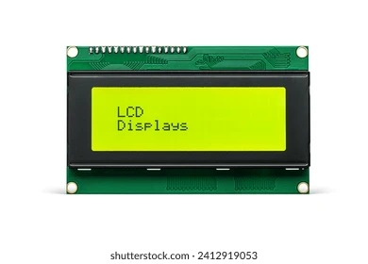

# Fig. (e) LCD display

16x2 LCD displays are a compact type of liquid crystal display that can show 16 characters on 2 lines. They are commonly used in small electronic devices like calculators, clocks, and measurement instruments. These displays work by using a backlight to illuminate the screen, while liquid crystals control the passage of light to form the desired characters. The characters are stored in a character generator, and a controller sends signals to the liquid crystals to create the correct patterns. 16x2 LCD displays are a popular choice for projects that require a simple and easy-to-read display.

1. **Flowchart**

# 

# Fig. (f) Flowchart of proposed system

# CONCLUSION

# The primary goal of this system is to locate any leaks in the water pipeline. Because there are numerous water pipelines and leaks in smart cities, this system is very beneficial. Thus, leak detection in the water pipeline can be easily detected and associated issues can be easily fixed with this system's assistance. The remote location water distribution system can also make use of this system.

# Water flow sensors serve as an ideal tool for tracing and identifying water leakages in intricate water pipeline management systems, as per research data. Given the abundance of water pipelines in urban areas and the likelihood of multiple leaks, this system proves to be immensely valuable. Currently, only the water distribution personnel are responsible for identifying leaks in our cities. By integrating this system, we can expedite the resolution of such issues. Furthermore, this technology can be employed in water delivery systems for distant areas.

# REFRECENCES

1. D Mahesh Kumar and T Jagadeep 2022 J. Phys.: Conf. Ser. 2267 012122
2. M. S. Mehta and R. R. Misra, Int. J. Eng. Res. Technol., vol. 8, no. 10 (2019) pp. 230–232.
3. Arya Vijayan and M. K. N. Mr. Raju Narwade, Ijarcce, vol. 6, no. 3 (2017) pp. 378–380, doi: 10.17148/ijarcce.2017.6386.
4. Kane SN, Mishra A, Dutta AK. Preface: International Conference on Recent Trends in Physics (ICRTP 2016). J Phys Conf Ser. 2016; 755(1).
5. Suriya JV. Smart Pipeline Water Leakage Detection System. Int J Appl Eng Res. 2017; 12(16): 5559–64.
6. Vijayakumar T, Ramachandran T, Vigneshkumar M, Mohananthini N, Saravanan S. Home Water Leakage Detection and Monitoring System Using IOT. J Netw Commun Emerg Technol. 2019; 9(4): 5–10.
7. B. Sithole, S. Rimer, K. Ouahada, C. Mikeka, and J. Pinifolo, “Smart water leakage detection and device,” IST-Africa 10.1109/ISTAFRICA.2016.7530612.
8. H. Hafiz Kadar, S. Syarmila Sameon, and M. Ezanee Rusli, Int. J. Eng. Technol., vol. 7, no. 4.36 (2018) p. 448, doi: 10.14419/ijet.v7i4.36.23914.