**A STUDY ON “REAL ESTATE VS MUTUAL FUND A PERSPECTIVE” MOHAMMED JABIR KUNNIL**

STUDENT HSNC UNIVERSITY MUMBAI

H.R COLLEGE OF COMMERCE AND ECONOMICS CHURCHGATE,MUMBAI

**EXECUTIVE SUMMARY**

Real estate refers to land and any permanent improvements attached to it, such as buildings, homes, fences, and natural resources like water and minerals. It is a physical asset, distinct from personal property, which includes movable items like vehicles or furniture. Real estate ownership includes rights to possess, sell, lease, and enjoy the land.

In contrast, a mutual fund is a financial service that pools money from multiple investors to invest in various securities such as stocks, bonds, and other assets. Managed by professional fund managers, mutual funds aim to generate returns for investors by diversifying investments across different sectors. Each shareholder in a mutual fund participates in the fund's gains or losses, with performance tracked through the overall value of the portfolio. Unlike stocks, mutual fund shares do not offer voting rights but provide exposure to a broad range of investments.

This research explores the key differences between real estate and mutual funds, focusing on investor preferences. It examines why people may choose to invest in one asset over the other, considering factors like risk, potential returns, and personal financial goals..

**INTRODUCTION**

Real estate is land along with any permanent improvements attached to the land, whether natural or manmade—including water, trees, minerals, buildings, homes, fences, and bridges. A real estate is a form of real physical property. It differs from personal property, which is things just not permanently attached to the land, such as vehicles, boats, jewelry, furniture, and farm equipment. People often use the terms land, real estate, and real property interchangeably, but there are subtle distinctions. Broadly speaking, real estate includes the physical surface of the land, which includes what lies above and below it, what is permanently attached to it, plus all the rights of ownership—including the right to possess, sell, lease, and enjoy the land.

On the other hand mutual fund is a type of financial serivice made up of a pool of money collected from many investors to invest in securities like stocks, bonds, money market instruments, and various other assets. Mutual funds are operated by professional money managers, who allocate the fund's assets and attempt to produce capital gains and income for their investors. A fund's portfolio is structured and maintained to match the investment objectives stated in their prospectus. as said earlier Mutual funds give small or individual investors access to professionally managed portfolios of equities, bonds, and other securities. Each shareholder, therefore, participates equally in the gains or losses of the fund. Mutual funds invest in a large number of securities, and performance is usually tracked as the change in the total market cap of the fund—derived by the aggregating performance of the underlying investments

The value of the mutual fund company depends on the performance of the types of securities it decides to buy. So, when you buy a unit or share of a mutual fund, you are buying the performance of its portfolio or, more precisely, a section of the portfolio's value. Investing in a share of a mutual fund is different from investing directly in shares of stock. Unlike stock, mutual fund shares do not give their shareholders any voting rights. A share of a mutual fund represents investments in many different stocks (or other securities) instead of just a single holding.

In this research, we are trying to mainly learn the difference between real estate and mutual funds and what do the majority of people prefer and why do they prefer to invest in that particular asset.

**OBJECTIVE**

* To study the preferences of people between mutual funds and real estate
* To study the awareness level of mutual funds in comparison to real estate
* To study the relationship between demographic factors like Age, Gender, Employment Type, Annual Income, etc and the type of investment they prefer from real estate and mutual fund

**RESEARCH METHODOLOGY**

Research methodology is a highly critical component that allows a researcher to conduct a systematic study. To conduct this study in a systematic manner, certain research methods were employed. Keeping the objectives in mind, relevant quantitative and qualitative data was obtained, later used to draw inferences, through both secondary and primary sources

DATA COLLECTION

**PRIMARY DATA :**  Primary techniques were as important in achieving the objectives of this research. They played a major role in collecting first hand data. To conduct primary investigation, a survey was performed which allowed collection of fresh data

**SECONDARY DATA :**  At initial stages of the research, secondary methods were employed to obtain the necessary qualitative data. Sources such as published books, research papers and internet were actively used to understand the concepts relevant to the topic. The main purpose of secondary tools was to capture as much information as possible

**SAMPLING TECHNIQUES:-** The research study was conducted using a simple random sampling technique to gather data from a sample of individuals based in Mumbai. The population from which the sample was drawn was confined to the city of Mumbai, and the survey was conducted during october2024. A total sample size of 50 members was selected to participate in the survey.

**DATA ANALYSIS METHODS**

* Exploratory Research analysis: The major emphasis in exploratory Research Design is on discovery of ideas and insights.
* Descriptive Research analysis The descriptive Research Design study is typically concerned with determining the frequency with which something occurs or the relationship between two variables.
* Causal Research analysis: - A Causal Research Design is concerned with determining cause and effect relationship.

**SCOPE OF STUDY**

In my research the scope of study is that we will learn in depth about real estate and mutual fund. Along with learning in depth about real estate and mutual funds we will also distinguish between both of the investments. After that the details of research which includes the data of 103 samples of survey conducted will also be shown. In this project the data which was collected using the survey will be analysed deeply with the help of various techniques. This project will also include conclusions for the same

**SIGNIFICANCE OF STUDY**

In india most of the people tend to invest in real estate as it’s the oldest and traditional approach of investing. But now as the population is becoming more aware about stock market and various other types of investment it has become more important to give people more insights about the same. With this study people will understand the basic difference of real estate and mutual fund. Also with the help of this research people will be able to invest their money better according to their risk capability, time frame of investment, amount of money they are investing etc.

**LIMITATION OF STUDY**

People generally were reluctant to disclose information relating to their savings, investments and their investing preferences

• The study is restricted to limited period.

• In the secondary data, there were discrepancies in the data available from various sources. As there was no direct comparison between mutual funds and real estate.

• The study is limited to Mumbai.

• The study is based on the assumption that samples are earning income

• Most of the people may be busy as they are workings individuals or business owners so that they may not spend much time for providing information.

• As the sample size is too small, the result may not be completely accurate.

• The study includes only 100 respondents, whose opinions needs to be analyzed. Thus, it is possible that the study would limit to the sample itself and perhaps not beyond it.

• There may be some biases due to ignorance on the part of respondents.

• There can be a majority in the respondents belonging to certain category, and the result being influenced due to their responses in majority.

• More data from males was collected as compared to females as the ratio of working men to working women is skewed in favor of men. In spite of the above limitations, all efforts were made to ensure correctness in the data collection

**DATA ANALYSIS AND INTERPRETATION**

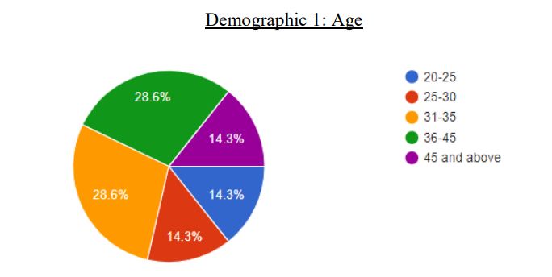

As Per The Pie Chart We Can See Tjhat Most Number Of Samples Are Between The Age 31-45 And 36-45 . From This We Can Say That These People Will Be Having A Steady Income Source To Invest

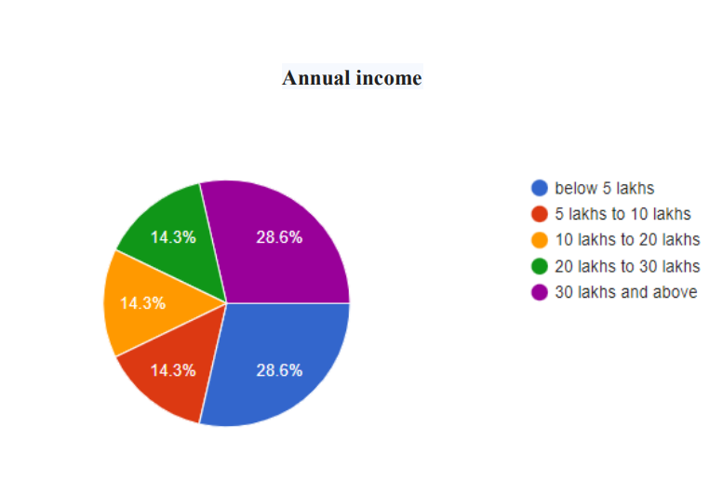

Analysis:- the samples of this research are businessmen, salaried employee, and professionals, so the amount of income that they generate is considerably high in comparison with the per capita income of india . in this chart we can see that good number of samples earn more than 30 lakhs per annum which is great. So these individuals have the options to invest both in real estate as well as mutual funds. But we can also see that amount of people earning less than 5 lakh is also high. So these people cannot directly invest into real estate as compared to people who earn more than 30 lakhs

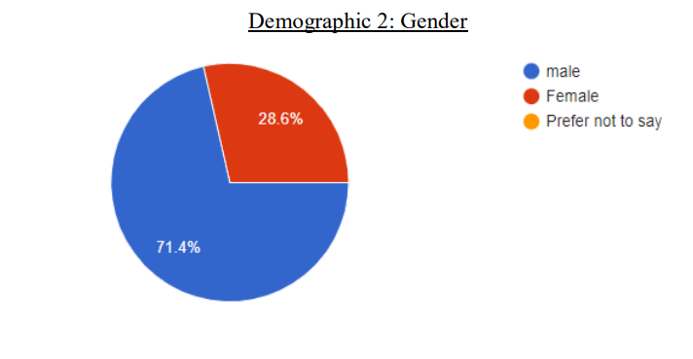

From the diagram we can conclude that majority of the samples are male.it means that females are not willing to fill the form.

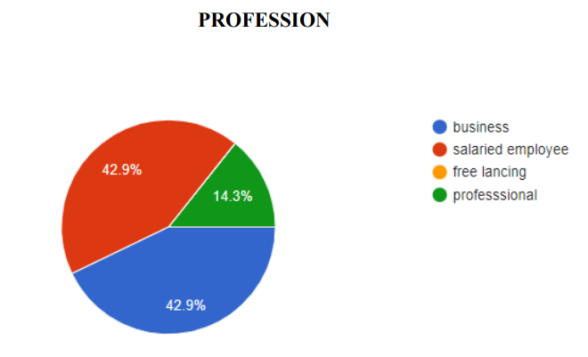

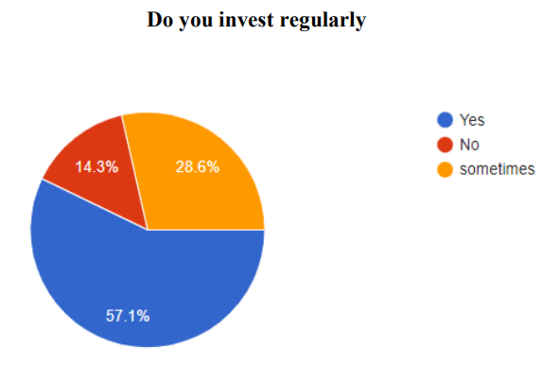

Analysis :- From this diagram we can get to know that most of the people save money from the income that they generate. Only a small percentage of people are not into saving or investing their income

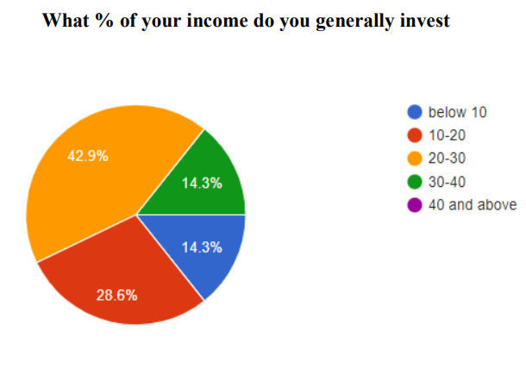

Analysis:- most of the samples of our survey invest atleast 20 % of their income on various investments. We can also see that only few samples saves and invest highly. So the ideal range of saving from income and investing is between 10 to30 %

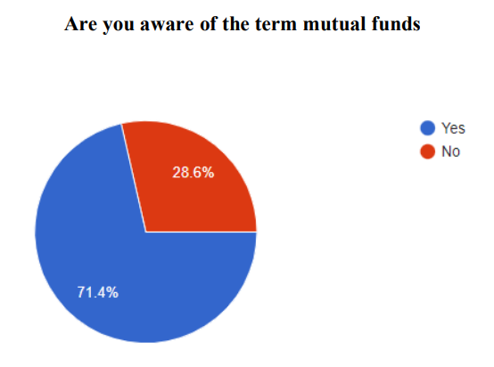

Analysis :- most of our samples are aware of the term mutual funds. Only 28.6 % of the samples are not aware of the term. This maybe mainly because of the older generation not knowing about the new age investments

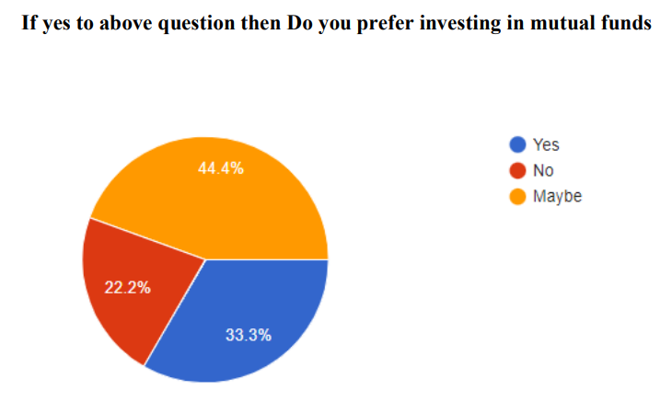

Analysis:- most of our samples are not sure whether they will invest in mutual funds. Only one third of our samples are willing to invest in mutual funds. Also a considerable amount of our samples are not willing to invest in mutual funds. This may be mainly because they may not know the benefits of mutual funds or they are only aware about the risk elements of mutual funds

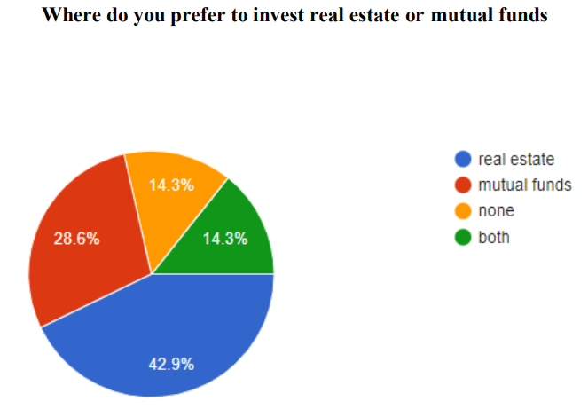

analysis :- when we look into the pie chart we can see that most of the people are willing to invest in real estate as compared to mutual funds. This maybe mainly because of the emotional element in Indian culture. As mostly people have an ambition a house, this can lead people to invest real estate in comparison with mutual funds .however there are significant other samples who are not willing to invest in both real estate as well as mutual funds

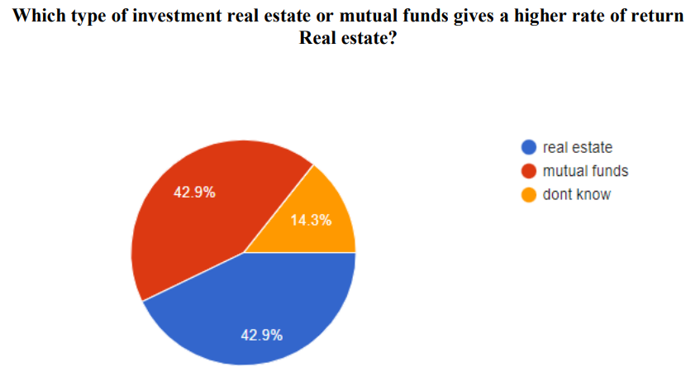

analysis:- after analysis the pie chart we can see that most people think real estate gives a higher rate of return as compare to mutual funds. This can be true in some cases but most of the mutual funds with moderate risks tend to give a return of 12 % annually. On the other hand the average return real is between 8% to 10 %. Since the past decade the return on real estate investment has been coming down. But we can also see that the same number of samples also thinks that mutual fund has a higher rate of return compared to real estate.this can be only achieved if the risk apetite is between moderate to high

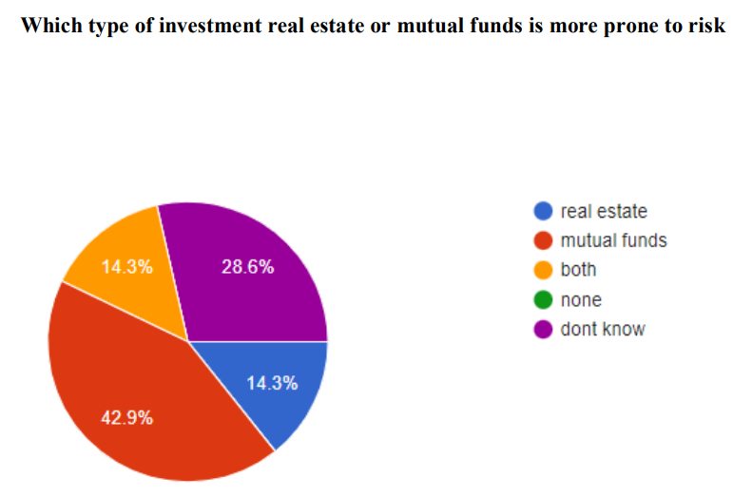

analysis :- Many of our samples think that mutual fund has a higher risk than real estate. It is partially true but a person can always choose the amount of risk in mutual funds. On the other hand real estate risk can be chosen in terms of the type of real estate one is buying. But considerably real estate is a safer option as compare to mutual funds as the full control of the same is in hands of us, not like mutual funds in which decisions are taken by fund manager. Also in real estate one does not need to have an in depth knowledge of various aspects like mutual funds

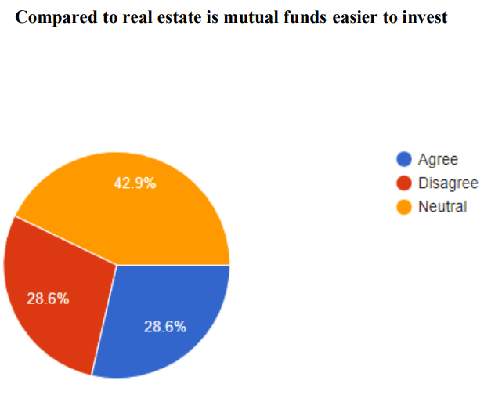

Analysis :- As per the chart we can see that most people have selected neutral on whether mutual fund is easier to invest than real estate or not . from this we can say that people do not have the knowledge on ease of investment as one does not know how to invest in mutual funds

**FINDINGS**

It can be seen that people who ear more income tend to invest in real estate rather than mutual funds even though it has a higher rate of return. It is mainly because real estate is a traditional method of investing compared to mutual funds. However people are moving towards the new age investment schemes which has variable risk factors.

• It is also found that women in this survey has not participated in significant numbers compared to men. • Respondents below the age of 35 years seemed to be more financially literate compared to the older generation. This can be due to the availability of easily accessible information and technology

• We can see that people with less income does not have the ability to invest in real estate as the capital required for the same is considerably higher. But with the introduction of remf one need not to worry about the investment amount as this mutual fund does not require that kind of money. So now a person with less income also can invest in real estate with the help of real estate mutual funds

• The respondents have maximum awareness regarding real estate as an investment avenue. This can be because real estate has been a highly esteemed investment avenue in India since time immemorable. Investments in real estate deliver returns in two ways - capital appreciation and rentals.

• This is followed by equity. Since majority of the respondents are below the age of 35 years, it shows that the younger generation is highly interested in equity as in provides high risk-high return investment options to them

**CONCLUSION**

As a conclusion we can say that more awareness regarding mutual funds can be done with respect how it actually works in real life, what are the key metrics to be seen in order to track and how it can outperform other forms of investment with same or less risk

In comparison to real estate, mutual fund is a more accessible way of investment. As the amount required for investment is less in mutual funds its easier to invest. Also compared to real estate, mutual fund has a variety of options to choose and invest with respect to the risk appetite of the investor

**RECOMMENDATIONS**

Based on the findings of this research, the following key recommendations are provided for investors, financial advisors, and policymakers:

1. Enhance Awareness of Mutual Funds and Real Estate:
   * For Investors**:** It’s important to increase knowledge about both mutual funds and real estate. Investors should understand the key metrics for each—such as NAV, expense ratios, and risk-adjusted returns for mutual funds, and ROI, capitalization rates, and market trends for real estate. Financial literacy programs should cover both investment options to help investors make informed decisions.
   * For Policymakers**:** Support initiatives to enhance financial education regarding mutual funds and real estate, making these options more accessible and understandable to a wider population.
2. Tailor Investment Choices to Risk and Financial Goals:
   * For Investors**:** Investors should evaluate their risk tolerance and financial objectives when choosing between mutual funds and real estate. Mutual funds provide more liquidity and diversification, while real estate offers long-term capital appreciation and stability.
   * For Financial Advisors**:** Advisors should help clients balance real estate and mutual funds in a portfolio, taking into account their risk profiles and long-term goals, and recommending a mix that optimizes both return and risk.
3. Diversify Using Mutual Funds and Real Estate:
   * For Investors**:** Combining mutual funds and real estate can provide a diversified investment strategy. Mutual funds offer easy diversification across sectors and asset classes, while real estate can add stability and act as a hedge against inflation.
   * For Financial Advisors**:** Advisors should guide clients to create balanced portfolios that leverage the advantages of both asset classes. Real estate can offer income generation (via rent) and long-term capital gains, while mutual funds provide flexibility and liquidity.

**BIBLOGRAPHY**

websites

• <https://cleartax.in/>

• <https://www.cityvest.com/>

• https://www.livemint.com/

• <https://www.investopedia.com/>

• https://www.taxmann.com/

• <https://taxguru.in/>

• <https://www.ibef.org/>

• <https://www.adityabirlacapital.com/>

• <https://housing.com/>

• <https://www.biggerinvesting.com/>

**ANNEXURE**

QUESTIONNAIRE:

AGE

• 20-25

• 20-25

• 25-30

• 30-35

• 40-45

• 45 and above

Gender

• Male

• female

Profession

• Business

• Salaried

• Freelancing

professional Annual income

• Below 5 lakhs

• 5lakhs to 10 lakhs

• 10 lakhs to 20 lakhs

• 20 lakhs to 30 lakhs

• 30 lakhs and above

Do you invest regularly

• Yes

• No

What % of your income do you generally invest

• Below 10

• 10-20

• 20-30

• 30-40

• 40 and above

Are you aware of the term mutual funds

• Yes

• No

If yes to above question then Do you prefer investing in mutual funds

• Yes

• No

• maybe

Where do you prefer to invest real estate or mutual funds Real estate

• mutual funds

• none

Which type of investment real estate or mutual funds gives higher rate of return

• Real estate

• Mutual funds

• Don’t know

Which type of investment real estate or mutual funds is more prone to risk

• Real estate

• Mutual funds

• none Compared to real estate is mutual funds easier to invest

• Yes

• No

• Maybe