IOT FOGGER SYSTEM FOR DAIRY FARMING

## 1Bhargav Kale, 2Chaitanya Sahare, 3 Shravan Wanve, 4Abhijeet Deshmukh and 5Harshwardhan Khurad.

6R.M. Gharat

## 1,2,3,4,5Students, Electronics Engineering.

6Lecturer/HOD, Electronics Engineering,

## Dr. Panjabrao Deshmukh Polytechnic, Amravati, Maharashtra, India.

### *Abstract: -*

### This paper presents an IoT-based fogger system designed to mitigate heat stress in dairy cows, thereby enhancing milk production. Heat stress negatively impacts cow health, leading to reduced milk yield and overall productivity. The proposed fogger system operates wirelessly and incorporates an inbuilt timer, allowing for automated and efficient cooling during peak temperature periods. By maintaining optimal temperature and humidity levels in the barn, the system aims to improve cow comfort and welfare, resulting in better milk production. This study evaluates the system's effectiveness, highlighting the potential of smart, automated solutions in modern dairy farming to combat heat stress.

***Keywords— Fogger System; Dairy Farming; Heat Stress; IoT; NodeMCU.***

# INTRODUCTION

In dairy farming, heat stress poses a significant challenge, particularly in warmer climates or during the summer months. When cows are exposed to high temperatures and humidity, their ability to regulate body temperature becomes compromised. This leads to a range of physiological responses such as increased respiration, reduced feed intake, and elevated body temperature, all of which can result in lower milk production, decreased fertility, and poor overall health.

Managing heat stress is therefore a crucial aspect of maintaining both animal welfare and farm productivity.

Traditional cooling methods, such as fans and water sprinklers, are commonly used to alleviate heat stress in dairy barns. However, these systems often lack precision and adaptability, leading to inefficiencies and inconsistent results. With advancements in technology, the integration of the Internet of Things (IoT) has opened new possibilities for automating and optimizing cooling systems on dairy farms.

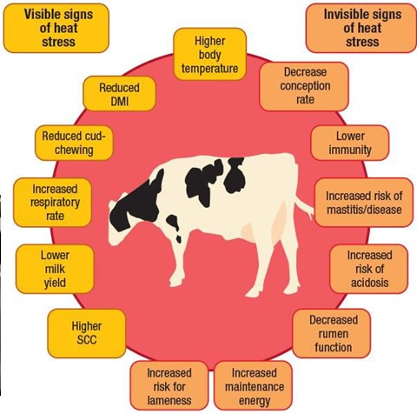By implementing such smart technologies, farmers can address the growing issue of heat stress more efficiently, improving both animal welfare and economic outcomes.

Figure A: Visible signs of Heat stress

The impact of heat stress on dairy cows is well-documented, with studies showing significant drops in milk yield when cows are subjected to excessive heat. Cows have an optimal temperature range, known as the **thermoneutral zone**, where their bodies do not need to expend extra energy to maintain a stable body temperature. When environmental temperatures exceed this range, typically above 25°C (77°F), cows begin to experience heat stress. This stress not only affects milk production but also negatively influences reproduction rates, feed efficiency, and overall animal welfare. Heat-stressed cows may also be more susceptible to diseases, which further exacerbates productivity losses.

# LITERATURE REVIEW

Recently, the interest of the investers is getting towards the IoT based diary farm for better and more profitable outcome that monitures the cows health . In the research done by Sanjay Mate et al. [1] IoT helps make precise decisions, saving energy and time earlier consumed by human and machine errors. In many countries, the agriculture allied sector accepts dairy farming. It shows how the cows health will get affected or get strengthen by the monitoring and control of the IoT based sheds system which shows an growth in the Cow milk business and allied sector

The low productivity of per animal and availability and affordability of the quality feed and fodder remains to be the major challenges and The government should take initiative to promote the dairy farming as major industry as this thoughts was proposed by the research done by Shanthi Kuchibhatla et al [2]

In research done by N Akhila et al [3] shows that the dairy farming is not only a side business but some people it is occupation and only source of food and income For rural area people in India dairy play an important role in life of farmers but continuous reduction in rain fall in Tamil nadu and changing climate causes sever drought reduced milk production . The productive and reproductive performance of dairy animals based on environment provide them suitable environment and feed properly dlfor increased in milk production

An another research done by Rehman Habib Ur et al [4] says that the one of most affected sector by the climate change is the dairy sector .The dairy sector is often affected by temperature and humidity. The health status of dairy animals and the decrease in the milk production is affected by the environmental stress .The heat stress play an important role in declining of the fertility in lactating dairy cows

Also a research by Prathap Pragna et al [5] states that the elevated temperature and humidity can negatively affect the feed intake of the cows which affect the reproduction potential and ultimately will reduce the production of milk .Apart from the reducing the milk production the quality of milk will also get reduced .It concluded that heat stress is adversely impacting the quality as well as the quantity of the milk

A research done by Sumitra Goswami et al [6] observe that during the summer, the temperature in the north western side of the Rajasthan’s area get varies upto approx 50°C and it does affect the heath of the animals and affects the milk production . Many approaches has taken towards to avoid such kind of climatic problem. Which is been avoided by using technology such as integrated, wireless sensor, and IOT. The wireless temperature sensor detects the environmental temperature of the livestock shed in this temperature-based cooling system for livestock and cattle farm in the western area of Rajasthan using Arduino system, and if the temperature goes high, the cooling system Fogger system begins, and if the temperature goes down, the fogger system goes off automatically

Sindiso M. Nleya and Siqabukile Ndlovu et al. [7] Due to the global hunger problem there is increase in dairy demands. To deal with this problem there is going a significant increase in sensors ,Internet of things(IoT),Broadband technologies etc to craft innovative solution and systems. The innovative solution not only improve the milk production but also will improve the dairy process

The system made by Roshan Kumar Bhuradia et al. [8] The sprinkler with fan shows a reduce in the body temperature and helped in normal behavioural of the animals

Similar The another research is done by the Muhammad Osama Akbar et al. [9] shows that the demand of milk and milk product increased since 2015 and for farmers compete with worldwide market and fullfill the increasing demand of milk Smart dairy farm and IOT technology is the key concept to improve milk production and cow health issues and climatic issue such as temperature and humidity and compete with the world market

The research done by the G Rajeshkumar et al. [10] shows that the previous we use analog switches mounted on our walls to ON /OFF the lights ,fans and tubelight in this system we have physically ON/OFF the switch and problem is some we forget to switch OFF and we have come back home to Switch OFF .Which consume much energy and time if we do apply in the dairy farm then Automation the device that Control the home appliances by Smart phone via internet these system reduced human efforts, save Time

# METHODOLOGY

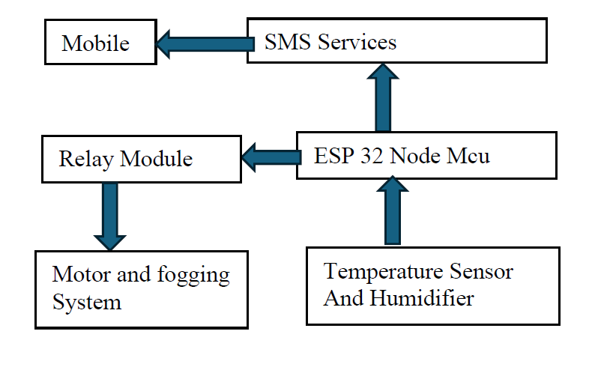

Figure B: Block diagram of methodology

Main contents of the project

1. ESP 32 Node MCU: The NodeMCU in the system allows the operator to monitor and control the fogger system wirelessly via a web interface or mobile app. It connects to the Wi-Fi network, sending real-time data from sensors (like temperature) to the operator. When the temperature exceeds 40°C, the NodeMCU triggers the fogger system automatically.

The operator can also manually turn the fogger on or off and monitor the system’s status remotely, ensuring easy management and efficient operation of the cooling system for the cow.



Figure C: ESP 32 Node MCU

1. Temperature and Humidity sensor : The temperature sensor in the system will continuously monitor the ambient temperature of the room or barn where the cows are housed. Once the temperature exceeds 40°C, the sensor will detect this increase and immediately trigger the fogger system. This is achieved by programming the system to automatically activate when the sensor registers a temperature threshold of 40°C or higher.

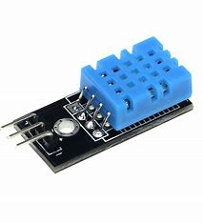

Figure D: Temperature and humidity Sensor (DTH 11)

1. Relay module: The relay module in this project acts as a switch, controlled by the Arduino. When the temperature sensor detects that the temperature exceeds the set threshold, the Arduino sends a signal to the relay, which then activates the high-pressure pump or fogger. The relay allows the Arduino to control high-power devices like the fogger using a low-power signal. When the temperature drops below the set point, the relay turns off the fogger, stopping the cooling process.



Figure E: Relay Module

1. Power supply : The Power Supply is responsible for providing the necessary voltage to the ESP 32 . In this system, it converts the standard 220V AC from the main power source into 5V DC, which is required to power the ESP32 board. This transformation ensures that the ESP32 receives a stable and safe voltage to operate effectively, allowing it to control the fogger system and other connected components without any risk of damage due to overvoltage.
2. Fogger : The Fogger system operates using evaporative cooling, where tiny water droplets are dispersed into the warm air. As these droplets evaporate, they absorb heat from the surrounding environment, creating a cooling effect similar to a traditional air cooler.

In this setup, the fogger is activated automatically when the temperature sensor detects a temperature exceeding 40°C.

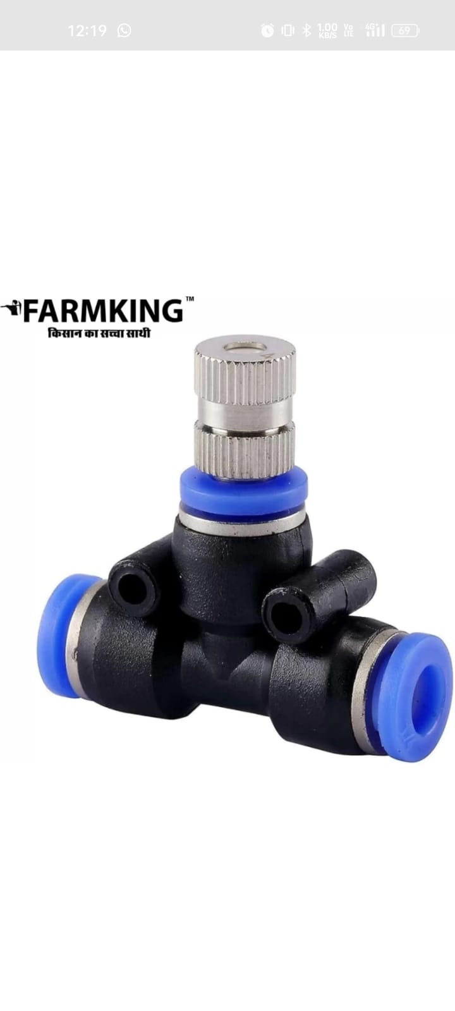

Figure F: Fogger Device or Mist device

1. **Fogger System and Use of fogger system in Dairy Farming**

**A. Fogger System:**

Fogger systems are also called as misting systems; they are devices that produce a fine mist of water droplets. They are applied in most buildings, including agricultural facilities and greenhouses, and very functional in industrial ones. Mist fogger systems are particularly very good for dairy farms since they increase the comfort and health of the Cow accommodated inside. Foggers lower the temperature stress of the Animal, control insects, suppress dust, and enhance the quality of the air due to the fine mist generated in the air.

4.1. A fogger is usually an apparatus used in applications which produces a thick misty condition, for example in

1. Cooling: Evaporative cooling in industries, commerce, and agricultural fields such as dairy farms.

2. Humidification: Green houses, museums, etc. require appropriate humidity levels.

3. Special Effects: Fog or haze for entertainment, film, and theatre productions.

4. Pest Control: Repel insects as well as other pests around agricultural and residential fields.

5. Fire Protection: Creation of a fog type atmosphere that suppresses fires or contributes to fire extinguishing.

4.2. The basic parts of a fogger system include:

1. Source of water.

2. A pump.

3. A fogging nozzle or atomizer.

4. A control system.

4.3. There are some benefits: Fogger systems

1. Energy use

2. Cost-effective

3. Environmentally friendly

4. Flexibility in usage

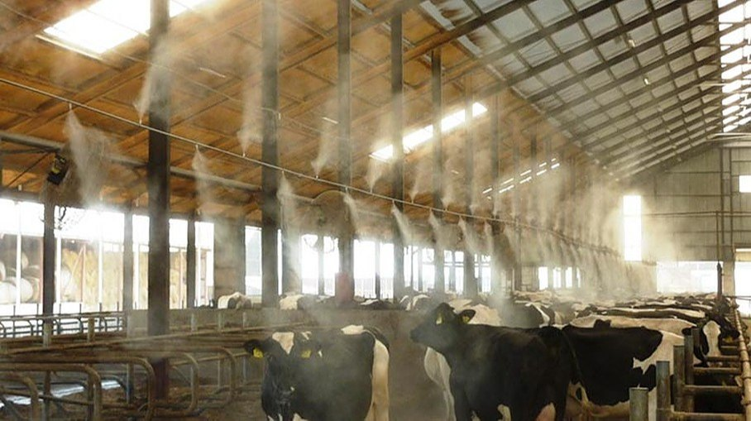

Figure G: Fogger system Applied in a dairy farm

4.4. However, some weaknesses and factors for the fogger systems exist:

1. Water Quality and Treatment.

2. Maintenance and up-keep .

3. Noise Level: According to the type .

4. Risk of over-humidification or accumulation of fog

**Conclusions :-**

The IoT based fogger system aims to :

The implementation of an IoT-based fogger system for dairy cows represents a significant advancement in managing heat stress and enhancing overall productivity in dairy farming. This project demonstrates the effectiveness of integrating modern technology with traditional farming practices to create a more sustainable and efficient system. By employing temperature and humidity sensors to monitor environmental conditions, the system automatically activates foggers when temperatures exceed critical thresholds, providing timely cooling and ensuring the comfort of the cows.

The automated nature of the fogger system reduces the need for manual intervention, allowing farmers to focus on other critical aspects of herd management while ensuring optimal conditions for their livestock.

**Refernces:**

1. Sanjay Mate1,Vikas Somani , Prashant Dahiwale, [Intelligent System for Cow Monitoring: A Smart Housing for Dairy Animal using IoT],Research Scholar, Sangam University Bhilwara and Dept. of Information Technology,Government Polytechnic Daman, India
2. Shanthi Kuchibhatla, Muskan Banu,Shaista Taskeen, Shama begum, Samreen Sultana, Geethanjali Karli,"Dairy Farming – a Case Study"5UG - Biotechnology, Indira Priyadarshini Govt. Degree College for Women(A), Nampally, Hyderabad, Telangana, India.1,6Associate Professor, Biotechnology, Indira Priyadarshini Govt. Degree College for Women(A), Nampally, Hyderabad, Telangana, India. ,e ISSN: 2584-2854 Volume: 02 Issue: 01 January 2024, Page No: 16-19.
3. N Akila and M Jothi Lakshmi,"Interventions to sustain dairy production and productivity in changing climate of Namakkal district, Tamil Nadu",Indian J Dairy Sci 73(4): 371-375,Received: 16 April 2020 / Accepted: 24 June 2020 / Published online: 10 September 2020. Indian Dairy Association (India) 2020
4. Rehman Habib Ur , Kakar Asmat ullah , Kakar Niamat ullah , Rehman Fazal ur , Khan Deedar Ahmed , Ahmed Sarfaraz Khan and Ahmed Shakeel ,"Detrimental characteristics of climate change on livestock production and reproduction",World Journal of Advanced Research and Reviews, 2020, 05(03), 114–123.
5. Prathap Pragna,P.R. Archana, Joy Aleena, Veerasamy Sejian, Govindan Krishnan, Madiajagan Bagath, A. Manimaran, V. Beena, E.K. Kurien, Girish Varma and Raghavendra Bhatta,"Heat Stress and Dairy Cow: Impact on Both Milk Yield and Composition",International Journal of Dairy Scienc, Indian Council of Agricultural Research, National Institute of Animal Nutrition and Physiology, Adugodi, 560030 Bangalore, India.
6. Sumitra Goswami1 "Implementation of Automatic Cooling System for Cattle Shed and Its Effect on Milk Production",Teaching Asso., Engineering & Technology Centre for Animal Sciences, RAJUVAS, Bikaner, Rajasthan

Corresponding author e-mail : summy_15@yahoo.co.in,Paper Received on March 16, 2021, Accepted on April 17, 2021 and Published Online on May 01, 2021.

1. Sindiso M. Nleya and Siqabukile Ndlovu,"Smart Dairy Farming Overview: Innovation, Algorithms and Challenges"
2. Roshan Kumar Bhuradia, Navav Singh, Sanjita Sharma,Sanjay Choudhary, Nischay Singh, Gireesh Joshi and Anita Kavia1,"Effect of sprinkler with fan on growth, physiology and behaviour of Murrah buffalo calves",Indian J Dairy Sci 76(1): 78-83,Received: 27 June 2022 / Accepted: 17 October 2022 / Published online: 20 February 2023 Indian Dairy Association (India) 2023.
3. Roshan Kumar Bhuradia, Navav Singh, Sanjita Sharma,Sanjay Choudhary, Nischay Singh, Gireesh Joshi and Anita Kavia1,"Effect of sprinkler with fan on growth, physiology and behaviour of Murrah buffalo calves",Indian J Dairy Sci 76(1): 78-83,Received: 27 June 2022 / Accepted: 17 October 2022 / Published online: 20 February 2023 Indian Dairy Association (India) 2023.
4. G. Rajeshkumar, P. Rajesh Kanna, S. Sriram, S. Sadesh, R. Karunamoorthi, and Prasad Mahudapathi,"Home Automation System Using

Nodemcu (ESP8266)",The Author(s), under exclusive license to Springer Nature Singapore Pte Ltd. 2023.