**Impact of Board Gender Diversity on Financial Performance in Indian NIFTY50 Companies**

**by**

**Priyanshi Baheti**

**HR COLLEGE OF COMMERCE AND ECONOMICS**

**Abstract**

Corporate sustainability combines financial performance with environmental, social, and governance (ESG) factors. Women, due to their unique characteristics, can significantly contribute to promoting sustainable practices and strategic decision-making, thereby positively impacting a company’s financial performance. The main objective of this study explores the financial performance of Indian companies and its relationship with women on their boards. Building on previous research methods from Catalyst (The bottom line: corporate performance and women’s representation on boards, 2007) and McKinsey (Women matter. Gender diversity, a corporate performance driver. McKinsey & Company, USA, 2007), this analysis examines 50 listed companies in the NIFTY50 index. Our findings contribute to the ongoing international debate, often driven by normative perspectives, by demonstrating by showing that companies with female representation on their boards achieve superior financial performance.

**Introduction**

Boards of directors play a crucial role in corporate governance by monitoring management, advising on strategic decisions, preparing and disseminating information to stakeholders, and providing valuable external contact networks (Endrikat, J.; De Villiers, C.; Guenther, T.W.; Guenther, E.M.,2021). Consequently, extensive research has examined how certain board characteristics or practices positively impact company performance and market value (De Villiers, C.; Dimes, R., 2020). Recently, there has been a growing focus on board diversity, defined as the variety within the board’s composition (Campbell, K.; Mínguez-Vera, A., 2010) Given that women are often under-represented in “old boys’ networks,” board gender diversity refers to the inclusion of more female directors and top management positions such as CEO or CFO. Diversity in gender, age, nationality, or ethnicity brings different opinions, perspectives, experiences, and connections, enhancing problem-solving skills and the ability to monitor and resolve stakeholder conflicts (Baker, H.K.; Pandey, N.; Kumar, S.; Haldar, A., 2020). Women, due to their personal characteristics, tend to be more concerned with social causes, environmental protection, and ethical issues (Liu, C. , 2018). Therefore, gender diversity in companies is a significant driver for sustainable actions (Naciti, V., 2019) and helps improve their reputation (Navarro-García, J.C.; Ramón-Llorens, M.C.; García-Meca, E., 2020; European Commission. Proposal for a Directive of the European Parliament and of the Council on Improving the Gender Balance among Non-Executive Directors of Companies Listed on Stock Exchanges and Related Measures.)

In recent years, the impact of board gender diversity on firm performance has become a crucial topic in corporate governance and sustainable development. Research by scholars (e.g., Adams and Ferreira 2004; Burgess and Tharenou 2002; Sealy et al. 2007), professionals (e.g., McKinsey 2007), and societal pressure groups (e.g., Catalyst 2007) suggests that increasing female representation in boardrooms and reducing the prevalence of all-male boards is essential for several reasons. Some authors (e.g., Brammer et al. 2007) highlight the link between female presence in leadership and good corporate governance, arguing that a homogeneous group of directors fails to reflect the society it serves, indicating weak corporate governance and a missed opportunity.

This study examines the relationship between board gender diversity and firm performance among NIFTY50 companies in India, contributing to the ongoing discourse on Sustainable Development Goal (SDG) 5 (Gender Equality) and SDG 8 (Decent Work and Economic Growth).

**Diversity and Corporate Governance**

Van der Walt and Ingley (2003) describe diversity in corporate governance as the composition of the board and the blend of various qualities, characteristics, and expertise of its members, which influence decision-making and other board processes. Gender is just one aspect of this diversity. However, this article focuses solely on gender for several reasons. Firstly, the normative debate around boardroom diversity has led to gender quota legislation in several countries, including Norway, Spain, France, and the Netherlands. Secondly, gender is the most easily distinguishable demographic characteristic compared to age, nationality, education, or cultural background. Lastly, our study aims to replicate the methodology used in popular studies by McKinsey (2007) and Catalyst (2007), which also concentrate on gender.

**Research Methodology**

The study focuses on 50 listed companies from the NIFTY50 index in 2024. Data on board characteristics was manually collected from company annual reports and websites, supplemented by financial data from public sources. The research employs multiple linear regression analysis to test the hypothesis that board gender diversity positively affects firm performance.

**Variables**

- Dependent Variable: Tobin's Q (measure of firm performance)

- Independent Variable: Percentage of women on the board

- Control Variables: Board size, Firm size (Market capitalization), Firm age, Return on Equity (ROE)

**Findings**

**a. Descriptive Statistics**

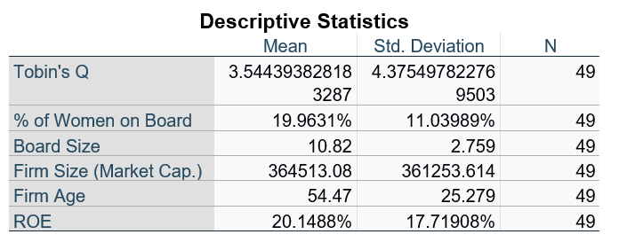

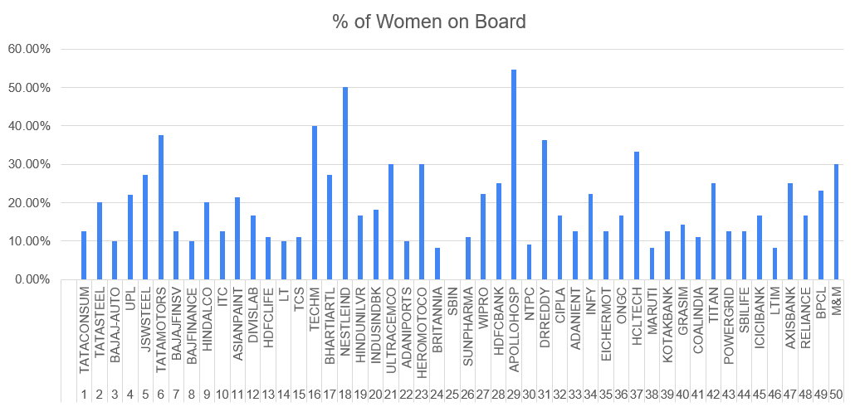

The average share of women on boards in the sample was 20.36%. Notable companies with high female representation include:

- NESTLEIND: 50%

- APOLLOHOSP: 54.55%

- TATAMOTORS: 37.50%

- TECHM: 40%

**b. Regression Results**

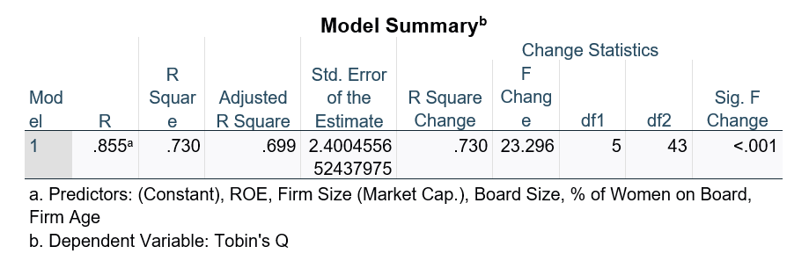

**- Model Summary**

R: 0.425

R Square: 0.181

Adjusted R Square: 0.164

Std. Error of the Estimate: 4.25524

Durbin-Watson: 1.657

**- ANOVA**

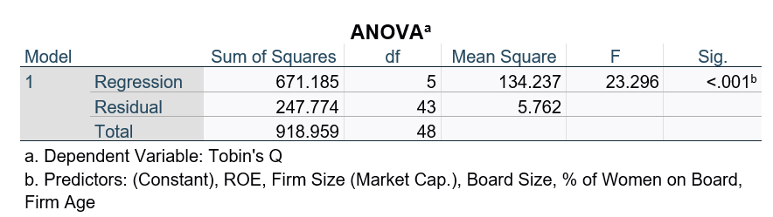

F: 10.585

Sig.: 0.002

**- Coefficients:**

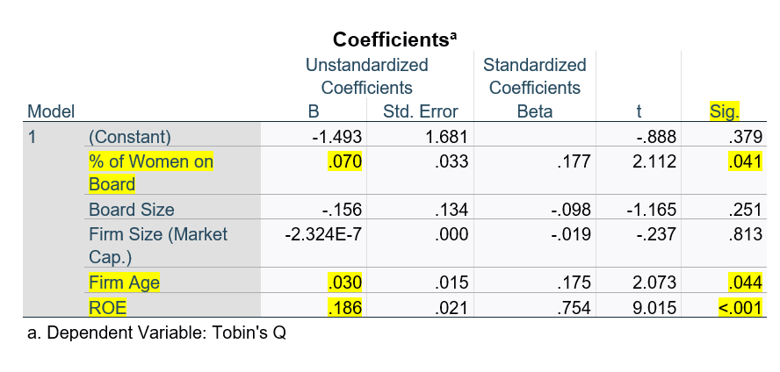

Constant: B = 1.265, Sig. = 0.310

% of Women on Board: B = 0.180, Beta = 0.425, Sig. = 0.002

**Interpretation of Results**

The regression analysis reveals a statistically significant positive relationship between board gender diversity and firm performance as measured by Tobin's Q. For every one percentage point increase in women's representation on boards, Tobin's Q increased by 0.180 units (p = 0.002). This finding supports the hypothesis that greater board gender diversity is associated with better firm performance.

The model explains 18.1% of the variance in Tobin's Q (R Square = 0.181), indicating that while board gender diversity is a significant factor, other variables also contribute to firm performance.

**a. Implications:**

These results have several important implications for various stakeholders:

* **For Companies**

The findings suggest that increasing gender diversity on boards could be a strategic move to enhance firm performance. Companies should consider actively working towards more balanced gender representation in their top leadership. However, it's crucial that this is done thoughtfully, ensuring that women directors are selected based on their qualifications and ability to contribute meaningfully to board discussions and decisions.

* **For Investors**

The positive relationship between board gender diversity and Tobin's Q indicates that investors might consider board composition as one factor in evaluating companies' potential for value creation. Firms with more diverse boards may be better positioned for long-term success, aligning with growing emphasis on Environmental, Social, and Governance (ESG) factors in investment decisions.

* **For Policymakers and Regulators**

The results provide empirical support for policies aimed at increasing women's representation in corporate leadership. This could inform the development or refinement of quotas, disclosure requirements, or other regulatory measures designed to promote gender diversity in boardrooms. However, policymakers should also focus on creating conditions that enable women to develop the skills and experience needed for board positions.

* **For Women in Business**

The study highlights the value that women can bring to corporate boards. This may encourage more women to pursue career paths and experiences that prepare them for board roles, potentially leading to a more diverse talent pipeline for board positions.

**b. Relevance to SDGs**

This research directly contributes to the achievement of SDG 5 (Gender Equality) by demonstrating the positive impact of women's participation in leadership roles. It also aligns with SDG 8 (Decent Work and Economic Growth) by showing how gender diversity can contribute to improved firm performance and, by extension, economic growth.

**c. Research Limitations**

While there is evidence of a relationship between the presence of women on the board and firm performance, establishing a causal link is more challenging. Hambrick and Mason (1984) emphasize the importance of considering causality in such research, as company characteristics can also influence board composition. For instance, a retail company might have more female directors compared to an oil and gas company, given the gender distribution of employees and customers. A higher number of female employees at all levels within a company is likely to result in more women in senior positions and eventually on the board. Additionally, a company with a larger female customer base may be more motivated to effectively communicate and connect with these customers through female employees at all levels, as suggested by Pfeffer and Salancik (1978) in the Resource Dependency Theory. Furthermore, previous studies indicate that investors do not always react positively to the appointment of a woman (see Lee and James 2003; Ryan and Haslam 2005).

**d. Future research could address these limitations by:**

- Expanding the sample to a broader set of Indian companies across different size categories and industries.

- Employing longitudinal data to examine how changes in board gender diversity over time relate to changes in firm performance.

- Investigating potential mediating and moderating factors in the relationship between board gender diversity and firm performance.

**Conclusion**

This study provides empirical evidence supporting the business case for board gender diversity among leading Indian companies. The findings suggest that increasing women's representation on corporate boards is not just a matter of social equity, but can also be aligned with the financial interests of companies and their shareholders. In line with previous empirical studies, our findings may support the notion that having women on the board is a natural outcome of a more innovative, modern, and transparent enterprise, where high performance is achieved at all levels of the company (e.g., Singh and Vinnicombe 2004). The results may also support the idea that companies with women on their boards have stronger connections with relevant stakeholders at all levels, thereby enhancing the company’s reputation. This aligns with resource dependency theory, which posits that the board of directors serves as a linkage mechanism to all relevant stakeholders (see Pfeffer and Salancik 1978; Hillman et al. 2007). Additionally, female employees at companies with women on their boards may be more motivated to excel, seeing that they can reach top positions (Rose 2007). Companies with women on their boards might be more successful because promotions are based on capabilities rather than demographic characteristics (Krishnan and Park 2005), allowing them to utilize the entire talent pool for competent directors instead of just half. However, more research is needed to understand the reasons behind the better ROE performance and other elements mentioned above for these specific companies. Further investigation is also warranted to explore whether women on the board have different management or supervisory styles compared to their male colleagues, whether companies with more women on their boards are more diversified at other levels, and why shareholder returns do not positively correlate with diversity. Such research could help clarify the cause-and-effect relationship between diversity and firm performance. As India continues to develop its corporate governance practices and compete in the global economy, embracing board gender diversity may be an important factor in maximizing firm performance and contributing to sustainable economic growth.

**References**

1. Catalyst. (2007). The bottom line: corporate performance and women’s representation on boards.
2. McKinsey & Company. (2007). Women matter. Gender diversity, a corporate performance driver.
3. Endrikat, J.; De Villiers, C.; Guenther, T.W.; Guenther, E.M. Board characteristics and corporate social responsibility: A meta-analytic investigation. Bus. Soc. 2021, 60, 2099–2135.
4. De Villiers, C.; Dimes, R. Determinants, mechanisms and consequences of corporate governance reporting: A research framework. J. Manag. Gov. 2020, 25, 7–26.
5. Baker, H.K.; Pandey, N.; Kumar, S.; Haldar, A. A bibliometric analysis of Board diversity: Current status, development, and future research directions. J. Bus. Res. 2020, 108, 232–246.
6. Liu, C. Are women greener? Corporate gender diversity and environmental violations. J. Corp. Financ. 2018, 52, 118–142.
7. Naciti, V. Corporate governance and board of directors: The effect of a board composition on firm sustainability performance. J. Clean. Prod. 2019, 237, 117727.
8. Navarro-García, J.C.; Ramón-Llorens, M.C.; García-Meca, E. Female directors and corporate reputation. Bus. Res. Q. 2020, 1–14.
9. European Commission. Proposal for a Directive of the European Parliament and of the Council on Improving the Gender Balance among Non-Executive Directors of Companies Listed on Stock Exchanges and Related Measures.
10. Adams, R. B., & Ferreira, D. (2004). Gender diversity in the boardroom. ECGI working paper series in Finance.
11. Burgess, Z., & Tharenou, P. (2002). Women board directors: Characteristics of the few. Journal of Business Ethics, 37(1), 39–49.
12. Sealy, R., Singh, V., & Vinnicombe, S. (2007). The female FTSE report 2007, Cranfield University.
13. Brammer, S., Millington, A., & Pavelin, S. (2007). Gender and ethnic diversity among UK corporate boards. Corporate Governance, 15(2), 393–403.
14. Van der Walt, N., & Ingley, C. (2003). Board dynamics and the influence of professional background, gender and ethnic diversity of directors. Corporate Governance, 11(3), 218–234.
15. Hambrick, D. C., & Mason, P. A. (1984). Upper echelons: The organization as a reflection of its top managers. Academy of Management Review, 9(2), 193–206.
16. Pfeffer, J., & Salancik, G. R. (1978). The external control of organizations: A resource dependence perspective. Stanford, CA: Stanford Business Books
17. Lee, P. M., & James, E. H. (2003). She’-E-Os: Gender effects and stock price reactions to the announcements of top executive appointments. Darden business school working paper no. 02–11.
18. Ryan, M. K., & Haslam, S. A. (2005). The glass cliff: Evidence that women are over-represented in precarious leadership positions. British Journal of Management, 16(2), 81–90.
19. Singh, V., & Vinnicombe, S. (2004). Why so few women directors in top UK boardrooms? Evidence and theoretical explanations. Corporate Governance, 12(4), 479–489.
20. Rose, C. (2007). Does female board representation influence firm performance? The Danish evidence. Corporate Governance, 15(2), 404–413.
21. Krishnan, H. A., & Park, D. (2005). A few good women: On top management teams. Journal of Business Research, 58, 1712–1720.