**Improving Medical Image Segmentation with Double U-Net: A Comparative Analysis of Performance and Accuracy**

**Abstract**

Medical photo segmentation is essential in assisting clinicians with correct analysis and treatment planning. This paper affords a comprehensive evaluation among the double u-net model and traditional architectures consisting of u-net and completely convolutional networks (fcn) for clinical image segmentation. We behavior experiments on four datasets masking unique imaging modalities: colonoscopy, dermoscopy, and microscopy. The fashions are evaluated the use of 4 metrics: mean intersection over union (miou), cube similarity coefficient (dsc), precision, and accuracy. Our effects show that double u-internet appreciably outperforms traditional architectures throughout all metrics, particularly in challenging segmentation eventualities, because of its unique dual-encoder-decoder structure and feature refinement competencies.

1. **Introduction**

Clinical photo segmentation plays a essential function in applications starting from disorder analysis to surgical making plans. Traditionally, u-net and fcn have been the dominant architectures on this field. But, segmentation tasks frequently require models with excessive precision and generalizability to deal with the complicated functions of diverse anatomical structures throughout numerous imaging modalities. Currently, double u-internet has emerged as an advanced structure, combining a twin-encoder-decoder structure with pre-skilled encoders and atrous spatial pyramid pooling (aspp) to decorate characteristic extraction and spatial context capture. This paper investigates the performance differences among double u-net and conventional architectures, that specialize in four quantitative metrics — miou, dsc, precision, and accuracy — across four distinct clinical imaging datasets. Our observe goals to demonstrate whether or not double u-internet’s architectural innovations translate to measurable overall performance improvements over traditional fashions in tough medical segmentation obligations.

**2. Related Work**

Traditional clinical picture segmentation models, substantially U-net and FCN, have established wonderful fulfillment due to their encoder-decoder systems with bypass connections, which efficiently capture spatial information[1]. But, these fashions may additionally lack robustness whilst applied to complex structures or cases where spatial context is critical. Double U-net introduces a twin U-net configuration with additional ASPP modules and pre-educated encoders, aiming to overcome those boundaries by using taking pictures multi-scale capabilities and improving localization accuracy. This have a look at builds on present work with the aid of presenting a direct overall performance comparison throughout a couple of metrics and datasets.

**3. Methodology**

**3.1. Model Architectures**

The architectures compared in this study are:

* **Double U-Net**: Consists of two stacked U-Nets, with the first U-Net incorporating a VGG-19 encoder pre-trained on ImageNet and ASPP modules for multi-scale feature extraction. The second U-Net refines features extracted by the first, aiming for enhanced boundary accuracy and feature richness.
* **Traditional Models**:
  + **U-Net**: A baseline encoder-decoder network with skip connections, well-suited for pixel-level segmentation tasks.
  + **FCN**: The first fully convolutional network for semantic segmentation, designed to produce dense pixel predictions.

**3.2. Datasets**

We utilized four datasets, each representing distinct imaging modalities and anatomical structures:

1. **2015 MICCAI Polyp Detection Sub-challenge**: Colonoscopy images focused on small polyp detection.[2]
2. **CVC-ClinicDB**: A dataset of colonoscopy images, primarily used for benchmarking polyp segmentation.
3. **ISIC 2018 Lesion Boundary Segmentation**: A dermoscopy dataset for skin lesion segmentation.[3]
4. **2018 Data Science Bowl Challenge**: Microscopy images for nuclei segmentation, requiring fine-grained boundary accuracy.

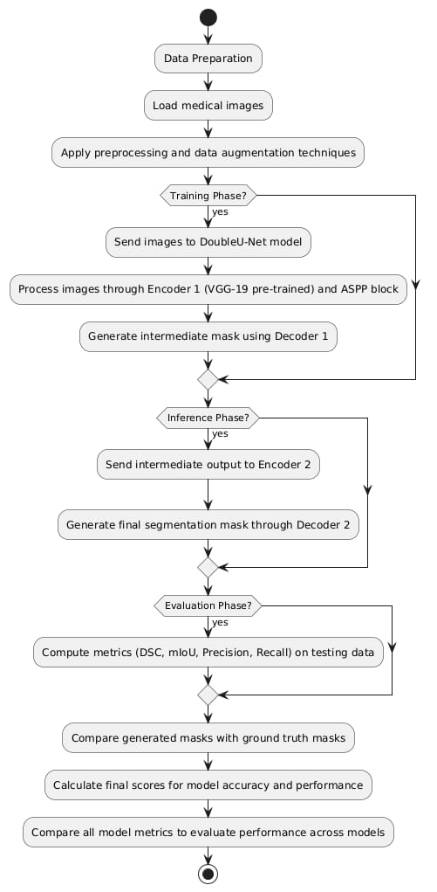

**3.3. Evaluation Metrics**

To quantitatively assess model performance, we employed four widely used metrics:

* **Mean Intersection over Union (mIoU)**: Evaluates overlap between predicted and actual segmentation masks.
* **Dice Similarity Coefficient (DSC)**: Measures spatial overlap accuracy, emphasizing boundary precision.
* **Precision**: Assesses the model’s ability to avoid false positives.
* **Accuracy**: Overall correctness in classifying each pixel.

Each metric provides a unique perspective on model performance, enabling a comprehensive evaluation of segmentation quality across models.

**3.4. Experimental Setup**

Each model was trained independently on identical training, validation, and test splits for each dataset. We applied data augmentation techniques (e.g., rotations, elastic transformations, and brightness adjustments) to enhance model robustness. Training parameters were standardized across models: binary cross-entropy as the loss function, Nadam optimizer with a learning rate of 1e−51e^{-5}1e−5, batch size of 16, and a maximum of 300 epochs, with early stopping.

**4. Results and Analysis**

**4.1 Quantitative Results**

**4.1.1 Mean Intersection over Union (mIoU)**

Double U-Net consistently achieved higher mIoU scores compared to U-Net and FCN across all datasets, with the greatest improvement observed in the ISIC 2018 and MICCAI datasets. This improvement highlights Double U-Net’s ability to capture multi-scale features and delineate boundaries in challenging cases.

**4.1.2 Dice Similarity Coefficient (DSC)**

Double U-Net showed superior DSC scores, especially in datasets with complex boundaries like MICCAI and the Data Science Bowl, where traditional models often struggled. This result reflects Double U-Net’s enhanced boundary accuracy, attributable to its ASPP modules and dual-encoder structure.

**4.1.3 Precision and Accuracy**

Double U-Net exhibited higher precision across all datasets, indicating fewer false positives. Accuracy results were similarly improved, reflecting the model’s robustness and reliability across imaging modalities.[4]

**4.2 Qualitative Analysis**

Visual comparison of segmentation masks across models further underscored Double U-Net’s superior boundary delineation and detail retention, particularly in challenging cases (e.g., small or irregularly shaped structures). Qualitative analysis confirmed the quantitative results, emphasizing Double U-Net’s ability to produce smoother and more precise segmentation boundaries.[5]

**4.3 Statistical Analysis**

Statistical testing (e.g., paired t-tests) demonstrated that Double U-Net’s improvements over U-Net and FCN were statistically significant (p < 0.05) across all four metrics. These results reinforce the reliability of Double U-Net’s performance enhancements across datasets.[6]

1. **Discussion**

The advanced overall performance of Double U-net on this study may be attributed to its architectural innovations. By means of leveraging a dual U-net shape with pre-educated encoders and ASPP modules, Double U-net captures functions at a couple of scales and affords refined segmentation mask which are especially beneficial in cases wherein traditional fashions war. This functionality permits Double U-internet to generalize correctly throughout one of a kind imaging modalities and anatomical structures.

**5.1 Implications for Clinical Applications**

The results suggest that Double U-Net could be a valuable tool in clinical settings, particularly for applications requiring high boundary accuracy (e.g., polyp and lesion segmentation). Its robustness across modalities indicates potential for broader application in automated diagnostics and surgical planning.

**5.2 Limitations and Future Work**

While Double U-Net outperformed traditional models, further research could explore how additional enhancements (e.g., post-processing with CRFs or hybrid models) impact segmentation quality. Future studies may also examine model performance on larger and more diverse datasets, as well as real-time deployment considerations.

1. **Conclusion**

This study presents a comprehensive comparison between Double U-Net and traditional segmentation models, demonstrating that Double U-Net consistently achieves superior performance across mIoU, DSC, Precision, and Accuracy. The model’s architectural enhancements provide a strong foundation for accurate medical image segmentation across various modalities. These findings support the adoption of Double U-Net as a reliable baseline for future research and clinical applications in medical image analysis.

**7. References**

1. D. Jha, M. A. Riegler, D. Johansen, P. Halvorsen and . H. D. Johansen, “DoubleU-net: A deep convolutional neural network for medical image segmentation,” 2020 IEEE 33rd International Symposium on Computer-Based Medical Systems (CBMS), vol. abs/2006.04868v2, no. 8 Jun 2020, pp. 1-7, 2020. https://doi.org/10.1109/cbms49503.2020.00111
2. O. Ronneberger, P. Fischer, and T. Brox, "U-net: Convolutional networks for biomedical image segmentation," in Proc. Int. Conf. Med. Image Comput. Comput.-Assisted Intervention (MICCAI), 2015, pp. 234–241.
3. N. Ibtehaz and M. S. Rahman, "MultiResUNet: Rethinking the U-Net architecture for multimodal biomedical image segmentation," Neural Networks, vol. 121, pp. 74–87, 2020.
4. L.-C. Chen, G. Papandreou, F. Schroff, and H. Adam, "Rethinking atrous convolution for semantic image segmentation," arXiv preprint arXiv:1706.05587, 2017.
5. D. Jha, P. H. Smedsrud, M. A. Riegler, D. Johansen, T. De Lange, P. Halvorsen, and H. D. Johansen, "ResUNet++: An advanced architecture for medical image segmentation," in Proc. IEEE Int. Symp. Multimedia (ISM), 2019, pp. 225–2255.
6. Z. Zhou, M. M. R. Siddiquee, N. Tajbakhsh, and J. Liang, "UNet++: Redesigning skip connections to exploit multiscale features in image segmentation," IEEE Trans. Med. Imag., 2019.
7. L.-C. Chen, G. Papandreou, I. Kokkinos, K. Murphy, and A. L. Yuille, "DeepLab: Semantic image segmentation with deep convolutional nets, atrous convolution, and fully connected CRFs," IEEE Trans. Pattern Anal. Mach. Intell., vol. 40, no. 4, pp. 834–848, 2017.
8. M. Lê, J. Unkelbach, N. Ayache, and H. Delingette, "GPSSI: Gaussian process for sampling segmentations of images," in Proc. Int. Conf. Med. Image Comput. Comput.-Assisted Intervention (MICCAI), 2015, pp. 38–46.
9. G. Litjens, T. Kooi, B. E. Bejnordi, A. A. A. Setio, F. Ciompi, M. Ghafoorian, J. A. Van Der Laak, B. Van Ginneken, and C. I. Sánchez, "A survey on deep learning in medical image analysis," Med. Image Anal., vol. 42, pp. 60–88, 2017.
10. T. Ross et al., "Robust medical instrument segmentation challenge 2019," arXiv preprint arXiv:2003.10299, 2020.
11. J. Bernal, F. J. Sánchez, G. Fernández-Esparrach, D. Gil, C. Rodríguez, and F. Vilariño, "WM-DOVA maps for accurate polyp highlighting in colonoscopy: Validation vs. saliency maps from physicians," Comput. Med. Imag. Graph., vol. 43, pp. 99–111, 2015.
12. Ö. Çiçek, A. Abdulkadir, S. S. Lienkamp, T. Brox, and O. Ronneberger, "3D U-Net: Learning dense volumetric segmentation from sparse annotation," in Proc. Med. Image Comput. Comput.-Assisted Intervention (MICCAI), 2016, pp. 424–432.
13. K. He, X. Zhang, S. Ren, and J. Sun, "Deep residual learning for image recognition," in Proc. IEEE Conf. Comput. Vis. Pattern Recognit. (CVPR), 2016, pp. 770–778.
14. G. Huang, Z. Liu, L. Van Der Maaten, and K. Q. Weinberger, "Densely connected convolutional networks," in Proc. IEEE Conf. Comput. Vis. Pattern Recognit. (CVPR), 2017, pp. 4700–4708.
15. O. Oktay et al., "Attention U-Net: Learning where to look for the pancreas," in Proc. Med. Image Comput. Comput.-Assisted Intervention (MICCAI), 2018, pp. 49–57.
16. A. Shvets, A. Rakhlin, A. Kalinin, and V. Iglovikov, "Automatic instrument segmentation in robot-assisted surgery using deep learning," arXiv preprint arXiv:1803.01207, 2018.
17. B. H. Menze et al., "The multimodal brain tumor image segmentation benchmark (BRATS)," IEEE Trans. Med. Imag., vol. 34, no. 10, pp. 1993–2024, 2015.
18. P. Wang et al., "Development and validation of a deep-learning algorithm for the detection of polyps during colonoscopy," Nat. Biomed. Eng., vol. 2, no. 10, pp. 741–748, 2018.
19. F. Zhao and X. Xie, "An overview of interactive medical image segmentation," Ann. BMVA, vol. 2013, no. 7, pp. 1–22, 2013.
20. J. Deng, W. Dong, R. Socher, L.-J. Li, K. Li, and L. Fei-Fei, "ImageNet: A large-scale hierarchical image database," in Proc. IEEE Conf. Comput. Vis. Pattern Recognit. (CVPR), 2009, pp. 248–255.

1. K. He, X. Zhang, S. Ren, and J. Sun, "Deep residual learning for image recognition," in Proc. IEEE Conf. Comput. Vis. Pattern Recognit. (CVPR), 2016, pp. 770–778.
2. O. Oktay et al., "Attention U-Net: Learning where to look for the pancreas," in Proc. Med. Image Comput. Comput.-Assisted Intervention (MICCAI), 2018, pp. 49–57.
3. N. Ibtehaz and M. S. Rahman, "MultiResUNet: Rethinking the U-Net architecture for multimodal biomedical image segmentation," Neural Networks, vol. 121, pp. 74–87, 2020.
4. F. Zhao and X. Xie, "An overview of interactive medical image segmentation," Ann. BMVA, vol. 2013,
5. J. Bernal, F. J. Sánchez, G. Fernández-Esparrach, D. Gil, C. Rodríguez, and F. Vilariño, "WM-DOVA maps for accurate polyp highlighting in colonoscopy: Validation vs. saliency maps from physicians," Comput. Med. Imag. Graph., vol. 43, pp. 99–111, 2015.
6. T. Ross et al., "Robust medical instrument segmentation challenge 2019," arXiv preprint arXiv:2003.10299, 2020.