# 

# H.R. College | Mumbai

# **H.R COLLEGE OF COMMERCE & ECONOMICS**

**NAME**- LAVINA BATRA

**CLASS**- FY.M.COM BANKING & FINANCE SEM-3 **ROLL NO**. 005

**PROJECT REPORT ON LENSKART HUSTLR LAUNCHED IN 2023**

**INDEX-**

|  |
| --- |
| INTRODUCTION |
| OBJECTIVE |
| HYPOTHESIS |
| REVIEW OF LITERATURE |
| SECONDARY DATA |
| PRIMARY DATA |
| DATA ANALYSIS |
| SUGGESTIONS |
| CONCLUSION |
| REFERNCES |

**INTRODUCTION**:

Lenskart has today become one of the fastest growing eyewear business on the global stage. The company was founded in 2010 by a former Microsoft employee who had no money but an enormous passion to change the world. Peyush co-founded a business in the field of innovation called â€~VALYOO technologies along with Amit Chaudhary and Sumeet Kapahi. True to its name, the goal was to eliminate the middlemen, induce high-quality production in-house and reach the customer directly. This allowed for not only cost cutting, but also high quality assurance of high-tech in-sourced robotic lens manufacturing and assembly that incorporated american quality standards. Lenskart is transforming the eyewear industry by having a distinct blend of e-commerce and interestingly created brick-and-mortar stores increasing its customer base to over 3 million within a span of 3 years, allowing it to service over 100,000 clients a month owing to its efficient supply chain.

**OBJECTIVE**:

This research methodology project seeks to explore the market entry brand strategy of Lenskart’s Hustlr brand, appraise its marketing plans and carry out an all-inclusive competitor analysis. The study aims to accomplish the following specific objectives:

1. To explore the reasons that motivated Lenskart to launch the Hustlr brand and which market it seeks to penetrate.
2. To review the Luxottica strategies that are employed in marketing the Hustlr brand of lenses. This will include evaluation of the advertising campaigns, promotion strategies and pricing strategies.
3. To study the target market’s attitudes towards the Hustlr brand and its products as well as suggest areas that require improvement.
4. To do an appraisal of the key competitors of Lenskart in the eyewear market in terms of market share, range of products, pricing strategies as well as marketing strategies.
5. To suggest ways that Lenskart can take advantage of the marketplace to strengthen the brand positioning of the Hustlr brand and its competitiveness.

For this research, the participants will be exposed to both qualitative and quantitative approaches including administers focus groups, participation in surveys and secondary data analysis. This study is expected to offer valuable suggestions towards the Lenskart marketing and branding approaches, as well as market intra-competitiveness in terms of the type of products offered in the eye wear com industry.

**HYPOTHESIS**

The launch of Hustlr by Lenskart in 2023 is a wise decision as it will help Κatar to penetrate undecided Tier 2 and Tier 3 Indian markets. The company’s intent to achieve this that it has a strong brand, product offerings ‘and the presence across multiple channels. Through the inclusion of these markets, Lenskart will have a large customer fixed even as it expands the total market share.

• Lenskart has been gradually increasing its store footprint in India including Tier 2 and Tier 3 towns.

• The company has also focused on its online and mobile channels so that the consumers in these markets can order eyeglasses without too much hassle.

• Lenskart has a good name in India and this is expected to work to its advantage in these target markets.

• The company has a wide variety of its product offerings in order to meet the expectations of the consumers in these markets.

• The multichannel nature of the business of Lenskart will enable it reach consumers in these markets through online, offline and mobile means.

Reasonable expectations:

• Lenskart stands to gain impressive increase in the number of customers and the market share.

• The company will enhance its interested to these markets and awareness in terms of brand.

• Lenskart has the potential to effectively increase its profit margins by venturing into these particular markets.

**REVIEW OF LITERATURE:**

Eyewear, in the last few years, has shown spectacular growth as consumers increasingly strive for balance between style and functionality in selection of eyewear. Still, there is a significant hole as regards to product designed directly to meet the needs of an active and busy individual who must maintain durability, comfort, and eye protection.  
  
Blue light exposure has been found to cause negative effects on the ocular system, including digital eye strain and sleep pattern disruption, according to recent studies. Consumers are also more interested in products that are lightweight and scratch- and crack-resistant.  
  
Based on these needs, Lenskart has released the new brand - Hustlr. Advanced features in the category of blue light blocking, lightweight design, and scratch/crack resistance make them comfortable and protective for the active and busy wearer who spends more time in front of digital screens.  
  
Although this market is relatively new to eyewear, interest is growing, and the demand is coming into reality. Reviewing the existing literature has shown that blocking blue light technology helps with good quality sleep and reduces symptoms for digital eye strain. Furthermore, consumers have been drawn towards light and durable eyewear, both regarding functionality and aesthetics.

# 

# **SECONDARY DATA:**

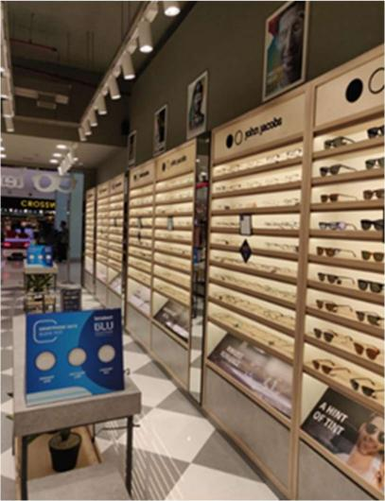**About Lenskart:**



**Lenskart.com is the leading retailer of eyewear in India. They have a portfolio of high-quality fashionable and trendy eyewear products offered at Lenskart.com. Founded by Peyush Bansal, Lenskart's vision was revolutionizing the purchase and wearing of eyewear. This company has been praised for its avant-garde approach and extraordinary customer service.  
  
This modern company offers a complete range of eyewear products-from prescription glasses and sunglasses to contact lenses and reading glasses-all under its own brand and range of other well-known brands-so as to cater to the unique needs and preferences of its customers.  
  
Apart from this, Lenskart has applied cutting-edge technology. It operates primarily online as well as having physical stores in different locations throughout the country to further facilitate the shopping experience of its customers. It boasts an innovative virtual try-on feature, making use of augmented reality in enabling customers to see how frames would look on their face before making a purchase. The company also provides home eye check-ups to the customers so that they can be facilitated with the quality products and services matched with the company reputation as a market leader and eyewear retailer of repute.  
  
About Lenskart Hustlr:  
Lenskart Hustlr launched recently in 2023 and was sported by the CEO and Founder of Lenskart, Peyush  
Bansal on Shark Tank India. The brand Lenskart Hustlr is for people's needs and aspiration and also the sprit of men and women who aggressively engage in the act of hustling and yield consistent and determined efforts to achieve their objectives. The group of eyewear brands under the company is bound to offer  
The necessary comfort and style must also serve to enhance the dynamism of the hustling lives of those people.  
  
  
Durable materials and innovative designs have been used in the eyewear for the hustling individual, who always demands more from his or her eyewear for the fast-paced challenging environment. The brand inspires and empowers the hustle to pursue their passions and dreams with confidence and clear sight, literally and figuratively. Essentially, Lenskart Hustlr symbolizes tenacity, resilience, and spirit of the modern-day hustler.**

HOW LENS CART Entered THE MARKET  
  
a) MARKET POSITIONING - Choosing the target market  
  
With a sense of savvy market positioning, Lenskart has leveraged the rising tide of Indian consumers embracing a home-grown brand that aligns with their values, beliefs, and lifestyle preferences. The Shark Tank India television program in which Peyush Bansal appears, has gained momentum as a catalyst for an entrepreneurial wave in the country.  
  
The program features young entrepreneurs pitching business ideas to accomplished investors, seeking the investments needed to scale up the venture. Success of the show has made investment opportunities accessible to entrepreneurs and developed the hustle culture.  
  
b) Market Positioning - Know the Target Audience  
  
The brand identity that Lenskart has established is relatable, aspirational, and trustworthy. The commitment to affordable, high-quality eyewear options has further cemented its reputation as a value-for-money brand.  
  
Substantially targeting the hustlers and then offering affordable yet premium quality optical eyewear, Lenskart has been able to carve out a niche for itself in the Indian eyewear market. Its ability to connect with its customers and willingness to innovate and keep pace with market dynamics seems well in place for its future growth and success.  
c) Brand awareness and trust points  
  
Lenskart Hustlr uses digital marketing to get the attention, as well as to drive sales. It uses Google Ads, Facebook Ads, and Instagram Ads for targeting the right consumers for promoting Hustlr. It has a good social presence on sites like Facebook, Instagram, and Twitter to promote Hustlr.  
  
It partners with social media influencers to promote their newly launch brand Hustlr and spread brand awareness. They partner with influencers who have a large following in their target audience  to showcase their products and increase visibility. It has a very wide network of retail stores across India, which not only serve as sales channels but also as brand touchpoints.  
  
Peyush Bansal, the founder and CEO of Lenskart, did a lot to build a brand and earn the trust of the customers. One of the major approaches he used was wearing Lenskart glasses himself and showing them to others. That helped build social proof and eventually proved the quality and durability of the products.  
d) Developing Marketing Strategy  
  
A marketing strategy in entering a new market involves identifying the target audience, selecting a right marketing channel mix, such as social media, email marketing, content marketing, influencer marketing, search engine marketing, search engine optimization, events, and sponsorships; developing a messaging strategy, together with creating a content plan.  
e) Competitor Analysis  
  
Therefore, Lenskart is targeting a niche of the market that may be ignored by most other eyewear brands. Positioning their "Hustlr" brand as specific to hardworking persons, Lenskart is tapping into a form of identity and pride most people within India may feel. Other brands may have a product that applies to the "hardworking individual," but they may not market themselves in such a manner. In doing so, Lenskart would carve out a distinct niche for itself and potentially differentiate itself from others.

**MARKETING STRATEGY OF LENSCART HUSTLR   
  
7P's of Marketing  
  
1. PRODUCT  
  
Product refers to that good or service offered by a company to its customers. It involves from designs and packaging to the quality and functional of the product.  
  
 Design: The design of a product is also an important factor that may affect the way customers perceive it. A product that will not only be pleasing to the eyes but also charming to look at will attract more potential customers. In addition to these, an interesting feature of the Lenskart Hustlr eyewear is its accommodation to all types of faces. That has been done through careful design elements meant to enhance the natural appearance of the respective face shapes.  
One of the notable design features of the Lenskart Hustlr eyewear is its frame shape. Designed frames can compensate for lopsided facial features and even make it appear that the face is evenly proportioned. Additionally, one of the features of the Lenskart Hustlr eyewear making it attractive to various face types is the use of color. The eyewear has colors like Monza Red, Amethyst, Salmon, Dark Night, Midnight Blue, Sky Blue, Military Green, Sand Dune, and Amber, that have a matte finish.**

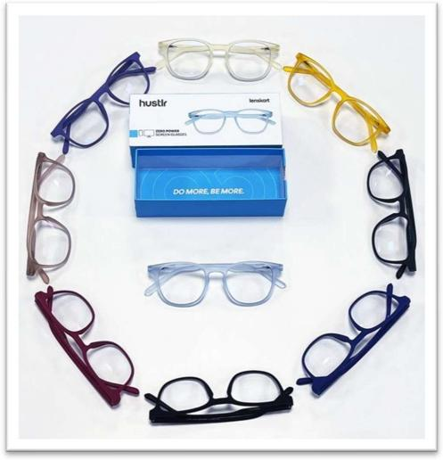

Features: Features of a product deal with the functional attributes that would make a product useful for the customers. It deals with the sort of needs and wants of the target audiences by companies concerning the features to be included in a product.  
The features on the Lenskart Hustlr eyewear will make for much differences in terms of comfort, protection and style. Notably, such eyewear includes blue light CR39 lenses that block 90% of the blue rays and 420 nm of harmful blue light emitted by electronic devices. The anti-glare coating keeps away glare and ensures UV protection. The frame is TR90 material, which is flexible and comfortable due to the lightweight and crack-resistant material. It sports flexible spring hinges, nose pads integrated into the framework, and rubberized temples for a comfortable grip. With a weight of under 11 grams, the Lenskart Hustlr eyewear presents itself as a stylish and practical choice for any quality-conscious user.

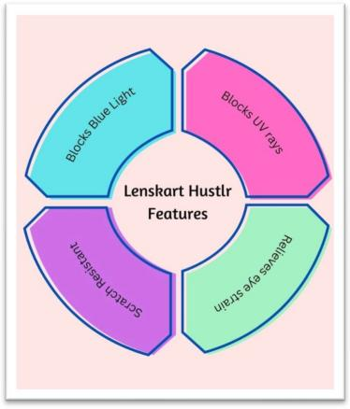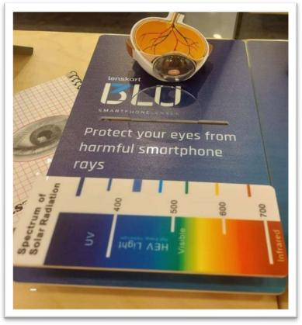

Quality: The quality of the product is imperative since it greatly affects customers' satisfaction and desire to come back again for the same. A superior product that exceeds customers' expectations creates an impression that gradually builds brand loyalty and then trust. Lenskart Hustlr eyewear is highly advisable with quality by customers and eyewear lovers. The brand is known to have premium materials and advanced manufacturing techniques that bring stylish and wearable eyewear.

The outstanding quality of Lenskart Hustlr eyewear can be attributed to the use of premium-grade materials. Materials, such as TR90 and acetate, along with metal, are famous for their durability and flexibility while crafting these frames.

Packaging & Branding: Also, the packaging of the product can influence the way in which the final product will look to customers. An attractive package that is well-designed can give a product more of a chance to standout from competitors at point of sale and attract potential customers to buy the product.

The packaging of eyewear by Lenskart Hustlr is very sleek and stylish. It's obviously done with great care, not only looking good but delivering enough protection in the long haul during shipping and handling.

Lenskart Hustlr is one of the few eyewear brands using a hard case with each pair of eyewear. The material of the case has good strength and mainly consists of polycarbonate or hard plastic, thus protecting the eyewear from scratches, cracks, or any form of damage. Also, this case has the option in various colors and designs according to the eyewear.

Along with the hard case, the eyewear from Lenskart is shipped within a robust cardboard box. The box is posted to the customer with firmly packaged eyewear so that it doesn't suffer the slightest damage during transport. Added to the above is also an additional feature of a cleaning cloth and product manual inside the box, which makes this shipment all the more luxurious.

Branding on products is the process in which a company may use its name, logo, slogan, or an easily identifiable mark or symbol on the product to provide the consumer with an easy way to identify with the brand. It provides companies with a means to establish and market their identity, express their values, and differentiate their products from others. Another key factor that might affect customers' perceptions of a product includes its branding. This allows building trust and loyalty for customers from the basis of a strong brand with associated values to the best quality and customer satisfaction.

2. Pricings

Pricing is the process of determining the value of a product or service and setting an acceptable price of the product or service to both the consumer and the producer. In many ways, pricing can be determinant to the success of a product or service as it directly influences the revenue and profit of any given company.

Lenskart Hustlr: Value-based Pricing The basic strategy for this method is based on how much value the customer perceives in the product or service. It focuses on benefits received from products or services rather than cost while going for production. Generally, this pricing method is apt for a unique and distinguished feature product. There is instead the value the product or service brings to the customer on which it is based. There are such features of a value-based pricing strategy as follows:

• Customer-centric: Value-based pricing is the process of setting the value based on how much the customer values the product or service. Therefore, this allows a company to set its price at what level it knows the customer is willing to pay.

•Differentiation: Value-based pricing allows differentiation of the product or service. This is because offering unique features and benefits will allow companies to charge premium prices for their products or services.

•\\tProfit Maximization: Value-based pricing might eventually raise the profits of the company because it allows them to charge a price higher than what it costs them to make such a product. The prerequisite in value-based pricing would include their customer's willingness to pay, hence maximizing their profit.

• Market Segmentation: Value-based pricing allows companies to divide their market according to the value which their customers place on the product or service. The division of the market into groups of people willing to pay a premium price for the product or service can be done.

• Continuous Improvement: Value-based pricing is an ongoing process that requires companies to continuously monitor the market and customers' perception of value. In this manner, a company can alter its prices to keep in pace or even have the edge over the competition and maximize their profits.

In a nutshell, value-based pricing is a customer-centric pricing strategy that allows companies to differentiate their products or services, maximize profits, segment their market, and continuously improve their pricing strategy.

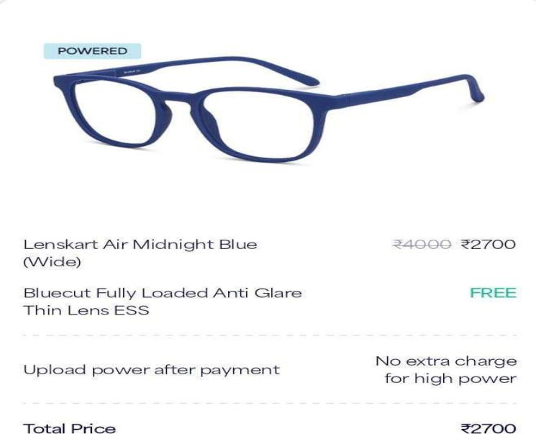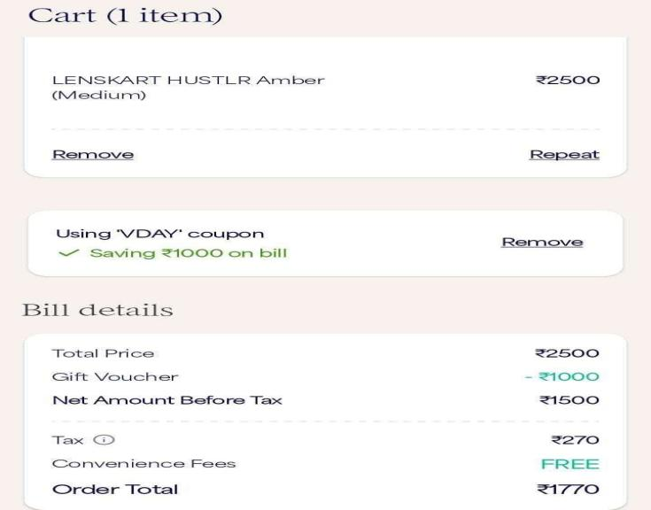

The strategy that Lenskart is using involves pricing and marketing. They are charging different prices for zero-powered glasses and powered glasses, plus a discount valid for only a little time to attract customers. They are looking to promote sales as more customers are seeking ways to protect their eyes from blue and UV rays.

Through such price offering, zero-powered glasses by Lenskart, targeting customers who do not need prescription glasses, may still be deeply worried about protecting their eyes against harmful rays. Through this, the company can expand its customer base, attracting more people to its stores or website.

Moreover, this offers zero-powered glasses at a relatively affordable price, and Lenskart Hustlr is also positioning these glasses as a protector of eyes from blu and UV rays. That is a message that should resonate with the concerned customers who can do something about eye health and protect their vision.

The Lenskart Hustlr provides discount for a very limited period and tries to create the urgency in the customers and compel them to make a sale. Therefore, this company is hoping customers will act fast by highlighting the time-limited nature of the discount.

Overall, the price and marketing strategy of Lenskart Hustlr appear to be closely oriented toward establishing a great value proposition for customers and to differentiate the

The company targets low-brow customers by offering a lower price for zero-powered glasses and emphasizing health benefits. This way, customers who have not considered the need to buy glasses before may consider purchasing glasses as long as they are zero-powered. The limited period discount is a smart marketing tactic that can help in adding additional sales volumes and generating new customers to the brand.

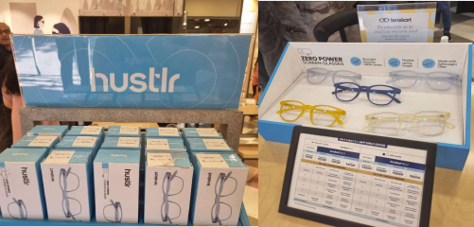**3.PLACE:**

This includes all physical and virtual places where the product is sold to customers, as well as the logistics and the supply chain that assist in getting the product to them. The most conventional physical points of distribution are retail stores and warehouses. A company can either sell its products through retail stores that belong to the business or through a deal with other businesses that will carry the business's products, for example, departmental stores or specialty stores. Warehouses also are significant for the storage and onward flow of the products to retailers and customers.

Online marketplaces and other digital channels have become a need in recent times. Social media platforms like Facebook and Instagram also have become important media for the sales of the products of a business firm and reach targeted customers.

Proper logistics and supply chain management are, therefore, highly essential in order to have the efficient distribution of a product. Logistics and supply chain can involve all transportations, shipping, and inventory management to fulfill orders. Every company should take good care to have them deliver their products to their customers promptly and satisfactorily, yet at the same time, having control of the cost and optimising supply chain.

Choice distribution channels depend on the type of product, target markets, and the competition in general. Businesses have to weigh several variables against their requirements with reference to cost and efficiency in different channels and customer and brand image associated with each one of them.

This is where Lenskart comes in - the eyewear company sells its products on two sets of marketplaces, that is, online and offline. This idea should now be based on combining the two experiences-both physical and digital shopping-by offering a person with both channels toward their convenience of a streamlined buying experience.

At the same time, Lenskart operates a network of physical stores all over India, in which people can see and try frames in person. These stores are strategically located in the most high-traffic areas to offer a wide range of products and services, including eye exams, frame fittings, and repairs.

The brand offers both off- and online market places that allow customers to shop at a time of their convenience. These 3D try-ons and other online services maximize the comfort of the offerings. The physical stores open ways for people to touch products and be adequately served by trained eyewear specialists. In this regard, Lenskart has succeeded in building a powerful brand image and an ardent customer base through its omni-channel approach.

The design of Lenskart Hustlr itself is centered in the layout of the eyewear show room so that the eye balls are forced to land on it. Similarly, at present, the layout of the Lenskart website throws a prominent product called "Lenskart Hustlr" right at the center of the webpage. This could be yet another intentional move and draws attention to this "Lenskart hustlr" product or service or marketing campaign. Placing most wanted and most visible element in the center of the website is the common web design that focuses visitor's attention and makes it probable that the visitor will interact with the featured element.

**4.PROMOTION**

**Promotion is one of the major components of the 4 P's of marketing and plays a critical role for Lenskart in developing brand recognition and boosting sales. With digital marketing on the rise, the company can use various other channels to sell their products and reach an enhanced customer base. Here are some ways through which Lenskart can use promotion in its marketing strategy:-  
  
Digital Marketing  
  
Digital marketing is an application of digital channels (in which the information is exchanged between buyers and sellers in digital forms) to deliver promotional messages to customers and prospects. The digital channels can include search engines, social media, email, among others. Lenskart may thus optimize its website using SEO and SEM and increase traffic to its site. It could, as well, use display advertising on websites and social media platforms. Google Ads is a niche kind of digital marketing through which business houses can show targeted ads to those who use either Google or a partner website while searching for products or services. It is another paid form of advertising which works on the principle of pay per click model.  
The bidder specifies the keywords related to his business, and Google determines which advertisement it is to serve, when to serve it, based on multifaceted factors. By way of Google Ads, businesses have a powerful opportunity to connect with their target markets and attract targeted traffic into their website. By ads on Google, businesses can elevate their online presence, garner more leads, and ultimately, higher sales and revenue.**

Social Media Marketing: The lenses offered by Lenskart can be promoted greatly through social media websites such as Facebook, Twitter, Instagram, and LinkedIn. Through such social media, the Company can promote its products and get in touch with customers through engaging content available in various forms such as videos and images and through holding polls. Exclusive discounts and promotions on social media for followers should be offered by Lenskart so that engagement levels increase further.  
  
Influencer Marketing: Influencer marketing is a process of collaborating with a media influencer who happens to have a significant influence in a particular social media platform for the purpose of promoting a product. In this regard, Lenskart can affiliate with influential people in the fashion and beauty industry to promote their products to a wider audience. They can create content featuring the Lenskart product and share it among their followers.  
  
  
YouTube and Podcasts: Through YouTube, Lenskart could produce tutorial videos on the product and upload them. The company can also get associated with popular podcasts to publicize its products to a much larger group.  
  
Sylists and Tutorial Videos: The company can collaborate with the fashion and beauty stylists to display their products and give styling tips to the customers. It will create tutorial videos of its products that will be displayed on social media sites.  
  
5.PEOPLE  
  
People is one aspect of Lenskart's marketing strategy based on the 7 P's of marketing. People are individuals associated with providing the product or services for the customers. For the case of Lenskart, people include employees, customer service, optometrists, partners, suppliers, management, and brand ambassadors. The company trains and develops its employees in order to give the customers quality service. In the optometrists, there is a significant role in giving an accurate prescription to each and every individual. Moreover, partners and suppliers create more effective delivery and high-quality standards. The vision, values, and the direction of a company are determined by its management. Brand ambassadors also promote the products and services offered under a brand.

6.PROCESS  
  
The process of Lenskart Hustlr is making the buying of eyewear products simple for customers. It is possible either online or offline. The company has also introduced the feature 3D Try On, which allows the customer to experience the product virtually before buying. The delivery is quick with minimal hassles, and the after-sales support is very good.

7 Tangible Evidence

The evidence of Lenskart Hustlr in the tangible context is related to its packaging, branding, and overall customer experience. The company ensures that the products are nicely packaged and branded and the customer experience is seamless, hassle-free experience with the company.

Competitive Analysis

It is through innovative and more effective marketing strategies that Lenskart Hustlr has come out of the mire to be a leader in eyewear products. The marketing approach of Lenskart Hustlr is way more dynamic, focused, and personalized compared to Titan Eye Plus, Fasstrack, or Ray-Ban.

However, one of the biggest strengths of the Lenskart Hustlr marketing strategy is its emphasis on digital marketing. The brand will use social media websites, online advertisements, and influencer marketing to connect the company with potential audiences in a more personalized manner. They have also focused much on the aspect of offering seamless ecommerce through their website as well as mobile application. This has enabled Lenskart to tap into a much larger audience and also develop a loyal client base.

The marketing strategy of Lenskart Hustlr emphasizes innovation. It released a new product line almost every week, their blue light blocking glasses, and has ensured that they stay in front of the curve with respect to competing companies. They also have a feature on the application regarding virtual try-ons, through which customers can try out the glasses from the comfort of their homes. Innovation has kept Lenskart relevant, and, therefore, at a market leadership position.

In summary, the strategic marketing strategies applied have streamlined Lenskart as different from the rest. Being eye on digital marketing and experiential marketing together with innovation has positioned the company well in creating its brand image, driving the loyalty of customers, and serving ahead of competitors in the highly competitive marketplace.

**PRIMARY DATA**

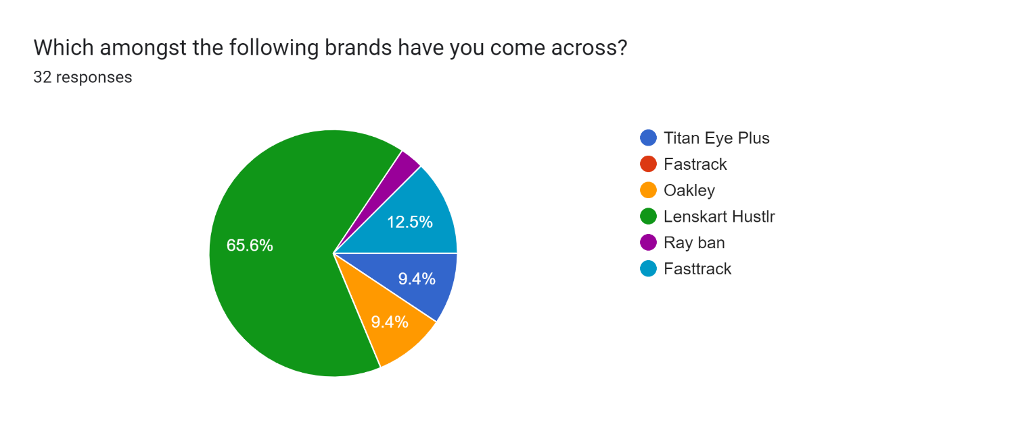

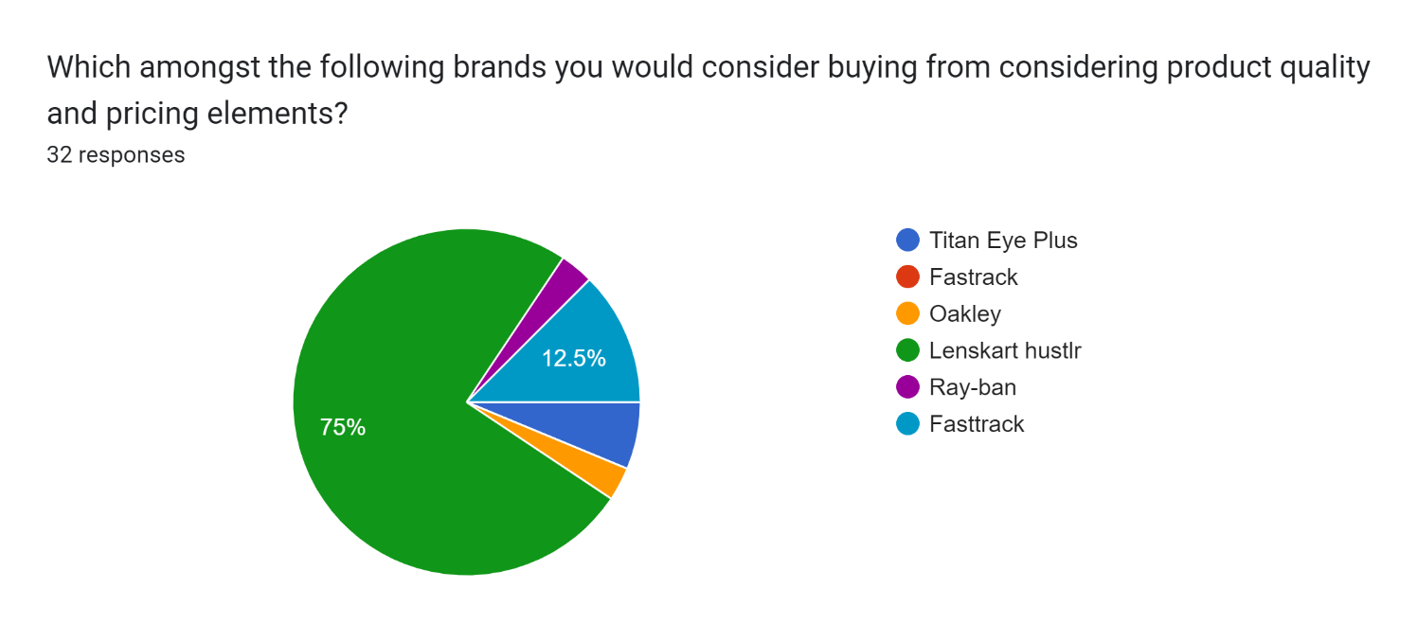

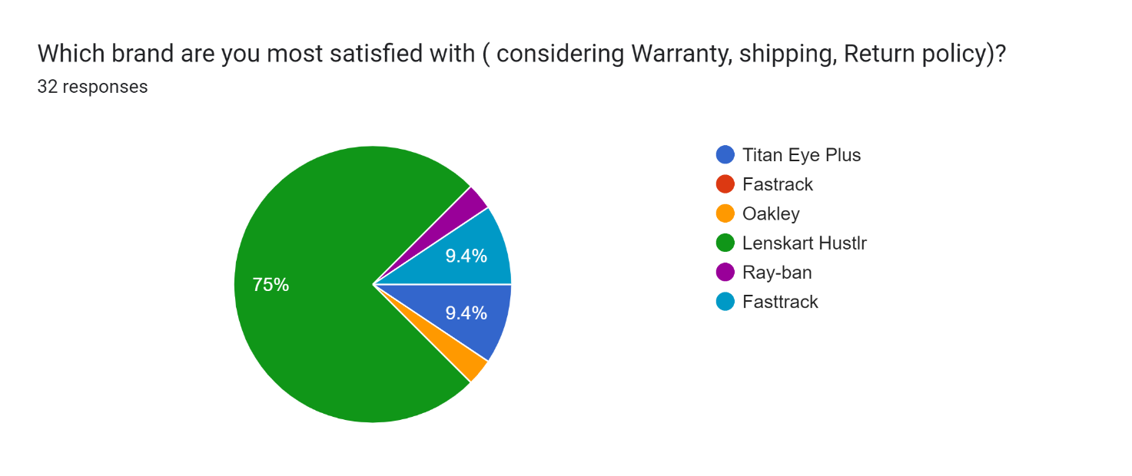

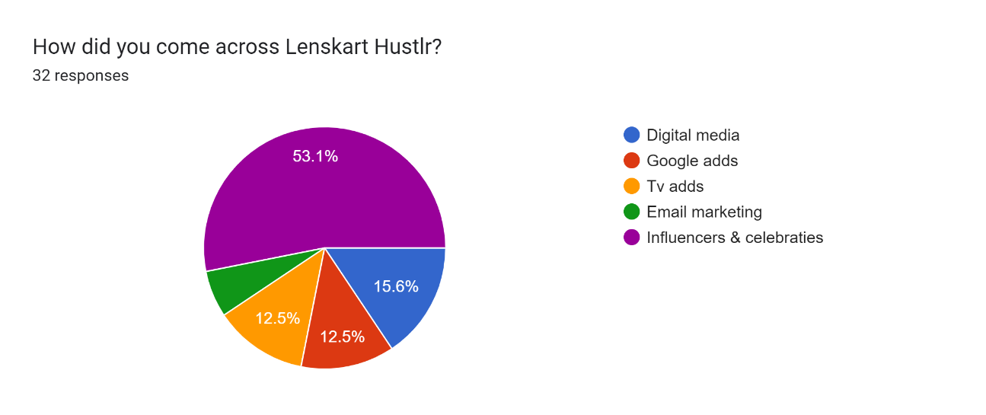

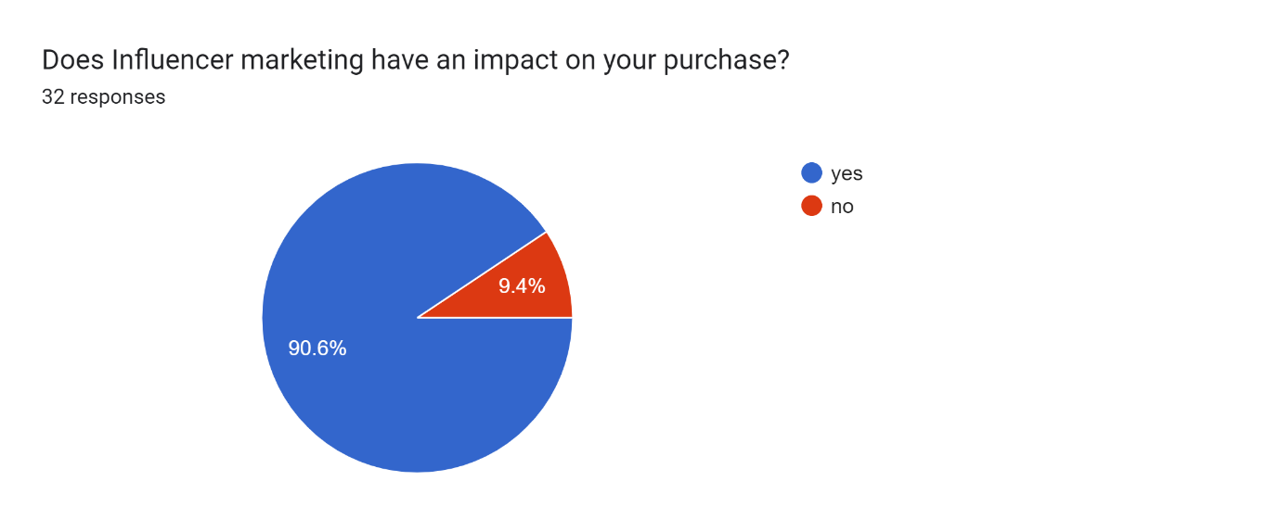

ANALYSIS OF DATA

From the results of the survey, it is evident that most respondents have a preference towards the brand awareness in relation to Lenskart Hustlr, followed by Titan Eye Plus and FastTrack. In addition, if taken into consideration

factors such as Warranty, Shipping, and Return Policy, Lenskart Hustlr was rated the highest among the surveyed brands. Google Ads and Digital Media proved the most effective in terms of marketing and reaching out to customers. Also people have come across Lenskart hustlr through Influencers & Celebreties. 90.6% of the participants were in the opinion that influencer marketing affects their purchases.

SUGGESTIONS

Lenskart and brands like Titan Eye Plus, Fastrack, and Ray-ban have become household brands in the eyewear space.

The other critical area for the brands is to utilize technology and digital media to gain brand awareness, as well as to acquire more customers. An increasing usage of smartphone and social media makes every business require a digital presence. Utilizing the use of technology also assists in elevating the level of user experience and help to provide personalized recommendations based on customer preferences and purchase history.

On the other hand, the platform of Lenskart can be further developed with other filters that aid the experience of users and make it easier to locate what the customers may need to get. Apart from that, proofing social, whereby the amount of people who purchased a certain product increases the confidence that a customer will have on it.

CONCLUSION

Concluding by way of, Lenskart Hustlr marketing strategies have been effective terms of differentiation, as they become increasingly focused on targeting the millennial and Gen Z markets. Their brand image is quite unique and speaks to a specific kind of audience or demographic. This aspect is one reason it succeeded in using the services of social media platforms for marketing purposes, using influencers, and experiential marketing. This makes them pretty strong online and better suited to communicate with a customer on a much more individual level.

Moreover, their competitors also have adopted the same strategies and are able to take strong foothold in the market. Though Lenskart Hustlr has been able to create a distinct brand image, the strongest online presence and engagement could be provided by their competitors.

After all, it will be subjected to the adaptability of one firm over another to varied market trends and consumer preferences. Innovations through frequent offerings of values to the customers by firms like Lenskart Hustlr and their peers will essentially help them survive well in a rather competitive market

**WEBLIOGRAPHY –**

* 1. https://[www.socialsamosa.com/2020/06/lenskart-hustlr-disrupting-eyewear-](http://www.socialsamosa.com/2020/06/lenskart-hustlr-disrupting-eyewear-) industry-marketing-strategies/
  2. https://[www.marketing91.com/marketing-strategies-lenskart/](http://www.marketing91.com/marketing-strategies-lenskart/)
  3. https://[www.impact.com/blog/how-lenskart-is-leveraging-influencer-](http://www.impact.com/blog/how-lenskart-is-leveraging-influencer-) marketing-to-target-millennial-and-gen-z-consumers/
  4. https://[www.semrush.com/blog/competitor-analysis-tools-to-improve-your-](http://www.semrush.com/blog/competitor-analysis-tools-to-improve-your-) marketing-strategy/
  5. https://[www.lenskart.com/](http://www.lenskart.com/)
  6. <https://forms.gle/X9d9QEQTKgeQhGQQ9>