# Introduction

Social media has a significant and dynamic impact on stock market movements in the quickly changing world of modern finance. The emergence of social media platforms such as Reddit, Twitter, and others has led to an unparalleled spread of information that affects trading decisions and investor sentiment. This essay explores the complex relationship between social media and stock markets, focusing on how the sharing of news, opinions, and real-time interactions on these platforms can have a big impact on market dynamics.

**Thesis Statement:**

The argument put out in this essay is that the widespread use of social media has significantly changed the conventional methods for analysing and making decisions in the stock market. Online communities and financial markets are becoming more intertwined, which not only magnifies market sentiment but also presents new opportunities and difficulties for financial institutions and investors alike. This essay seeks to clarify the complex relationship between social media and stock market trends by looking at case studies, regulatory responses, and the function of algorithmic trading. In the process, it hopes to advance knowledge of this developing phenomenon in the modern financial environment.

**Background**

Thesis Statement:  
Social media’s adoption by the financial industry has had a profound impact on how information is exchanged and used in the world’s financial system.

**Social media’s evolution in the finance industry:**

The emergence of social media platforms signalled a paradigm shift in communication, therefore it made sense for them to spread throughout the industry. After beginning as personal message boards, social media sites like Facebook, LinkedIn, and Twitter changed to include financial conversations, news, and investment-related content. Due to this evolution, financial information is now more accessible to a wider audience, allowing them to participate in conversations that were previously exclusive to established financial channels.

**Important Social Media Platforms:**

A number of social media platforms have come to be recognised as vital conduits for the exchange of financial knowledge and the development of market discourse. Because it is real-time, Twitter has developed into a central location for breaking news, professional analysis, and crowdsourced knowledge. Reddit has become well-known for its effect on certain stocks, especially through its subreddits like WallStreetBets, demonstrating the ability of online communities to shape market behaviour. Furthermore, websites like StockTwits and Seeking Alpha target the financial community in particular, promoting conversations and giving financial content makers a forum.

**Role in Financial Information Dissemination:**

Social media sites are becoming crucial for the quick distribution of financial information. Real-time sharing of news stories, comments, and analyses by users fosters an environment in which events that move markets are swiftly taken in by a worldwide audience. Retail investors now have greater capacity to make well-informed decisions and are posing a challenge to the established gatekeepers of financial knowledge thanks to the democratisation of financial information.

**Social Media and Market Sentiment:**

**Impact of Social Media on Investor Sentiment:**

Social media sites have a big say in how investors feel since they are lively spaces where ideas, thoughts, and feelings come together in real time. The rapid dissemination of information on these platforms has the potential to generate a potent feedback loop that influences investors’ perceptions of the state of the market. Conversations on Twitter, forums devoted to stocks, and other social media platforms frequently add to the general mood that can influence trading choices.

**Positive Sentiment’s Effect:**

Stock prices can be directly impacted by positive sentiment that is trending on social media. Positive comments made by users regarding a specific company or market trend can draw in interest and attention from a larger group of investors. A stock’s price may rise as a result of greater demand brought on by positive sentiments. This effect is more noticeable when it comes to new technology, creative businesses, or industries with room to grow since enthusiastic social media posts can increase market excitement.

**Negative Sentiment’s Effect:**

On the other hand, unfavourable attitudes expressed on social media can drive stock values lower. Investors may reevaluate their positions as a result of fast-moving critical conversations, worries about a company’s performance, or bad news. Because social media posts have the potential to go viral, negative sentiment can have a greater effect, which can lead to sell-offs and increased market volatility. Especially, the emergence of Reddit communities like WallStreetBets has shown how collectively negative sentiment may disrupt traditional market dynamics.

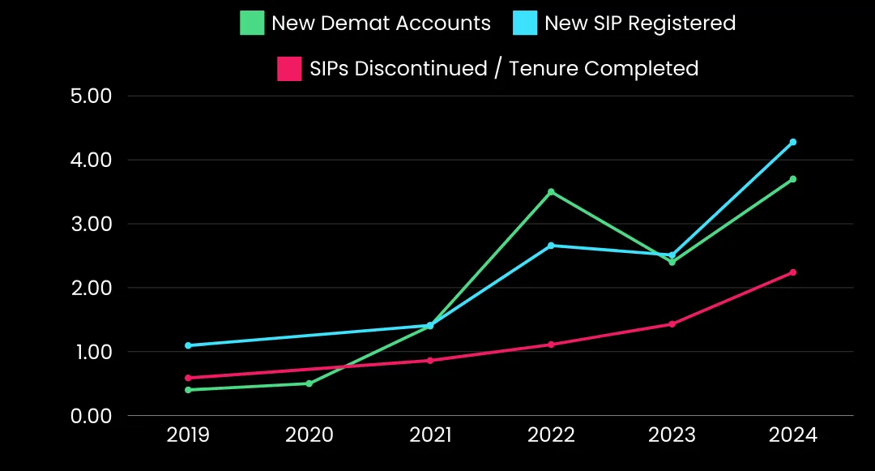

## Algorithmic Trading and Sentiment Analysis:

The impact of social media on market sentiment has been amplified even more with the introduction of automated trading tactics. Large volumes of social media data can be analysed by algorithms to determine sentiment trends. The speed and effectiveness of market reactions are subsequently increased by using positive or negative mood cues to guide automated trading decisions.

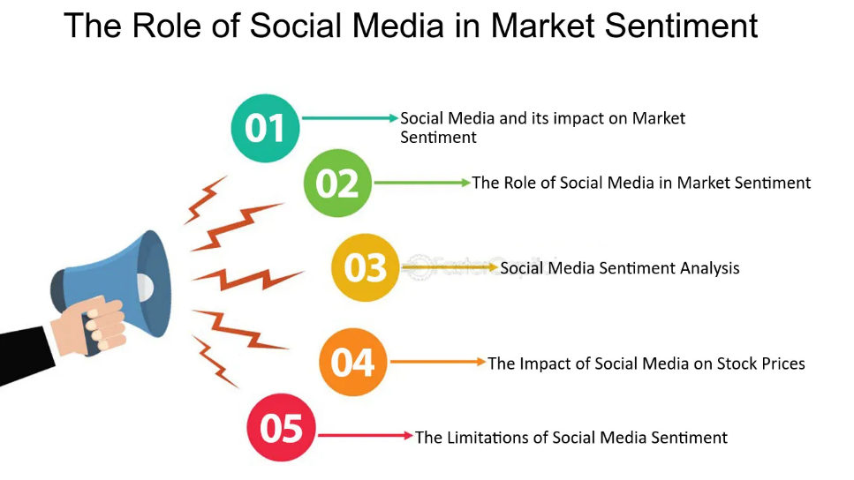

# Case studies

## GameStop (GME) Short Squeeze (2021):

The GameStop saga stands out as one of the most noteworthy recent examples. Institutional investors were taken by surprise when a short squeeze on GME stock was started by retail investors, who were grouped through WallStreetBets on Reddit. GameStop’s stock price experienced a notable increase as a result of the coordinated buying attempt, which was largely driven by social media. This particular case highlights the ability of virtual communities to question established market dynamics and the ensuing examination of market laws.

## Elon Musk’s Tweets and Tesla’s Stock Price:

Elon Musk, the CEO of Tesla, is well-known for interacting with the public on Twitter. It has been demonstrated that Musk’s tweets, whether they are about personal or business-related developments at Tesla, affect the stock price of the company. For example, tweets regarding Tesla’s valuation or upcoming goods have caused significant price swings, illustrating the direct influence of prominent users on social media on market trends.

## COVID-19 Vaccine Announcements and Biotech Stocks:

The news of successful vaccine breakthroughs during the global COVID-19 pandemic response had an instant effect on biotech markets. The material was primarily shared through social media, and investor sentiment was impacted by conversations about the news on sites like Twitter and stock forums. Sharp price swings in biotech stocks followed the general mood, demonstrating how real-time information sharing on social media can influence market trends.

# Future Outlook:

Predicting Potential Future Developments in the Relationship between Social Media and Stock Market Trends:

## Integration of Advanced Technologies:

It is possible that in the future, financial analysis led by social media will incorporate cutting-edge technologies like machine learning and artificial intelligence. With the use of these technologies, sentiment analysis will become more sophisticated and accurate, offering more in-depth understanding of market dynamics.

## Evolution of Regulatory Frameworks:

Regulatory agencies anticipate updating existing rules as social media’s impact on stock markets grows. Prospective regulatory measures could concentrate on tackling issues associated with market manipulation, disinformation, and the moral utilisation of social media data in algorithmic trading.

## Increased Collaboration with Social Media Platforms:

Financial institutions and regulators may work more closely with social media companies to improve market monitoring and handle possible threats. Enhanced collaboration could result in the creation of uniform reporting procedures and guidelines for managing financial data on social media platforms.

## Rise of Niche Communities and Platforms:

There may be the emergence of niche communities and platforms devoted to particular companies, sectors, or investing approaches. These niche forums might offer more targeted conversations and analysis, meeting the various needs of traders and investors.

## Enhanced Privacy Measures:

Increased awareness of privacy issues could result in the adoption of more stringent privacy policies on social media sites, which would affect the accessibility and evaluation of user-generated financial content. A crucial factor to take into account will be finding a balance between information accessibility and privacy protection.

Discussing Areas for Further Research and Exploration:

## Behavioral Finance and Social Media:

Subsequent investigations may explore the convergence of social media and behavioural finance in further detail. There is still much to learn about how the actions of both individual and group investors on social media affect trading patterns and market dynamics.

## Impact of Social Media on Market Efficiency:

The long-term effects of social media on market efficiency might be investigated by researchers. Understanding the general state of the financial markets requires evaluating whether social media-driven developments promote more effective pricing mechanisms or contribute to market inefficiencies.

## Ethical Considerations in Algorithmic Trading:

The ethical issues of algorithmic trading based on social media data may be the subject of future studies. It would be beneficial to investigate the consequences of automated trading decisions impacted by internet sentiment as well as the duties of algorithmic traders.

## Global Perspectives on Social Media Influence:

Studies comparing the effects of social media on stock markets across geographies may shed light on the legislative and cultural contexts that determine how online conversations affect investing choices.

## Long-Term Investor Behavior on Social Media:

A thorough grasp of the various roles that various investor segments play in online financial communities can be attained by examining the behaviour of long-term investors on social media platforms and learning how they manage short-term market movements and noise.

# Conclusion

In summary, the changing relationship between social media and stock market movements is a dynamic environment that greatly influences modern financial dynamics. Social media platforms present issues with market manipulation, disinformation, and the moral use of data even as they continue to democratise access to financial information and empower ordinary investors. In order to tackle these issues, regulatory solutions are changing and placing more emphasis on social media platform cooperation, improved monitoring, and communication rules. The view for the future calls for the adoption of cutting-edge technologies, the development of legal frameworks, and ongoing innovation in social trading platforms.