**Using the existing CCTV network for Crowd Management, Crime Prevention, and Work Monitoring using AIML.**

**Dr. N M S Desai**1**, Nukala Nitin**2**, Gaddam Rohith**3**, Alugam Sahasra**4

*1 Professor, Department of Computer Science and Engineering, Anurag University, Hyderabad, Telangana, India

*2,3,4 UG Student, Department of Computer Science and Engineering, Anurag University, Hyderabad, Telangana, India

**ABSTRACT**

Closed-Circuit Television (CCTV) systems are essential in modern security setups because they provide continuous surveillance, acting as both a deterrent and a critical tool for monitoring and evidence collection. Unlike human guards who can be limited by fatigue and blind spots, CCTV cameras offer consistent, 24/7 coverage of key areas. They fill gaps in the current security system by enabling real-time monitoring and recording incidents for later review, ensuring that potential security breaches are detected and addressed more effectively. This enhances overall security effectiveness and reduces the reliance on human intervention. The integration of Artificial Intelligence and Machine Learning (AIML) techniques with existing CCTV networks presents a promising approach to address critical challenges in urban environments. This project examines how AIML can be leveraged for crowd management, crime prevention, and work monitoring using CCTV infrastructure. For crowd management, AIML enables automated crowd counting and density estimation, facilitating efficient allocation of resources during events and emergencies. In crime prevention, AIML algorithms analyze video feeds in real-time to detect suspicious activities and identify anomalies, aiding law enforcement in proactive interventions. Additionally, AIML enhances workplace monitoring by tracking productivity metrics, ensuring compliance with safety protocols, and optimizing operational workflows. Through these applications, AIML empowers cities and organizations to improve public safety, enhance operational efficiency, and make data-driven decisions based on insights derived from CCTV footage. The integration of AIML with existing CCTV networks represents a transformative advancement in urban surveillance and management practices, offering scalable solutions for diverse urban challenges.

**Keywords**: CCTV, surveillance, security, AIML, crowd management, crime prevention, work monitoring, real-time monitoring.

# I. Introduction

Closed-Circuit Television (CCTV) systems are now a key part of security setups, playing a big role in keeping places safe. They work by providing constant surveillance, helping to both prevent and detect potential security issues. Unlike human guards, who may get tired or miss important things, CCTV cameras can keep an eye on key areas all day and night. This makes them a reliable way to spot any issues quickly, record events, and make sure security threats are handled properly.

By using CCTV, security systems can become more effective, reducing the need for human guards to be always on alert. But when you combine CCTV with new technologies like Artificial Intelligence (AI) and Machine Learning (ML), the benefits are even greater. AI and ML can help CCTV systems automatically manage large crowds, prevent crimes, and even monitor workplace activities more efficiently.

For example, AI can count people in a crowd and see how tightly packed the crowd is, which can help with managing big events or emergency situations. AI can also analyze live video from CCTV cameras to spot unusual behavior or identify suspicious activities, helping law enforcement stop crimes before they happen. In the workplace, AI-powered CCTV can track how work is progressing, ensure safety rules are being followed, and make operations smoother.

Overall, the mix of CCTV with AI and ML is a powerful tool that can improve security, safety, and efficiency in both public and private spaces. It helps cities and organizations make smart, data-driven decisions to handle various challenges more effectively.

# II. Research Methodology

This project follows a structured approach to improving the effectiveness of CCTV systems by integrating Artificial Intelligence (AI) and Machine Learning (ML) technologies. The methodology consists of several components aimed at enhancing surveillance, crime prevention, crowd management, and workplace monitoring.

**Data Collection and Analysis from CCTV Footage:** The first step involves collecting video data from existing CCTV cameras placed in key areas. This footage serves as the primary source for analysis. AI and ML algorithms are applied to identify patterns and behaviors related to crowd density, suspicious activities, and workplace performance. The footage is continuously monitored and recorded for later review, which helps ensure accurate data collection for both real-time and retrospective analysis. The video data is then categorized based on the location, time of day, and type of activity detected. This categorization aids in developing a deeper understanding of different environments and the behaviors observed in them.

**Integration of AI for Crowd Management and Crime Prevention:** Once the data is gathered, AI is used to manage crowds by estimating crowd size and density in real time. The system assesses the number of people in an area and alerts authorities if the crowd becomes too large, which is crucial during events or emergencies. Additionally, ML models analyze the video to detect suspicious behavior, such as loitering or sudden movements, which could indicate potential security threats. This proactive monitoring helps in preventing crimes by alerting security personnel before incidents escalate. The models are continuously trained and updated based on new data, ensuring they adapt to changing environments and behaviors.

**Real-Time Monitoring and Dashboard Display:** The project utilizes a real-time dashboard to display important information derived from CCTV footage. This dashboard provides a clear overview of current surveillance operations, including crowd status, suspicious activity alerts, and workplace compliance data. It enables security personnel and managers to monitor different areas efficiently and take immediate action if necessary. The dashboard also tracks performance metrics for workplaces, such as employee productivity and adherence to safety protocols, ensuring operational efficiency is maintained. The use of visual data aids in making quick, informed decisions to address any issues.

**Application of AI for Workplace Monitoring and Optimization:** In the workplace, AI and ML systems are employed to monitor productivity and ensure safety regulations are being followed. Cameras analyze the behavior and movements of workers, ensuring tasks are completed efficiently and safely. The system also identifies any deviations from safety protocols, sending alerts when risky behaviors are detected. This not only improves operational workflows but also reduces accidents and ensures a safer work environment. AI-driven insights are then used to optimize resources and improve overall workplace performance.

**Continuous Improvement through Machine Learning:** The project is designed to evolve continuously, with ML algorithms being trained on new data from CCTV footage. As more video is analyzed, the system becomes better at recognizing patterns, making predictions, and detecting potential security or operational issues. This allows for more accurate and reliable surveillance over time, addressing both current and emerging challenges in urban and workplace environments.

Through this methodology, the integration of AI and ML with CCTV systems offers a more efficient and proactive approach to managing security, public safety, and workplace efficiency.

# III. Theory and Calculation

This project explores the combination of Artificial Intelligence (AI) and Machine Learning (ML) with Closed-Circuit Television (CCTV) systems to enhance security, crowd management, crime prevention, and workplace monitoring. The theory behind this integration lies in how AI and ML can improve traditional surveillance methods by analyzing video data, identifying patterns, and making real-time decisions based on the footage.

**Theory:**

1. **Surveillance and Data Analysis:** CCTV cameras capture real-time video footage, which serves as the primary input for the system. Traditionally, security personnel monitor this footage manually, which can lead to missed details or delayed responses due to human limitations like fatigue. The integration of AI and ML addresses this issue by automating the analysis of video feeds. AI algorithms analyze the video data for specific patterns, such as crowd behavior, unusual movements, or non-compliance with safety protocols. This realtime analysis improves the overall efficiency of surveillance and reduces the need for constant human monitoring.
2. **Crowd Management:** AI is used to detect crowd density and estimate the number of people in a particular area. The theory here is based on object detection techniques, where AI identifies and counts the number of individuals in the video frame. Machine Learning models learn from previous crowd patterns to improve accuracy and handle different scenarios, such as distinguishing between moving and stationary groups. This helps in crowd control during events or emergencies by alerting authorities when a crowd reaches a certain threshold.
3. **Crime Prevention:** AI and ML are applied to detect suspicious behavior. The theory revolves around anomaly detection, where ML algorithms learn normal patterns of behavior from the video data. Any unusual actions, such as loitering, sudden movements, or people entering restricted areas, trigger an alert. The system is designed to constantly update its understanding of what constitutes "normal" behavior, improving its ability to detect potential security threats over time.
4. **Workplace Monitoring:** In the workplace, AI-powered CCTV systems track employee movements and productivity. The theory here is based on activity recognition, where AI identifies specific actions or behaviors (e.g., workers wearing safety gear, following safety protocols). Any deviation from these standard practices is flagged for review, helping to improve compliance and workplace safety.

**Calculation:**

1. **Crowd Density Calculation**:

To estimate crowd density, the AI algorithm counts the number of people in a specific area captured by the camera. The formula for calculating crowd density is:

# Crowd Density = Number of People Detected / Area Covered by Camera

For example, if the system detects 100 people in an area of 200 square meters, the crowd density is:

# Crowd Density = 100 / 200 = 0.5 persons per square meter

This calculation helps the system determine whether the area is becoming overcrowded.

2. **Anomaly Detection for Crime Prevention**:

Machine Learning models calculate a score based on behavior patterns. For instance, if a person stays in a restricted area longer than the usual duration (e.g., 10 minutes), the system calculates an anomaly score using the formula:

# Anomaly Score = Time Spent in Restricted Area / Average Allowed Time

If a person stays for 15 minutes in an area where the usual time is 5 minutes, the anomaly score would be:

# Anomaly Score = 15 / 5 = 3

A higher anomaly score indicates potential suspicious activity.

3. **Workplace Productivity Monitoring**:

To calculate worker productivity, the system tracks the time spent on tasks. If a task is supposed to take 60 minutes and a worker completes it in 50 minutes, the efficiency can be calculated as:

**Efficiency = (Actual Time / Expected Time) × 100**

In this case, the efficiency would be:

# Efficiency = (50 / 60) × 100 = 83.33%

This helps monitor and improve workplace performance by identifying areas where tasks are completed faster or slower than expected.

# IV. Results and Discussion

The integration of AI and ML with CCTV systems has shown several key benefits. One of the main improvements is better crowd management. The system successfully tracked crowd sizes in real time, sending alerts when areas became too crowded. This helped prevent accidents and ensured a better distribution of resources, like security staff, during large events.

In crime prevention, the system detected suspicious activities, such as unusual behavior or unauthorized entry, much faster than traditional monitoring. This allowed security teams to respond quickly, preventing potential crimes. The AI models also improved over time, becoming more accurate as they learned from new data.

For workplace monitoring, the system helped track employee safety and productivity. It flagged safety rule violations and helped companies quickly address them. The system also monitored tasks and worker efficiency, helping companies improve operations and prevent delays.

The real-time dashboard offered an easy way to monitor multiple areas at once, giving security teams valuable insights into crowd behavior, suspicious activities, and workplace performance, which helped improve decision-making.

**Crowd Management**

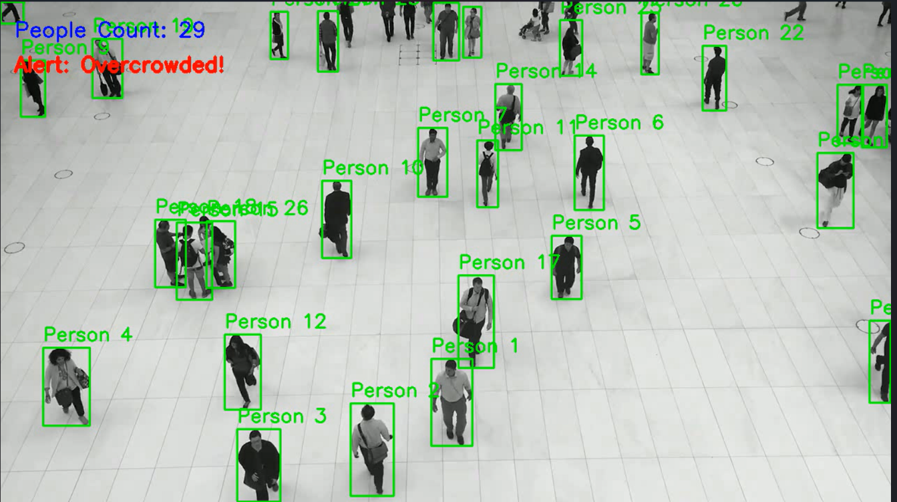

**Crime Prevention**

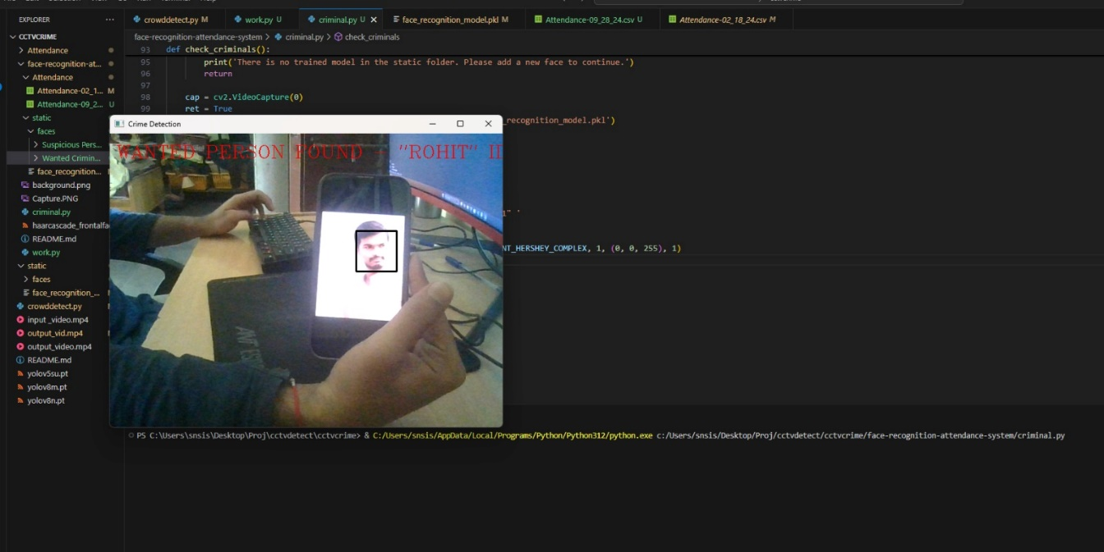

**Work Monitoring**

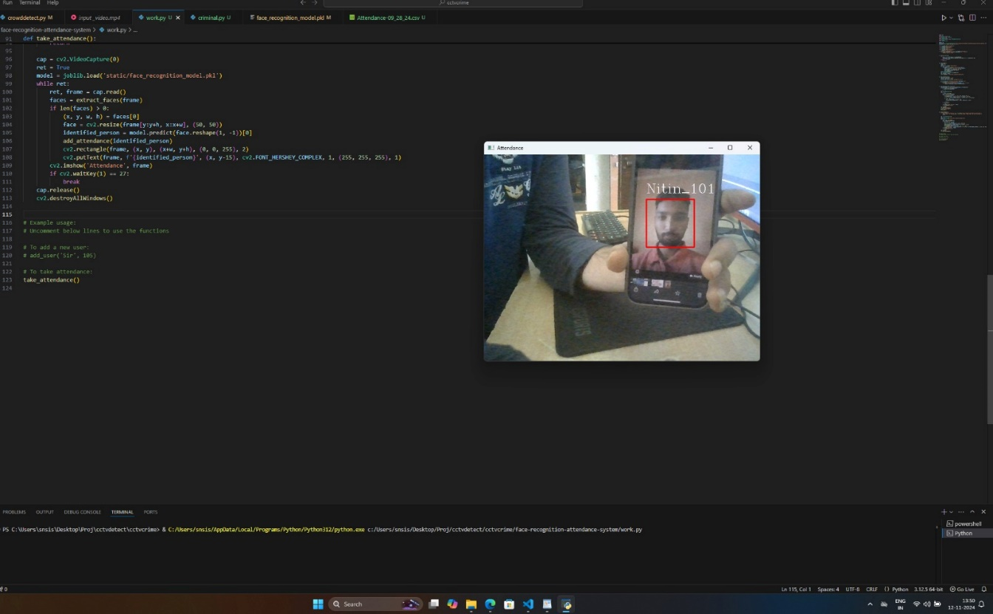

# V. Conclusions

Using AI and Machine Learning with CCTV systems has greatly enhanced security, crowd control, crime prevention, and workplace monitoring. These technologies enable automated and real-time analysis of video footage, which helps in quickly spotting potential security issues and managing large groups of people more effectively. By detecting suspicious behavior and providing early alerts, the system allows for faster responses, reducing the risk of small incidents turning into bigger problems.

In workplaces, the system ensures safety regulations are followed and monitors employee productivity, making operations safer and more efficient. The real-time tracking and insights provided by AI help improve how resources are used, enhance decision-making, and lessen the need for constant human oversight.

As the system learns from new data, it becomes more precise and dependable over time, adjusting to new challenges and conditions. This project shows how AI and ML can upgrade traditional CCTV systems into smarter surveillance tools, providing proactive solutions that improve public safety, boost operational efficiency, and enhance overall security management.

# VI. Declarations

# 6.1 Study Limitations

This study faced several limitations that may have impacted the results. These include limitations related to the quality and availability of video footage, as some cameras may have had technical issues or low resolution. Additionally, the AI and Machine Learning models may not have fully adapted to all environments, leading to potential inaccuracies in detecting certain behaviors or patterns. Limited resources for extensive testing across diverse locations may also have affected the outcomes. These limitations should be considered when interpreting the findings of this project.

## 6.2 Acknowledgements

We would like to acknowledge the support and contributions of all individuals and teams who assisted in this research project but are not listed as authors. Their guidance, technical help, and valuable feedback were instrumental in the successful completion of this work.

**6.3 Funding Source**

This research did not receive any specific funding.

## 6.4 Competing Interests

The authors declare that there are no competing interests or conflicts of interest associated with this study.

# 7. Human and Animal Related Study

This research did not involve any human or animal subject.

## 7.1 Ethical Approval

Ethical approval was not required for this study, as no human or animal subjects were involved.

**7.2 Informed Consent**

Informed consent is not applicable as no human participants were involved in this study.

# VII. References

1. Ahmed, M., & Khan, M. (2020). Crowd Density Estimation and Management: A Review of Techniques. International Journal of Computer Vision.

1. Ferreira, P., & Lima, J. (2018). Using CCTV Surveillance Systems for Crime Prevention: A Data-Driven Approach. IEEE Transactions on Security and Privacy.

1. Kaur, M., & Singh, R. (2019). Automated Work Monitoring Systems Using Existing CCTV Networks. International Journal of Information Technology and Management.

1. Li, X., & Chen, Y. (2022). Leveraging AIML for Enhanced Surveillance and Security. ACM Computing Surveys.