***“Soil Moisture-Based Valve Control for Precision Irrigation Systems”***

Dr. G.Balram,M.Nagasri, P.Venkat Sai Reddy, B.Sreedatta

Dept. Of Computer Science and Engineering, Anurag University Hyderabad, Telangana

UG student,Department of Computer Science and

Engineering,Anurag University,Hyderabad,Tealngana,India

**ABSTRACT**

Effective water management is vital for sustainable agriculture. This project introduces an IoT based, AI-driven irrigation system that optimizes valve control using real-time soil moisture data. Soil moisture sensors continuously assess root zone moisture and relay this data to an AI framework, determining precise irrigation needs. The system autonomously adjusts valves according to environmental conditions, minimizing water waste and enhancing crop hydration. Machine learning algorithms, notably the random forest algorithm, analyze soil moisture and weather variables to inform irrigation schedules.

**Keywords:** IoT-based system, Automation, smart irrigation ,Machine learning

# I. Introduction

Water management is a pressing concern in modern agriculture, especially in arid regions.

Traditional irrigation methods often lead to waste, uneven crop growth, and lower productivity. Smart irrigation systems have emerged to tackle these issues by using advanced technologies to optimize water usage. This study focuses on creating an automated irrigation system that controls water release through valves based on real-time soil moisture data. Integrated with a micro-irrigation network, the system employs AI to predict and manage irrigation needs, ensuring crops receive optimal water while minimizing waste and enhancing agricultural efficiency.

The system uses sensors to monitor soil moisture and an AI model to forecast future moisture conditions based on variables like temperature and humidity. When moisture levels fall below a set threshold, the system activates valves to irrigate, preventing both over- and under-irrigation. This strategy not only conserves water but also promotes healthy crop growth.

**II. Research Methodology**

**Problem Definition** : We employed a team-based approach to develop an IoT-based system to

prevent over watering or under watering of irrigation fields. First, we identified key challenges in current irrigation practices through discussions with farmers .we noted all the necessary inputs like crop type ,water availability in different seasons.

**Literature Review and Analysis** : An extensive literature review examines advancements in smart irrigation technologies and AI applications in agriculture. This review identifies gaps in traditional irrigation methods and explores how AI can enhance water management, laying the groundwork for a system that automates irrigation and improves crop yields.

**System Design and Development** : The system design involves selecting appropriate hardware and software components. Key hardware includes soil moisture sensors, temperature and humidity sensors (e.g., DHT11), and a microcontroller (e.g., ESP8266). These components are integrated into a micro-irrigation network for real-time monitoring. valves and relay modules control water flow, while IoT platforms like ThingSpeak and Blynk enable remote monitoring and data analysis.

**Hardware and Integration** : In the design phase, we have focused on implementing the selected components, integrating sensors onto irrigation fields. They ensured seamless connectivity between the hardware and the central monitoring platform, where data would be transmitted and processed.

**Implementation and Testing** :During the trial phase, we have monitored system performance in real-time, ensuring that soil moisture data was being accurately captured and transmitted. **Data Analysis and Validation** : Data collection occurs through installed sensors that monitor soil moisture, temperature, humidity, and water flow. This data is essential for training the AI model. Preprocessing steps address noise and inconsistencies in the raw data, ensuring it is clean and structured for machine learning. Historical data is also incorporated to enhance the model’s predictive capabilities.

**Evaluation and Reporting** : We evaluated the overall performance of the IoT system .A final report was compiled, detailing the system's success and providing recommendations for largescale deployment across the irrigation fields. Field Testing and Performance Evaluation:

Field testing is essential to evaluate the real-world performance of the system. A pilot test is conducted in a controlled agricultural environment to monitor the system's ability to manage water efficiently. Various parameters such as water usage, soil moisture levels, and crop growth are recorded before and after implementing the AI-driven irrigation system. A comparative analysis is conducted between the proposed system and traditional irrigation methods, focusing on water conservation, irrigation efficiency, and crop yield improvements. The performance metrics from the field tests are analyzed to determine whether the system meets its design goals of reducing water wastage and optimizing irrigation practices. Additionally, feedback from field experts and farmers is collected to make iterative improvements to the system's design and functionality.

## III. Mathematical Expressions and Symbols

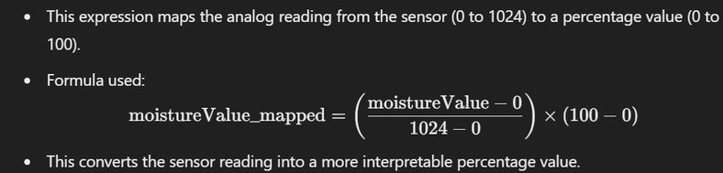

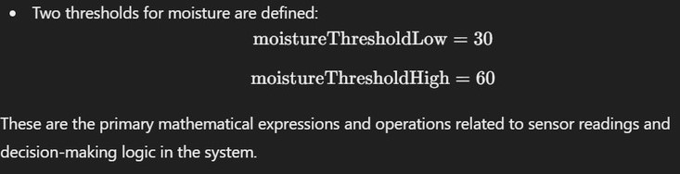

## IV. Results and Discussion

To implement and monitor the automatic irrigation system using Blynk and ThingSpeak, start by assembling the hardware: ESP8266, soil moisture sensor, DHT11, PIR sensor, water pump, relay, and LCD display. Ensure proper connections and power supply. In the Arduino IDE, install libraries for Blynk, ThingSpeak, DHT11, and the LCD. Set up the Blynk app on your mobile device, creating a new project, and adding widgets for soil moisture, temperature, humidity, pump control, and motion detection. Obtain the Blynk **AuthToken** and configure virtual pins. Then, create a ThingSpeak account, set up a channel, and configure fields for soil moisture, temperature, and humidity. Write the Arduino code to connect sensors and devices, monitor soil moisture, and control the water pump based on moisture thresholds. The code should also send data to Blynk and ThingSpeak. After uploading the code to the ESP8266, monitor real-time data and graphs on ThingSpeak, while controlling and receiving notifications from the Blynk app. This allows you to manage the irrigation system remotely with optimal water usage.

1)**soil moisture sensor:**

A **soil moisture sensor** is an electronic device that measures the volumetric water content of the soil. It is commonly used in agricultural and gardening applications to help monitor the moisture level in the soil, ensuring optimal irrigation practices. These sensors can help prevent overwatering or underwatering of crops by providing real-time data on soil moisture levels.

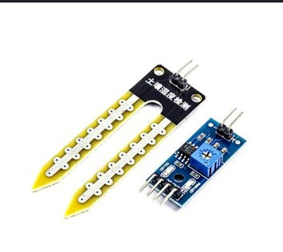

## 2)NODEMCU (ESP8266)

The ESP8266, popularized by the ESP-01 module in 2014, is a low-cost Wi-Fi chip used in IoT projects. It allows microcontrollers to connect to Wi-Fi networks with minimal external components. The ESP8285 is a similar chip with 1 MiB flash memory. ESP8266 is often used with NodeMCU, a development board that simplifies Wi-Fi connectivity and IoT application development. NodeMCU features an open-source firmware based on Lua, a lightweight scripting language, making it easy for beginners. The board includes USB support, a Wi-Fi antenna, reset button, and GPIO pins, making it accessible for prototyping and experimentation in IoT projects.

The ESP32 has since succeeded it.

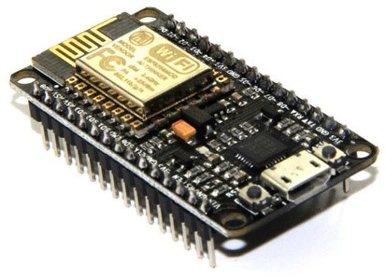

## 3) DHT11 sensor(temperature and humidity)

The **DHT11 sensor** is a low-cost digital sensor used to measure both **temperature** and **humidity**. It is widely used in environmental monitoring systems, weather stations, and home automation projects due to its ease of use and affordability. The sensor provides readings via a

single digital signal, making it suitable for integration with microcontrollers like Arduino and ESP8266

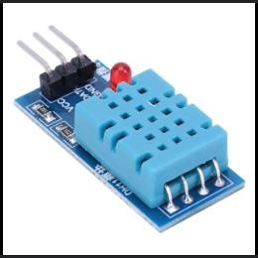

**4)CONNECTIONS:**

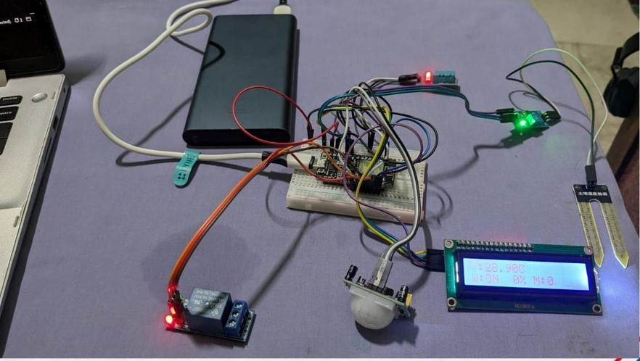

**5)RELAY MODULE:**

**A relay module is an electrical switch that allows a low-power circuit (such as from a microcontroller like Arduino, ESP8266, or ESP32) to control a high-power circuit (such as a water pump, light, fan, or other devices). The relay module acts as a bridge between the two circuits, enabling control of appliances that operate on higher voltages, such as 220V AC, with a small control signal from a low-voltage digital system.**

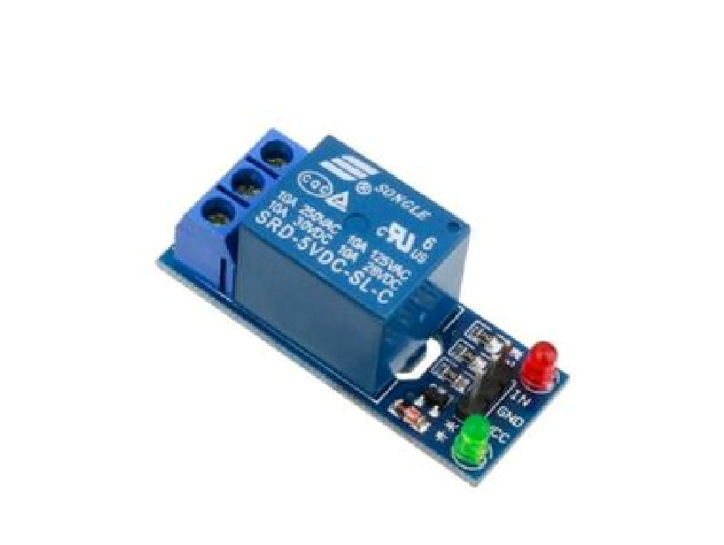

**6)IC2 DISPLAY:**

**An I2C (Inter-Integrated Circuit) display, commonly referred to as an I2C LCD display ,is a type of LCD screen that uses the I2C communication protocol to interface with microcontrollers like Arduino, ESP8266, or Raspberry Pi. It is widely used in electronics projects because of its simplicity ease of wiring, and low pin usage compared to traditional LCDs.**

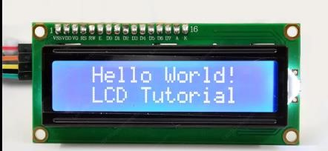

1. **BLYNK APP**

Blynk is an IoT platform with iOS and Android apps that allows users to control devices like Arduino over the internet. It provides a digital dashboard where users can build interfaces by dragging and dropping widgets. Blynk Bridge enables communication between two ESP8266 modules. The platform consists of three main components: the Blynk App, which creates project interfaces; the Blynk Server, handling communication between devices and data modules through the cloud; and Blynk Libraries, which support various hardware platforms, enabling communication with the server.

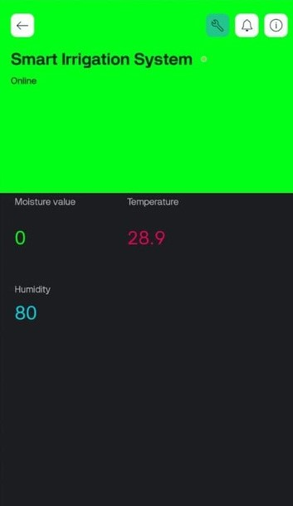

1. **THING SPEAK**

ThingSpeak is an IoT analytics platform that allows users to collect, store, and analyze data from IoT devices over the internet. It is commonly used with devices like Arduino and ESP8266 for remote monitoring and control. ThingSpeak provides real-time data collection and visualization, and supports data processing through MATLAB analytics.

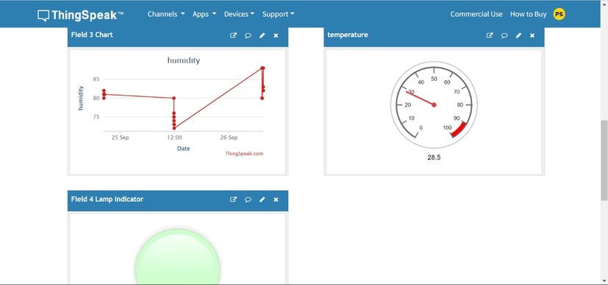

## V. Conclusions

In conclusion, the proposed research methodology provides a comprehensive approach to developing an AI-driven irrigation system that automatically regulates water release based on soil moisture levels. The system integrates advanced sensor networks, AI predictions, and IoT platforms to deliver a solution that conserves water while enhancing crop productivity. The field testing and performance evaluation offer valuable insights into the system's effectiveness, with promising results in terms of water efficiency and crop health. Future research may focus on refining the AI model, incorporating more sophisticated algorithms, or expanding the system's capabilities to other environmental factors. Additionally, further work could explore the use of renewable energy sources to power the system, enhancing its sustainability.

### VI. Declarations

**6.1Study Limitations** The proposed AI-driven irrigation system faces limitations including reliance on accurate sensor data, challenges in generalizing across regions, and high initial setup and maintenance costs. Unreliable internet connectivity and energy requirements also pose operational issues, particularly in remote areas. Additionally, the system may need adjustments for varying crop types, soil conditions, and regulatory constraints. Addressing these challenges is crucial for the system's widespread adoption and long-term success.

**6.2 Acknowledgements**

We would like to thank the faculty of [Computer Science and Engineering] for their guidance and support throughout this mini project. Special thanks to the [Railway Operator] for providing insights into current industry practices and allowing us to conduct initial trials.

6.3 **Funding source** None.

6.4 **Competing Interests**

The authors declare no competing interests related to this publication.

7.**Human and Animal Related Study**

Not applicable. This study did not involve human or animal subjects.

7.1 **Ethical Approval**

Not applicable, as no human or animal subjects were involved in this research.

7.2 **Informed Consent**

Not applicable, as no human subjects were involved in this research.

## VII.References

[1] S. Parthasarathy, T. Arun, S. Hariharan, and D. Lakshmanan, “Smart irrigation system,” Int. J. Innov.

Technol Explor . Eng., 2019, doi: 10.2139/ssrn.3462943.

[2]Sharma, R., Verma, K., & Gupta, P. “IoT and AI-Based Automated Irrigation System for Precision Agriculture” International Conference on Smart Computing,2019.

[3]Singh, A., & Kumar, R.AI-Enabled IoT Smart Irrigation System for Optimal Crop Management Journal of Agricultural Informatics.

[4]Patel, N., & Jain, A, An Intelligent IoT System for Smart Agriculture Using AI Techniques ,IEEE Internet of

Things Journal,2021