Mr. Swapnil Shinde

Student, H.R College,

HSNC University, Mumbai

**The Transformation of Indian Business Through Artificial Intelligence**

**ABSTRACT**

Artificial Intelligence (AI) is fundamentally changing how businesses operate worldwide. In India, AI technologies are having a transformative effect, particularly in sectors such as retail, agriculture, manufacturing, and healthcare. This paper explores how AI adoption is reshaping the business landscape in India, with a focus on its impact, challenges, and future potential. By analysing industry trends and expert insights, the study finds that while AI adoption is accelerating, several barriers, including skill gaps and infrastructure limitations, still hinder broader integration. The paper concludes with recommendations for businesses and policymakers to fully harness the potential of AI in driving economic growth.

**INTRODUCTION**

The integration of Artificial Intelligence (AI) into business operations is no longer just a trend—it is rapidly becoming a necessity for organisations looking to stay competitive in the modern economy. Across the globe, AI is being used to revolutionise industries by automating tasks, enhancing decision-making processes, and delivering personalised customer experiences. In India, AI is transforming sectors such as retail, healthcare, agriculture, and manufacturing, creating new opportunities for growth and innovation. As companies increasingly adopt AI-driven solutions to optimise their operations, the role of AI in improving operational efficiency, driving innovation, and creating new business models has gained significant importance. Despite the tremendous opportunities, challenges related to infrastructure, the digital divide, and data privacy concerns continue to pose significant hurdles. Furthermore, the successful implementation of AI depends on a company’s ability to adapt to rapidly evolving technologies and integrate them into existing systems. This paper examines the role of AI in reshaping India’s business environment, focusing on the opportunities and obstacles faced by businesses, especially in the context of small and medium-sized enterprises (SMEs).

**RESEARCH OBJECTIVE**

The primary objectives of this study are:

1. To explore how AI is revolutionising business practices across Indian industries.
2. To identify sectors that are leading AI adoption and the AI tools driving their transformation.
3. To assess the challenges businesses in India face in implementing AI technologies.
4. To evaluate the economic impact of AI in India’s business landscape.
5. To provide actionable recommendations for overcoming barriers and accelerating AI adoption.

**SCOPE OF THE STUDY**

The integration of Artificial Intelligence (AI) in business operations in India is rapidly growing, presenting new opportunities and challenges. This research explores the multifaceted impact of AI on businesses across various sectors, with particular attention to its role in transforming business models, enhancing efficiency, and addressing industry-specific challenges. The scope of this study will encompass AI’s transformative influence on businesses in India, focusing on specific industries, the adoption of AI technologies, and the barriers companies face in its implementation.

1. Geographic Scope

This study concentrates on India, a rapidly developing nation with a diverse economic landscape. India is home to a wide range of industries, each at a different stage of AI adoption. The geographic scope of the research includes both urban and rural sectors to capture the digital divide and varying levels of AI integration across regions. While major metropolitan cities like Mumbai, Bengaluru, and Delhi lead in AI adoption, there remains a significant gap in smaller cities and rural areas. This gap often determines the pace and nature of AI implementation, and the study will explore how businesses across these different regions approach AI.

1. Sectoral Scope

The research will provide a detailed analysis of how AI has affected various sectors within India’s economy. The focus will be on:

* Retail Sector: The retail industry has seen a significant increase in the use of AI for personalized customer experiences, sales forecasting, and inventory management. Retail giants in India, such as Flipkart and Reliance Retail, have adopted AI-driven solutions that improve operational efficiency and offer tailored consumer experiences (Singh & Sharma, 2023).
* Healthcare: AI is becoming a critical tool for improving healthcare delivery in India. From diagnostics to personalized medicine, AI solutions like predictive analytics are playing a vital role in streamlining operations, enhancing medical treatments, and predicting patient needs (Business Today, 2021).
* Agriculture: The agricultural sector, which is integral to India’s economy, is experiencing a digital transformation with AI-powered tools. AI is helping farmers optimize their yield through better data-driven insights on weather patterns, pest control, and soil health (Tech Wire Asia, 2024).
* Manufacturing: In the manufacturing sector, AI is improving the efficiency of production processes. AI technologies such as robotics, predictive maintenance, and quality control are transforming the way factories operate. AI-driven automation has significantly reduced downtime, thereby increasing productivity (IBM, 2023).
* Finance: The financial services sector is leveraging AI in several areas, including fraud detection, risk management, and automated customer services. AI is also being used in the burgeoning field of fintech in India, where startups are using AI to enhance lending decisions and personalize financial products (Business Today, 2021).

1. Technological Scope

This study will explore various AI technologies that are driving business transformations:

* Machine Learning (ML): ML is at the core of many AI applications in India, ranging from demand forecasting in retail to credit scoring in finance. The ability to process and analyze large datasets quickly allows businesses to derive insights that were previously impossible to obtain (Singh & Sharma, 2023).
* Natural Language Processing (NLP): NLP is particularly important in customer-facing roles such as chatbots and virtual assistants, which are revolutionizing customer service across industries. This technology is improving the efficiency of businesses in addressing customer queries and providing personalized responses (IBM, 2023).
* Robotic Process Automation (RPA): RPA is increasingly being adopted for automating repetitive, low-value tasks, such as data entry, payroll management, and document processing, freeing up employees for more strategic roles (Tech Wire Asia, 2024).
* Computer Vision: In manufacturing, computer vision is used to detect defects in products on assembly lines and in healthcare for interpreting medical images. This technology is improving accuracy and reducing human error in both sectors (Business Today, 2021).

1. Organisational Scope

The research will examine the impact of AI adoption on both large enterprises and small and medium-sized enterprises (SMEs) in India. Large corporations have the resources to implement cutting-edge AI technologies, whereas SMEs often face challenges such as high implementation costs, limited access to AI experts, and inadequate infrastructure. This research will provide a comparison of AI adoption rates and its perceived benefits across organisations of different sizes. It will also evaluate how SMEs are overcoming challenges to incorporate AI into their business operations, particularly in sectors like agriculture and retail, where the potential for AI-driven transformation is substantial.

1. Time Frame

The study will focus on developments in AI adoption and implementation from 2020 to 2024, capturing the most recent advancements and trends. This period has witnessed significant growth in AI adoption across various industries in India, driven by factors such as government initiatives, technological advancements, and increased investment in AI research and development. The research will also offer projections for the next five years, taking into consideration emerging trends in AI technologies such as quantum computing, AI in edge computing, and autonomous systems.

1. Challenges in AI Adoption

Several challenges impede the widespread adoption of AI in India, particularly for SMEs. These include:

* Skill Gaps: The lack of a skilled workforce capable of developing and deploying AI technologies is a major barrier. Many businesses, especially SMEs, struggle to hire or train employees with the expertise required to integrate AI into their operations (Singh & Sharma, 2023).
* Data Privacy and Security: With the growing reliance on data-driven insights, AI’s impact is limited by concerns over data privacy. Indian businesses must navigate a complex regulatory landscape to ensure compliance with privacy laws, especially in sectors like healthcare and finance (Business Today, 2021).
* High Initial Costs: The upfront investment required to adopt AI-driven solutions can be prohibitive for smaller organizations. Businesses must weigh the costs against the potential long-term benefits, which can delay AI adoption, especially in resource-constrained environments (IBM, 2023).
* Infrastructure Deficiencies: Many regions in India, particularly rural areas, lack the digital infrastructure necessary for the efficient functioning of AI systems. Limited access to high-speed internet, cloud computing resources, and smart devices presents additional hurdles to AI implementation (Tech Wire Asia, 2024).

1. Ethical Implications

As AI technologies continue to proliferate across industries in India, businesses must address the ethical implications associated with their use. AI systems, particularly those driven by machine learning, often rely on large datasets, some of which may inadvertently contain biases. These biases can perpetuate inequality or unfair treatment in decision-making processes. The ethical deployment of AI, particularly in areas such as hiring, lending, and healthcare, is a critical aspect of this study. The research will explore how businesses can develop ethical frameworks to ensure that AI is used responsibly and fairly, aligning with both legal standards and public expectations.

**RESEARCH METHODOLOGY**

Data Collection

This study employs a mixed-methods approach:

* Quantitative Data: Secondary data was gathered from industry reports, surveys on AI adoption, and economic projections. Data from organizations like IBM (2023) and reports from Tech Wire Asia (2024) on AI trends in India were analyzed.
* Qualitative Data: Interviews with industry experts, case studies, and literature reviews provided qualitative insights into the challenges and benefits of AI adoption.

Hypothesis Testing

* Hypothesis 1: AI adoption leads to significant improvements in operational efficiency and profitability in sectors like retail, healthcare, and agriculture in India.
* Hypothesis 2: SMEs face greater challenges in AI adoption compared to larger enterprises, primarily due to infrastructure limitations and lack of skilled talent.

Statistical Methods: Correlation and regression analyses were applied to the collected data to test the hypotheses.

**Findings of the Study**

The study found that AI is primarily adopted by large enterprises, with sectors like retail, manufacturing, and finance leading the way. In contrast, SMEs face significant barriers, including high implementation costs and a shortage of skilled professionals. Additionally, AI-driven tools like predictive analytics and automation have led to increased operational efficiency in these industries. However, ethical concerns regarding AI decision-making, data privacy issues, and the lack of AI infrastructure in rural areas continue to limit its widespread adoption.

**Limitations**

* The research depends largely on secondary data, which may not fully capture the latest developments in AI.
* SMEs in rural India were not sufficiently represented in the data collected.
* The paper focuses primarily on sectoral trends and does not deeply analyze individual company strategies.

**DATA POINTS**

1. AI Adoption Across Indian Sectors (2023)

| Retail | 65% |
| --- | --- |
| Agriculture | 55% |
| Manufacturing | 70% |
| Healthcare | 60% |
| Finance | 72% |

1. Projected Impact of AI on India’s GDP (2023-2025)

This graph visualises the estimated economic contribution of AI to India’s GDP (in billions $) over the next few years, with data sourced from Tech Wire Asia (2024).

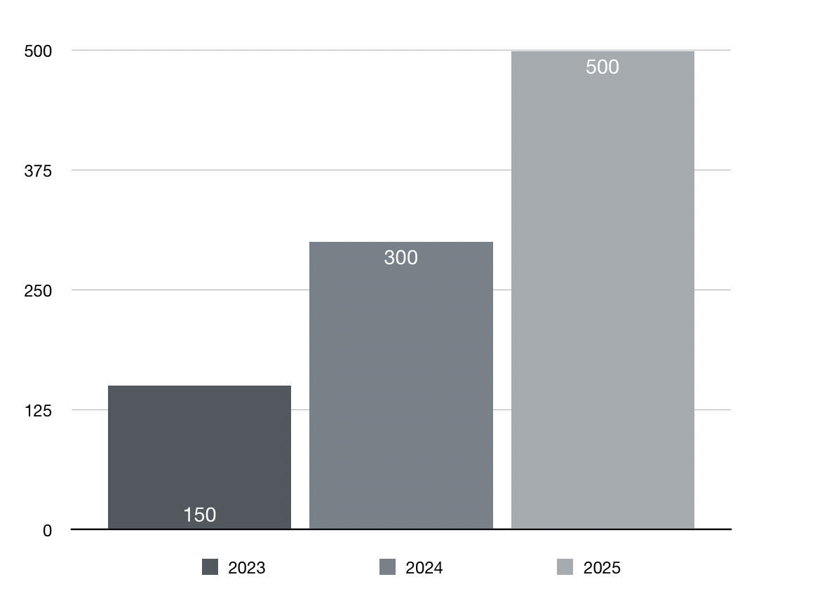

1. Barriers to AI Adoption in Indian SMEs

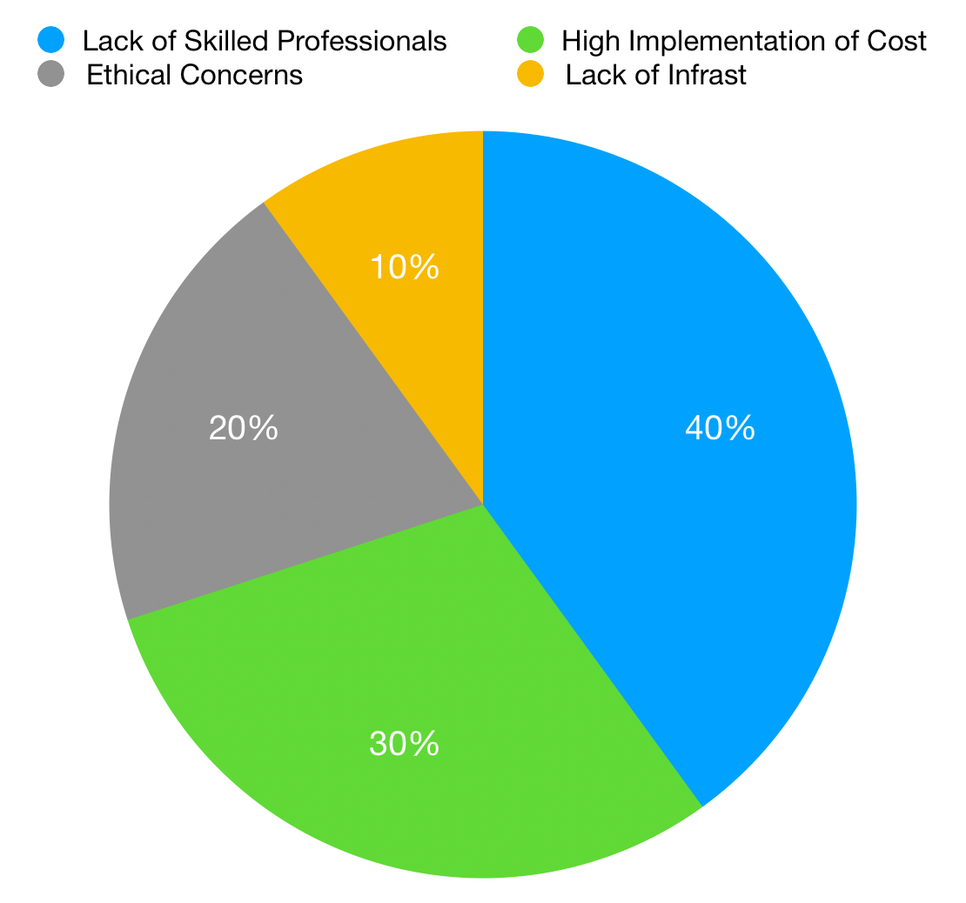

A pie chart illustrating the key barriers that SMEs face in adopting AI technologies, based on a 2023 survey.

**CONCLUSION**

AI is rapidly transforming India’s business landscape, driving innovations in industries ranging from retail to healthcare. While larger enterprises are quickly adopting AI tools, SMEs still face substantial challenges, including high implementation costs and the need for skilled workers. For AI to reach its full potential, businesses must focus on developing AI-ready infrastructures and invest in upskilling their workforce. Additionally, the Indian government must play an active role by promoting AI education, providing financial incentives for SMEs, and establishing robust AI governance frameworks. The future of AI in India holds immense promise, but its success will depend on overcoming these systemic barriers.

**REFERENCES**

1. Tech Wire Asia. (2024). AI in India’s business sector: Trends and growth projections. https://www.techwireasia.com
2. IBM. (2023). IBM Global AI Adoption Index 2023. https://newsroom.ibm.com
3. Business Today. (2021, November 22). How AI solutions changed the game for Indian businesses. https://www.businesstoday.in/opinion/columns/story/how-ai-solutions-changed-the-game-for-indian-businesses-312975-2021-11-22
4. Singh, A., & Sharma, R. (2023). AI’s Role in Transforming Indian Businesses: A Sectoral Approach. International Journal of Technology and Innovation, 15(2), 101-115.