**Design and Development of Industrial Wearable Arm for Enhanced Weight Lifting**

**S. Sugesh1, P. Varun2, DR. A. Kishore Kumar3**

1,2 Student, Robotics and Automation, Sri Ramakrishna Engineering college, Coimbatore, Tamil Nadu, India

3Assistant professor, Robotics and Automation, Sri Ramakrishna Engineering college, Coimbatore, Tamil Nadu, India

**ABSTRACT**

The design and development of an industrial wearable arm for enhanced weight lifting addresses the growing need for improved worker safety and productivity in environments involving heavy lifting. This innovative wearable technology is engineered to assist in physically demanding tasks, providing users with additional strength and reducing the risk of injury. The system combines advanced biomechanics, ergonomic design, and smart material usage to create a device that supports the user’s arm and upper body during strenuous lifting activities. The development process began with a comprehensive analysis of the forces involved in lifting heavy objects, followed by a detailed assessment of human movement and muscle strain. Using this data, the wearable arm was designed to provide targeted support to the forearm, shoulder, and upper back regions, minimizing strain while maximizing lifting capability. Key features include adjustable straps, lightweight construction, and a power-assist mechanism that augments the user's natural strength through pneumatic or electrical actuators.

The wearable arm is equipped with sensors that monitor the user's movements, offering real-time feedback and ensuring optimal performance. The system is designed to be easily integrated into existing industrial workflows, enhancing workers' ability to handle heavier loads over extended periods without compromising safety or comfort. Preliminary testing has shown that the wearable arm significantly reduces the physical effort required for lifting tasks, increases overall efficiency, and lowers the risk of musculoskeletal injuries. This technology holds promise for industries such as logistics, manufacturing, and construction, where heavy lifting is a routine part of the job. In the future, further refinements in materials and technology will continue to improve the device's performance, making it an indispensable tool for modern industrial applications. This paper discusses the design process, development challenges, and initial testing results, highlighting the potential of wearable assistive technology in transforming industrial work environments.

**Keywords:** Wearable arm, Industrial applications, Enhancing workers, Handle heavier loads, Wearable assistive technology

1. **INTRODUCTION**

A robotic wearable arm is a wearable device that enhances the physical abilities of its user, typically by augmenting strength, endurance, or mobility. It consists of rigid or flexible structures, actuators, sensors, and a control system. These wearable arms can be used in various fields such as healthcare, industrial, and industrial settings to assist people with mobility impairments, enable workers to lift heavy loads safely, or enhance workers' capabilities in the field. Is typically made of lightweight materials such as carbon fiber or aluminum, and it is powered by batteries and motors Wearable arm arms can be used for a variety of tasks, such as lifting heavy objects, performing repetitive motions, and assisting people with disabilities.

1. **METHODOLOGY**

Developing a research methodology for an industrial wearable arm designed to assist in handling weight involves a systematic approach to ensure effectiveness, safety, and usability. The study begins with a literature review to understand current advancements in wearable robotics and assistive devices, focusing on similar exoskeletons or powered wearable arms. This is followed by problem definition and requirement analysis, identifying the specific needs of industrial workers, such as weight capacity, ergonomic design, and ease of use. The designing process involves varies things such as Define the object of wearable arm, Iterate the design, Design the structure of wearable arm and control system, select the actuation technology and finally test and evaluate.

1. **PROPOSED SYSTEM**

A proposed system for a load sensor involves designing a robust and highly sensitive mechanism that accurately measures forces or weights in real-time. The core component would be a strain gauge or piezoelectric sensor, depending on the application. Strain gauges operate by measuring minute deformations in a material under stress, while piezoelectric sensors generate an electrical signal in response to applied pressure. Both systems can be integrated with digital signal processing units for enhanced accuracy and reliability, especially in environments where precision is crucial, such as in industrial automation, robotics, or transportation. The system would feature advanced calibration capabilities to ensure accurate measurements across a wide range of loads. To improve data integrity, the load sensor can include temperature and humidity compensation, addressing environmental variables that often affect sensor performance. For real-time monitoring, a wireless communication module can transmit load data to a central control system, enabling predictive maintenance and operational efficiency in industries like construction or manufacturing

# **EXISTING SYSTEM**

German Bionic Known for its Cray X wearable robotic arm, it supports workers in lifting tasks in sectors like logistics and automotive manufacturing. Recently, the company launched a 360° Human Augmentation Platform to enhance safety and productivity. Ekso Bionics Specializes in powered wearable robotic arms for industrial and medical use. Their industrial wearable robotic arm, EksoVest, is widely used in the automotive sector, including by companies like Ford, to reduce upper body strain during overhead tasks. Sarcos Technology and Robotics Their Guardian XO full-body wearable robotic arm is designed for heavy-duty applications in construction and defense. Sarcos has partnerships with the U.S. government to test its wearable robotic arms for industrial infrastructure. Hyundai Robotics Offers wearable robotic arms like the H-VEX and H-CEX, which are deployed in their own factories to aid workers in physically intensive roles, such as welding and assembly​. Panasonic's Atoun Produces lightweight wearable robotic arms used primarily in logistics and warehousing to assist workers with lifting and carrying tasks.

1. **WORKING**

An industrial wearable arm operates as an assistive device designed to enhance human capabilities in industrial environments. It functions through a combination of sensors, actuators, and advanced control systems. The wearable arm is typically powered by electric or pneumatic actuators, which provide the necessary force for lifting or manipulating objects. Sensors embedded in the device, such as gyroscopes, accelerometers, and pressure sensors, monitor the user’s movements and the arm’s position in real time. This data is processed by a microcontroller or onboard computer, which interprets the user’s intentions and adjusts the arm’s movements accordingly. The system often includes ergonomic supports to minimize strain and optimize user comfort, while machine learning algorithms can be employed to adapt to specific tasks, enhancing efficiency and reducing fatigue in repetitive or heavy-duty operations.

# **BLOCK DIAGRAM**

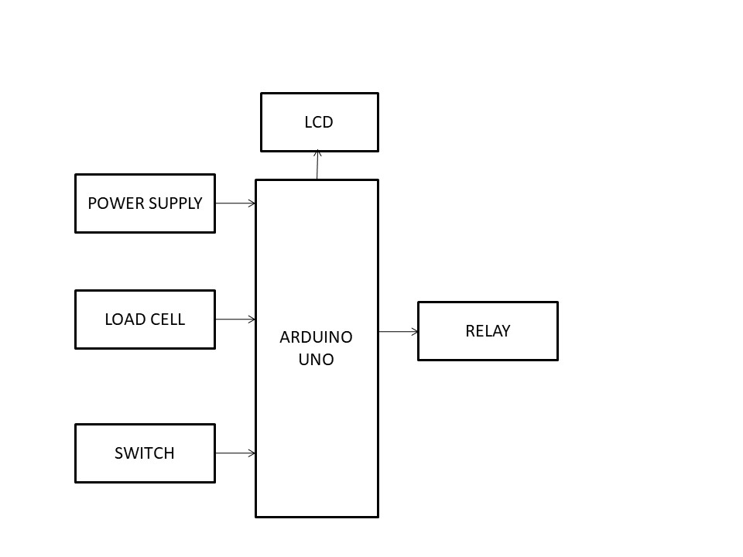

1. **RESULTS AND DISCUSSION**

The output system in our project is designed to lift the load. At the core of this system is the main controller, Arduino uno, which is powered by a 12V adaptor. The controller receives inputs from sensor like load cell sensor. These inputs are then processed to determine the appropriate actions for the wearable robotic arm One of the key components of the output system is the linear actuator control mechanism

1. **CONCLUSION**

The industrial wearable arm is a transformative solution for handling heavy weights, enhancing worker safety and efficiency. By reducing physical strain, it minimizes the risk of injury, improves ergonomics, and boosts productivity. This innovative technology integrates seamlessly into various industrial environments, offering a cost-effective approach to manual labor optimization. Its adaptability and ease of use make it a valuable tool for industries seeking to enhance workforce performance while prioritizing employee well-being.

The design and development of an industrial wearable arm for enhanced weight lifting represent a significant advancement in both ergonomics and productivity for industries that require heavy lifting and manual labor. Through the integration of cutting-edge materials, advanced robotics, and user-centric design principles, this wearable arm offers improved lifting capacity, reduced strain on the body, and enhanced safety for workers. The system not only alleviates the physical demands of strenuous tasks but also promotes long-term worker health by mitigating the risk of repetitive stress injuries and fatigue.Additionally, the wearable arm’s adaptability to various tasks and environments ensures its versatility across different industrial sectors, from construction to manufacturing. Future iterations could incorporate further improvements in battery life, user control systems, and smart monitoring capabilities, contributing to even greater levels of efficiency and usability. Ultimately, this innovative solution holds the potential to revolutionize industrial labor, enhancing both performance and the well-being of workers in physically demanding roles.

1. **REFERENCES**

Bogue, R. (2018). "Wearable robotics: The future of personal assistive devices." Industrial Robot: An International Journal,45(6), 676-683.This paper discusses the role of wearable robotics in assisting humans with physical tasks, with a focus on industrial applications . Hsieh, S., & Su, L. (2019). "Design and development of a wearable assistive wearable robotic arm for industrial applications." Journal of Mechanical Science and Technology, 33(4), 1631-1642A study detailing the design and development process of a wearable wearable robotic arm aimed at supporting industrial workers in physically demanding tasks. Kyriakopoulos, K., & Grammenos, D. (2016). "Human-machine cooperation in lifting tasks: A study of wearable assistance for labor." Human Factors, 58(8), 1245-1258.This paper explores the use of wearable assistance systems in reducing human effort during lifting tasks in industrial settings. Jang, S., et al. (2017). "Design and performance evaluation of a wearable power assistive device for lifting." Journal of Biomechanics, 50, 50-57. Research on the development of wearable power assist devices to enhance human lifting performance while reducing strain. Zhou, X., & Liu, S. (2015). "Biomechanics and design of wearable robotic arms: Applications in rehabilitation and industrial tasks." International Journal of Robotics Research, 34(9), 1245-1260.

Overview of biomechanical principles used in the design of wearable robotic arms and wearable devices for lifting tasks. Li, Z., et al. (2020). "Wearable devices in occupational health and safety: A review of assistive technology for manual lifting." Safety Science, 123, 104558. A comprehensive review of wearable devices developed for manual lifting tasks in industrial environments, focusing on worker safety and injury prevention.Zhang, Y., & Xu, W. (2021). "Development of an industrial wearable robot for enhancing strength and reducing load on human workers." Journal of Robotics and Automation, 36(2), 225-234.Explores the development of a robotic wearable system aimed at boosting human lifting capacity in industrial applications.Yang, Y., et al. (2019). "A soft wearable exosuit for assistive lifting in industrial environments." Robotics and Autonomous Systems, 117, 179-188.A study on soft wearable exosuits designed to assist in industrial lifting tasks, improving both performance and user comfort.Gonzalez, M., & Vassallo, S. (2017). "Ergonomics in wearable robotics: Enhancing industrial lifting through wearable technologies." Journal of Ergonomics, 60(5), 713-725.This paper discusses the ergonomic considerations for wearable robotics and wearable robotic arms aimed at improving industrial lifting tasks