### A PROJECT REPORT ON

**“A STUDY ON ADAPTATION & GROWTH OF DIFFERENT VIRTUAL COMMUNICATIVE PLATFORMS AMONGST THE INIDAN HIGHER EDUCATION STUDENTS DURING COVID-19”**

### SUBMITTED BY:

**SIDDHI RAJESH GANDHI**

### SYMCOM (SEMESTER III)

**ROLL NO – 016**

### ACADEMIC YEAR 2024-2025

**UNDER THE GUIDANCE OF DR. JAYA MA’AM**

### DATE OF SUBMISSION 20th FEBRUARY 2023

**H.R. College of Commerce and Economics**

**College in Mumbai, India**

### A PROJECT REPORT ON

**“A STUDY ON ADAPTATION & GROWTH OF DIFFERENT VIRTUAL COMMUNICATIVE PLATFORMS AMONGST THE INIDAN HIGHER EDUCATION STUDENTS DURING COVID-19”**

### SUBMITTED BY:

**SIDDHI RAJESH GANDHI**

### SYMCOM (SEMESTER III)

**ROLL NO – 016**

### ACADEMIC YEAR 2023-2024

**UNDER THE GUIDANCE OF DR. JAYA MA’AM**

### DATE OF SUBMISSION 20th FEBRUARY 2023

**H.R. College of Commerce and Economics**

**College in Mumbai, India**

**H.R. College of Commerce and Economics**

**College in Mumbai, India**

**NAAC RE-ACCREDITED GRADE A (CGPA: 3.42)**

# Certificate

This is to certify that **Ms. SIDDHI RAJESH GANDHI** has worked and duly completed her/his Project Work for the degree of Masters in Commerce (Banking & Finance) under the Faculty of Commerce and his project is entitled, **“A STUDY ON ADAPTATION & GROWTH OF DIFFERENT VIRTUAL COMMUNICATIVE PLATFORMS AMONGST THE INIDAN HIGHER**

**EDUCATION STUDENTS DURING COVID-19”** under my supervision.

I further certify that the entire work has been done by the learner under my guidance and that no part of it has been submitted previously for any Degree/Diploma of any University.

It is her own work and facts reported by her/his personal findings and investigations.

Date of submission: 20th February, 2023

# Declaration by learner

I the undersigned **Ms. SIDDHI RAJESH GANDHI** here by, declare that the work embodied in this project work titled **“A STUDY ON ADAPTATION & GROWTH OF DIFFERENT VIRTUAL COMMUNICATIVE PLATFORMS AMONGST THE INIDAN HIGHER EDUCATION**

**STUDENTS DURING COVID-19”**, forms my own contribution to the research work carried out underthe guidance of Rifa Ma’am is a result of my own research work and has not been previously submitted to any other University for any other Degree/ Diploma for any other University.

Wherever reference has been made to previous works of others, it has been clearly indicated as such and included in the bibliography.

I, here by further declare that all information of this document has been obtained and presented in accordance with academic rules and ethical conduct.

Ms. Siddhi Gandhi

# Acknowledgment

To list who all have helped me is difficult because they are so numerous and the depth is so enormous.

I would like to acknowledge the following as being idealistic channels and fresh dimensions in the completion of this project.

I take this opportunity to thank the **H. R. College** for giving me a chance to do this project.

I would like to thank my **College Library**, for having provided various reference books and magazines related to my project.

Lastly, I would like to thank each and every person who directly or indirectly helped me in the completion of the project especially **my Parents and Peers,** supported me throughout project.

## TABLE OF CONTENTS

|  |  |  |
| --- | --- | --- |
| **Sr. No.** | **Contents** | **Page No.** |
|  | Abstract | 1 |
| 1 | CHAPTER 1: Introduction | 2-19 |
| 1.1 | Indian Higher Education | 2-5 |
| 1.2 | Virtual Communicative Platforms | 6-7 |
| 1.3 | Covid 19 in India | 8-10 |
| 2 | CHAPTER 2: Literature Review | 11-19 |
| 3 | CHAPTER 3: Research Design | 21-25 |
| 3.1 | Research Objectives | 21 |
| 3.2 | Hypothesis | 22 |
| 3.3 | Scope of the Study | 22 |
| 3.4 | Operational Definitions | 23 |
| 3.5 | Research Methodology | 23 |
| 3.6 | Data Collection | 24 |
| 3.7 | Limitations | 25 |
| 3.8 | Variables | 25 |
| 4 | CHAPTER 4: Data Collection | 26-51 |
| 4.1 | Annexure 1 - Introduction, questions & analysis | 26-39 |
| 4.2 | Annexure 2 - Introduction, questions & analysis | 40 - 44 |
| 4.3 | Revenue Models | 45 |
| 4.4 | Indian Higher Education & Covid-19 | 46-48 |
| 4.5 | Virtual Communicative Platforms & Covid-19 | 49-51 |

|  |  |  |
| --- | --- | --- |
| **Sr. No.** | **Contents** | **Page No.** |
| 5 | CHAPTER 5: Summary of Findings | 52-53 |
| 6 | CHAPTER 6: Conclusion & Suggestions | 54-58 |
| 7 | Annexure 1 & 2 | 59-60 |
| 8 | References | 61-62 |

**TABLE OF GRAPHS**

|  |  |  |
| --- | --- | --- |
| **Sr. No.** | **Contents** | **Page No.** |
| 4.1.1 | Effectiveness | 29 |
| 4.1.2 | Dissemination | 29 |
| 4.1.3 | Time Saving | 30 |
| 4.1.4 | Interactive Ness | 31 |
| 4.1.5 | Doubt clarification | 32 |
| 4.1.6 | Lack of Computer Skills | 33 |
| 4.1.7 | Online Class Participation | 34 |
| 4.1.8 | Distraction | 35 |
| 4.1.9 | Lazy or disinterested | 36 |
| 4.1.10 | Demotivation | 37 |
| 4.1.11 | Internet Connectivity | 38 |
| 4.1.12 | Concentration | 39 |
| 4.2.1 | Preference in terms of Platforms | 42 |
| 4.2.2 | Cost effectiveness | 43 |
| 4.2.3 | Convenience | 44 |

## ABSTRACT

***Purpose:*** This paper sought to measure the impact of Covid 19 in transforming and digitalizing Indian Higher Education. This paper also examines the growth of Virtual Communicative Platforms during lockdown and focuses on three major players in these sectors- Zoom, Google Meet, and Microsoft Teams/

***Methodology/Approach:*** In order to analyse the rate at which virtual platforms were used by universities, data were obtained through secondary sources and Questionnaires. This study finds that lockdown has truly transformed the Indian Education sector by unleashing numerous platforms to conduct online learning. This also portrays the potential and scope available in Indian Higher Education and the pockets of excellence to lead this to the next level.

In this paper we will analyse the success and failures of virtual platforms through their financial reports and user data along with the impact of lockdown on Indian Higher Education through use of secondary data and collected samples for the study.

***Keywords:*** Covid-19, Indian Higher Educations, Virtual Learning, Teaching-Learning, Virtual Communicative Platforms, Zoom, Cisco Webex, Google Meet.

***Paper type:*** Research Paper

## CHAPTER 1: INTRODUCTION

* 1. **Indian Higher Education**

The education system of India falls broadly under the [Ministry of Human Resource](https://en.wikipedia.org/wiki/Ministry_of_Human_Resource_Development) [Development](https://en.wikipedia.org/wiki/Ministry_of_Human_Resource_Development)(MHRD). Amongst the branches of the MHRD, the Department of Higher Education is responsible for overseeing the growth of the higher education sector. India’s education system is the 3rd largest system in the world after China and the USA. There are three levels of schooling namely Pre- Primary, Primary and Secondary schools. The higher education is of 3 kinds namely Vocational, Tertiary and Technical. The structure of higher education in India follows three main levels. These levels are bachelor/undergraduate level, master/postgraduate level, and doctoral/pre-doctoral level.

#### Pre-Independence

India is classified by many as a source of rich legacies of culture and literary pursuits. The history of Indian education is nearly 5000 years old. Earlier, India had a Gurukul system where students and teachers would live together in a distant place and the students would be taught subjects such as arts, philosophy, archery, self-defense techniques etc. Traditionally only high caste Brahmin boys were allowed to gain education. Moving towards the colonial era, education in India has taken wild turns. The East India Company brought with itself various missionaries to spread the religion of Christianity among the Indians through English medium schools. Lord Macaulay played an important role in solving this particular problem by introducing bilingualism in the Indian education system.

#### Post-Independence

The first milestone in the development of education in independent India was the enactment of the Indian Constitution in 1950 which laid down broad educational policies for the country. During this time Indians were subject to disparities between men and women, upper and lower caste, etc. The main pillar of the Indian education policy was free and compulsory education for all children up to the age of 14. Better said than done, it was exceedingly difficult to ensure that all those children up to 14 years had access to education. Many of rural population still indulges in child labor which was of course ridiculously cheap and more than 50% of them are concentrated in 5 states namely Madhya Pradesh, Uttar Pradesh, Bihar, Maharashtra, and Rajasthan. As per Census2011, the total child population in India in the age group (5-14) years is 259.6 million Due to the situation presented above not every child got the basic education which was generally his/her fundamental right.

The advanced education framework in India incorporates both private and state funded colleges. State funded colleges are upheld by the Government of India and the state governments, while private colleges are generally upheld by different bodies and social orders. Colleges in India are perceived by the University Grants Commission (UGC), which draws its force from the University Grants Commission Act, 1956. There are 993 universities including central, state, deemed and private ones.

The growth of higher education from post-independence till 2011 (by UGC) has been shown below:

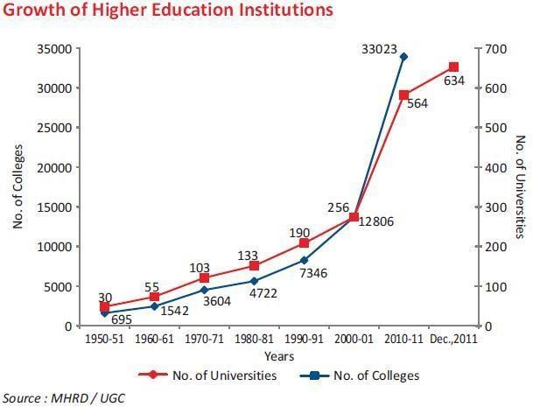

The education system has reformed is majorly due to the National Education Policy 2020. It emphasized a lot on experiential learning, vocational learning, blended mode of learning in classes. The National Education Policy 2020 (NEP 2020), which was affirmed by the Union Cabinet of India on 29 July 2020, diagrams the vision of India's new schooling system. The new strategy replaces the past National Policy on Education, 1986. The arrangement is a completely new structure for education. The arrangement expects to change India's schooling framework by 2021.

How has the NEP transformed higher education? For the first time in history, universities can provide multiple exit options to students throughout their study year(3-4yr).

A certificate after completing 1 year of study. A diploma after completing 2 years of study.

A Bachelor's degree after completion of a 3-year program. A 4-year multidisciplinary bachelor’s degree.

A Higher Education Council of India (HECI) will be set up to regulate higher education.

Other than these fundamental changes, the policy proposes to internationalize education in India. Foreign universities can now set up campuses in India. The fees of both private and public universities will be fixed.

## Virtual Communicative Platforms

Virtual Communicative means a platform where people interact with each other without being physically present in the same room. It has been adopted by several organizations, governmental agencies, enterprises, and universities to conduct virtual meetings and share information in real time. It is a very cost saving means to conduct meetings as it helps in saving transport costs. These companies give a platform to conduct virtual meetings, webinars, conferences, and online classes. Some of the benefits of this are- it allows its participants to extract information by recording the meeting and also it connects and allows people all over the internet to share information on any given topic.

The global online meeting software is growing at a significant rate. For this study we choose three biggest competitors in these markets present in India- Google Meet, Zoom, and Microsoft Teams.

### Google Meet



It is a video-communication service platform developed by google. It is a combined and a better version of Google’s previous two apps Google Hangouts and Google Chats. It was offered as a secure alternative compared to its competitors. It can host gatherings up to 250 participants. It is compatible with both IOS and Android devices. It offers three different plans: G suite Basic ($6 per month), G suite business ($12 per month), and G suite enterprise ($25 per month). Currently Google Meet is registering over 3mn users every day and holding meetings for over 100mn participants.

### Microsoft Teams



Microsoft CEO Satya Nadella announced the public preview of Microsoft Teams, a chat- based work space in Office 365 & is a popular unified communication and collaboration platform in Office 365. This introduction to MS Teams training course prepares end-users for immediate and long-term success with MS Teams. Attendees learn how to use teams and channels, persistent workplace chat, file storage, online conference meetings, and application integration including third-party apps.

### Zoom



It is telephony software developed by Zoom Video Communications. Unlike its competitors, Zoom has a restriction on its free plan. Up to 100 participants can communicate with a 40- minute time restriction. It became the 5th most downloaded mobile app in the world with over 477mn downloads in 2020. It was once criticized for its security and privacy policy. For this it was banned in several organizations and countries including Indian Ministry of Home Affairs, Australian Defense Force, Google, and SpaceX. But many of them lifted it after it revised its security policy. This also resulted in an increase of 355% in the company's revenue to USD 663.5mn by September2020.

## Covid 19 in India

Coronavirus disease 2019 is a very contagious disease. It is caused by severe acute respiratory syndrome coronavirus 2. The disease has spread worldwide which resulted in a current pandemic. The first case worldwide was detected in Wuhan, China, in December 2019. In India, it was first detected in Thrissur, Kerala in January 2020. India which has the second highest covid cases after the US has recorded over 154,000 deaths by February 2021. Total number of cases has crossed the mark of 1 crore and when the Novel Coronavirus was at its peak i.e., mid-September, India recorded over 90,000 cases per day.

When the outbreak affected a dozen states and union territories it was declared as an epidemic and Epidemic Diseases Act, 1897 was invoked. It led to closure of educational and commercial establishments for the period till the situation got under control. All tourist visas were also suspended in March.

Covid-19 affected India in many ways like sharp decline in GDP witnessing largest ever contraction in Q1 i.e., -24%. It resulted in rise in unemployment, collapse of the tourism industry, reduced consumer activities, a plunge in fuel consumption, and also affected India’s trade relations with foreign countries, majorly with China.

India’s economy was severely affected due to this pandemic. As per UN report, due to the flash crash of 2nd March 2020, BSE SENSEX witnessed a trade impact of USD 348mn making India one of the 15 worst affected economies in the world. It didn’t stop there; Indian stock market witnessed its worst crash since June 2017 where the BSE SENSEX dropped by 8.18% (2919 points).

Impact on the economy has been largely disruptive. In the 4th quarter of the fiscal year 2020, India’s growth went down to 3.1% (source: Ministry of Statistics). As per the statement by the World Bank, the pandemic has "magnified pre-existing risks to India's economic outlook". As per the initial revised reports of some rating agencies, India’s growth for fiscal year 2021 would have been the lowest in the last three decades since economic liberalization in the 1990s. CRISIL on 26th May also announced that this will be India’s worst recession since independence (1947).

It is estimated that over 140 mn people lost employment and faced salary cuts during the lockdown. During the first 21-days lockdown, India was expected to lose over USD 4.5 bn every day. Over 45% of the Households across the nations reported an income drop during this outbreak. Many large companies in India like L&T, UltraTech Cement, BHEL, and Tata Motors temporarily suspended or reduced their operations. Funding of new startups was also affected.

To combat this the Government also took several measures to protect the people, businesses, and economy. Government announced several economic stimulus packages such as- on 12 May, PM announced a package of USD 280 bn almost 10% of India’s overall GDP, with promoting India asa self-reliant nation. On 12th October and 12th November as well, the Government announced twomore packages which made the overall economic stimulus to USD 420 bn i.e. over 15% of India’s GDP.

Health sector was significantly promoted, and significant investments were made to help the country to fight this virus. It is believed that India might be the only major economy that successfully implemented a herd immunity strategy. Over 30 anti-COVID vaccines are developing. Few of which have already been approved by the Government for public use. World’s largest ever Covid vaccination drive was initiated on 16th January where in just 18 days over 4.1 mn healthcare workers were vaccinated.

## CHAPTER 2: LITERATURE REVIEW

### April 2020

In a journal *“Impact of online learning during covid 19: students and teachers’ perspective”* by Deepika Nambiar found that though there is a certain level of comfort for both the teacher and student in online learning, the overall experience is not very commendable. It is frustrating for some students to concentrate in an environment apart from the traditional school environment. The results of the survey in this paper showed that 87.1% of the students reported that they preferred classroom teaching method more than online teaching mode. 12.9% preferred online classes. Alongside 22.1% of students under this study complained that online classes were difficult to understand especially when it comes to practical subjects. The frustration with the new class structure and design is translating into a poor learning outcome. They suggested that improving the quality of online classes with the help of various service providers, along with support from different colleges and universities can help in making online mode of education more effective and easily acceptable all over India. Priority shall be given to proper training to the teachers in order to fully consume the benefits of the technology driven education material.

*An article of the World Economic Forum “The COVID-19 pandemic has changed education forever”* by Cathy Li and Farah Lalani found that the effectiveness of learning online differs amongst age groups. A study (cited by the author) found that the younger children need a more well-established learning environment as they are easily distracted. BYJU’s Bangalore based educational technology and online tutoring has seen a 200% increase in the no. of new students for its product after launching free classes. For those who have stable internet connection studies have proved that online learning has increased retention capacity (+25-60%) of information, and takes less time(-60%) to be consumed as per a research study.

### May 2020

The situation and position of online education with special reference to medical students in Pakistan has been shown in the paper *“Advantages, Limitations and Recommendations for online learning during COVID-19 pandemic era”* in Pak J Med Sci. The objective of the paper was to find out if online education is better than the traditional form. The findings in the paper were solely analyzed from qualitative case study using maximum variation sampling. The paper observed that teachers could only teach and assess knowledge. And since they were unable to receive feedback in real time, they were unable to assess understanding of students on online mode. It concluded that online learning in medical institutes had its various merits and they supported the same. It was suggested that faculties need to develop their skills to conduct online classes more effectively and interactively.

*“Impact of Digital Social Media on Indian Higher Education: Alternative Approaches of Online Learning during COVID-19 Pandemic Crisis”* by Dr Ankuran Dutta sought to find answers as to how social media as an alternative has saved the educational loss felt by the institutions. Due to the Novel Coronavirus lockdown of 40 days (first and second phase), in all the institutions, a total of about 10 million academic hours was estimated to be compromised. This study showed that the online platforms such as YouTube, Skype, Webex etc. have helped institutions cover such a huge loss of teaching hours. It became evident that the opportunities and benefits of digital social media for academic purposes incurred by the students became visible only after the crisis took place. Through informal interactions with students, the author found out that these online platforms have brought teachers and students closer as they cannot meet and chat informally in a closed shared space. The boredom that has surrounded the students and the pandemic that has taken a toll on them has been addressed by the existence of social media and online classes.

### June 2020

“EdTech cannot replace a teacher but it can enhance instruction”. In a paper named *“Online Learning: A Panacea in the Time of COVID-19 Crisis”* by Shivangi Dhawan sought to find out the immense growth of EdTech sectors amid a pandemic. As indicated by the reports by KPMG and Google, the EdTech area will boom and is probably going to stretch around 2 Billion Dollarsby 2021. A portion of the renowned EdTech new companies incorporate Byju's, Adda247, Alo Learning, Aptus Learn, Asmakam, Board Infinity, ClassPlus, CyberVie, Egnify, Embibe, ExtraaEdge, iStar, Jungroo Learning, Global Gyan, Lido Learning, Pesto, Vedantu, Edubrisk, ZOOM Classroom, ZOOM Business, Toppr, Unacademy, Coursera, Kahoot, Seesaw, Khan Academy, e-pathshala, Guru Q, and the rundown is long. The author emphasized in his study, the need to embrace e-learning technology before it's too late. The author believes that the time we have spent to understand the modes and functionality of these platforms could have been used to create more content had we appreciated the e learning process before the pandemic struck.

The journey from tea steeping model to competency-based learning program in optometry education system has been described in an article by Vidyut Rajhans, Usman Memon *“Impact of COVID-19 on academic activities and way forward in Indian Optometry”.* The paper observed disruptions from Covid-19 as an opportunity to restructure the optometry educational system. The study compared data collected in two years i.e., 2018 and 2020. After interpreting it, the survey of2018 showed that conventional classroom-based systems were mostly used by all optometry institutions while the 2020 survey showed that over 90% of optometry institutions adopted E- learning mode. The paper concludes that this is a once in a lifetime opportunity to make sudden massive transitions and it assured that this change in the direction of coming trends of optometry practice will have positive rewards in future.

*“Impact of Covid-19 on higher education in India”*. The paper by Pravat Kumar Jena analyses the impact of Covid-19 on education, in general and on higher education, in particular. It enlightens the way Higher Education Institutions (HEIs) have managed to ensure the continuity of teaching-learning using different tools and techniques. Author has used secondary data for this research using different journals and articles. This paper not

### July 2020

Creation of seller’s market in ed-tech firms was created by this pandemic. The terms “seller’s market” and “educationalization” were vastly covered in an article *“Post-Covid-*

*19 Education and Education Technology ‘Solutionism’: A Seller’s Market”.* It was discussed that a rush was created amongst digital learning platforms to support this unpredicted push to online learning, sometimes for free. This paper challenged the claims that ‘education is broken, and it should and can be fixed with technology’. It discussed that ed-tech is already redefining and reducing concepts and patterns of learning and teaching. It has pointed out that instead of focusing on how technologies can solve existing problems, education research should focus on new problems raised by education technology. This article also raised a question: will post-covid-19 education be shaped for public good and holistic learning, or will it be solely influenced by the company's interest for a new market.

### August 2020

*“Impact of Covid-19 Pandemic on Higher Education and Research”* by Shazia Rashid and Sunishta Singh Yadav have stated that the privacy and surveillance implications due to such exposure of students on to an online platform is a major issue which has not been properly vetted for educational purposes. Further in this journal the author has raised concerns over a large number of research students that the career plans of many research students and postdoctoral researchers are at risk due to this sudden interruption in their research plan by the pandemic. Non COVID research projects might not get a lot of funding or even importance because of the financial strain as well imposed by the government. There are no set models that the universities shall follow in order to overcome problems and safeguard their students. They will have to identify, understand, and formulate solutions to get rid of the post pandemic era.

### September 2020

During this pandemic, various virtual tools were unleashed to facilitate online education. Access to proper education has always been a challenge in India but this lockdown has given us an opportunity to assess successes and failures of already deployed technologies, analyzing the cost involved, and a chance to make these more efficient. The paper by Surendra Agarwal *“The digita ltransformation of education in India during the period of lockdown due to covid-19”* interprets the transformation of education in India. Though the conceptual nature followed in this article has limited the nature of data, it successfully answers ‘what is the effect of COVID-19 in speeding up the digital revolution for the purpose of education?’. Some of the suggestions made were a need for a data security and privacy unit, setting up proper schedules for distance learning programs and to enhance communication.

### October 2020

In an article by Alekxander Aristonovik. Damizana Kerzic, Dejan Revselj, Nina Tomazevic and Lan Umek, *“Impacts of the COVID-19 Pandemic on Life of Higher Education Students: A Global Perspective”* found that though teaching staff and many universities offered a great support to the student at higher education level, but the lack of computer skills and the perception of a relatively higher workload prevented students from perceiving a higher performance while adapting to the ‘new normal’, The factor that played the most important role was the socio demographic structure. Students who had access to all the technological means were able to pay full cost for such new reforms and those who lived in more developed areas such as Europe were more satisfied with the roles and measures that their education institute took for them. On the other hand students who lived across places such as Asia and Africa which were severely hit by the pandemic were strongly affected by this. Their findings particularly called out for public and higher authorities to closely look into these matters in order to resolve such diverse problems of socio-economic gaps.

A critical review presented by Jyoti Bania and Ishani Banerjee *“Impact of Covid-19 Pandemic on Higher Education”* concerns were portrayed over the fact that whether students through online learning actually are actually intellectually engaging with the course and its materials, which then proves that there is a need to deal with making social presence during the online course. A few apparatuses can be used to make the presence felt by the members of the online course, for example, asking student’s individual data, encouraging interaction between understudies, supporting video interchanges with the goal that the outward appearances of the understudies and their voices are likewise obviously heard furthermore, Also, Miller (2016) contends that there is a need to trade social prompts and produce the inclination that there is valid connection between the individuals in the virtual stage. The achievement of the online course is unquestionably subject to this other than making the online class wonderful.

Growth of ed-tech firms due to Covid 19 was thoroughly covered in an article published by NASSCOM *“Re-Imagining Ed-tech - The COVID Effect”*. The focus of the article was to capture the growth in subscriber base, funding, competition, and overall technology. It was observed thatover 5 times growth was seen in EdTech firms during H1 2020. 50% rise in engagement i.e., from60 minutes to 90 minutes along with 2.5X increase in funding. Subscriber base solely in the first half of 2020 increased by 83%. Overall, the ed-tech industry saw the investment of over $1bn from Mar-Sept 2020 where $200mn were invested in new start-ups. The article concluded that online education will stay in India i.e. it is not just a temporary solution but schools and universities will have to partner up with them for relevant courses and technology collaborations. It was also concluded that the launch of new start-ups shifted focus of investors to the rising demand of ed- tech products.

### November 2020

The Ministry of Human Resource Development (MHRD) presented the Alternative Academic Calendar for Students (AAC) that stated education for the academic year 2020- 21 should be conducted in online mode but as of December 2019 only 23.8 percent of households had an internet facility that includes broadband connection and mobile data. The paper by Rammohan Khanapurkar, Shalini Bhorkar, Ketan Dandare and Pralhad Kathole *“Strengthening the Online Education Ecosystem in India”* analyses the digitalized education in India and also assess the case of Maharashtra’s 2015 initiative to digitalize rural government schools. The findings of the paper were that the term ‘digital school’ has been very poorly defined and the government’s tick the box approach does not address some crucial aspects of having a well-oiled digital ecosystem at schools and colleges. It concludes that levels of digitalization should be identified and promoted in structured, detailed, and clearer ways to make it suitable for benchmarking.

### December 2020

Impact of covid-19 particularly on teachers has been discussed in an article *“Teachers’ Voices on the Impact of COVID-19 on School Education: Are Ed-Tech Companies Really the Panacea?”*. It discussed the views of affected teachers in three-gap framework: access, usage and pedagogical skills. It argued that the gap between private and government schools have been sharpened more due to a shift in online education. It also presented the situation of students residing in economically weaker sections and how it is hard for teachers to reach these students. Along with this it questioned whether ed-tech companies are really panacea to this problem? Since teachers have not been trained in online pedagogies. It concluded that instead of assisting teachers in their work, ed-tech firms are trying to replace them through several personalized software. It focused on training teachers to acquire these pedagogical skills and train them for online situations.

### January 2021

*“Covid-19 and Digital Divide in Higher Education: Exploring the Indian Scenario”*. The paper by Sharif Khan & Lalit Lalitav Mohakud has explored the inequality in digital transformation in urban and rural areas. It also discussed the infrastructure present for this education and measures taken by the government to improve the same. It emphasized the digital divide in Indian higher education. The method used by the authors to present this study is documentary analysis and narrative literature analysis. This paper observes that even though there are a lot of negative impacts, the digital divide still provides an opportunity to make effective use of the internet. It concludes that electronic gadgets are not enough to bridge the digital divide, a person also requires skill and knowledge to make effective use of technology.

### February 2021

In an article by Prarthana Bannerjee *“EdTech market is booming in India” (February 2021)* explained how the next 5 years are going to be the best for these EdTech companies. There are over 4,530 active EdTech start-ups in India today, out of which 435 were founded in the last 24- months alone. The total funding raised by these EdTech firms since 2010 stands at $2.46 billion. This success is definitely backed up by the NEP (National Education Policy) 2020. Information sourced from Omidyar Network India backs up the investigation by Red Seer Consulting that the

$735 million EdTech market, which builds up under 1 percent of India's $90-billion private schooling market, is anticipated to pack 120 percent development in FY2020 and reach $1.7 billion before the year's over. A groundbreaking deal was made by the BYJU’s by acquiring the White Hat Jr for $300million to make the quickly developing portion of coding in training innovation accessible to understudies. This is only one illustration of how quickly the area is growing. There is huge potential for such EdTech firms as the economy is approaching a more hybrid form of learning.

## CHAPTER 3: RESEARCH DESIGN

**Statement of Problem**

On 30th January 2020, the first case of covid-19 was reported in Kerala, India. Soon after on 16 March 2020, the central govt declared a countrywide lock-down of schools and colleges. On 25thMarch 2020, the government declared a country wide lockdown. School and colleges were shut, the stock market crashed, and everybody has to sit at home watching the pandemic take lives.

Finally, the Ministry of Human Resource Development of Government of India issued a letter on 21 March 2020 promoting the use of digital learning platforms during this lockdown so that the learning doesn't stop. But was there really sufficient infrastructure to facilitate digital education? As per UNESCO report over 157 crore students were affected worldwide. Out of which, almost 20% of students were affected in India. So, was Indian education system really ready to accommodate these students on an online platform? As per report published by Statista in February2020, the Internet Penetration Rate (IPR) in India was just 50%. Now this means over half of the people living in India didn’t even use the Internet.

It is estimated that almost 68% of the students have to access classes through their smartphones. This percentage was affected more due to the difference between the infrastructure of rural and urban areas. In rural areas, only 14.9% of houses had access to the internet compared to urban areas where 42% of houses were able to access internet facilities. So, to transform the education sector definitely required more resources and aid from the Government.

Along with this, the need for teachers to adapt these new teaching methods. Many teachers didn’t know how to use equipment and different software used to conduct online classes. Also, unlike the dynamic environment in physical classes, Teachers had to find new and more creative ways to make the conversation interesting and effective.

Now, what was the impact on Virtual Communicative Platforms? The tools and technology required to transform the education sector had to be provided by someone. As per a report published by mobile market data provider App Annie, the demand for video conferencing had surged to 62 million users by the third week of March 2020.

Existing papers have talked about different ways Covid 19 has affected Indian education. However, in this paper we aim to study impact specifically on higher education and different Virtual platforms. We also aim to provide suggestions regarding various problems that are discussed in the paper ahead.

## Research Objectives

The aim of this study is:

* To highlight the impact of Covid 19 specifically on Indian higher education.
* To Study the overall growth of virtual communication platforms companies during Covid.
* To analyze the impact of online learning over and above offline learning (vice versa).
* To analyze the use of online resources pre and post Covid 19 era.
* To suggest a few ways to reduce this gap and make this process more effective.

## Hypothesis

H1: Lockdown has led to digitalization Indian Higher Education H2: Covid 19 helped in growing Virtual Communicative Platforms H3: Online learning is effective than offline learning

H4: Internet accessibility in India has adversely affected online learning

## Scope of the Study

We aim to analyze the impact of Covid 19 and changes it brought in Indian higher education. We will be analyzing the changes in associated partner firms before and after Covid 19 through use of no. users and downloads and profit before and after this pandemic. Our study is strictly based on the data collected in 2019, 2020, and 2021 as this correctly defines the situation of the pre and post Covid era.

For this study, we will be focusing on three major virtual communication platform companies- Zoom, Google Meet, and Microsoft Teams. Their financial performance will be analyzed through the data available on the Internet and news articles.

We will be also integrating this data with the impact on Indian higher education students and for the same sample size has been restricted to people who are currently studying either graduates or postgraduates.

## Operational Definitions

*Virtual Communicative Platforms:* All the companies providing a platform to conduct web conferencing or online learning. Consisting of software and apps used as a tool to conduct these activities.

*Pre Covid 19:* Period before March 2020 in India. Time before lockdown was first implemented in India.

*Post Covid 19:* Period after March 2020 till now in India. Time where lockdown was implemented and was gradually unlocked to control the Covid 19 virus.

## Research Methodology

In our research we aim to analyze different factors pertaining to Indian education and how they changed before and after covid-19. To conduct this study, we will be analyzing both quantitative and qualitative variables. For this study we will be using descriptive research design as we are only collecting, analyzing, and presenting the existing data.

There are various factors which affected the chosen variables, but we aim to analyze only the factors raised due to this pandemic and can be presented effectively. To assess the impact on financial performance of the chosen companies, we are required to assess several financial measures. Measures such as overall growth, revenue, market share and no. users of these software. This study consists of both quantitative and qualitative variables to analyze and present the relationship between Covid 19 and digitalization of Higher education in India. These data were available on different platforms and were analyzed without any modification or alteration.

The aim of this research is to identify and evaluate various characteristics of these virtual communication platforms companies- Zoom, Google Meet, and Microsoft Teams using various quantitative and qualitative methods. As the study involves observation of the variables over a period of three years- 2019, 2020, 2021 and it may be further classified as longitudinal study.

We will be conducting this study based on secondary data available on these three companies’ websites that are Zoom, Google Meet, and Microsoft Teams and in existing papers, articles, and journals.

## Data Collection

This study will use questionnaires as data collection mode. These questionnaires will be used to collect and analyze information from respondents. They are preferred here as they will cover larger areas and numbers compared to any other mode like interviews. They are also cost and time effective. Along with this secondary data has been used. Data available on the Internet majorly on selected companies’ websites and other news articles has been used. This will make researchers to cover all groups included in this study at the same time making the data collection process simple and economical.

## Limitations

The current study is limited as the:

* Focus is solely on India’s education in general and higher education, in particular.
* Focus is solely on Virtual Communication Platforms associated with online education.
* Period of study is limited to 2019, 2020, 2021.
* Secondary data is not always reliable - the chances of it being biased always exists.
* Other factors that might have an impact on digitalization of education are not considered.
* Restricted to Three companies- Zoom, Google Meet, and Microsoft Teams.

## Variables

The variables are:

* No. of users of communicative platforms
* Rise in usage of communicative platforms
* Internet accessibility in India
* Preference of online platform over others (user %)
* Survey of student’s perception of online classes

## CHAPTER 4: DATA ANALYSIS AND INTERPRETATION

The data presented below for the purpose of the study has been gathered through primary and secondary sources. Data collected through secondary data has been cited in the reference thoroughly which is provided at the end of the study.

We asked our fellow classmates to answer some of the questions related to online classes, modes of communication etc.

These questionnaires have been created by the researchers with 100% of originality in data. There are two annexures provided below to better understand the questions asked and further an analysis of the same has been provided.

## Annexure 1

This was a cross-sectional survey, carried out using Google forms. The study comprised 117 respondents among which 49 (41.9 %) are females and 67 (57.3 %) are males. The total number of respondents include 1st-2nd-3rd year graduates and PG students. Undergrads are majorly from NM College.

In order to gain better understanding we have asked graduates from other colleges as well to become respondents in our study. Though we have not segregated the respondents on the basis of the university that they attend.

There is clear segregation of choices that the respondents have made, and we have recorded it accordingly. However, the analysis is compiled to show results such as how many respondents (regardless of their status) are comfortable with the online mode.

It is mainly focused on the impact of covid 19 and online study on higher education. Through this questionnaire we wanted to study how covid 19 has affected the students and were they capable to cope up with the sudden changes.

We asked our respondents a set of 12 questions based solely on online education and whether they prefer online mode over offline.

## Table to Annexure 1

|  |  |  |  |
| --- | --- | --- | --- |
| **Q No.** | **Questions** | **Agree (%)** | **Disagree (%)** |
| 1. | *Is online mode more effective than classroom mode?* | 18.8 | 81.2 |
| 2. | *Is knowledge dissemination more in online mode?* | 30.8 | 69.2 |
| 3. | *Do online classes save time?* | 79.5 | 20.5 |
| 4. | *Is online class more interactive than offline?* | 10.3 | 89.7 |
| 5. | *Is it difficult to clarify doubts in online classes compared to classroom mode?* | 61.5 | 38.5 |
| 6. | *Does lack of computer skills make you uncomfortable during online classes?* | 35 | 65 |
| 7. | *Do you feel more comfortable to participate in online class discussions compared to the classroom?* | 35 | 65 |

|  |  |  |  |
| --- | --- | --- | --- |
| 8 | *Do you easily get distracted during online classes than offline?* | 89.7 | 10.3 |
| 9 | *Do you feel lazy and disinterested during online classes?* | 88 | 12 |
| 10 | *Do you feel demotivated to participate in online class discussions?* | 75.2 | 24.8 |
| 11 | *Do you have a proper stable/continuous*  *Internet connection either through Wi-Fi or mobile data?* | 77.6 | 22.4 |
| 12 | *Were you able to concentrate on your physical and mental well-being amidst the pressure of online classes and assignments?* | 47.9 | 52.1 |

* + 1. *Is online mode more effective than classroom mode?*

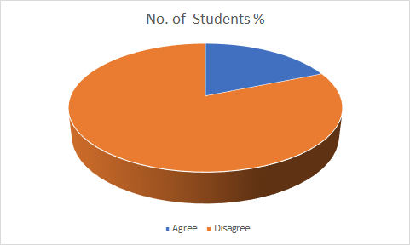

Over 80% of total students believed that Offline/classroom mode is more effective than online classes. Now this could be because of connectivity issues as if the connection gets broken it will break their flow and they will get demotivated easily or maybe because this change is still very new to students and it might take a bit more time for them to get used to it. Another possible reason could be to maintain focus and concentration in online classes. As 90% of students get distracted easily (Q.8), so lack of concentration could be the reason they feel that online classes are ineffective.

* + 1. *Is knowledge dissemination more in online mode?*

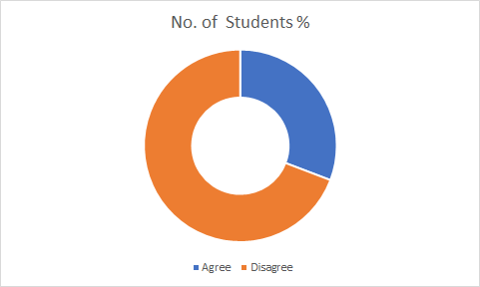

Now there could be many reasons due to which 70% of students felt that online classes lack knowledge distribution. This could be due to limited availability of resources in virtual classes. A teacher could only share his/her screen or maybe present a PPT but on the other hand in Classroom modes, teachers have access to a wide variety of resources starting from Presenting any real model to taking students on field trips for better understanding of a topic. Also, lack of knowledge distribution could also arise if the teachers do not have required computer skills. Online classes require certain skills to present ideas through use of different tools. If the teacher is lacking in these skills, then it will be problematic for students and they would not be able to understand any topic clearly and this will result in doubts and unanswered questions.

* + 1. *Do online classes save time?*

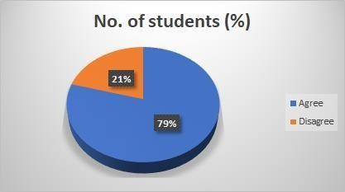

Almost 80% of students believed that online classes are more convenient and time saving. It is because travelling time has been cut down to zero as students attend these classes from their laptops and mobiles. During on campus classes, students had to travel all the way from their hostel/PGs to classrooms that too in proper dress code which is also a time-consuming activity while in Virtual classes there is no specific dress code or anything. This is extremely useful for students as they can learn in their most comfortable environment. This might be the reason behind why the majority of students believe online classes save time.

* + 1. *Is online class more interactive than offline?*

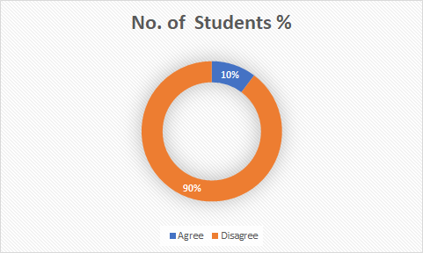

The reason behind why the majority of students disagreed is pretty clear from the previous discussions. It is quite easy to communicate and connect with someone physically then virtually. First of all, a student does not bother much to chat with his/her colleague outside online classes. Since they all are busy in their own lives and rarely see one another other than virtual classes. This makes it difficult for them to make friends. Secondly, in online classes a professor teaches a whole class at once and if any specific student has any academic or maybe personal problem then it becomes difficult for them to communicate with the professor privately.

* + 1. *Is it difficult to clarify doubts in online classes compared to classroom mode?*

Software built for virtual classes currently has limited features. Unlike theory questions, practical questions need a proper workspace and tools to perform calculations. Also, students are generally more comfortable in asking a doubt privately to the professor but unlike classroom mode where they can just walk up and ask the question, in virtual class this is not possible, causing students feel more comfortable in asking doubts in offline mode.

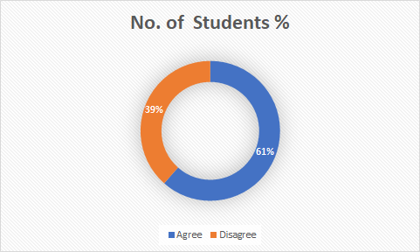

* + 1. *Does lack of computer skills make you uncomfortable during online classes?*

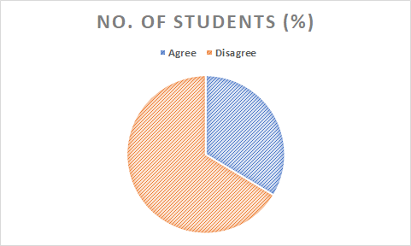

This questionnaire was made for students and the majority of current generation have required technological skills as they have been around computers and mobile phones since the very beginning. Also, virtual classes require skills not only in communication platforms but other software as well like MS-office for completing assignments, Google classroom to download and upload resources.

To acquire these skills Primary education is particularly important. According to an ASER study conducted in 2018 in 596 government schools of 619 districts overall, only 21.3% of the students have access to computers in their schools. This indicates the overall infrastructure needs to be improved from the very beginning so that students can get used to the automation process and the digital world. This might be the reason why few students are having difficulties due to lack of computer skills.

* + 1. *Do you feel more comfortable to participate in online class discussions compared to the classroom?*

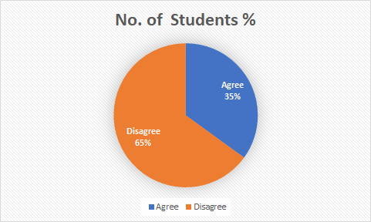

This question was made keeping in mind how students would react to the Interactive Ness during the offline classes. Now we understand that in order to grasp things quickly one needs to interact with its fellow classmates to better understand concepts. Up until now I personally believed that it is important that we as students go through face-to-face interaction. But to our surprise when we asked our respondents whether they feel more comfortable participating in discussion during online classes, 76 out of 117 respondents voted no. That means 65% of students felt that it is easier for them to discuss in online classes. Now we tried to figure out what exactly drives this conclusion and according to us the level of Interactive Ness between a teacher and a student is stronger online, because students feel it easier to answer to the teacher even if they are wrong. As there is no humiliation felt by them during online classes. A lot of students are introvert when it comes to active interactions in class which also brings them humiliation from fellow classmates if they turn out to be wrong.

* + 1. *Do you easily get distracted during online classes than offline?*

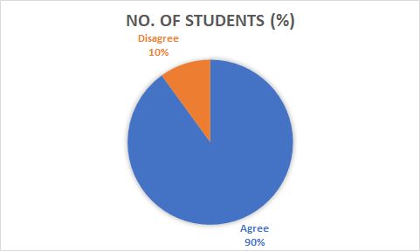

We asked respondents whether learning through devices they get distracted by various other things for example social media. The responses that we got were not surprising at all. 90% of students are heavily distracted by their devices which have so much to offer them. Shifting from conventional teaching to modern methods is a huge transition. It is understandable that students are finding it difficult to concentrate on such teaching patterns but looking at it from a practical view it is not appreciable that the students completely forgot the true meaning of studying with cent percent concentration. A much bigger role is played by social media when it comes to distraction during the usage of devices. Students have been deeply trapped by social media and this number particularly rose by 87% during the pandemic. So, the above results are no surprise as this was bound to happen as we were not given enough time to segregate our social and student life; in the sense that we were separated from our friends and had social media as our only source of communication.

* + 1. *Do you feel lazy and disinterested during online classes?*

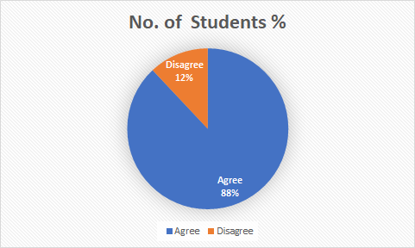

Our purpose for asking this question was to find out how students reacted to the fact that they probably sat around in a corner of their room or on a desk all throughout the day until their classes got over. Not surprisingly enough 89% of students feel lazy and disinterested in online classes. Why this happens is maybe we were so used to interactive offline classes that this transition where we were forced to sit alone in one room and try to pay attention in the class. There is a term associated with such a behavior which is known as Zoom Fatigue. This term was coined by Jeremy Bailens on while he was studying the pattern of office people while noting the possible causes for such an exhaustion. In general fatigue happens to students as well no matter what platform they are using which makes them lazy and disinterested. Another reason for showing disinterest is maybe because online classes lack that alertness that students show in front of their teachers while attending offline classes.

* + 1. *Do you feel demotivated to participate in online class discussions?*

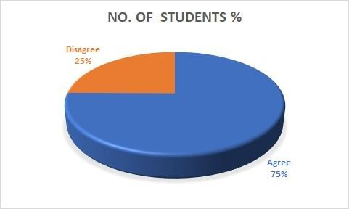

Similar to above findings, we found out that not only people are lazy, but they also feel demotivated to participate in online classes. Reason for this is that students feel obligated and are motivated to participate in offline classes under direct supervision of their teacher. Being in an one to one face interaction, students are bound to participate in discussions but the same discussions when held in online mode students do not feel the urge to participate as they are not being supervised properly and they are free to do whatever they want. Not all schools and colleges have mandated video conferencing due to privacy reasons and this makes students more demotivated as they are not obliged to pay attention. Our survey has also backed up this fact as 75% of them clearly agree to the question asked. It is alarming to see such a huge number accepting that they feel demotivated and unobligated during online classes. Few of them (25%) who actually tried to pay attention can also be demotivated if not challenged. To add more problems, lack of technology or internet accessibility makes it even more difficult for students to be motivated enough. We cannot rule out the fact that students who have contracted the virus or whose family members have been infected are in any way going to be motivated to study in such difficult times.

* + 1. *Do you have a proper stable/continuous internet connection either through Wi-Fi or mobiledata?*

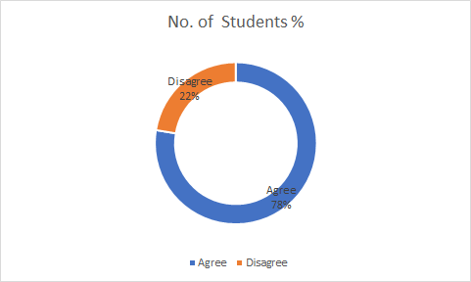

We asked our respondents whether bad internet is something which is stopping them from scoring that perfect 100, but to our surprise 78% have stable proper connection. One might ask why this a surprise is, well looking at the condition of internet infrastructure in India this comes as a surprise most often. Well, our sample size was mostly Christ University students and others from different public private universities who mostly reside in urban areas therefore there is a huge explanation why they have stable Wi-Fi and internet connection. Still 22% of students have faced difficulties due to unavailability of proper internet connection. According to Wikipedia as of 2020, there are

718.74 million active internet users that comprise 54.29% of the population. Maximum efforts should be made to increase this number as this is just the beginning of such pandemics and the internet is going to be a major part of our lives.

* + 1. *Were you able to concentrate on your physical & mental well-being amidst the pressure of online classes and assignments?*

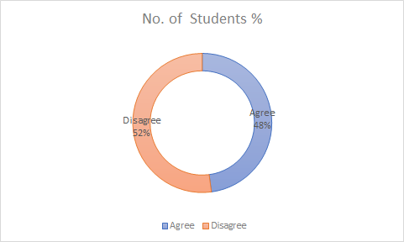

As mentioned earlier, we wanted to find out how the pandemic has affected the mental and physical well-being of students while being taught online. Now online learning includes assignments, tasks, tests etc. along with lectures or sessions. So, we asked our respondents if they were able to concentrate on their total well-being. More than 50% of students have disagreed with the above question. As there is almost a draw among the responses it will be unethical to talk about the side with a slightly greater percentage in either. Now being at home with your family definitely cures your anxiety and stress post classes but we cannot forget the amount of work loads that students receive from the teacher. Many teachers give extra assignments just because students are staying at home and have nothing better to do. On the other hand, there are almost equal numbers of students who were able to concentrate on their well-being both mentally and physically. Popular opinion is that managing stress and anxiety can be achieved through proper time management and diet as well. This study showed that 50% of students might have had a great time at home with their family members who also have helped them to manage college stress properly.

## Annexure 2

The total number of respondents for this questionnaire are 50 people.

This questionnaire has limited number of questions only. It is more like a brief collection of data to understand the student’s choice of communicative platform. We gave them 3 options to select from, as they are the key market players and also the most popular ones.

Through this exercise we wanted to find out which platform students like to use when asked to attend online classes. Along with this we wanted to find out what made them like a particular communication platform over the others.

The inclination towards the online mode is seen in many but also at the same time people want to socialize and connect to peer groups. No one wants to work as an individual. To understand this thought process much better we gave the respondents a question to analyze what their views on were the same.

All the answers were provided by the respondents through due procedure. The platform in which the questionnaire was made is Google Forms. These were circulated throughout our college and outside as well.

## Table to Annexure 2

|  |  |  |  |  |
| --- | --- | --- | --- | --- |
| Q. No. | Questions | Microsoft Teams | Zoom | Google Meet |
| 1. | *Which mode of online teaching do you prefer?* | 73.1 | 11.5 | 15.4 |
| 2. | *Which of the following is more Cost effective?* | 50 | 3.8 | 46.2 |
| 3. | *Which of the following is more convenient?* | 69.2 | 15.4 | 15.4 |

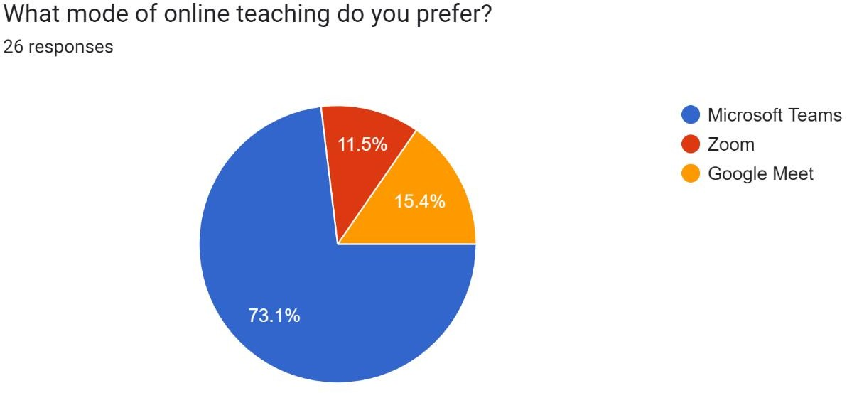

4.2.1

It can be clearly seen that over half of the students chose Microsoft Teams as the preferred mode of online teaching. Though Zoom has the greatest number of users worldwide here it was preferred by only 11.5 % of the total students. A plausible reason behind this could be that this questionnaire was majorly circulated amongst

H.R. College, Mumbai students and Microsoft Teams is a virtual communication platform used by majority of university students. So, it is very obvious out of all platforms, students have used MS Teams majorly as all the classes were scheduled on this and could be the reason why they opted for it.

Another major reason could be that Zoom offers the least maximum meeting time in its basic free plan i.e., 40 minutes making it a bit less popular among students as generally class meetings are 50-60 minutes long. Also, Zoom was forced to change its security and privacy policy in April- May 2020 due to some incidents where meetings got hacked and user data were getting stolen. After this global privacy issue, Zoom got a bit less popular in the educational sector.

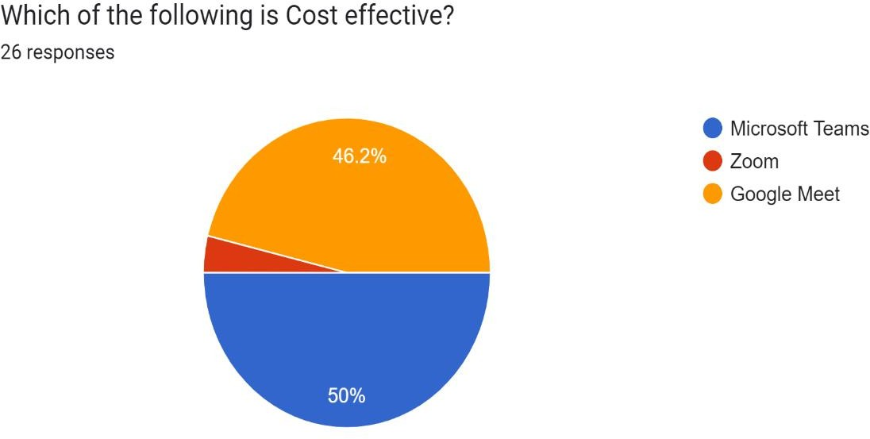

4.2.2

It can be clearly seen that Microsoft Teams & Google meet is far more cost effective in comparison to Zoom and it has a limit for those who are using its Free plan. Although you can make an unlimited number of calls, each call can only last up to 40 minutes. So if your meeting lasts less than 40 minutes and you’re with less than 100 people, the free version will suffice. If you’re using a pro account or anything more expensive than that, the limit moves up to a 24-hour duration.

Google Meet and Microsoft Teams doesn’t have any limits on the length of calls you can make.

Fortunately, when it comes to Google Meet and Microsoft Teams, you can't get much more comprehensive. These two powerhouses in the tech industry have created two truly impressive platforms that can help you stay productive while working from home & cost effective.

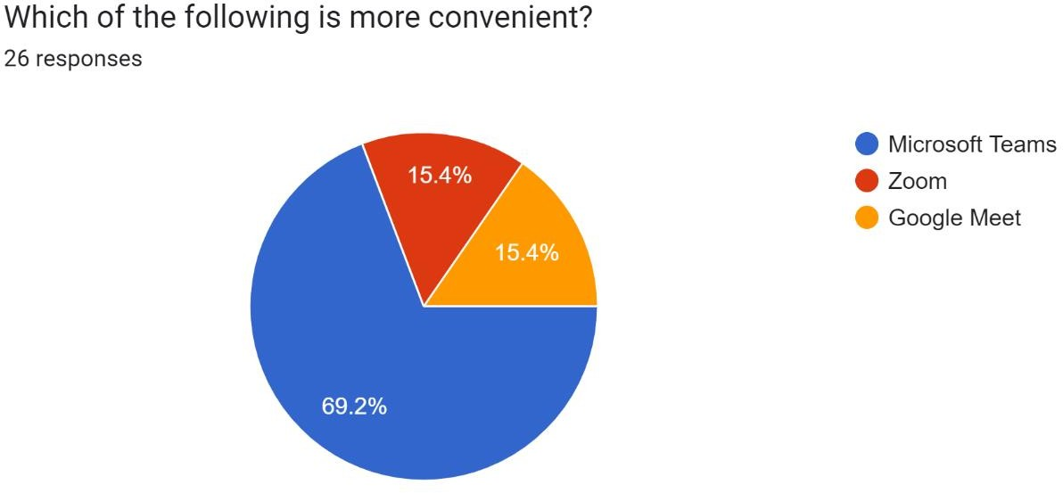

4.2.3

Google Meet, Zoom and Teams have approximately the same features and tools available to make video conferencing work for your business, colleges etc. These collaboration and video conferencing tools are very convenient for those working from home or in the office. As you can see, there are pros and cons for each app, depending on your needs.

Google Meet and Microsoft Teams are better for those that really want to be able to collaborate in real-time, because they have full integration with respectively Google Workspace, formerly G Suite, and Office 365 – office suites which several businesses already have available for their employees. Google Meet is also the best choice if you want to have the option for video meeting participants to join via dial-in, because Meet doesn’t charge an additional call-in fee. Overall, Google Meet is more cost-effective.

But based on our analysis, Microsoft Teams has proved to be a more convenient virtual communicative platform, as the questionnaire was circulated mostly among students, out of which, majority of students were from NM College. Clearly, there’s no obvious winner for the ideal video conferencing tool – the final choice depends on your own business needs and requirements.

## Revenue Models

**Microsoft Teams:**

Microsoft Teams saw a huge uptick in users during the pandemic, rising from 20 million users in November 2019 to 44 million in March 2020, then 75 million by April.

It managed to retain these users post pandemic, and has grown considerably since. In 2022, Microsoft announced that Teams was used by 270 million users, making it by far the most popular business communication platform.

Key Statistics:

* Microsoft Teams reached 270 million users in 2022, up from 145 million it reported in 2021
* From March to June 2020, Microsoft Teams noticed 894% growth, more than zoom.

## Zoom:

As the following chart shows, Zoom saw its revenue skyrocket throughout the fiscal year ended January 31, 2021. For the twelve months ended January 31, 2021, Zoom's revenue amounted to $2.65 billion, up more than 300 percent from just $623 million the previous year. In the fiscal year ended January 31, 2022, Zoom's grew another 55 percent to $4.10 billion. For the ongoing fiscal year 2023, the company is expecting between $4.53 billion and $4.55 billion in revenue and non-GAAP operating income of $1.48 to $1.50 billion.

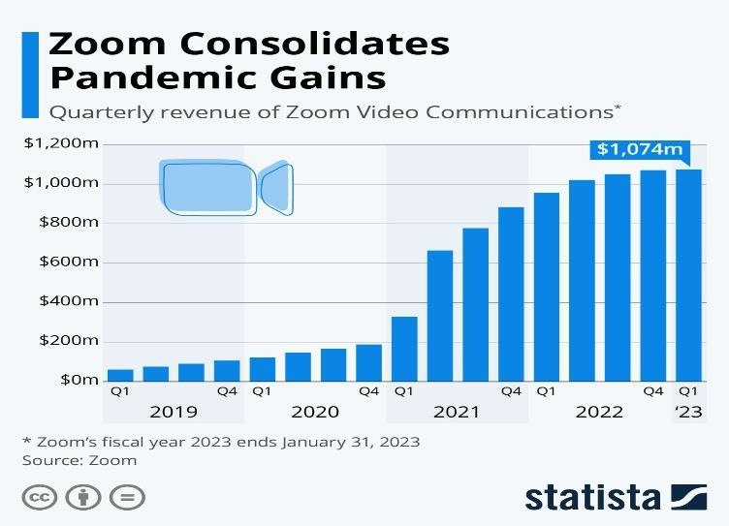

## Indian Higher Education and Covid-19

In our introduction section we provided a brief history of the pre- and post-independence Indian higher education system. There we talked about how the education pattern; system ed-technology have evolved for the betterment of society.

Now we will see how Indian higher education has been impacted due to COVID-19.

#### Pre Covid-19

This analysis will be limited to the year 2018-2019 (more of 2019) as they are considered actual pre covid times. Pre covid higher education had characteristics like offline classes, face to face interaction, lesser technology more books, conventional methods of teaching on black board/whiteboard, co-curricular activities etc. up until 2019 students used to have a proper routine from morning to evening, every subject being taught daily (in some colleges). This type of teaching not only helps students to maintain a proper schedule, but it also makes them disciplined and responsible towards their life. The type of life they lived was something that has been in practice since ages.

Now conventional teaching was something that teachers and students were comfortable with because they have been doing this since centuries. At that time there was no such alternative or people were not aware of such ed-techs. Online teaching was not seen as something that could also exist in society as a way of teaching. In offline classes the teacher made sure that everyone was paying attention in the class and were participating as well. Class learning is complemented by strict rules and policies passed on by the school management and even teachers had some kind of autonomy for framing specific subject related guidelines. There were proper general school rules and regulations which taught children discipline and behavioral aspects. Learners also found it easier to retain the knowledge and skills they had learnt through offline training plus it provided them with an opportunity to interact with like-minded people of the same age. This helped them to develop their social skills leading to an overall personality growth.

It is nearly impossible to work/study alone. Studies such as Linguistic and Education, June 2005 issue has shown that peer learning helps students to learn faster and retain knowledge rather than just sitting alone at their desk.

Although there are now modern methods evolving year by year which prove that they are more effective, nothing can surpass the old traditional face to face learning which has been the core of education in India, but people are now open to changes and accept it for their own betterment.

#### Post Covid 19

In March 2020 covid 19 was declared as pandemic and changed everyone’s life from that day onwards. People were forced to sit and work from home. Even students were forced out of the schools/colleges as thousands of them were shut down due to the pandemic all over the world.

In India schools and colleges were shut down on 16th march for an indefinite period and all the exams were postponed as well. For days colleges did not have a single idea on how to start again with the classes. But then by mid- April almost all the colleges had started online teaching. Things had changed for both students and teachers as now they had to deal with a whole new set of platforms, protocols, etc. It was initially difficult to set their hands straight on the whole thing but dire situations require dire solutions. Various institutions gave training to their teachers on how to manage this new form of learning, but it was mostly informal training as colleges were shut down. As far as students are concerned, they did not need a lot of training per se as they are already aware about how these technologies work.

Easier said than done, there were many students who did not have appropriate resources to deal with online classes such as technology (laptops, phones, tablets) or stable internet connection. As we found out in our survey that 22% of our sample class which was from urban areas did not have proper stable connections. In India, the rural population still does not have proper stable internet connection. As of 2020, there were nearly 700 million active internet users that comprise just 54.29% of the population.

Below is the Number of internet users in India 2015-2020 with a forecast until 2025 in million

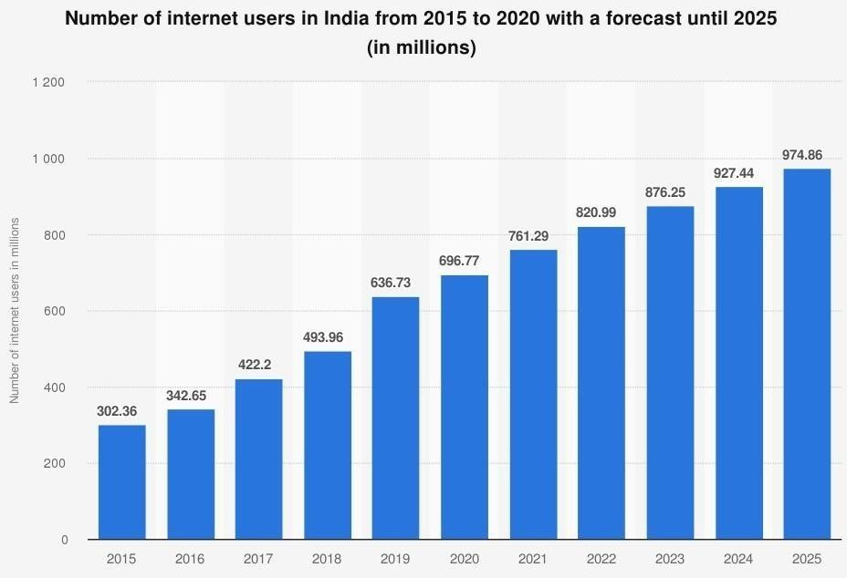

(Source: [https://www.statista.com/statistics/255146/number-of-internet-users-in-india/)](https://www.statista.com/statistics/255146/number-of-internet-users-in-india/)

Interpretation:

In 2020, India had almost 700 million web clients all over the nation. This figure was projected to develop to more than 974 million clients by 2025, demonstrating a major market potential in internet providers for the south Asian country. India was positioned as the second biggest online market worldwide in 2019, coming next just to China. The quantity of web clients was assessed to increase in both urban and rural areas demonstrating a dynamic growth in access to the internet. This might help us to address the above problem of limited connection and availability of internet facilities. But merely establishing these would not help at all, service providers need to ensure that such services reach the rural boundaries of the country. The gap between the users does not just lie among the rich and poor, but it is significant between male and female, older adults, and younger ones as well. The reason why there is a gap between the older adults and the younger ones is due to internet literacy and technological know-how.

## Virtual Communicative Platforms and Covid-19

#### Pre Covid 19

Before March 2020, virtual communicative platforms existed but their reach was extremely limited. It was majorly used by MNCs to conduct different online meetings to avoid travelling. In2019 itself analysts detect the growth in the Video Conferencing Market. It was estimated at $4.8bn in 2019 to reach $9.2 bn by 2027. This market was projected to grow at CAGR of 11.45% from2019 to 2026. This shows us the potential in this field. It was always assumed that technology will slowly take over and will change the ways we perform certain tasks, but nobody knew that within the next few months it’ll increase significantly and at a rate one could never imagine.

In the Pre Covid era, Video conferencing apps were majorly used by large organizations, it was rarely used in universities and schools. Also, the services were paid. Only Google Hangout, which was replaced by Google Meet later in 2020, was available to people at no cost for conducting videocalls and meetings. Many people did not know that companies like Zoom, Cisco Webex even existed. They simply ignored them as they thought these are not made for them. But soon in 2020, people realized the use of these and the need of them in their daily tasks.

#### Post Covid-19

The Covid has pushed the world to an extraordinary lockdown. The difficulties because of this outbreak are enormous and keep on developing. With the expectation of adapting to these difficulties and at the instruction of governments, organizations are investigating approaches to help their employees work effectively from home and learning institutions are investigating ways to conduct online learning. While a significant number of us in tech underestimated it, most businesses, governments, and schools have not needed to WFH or remotely as of recently.

Google Meet

Google Meet has expanded significantly due to Covid. Alongside the remainder of Google's G Suite portfolio, Google Meet has seen plenty of upgrades over the numerous years it has been around. Google CEO Sundar Pichai has disclosed that by April 13, 2020 daily 2mn new users were connecting on Meet every day and users spent 2 bn minutes or almost 3800 years in a single day on Meet.

Along with this, meet surpassed 6mn paying businesses and above 2 bn active users. Due to Covid-19, its day-to-day growth increased to 60% and by April 2020 its daily usage was almost 25 times of what it was in January 2020.

Unlike its competitor Zoom, which was criticized for not taking privacy and security of users too seriously, Google Meet offers cloud-based security and made itself an enterprise- level video call platform to ensure reliability and security by creating a cloud-based infrastructure. These figures portray the success story of Meet and made it one of the most reliable and secure web conferencing platforms for enterprise, customers, and universities.

Zoom

Zoom has flourished as a town square for digital networks, with some extremely imaginative use cases in a period of social distancing. Some have utilized this to have fitness and yoga classes, arranging birthday celebrations or even toss karaoke parties.

In April 2020, it became the world’s most downloaded non-gaming app with over 131mn installs. It had over 200mn daily active users. Zoom’s shares on NASDAQ were valued at

$87.66 at the beginning of Feb and by the end of April they were being traded at $169.09 i.e., almost a 100% growth. It saw a 50% increase in daily meeting participants and i.e., only after a month of Covid-

19. To handle the increased demand Zoom has to add 5000-6000 servers on AWS every night.

The flooding use of Zoom exposed it to serious privacy issues, prompting data security issues and cyber-attacks. As Zoom had been using Chinese servers and was obligated to Chinese laws, they were needed to reveal all data that dwelled on their servers. It has possibly been dishonest about its software encryption and this led to compromising security of users which allowed breaches into private meetings. This ultimately led to numerous users moving to different platforms.

Nonetheless, toward the beginning of May, the Zoom 5.0 update helped cover security issues and zoom declared its procurement of encryption startup Key base to add some degree of security credibility to their platform. This was also majorly responsible behind Zoom’s astonishing financial result of FY 2020-21. Where Market Cap was increased from

$17.83 bn in Jan 2020 to

$93.953 bn in March 2021. Profit was increased from $25mn in FY 2019-20 to $672mn in FY 2020-21. This makes Zoom’s success and growth evident due to Covid 19.

Microsoft Teams

The number of daily active users of Microsoft Teams have almost doubled the past year, increasing from 145 million users in 2021 to 270 million in 2022. Due to the impact of the coronavirus (COVID-19) outbreak and the growing practices of social distancing and working from home, Microsoft has seen dramatic increases in the daily use of their communication and collaboration platform within a short period of time

## CHAPTER 5: SUMMARY OF FINDINGS

After the above discussion we have made the following findings:

* As per the Annexure 1, students feel offline mode is still more effective than online mode.
* Though the majority of students have required computer skills, but they still can't focus in online classes. Virtual platforms are not able to make these classes as interactive as required by the students.
* Everyone would have thought that since virtual classes save time and provide a comfortable space to students, it will help them to maintain their physical and mental health, but this isn’t what students feel. As per them, on campus class helped them better in shaping their body and brain.
* Microsoft Teams is the most preferred mode for virtual classes, but it was not opted just because the brand is known. In that case, relatively other two platforms- Google Meet and Zoom are recognized more by their brands.
* The above point has been supported by the argument that students preferring Microsoft Teams are less likely to attend offline classes than the students preferring other two platforms. Google Meet and Zoom have successfully made them one of the largest global brands, but students are still not completely comfortable with the features they provide. That is why they are more likely to attend offline class then to attend online class on their platform.
* Though Covid 19 has digitalized Indian Higher Education in a significant manner but the infrastructure existing in India does not support this transformation. Students still do not have access to required internet connectivity. This creates a huge problem while attending any online class, meeting, or webinar.
* India is the second largest online market worldwide. It has over 700mn web clients. Now this figure could reach above 950mn if India starts to take measures to improve its infrastructure such as improving internet connectivity, increasing internet facilities, and reducing the digital gap between rural and urban areas.
* After looking at the figures reported by Virtual Communicative Platforms in 2020-21, it is safe to say that Covid 19 was the only reason behind this unbelievable growth.
* Though the potential in virtual platforms was visible before 2020 a well but it was boosted during the lockdown caused by this pandemic.
* All the platforms have expanded their operation during Covid 19. Google meet reported a usage of its platform in April 2020 was 25 times of what it was in January 2020. Zoom became the most downloaded non-gaming app on Google play store by April 2020.
* Now these figures surely show the growth of these virtual platforms, but this growth has come with several challenges. Many platforms faced serious issues related to privacy of users and meetings. Zoom was one of these platforms who faced security issues in May 2020. It was criticized for poor encryptions of meetings which led to trolls hacking them and causing disruption.
* This has raised an overly concerning issue that this digital transformation might have come up with serious negative impacts. If these issues are not addressed quickly then privacy will just become a word with no meaning in the digital world.

## CHAPTER 6: CONCLUSION AND SUGGESTIONS

After thorough analysis we can conclude that students prefer offline mode more than online mode. We saw in our analysis that the knowledge dissemination is more in offline mode. This is due to the fact that throughout our learning years from nursery to graduate level students have been experiencing the traditional school methods and there was nothing to be questioned about it. A sudden transition from offline mode to online mode is incredibly challenging and certainly difficult to cope up with. Without proper orientation and guidance, it is nearly impossible to manage a change so huge on the students as well as teachers’ side. Though online classes save a lot of student’s time which can be henceforth utilized somewhere else, the social skills needed to conquer the outside world is long forgotten in this type of learning. This is the 21st century and what we believe is that simply gaining knowledge is not what it takes to be successful in life. A person should have adequate skills to make human interaction beneficial to oneself along with the required knowledge.

We also saw that students cannot concentrate properly in the classes as they are often distracted by the un-ending entertainment provided by the internet. The internet has a vast resource at its dispense, majority of which are useful and others a total waste of student life. Students don’t know how to differentiate between these two and hence are often trapped by the vast availability of entertainments. We also found out that almost 50% of students of our sample size were unable to focus on their mental & physical wellbeing and this certainly is an alarming situation.

H1:

Lockdown has made it rather compulsory for schools and colleges to digitize their study material such as books, notes, lectures etc. Indian higher education has changed a lot, rather was made to change due to circumstances. The Indian National Commission for Cooperation with UNESCO (INCCU) was also working and

promoting online learning during this pandemic. The governments developed several platforms to support e-learning. Platforms like DIKSHA, e-PATHSHALA, and SWAYAM. The commission also stated that “The lockdown period has seen a huge upsurge in digital learning. The access to the above digital resources has grown nearly five times. In addition to these, many institutions are holding online classes through various modes.” This proves that lockdown has led to digitalization of Indian Higher Education.

H2:

Yes, our hypothesis stands corrected as Covid 19 has helped Virtual Communicative platforms ingrowing and expanding their operations. Though this growth was projected in 2019, where the online market was projected to grow to $9.2 bn by 2027. But this growth was fast forwarded due to this pandemic. All the three platforms assessed by us have reported figures that are astonishing. Google Meet reported that users are spending 2 bn minutes on its platform daily. Zoom reported that to cope up with the increasing demand it has to add 5000-6000 servers on AWS every night. These figures are the evidence of the growth of these Virtual Conferencing platforms due to Covid.

H3:

Through the questionnaire we understood what value does online studying hold in the minds of the student. We found out that the results were not very impressive, and students were performing better in offline mode. Anyway, it is still early to deduce a conclusion that online mode is ineffective. Students should be given ample time to understand and value the advantages provided to them through online mode which shall make them more comfortable in the coming years. Therefore, our hypothesis stands wrong as we can clearly see that offline learning is more effective than online learning.

## Suggestions

Internet accessibility in urban rural areas.

Rural: Numerous schools presently supply, or are thinking about providing, an Internet- associated gadget for every student. These 1:1 project that allocate a PC, tablet, or comparable gadget to every student can uphold separated guidance, project-based learning, improved coordinated effort, practice communicating in multiple formats, and a host of other instructional strategies. When selecting instructional materials, schools may wish to make sure all materials can be downloaded to and stored on devices so people can access the material when not connected to the Internet.

Urban: a lot of urban places do have proper internet connection, but they lack the stability in the same. This can be overcome only by the service providers such as Jio or Airtel etc. by increasing their no. of towers to cover large numbers of urban population. An affordable, good-bandwidth Internet service is the need for an hour. Companies should be given incentives by the government to take up such tasks that increase the internet accessibility among the people.

Lack of computer skills

Many teachers and students reported having difficulty during online class due to lack of computer skills. To solve this issue, the Government should involve digital learning in curriculum from the primary schools. Digital learning should involve use of different software, tools and techniques instead of teaching how to start a computer. So that students can get a better grasp of these platforms and can study effectively.

On the other hand, even, teachers need full training in order to use it properly. During the lockdown, many teachers have faced difficulty to teach using phones, tablets, or laptops. This problem arose due to the fact that teachers were not given proper training as this was a sudden change. Now to overcome this problem schools should actively participate in

giving training to the teachers offline (after following proper covid guidelines). This is the only way to overcome this problem. Unless the teaching faculty is not fully trained in using the technologies it will be difficult for them to impart their knowledge to their students which is an ultimate harm to the students.

Coping with the Demand

Lockdown has led to significant increase in usage of these Virtual Communicative Platforms and to keep with the rising demand regular updates are much needed. Leading players have to introduce new features to their meeting platform to meet expectations of users. Features like, creating an enterprise solution, covering the consumer market by improving the free and basic plan, and enhancing user experience.

Disruption to Digital Transformation

Coronavirus has led the growth of the digital market into overdrive. It is projected that these Virtual Communicative platforms will be used 1000 times in the next couple of years. But challenges like security breach, hacking into private meetings, and unauthorized use of user’s data has raised some serious questions. Addressing these issues should become the primary objective of every platform. Measures such as improving meeting encryption, increasing security for private meetings, creating a unique user ID and password for every invited user to avoid trolls hacking into the meetings.

Making online learning effective

As per the analysis done by us, we found out that though use of virtual platforms has significantly increased it still has a lot of scope and potential to improve the user experience. To make online platforms effective, virtual platforms should include features like only meeting creators should have authority to mute or remove participants, to approve requests made by any participant to join the meeting, and to unmute anyone at any point to ensure that the students are concentrating in the meeting. Other than these, platforms can include a feature to automatically send the recorded meeting URL to all the participants. This will make it easier for teachers to avoid sending these URLs separately in the class group. These features might fulfill students and teachers' needs and will make it easier for them to use virtual platforms, hence, making online learning more effective.

## ANNEXURE 1:

1. Is online mode more effective than classroom mode?
   * Agree
   * Disagree
2. Is knowledge dissemination more in online mode?
   * Agree
   * Disagree
3. Do online classes save time?
   * Agree
   * Disagree
4. Is online classes more interactive than offline?
   * Agree
   * Disagree
5. Is it difficult to clarify doubts in online classes compared to classroom mode?
   * Agree
   * Disagree
6. Does lack of computer skills make you uncomfortable during online classes?
   * Agree
   * Disagree
7. Do you feel more comfortable to participate in online class discussions?
   * Agree
   * Disagree
8. Do you feel lazy and disinterested during online classes?
   * Agree
   * Disagree
9. Do you feel demotivated to participate in online classes discussions?
   * Agree
   * Disagree
10. Do you have proper stable internet connection either through Wi-Fi or mobile data?
    * Agree
    * Disagree
11. Were you able to concentrate on your physical and mental wellness amidst all this?
    * Agree
    * Disagree

## ANNEXURE 2:

1. Which mode of online teaching do you prefer?
   * Microsoft Teams
   * Zoom
   * Google Meet
2. Which of the following is cost effective?
   * Microsoft Teams
   * Zoom
   * Google Meet
3. Which of the following is more convenient?
   * Microsoft Teams
   * Zoom
   * Google Meet

# REFERENCES

D. Nambiar (April 2020). The impact of online learning during COVID19: students' and teachers’ perspective. International Journal of Indian Psychology. [The impact of online learning during](https://ijip.in/articles/the-impact-of-online-learning-during-covid-19-students-and-teachers-perspective/) [COVID-19: students' and teachers' perspective » The International Journal of Indian Psychȯlogy](https://ijip.in/articles/the-impact-of-online-learning-during-covid-19-students-and-teachers-perspective/)

Cathy Li and Farah Lalani (April 2020). The COVID-19 pandemic has changed education forever. World Economic Forum article. [The rise of online learning during the COVID-19pandemic](https://www.weforum.org/agenda/2020/04/coronavirus-education-global-covid19-online-digital-learning/)

Khadijah Mukhtar, Kainat Javed, Mahwish Arooj, and Ahsan Sethi (May 2020), Advantages, Limitations and Recommendations for online learning during COVID-19 pandemic era. Pak J Med Sci. [Advantages, Limitations and Recommendations for online learning during COVID-19](https://www.ncbi.nlm.nih.gov/pmc/articles/PMC7306967/) [pandemic era](https://www.ncbi.nlm.nih.gov/pmc/articles/PMC7306967/)

Dr Ankuran Dutta (May 2020). Impact of Digital Social Media on Indian Higher Education: Alternative Approaches of Online Learning during COVID-19 Pandemic Crisis. International Journal of Scientific and Research Publications. [Impact of Digital Social](http://www.ijsrp.org/research-paper-0520.php?rp=P10110025) [Media on Indian Higher Education: Alternative Approaches of Online Learning during COVID-19 Pandemic](http://www.ijsrp.org/research-paper-0520.php?rp=P10110025) [Crisis](http://www.ijsrp.org/research-paper-0520.php?rp=P10110025)

Shivangi Dhawan (June 2020). Online Learning: A Panacea in the Time of COVID-19 Crisis. Sage Journals. <https://journals.sagepub.com/doi/full/10.1177/0047239520934018#_i16>

Vidyut Rajhans, Usman Memon (Jun 2020). Impact of COVID-19 on academic activities and way forward in Indian Optometry. Journal of Optometry. [Impact of COVID-19 on academic activities](https://www.sciencedirect.com/science/article/pii/S1888429620300558) [and way forward in Indian Optometry](https://www.sciencedirect.com/science/article/pii/S1888429620300558)

[Pravat Kumar Jena](https://papers.ssrn.com/sol3/cf_dev/AbsByAuth.cfm?per_id=4363994) (June 2020). Impact of COVID-19 on Higher Education in India. International Journal of Advanced Education and Research. [Impact of COVID-19 on Higher Educationin](https://papers.ssrn.com/sol3/papers.cfm?abstract_id=3691541) [India by Pravat Kumar Jena :: SSRN](https://papers.ssrn.com/sol3/papers.cfm?abstract_id=3691541)

Mohammad Ziaul Hoq (June 2020). E-Learning During the Period of Pandemic (COVID- 19) in the Kingdom of Saudi Arabia: An Empirical Study. American Journal of Educational Research. [E-Learning During the Period of Pandemic (COVID-19) in the Kingdom of Saudi Arabia: An Empirical Study](http://article.scieducationalresearch.com/pdf/education-8-7-2.pdf) Marko Teräs, Juha Suoranta, Hanna Teräs & Mark Curcher (July 2020). Post-Covid-19 Education and Education Technology ‘Solutionism’: a Seller’s Market. [Postdigital Science](https://link.springer.com/journal/42438) [and Education](https://link.springer.com/journal/42438) volume. [Post-Covid-19 Education and Education Technology ‘Solutionism’: a Seller’s Market](https://link.springer.com/article/10.1007/s42438-020-00164-x)

Shazia Rashid and Sunishta Singh Yadav (August 2020). Impact of Covid-19 Pandemicon Higher Education and Research. Indian Journal of Human Development. [(PDF) Impact of Covid-](https://www.researchgate.net/profile/Shazia_Rashid2/publication/343820992_Impact_of_Covid-19_Pandemic_on_Higher_Education_and_Research/links/5f5e27b892851c0789635c8c/Impact-of-Covid-19-Pandemic-on-Higher-Education-and-Research.pdf) [19 Pandemic on Higher Education and Research](https://www.researchgate.net/profile/Shazia_Rashid2/publication/343820992_Impact_of_Covid-19_Pandemic_on_Higher_Education_and_Research/links/5f5e27b892851c0789635c8c/Impact-of-Covid-19-Pandemic-on-Higher-Education-and-Research.pdf)

Surendra Agarwal (September 2020). The digital transformation of education in India during the period of lockdown due to covid-19. 2020 JETIR May 2020, Volume 7, Issue

[(PDF) The digital transformation of education in India during the period of lockdown due to covid-19](https://www.researchgate.net/publication/344126714_The_digital_transformation_of_education_in_India_during_the_period_of_lockdown_due_to_covid-19)

Alekxander Aristonovik. Damizana Kerzic, Dejan Revselj, Nina Tomazevic and Lan Umek (October 2020). Impacts of the COVID-19 Pandemic on Life of Higher Education Students: A Global Perspective. Article by Faculty of Public Administration, University of Ljubljana. [Impacts of the COVID-19 Pandemic on Life of Higher Education Students: A Global Perspective](https://www.mdpi.com/2071-1050/12/20/8438)

Jyoti Bania and Ishaani Banerjee (October 2020). Impact of Covid-19 Pandemic on Higher Education. Article. [Impact of Covid-19 Pandemic on Higher Education: A Critical Review Authors: Jyoti Baniaand Ishani](http://www.guninetwork.org/files/guni_impact_of_covid_19_pandemic_on_higher_education_a_critical_review_india.pdf) [Banerjee Introduction The](http://www.guninetwork.org/files/guni_impact_of_covid_19_pandemic_on_higher_education_a_critical_review_india.pdf)

Cathy Li and Farah Lalani (October 2020). Re-Imagining Edtech - The COVID Effect. NASSCOM Articles. [Re-imagining Edtech - the COVID Effect | NASSCOM](https://nasscom.in/knowledge-center/publications/re-imagining-edtech-covid-effect)

Rammohan Khanapurkar, Shalini Bhorkar, Ketan Dandare and Pralhad Kathole (November 2020). Strengthening the Online Education Ecosystem in India. ORF Occasional Paper No. 282, Observer Research Foundation. [ORF Strengthening the Online Education](https://www.orfonline.org/research/strengthening-the-online-education-ecosystem-in-india/) [Ecosystem in India](https://www.orfonline.org/research/strengthening-the-online-education-ecosystem-in-india/)

Samta Jain, Marie Lall and Anviti Singh (December 2020). Teachers’ Voices on the Impact of COVID-19 on School Education: Are Ed-Tech Companies Really the Panacea? Contemporary Education Dialogue. [Teachers' Voices on the Impact of COVID-19 on School Education: Are Ed- Tech](https://journals.sagepub.com/doi/full/10.1177/0973184920976433) [Companies Really the Panacea? - Samta Jain, Marie Lall, Anviti Singh, 2020](https://journals.sagepub.com/doi/full/10.1177/0973184920976433)

Sharif Khan, Lalit Lalitav Mohakud (Jan 2021). Covid-19 and Digital Divide in Higher Education: Exploring the Indian Scenario. The Novel COVID -19: The Human Rights Issues in India. [(PDF) Covid-19 and Digital Divide in Higher Education: Exploring the](https://www.researchgate.net/publication/342833945_Covid-19_and_Digital_Divide_in_Higher_Education_Exploring_the_Indian_Scenario) [Indian Scenario](https://www.researchgate.net/publication/342833945_Covid-19_and_Digital_Divide_in_Higher_Education_Exploring_the_Indian_Scenario)

Prarthana Bannerjee (February 2021). EdTech Market Is Booming In India. BW Business World article. [EdTech Market Is Booming In India](http://www.businessworld.in/article/EdTech-Market-Is-Booming-In-India-/20-09-2020-322696/)