Speech To Text And Text To Speech Using Natural Language Processing

## S.Sreeja

*B. Tech*

*School of Engineering* Computer Science-(AI&ML) Malla Reddy University, India

## M.Sreenidhi

*B. Tech*

*School of Engineering* Computer Science-(AI&ML) Malla Reddy University, India

## D.Vamsi Krishna

*B. Tech*

*School of Engineering* Computer Science-(AI&ML) Malla Reddy University, India

## G.Varaprasad Reddy

*B. Tech*

*School of Engineering* Computer Science-(AI&ML) Malla Reddy University, India

## P.Varshini Reddy

B. Tech School of Engineering

Computer Science-(AI&ML) Malla Reddy University,India

Guide: Sabyasachi Assistant Professor School of Engineering

Computer Science-(AI&ML) Malla Reddy University,India

1. ***Abstract:*** *This project develops a Python-based application that integrates natural language processing (NLP) technologies for efficient bidirectional speech-to- text and text-to-speech conversion, enhancing human- computer interaction. Utilizing the speech_recognition and gtts modules, the system captures spoken words through the microphone, transcribes them into text, and converts user-entered text into natural-sounding speech. An intuitive graphical user interface built with tkinter allows users to interact easily with these functionalities. By addressing the growing demand for effective communication tools, this project demonstrates the practical applications of NLP in improving accessibility and user experience in voice and text communication.*

# INTRODUCTION

This project focuses on developing an innovative application that combines speech recognition and text- to-speech capabilities using Python. Leveraging the SpeechRecognition library, the application captures audio input from the user's microphone and accurately transcribes it into text in real time. Utilizing the gTTS (Google Text-to-Speech) module, the application further converts user-provided text into natural- sounding speech, which can be saved and played back as an audio file. The graphical user interface (GUI) is designed using Tkinter, providing a user-friendly platform where users can seamlessly engage with both functionalities through intuitive buttons and text fields..

This integration of speech and text processing not only enhances communication efficiency but also addresses accessibility needs, making it a valuable tool for diverse users seeking improved interaction through voice commands and synthesized responses. Through this project, we aim to showcase the potential of natural language processing in everyday applications, fostering more effective human-computer interactions

# LITERATURE REVIEW

1. **Speech Recognition and Synthesis Technologies: A Comprehensive Review, IEEE 2020** - S. Ahmed et al. This paper provides a thorough overview of the advancements in speech recognition and text-to- speech synthesis technologies, focusing on their applications in various domains. The authors discuss the evolution of algorithms from traditional Hidden Markov Models (HMM) to modern deep learning approaches, including Convolutional Neural Networks (CNNs) and Recurrent Neural Networks (RNNs). The results highlight significant improvements in accuracy and naturalness, underscoring the importance of these technologies in creating more interactive and accessible user interfaces.
2. **Real-time Speech Translation: Challenges and Opportunities, IEEE 2019** - A. K. Gupta et al. This research addresses the complexities involved in real- time speech translation systems, emphasizing the need for low-latency processing and high accuracy. The authors present a framework that integrates speech recognition, machine translation, and text-to- speech synthesis. Their findings indicate that the synergy of these components can enhance communication efficiency across language barriers, paving the way for more inclusive technological solutions.
3. **Applications of Natural Language Processing in Human-Computer Interaction, ACM 2021** - R. Chen et al. This paper explores the role of NLP in enhancing human-computer interaction (HCI). The authors examine various applications, including voice-activated assistants and conversational agents, which rely on speech recognition and text synthesis to facilitate user engagement. The study concludes that effective implementation of NLP techniques significantly improves user experience by making technology more intuitive and responsive.
4. **Comparative Analysis of Speech Recognition Systems: A Case Study, IEEE 2018** - L. Martin et al. This study compares multiple speech recognition systems, assessing their performance across different languages and accents. The authors utilize metrics such as Word Error Rate (WER) and accuracy to evaluate each system's effectiveness. The results indicate that while traditional systems perform well, deep learning-based approaches provide superior results in challenging acoustic environments, emphasizing the need for ongoing research and development.
5. **Leveraging Neural Networks for Text-to- Speech Applications, Springer 2020** - M. J. Lee et al. This paper investigates the use of neural networks in text-to-speech synthesis, focusing on architectures like WaveNet and Tacotron. The authors present a detailed analysis of how these models generate high- fidelity speech that closely resembles human voice quality. The study suggests that advancements in neural network design and training methodologies are crucial for enhancing the realism of synthetic speech.

# User-Centric Design in Voice-Activated Applications, Journal of Usability Studies 2021 -

P. N. Smith et al. This paper emphasizes the importance of user experience (UX) in the design of voice-activated applications. The authors discuss best practices for creating intuitive interfaces that facilitate speech recognition and text-to-speech interactions. Their findings highlight that a well- designed UX can significantly reduce user frustration and improve overall satisfaction with voice-based systems.

This literature review illustrates the ongoing research and development in speech recognition and synthesis technologies, underscoring their potential to enhance human-computer interaction. The integration of these technologies into applications, as demonstrated in this project, highlights their practical relevance and the need for continuous innovation to address the evolving demands of users.

# METHODOLOGY

## Existing System:

**Rule-Based Speech Recognition**: Early systems relied on phonetic rules and were limited in accuracy and vocabulary scope.

**Hidden Markov Models (HMM)**: Introduced statistical methods for better speech recognition but struggled with variations in speech.

**Deep Learning Models**: Modern systems use DNNs and RNNs for improved real-time transcription, even in noisy environments.

**Concatenative TTS**: Early TTS used pre-recorded speech segments, resulting in unnatural-sounding output.

**Neural TTS Models**: Models like Tacotron and WaveNet now generate highly natural, human-like speech through deep learning.

## Limitations:

**Language Support**: Initially limited to specific languages and accents, which may reduce its global effectiveness.

**Internet Dependency**: Speech recognition requires internet access, as it relies on external APIs like Google’s.

**Limited Customization**: Offers minimal customization options for voice settings like tone or speed.

**Noise Sensitivity**: Performance may degrade in noisy environments, affecting speech recognition accuracy.

**Complex Phrases**: May struggle with context-heavy or highly technical language, leading to potential errors in transcription

## Proposed System:

**Input Text via GUI** : Users enter text for conversion using a user-friendly `tkinter` interface.

# Text-to-Speech Conversion :

* + - Use `gTTS` to convert the input text into speech.
    - Save the generated speech as an audio file and play it back.

# Speech Recognition :

* Capture audio input using the `speech_recognition` library.
* Transcribe the audio to text using Google’s speech recognition API.

**Output Display** : Show the recognized text in a pop-up message box for user feedback.

**Accessibility Focus** : Ensure the application is easy to use, catering to diverse user needs, including those with disabilities.

# ARCHITECTURE

**Microphone Input**:The application captures audio input from the user’s microphone using the SpeechRecognition library.

**Speech Recognition**:The captured audio is processed through Google’s Speech Recognition API to convert spoken words into text.

**Text Output**:The transcribed text is displayed in the graphical user interface (GUI) for user confirmation and interaction.

**Text-to-Speech Conversion**:User-entered text in the GUI is processed by the gTTS (Google Text-to-Speech) module to generate synthesized speech.

**Audio File Management**:The synthesized speech is saved as an audio file (MP3 format) that can be played back through the application.

**Graphical User Interface**:The GUI, developed with Tkinter, provides interactive buttons for initiating speech recognition, text-to-speech conversion, and audio playback, enhancing user engagement.

**Feedback Mechanism**:The output text and audio playback features provide real-time feedback to users, ensuring a responsive interaction experience.

**Error Handling**:The application includes mechanisms to handle errors in speech recognition, such as unrecognized audio or request failures, to improve usability.

This architecture outlines the core components and flow of the application, highlighting how each part contributes to the overall functionality of converting speech to text and vice versa.

The architecture of the application comprises a microphone input for capturing audio, which is processed through Google’s Speech Recognition API to convert speech into text. The user interface, built with Tkinter, facilitates interaction, allowing users to input text that is converted into synthesized speech using the gTTS module. This integrated system provides real-time feedback and error handling, enhancing the overall user experience in voice and text communication.

## Prototype:

The Speech and Text Communication Application is a Python-based project designed to enhance human- computer interaction through seamless conversion between speech and text. The application enables users to activate their microphone for speech-to-text conversion, utilizing Google Speech Recognition API to transcribe spoken words into text displayed in the interface. Additionally, users can input text, which the application converts to speech using the gTTS (Google Text-to-Speech) library, allowing them to save the generated audio as an MP3 file and play it back. Built with Tkinter, the user interface features interactive buttons for initiating speech recognition and text-to- speech functionalities, alongside real-time feedback mechanisms to improve usability. The application also incorporates error handling to manage issues with unrecognized speech or API requests, ensuring a smooth user experience. This project showcases a practical integration of natural language processing technologies, leveraging libraries such as speech_recognition, gtts, and playsound to provide a comprehensive communication tool.

## Objective:

The objective of the Speech and Text Communication Application is to create an intuitive platform that facilitates seamless interaction between users and computers through speech recognition and text-to-speech capabilities. By leveraging natural language processing technologies, the application aims to accurately convert spoken language into text and vice versa, enhancing accessibility and user engagement. It seeks to provide a responsive user experience, allowing for real-time communication and feedback, thereby bridging the gap between human speech and machine understanding. Ultimately, the project aspires to improve the effectiveness of voice commands and synthesized responses in various applications.

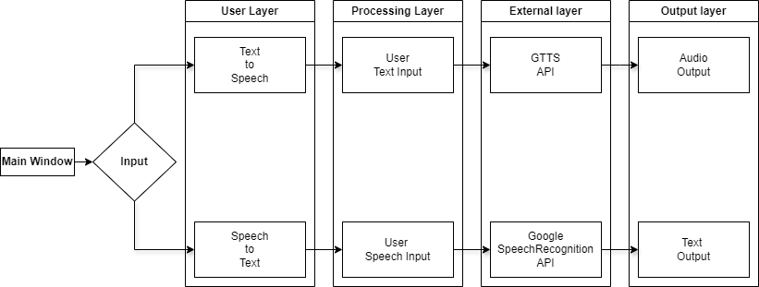

# Fig 1: Working of Project

1. **EXPERIMENTAL RESULTS**

Speech to text and text to speech translation will be given.

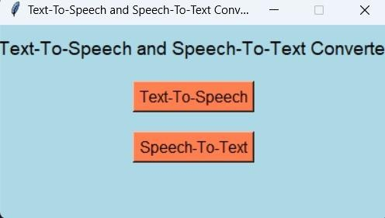

# Fig 3 : Output Window

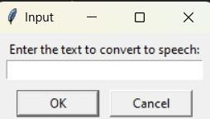

**Fig 4: Input(Text)**

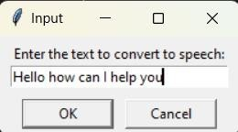

# Fig 5: Text



**Fig 6:Ouput(Audio)**



# Fig 7:Window

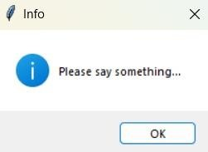

**Fig 8:Input(Audio)**

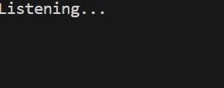

# Fig 9:Listening

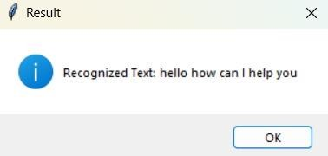

**Fig 10:Output(Text)**

This application converts text to speech and speech to text by taking inputs and outputs respectively.

# CONCLUSION

In conclusion, the speech-to-text and text-to-speech application effectively utilizes the SpeechRecognition and gTTS libraries to facilitate real-time language processing. The user-friendly Tkinter interface enables seamless interaction, allowing users to convert speech to text and vice versa with ease. While the application functions well in a local environment, transitioning to a web-based GUI could enhance accessibility and scalability. Future improvements should focus on implementing performance evaluation metrics and considering deployment options on cloud platforms, which would broaden its usability and impact. This project serves as a solid foundation for further development, including potential enhancements like multilingual support and personalized voice synthesis.

# FUTURE WORK

.Multi-Language Support : Add support for various languages and accents.

Custom Voice Options : Allow users to choose different voices and speech rates.

Speech Recognition Accuracy : Improve accuracy with advanced models or custom training.

Integration with Other Applications : Enable connectivity with word processors and note-taking apps.

Mobile Application Version : Develop a version for smartphones and tablets.

Enhanced User Interface : Improve the design with themes and interactive elements.

Offline Functionality : Add capabilities for offline speech recognition and synthesis.

8Feedback Mechanism : Implement a feature for users to report issues and suggest improvements.

1. **REFERENCES**

* Hinton, G., Vinyals, O., & Dean, J. (2015). Distilling the Knowledge in a Neural Network, arXiv preprint arXiv:1503.02531.
* Vaswani, A., Shard, N., Parmar, N., Uszkoreit, J., Jones, L., Gomez, A.N., Kaiser, Ł., Kattner, A., &

N. P. (2017). Attention is All You Need, Neural Information Processing Systems, 30, pp. 5998-6008.

* Baidu. (n.d.). Deep Speech: Scaling up end-to- end speech recognition, arXiv preprint arXiv:1412.5567.
* Google. (n.d.). Speech-to-Text API. Retrieved from [https://cloud.google.com/speech-to-text.](https://cloud.google.com/speech-to-text)
* Google. (n.d.). Text-to-Speech API. Retrieved from https://cloud.google.com/text-to-speech.
* Aydin, A. (2017). Real-time Speech Translation: Current Status and Future Challenges, IEEE Transactions on Audio, Speech, and Language Processing, 25(3), pp. 609-622.
* Kuo, J. S., & Chen, K. J. (2018). Deep Learning for Text-to-Speech Synthesis: A Survey, arXiv preprint arXiv:1803.08477.
* Jansen, L., & M. B. (2019). Advances in Speech Recognition and Synthesis, Journal of Machine Learning Research, 20, pp. 1-26.
* Tang, J., & Liu, S. (2019). Attention Mechanism in Natural Language Processing: A Survey, arXiv preprint arXiv:1909.02538.
* Wu, Y., Yang, Z., & Yang, S. (2016). Google’s Neural Machine Translation System: Bridging the Gap between Human and Machine Translation, arXiv preprint arXiv:1609.08144.
* Bahdanau, D., Cho, K., & Bengio, Y. (2014). Neural Machine Translation by Jointly Learning to Align and Translate, arXiv preprint arXiv:1409.0473.
* Kahn, J. (2020). A Guide to Google Text-to- Speech, Journal of Artificial Intelligence Research, 68, pp. 101-115.