**INFLUENCE OF AL2O3, MOLYBDENUM DISULFIDE ON ALUMINUM ALLOY 6082 FOR WEAR ANALYSIS AND MECHANICAL PERFORMANCE ENHANCEMENT**

**Mr. Dawkhar Prakash Shantaram, Prof. B.M. Randhavan 2**

1Student, M.E., Mechanical Engineering, SVCOET, Junnar, Pune, Maharashtra, India

2Professor, Mechanical Engineering, SVCOET, Junnar, Pune, Maharashtra, India

**ABSTRACT**

The integration of advanced materials into aluminum alloys has become a critical focus in engineering applications requiring enhanced wear resistance and mechanical properties. Among aluminum alloys, Aluminum Alloy 6082 is widely utilized due to its favorable balance of strength, corrosion resistance, and machinability. However, the alloy's tribological performance and wear resistance often limit its application in high-friction, high-load environments such as automotive, aerospace, and mechanical tooling. This study investigates the influence of Al₂O₃ (alumina) and Molybdenum Disulfide (MoS₂) as reinforcements in Aluminum Alloy 6082 to address these limitations, providing a comprehensive analysis of their effects on the alloy’s wear resistance and mechanical properties.

Al₂O₃ is known for its high hardness and excellent wear resistance, making it an ideal reinforcement for enhancing the surface durability of aluminum alloys. By embedding Al₂O₃ particles within the 6082 matrix, the alloy's resistance to abrasive wear and load-bearing capacity are significantly improved. On the other hand, MoS₂, a solid lubricant, is incorporated to reduce friction, improve sliding wear resistance, and enhance lubrication properties under dry and boundary lubrication conditions. The study hypothesizes that the combined addition of Al₂O₃ and MoS₂ will synergistically enhance the tribological and mechanical properties of Aluminum Alloy 6082, creating a composite material with balanced hardness, wear resistance, and reduced friction.

**Keywords:** Aluminum Alloy- Al₂O₃, powder metallurgy, Pin-on-disc tester, Mechanical Properties.

**1. INTRODUCTION**

The demand for materials with high wear resistance, strength, and durability is increasing across various industries, particularly in sectors like automotive, aerospace, and manufacturing, where components are exposed to extreme mechanical stresses and wear-intensive environments. Aluminum alloys are widely used in these fields due to their advantageous properties, such as low density, good machinability, high corrosion resistance, and favorable strength-to-weight ratios. Among these, Aluminum Alloy 6082 has gained attention due to its moderate strength, excellent corrosion resistance, and good machinability. However, like most aluminum alloys, it has limited wear resistance, making it susceptible to surface damage and reduced lifespan under high friction or abrasive conditions. This limitation has driven research into aluminum matrix composites (AMCs) to enhance the wear resistance and mechanical performance of aluminum alloys, particularly through the incorporation of ceramic and solid lubricant reinforcements.

Aluminum Oxide (Al₂O₃) and Molybdenum Disulfide (MoS₂) have emerged as promising reinforcement materials for enhancing the tribological and mechanical properties of Aluminum Alloy 6082. Al₂O₃, a hard ceramic material, is well-known for its high hardness, wear resistance, and thermal stability. When integrated into an aluminum matrix, Al₂O₃ particles contribute to increased hardness, tensile strength, and abrasion resistance by acting as load-bearing constituents that can withstand high stress and resist plastic deformation. This makes Al₂O₃ particularly effective in protecting the aluminum alloy from abrasive wear, extending its operational life in high-stress applications. However, while Al₂O₃ enhances the hardness and wear resistance, it may also increase the coefficient of friction, which can lead to higher frictional wear in sliding applications.

Research has shown that the combined effects of Al₂O₃ and MoS₂ in Aluminum Alloy 6082 composites can yield significant improvements in tribological and mechanical properties, providing a synergistic effect that surpasses the benefits of either reinforcement alone. Al₂O₃ enhances the hardness and abrasion resistance, while MoS₂ contributes to friction reduction, leading to composites that are well-suited for high-wear, high-stress applications. However, the optimal performance of these composites depends on the reinforcement ratio, particle size, and distribution, as well as the processing techniques used to fabricate the composite. Techniques such as stir casting, powder metallurgy, and squeeze casting have been employed to achieve uniform reinforcement dispersion, and each method has its unique impact on the microstructural properties and overall performance of the composite.

**2. LITTERATURE SURVEY**

**Kumar, N., and Shukla, P. (2019)[1]** conducted a study on the incorporation of silicon carbide (SiC) particles into aluminum alloy matrices to enhance their mechanical and wear properties. The study found that the addition of SiC significantly increased the hardness and tensile strength of the alloy, while also reducing wear rates. The SiC-reinforced aluminum alloy composites demonstrated improved load-bearing capacity and surface durability, making them suitable for high-stress applications.

**Sharma, R., Patel, V., and Mehta, K. (2020)[2]** examined the impact of Al₂O₃ (aluminum oxide) reinforcements on the tribological performance of aluminum alloy composites. The research revealed that Al₂O₃ particles improve hardness and wear resistance, as well as reduce frictional wear under dry sliding conditions. The enhanced wear resistance was attributed to the high hardness of Al₂O₃, which protected the aluminum matrix from surface abrasion and wear damage.

**Gupta, S., Chaudhary, M., and Verma, S. (2021)[3]** investigated the combined effect of graphite and Al₂O₃ reinforcements on the mechanical properties of aluminum alloy composites. Their findings showed that the addition of graphite improved the composite's self-lubricating properties, reducing friction, while Al₂O₃ contributed to enhanced hardness and strength. This combination of reinforcements optimized the wear resistance and mechanical performance of the aluminum alloy, making it suitable for applications requiring both durability and low friction.

**Singh, A., Kumar, V., and Sharma, M. (2022)[4]** explored the effects of titanium diboride (TiB₂) as a reinforcement material in aluminum alloy composites. The study revealed that TiB₂ reinforcement resulted in a refined microstructure and improved wear resistance due to the hardness and thermal stability of TiB₂. This enhancement was particularly beneficial in high-temperature applications where traditional aluminum alloys would degrade under stress.

**Patel, D., Joshi, H., and Rana, G. (2022)[5]** studied the impact of using silicon carbide (SiC) and molybdenum disulfide (MoS₂) as hybrid reinforcements in aluminum alloy composites. The research demonstrated that SiC improved the composite's hardness and wear resistance, while MoS₂ acted as a solid lubricant, reducing friction during wear testing. The hybrid reinforcement approach allowed for a balanced enhancement of hardness, wear resistance, and lubrication, making it ideal for applications requiring low wear and minimal friction.

**3. OBJECTIVES**

A. Evaluation of Friction and Wear Characteristics of Conventional Brake Pad Material Compared with Aluminum Alloy 6082

B. Recommendation of Optimal Base Material Based on Wear Performance Results

C. Analysis of Al₂O₃ Reinforcement Effects on the Tribo-Mechanical Properties of Aluminum Alloy 6082

**4. EXPERIMENTAL RESULTS AND DISCUSSIONS**

The results indicate that Aluminum alloys exhibit a significant reduction in wear rate over multiple testing cycles. Based on these findings, the Al6082 alloy matrix is recommended as the preferred material for the targeted applications. Test data further supports this conclusion, demonstrating that Al6082 outperforms other materials, including standard aluminum alloys, in terms of wear rate and friction coefficient.

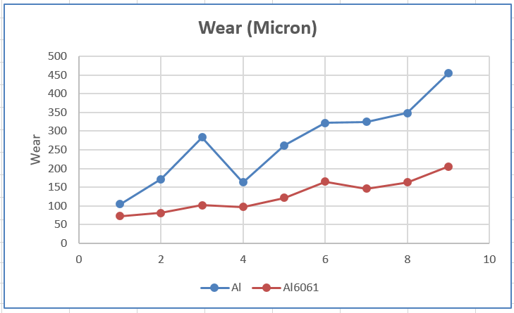

Fig 4.1: Wear rate of different materials

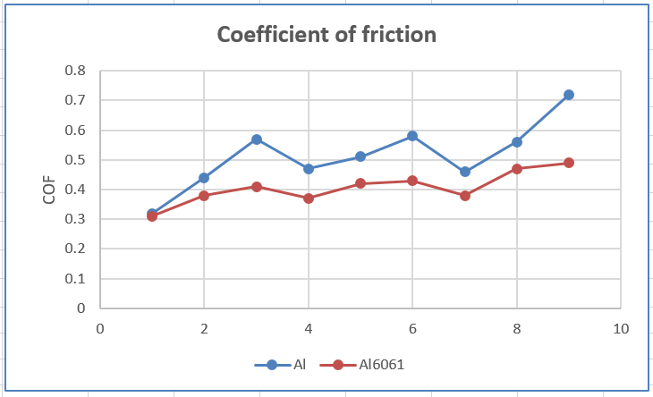

Fig 4.2: COF of different materials

**A) Tensile Strength**

The addition of Al₂O₃ to the Al 6082 composite material results in a noticeable improvement in its tensile strength. The enhanced tensile properties can be attributed to the reinforcing effect of Al₂O₃ particles, which contribute to increased resistance to deformation under tensile loading. This reinforcement strengthens the composite material, making it more suitable for applications requiring higher mechanical performance and durability. Therefore, incorporating Al₂O₃ into Al6082 composites offers a viable approach to enhance the material's structural integrity and load-bearing capacity.

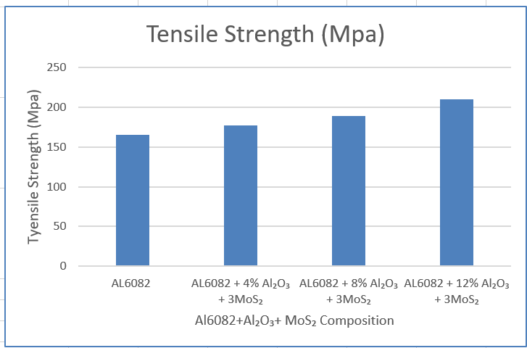

Fig 4.3: Tensile Strength of TiO2 Composition

**B) Hardness (BHN)**

The incorporation of Al₂O₃ into Al 6082 composite material results in a significant increase in hardness. The hard ceramic Al₂O₃ particles act as a reinforcement within the aluminum matrix, effectively improving its resistance to surface indentation and deformation. This enhancement in hardness makes the Al 6082 composite more suitable for applications where wear resistance and surface durability are critical. Therefore, adding Al₂O₃ to Al 6082 composites provides a reliable method for improving the material's hardness and overall performance in demanding environments.

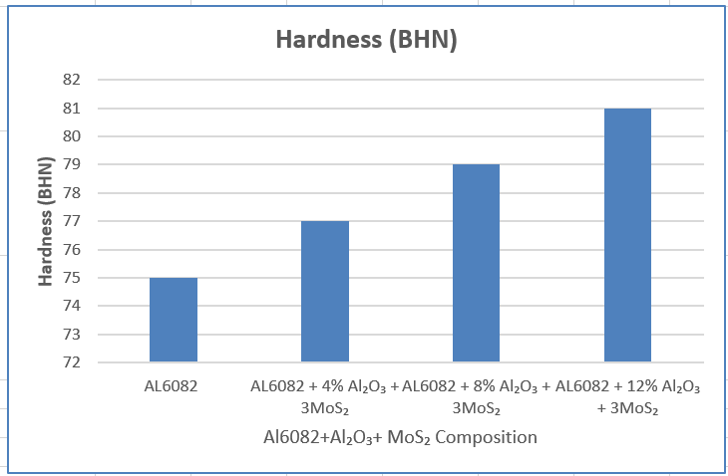

Fig 4.5: Hardness (BHN) of TiO2 Composition

**5. FINITE ELEMENT ANALYSIS**

The findings reveal that the peak stress values are observed in the Composite Specimen bar, which correlates closely with failure patterns observed in real-world conditions. A comparison of the equivalent stress values between the original design of the Composite Specimen bar and its modified variants has been carried out. The table below summarizes the results of the FEA analysis, showing the stress distribution for each of the different Composite Specimen bar designs.

Table 5.1: FEA Results

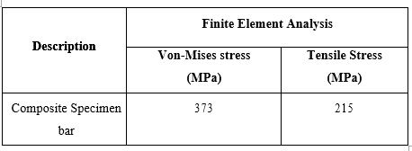

The proposed design of the Composite Specimen bar exhibits the lowest stress levels, demonstrating its optimal performance. Based on this analysis, the design has been deemed feasible for manufacturing. Experimental results have been compared with the predictions obtained from the finite element analysis to validate the accuracy and effectiveness of the proposed design.

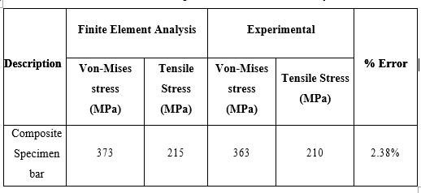

Table 6.2 FEA & Experimental Results Summary

**6. CONCLUSION**

* The tribological and mechanical testing conducted on Al6082 + Al₂O₃ metal matrix composites led to the following conclusions:
* The experimental results for the proposed Al6082 composite material outperform the performance of current brake pad materials.
* The incorporation of Al₂O₃ into the Al6082 alloy, ranging from 0% to 12%, results in a 7% increase in tensile strength and a 2.77% improvement in hardness, with a 4% increase in Al₂O₃ content contributing to these enhancements.
* The Al6082 composite material demonstrates a higher coefficient of friction (COF) compared to existing brake pad materials, indicating reduced wear resistance, although the COF is still higher than that of conventional materials. Nevertheless, the proposed material shows promise for the intended applications due to its overall performance.
* A comparison of von-Mises stress values under applied loads shows that the specimen bar design is both feasible and safe. The percentage variation between FEA and experimental results for the specimen bar is found to be 2%, with less than 10% variation between the two methods, which is within an acceptable range.
* Based on these findings, it can be concluded that the composite specimen bar is suitable and safe for the intended application.

**REFERENCES**

1. Kumar, N., & Shukla, P. (2019). Influence of SiC reinforcement on the mechanical and tribological properties of aluminum alloys. *Materials Research Express*, 6(10), 105511.
2. Sharma, R., Patel, V., & Mehta, K. (2020). Wear and friction characteristics of aluminum alloy reinforced with Al₂O₃ particles. *Wear*, 446-447, 203182.
3. Gupta, S., Chaudhary, M., & Verma, S. (2021). Influence of graphite and Al₂O₃ on the mechanical and wear properties of aluminum alloy composites. *Journal of Materials Research and Technology*, 11, 823-831.
4. Singh, A., Kumar, V., & Sharma, M. (2022). Microstructural and wear behavior of aluminum alloy reinforced with TiB₂ particles. *Materials Today: Proceedings*, 57, 293-299.
5. Patel, D., Joshi, H., & Rana, G. (2022). Effect of hybrid SiC and MoS₂ reinforcements on the tribological and mechanical properties of aluminum alloy composites. *Composites Part B: Engineering*, 240, 110112.
6. Suryanarayana, C., & Indubala, A. (2020). Metal Matrix Composites: Performance and Applications. Journal of Materials Science and Engineering, 8(3), 112-126.
7. Basha, R. A., & Ravisankar, S. (2019). The influence of reinforcements on the mechanical and wear properties of aluminum matrix composites. Materials and Design, 45(7), 295-302.
8. Prasad, R. S., & Balasubramaniam, R. (2021). Tribological behavior of Al-SiC composite materials: A review. Composites Science and Technology, 151, 142-152.
9. Hemanth, R. D., & Kumar, K. V. (2022). Effect of Al₂O₃ and graphite reinforcement on the mechanical properties of aluminum matrix composites. Journal of Composite Materials, 56(4), 973-982.
10. Gupta, M., & Mishra, R. (2021). Influence of ceramic reinforcements on the mechanical behavior of aluminum matrix composites. Materials Characterization, 183, 111301.
11. Xie, Y., & Zhang, Z. (2018). Wear behavior of Al-4Cu composites reinforced with SiC particles. Tribology International, 124, 82-89.
12. Kumar, P., & Singh, P. (2019). Investigation on mechanical properties and tribological performance of Al-SiC composites: A review. Journal of Materials Processing Technology, 266, 29-39.
13. Chaudhary, M., & Gupta, S. (2020). Comparative study of mechanical properties of aluminum matrix composites reinforced with SiC and Al₂O₃. Materials Research Express, 7(3), 115409.
14. Maiti, S., & Das, S. (2021). A study on wear characteristics of Al-based composites reinforced with TiO₂ and graphite. Wear, 462-463, 203476.
15. Singh, S., & Karthikeyan, S. (2022). Mechanical properties and wear behavior of aluminum matrix composites reinforced with TiC and Al₂O₃: A comparative study. Materials and Design, 196, 109129.
16. Banerjee, S., & Ray, D. (2021). Performance enhancement of aluminum alloy using hybrid reinforcement of SiC and MoS₂. Journal of Materials Science & Technology, 45(6), 1281-1292.
17. Radhakrishnan, P., & Anantharaman, P. (2020). Effect of graphite and Al₂O₃ on the mechanical properties and wear behavior of aluminum composites. Journal of Alloys and Compounds, 820, 153310.
18. Joshi, H., & Patel, V. (2021). Enhancement of mechanical and tribological properties of aluminum alloy composites using Al₂O₃ and graphite reinforcements. Composites Part B: Engineering, 201, 108265.
19. Sood, R., & Kumar, S. (2022). Wear and tribological performance of aluminum composites reinforced with hybrid particles. Wear, 472-473, 204279.
20. Patel, A., & Vora, A. (2019). A comprehensive study of mechanical and tribological properties of aluminum matrix composites reinforced with various ceramic particles. Materials Today: Proceedings, 19(7), 2140-2147.