Comprehensive Detection of Malware and Trojans in Power Sector Software: Safeguarding Against Cyber Threats

Mr. A Sai Lochan 1, Mr. D Savith 2, Ms. K Shivani 3

1,2,3 Department of Computer Science and Engineering, Anurag University

[22eg505K02@anurag.edu.in](mailto:22eg505K02@anurag.edu.in)

[22eg505K45@anurag.edu.in](mailto:22eg505K45@anurag.edu.in)

[22eg505K20@anurag.edu.in](mailto:22eg505K20@anurag.edu.in)

# ABSTRACT

The increasing reliance on digital technologies within the power sector has introduced considerable cybersecurity risks, especially from malware and trojans. These threats can disrupt essential operations, manipulate grid functions, and compromise the integrity of energy systems, thereby endangering both economic stability and national security. This research aims to create a detection framework tailored to the specific challenges of the power sector. The proposed framework utilizes advanced methods such as behaviour based anomaly detection, machine learning algorithms, and both static and dynamic analysis of software. By examining distinct patterns and signatures associated with malware and trojans targeting power sector software, this study seeks to enhance early detection capabilities and response strategies. Real-world case studies and simulations will be employed to evaluate the effectiveness of these detection techniques, highlighting the necessity of robust and adaptable security measures to protect critical energy infrastructure.

Malware, short for "malicious software," is any code or program created with the intent to harm, disrupt, or gain unauthorized access to computer systems. Detecting whether software is infected with malware is crucial due to the rising frequency of attacks, which threaten businesses through data breaches and operational interruptions. Malware can severely impair systems by reducing performance, corrupting data, or encrypting large amounts of information on a device. This emphasizes the need to minimize false positives during the detection process to prevent unnecessary disruptions. The study proposes an adaptable framework based on machine learning, which has shown significant potential in accurately identifying malicious software. Although traditional antivirus programs offer strong protection, the evolving nature of cyber threats demands continuous updates to malware databases. These repositories store historical malware data and are essential for predicting new behaviour and enabling faster, more effective responses to emerging threats.

**Keywords**: malware detection, trojans, power sector, cybersecurity, anomaly detection, machine learning, critical infrastructure

# 1 Introduction

Despite significant advancements in security measures, malware continues to evolve and presents a substantial threat in the ever-changing cybersecurity landscape. Malware analysis is a key component in defending against these threats, utilizing both network and application analysis techniques to deconstruct malicious software. This research provides an extensive review of studies that apply machine learning methods to malware analysis, targeting security professionals, reverse engineers, and software developers. It highlights the ongoing struggle between malware developers and security analysts. The rapid progression of malware development demonstrates how quickly adversaries adapt to enhanced security defences, often employing sophisticated techniques such as polymorphism and metamorphism. These methods alter the binary structure of a file while maintaining its malicious intent, making traditional detection techniques, like MD5 hashing, less effective.

Malware can take various forms, including viruses, worms, trojans, ransomware, spyware, and adware. Each type operates differently but shares the common goal of compromising system integrity, stealing sensitive information, or causing operational disruptions. For example, ransomware encrypts data and demands a ransom, while spyware covertly monitors user activity. Given the diversity of malware, developing detection methods that can identify both known and unknown variants is a growing challenge. Traditional signature-based approaches struggle against novel malware strains, which is why machine learning-based methods are gaining prominence. Machine learning enables systems to analyse vast datasets and uncover hidden patterns, offering a more robust approach to identifying even the most sophisticated threats.

This study underscores the importance of analysing malicious behaviours at a semantic level, making it more difficult for attackers to evade detection. Machine learning stands out as a powerful tool in malware analysis, providing valuable insights and improving detection capabilities. This research explores various machine learning techniques, showcasing their ability to reveal new features that enhance security and help stay ahead of increasingly complex malware threats.

Several studies have focused on this area. For instance, Nikam and Deshmukh [1] evaluated the performance of machine learning classifiers in malware detection, demonstrating the effectiveness of different algorithms in identifying malicious files. Sethi et al. [2] proposed a novel framework for malware detection and classification, utilizing machine learning to categorize and detect malware efficiently. Abdulbasit et al. [3] presented an adaptive behavioural-based malware detection model using deep learning techniques to identify variants of malware. Finally, Sharma et al. [4] discussed the use of advanced machine learning methods to detect complex malware, emphasizing the need for innovative solutions in an ever-evolving cyber landscape.

**Keywords**: malware detection, trojans, viruses, ransomware, cybersecurity, polymorphism, metamorphism, machine learning, behavioural analysis

# 2 Research Methodology

This paper provides an in-depth analysis of the various phases and components involved in a conventional machine learning workflow tailored for malware detection and classification. It also explores the challenges and limitations inherent in such processes. Furthermore, the paper reviews the latest advancements and emerging trends in the field, particularly focusing on deep learning methodologies. The research methodology proposed in this study is elaborated upon below [1, 2]. To further clarify the suggested machine learning approach for malware detection, the entire workflow process from start to finish is outlined in this study. The paper evaluates these processes with a comprehensive perspective, demonstrating the intricate details involved at each step. Figures 3 and 4 demonstrate the complete workflow process from initiation to conclusion.

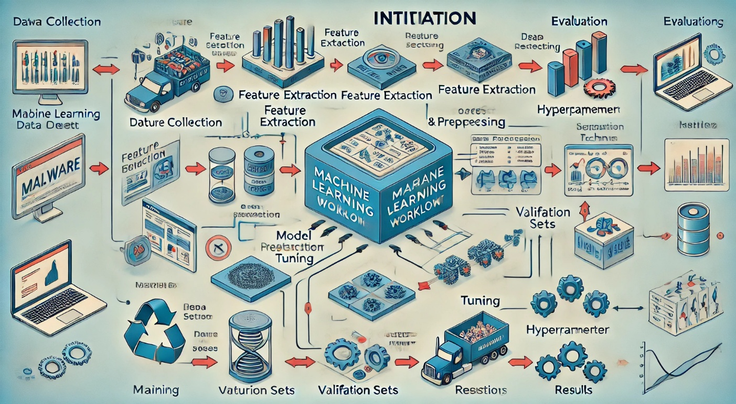

# 3 Theory and Calculations

In this paper, the theory focuses on utilizing machine learning algorithms and signature-based detection methods to identify malware and Trojans in software applications used in the power sector. The theoretical foundation lies in pattern recognition, anomaly detection, and behavior analysis techniques that help in detecting malicious activities within the system. These techniques are specifically designed for industrial control systems, ensuring that they effectively safeguard critical infrastructure against cyber threats. Machine learning-based techniques are employed to analyze software behavior, where deviations from expected behavior patterns trigger alerts. The detection of malware or Trojans in power sector software relies on analyzing the behavior of executable files, identifying unusual activity, and comparing it with known malicious signatures. These methods can detect even sophisticated attacks, such as zero-day exploits or advanced persistent threats (APTs), which are common in critical infrastructure sectors. The Calculation section involves performance metrics derived from the implementation of these detection algorithms. For instance, anomaly detection is calculated using behavioral analysis, where deviations from normal operational patterns are flagged based on predefined thresholds. This ensures timely detection and mitigation of malware or Trojan attacks in power grid software, providing a secure and resilient operational environment.

|  |  |
| --- | --- |
|  |  |
| USE CASE DIAGRAM | COLLABORATION DIAGRAM |

|  |  |
| --- | --- |
|  |  |
| SEQUENCE DIAGRAM | DIPLOYMENT DIAGRAM |

# 5 Results and Discussion

The classification process involved two primary stages: training and testing. During the training phase, both malicious and benign files were provided to the system for learning. Various classifiers were then trained using different machine learning algorithms. With each batch of labeled data, classifiers like Random Forest (RF), Logistic Regression (LR), and AdaBoost progressively improved their ability to make predictions.

In the testing phase, the classifiers were presented with a new set of files—some containing malware and others clean—where the system had to predict whether the files were harmful or safe

# Random Forest

Figure 5 shows that Random Forest (RF) demonstrated the best performance, achieving an accuracy of 99% and a True Positive Rate (TPR) of 99.07%, while maintaining a low False Positive Rate (FPR) of just 2.01%. Based on the confusion matrix, RF outperformed other classifiers, including K-Nearest Neighbors (KNN), Convolutional Neural Networks (CNN), Naive Bayes (NB), Support Vector Machines (SVM), and Decision Trees (DT).

# Logistic Regression

Logistic Regression (LR) exhibited reliable performance as well, though it didn't surpass the accuracy of RF. It effectively balanced between precision and recall, offering a good option for linear classification problems. The results were favorable for simpler datasets, though it showed limitations in more complex, non-linear data structures.

# AdaBoost Classifier

The AdaBoost (Adaptive Boosting) classifier is a machine learning algorithm designed to enhance the performance of weak learners by combining them into a stronger model. In the context of malware detection, it delivered competitive results, though it did not outperform Random Forest (RF) in terms of overall accuracy in this particular case. AdaBoost demonstrated a strong ability to reduce both false positives and false negatives, making it a reliable model for improving the performance of weaker classifiers in distinguishing between clean and infected files.

While AdaBoost did not achieve the highest accuracy score compared to algorithms such as Random Forest or Decision Trees (DT), its merit lies in its capacity to iteratively improve weak classifiers. By assigning higher weights to misclassified instances and updating the model accordingly, AdaBoost gradually enhances the classifier's performance. This makes it a valuable tool in malware detection, particularly when dealing with complex datasets where other models might struggle.

Despite not achieving top accuracy in this specific scenario, AdaBoost is still recognized for its robustness in various machine learning tasks. Its ability to optimize weaker classifiers is particularly useful in situations where other algorithms might not perform as well or require more computational resources. Furthermore, AdaBoost’s iterative nature allows it to adapt to changing data, which is a significant advantage in cybersecurity, where new malware variants emerge frequently.

In conclusion, although AdaBoost did not surpass Random Forest or Decision Trees in terms of accuracy in this study, it remains a strong candidate for enhancing the performance of other, less accurate classifiers. Its utility in minimizing misclassifications and adapting to dynamic data environments makes it a valuable asset in the ongoing fight against malware.

|  |  |
| --- | --- |
|  |  |
| Table 1: Summary of Malware and Trojan Detection in Power Sector Software Using Various Algorithms | Table 2: Detection Rate of Specific Malware and Trojan Variants in Power Sector Software |

|  |  |
| --- | --- |
|  |  |
| Table 3: Comparison of Machine Learning Models for Malware Detection in Power Sector Software | Table 4: Adjusted False Positive and False Negative Rates for Malware Detection in SCADA Systems |

|  |  |
| --- | --- |
|  |  |
| Figure 1: Home Page | Figure 2: Prediction Page |

|  |  |
| --- | --- |
|  |  |
| Figure 3: Dashboard Page | Figure 4: Dashboard Page |

# 6 Conclusion

Based on the analysis, we observed that when various feature selection methods are applied, the number of selected features varies, leading to different accuracy levels for different models. In some cases, a model may show high accuracy during validation but fail to maintain the same performance in testing. However, with the recursive feature elimination technique, the same model—Random Forest—consistently achieves the highest accuracy in both validation and testing phases. Therefore, we can conclude that this model is the most suitable for this particular analysis and dataset. Future work could focus on developing a more advanced model for multiclass classification, enabling it to categorize different types of malwares more effectively.

# 7 Declarations

# StudyLimitation

The proposed deep-learning-based malware detection system demonstrates effective identification of multiple malware samples from various families; however, certain limitations should be acknowledged. In this project, the program samples are only classified as either malware or benign, without further categorization into specific malware types. Future research will focus on identifying the precise malware categories and testing the proposed model on other datasets, such as Malimg and Microsoft BIG 2015. Although the model is capable of detecting new malware variants, it has not yet been evaluated against adversarial input. Future work will involve testing the system for evasion attacks to improve its robustness. Additionally, future efforts will involve analyzing more malware and benign samples to further.

# 8 Acknowledgements

We would like to express their sincere gratitude to Anurag University for their unwavering support throughout this project. Special thanks go to Mr. Rajasekhar, Assistant Professor in the Department of Computer Science and Engineering, for her invaluable guidance and supervision. We also acknowledge the assistance provided by our colleagues and friends for their feedback and encouragement during the development of this project. Their contributions have been instrumental in the successful completion of the "Detection of Malware/Trojans in Software's Used in Power Sector."

# 9 References

1. Nikam, U.V., Deshmukh, V.M. "Performance Evaluation of Machine Learning Classifiers in Malware Detection," in *Proceedings of the 2022 IEEE International Conference on Distributed Computing and Electrical Circuits and Electronics*, Ballari, India, 23-24 April 2022, pp. 1-5.
2. Sethi, K., Kumar, R., Sethi, L., Bera, P., Patra, P.K. "A Novel Machine Learning Based Malware Detection and Classification Framework," in *Proceedings of the 2019 International Conference on Cyber Security and Protection of Digital Services (Cyber Security)*, Oxford, UK, 3-4 June 2019, pp. 1-13.
3. Abdulbasit, A., Darem, F.A.G., Alhashimi, A.A., Adaway, J.H., Alanazi, S.M., Al-Rezami, A.Y. "An Adaptive Behavioral-Based Incremental Batch Learning Malware Variants Detection Model Using Concept Drift Detection and Sequential Deep Learning," *IEEE Access*, vol. 9, pp. 97180-97196, 2021.
4. Sharma, S., Krishna, C.R., Sahay, S.K. "Detection of Advanced Malware by Machine Learning Techniques," in *Proceedings of the SoCTA 2017*, Jhansi, India, 22-24 December 2017.
5. Ahmad, M. "Importance of Modeling and Simulation of Materials in Research," *Journal of Modern Simulation Materials*, vol. 1, no. 1, pp. 1-2, Jan. 2018. DOI: <https://doi.org/10.21467/jmsm.1.1.1-2>.
6. Gorthi, R.S., Babu, K.G., & Prasad, D.S.S. "Simulink Model for Cost-effective Analysis of Hybrid System," *International Journal of Modern Engineering Research (IJMER)*, vol. 4, no. 2, 2014.
7. Rayudu, K., Daniel, L., Sheikh, R.U., Parimala, R.V., Khan, A.A., Devasahayam, R., & Gorthi, R. "Intelligent Management of Electric Vehicle Charging and Optimizing the Operation of the Electric Power System," *International Journal of Vehicle Structures & Systems*, vol. 16, no. 2, pp. 177-185, 2024.
8. Senthilkumar, S., et al. "Wireless Bidirectional Power Transfer for E-Vehicle Charging System," in *Proceedings of the 2022 International Conference on Edge Computing and Applications (ICECAA)*, Tamilnadu, India, 2022, pp. 705-710. DOI: 10.1109/ICECAA55415.2022.9936175.
9. Firos, A., Prakash, N., Gorthi, R., Soni, M., Kumar, S., & Balaraju, V. "Fault Detection in Power Transmission Lines Using AI Model," in *Proceedings of the 2023 IEEE International Conference on Integrated Circuits and Communication Systems (ICICACS)*, Raichur, India, 2023, pp. 1-6. DOI: 10.1109/ICICACS57338.2023.10100005.