**A STUDY OF FUNDAMENTAL ANALYSIS OF NBFC IN INDIA**

**by Ronit Khandelwal**

**Course – SY MCOM (Banking & Finance)**

**HR College of Commerce & Economics**

**Mob – 7412915100**

**ronitkhandelwal01@gmail.com**

**NOVEMBER 2024**

**A STUDY OF FUNDAMENTAL ANALYSIS OF**

**NBFC IN INDIA**

# TABLE OF CONTENTS

|  |  |  |
| --- | --- | --- |
| SR NO | TITLE | PAGE NO. |
|  | **CHAPTER - 1 INTRODUCTION** |  |
| **1.1** | FUNDAMENTAL ANALYSIS | 8 |
| **1.2** | NON-BANKING FINANCIAL INSTITUTION | 10 |
| **1.3** | 50-50 CRITERIA | 13 |
| **1.4** | BANKS VS. NBFCS | 14 |
| **1.5** | MULTI-REGULATOR MODEL | 15 |
| **1.6** | CLASSIFICATION OF NBFC | 16 |
| **1.7** | SIZE OF NBFCs | 18 |
| **1.8** | TYPES OF NBFC | 19 |
| **1.9** | REQUIREMENT FOR REGISTRATION WITH RBI | 24 |
|  | **CHAPTER 2-RESEARCH METHODOLOGY** |  |
| **2.1** | RESEARCH DESIGN | 26 |
| **2.2** | FUNDAMENTAL ANALYSIS | 28 |
| **2.3** | SCOPE OF NBFCs | 31 |
| **2.4** | CHALLENGES | 34 |
| **2.5** | IMPORTANCE OF NBFCs IN INDIA | 35 |
| **2.6** | FUTURE OF THE NBFC SECTOR | 38 |
| **2.7** | FUNDAMENTAL ANALYSIS TOOLS | 39 |
|  | **CHAPTER 3 -REVIEW OF LITERATURE** |  |
| **3.1** | INDIAN STUDIES | 42 |
| **3.2** | FOREIGN STUDIES | 46 |
| **3.3** | RESEARCH GAP | 51 |
|  | **CHAPTER 4 – DATA ANALYSIS AND**  **INTERPRETATION** |  |
| **4.1** | RESPONSE ANALYSIS & INTERPRETATION | 52 |
| **4.2** | FINDINGS | 66 |

|  |  |  |
| --- | --- | --- |
|  | **CHAPTER 5- CONCLUSION AND SUGGESTION** |  |
| **5.1** | CONCLUSION | 68 |
| **5.2** | LIMITATION OF STUDY | 70 |
| **5.3** | SUGGESTIONS AND RECOMMENDATION | 71 |
|  | **CHAPTER 6- BIBLIOGRAPHY** | 73 |
|  | **CHAPTER 7- ANNEXURE** | 74 |

**ABSTRACTs**

Fundamental analysis involves examining the economic-financial and other qualitative and quantitative factors related to security to determine its intrinsic value. If company stock is trading above the intrinsic value or fair value, then the stock is overvalued. If the company stocks are trading below the intrinsic value, then the stock is undervalued. It attempts to study everything that can affect the security’s value, including macroeconomics factors (like the overall economy and industry conditions) and individually specific factors (like the financial conditions and management of the companies).

Fundamental analysis which is also known as quantitative analysis involves delving into company financial statements such as profit and loss and balance sheets to study various financial indicators such as revenue earning liabilities expenses and assets.

The main purpose of the study is to understand and interpret the factors affecting the non-banking financial companies in India.

## Chapter 1 INTRODUCTION:-

### FUNDAMENTAL ANALYSIS

Fundamental analysis is a method of evaluating the intrinsic value of the asset and analyzing the factors that could influence its price in the future. This form of analysis is based on external events and influence, as well as financial statements and industry trends.

Fundamental analysis is one of two major methods of market analysis, with being the technical analysis. While technical traders will derive all the information they need to trade from charts, fundamental traders look at the factors outside of the price moments of the assets themselves.

Fundamental analysts study anything that can affect the security's value, from macroeconomic factors such as the state of the economy and industry conditions to microeconomic factors like the effectiveness of the company's management.

The end goal is to arrive at a number that an investor can compare with a security's current price to see whether the security is undervalued or overvalued.

This method of stock analysis is considered to be in contrast to technical analysis, which forecasts the direction of prices through an analysis of historical market data such as price and volume.

The various fundamental factors can be grouped into two categories: quantitative and qualitative. The financial meaning of these terms isn't much different from their standard definitions. Here is how a dictionary defines the terms:

Quantitative – "related to information that can be shown in numbers and amounts."

Qualitative – "relating to the nature or standard of something, rather than to its quantity."

In this context, quantitative fundamentals are hard numbers. They are the measurable characteristics of a business. That's why the biggest source of quantitative data is financial statements. Revenue, profit, assets, and more can be measured with great precision.

The qualitative fundamentals are less tangible. They might include the quality of a company's key executives, its brand-name recognition, patents, and proprietary technology.

Neither qualitative nor quantitative analysis is inherently better. Many analysts consider them together.

Qualitative Fundamentals to Consider

There are four key fundamentals that analysts always consider when regarding a company. All are qualitative rather than quantitative. They include:

* The business model
* Competitive advantage
* Management
* Corporate Governance

Financial Statements: Quantitative Fundamentals to Consider

* + The Balance Sheet
  + The Income Statement
  + Statement of Cash Flows:-
    1. Cash from investing (CFI)
    2. Cash from financing (CFF)
    3. Operating Cash Flow (OCF)

# NON-BANKING FINANCIAL INSTITUTION

Non-Banking financial companies are financial companies that perform likes banks but they are not the actual banks. These types of financial companies have to register under the companies act, 1956. NBFC is a financial institution that does not have a full banking license or is not supervised by a national or international banking regulatory agency.

These financial companies engage in the business of financial loans and advances, acquisition of securities /bonds/debentures which are issued by the government or local authority or the marketable securities of a like nature, leasing, hire purchase, insurance business, chit business but does not include whose prime principal business is that of agriculture activity, industrial activity, purchase or sale of any goods. A Non-Banking financial institution company accepting stores under any plan or course of action in one singular amount or portions by the method for commitments or in some way is additionally a Non-Banking budgetary organization.

NBFCs garnered the attention of the reserve bank of India RBI when several depositors lost their money, during the failure of several banks in the late 1950s and early 1960s.

To prevent the large numbers of depositors, RBI initiated regulations by introducing chapter IIIB in the Reserve bank of India Act, 1934. In March 1996, there were around 41,000 NBFCs in India and they were not recognized as a separate class. In the late 90s, sweeping charges were brought to protect the interest of depositors and ensure the desired functioning of NBFCs.

The capital requirement was changed in the year 1999, NBFCs getting registered onor after the issuance of notification date April 21, 1991, were required to have the minimum net owned funds of 200 lakhs to commence the business of an NBFC.

Due to snowballing trend in the sector and to ensure the growth of the sector healthily and efficiently various regulatory measures are taken for identifying the systematically important companies and bringing them under the austere norms.

The Non-deposit taking Non-Banking Financial Companies with assets size of Rs 100 core or more were considered to be systematically important companies. In the FY 2011- 12, two new categories of Non-Banking Financial Companies were introduced viz,

Infrastructure debt finance and microfinance institution. In September 2012, a new category NBFC- Factors was introduced and three separate regulations were introduced for regulating these categories. The RBI vide the press release 2013-14/1931 date April 2014 suspended the fresh registration of NBFCs which was uplifted vide press release 214-15/1952 dated November 10, 2014. To transform the sector, the entire regulatory framework was revised regulatory framework was issued on November 10, 2014, with a notification to follow. The regulations were in the line of recommendations made by the committee on the issue and concern in the NBFC sector, chaired by Smt Usha Thorat and the committee on comprehensive financial services for small business and low- income households, chaired by Dr . Nachiket Mor.

The Non-Banking Financial Companies is registered under the companies act 1956 and is engaged in the business of the financial institutions.

Section 45I (f) of the RBI ACT, 1934 defines “Non-banking financial company” as –

* A financial institution which is a company
* A non-banking institution which is a company and which as its principal business the receiving of deposits, under the scheme or arrangement or in the order manner or lending in any manner.
* Such other non-banking institution or class of such institution as the bank may with the previous approval of the central government and by the notification in the official gazette, specify.

Section 45I(c) of the RBI ACT, 1934 defines the term “financial institution” as

“Financial institution” means any non-banking institution which carries on as its business or part of its business any of the following activities namely:-

* The financing, whether by the way of making loans or advances or otherwise of any activity other than its own:
* The acquisition of shares, stock, bonds are the securities issued by a government or local authority or other marketable securities of a like nature
* The carrying one of any class of insurance business:
* Fundamental analysis of non-banking financial institutions. chips as defined in any law which is for the time of being in force in any state or any business which is similar thereto”
* Collecting for any purpose arranged by the whatever name called, monies in a lump sum by the way of subscriptions or by the sale of units i.e. whether in cash or kind of disbursing monies in any other way to persons from whom monies are collected or to any other person, but does not include any institution, which carries on as its principal business –

1. Agriculture operations or
2. Industrial activity
3. The purchase or sale of goods or the providing of any services
4. The purchase, construction, or sale of the immovable property so however that no portion of the income of the institution is derived from the financing of the purchase, construction, or sale of immovable property by another person.

These companies which fall outside the definition of the financial institution those companies are known as non-banking companies. Also, the term principal business has not been defined by RBI. However, various rulings emphasize the various parameters viz history of the party, current and past year development of the capital breakup of the income earned during the relevant and past years the nature of activities, and the intent of the party. In the order to identify a particular company as an NBFC, RBI came with principal business criteria.

# 50-50 CRITERIA

RBI vide its press release 1998/99 1269 April 8, 1995, laid down the criteria for determining the principality of business (popularly known as 50-50 principal business criteria). The asset and income pattern as evidenced from the last audited balance sheet of the company shall be conducted. The following criteria shall be satisfied by a company to be known as an NBFC-

* + Financial assets are more than 50 percent of its total assets and
  + Income from financial assets should be more than 50 percent of the gross income.

The aforementioned criteria is a thumb rule is for determining whether a company qualifies to be an NBFC. The conditions are cumulative that is both the test are required to be satisfied simultaneously as the determinant factor for the principal business of a company.

Based on the above press release, the RBI came with another circular no DNBS (PD) CC NO. 81/03.05.2002 / 2006-07 dated October 18, 2006, insisting NBFCs to obtain an annual certificate from the auditor of the company continues to carry on the business of NBFI and its full filling the criteria for the principal business as detailed in the press release dated April 8, 1999.

# BANKS VS. NBFCS

NBFCs activities are akin to that of banks. However below mentioned are a few differences:

* + NBFC cannot accept deposits
  + NBFCs do not form part of the payment and settlement system and cannot issue cheques drawn o themselves;
  + The deposit insurance facility of deposit insurance and credit guarantee corporation is not available to depositors of NBFCs, unlike in the case of banks;
  + NBFCs do not have power under SARFAESI ;
  + 100 percent FDI in NBFC is allowed under the automatic route in 18 specified activities subject to minimum capitalization norms;
  + 74 percent FDI permitted in private sector banking 49 percent under automatic route and beyond 49 percent and up to 74 percent under the approval route.

# MULTI-REGULATOR MODEL

Unlike the UK, India works on the multi regulatory model. There is a certain class of NBFCs regulated by other regulators that are exempted from the requirement of registration under section 45-IA of the RBI Act, 1934 with RBI.

**RBI**

**VENTURE**

**CAPITAL FUND**

**MERCHANT**

**SEBI**

**BANKING**

**NBFCS**

**STOCK BROKING**

**MCA**

**PALAK COMPANIES**

**NHB**

**HOUSING FINANCING**

**COMPANIES**

**IRDA**

**INSURANCE**

**COMPANIES**

**STATE**

**GOVERNMENT**

**CHIT FUND**

**COMPANIES**

# CLASSIFICATION OF NBFC

NBFCs are broadly categorized based on liability, size and activities carried company.

NBFCs

LIABILITY

SIZE

NON-DEPOSIT

ACCEPTING

NON-

SYSTEMICALLY IMPORTANT NBFCs

DEPOST ACCEPTING

SYSTEMICALLY IMPOTANT NBFCs

#### Deposits accepting NBFCs

All NBFCs are not entitled to accept public deposits. Only those NBFC holding a valid CoR with authorization to accept public deposits can accept/ hold public deposits.

Section 45I (bb) of the RBI Act, 1934 defines the term deposit as-

“Deposits” includes and shall be deemed always to have included any receipt of money by way of deposit or loan or in any other form but does not include –

* Amounts raised by the way of share capital;
* Amounts contributed as capital by partners of a firm
* Amounts received from a scheduled bank company as defined in clause (c)

Of section 5 of the banking regulation act 1949

* Any amount received from-

1. A state financial corporation
2. Any financial institution specifies in or under section 6a of the IDBI Act 1964or
3. Any other institution that may be specified by the bank on this behalf:
   * Amounts received in the ordinary course of business by the way of –
4. Security deposit
5. Dealership deposit
6. Earnest money
7. Advance against orders for goods, properties, or services,
   * Any amount received by the way of subscription in respect of a chit
   * Any amount received from an individual or a firm or an association of individuals not being a body corporate registered under any enactment relating to money lending which is for the time being in force in any state and

Further exclusions are provided under para 2(1) of the Non-banking financial companies’ acceptance of public deposits directions 1998.

The total number of NBFCs registered with the RBI has been consistently tumbling from 12809 as at end of March 2008 to 11842 as of March 2015. There has also been a decline in the deposit accepting NBFC from 784 at end of March 2008 to 220 at the end of March 2015. This decline is mainly due to-

* + Cancellation of certificate of registrations of NBFCs during the year RBI has canceled CoR of the 56 NBFCs
  + Restricting the companies to register as NBFC-D
  + Restricting the companies from accepting deposits.

## SIZE OF NBFCs

NBFCs are categorized into two different categories viz deposit accepting and non- deposit accepting. The non-deposit accepting NBFC is further bifurcated into systemically important and non-systemically important companies. The term ‘ Systemically important non-deposit taking non-banking financial company has been defined to means a non-banking financial company not accepting holding public deposit and having total assets of 500 crores and above as shown in the last audited balance sheet.

NBFC-ND-SI

NBFCs registered with RBI 11842

NBFC - D 220

NBFC-ND-NON-SI

The total number of NBFCs registered with RBI as of March 31. 2015 were 11842 of which deposit-taking NBFCs are 220 and non-deposit-taking NBFCs are 11622. The non-deposit taking NBFCs is further classified into two classes i.e. non-deposit taking NBFCs with the asset size of 100 crores and above are 200 and non-deposit taking NBFCs with asset size 100 crore are 11422.

# TYPES OF NBFC

1. Asset finance company (AFC)

The term asset financing generally means underlying one or more assets securing for availing credit. An AFC is a company that is a financial institution carrying on as its principal business of financing of the physical assets supporting productive/economic activity, such as automobile, tractor, earthmoving and material handling equipment, moving on own power and general-purpose industrial machines. The financial asset and the income from such financial asset shall not be less than 60% of its total assets and total income respectively.

E.g.: Magma Fencer limited, Srei equipment finance limited.

1. Investment Company

Investment Company means any company which is a financial institution carrying on as its principal business the acquisition of securities.

E.g. Tata Investment Corporation Limited

1. Loan Company (LC)

LC means any company which is a financial institution carrying on as its principal business the providing of finance whether by making loans or advances or otherwise for any activity other than its own but does not include an Asset Finance Company.

E.g. Fullerton India Credit Company Limited, India Infoline Finance Limited.

1. Infrastructure Finance Company (IFC):

IFC is a non-deposit taking non-banking finance company

* 1. Which deploys at least 75 percent of its total assets in infrastructure loans,
  2. Has a minimum Net Owned Funds of `300 crore,
  3. Has a minimum credit rating of ‘A ‘or equivalent

1. and a CRAR of 15 percent.

E.g. L&T Infrastructure Finance Company Limited, IDFC Limited.

1. Systemically Important Core Investment Company (CIC-ND-SI):

CIC-ND-SI is an NBFC carrying on the business of acquisition of shares and securities which satisfies the following conditions:-

1. It holds not less than 90% of its Total Assets in the form of investment in equity shares, preference shares, debt, or loans in group companies
2. Its investments in the equity shares (including instruments compulsorily convertible into equity shares within a period not exceeding 10 years from the date of issue) in group companies constitutes not less than 60% of its Total Assets 14
3. It does not trade in its investments in shares, debt, or loans in group companies except through block sale for dilution or disinvestment;
4. It does not carry on any other financial activity referred to in Section 45I(c) and 45I

(f) Of the RBI act, 1934 except investment in bank deposits, money market instruments, government securities, loans to and investments in debt issuances of group companies or guarantees issued on behalf of group companies.

1. Its asset size is Rs 100 crore or above and (f) It accepts public funds.

E.g. Tata Capital Limited.

1. Infrastructure Debt Fund: Non-Banking Financial Company (IDF-NBFC):

IDF

TRUST

COMPANY

KNOWN AS NBFC-

MF(REGULATED BY SEBI)

KNOWN AS NBFC-

IDF ( REGULATED BY RBI)

Figure: IDF Structure

IDF-NBFC is a company registered as NBFC to facilitate the flow o long-term debt into infrastructure projects. IDF-NBFC raises resources through the issue of Rupee or Dollar denominated bonds of minimum 5-year maturity. Only Infrastructure Finance Companies (IFC) can sponsor IDF-NBFCs.

“Public funds" include funds raised either directly or indirectly through public deposits, Commercial Papers, debentures, inter-corporate deposits, and bank finance but exclude funds raised by the issue of instruments compulsorily convertible into equity shares within a period not exceeding 5 years from the date of issue. IDF Trust is known as NBFC-MF (regulated by SEBI) Company Known as NBFC-IDF (regulated by RBI)

E.g. As of June 30, 2015, only 3 companies are registered with RBI i.e. India Infra debt Limited, L&T Infra Debt Fund Limited, IDFC Infra Debt Fund Limited.

1. Non-Banking Financial Company -Micro Finance Institution (NBFC-MFI):

NBFC-MFI is a non-deposit taking NBFC (other than Section 8 companies) having a minimum net owned fund of ` 5 crores (if registered in the North Eastern Region -`2 crores) and shall not less than 85% of its assets like qualifying assets which satisfy the following criteria:

1. loan disbursed by an NBFC-MFI to a borrower with a rural household annual income not exceeding `1,00,000 or urban and semi-urban household income not exceeding Rs1,60,000;
2. Loan amount does not exceed `60,000 in the first cycle and `1,00,000 in subsequent cycles.
3. Total indebtedness of the borrower does not exceed Rs 100000.
4. tenure of the loan not to be less than 24 months for loan amount over Rs 30,00010 with prepayment without penalty.

E. loan to be extended without collateral

F. aggregate amount of loans, given for income generation, is not less than 50 percent of the total loans given by the MFIs.

G. loan is repayable on weekly, fortnightly, or monthly installments at the choice of the borrower

E.g. SKS Microfinance Limited, Smith Microfin Limited.

1. Non-Banking Financial Company –Factors (NBFC-Factors):

NBFC-Factor is a non-deposit-taking NBFC engaged in the principal business of factoring. The term factoring business has been defined under Section 2(j) of the Factoring Act, 2011 as “the business of acquisition of receivables of assignor by accepting assignment of such receivables or financing, whether by way of making loans or advances or in any other manner against the security interest over any receivables but does not include-

(I) credit facilities provided by a bank in its ordinary course of business against the security of receivables,

(ii) any activity as a commission agent or otherwise for sale of agricultural produce or goods of any kind whatsoever or any activity relating to the production, storage, supply, distribution, acquisition, or control of such products or goods or provision of any services”.

The financial assets in the factoring business should constitute at least 50 percent of its total assets and its income derived from the factoring business should not be less than 50 percent of its gross income.

1. G. SBI Global Factors Ltd., India Factoring & Finance Solutions Pvt Ltd.
2. Mortgage Guarantee Companies (MGC):

MGC are financial institutions for which at least 90% of the business turnover is mortgage guarantee business or at least 90% of the gross income is from mortgage guarantee business and the net owned fund is ` 100 crore.

E.g. India Mortgage Guarantee Corporation.

1. NBFC-Non-Operative Financial Holding Company (NOFHC):

NOFHC is a non-deposit-taking financial institution through which promoter/promoter groups will be permitted to set up a new bank. It’s a wholly-owned Non-Operative Financial Holding Company (NOFHC) which will hold the shares of a bank as well as

all other financial services companies in the group, whether regulated by RBI or other financial sector regulators, to the extent permissible under the applicable regulatory prescriptions.

## Share of NBFCs



**Sales**

**11289, 95%**

IDF MFI

FACTOR CIC MGC AFC

OTHERS

Source: RBI -data as of June 30, 2015

As of the end of June 2015, RBI has canceled CoR of 2,607 NBFCs and prohibited 9 NBFCs from accepting deposits. Out of total 11,842 NBFCs registered with RBI, 3 companies are registered as Infrastructure Debt Funds, 65 companies are registered as Micro-Finance Institutions, 4 companies are registered as NBFC-Factors,38 companies are registered as Core Investment Companies, 1 company is registered as Mortgage Guarantee Company, 442 companies are registered as Asset Finance Companies and 11,289 companies are registered as other viz. Loan Company or Investment Company

# REQUIREMENT FOR REGISTRATION WITH RBI

Section 45-IA of the RBI Act, 1934states that –

No non-banking financial company shall commence or carry on the business of a non- banking financial institution without –

* obtaining a certificate of registration; and
* having the net owned fund Rs 2 crores (Before the issuance of the notification dated April 21, 1999, the requirement of having minimum NOF was revised from Rs 25 lakhs to Rs 2 crores)

However, as per the revised regulatory framework if an NBFC is having NOF of less than

`2 crores then such companies need to increase the NOF in the following manner –

* Rs 1 crores before April 1, 2016; and
* Rs 2 crores before April 1, 2017

An application for registration needs to be submitted by the Company in the prescribed format along with necessary documents for RBI’s consideration. RBI has specified a different indicative list of documentation/ information to be submitted along with the application for NBFC-CIC, NBFC-Factors, NBFC-MFI, and other NBFCs. However, to avert dual registration, RBI has exempted a certain class of companies from the requirement of registration with RBI.

#### Net Owned Fund

Net Owned Fund is defined in the Explanation to Section 45-IA of the RBI Act, 1934 as follows-

1. The aggregate of the paid-up equity capital and free reserves as disclosed in the latest balance sheet of the company after deducting therefrom-

* (i) accumulated balance of loss;
* (ii) deferred revenue expenditure; and
* (iii) other intangible assets; and

1. Further reduced by the amounts representing-
   1. Investments of such company in shares of-

* (i) its subsidiaries
* (ii) companies in the same group
* (iii) All other non-banking financial companies.
  1. The book value of debentures, bonds, outstanding loans, and advances (including hire-purchase and lease finance) made to, and deposits with-
* subsidiaries of such company
* (ii) Companies in the same group to the extent such amount exceeds ten percent, of above.

#### Residuary Non-Banking Companies

Residuary Non-Banking Company (RNBC) ara separate category of NBFCs. The principal business of RNBCs is receiving deposits, under any scheme or arrangement or in any other manner and not being Investment, Asset Financing, Loan Company.

In addition to liquid assets, RNBCs are required to maintain investments as per the directions of RBI. As such, there is no ceiling on the raising deposits by RNBCs. However, every RNBC has to ensure that the amounts deposited with it are fully invested in approved investments. To secure the interests of the depositors, such companies are required to invest 100 percent of their deposit liability into highly liquid and secure instruments, viz., Central/State Government securities, fixed deposits with scheduled commercial banks (SCB), Certificate of Deposits of SCB/FIs, units of Mutual Funds, etc.

# CHAPTER 2

### RESEARCH METHODOLOGY

RESEARCH DESIGN:-

The entire process involved in research methodology is called research design. The research requires developing the most efficient plan for gathering the needed information. This involves da decisions on the data sources, research approaches, research instrument, sampling plan, and contact method.

There are three types of research design as follows:-

1. EXPLORATORY RESEARCH
2. DESCRIPTIVE RESEARCH
3. CAUSATIVE RESEARCH

EXPLORATORY RESEARCH:- Exploratory research is conducted when the researcher does not know how and why a certain phenomenon occurs. The prime goal for this research is to know the unknown, this research is unstructured.

DESCRIPTIVE RESEARCH: **-** Descriptive research includes surveys and fact- finding inquiries of different kinds. It Tries to discover answers to the questions who, what, when, and sometimes how. Descriptive research is carried out to describe the phenomenon of market characteristics. This study is done to understand buyer behavior and describe the characteristics of the target market. This study is done for evaluation of the customer preference.

CAUSATIVE RESEARCH: **-** Causative research is done to establish the cause and effect relationship. I use descriptive research for my study. Causal research requires a strong degree of planning on the design as its success depends on the structure of the design.

**I use descriptive research for my study.**

### DATA SOURCES:-

PRIMARY DATA:-

Primary data is one a researcher collects for the specific purpose of investigating the research problem at hand. Primary data are collected by a study specifically to fulfill the data needs of the problem at hand. such data are original and are generated in a large number of surveys conducted mostly by the government and also by individuals, institutions, and research bodies.

SECONDARY DATA:-

Secondary data have not been collected for the immediate study at hand but purposes other than the problem at hand. Data that are not originally collected but rather obtained from published and unpublished sources are known as secondary data.

SOURCES OF SECONDARY DATA:-

* Published sources
* Unpublished sources

#### Objectives of this case study.

1. To know how fundamental analysis tools are used to predict the future behavior of the stocks
2. To check whether fundamental analysis alone can evaluate investment opportunitiesin the share
3. To forecast the future performance of the selected companies.
4. To determine the economic value-added and market value-added
5. To select the best performing company among the selected five compananie

# FUNDAMENTAL ANALYSIS

Fundamental analysis involves examining the economic, financial, and other qualitative and quantitative factors related to a security

#### There are two different approaches to fundamental analysis

While carrying out fundamental analysis investors can use either of the following approaches:

1. Top-down approach: In this approach, an analyst investigates both international and national economic indicators, such as GDP growth rates, energy prices, inflation, and interest rates. The search for the best security then trickles down to the analysis to total sales, the price level, and foreign competition in a sector

To identify the best business in the sector.

1. Bottom-Up approach: In this approach, an analyst starts the search with a specific business, irrespective of their industry/ region

#### How does fundamental analysis work?

Fundamental analysis is carried out to predict the future performance of any company. It is based on the theory that the market price of security tends to move towards its real value and intrinsic value. Thus the intrinsic value of anysecurity being higher than the securitymarket represent a time to buy. And if the value is lower than the market price then the investor should sell it.

The following are the steps are involved in fundamental analysis:

1. Macroeconomics analysis, which involves considering currencies commodities, and indices.
2. Industry sector analysis which involves the analysis of the companies that are part of the sector
3. Situational analysis of a company.
4. Financial analysis of the company.
5. Valuation

The valuation of any security is done through the discounted cash flow model which takes into consideration.

1. Dividend received by the investor
2. Earning or cash flow of a company
3. Debt, which is calculated by using the debt to equity ratio and the current ratio

#### Hypothesis

The following hypothesis has been found to test the differences in the ratio between the NBFCs during the study period.

There is no significant difference between the selected NBFCs in the terms of selected profitability ratio, leverage ratio, Interest coverage ratio, and Risk Indicator Ratio.

|  |  |  |
| --- | --- | --- |
| Ratio | Mean | S.D |
| Profitability Ratios |  |  |
| Gross profit/ Total Income | 27 | 11 |
| Profit before tax/ Total Income | 25 | 11 |
| Net Profit/ Total Tax | 17 | 8 |
| Return on net worth | 17 | 8 |
| Total Income/ Total Assets | 17 | 4 |
| Return on Assets | 3 | 2 |
| Return on capital employed | 13 | 4 |
| Return on Equity | 3 | 2 |

|  |  |  |
| --- | --- | --- |
| Earnings Per Share | 26 | 21 |
| Price-Earnings Ratios | 15 | 12 |
| Leverage Ratios | 81 | 10 |
| Borrowing To Total assets | 43 | 14 |
| Net worth to total assets | 18 | 8 |
| Bank borrowing to total assets | 53 | 17 |
| Debt equity ratio | 5 | 2 |
| Long term debt-equity ratio | 4 | 2 |

Table-1, reveals that the Overall average of Return on Net worth and Return on Capital Employed, Earnings Per Share, and Price Earnings Ratios show a better Profitability Position of the NBFCs. The average Current ratio of NBFCs is 4.24. The Current Ratio of the NBFCs shows an increasing trend. NBFCs have good solvency as they have a current ratio of more than the 2:1 standard yardstick. The Interest Coverage Ratio is low for the NBFCs. It shows the capacity to service the additional debts are low for the NBFCs. The average ratio of Debt Equity is 5 and for the Long- term Debt Equity is 4. The NBFCs have employed Long-term debts to the extent of 4 to 5 times that of Shareholder funds.

## SCOPE OF NBFCs

The NBFCs have exceeding product lines, wider reach, and a better understanding of customer segments. The substantial assets are in vehicle (both commercial and passenger) segments, personal loans and housing finances, etc. They fill the gap that traditional banks are wary to serve. They have been growing at a CAGR of 18% and are expected to maintain the same trend. The effectiveness of government schemes and greater disposable incomes will lead to persistent growth in the consumer finance segment. The small business segments also display a growth trajectory. Newly evolving digital trends increased consumption, and greater credit penetration will supplement the said growth trend (Singh, 2014).

NBFC covers sector-specific financing needs covering micro, small and medium enterprises (MSMEs), large industry infrastructure, and consumer and vehicle loans. About 60% of total credit goes to the industry followed by retail and agriculture (RBI, 2017). Retail credit has increased at the highest pace due to growth in consumer durable business and credit card receivables. While credit to agriculture and allied activities have been contracted due to demonetization and disruption in the cash transacting culture of farmers.

FIGURE 2 = Credit to select sectors by NBFCs

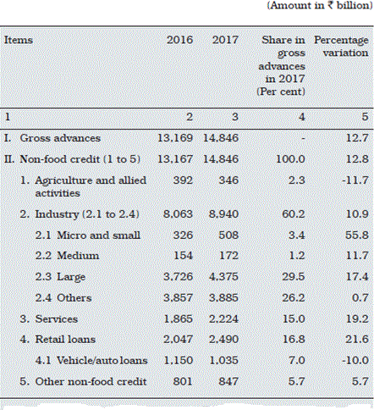

Ground-level understanding of MSME customers and their profile give NBFCs a cutting edge over the banks. They innovate and customize products according to customers’ needs more perfectly than traditional banks. The asset base of NBFCs has increased by 53.5% from 2012-to 2015. The total share of credit off-taking is expected to grow between 18-20% by 2020(Sunkara, 2016).

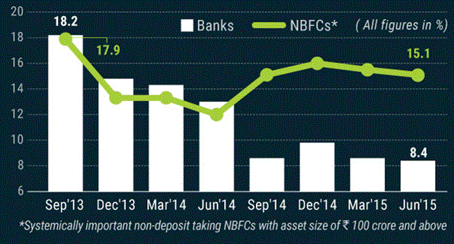

NBFCs have tremendous growth opportunities. Digital technology creates this scope. They can enhance their product portfolio, customer experience, and related processes by adopting digital technology. As India has a user base of 320 million customers in the smartphone market and is expected to increase in the future as well, it provides an opportunity for NBFCs to enrich their positioning of financial products. They can use

the vast customer data available on digital and social media platforms to improve customer serving. The creditworthiness of large and untapped market segments can also be found with help of this data which helps NBFCs increase their business. Online customer lending has grown from 3% in 2013 to 15% in 2015 providing scope to NBFCs to enter this space. Digital technology can help in identifying the individual, his intentions, and his ability to repay loans. NBFCs can increase customer satisfaction by using online calculators, knowledge centers, live chats, and live application tracking systems. Credit risk can be determined by analyzing data from mobile bill payments, browsing and download history, prepaid top-ups. NBFCs can enter into partnerships with banks and other related agencies to do robust data capturing. Psychometric tests can also be used to widen the customer base. They evaluate borrowers’ ability and willingness to pay (PwC &Assocham, 2015).

In this way, underserved consumers which are often neglected by traditional banks also get a chance to be eligible for small loans. Lenders can use this credit scoring to provide small ticket loans. For example, a Tanzanian mobile service provider Vodacom used First Access which is a data analytics company to develop and use credit scores from mobile data and provide loans to customers (Ascocham, 2016). The e-commerce business is expected to generate revenue of 120 billion USD by 2020. Further, the growing trend of online payments is expected to steer the e-commerce sector in India. This has generated a new breed of online lending platform. NBFCs can use this channel to generate more business (CRISIL, 2018).

# CHALLENGES

Around 82% of NBFCs registered with RBI are considered high-risk financial institutions. (Business today, 2018). NBFC faced deterioration in their asset quality on account of sluggish industrial growth. Both gross nonperforming assets (GNPAs) ratio and Net non-performing asset (NPA) ratio have increased from 2014 to 2017(RBI,2017). The NNPA ratio has increased from 2.5 in FY 2015 and 2016 to 4.1 in FY 2017. There has been inan creasing in GNPA ratio as well from 4.5 in FY 2016 to

6.1 in FY 2017.

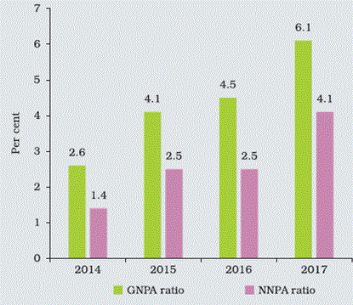

Figure – Number of registration and cancellations of NBFCs

The other challenge is while working on the online lending platform, it is difficult to predict the appropriateness of the online data. Data should represent the likelihood of repayment. It is difficult to integrate this alternate source of data with existing credit underwriting mechanisms. It is arduous to comply with data sources from social and digital media with government regulations. A kosher unification between different data sources is a must to reduce the default rate (Business Today, 2018).

## IMPORTANCE OF NBFCs IN INDIA

Non-Banking Financial Companies or NBFCs are playing a significant role in providing accessible and affordable financial services to the masses. They are becoming key players in boosting the living standards and financial awareness in the country. The NBFC players mainly target the business of granting loans, acquisition of shares, stocks, bonds, debentures, securities allotted by the government, leasing, hire purchase, etc. NBFCs are enabling Indian businesses, households, and self-employed individuals to be more financially confident and aware of the right financial solutions as per their requirements.

Industry Growth

The NBFC sector has had a tremendous growth graph during the past ten years. The sector has witnessed a rise in the Compound Annual Growth Rate, and many NBFCs have taken the lead and grown faster than many banking institutions in India.

The Return on Assets (RoA) of the NBFC sector has been on the rising side as compared to the Indian banking institutions. This is because of the lower operational costs, larger customer base, and digital presence of the NBFC players.

#### Importance of NBFCs in Promoting Inclusive Growth

NBFCs in India are playing a critical role in the development of the country by addressing the diverse financial needs of underserved customers who did not have access to banking services. Also, NBFCs are playing the leading role in providing more approachable and inclusive financial services to Micro, Small, and MediumEnterprises (MSMEs) by their entrepreneurial requirements.

NBFCs are playing a critical role in inviting more businesses and individuals from the low-income hierarchy to contribute to the development of the Indian economy. They are doing so by providing pushing more wealth creation, credit, and financial independence in rural regions. They are also working by the Indian government’s initiative of financial inclusion and supporting financially weaker sections of the society.

Infrastructure Lending

NBFCs are playing a centric role in Indian economic growth by lending financial assistance to infrastructure projects. These projects play a key role in the growth of a developing country like India. These projects usually involve a large number of funds, and the ROI is received over a long period. This makes infrastructure projects less attractive and riskier, making banking institutions skeptical about investing in them. However, NBFCs are contributing to infrastructure lending through their robust portfolio assessment abilities and risks management planning.

Credit to Micro, Small and Medium Enterprises – MSMEs

The Indian MSME sector has immense potential to grow and contribute to the economic growth and promotion of financial inclusion in rural and semi-urban regions in the country. However, a large segment of MSMEs is unable to access formal credit channels that provide safe credit solutions to them. NBFCs extend customizable loan solutions to this vast sector, allowing them to realize their business ideas and contribute to the country’s fiscal growth.

Contribution of NBFCs in Micro Finance

NBFC-MFIs are small finance companies that provide small-size, short-term loans to businesses and individuals. MFIs extend their financial solutions to the poorer sections in the rural regions and bridge the gap created by the commercial banks and private money lenders. NBFC-MFIs have emerged as growth enablers that extend financial services to the low-income generating section of the society, thereby promoting inclusive economic growth.

Improvement in the Standard of Living

NBFCs are allowing households and individuals to avail themselves of finer living standards for themselves by giving them the needed financial education and freedom. Improvement

in the standard of living of the large segment of individuals can propel the economic development and further allow entrepreneurs to grow

Growth in the Employment Sector

Non-Banking Financial Companies (NBFCs) are contributing significantly to the increase in employment opportunities in India. NBFCs are influencing MSMEs, self- employed professionals, and entrepreneurs to grow their businesses and hire more employees. NBFCs are helping this market to achieve its full business potential, allowing them to expand their operations and provide more employment opportunities and occupation practices.

Supporting Their Customers

NBFCs are regulated by the RBI, which requires them to implement adequate solutions to protect their customers. NBFCs prioritize the implementation of customer protection policies to safeguard them from any kind of deceptive, fraudulent, or unfair practices.

NBFCs also provide affordable interest rates, technology-driven processes, and channel connectivity to their clients to raise any kinds of queries or issues with the business for a prompt resolution.

NBFCs are also governed by the Master Directors by the Reserve Bank of India, which makes it mandatory for them to lay down a detailed strategic plan for risk management, audits, disclosure of information, maintenance of liquidity, transparency of operations, technology security, and much more.

Extent of Operations

NBFCs serve both individuals and businesses from different demographics. They serve a large market of undeserved entities and operate mostly via digital presence. This allows them to operate to a larger extent and serve a larger market.

Technology Innovation

The importance of NBFCs can also be highlighted in the fact that they are developing more innovative and tailor-made products for the diverse financial needs of their clients. NBFCs are revolutionizing the financial sector in India with their flexible products, affordable services, and multi-channel existence.

# FUTURE OF THE NBFC SECTOR

The banking sector would always remain an integral and core component of the economy due to the innumerable services and support they provide to businesses and individuals alike. Banks would remain the backbone of cash flow in the Indian economy and continue to dominate the financial market. However, despite this importance and criticality, the importance of NBFCs to improve the financial sector is undeniable.

NBFCs are playing an important role in the Indian economy, paving the way for a more inclusive and safer channel of financial assistance to all equally. NBFCs have a bright future in the Indian financial sector due to their innovative ideas, faster turnaround time in serving their customers, and more affordable and accessible solutions.

The NBFCs have become a priority sector for the RBI due to the role they play in creating a nexus between worthy financial solutions and a humongous unserved market in India.

The importance of NBFCsis also highlighted in the fact that they have garnered the trust of businesses and individuals quickly, with their robust operational strategies, constant connectivity, and efficient financial products. They are truly the game changers in the financial sector of India, who are contributing immensely to the financial inclusion of our diverse country as a whole.

Swart Advisors are comprised of a team of seasoned NBFC experts who can guide you at each step of your NBFC registration in India, NBFC compliance, NBFC Collaborations, Sale of NBFCs, Small Finance Company registration, and much more. At Swart Advisors, you can find a wide range of solutions to invest in India and establish your NBFC business effortlessly.

US and 264 percent in the UK. If one observes this fact that the largest segment in the banking sector is witnessing some challenges, then the opportunities to grow are expected to be higher.

Non-banking financial companies improved their performance on most metrics in the fiscal year 2015, as the banking industries struggled under the weight of a rising pile.

# FUNDAMENTAL ANALYSIS TOOLS

These are the most important tools of fundamental analysis

* Earning Per Share –EPS
* Price to Earnings Ratio – P/E
* Price to Book – P/B
* Dividend Payout Ratio
* Book Value
* Return on Equity

#### Ratio Analysis

Financial ratios are tools for interpreting financial statements to provide a basis for valuing securities and appraising financial and management performance.

A good financial analyst will build in financial ratio calculation extensively in a financial modeling exercise to enable robust analysis. Financial ratios allow a financial analyst to:

* Standardize information from financial statements across multiple financial years to allow comparison of a firm performance over time in a financial model.
* Standardize information from financial statements from different companies to allow an apples-to-apples comparison between firms of differing sizes in a financial model.
* Measure key relationships by relating inputs (costs) with output (benefits) and facilitates comparison of this relationship over time and across firms in a financial model.

In general, there are 4 kinds of financial ratios that a financial analyst will use most frequently, these are:

* Performance Ratios
* Working Capital Ratios
* Liquidity Ratio
* Solvency Ratio

These 4 financial ratios allow a good financial analyst to quickly and efficiently address the following questions or concerns

Performance Ratios

* What return is the company making on its capital investment?
* What are its profit margins?

Working Capital Ratios

* How quickly are debts paid?
* How many times is inventory turned?

Liquidity Ratios

* Can the company continue to pay its liabilities and debts?

Solvency ratios (longer term)

* What is the level of debt about other assets and equity?
* Is the level of interest payable out of profits?

#### Parameters for fundamental analysis of NBFCs

* Net Interest Margin(NIM): Net profit margin is the difference between the interest income that is paid to the lender
* Calculation Of Net Interest Margin: Net interest Margin investment Return-Interest expense / Average Earning Asset.
* Non-Performing Assets (NPA): NPA reflects the position of a bank’s loan portfolio look.
* Net Profit Margin: It is a profitability ratio that measures the amount of net income that is earned with each rupee of cash generated.
* Calculation of Net Profit Margin - Net profit / Sales
* Return on Assets (ROA): This is a significant indicator as it measures the performance of the bank.
* Calculation of ROA - Net profit /average total assets
* Return on Equity (ROE): This ratio calculates the rate of return that the owners of the stocks of a company receive as shareholders.

#### Financial Ratios

* Debt to Equity Ratio: DE = Total Liabilities / Shareholders Equity
* Current Ratio: CR = Current Assets / Current Liabilities
* Quick Ratio: QR = (Current Assets – Inventories)/ Current Liabilities
* Return on Equity: ROE = Net Income/Shareholder's Equity
* Net Profit Margin: NPM = Net Profit/Net Sales

#### Conclusion

Fundamental analysis is a significant step that individuals must take to understand a company. The analysis of NBFCs must be conducted before investing in it. NBFCs are major contributors and they have provided immense amounts of profits to the country.

# CHAPTER 3

### LITERATURE REVIEW

Recent literature highlights several significant features regarding the performance of Non-Banking Finance Companies (NBFC) in India. Some of the existing Indian and Foreign literature on the performance of NBFCs that are available from various sources Are reviewed here. Finally, based on the review, the research gap is identified for The present study.

# INDIAN STUDIES

1. Base, (1961), in his paper “Non-Banking Financial Intermediaries and Monetary Policy” explains that in India, the NBFC comprises a variety of institutions, which are defined under section 45 I (a) of the Reserve Bank of India Act, 1934. The author has discussed the nature of activities of the NBFCs. The paper also describes the types, monetary policies, and regulatory measures of NBFC.
2. Kantawala, (1997), in his study “Financial Performance of Non-Banking Finance Companies in India”, examined the performance of non-banking Financial companies for the period from 1985-86 to 1994-95. Based on Secondary data collected from different RBI bulletins regarding financial and investment companies, the study concluded that there was a significant difference in the profitability ratios, leverage ratios, and liquidity ratios of various categories of NBFCs. When the two categories were compared, the selected ratios were not statistically different from each other in the majority of the cases. When all the companies were taken together, the null hypothesis was accepted for only three ratios, indicating thereby that there was no significant difference. From

this, it can be inferred that the ratios for all categories of NBFCs were generally different from each other.

1. Bhargavi, (2004) in his study on “A Study on Performance of NBFCs Engaged in Leasing Business with Special Reference to Sundaram Finance Ltd., Chennai” found that all the sample companies had performed well except Tata Finance Ltd. Though these companies had faced recession during the period 2000-01, they had revived their performance in the subsequent period. After that, the companies had recorded better performance because they had diversified their activities. The study showed a decline in the performance of leasing companies. The main reason that can be held responsible for the downfall of the leasing industry was that capital-intensive industries which required huge plants and machinery were badly hit by recession during the period 2000-

01. The other reason was that companies had started to organize funds through loan and capital issues to procure assets.

1. Rani, (2008) in his thesis “Impact of Financial Sector Reforms on Non-Banking Financial Companies” studied the comprehensive legislation recommended by Narasimham Committee II which empowered RBI with extensive powers to manage the performance and existence of NBFCs. The study found that the growth rate of NBFC in respect of deposits continued to rise till the year 1997, but declined after 1998 as the regulatory framework in 1998 came as a source of extreme control to the genuine players in the market. However, it has been identified in the study that the main source of NBFCs had always been the acceptance of deposits.
2. Harikrishnan, (2008) in his thesis “Receivable Management in Nonbanking Finance Companies with special reference to vehicle financing” identified the key issues and problems in managing the receivable in respect of vehicle financing of NBFCs. For this purpose, the number of NBFCs and their deposits were taken for the period from 1971 to 2007. The data were collected from secondary sources. From the study, it was found that about 50 percent of the borrowers made repayment, 6.7 percent were defaulters from the very first installment, and the average cheque return was about 20 percent. Hardly 7 percent of them only contacted financiers by making alternate arrangements and it was seen that even a sizeable percentage of cheques of alternate payment made had bounced. About 3 percent of borrowers did not pay even a single

installment and 12 percent did not pay even 25 percent of the loan availed by them. This proved that there were problems in the repaying behavior of borrowers and it was concluded that the repaying behavior of borrowers was not satisfactory.

1. Bala and De (2009) in their paper entitled “NBFCs: A Major Show” showed that the NBFCs understudy had developed significantly and were even able to spread the financing activities considering the financing need throughout the country without having adequate security. NBFCs could reach the unorganized segments of society with their ability to provide innovative financial services. The NBFCs played a vital role in disbursing credit to the rural sector, thus preventing the concentration of credit risk in banks. The study also showed that in urban areas, NBFCs were also paying attention to non-salaried individuals, traders, transporters, and stockbrokers who were neglected by the banks.
2. Khan, (2010) in his study on “Non-Banking Financial Companies (NBFCs) in India: Functioning and Reforms” discussed the financial system in India emphasizing the activities of Non-Banking Financial Companies (NBFCs). The study covered the financial intermediaries including commercial banks, regional rural banks, cooperative banks, and NBFCs in India, and made a comparative analysis of their activities.
3. Gumparthi and Manickavasagam, (2010) in their paper “Risk Assessment Model for Assessing NBFC (Asset Financing) Customers” attempted to construct a risk assessment model for NBFCs based on market forces. The study found 28 parameters (ratios and factors) to determine the risk associated with the customer satisfaction and payment settlement system. The study found that out of 28 parameters only 12 parameters were found important in the assessment of the risk of financing.
4. Saravanan and Haneef (2011) in their paper “SWOT analysis of NBFCs in the global scenario” developed different strategies for NBFCs that took into account the SWOT analysis and constructed a matrix with those strategic factors. Strategies that could be worked out by those NBFCs were illustrated by SWOT (Strengths, Weaknesses, Opportunities, and Threats) matrix in the four quadrants with some illustrative examples. An attempt was made where the opportunities were compared with

apparent strength and weaknesses. Similarly, the threat was compared with strengths and weaknesses to suggest appropriate strategies. From the SWOT Analysis, it was clear that NBFCs could themselves take steps to minimize their weaknesses and face all the threats by making better use of their strengths and opportunities, identified by them. The area where effective intervention was required was the debt recovery for which support and back-up of the Government were required.

1. Sharma and Goel (2012) in their study on “Functioning and Reform Nonbanking Financial Companies in India” stated that Non-Banking Financial Companies (NBFCs) offered, in some cases, banking services, such as loans and credit facilities, retirement investment planning, money market activities, underwriting and merger activities and described the features of those services. Those companies played a vital role in providing credit to the unorganized sector and the small borrowers at the rural level. Hire purchase finance was found to be the largest activity of NBFCs. The rapid growth of NBFCs had led to a steady increase of dividing lines between banks and NBFCs, except the exclusive opportunity that commercial banks exercised in the Issuance of cheques.
2. Syal and Goswami (2012) in their study on “Financial Evaluation of NonBanking Financial Institutions: An Insight” analyzed the financial performance and growth of non-banking financial institutions in India during the period 2007 to 2011. The study was carried out on secondary data. The study found that the Indian financial system consisted of various financial institutions, financial instruments, and financial markets that facilitated and ensured effective channelization of payment and credit of funds from the potential investors of the economy. Non-banking financial institutions in India were some major stakeholders of that financial system and catered to the diversified needs by providing specialized financial services across the country. Those financial services mainly included investment advisory, leasing, micro-financing, hire purchase, asset management, etc.

# FOREIGN STUDIES

1. Koros (2001) in his research paper “An evaluation of the financial performance of non- banking financial institutions that converted into commercial banks in Kenya” evaluated the performance of Non-banking financial institutions (NBFIs) that were converted into full-fledged commercial banks. The data used covered 10 years and were collected from the Nairobi Stock Exchange (NSI) for the quoted companies while for the others, data were collected from annual publications or directly from the institutions. The study showed declining trends in most of the performance indicators, though, however, the trends were not statistically significant. The findings also indicated that the policy modification by the regulators in respect of the NBFIs showed inflexibility in the cash ratios and capital adequacy. This was due to ignorance of more fundamental issues that the NBFIs had failed to manage properly while adopting a conversion policy.
2. Cheema and Shah (2006) in their research paper “The Role of Mutual Funds and Non- Banking Financial Companies in Corporate Governance in Pakistan attempted to concentrate on the increasing importance as an investment vehicle, and their potential role in promoting better corporate governance. The Securities and Exchange Commission of Pakistan (SECP) had introduced a new framework for the regulation of mutual funds and their associated Non-Banking Financial Companies (NBFC). The State Bank of Pakistan (SBP) regulated and supervised the Non-Banking Financial Institutions (NBFI) before the implementation of separate NBFC rules. In December 2002, the responsibilities for the regulation and supervision of NBFIs were transferred from the SBP to the SECP by the recommendations of the Joint Committee for Reconstruction (JCR) of NBFIs in Pakistan. The Banking Companies Ordinance (BCO), 1962, and the Companies Ordinance (CO), 1984 were amended to attain this rebuilding. The SECP, in promulgating the NBFC Rules, gave privilege to the concept of the NBFCs, which brought together in one regulatory framework to serve all non- banking services including investment banking, venture

capital financing, asset-liability management, and investment advisory services. The study concluded that the SECP should be familiar with the implication of mutual funds and related NBFCs for better corporate governance and the role that they could have played in developing the investors’ confidence in the securities markets.

1. Islam (2007) in his thesis “The role of non-bank financial intermediaries (NBFIs) in economic growth (1971-2004): An empirical case study of Malaysia” discussed that NBFIs in Malaysia comprised broadly 4 groups of

Institutions, namely, the provident, pension, and insurance (together also called contractual savings, PPI) funds, development financial institutions (DFIs), savings institutions (SIs), and a group of other non-bank financial institutions (OFIs). They played a vital role in creating and enhancing opportunities to equip the financial intermediation for the economy. The most prominent function through which NBFIs performed a growth-stimulating role was the direct help to the development of the capital market by making available those long-term financial resources to productive investments, which were in general inappropriate for the banking system, particularly for the commercial banks. The reason behind that was that the financial assets that NBFIs mobilized were mainly long-term in nature which were channeled to the economy via direct participation in equity, bonds, Government bills, or securities. This enhanced capital market depth also eased the stress of liquidity risk of the firms and entrepreneurs with competitive costs. The findings of the study suggested that a well- developed financial system had positive impacts on the economic growth of Malaysia. However, distinct from banks and stock market development, the role of NBFIs in Malaysia was found to be an influencing factor for the overall economic development of thecountry. Finally, the study showed that the growth in NBFIs in respect of some selected performance indicators had a beneficial impact on economic growth in Malaysia both directly (in the case of private and small credit) and indirectly through motivating investment channels (in the case of NBFIs assets).

1. Zagaris (2007) in his paper entitled “Problems Applying Traditional AntiMoney Laundering Procedures to Non-Financial Transactions, ‘Parallel Banking Systems’ and Islamic Financial Systems” considered the distinctive and even positive nature of hawala and other informal fund transfer systems (IFTs) in the developing world. Reviewing primary and secondary reports from national regulators, international

organizations, and academics, the paper examined the conventional view that IFTs should be subject to extensive regulation and scrutiny because they have been abused by some participants. Many positive characteristics of hawala like speed, transaction cost, cultural convenience, and versatility also contributed to their mistreatment. The paper examined the modern uses of hawalas, including legitimate remittances from migrant workers, humanitarian and emergency-aid, personal investments and illegitimate money laundering, terrorism financing, tax, and customs evasion, circumventing exchange controls applications indicating the non-banking institution being involved in it. The paper also discussed legal issues involving IFTs in developing and developed countries. The factors of designing regulatory systems should consider the international community in respect of these transactions by non-banking institutions. The paper reviewed developing world IFT regulation in the UAE, Afghanistan, Somalia, the Eastern and South African Anti-Money Laundering Group, and Columbia, and developed world regulation in the Netherlands, the UK, and the USA. The paper concluded that IFTs were strong in jurisdictions where formal banking systems were absent or weak, or where structural obstacles distorted foreign exchange and other financial markets. The paper also considered the various aspects of licensing or registration requirements and the rationale for choosing over those instruments and the need for the competent authority of due diligence on IFT operators and control in respect of the functioning of non-banking institutions associated with them, especially in the Islamic Financial Systems.

1. Sufian (2009) in his research paper titled “Determinants of non-bank financial institutions' profitability: empirical evidence from Malaysia” analyzed the determinants of profitability measured by selected ratios for NBFIs in Malaysia as well as in some other developed countries. The study found that NBFIs in Malaysia had exhibited a higher risk with a lower profitability lev. On the other hand, the large Malaysian NBFIs in terms of the business volume showed high operational overhead expenses but exhibited relatively higher profitability performance, thus supporting the expense preference behavior hypothesis.
2. Ahmed, Khalil, and Group (2011) in their study “Financial Performance of Non- Banking Finance Companies in Pakistan” analyzed the financial performance of non-

bank finance companies (NBFCs) which were providing Investment Advisory Services (IAS), Asset Management (AMS), and Leasing and Investment Finance (IF). The study had been carried out for two years from 2008 to 2009. The traditional ratio analysis method was used to analyze the financial performance of non-bank financial institutions. The study concluded

That the performance of NBFCs adopting selected performance indicators was

Better in the year 2008 than in the year 2009. BaThe performance showed a declined situation in the year 2009. The study also suggested various factors for the decline in the performances in the year 2009 as compared to the year 2008 and recommended different initiatives to be taken to improve the performances of NBFCs.

1. Rahman and Farah (2012) in their research paper on “Non-Bank Financial Institutions’ Profitability Indicators: Evidence from Bangladesh” examined the indicators of the profitability of the companies involved in the activities of the Non-Banking Financial Institution (NBFIs) sector of Bangladesh. The study had been carried out by using the data of 30 NBFIs in Bangladesh for the period 2006 to 2008. The data had been collected from secondary sources. The study had been carried out by using Net Profit as the dependent variable and Current Asset, Financial Cost, long term liability, Interest Income, and other operating income as independent variables. The analysis also showed that liquidity position and operating efficiency had a significant impact on the profitability of the NBFI sector in Bangladesh. The results of the statistical analysis of multiple regressions and simple regression showed Consistent results for all the selected variables. The results that were statistically significant in all the cases provided an overall idea that liquidity was the primary determinant of profitability in the NBFI sector. The study concluded that the NBFI had been a promising and prospective financial service sector in Bangladesh.
2. Khandoker, Raul, and Rahman (2012) in their study “Determinants of profitability of Non-Bank Financial Institutions in a developing country: Evidence from Bangladesh” attempted to identify the major financial factors and most significant influencing variable that affected the profitability of the NBFC sector in Bangladesh. The data had been collected from secondary sources. The study found that the selected profitability determinants had a significant impact on net profit margin. But among all selected

independent variables considered in the study, only total asset, amount of deposit, operating

Revenue and operating expenses had a significant impact - some positive and some negative - on the profitability of the Non-Banking Financial Sector (NBFC) in Bangladesh. These results had been treated as sufficient impact to determine the overall profitability of the NBFCs in Bangladesh. The study also suggests various measures for managers to improve the financial performance NBFIs in

Bangladesh.

1. Costea, Adrian (2012) in his paper “Evaluating the Performance of NonBanking Financial Institutions by the Means of C-Means Algorithm” described the concept of C-Means as a statistical clustering technique first proposed by Mac Queen (1967). The goal of the C-Means algorithm was to minimize the sum of the variances within clusters. In this experiment, the study assessed the performance of different Non- Banking Institutions (NFIs) in Romania. NFIs included all the financial institutions other than banks that were engaged in lending activities in specialized schemes. The study was carried out for the period from 2007 to 2010. After considering the performance dimensions of the NFIs, the study selected a ratio for each dimension based on the analysis of the annual financial statements of the NFIs. It has been noted in the study that the state-of-art of using the existing Computational Intelligence (CI) methods had been used in the process of financial performance benchmarking to apply them in the performance assessment of non-banking financial institutions (NFIs). The study applied C-Means on the selected NFIs’ data set to assess the Performance and then compared the results with the results obtained by applying a neural network-based clustering algorithm, called the Self-organizing Map (SOM) algorithm. From the analysis of the C-Means, it has been found that in Romania NFIs were more involved in the activity of financial leasing. However, the study also suggested that the visualization capability of SOM should be taken into account while analyzing the performance evaluation for a long period.
2. Costea, Adrian (2013) in his research paper “Performance benchmarking of Non- Banking Financial Institutions using self-organizing map algorithm” compared the performance of Non-Banking Financial Institutions (NBFIs) in Romania by

constructing a benchmarking model based on predetermined selective measures in the form of two-dimensional Self-organizing Maps (SOM). The study showed how one Data Mining technique, namely, the SOM algorithm, could be used in determining the NBFIs’ performance benchmarking based on several financial (profitability, liquidity, and coverage) ratios that covered different performance dimensions. It included the measures of capital adequacy, assets quality risk, and overall profitability. It was seen that for the selected companies, data analysis showed a marginal drop in the performance of NFIs in 2009 as compared to that in 2008. The global financial crisis in the year 2009 also affected the financial performance of NBFIs in Romania. But the auto sales industry activities as supported by NBFIs were not affected in the year 2009. The study suggested the application of the neural networks model (NNM) to evaluate the comparative financial performance of NBFIs. It also suggested that with the effective application of this model, investors would be able to evaluate alternative investment opportunities.

### RESEARCH GAP

From the literature review, the following gaps have been identified:

* + Majority of the studies have been carried out in the context of various regulatory norms and strategies adopted by NBFCs which are theoretical.
  + Few studies were empirical. All those studies attempted to analyze the financial performance of NBFCs in India using primary data and that too in most of the cases over very short periods.
  + Most of the previous studies focused on the performance of very few companies using primary data on various deposits schemes and advances collected from individual customer-respondents.
  + Very few studies focused on both the categories of NBFCs after reclassification and, therefore, we hardly get any idea about the relative performance of these two categories of NBFCs during the post-classification period.
  + Very few studies have been conducted till now at the aggregative level helping us to get an idea about the performance of NBFCs in general.

# CHAPTER 4

## Data Analysis, Interpretation, and Presentation

### AGE-WISE CLASSIFICATION

|  |  |  |
| --- | --- | --- |
| OPTIONS | RESPONDANTS | PERCENTAGE |
| 18-25 | 32 | 45.7% |
| 26-32 | 18 | 25.7% |
| 33-40 | 15 | 21.4% |
| 41& ABOVE | 5 | 7.1% |
| TOTAL | 70 | 100% |

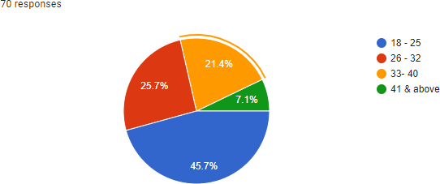

INTERPRETATION

* + 45.5% Of Respondents are the age group of 18-25
  + 25.7% Of Respondents are the age group of 26-32
  + 21.4% Of Respondents are the age group of 33-40
  + 7.1% Of Respondents are the age group of 41 & above

### OCCUPATION WISE CLASSIFICATION

|  |  |  |
| --- | --- | --- |
| OPTIONS | RESPONDANTS | PERCENTAGE |
| EMPLOYED | 45 | 64.3% |
| NON-EMPLOYED | 25 | 35.7% |
| TOTAL | 70 | 100% |

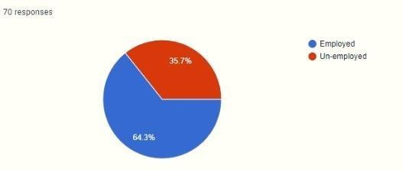

INTERPRETATION

* + 64.3% Of Respondents are employed
  + 35.7% Of Respondents are Unemployed

### INCOME WISE CLASSIFICATION

|  |  |  |
| --- | --- | --- |
| OPTIONS | RESPONDANTS | PERCENTAGE |
| BELOW 2 LAKH | 32 | 45.7% |
| 2-5 LAKH | 18 | 25.7% |
| 5 LAKH AND ABOVE | 20 | 28.6% |
| TOTAL | 70 | 100% |

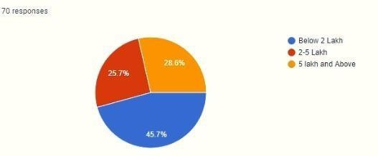INTERPRETATION

* + - 45.7% of respondents are having income below 2 lakh
    - 25.7% of respondents are having income between 2-5 lakh
    - 28.6% of respondents are having income above 5 lakh

### WHAT IS FUNDAMENTAL ANALYSIS

|  |  |  |
| --- | --- | --- |
| OPTIONS | RESPONDANTS | PERCENTAGE |
| Evaluating the value | 19 | 27.10% |
| The factor that influences the  price | 15 | 21.4% |
| Both | 36 | 51.4% |
| TOTAL | 70 | 100% |

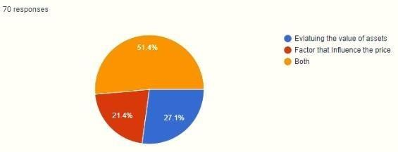

INTERPRETATION

* + 27.10% of the respondents think that evaluating the value of assets is a fundamental analysis.
  + 21.4% of the respondents think that factor that influences the price is fundamental analysis
  + 51.4% of the respondents think that both values of assets and factors that influence the price is known as fundamental analysis

#### Who uses the fundamental analysis

|  |  |  |
| --- | --- | --- |
| OPTIONS | RESPONDANTS | PERCENTAGE |
| Company | 32 | 37.10% |
| Investor | 26 | 45.7% |
| Institution | 12 | 17.1% |
| TOTAL | 70 | 100% |

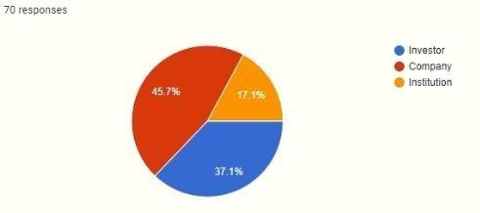

INTERPRETATION

* + 37.10 % of the respondents think that investors do the fundamental analysis
  + 45.7% of the respondents think that companies do the fundamental analysis
  + 17.1 % of the respondents think that institutions do the fundamental analysis

### WHAT ARE THE PARAMETER OF FUNDAMENTAL ANALYSIS?

|  |  |  |
| --- | --- | --- |
| OPTIONS | RESPONDANTS | PERCENTAGE |
| Net interest margin | 17 | 24.3% |
| Return on Asset | 17 | 24.3% |
| Net profit margin | 8 | 11.4% |
| All of the above | 28 | 40 % |
| Total | 70 | 100% |

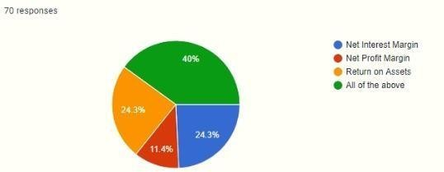

INTERPRETATION

* + 24.3 % of the respondents think that net interest margin is the parameter of fundamental analysis
  + 11.4% % of the respondents think that net profit margin is the parameter of fundamental analysis
  + 24.3% of the respondents think that return on assets is the parameter of fundamental analysis
  + 40% of the respondents think that all of the above is the parameter of fundamental analysis

#### Do u know the technique of fundamental analysis?

|  |  |  |
| --- | --- | --- |
| OPTIONS | RESPONDANTS | PERCENTAGE |
| Yes | 18 | 25.7% |
| No | 29 | 41.4% |
| Maybe | 23 | 32.9% |
| TOTAL | 70 | 100% |

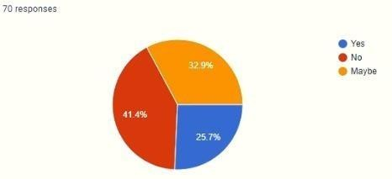

INTERPRETATION

* + 25.7 % of the respondents know the technique of the fundamental analysis
  + 41.4% of the respondents know the technique of the fundamental analysis
  + 32.9% of the respondents know the technique of the fundamental analysis

### WHAT ARE THE TECHNIQUE OF FUNDAMENTAL ANALYSIS?

|  |  |  |
| --- | --- | --- |
| OPTIONS | RESPONDANTS | PERCENTAGE |
| Quantitative analysis | 13 | 18.6% |
| Qualitative analysis | 07 | 10% |
| The bottom line | 13 | 18.6% |
| All of the above | 37 | 52.9% |
| Total | 70 | 100% |

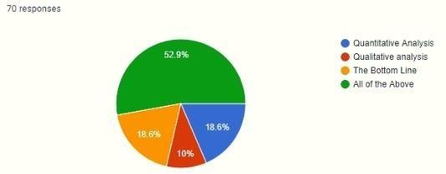

INTERPRETATION

* + 18.6 % of the respondents think that quantitative analysis is the technique used for fundamental analysis
  + 10 % of the respondents think that quantitative analysis is the technique used for fundamental analysis
  + 18.6% of the respondents think that quantitative analysis is the technique used for fundamental analysis
  + 52.9% of the respondents think that quantitative analysis is the technique used for fundamental analysis

1. **DO YOU KNOW WHAT AN NBFC IS?**

|  |  |  |
| --- | --- | --- |
| Option | RESPONDENTS | PERCENTAGE |
| YES | 39 | 55.7% |
| NO | 31 | 44.3% |
| TOTAL | 70 | 100% |

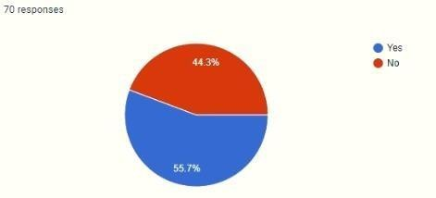

INTERPRETATION

* + 55.7% of the respondents know what is an NBFC
  + 44.3% of the respondents know what is an NBFC

#### What are the activities of NBFC?

|  |  |  |
| --- | --- | --- |
| OPTION | RESPONDENTS | PERCENTAGE |
| BANKING SERVICES | 22 | 32.8% |
| WITHOUT HOLDING BANK LICENSE | 12 | 17.9% |
| CAN ACCEPT DEPOSITS | 12 | 17.9% |
| PART-PAYMENT AND SETTLEMENT | 9 | 13.4% |
| CAN ISSUE CHQ DRAWN ON ITSELF | 12 | 17.9% |
| Total | 70 | 100% |

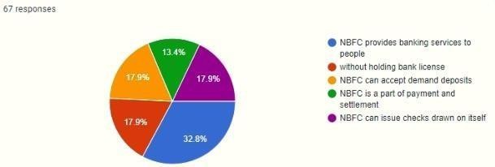

INTERPRETATION

* + 32.8 % of the respondents think that NBFC provides banking services to the people
  + 17.9 % of the respondents think that NBFC works without holding a bank license
  + 17.9% of the respondents think NBFC can accept the deposit
  + 13.4% of the respondents think that NBFC is part of payment and settlement
  + 17.9% of the respondent think that NBFC can issue check drawn on itself

#### Do u know the difference between NBFC vs. Banks?

|  |  |  |
| --- | --- | --- |
| Option | RESPONDENTS | PERCENTAGE |
| YES | 45 | 64.3% |
| NO | 25 | 35.7% |
| TOTAL | 70 | 100% |

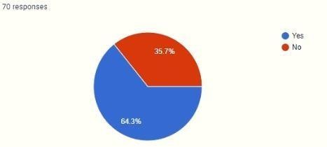

INTERPRETATION

* + 64.3% of the respondents know the difference between NBFC and bank
  + 35.7%% of the respondents know the difference between NBFC and bank

#### Who is the regulator of NBFC?

|  |  |  |
| --- | --- | --- |
| OPTION | RESPONDENTS | PERCENTAGE |
| RBI | 34 | 48.6% |
| SEBI AND RBI | 23 | 32.9% |
| IRDA | 10 | 14.3% |
| SEBI | 3 | 4.2% |
| Total | 70 | 100% |

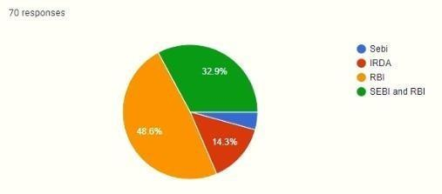

INTERPRETATION

* + 48.6% of the respondents think that RBI is regulatory of the NBFC.
  + 14.3% of the respondents think that IRDA is regulatory of the NBFC
  + 4.3% of the respondents think that SEBI is regulatory of the NBFC
  + 32.9% of the respondents think that RBI AND SEBI is regulatory of the NBFC

#### Rank the following top NBFC

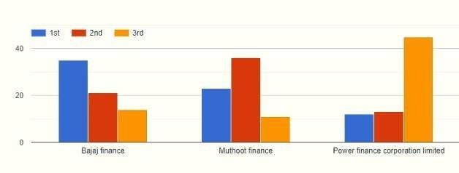

INTERPRETATION

* + 35% OF RESPONDENTS THINK THAT IT RANK 1ST
  + 36% OF RESPONDENTS THINK THAT IT RANK 2ND
  + 45% OF RESPONDENTS THINK THAT IT RANK 3RD

### DATA ANALYSIS

Data has been presented and analyzed using tables, graphs, and statistical tools. The various indicators of financial performance of NBFCs viz income, expenses, tax provisions, operating profit, net profit, total assets have been taken and analyzed for the last 4 financial years. Apart from this various ratios are also analyzed. The following table shows the various financial indicators from the financial year 2013- 14 to the financial year 2016-17

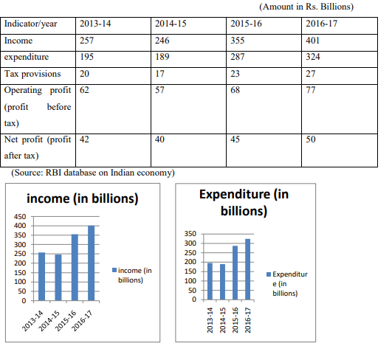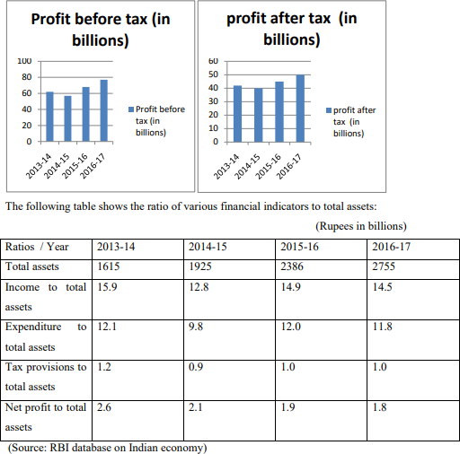

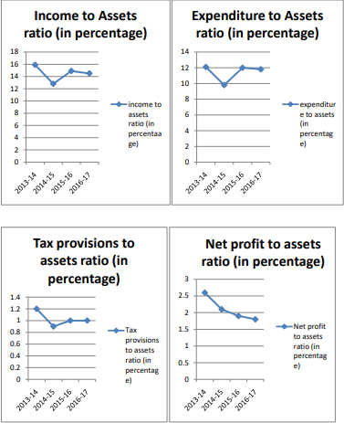

# FINDING

* + The Income of NBFCs from various sources decreased in the financial year 2014-15 as compared to the year 2013-14 but it is increasing in the year 2015- 16 and 2016-17.
  + The expenditures of NBFCs also decreased in the financial year 2014-15 as compared to the year 2013-14 but it is increasing in the year 2015-16 and 2016-17.
  + NBFCs are contributing to the economic development of the country in form of taxes.
  + However their tax provisions fall in the year 2014-15 as compared to the year 2013-14 but tax provisions are increasing in the year 2015-16 and 2016-17.
  + Both profits before taxes and profit after taxes fall in the year 2014-15 as compared to 2013-14 but rise in the year 2015 onwards. Total Assets of NBFCs are continuously increasing from 2013-14 till 2016-17.
  + The ratio of Income to total assets fall in the year 2014-15 as compared to 2013-14, irises in the year 2015-16, and again fall a bit in the year 2016-17. The ratio of expenditure to total assets fall in the year 2014-15 as compared to 2013-14, it rises in the year 2015-16 and again fall in the year 2016-17.
  + The ratio of tax provisions to total assets falls in the year 2014-15 as compared to 2013- 14, it rises in the year 2015-16 and remains constant in the year 2016- 17.
  + The ratio of Net profit to total assets is falling from the year 2014-15 onwards

# CHAPTER 5

**CONCLUSION AND SUGGESTIONS**

## Conclusion

A firm fundamental or intrinsic value is well determined by information reflected in the financial statement. Sometimes stock prices do not reflect promptly and or correct all such information and thus, deviate from fundamental values. The predictive approach relies on discovering accounting data that are not reflected in stock price and thus, helps predict future price stock price adjustment as market value gravitates later to fundamental values (2009).

A firm's value reflects, according to this approach its ability to generate positive future earnings, financial statements provide fundamental signals that are purported to inform the direction of future earnings, simple can shift the distribution of returns earned by an investor by separating eventual winner stocks from loser stocks. This discrimination seems to be possible according to the results of the fundamental strategy.

This study will help anyone with minimum knowledge about the stocks to choose the correct stock. Also, they will be able to analyze the basics on the spot with the help of quantitative factors which are readily available.

# OVERALL CONCLUSION

Individual company-wise analysis, as well as aggregative analysis of the structure of assets and liabilities of both the categories of NBFCs, show the almost same pattern of movement over the study period as far as main components like short term borrowings and financing, long term borrowings, and financing, and investments are concerned. About the main objectives of the study, i.e., growth of performance indicators (assets, liabilities, and selected ratios) under different categories of NBFCs, we find satisfactory results in respect of the growth of assets and liabilities at an aggregative level as well as company wise level. But dissatisfactory results are found in respect of the growth of different ratios as performance indicators of NBFCs.

Despite significant growth of assets and liabilities, we find a lower rate of returns; so

it indicates inefficient management of earning components (revenue and expenditure) during the

study period both at an aggregative level as well as company-wise level. It is also found in our study that the capital structure of the NBFCs is not managed in the way it should have been. In this respect, it is observed that the overall management of long-term solvency (DE Ratio) and short-term solvency (CR) position of the NBFCs Summary, Conclusions, and Suggestions are found to be dissatisfactory. The most interesting fact is that more or less the same pattern is noted for the companies under each category. Therefore, keeping the risk profile of the NBFCs at a minimum level and maximizing the wealth of the NBFCs, demands sound financial management. On

the analysis of selected profitability indicators (i.e., ROCE, ROA, ROE, and NPR), all the key ratios that are highly applicable for NBFCs are also found to be threatening in respect of their growth and average performance. The same result is also found for each category of NBFCs. So far as the performance assessment of each category of NBFCs is concerned, it is found that there is no significant difference between the average performances for the majority of the performance indicators of each category of NBFCs at the aggregative level. However, it is found that significant difference concerning selected performance indicators exists within the companies under each category of NBFCs. Considering the present operating position of the NBFCs, the DEA reveals that only 28% (approximately) of our sample companies are efficient but the only positive aspect is that they need some moderate modifications in respect of their financial health components, earning components, profitability ratios, and solvency ratios to become efficient.

SFA model has been used to measure the overall efficiency of the selected ICs and AFCs and to identify the factors contributing to different efficiency levels of the company. It is observed that the input variable ‘EC’ has an impact as a stochastic impulse on the efficiency level of the selected ICs and AFCs. As the overall mean efficiency of the selected ICs and the selected AFCs is less than the efficiency norm, they need to be enhanced with their given levels of inputs to become efficient. In this respect, it is found that the exiting level of efficiency varies more widely for the AFCs than for the ICs although both are operating below the efficiency level. From cross- tabulation analysis concerning DEA, one interesting thing is observed the probability of becoming efficient by the AFCs is slightly higher than ICs. On the whole, it can be said from our study that there is no difference between the performances of each category of NBFCs, even though there exists a difference

Like their activities.

#### Limitations of the Study:

* The study is based on secondary data. So it is subject to all the limitations that are inherent with secondary data.
* The interest income and interest expenses, which are the major components in the financial statements of NBFCs, are mainly related to long-term and short- term loans financing and borrowings. But the financial statements and their schedules of the selected NBFCs under study have no separate disclosure of interest on long-term loans and interest on short-term loans. Due to the non- availability of data in this regard, further analysis of the performance assessment of NBFCs could not be carried out concerning some relevant ratios.
* The study is based on a small sample although adequate for the analysis of our study.

## Suggestions/Recommendations for improvement of the performance of the NBFCs

1. The NBFCs should follow proper disclosure in preparation of schedules of the financial statements as per the required formats available in the Companies Act, 1956/Companies Act, and 2013.
2. The rates of return, measured by ROCE and ROA in particular, of the NBFCs, are found to be very low in our study. Hence, the recommendation that may be offered here is that the NBFCs should manage the earning components effectively in respect of the capital employed to increase the overall profitability of the shareholders.
3. The NPR of the NBFCs is also found to be low during the period of study. Therefore, the NBFCs should concentrate more on generating higher proportions of profit in terms of their total revenues.
4. The NBFCs should manage their capital structure effectively in terms of using external funds to make a proper balance between operating leverage and financial leverage to keep the risk profile of the NBFCs to the minimum.
5. The NBFCs have maintained a relatively higher level of CR during the study period. So, the NBFCs should maintain a reasonable level of liquidity in order Summary, Conclusions, and Suggestions to maximize the benefit of higher profitability by employing the excess fund in profitable activities.
6. Most of the NBFCs are under-performing in respect of their management of input and output factors; which are quite evident from our DEA and SFA analyses. So, attention should be given by the management to make their financial management more effective by focusing on the inputs that are responsible for the underperformance of the companies.
7. In India, most of the NBFCs are operating as private limited companies. So, they don’t need to publish their annual accounts. However, it is suggested that they would publish some key annual information on financial activities so that the stakeholders and beneficiaries of the NBFCs can get a few more useful financial information about the NBFCs. This will act as a marketing tool to encourage their

stakeholders and beneficiaries to get them more financially associated with NBFCs. This will increase the volume of business of the NBFCs.

1. RBI issues a list of NBFCs only. It is suggested that RBI should publish financial information in aggregate as well as in disaggregate forms. This will help the investors to make correct financial decisions concerning their investment decisions.

# CHAPTER 6

**BIBLIOGRAPHY**

* + [https://www.icsi.edu/media/portals/86/manorama/DBIMS%20Journal](https://www.icsi.edu/media/portals/86/manorama/DBIMS%20Journal%20.pdf)

[%20.pdf](https://www.icsi.edu/media/portals/86/manorama/DBIMS%20Journal%20.pdf)

* + [http://euroasiapub.org/wp-content/uploads/2016/12/1ESSNov-4112-](http://euroasiapub.org/wp-content/uploads/2016/12/1ESSNov-4112-1.pdf) [1.pdf](http://euroasiapub.org/wp-content/uploads/2016/12/1ESSNov-4112-1.pdf)
  + http://inet.vidyasagar.ac.in:8080/jspui/bitstream/123456789/5584/11/1 1_chapter_2.pdf
  + <http://www.econjournals.com/index.php/ijefi/article/viewFile/7220/pdf>
  + <https://www.investopedia.com/terms/f/fundamentalanalysis.asp>
  + [https://adityakhandekar.wordpress.com/2008/10/08/non-banking-](https://adityakhandekar.wordpress.com/2008/10/08/non-banking-financial-companies-in-india-nbfc-a-perspective/) [financial-companies-in-india-nbfc-a-perspective/](https://adityakhandekar.wordpress.com/2008/10/08/non-banking-financial-companies-in-india-nbfc-a-perspective/)

# CHAPTER 7

**ANNEXURE**

1. Name
2. Age
   * 18-25
   * 26-32
   * 33-40
   * 41 & above
3. Occupation
   * Employed
   * Un-Employed
4. What is your annual income?
   * Below 2 Lakh
   * 2-5 Lakh
   * 5 lakh and above
5. What is fundamental analysis?
   * Elating the value of assets
   * Factor that Influences the price
   * Both
6. Who uses fundamental analysis?
   * Investor
   * Company
   * Institution
7. What are the parameters of fundamental analysis?
   * Net Interest Margin
   * Net Profit Margin
   * Return on Assets
   * All of the above
8. Do you know the Technique of Fundamental Analysis?
   * Yes
   * No
   * Maybe
9. What is the Technique of Fundamental Analysis?
   * Quantitative Analysis
   * Qualitative analysis
   * The Bottom Line
   * All of the Above
10. Do you know what an NBFC is?
    * Yes
    * No
11. If yes then, what are the activities of NBFC?
    * NBFC provides banking services to people
    * Without holding a bank license
    * NBFC can accept demand deposits
    * NBFC is a part of payment and settlement
    * NBFC can issue checks drawn on itself
12. Do you know the difference between banks & NBFCs?
    * Yes
    * No
13. Who is the regulator of NBFC?
    * Sebi
    * IRDA
    * RBI
    * SEBI and RBI
14. Rank the following the top NBFC?
    * Bajaj finance
    * Muthoot finance
    * Power Finance Corporation limited