*A Research Paper on*

*“Cashless Economy Pre and Post Covid”*

*Submitted to*

*HSNC University, Mumbai for*

*Third Semester of Masters in Commerce (Banking and Finance)*

*Submitted by: Pawan Khatri*

*Roll no. 33*

*SY Mcom (Banking & Finance)*

*Mumbai*

*November 2024*

*Cashless Economy Pre and Post Covid19*

Abstract

In the age of COVID-19, many of us feel more squeamish about paper money and the germs that may be hitching a ride on it. Across the world, people are using way less cash. But the pandemic only accelerated a trend that was well underway, with the rise of contactless cards and digital payment apps making a cashless society more appealing than ever.

Keywords - Covid-19, Cashless transaction, RBI, E-Banking, Locked Down Online transaction

Introduction

Digital payments had started in India much before the Covid 19 pandemic. According to Razorpay’s ‘The Era of Rising Fintech’ report, between 2018-2019, digital payments in India grew by 383 percent. In 2020, Covid 19 forced institutions worldwide to rethink contact with any questionable surfaces, including people too, digital transactions started picking up in May mainly because of the fear of handling contaminated cash transactions. It was convenient to use digital payments which also promised greater transparency and less dependency on middle-men and banking monopolies.

Electronic payment has become the norm for everyday commerce and physical money may soon become a thing of the past. In the financial year 2019, India’s digital payments market was valued at **INR 1,638.49 trillion** which is expected to further go up to **INR 4,323.63 trillion** by 2024.

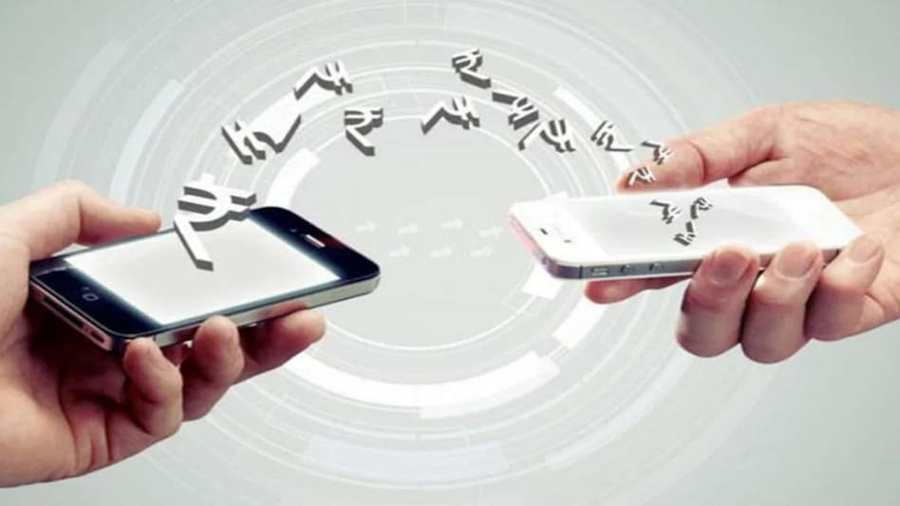

Literature Review

In the current COVID-19 situation, the digital payments sector witnessed a decline of 30 per cent in the transaction value, and recent data made available from National Payments Corporation of India (NPCI) attest to a sharp decline observed in the months when lockdowns were initiated (primarily due to the impact on the travel, hospitality and retail sectors). However, Government and regulator have pushed digital payments in such times by means of National electronic funds transfer (NEFT), Immediate payment service (IMPS), UPI, BHIM etc. so as to avoid usage of physical cash which has higher risk element of COVID-19 transmission.

**Jain**, **Sarupria** and **Kothari** (2020): studied “the Impact of COVID-19 on E-wallet’s payments in Indian economy” and analysed that happening of COVID-19 has brought a great boost for the Indian economy especially for the sectors like food and beverages, entertainment and others. The services of digital payments have seen huge growth that is from 5 per cent to 30 per cent after the happening of demonetarisation also with continuous efforts of government towards economy. There is a big contribution by entertainment and hospitality industry which is approximately 40 per cent to the economy which is helping for growth.

**Thirupathi**, **Vinayagamoorthi** and **Mathiraj** (2019): studied the concept of “Effect of Cashless Payment Methods: A case study perspective analysis” and quoted that several financial institutions and banks are getting interlinked with a system of digital payments by every day. This linkage assists Indian government in attaining economic prosperity and growth which can be seen due to effect of demonetization. They analysed that there is a presence of electronic payment only lesser than 5% of total and near about 26 per cent of the population has an access to internet. They further found that in order to increase habit of digital payments banks are now offering certain discounts to their customers if they make payments through their debit or credit cards along with an attractive offer via payments through digital wallets. Making transactions via electronic mode has made country people comfortable through having paperless proceedings. It was also quoted by them that now-a-days banks are making highest investments in area of mobile payment systems along with paying emphasis towards various initiatives in case of IT such as online and mobile banking.

**Sudha. G, Sornaganesh. V, Thangajesu Satish. M, Chellama. A.V, August 2020**. This paper discusses the different digital payment mechanisms used in the event of a pandemic based on primary data by gathering data from 220 respondents and the Digital India initiative is an Indian government flagship program whose vision is to turn India into a digital society and an information economy. In this futuristic world, all purchases can be made by contactless cards, smart phone apps and other electronic means. The Reserve Bank of India last year announced that it planned to raise digital transactions to about 15% of gross domestic product by 2021. The government is looking for a billion digital transactions per day as the fastest-growing mobile industry in the world.

Objectives

* To analyse whether covid has affected the payment behavior pre and post pandemic
* To know the reasons why did they switch to cashless transactions

Hypothesis

* Whether there is any significant difference between use of digital payments pre and post covid
* Whether the usage of digital transactions have increased post covid

Research Methodology

In this research, information was collected of 101 samples using primary data by questionnaire and some information was collected using secondary data from articles, research papers etc.

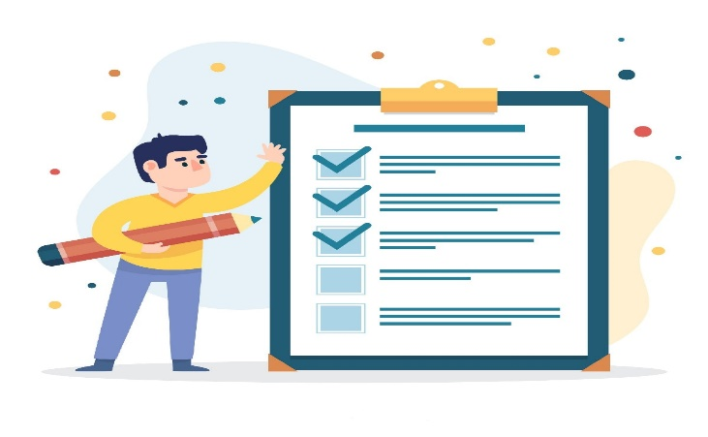

Analysis & Interpretation

While cash was losing its hold even before Covid 19, the pandemic has accelerated the global transition towards a cashless economy. Electronic payment has become the norm for everyday commerce and physical money may soon become a thing of the past.

It has been observed that there are several ways covid has pushed the usage of digital payments which has boosted the cashless economy: -

* Peer to peer payments: With sudden lockdowns imposed in the country, people were left stranded at home for weeks together. Person to person payment apps came to the rescue to send money to families and friends in need, to pay rent to houseowners, etc. All these transactions can be done through smartphones, without the use of physical cash.
* Best practices for Movie Theatres: Movie theatres are opting for practical contactless payment services which will help to cut down on contact between grubby bills and food-handling areas. Cinemark, one of the world’s largest movie exhibitors reopened its theatres in phases and declared that cash payments will not be accepted at the concession stand.
* Contactless Transactions at Grocery and Retail Stores: With the onset of Covid 19, the food retail industry quickly stepped up to adopt best practices in cleaning and sanitizing. Grocery stores offered cashless payment options to customers, such as wave payments.

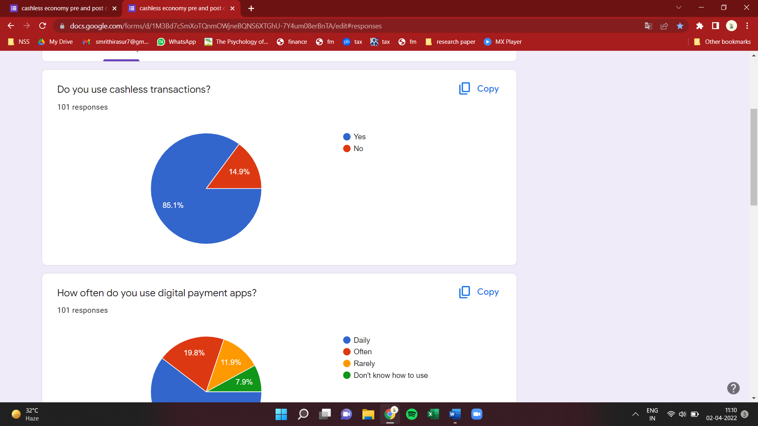

A sample of 101 people were taken to test the hypothesis. Around 85.1% of people prefer cashless transactions while 14.9% of sample still prefers to use cash over cashless. In a country like India there is a perception that having every transaction be tracked could invite trouble via more scrutiny or higher taxes. Cash doesn't leave a digital footprint which is what some consumers prefer. This isn't to say that cash is the default for shady transactions or tax evasion.  
When asked about their usage of digital payments apps, it was seen that more than 50% of the respondents used the digital payments apps daily for conducting their transactions, whereas, 7.3% of the respondents still don’t know how to use, it’s because people are not aware about the benefits of using digital payment apps.

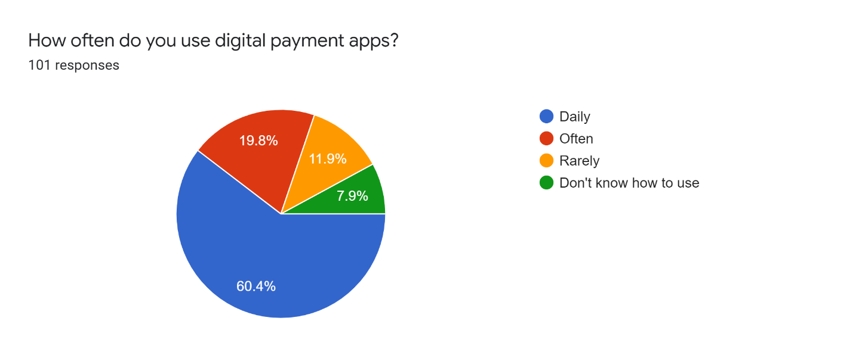

When asked about the usage of digital payment apps, around 60% respondents use daily for making payments and conducting various transactions. And 8% people don’t know how to use it might be due to lack of awareness about the digital payments apps or literacy.

For many, there is still a lack of trust for digital payments. There are those that don't yet feel safe using this as they don't trust the Internet and the perceived security risks. The perception that someone else has access to your bank account is a deal breaker for many.

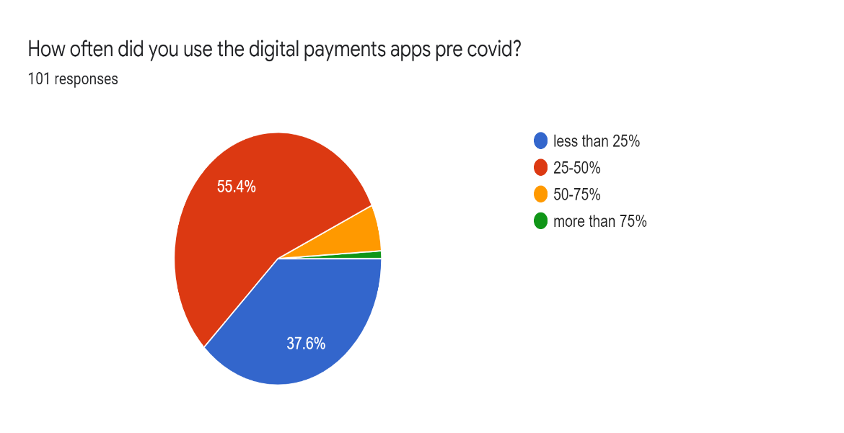

When asked about the usage of digital payments app pre covid, it was seen that majority of the respondents that is around 55.4% of total used about 25-50%.

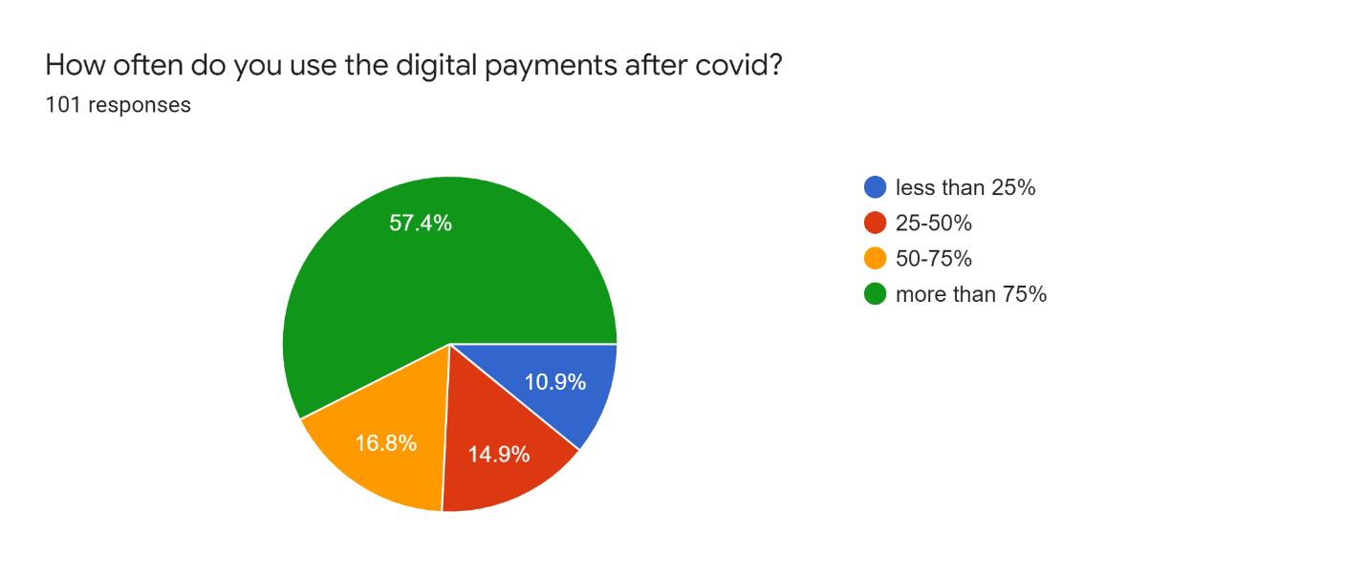

When asked about the usage of digital payments app post covid, it was seen that majority of the respondents that is around 57.4% of total used such apps more than 75%. Such drastic change in numbers can be due to various reasons like fear of handling cash, much more convenient to use

reduced costs and risks of handling cash, increased ease of conducting online transactions, and increased transparency among monetary transactions among people.

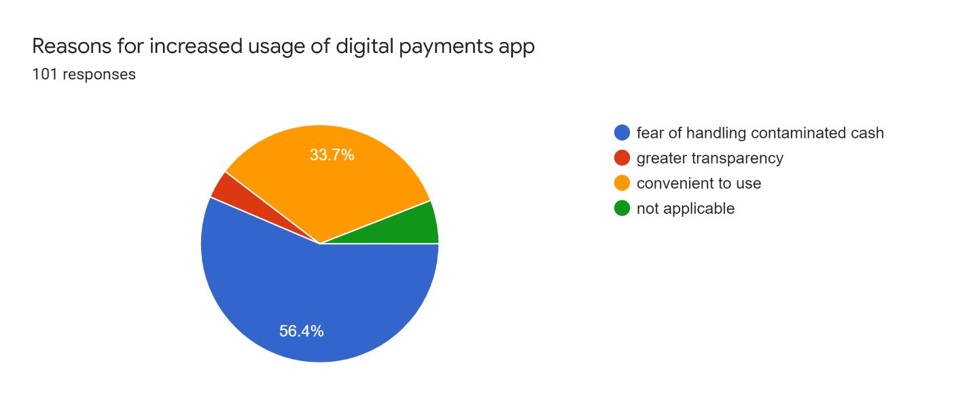

When asked about the reasons about the increased usage majority of respondents expressed the reason of fear of handling the contaminated cash. With the initial spread of Covid-19, people got panic as there was very less information about the virus and also the virus was spreading too fast adding to that Government also imposed lockdown which actually reduced the physical human interaction. Due to which people feared and preferred online cash transactions over physical cash transactions.

Around 33.7% believe it’s convenient to use, the ease of conducting financial transactions is probably the biggest motivator to go digital. One will no longer need to carry wads of cash, plastic cards, or even queue up for ATM withdrawals. It's also a safer and easier spending option when you are travelling.

About 4% people say they use because there is larger transparency. And rest say its not applicable as they do not use digital payment apps.

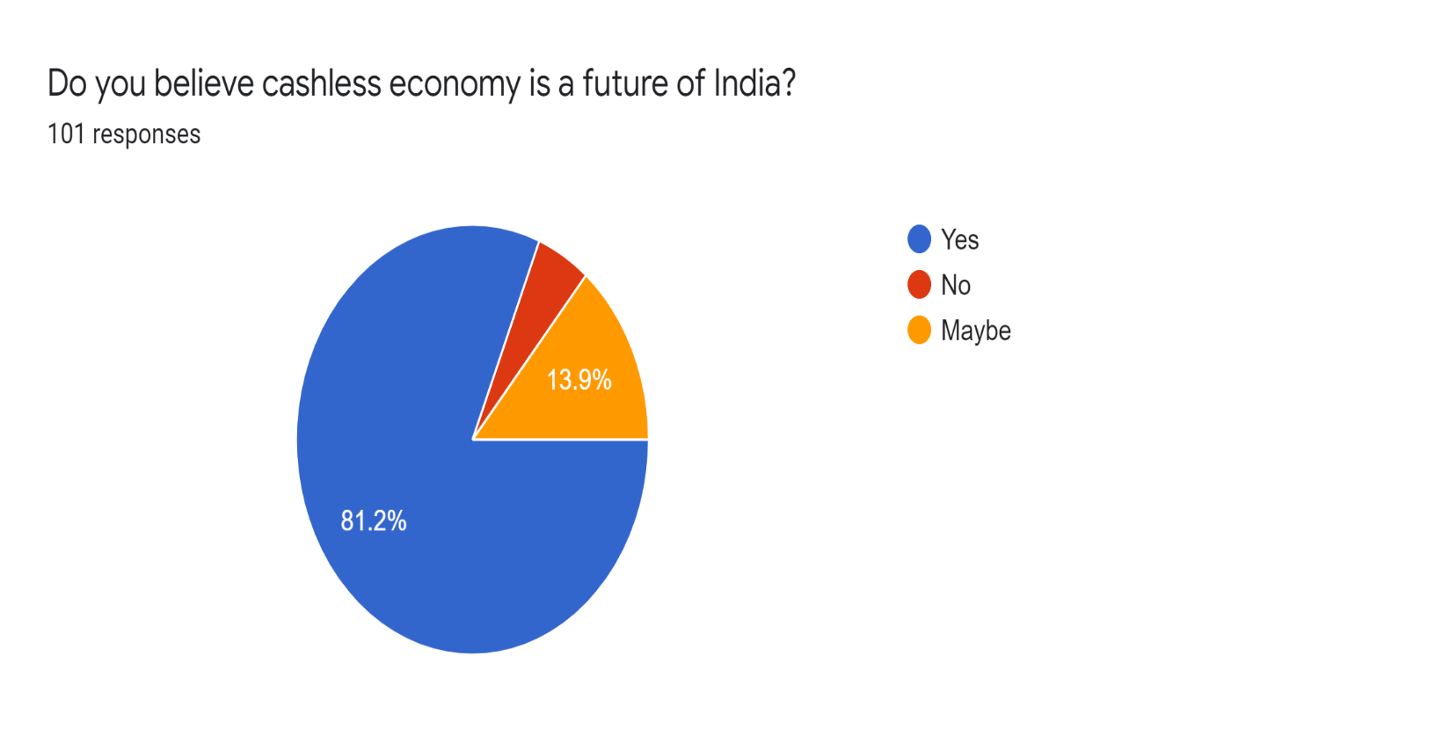

When asked about the future of cashless economy in India more than 80% of respondents believed that certainly there is future of cashless economy. The increasing availability of digital payment systems – including peer-to-peer payments, mobile wallets, mobile point-of-sale devices and digital coins, each promising transparency, efficiency and convenience.

Cashless payment systems can stimulate economic growth by making payments easier and convenient and, therefore, facilitate consumption. They can also provide time and cost savings opportunities for businesses, by reducing manual reconciliation, counting and cash handling, as well as reducing the governmental cost of issuing hard cash.

Findings

The digital payments market is forecast to grow at a compound annual growth rate of 13.7 percent between 2021 and 2026 according to ReportLinker – a demand driven by greater convenience, favourable government policies and evolving consumer behaviour, as well as COVID-19 disruption. Moreover, payments made via mobile devices alone are expected to exceed $2 trillion globally by 2025.

Today, while technological innovation allows financial transactions to be performed on computers and mobile devices so seamlessly that it is now taken for granted, going forward, caution should still be exercised. “In a post-pandemic world, it is likely that digital payments will become increasingly popular and widely used,” opines Ms Boden. “However, in our eagerness to make money quicker, faster and better, we must be careful not to exclude the most vulnerable people around us.”

Suggestions

India should promote Digital India Programme, e-payment and aware people about its use as it will help save time as well as hardship. The e-payment system will reduce the spread of COVID-19. The public also should be educated on the advantages and disadvantages of a cashless society. The government and private sector should promote the e-payment system, such as UPI, QR code, and e-Wallet.

Limitations

It is possible that some or many people are not aware about digital payment as they may do not use android mobile phone or computer. Due to lack of time, only a few respondents could be approached. Moreover, the survey was conducted only in Mumbai Suburban District. Some of the respondents were ignorant, were in a hurry so their responses might not be considerable.

Conclusion

People around the world have been affecting by the COVID-19 pandemic, but the e-payment system is able to reduce the spread of the virus as e-payment is contactless. The e-payment system has advantages and disadvantages; it is able to help the government to collect taxes more accurately. The e-payment can assist users to make financial transactions more transparently and efficiently. But users need to have technology skills, a smartphone, and a technology facility.

References

* <https://www.researchgate.net/publication/338596122_CASHLESS_ECONOMY-LITERATURE_REVIEW_AND_RELEVANT_FACTS>
* <https://www.bing.com/ck/a?!&&p=613a4dbbe33fd7e11da689dae6c325ba9a27cce553bcc87d2b2de3b5298dd2b1JmltdHM9MTczMTExMDQwMA&ptn=3&ver=2&hsh=4&fclid=03c41657-331f-6944-386e-028732ad68f4&psq=cashless+economy+pre+and+post+covid&u=a1aHR0cHM6Ly93d3cudm5zZ3UuYWMuaW4vaXFhYy9uYWFjL2MxL2MxMy9jMTM0L2ZpbGVzLzFFZFc2WDBDRnZ4d2w0VWJqT0ZlYWlTWTNYTkt3VEQwLS5wZGY&ntb=1>
* <https://assets.kpmg/content/dam/kpmg/in/pdf/2020/08/impacting-digital-payments-in-india.pdf>