**FACTORS AFFECTING BEHAVIOUR OF RETAIL INVESTORS IN STOCK MARKETS DURING THE PANDEMIC WITH REFERENCE TO THE CITY OF MUMBAI**

**Krishna Tulsian1**

1SYMCom., H.R. College of Commerce and Economics, Mumbai

**ABSTRACT**

This study examines the factors influencing investment decisions, particularly focusing on risk-return trade-offs, tax considerations, and market behaviour. It finds that while predicting the future performance of financial instruments like equities and government securities is challenging, past performance combined with strong demand suggests potential future gains. Investors generally favor short-term, low-risk products to maximize returns and rely on advisors, self-analysis, and online resources for investment decisions. The study reveals that economic and political stability are critical for stock selection, while market and personal factors heavily influence individual investors. Notably, the COVID-19 pandemic led to more cautious investments driven by personal experience and broker advice. Interestingly, factors like religious beliefs, social status, and family opinions do not significantly impact equity investments. The findings highlight the need for broader awareness initiatives beyond major cities to reduce trading biases. Future research could expand by exploring demographic influences, institutional investors, and larger, more diverse samples.

**Keywords:** Investments, Risk, Stability, Equity, Behaviour, COVID-19

1. **INTRODUCTION**

The novel coronavirus has led to unprecedented repercussions on daily life and the economy. The outbreak makes investors, policy makers, and the public at large aware of the fact that natural disasters can inflict economic damage on a previously unknown scale. While the aggregate effect of the pandemic on the stock market and the spending behaviour of households have been documented, little is known about the behaviour of retail investors during such a turbulent time. Considering that retail trades move stock prices in the direction of their trades and in particular retail short selling has predictive ability for future (negative) stock returns it is, however, important to investigate their behaviour in these unprecedented conditions at the micro-level to better understand aggregate market outcomes. We investigate trading patterns and financial risk-taking of a large sample of retail investors based on their individual trading records during the outbreak of COVID-19.

The economy of India is a developing mixed economy. It is the world's sixth-largest economy by nominal GDP and the third-largest by purchasing power parity(PPP). The country ranks 139th in per capita GDP (nominal) with $2,134 and 122nd in per capita GDP (PPP) with $7,783 as of 2018. After the 1991 economic liberalisation, India achieved 6-7% average GDP growth annually. In FY 2015 and 2018 India's economy became the world's fastest growing major economy, surpassing China. The long-term growth prospective of the Indian economy is positive due to its young population, corresponding low dependency ratio, healthy savings and investment rates, and increasing integration into the global economy. We use two lines of argumentation to express contrasting expectations about investor behaviour during the COVID-19 outbreak.

1. **OBJECTIVES OF STUDY**

Main objective of the research is to identify the factors affecting investment decision in the stock exchange.

The other objectives of the research were:

● To understand the behaviour of individual investors in Indian stock market, specifically their attitude and perception with respect to the stock market.

● To identify the preferred source of information influencing investment decision and to access the psychology of investors in different market situations.

● To understand the behaviour of individual investors in Indian stock market, specifically their attitude and perception with respect to the stock market.

● To identify and prioritize the factors that influence the investor behaviour in investment decisions making process.

● To identify the preferred source of information influencing investment decision and to access the psychology of investors in different market situations.

● To study in detail the demographic characteristics of selected respondents.

1. **HYPOTHESIS**

H0: Factors do not influence investor behaviour in stock market during the pandemic.

H1: Factors influence investor behaviour in stock market during the pandemic.

1. **REVIEW OF LITERATURE**

When examined relevant literature, factors influencing individual investors’ attitude were classified into two groups, namely social and economic factors, in general. But recent literature put emphasis on social factors in general and behavioural factors (psychological biases and personality traits) in particular that affect investors’ decisions, as the fluctuations in financial markets could not be explained with the principal doctrines of finance literature.

**4.1. Nagy and Obenberner (1994)** conducted a survey on determining the underlying criteria that affect decisions of individual equity investors with substantial holdings in fortune 500 firms.

According to empirical evidence, wealth-maximization criteria were found significant among respondents while the effect of recommendations of brokerage houses, individual stock brokers, family members and co-workers were identified as insignificant.

**4.2. Kiran and Rao (2005)** examined whether demographic and psychographic variables were effective on risk-bearing capacity of Indian investors by conducting a sampling survey. By analysing the collected data through multinomial logistic regression and factor analysis (FA) of SPSS, they verified a strong relationship between risk taking attitude and demographic and psychographic variables.

**4.3. Bennet et al. (2011)** sought to identify various factors that influence retail investors’ attitude towards investing in equity stock markets. They applied a structured questionnaire to retail investors in Tamil Nadu, India. Collected data were analysed through descriptive statistics and FA. According to the test results, out of the total 26 variables, it was found out that five factors (investors’ tolerance for risk, strength of the Indian economy, media focus on the stock market, political stability and government policy towards business) had a very high influence over retail investors’ attitude towards investing in equity stocks.

1. **SECONDARY DATA**

A Financial System of any country refers to a system that provides smooth and efficient relationship between the borrowers and the lenders. This system aims at establishing effective medium for generating funds from various sources. A financial system may be defined as a set of institutions, instruments and markets which fosters savings and channels them to their most efficient use. The main function of this financial system is to assemble wide spread savings from household individuals and industrial firms. Also, it helps to gather other productive investments in a country. This system helps in fastening the process of capital formation. This further accelerates process of economic prosperity of any nation. Financial System includes various aspects such as financial markets, financial institutions, banking firms, financial services, financial intermediaries, financial assets and instruments, etc. All these are closely related and work in combination with each other. Financial System through their huge network of elements helps to serve needs of different individuals, institutions and companies.

* 1. **Security Market:** The development of Indian security markets began with the launch of the Bombay Stock Exchange (BSE) in July 1875 and Ahmedabad Stock exchange in 1894. Since then, 22 other exchanges have traded in Indian cities. In 2014, India's stock exchange market became the 10th largest in the world by market capitalisation, just above those of South Korea and Australia. India's two major stock exchanges, BSE and National Stock Exchange of India, had a market capitalisation of US$1.71 trillion and US$1.68 trillion as of February 2015, according to World Federation of Exchanges.
  2. **Capital Market:** Capital Market is a place where transactions related to financial assets that have long time maturity period takes place. Capital market is a regular and ideal source of external finance required by business firms for long term investments. Capital market is defined as a market for borrowing and lending long term capital funds required by the business enterprises. It refers to all the facilities and the institutional arrangements for borrowing and lending both medium term and long term funds. This market comprises of borrowers on one side who demand funds and lenders on other side who supply those funds. In capital market, there is direct as well as indirect link between ultimate borrowers & ultimate lenders. It is a market mechanism organised in order to bring these two sets of people together. Capital market which is also known as Securities Market deals with securities such as shares, stocks, bonds, debentures, etc. It is not confined to any specific locations. It exists all over the economy wherever suppliers and users of capital come together to do business. According to Hebert E. Dougall, “Capital Markets are the complex of institutions and mechanisms, whereby intermediate term loans and long term loans are pooled and made available to business, government and individuals & whereby instruments already outstanding are transferred.” A well build capital market is very essential for both the industrial as well as economic development of a nation. It helps in solving the problem of scarcity of funds. Thus, it increases economic welfare of the society. Capital market plays a key role in assembling large volume of savings from numerous household investors into productive investments. The hard earned savings of individuals are collected and allocated among different corporate and other business houses.
  3. **Primary Market:** The primary market is where securities are created. It's in this market that firms sell (float) new stocks and bonds to the public for the first time. An initial public offering, or IPO, is an example of a primary market. These trades provide an opportunity for investors to buy securities from the bank that did the initial underwriting for a particular stock. An IPO occurs when a private company issues stock to the public for the first time. Primary Market deals with new or fresh issue of securities. Therefore, is also known as New Issue Market. Primary market is an important constituent of capital market. Business houses require financial resources either for setting up new undertaking or for expansion, modernization or diversifying their existing business.
  4. **Secondary Market:** Secondary Market also called as Stock Market or Stock Exchange provides a place for purchase or sale of existing / old securities. Secondary Market also known as Existing Securities Market facilitates trading in outstanding equity shares and/or debt claims. These securities may be either issued by public companies or local authorities or Government companies. This market provides a place for investor to convert their cash into securities and also vice versa. A stock exchange acts as a barometer for measuring the health of both, individual companies as well as overall economy. It ensures free and unrestricted transferability of different securities.
  5. **Investment:** Generally, Investment means employment of funds with an objective of achieving either additional income or growth in its value or both. Investment is commitment of funds either in real assets or financial assets. Investment involves sacrificing certain present value for some uncertain rewards in future. It involves commitment of funds which have been saved by postponing current consumptions. People postponed their present consumption in expectation that some benefits or rewards will take place in coming future. In broader sense, investment decision is a trade – off between both risk and return. It involves arriving at number of decisions including proper amount of funds, right timing, right class or grade of investment, etc. It is very important that investment decisions must not only be continuous, but also it must be rational.

Broadly speaking, there are three concepts of investments. First concept is the Economic Investment which normally means net additions to capital stock of the society. Capital stock of society means capital goods, i.e. those goods and commodities which are used in production of other goods and services. It also includes stocks of inventories and human capital that are used by manufacturers or producers in the process of production activities. Second concept indicates Investment in a more general or wider sense.

1. **PRIMARY DATA AND DATA ANALYSIS**

6.1. **Age:**

a) 18 – 25 years

b) 26 – 40 years

c) 41-60 years

d) Above 60 years

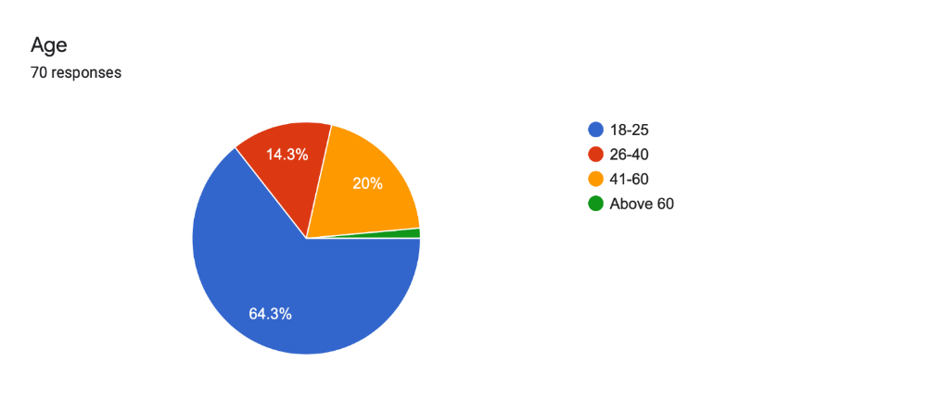

**Figure 1:** Age

**Data Interpretation:** As shown in the above table, the analysis includes respondents of different age groups. There are 45 respondents of age between 18-25 years making majority of the sample size that is 64%. No. of respondents between age 26-40 years are 10 making 14% of the sample size. There are 14 respondents of age between 41-60 years making 20% of the sample size. The least number of respondents are of age above 60 years with only 1 respondent and approximately 1% of the total sample size.

2. **Qualification:**

a) Graduate

b) Post-Graduate

c) Professional

d) Under-Graduate (None)

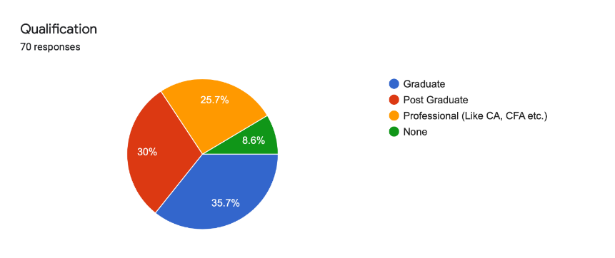

**Figure 2:** Qualification

**Data Interpretation:** The results show that 30% of the respondents had attained post-graduate as their highest level of education while 36% of the respondents had a graduate degree. On the other hand, 26% of the respondents were professionals. From the results, it shows that majority of the respondents had reached university level as their highest level of education. This implies that majority of the investors were knowledgeable on the subject of the study thus the reliability of the information given and subsequently the results presented in this report.

6.3. **What has been your per month income during the pandemic period?**

a) Below 25,000

b) 25,000-40,000

c) 40,000-55,000

d) Above 55,000

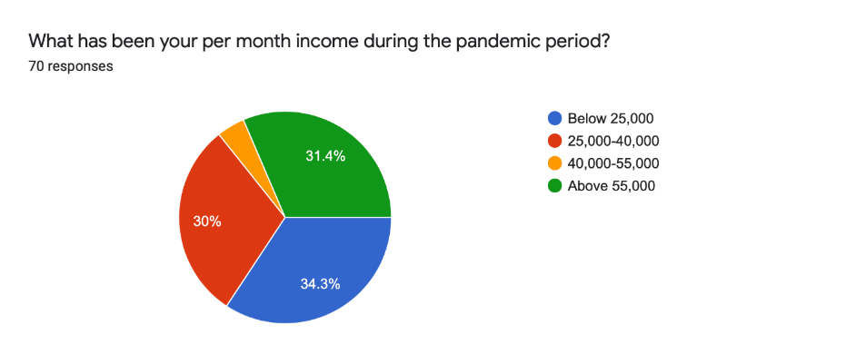

**Figure 3:** What has been your per month income during the pandemic period?

**Data Interpretation:** The above analysis shows that 34% of the respondents have monthly income below 25,000, 30% respondents of the total sample have monthly income between 25,000- 40,000. There are 31% respondents having monthly income between above 55,000 and the remaining 4% of the respondents have monthly income between 40,000-55,000. This shows that majority of the respondents have stable monthly income and are capable of investing a part of their income in stock market.

6.4**. How would you describe your risk aversion?**

a) Risk Averse

b) Risk Neutral

c) Risk Seeking

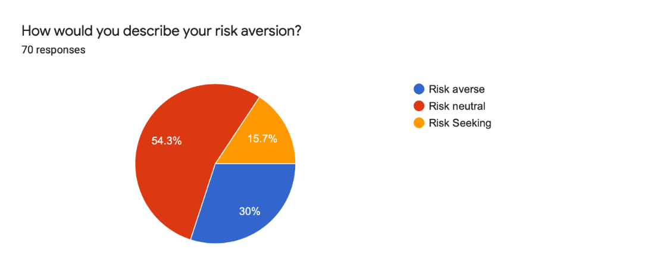

**Figure 4:** How would you describe your risk aversion?

**Data Interpretation:** The above table shows data relating to the risk aversion of the investors. The types taken into consideration in my research include risk averse, risk neutral, risk seeking. 30% of the respondents in the total sample size are risk averse i.e. not willing to take more risk than returns. There is a majority of 54% of the respondents who are risk neutral i.e. they prefer risk equal to return on their investment. The remaining 16% of the investors are risk seeking who are willing to take more risk than return. This implies that the respondents are more risk neutral and the risk factor not necessarily affects their investment decisions.

6.5. **What has been the most dominant source of your investment decisions in stock markets during the pandemic?**

a) Newspapers

b) Advisors

c) Company Analysis

d) Past Performance

e) Other

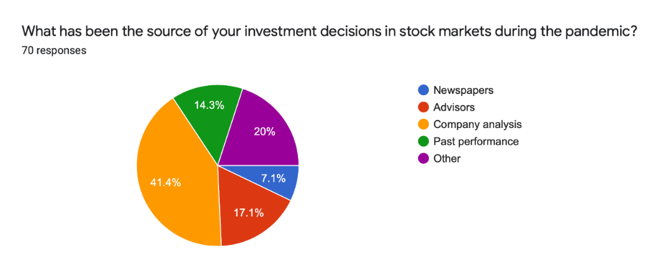

**Figure 5:** What has been the most dominant source of your investment decisions in stock markets during the pandemic?

**Data Interpretation:** The results in above table show that the company fundamentals and charts affect investment decisions as 41% of respondents indicated that to a great extent. It is also evident that the investments decisions are moderately affected by recommendations of advisors as 17% of the respondents indicated that. Taking decisions because of a company’s past performance is 15% of the total sample size. This implies that the opinion from stock brokers, other stake holders, investment groups and business news greatly influenced investment decisions.

6.6**. Do you take advice from financial analysts before investing?**

a) Yes

b) No

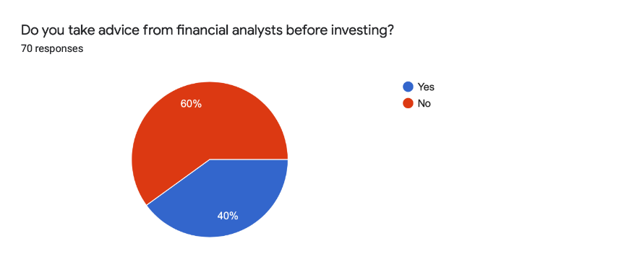

**Figure 6:** Do you take advice from financial analysts before investing?

**Data Interpretation:** The above table shows data regarding the number of respondents who take advice from financial analyst before investing. Majority of investors i.e. 60% of the total sample size do not take advice from financial analysts. Remaining 40% of the respondents take advice from financial analysts before investing. This depicts that advice from financial analyst also affect the investor behaviour in stock market up to a certain extent.

**6.7. What is the time period of your investments that you have made during the pandemic?**

a) Less than 1 year

b) 1-5 years

c) 5-10 years

d) More than 10 years

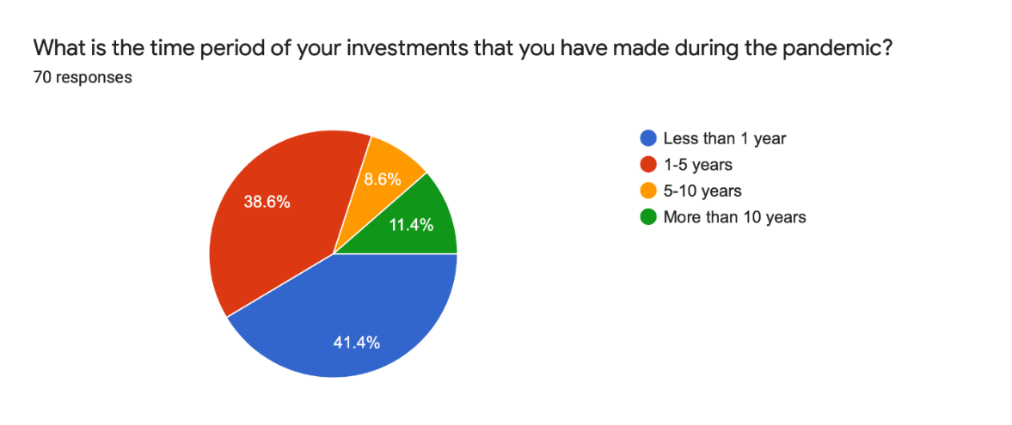

**Figure 7:** What is the time period of your investments that you have made during the pandemic?

**Data Interpretation:** The table above depicts information about the time period of investment of investors. There are 41% of the respondents who invest for less than 1 year. On the other hand, 39% of the respondents prefer investing for a time period between 1 year - 5 years. Only 9% of the respondents invest for a time period between 5 years - 10 years. 11% of the respondents of the total sample size invest for more than 10 years. This shows that many respondents did not prefer investing for a longer time period during the COVID-19 pandemic.

6.8. **Which of these factors do you take into consideration most while investing in stock markets?**

a) Company Analysis

b) GDP Growth

c) Political Factors

d) Market Volatility

e) Liquidity Needs

f) Taxation policy

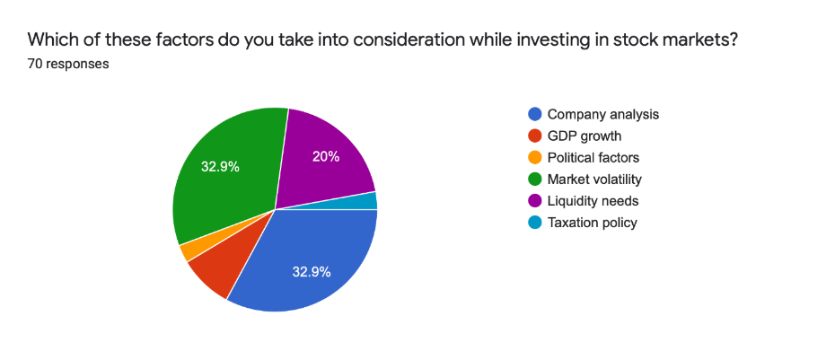

**Figure 8:** Which of these factors do you take into consideration most while investing in stock markets?

**Data Interpretation:** Above chart shows the analysis regarding the factors taken into consideration by investors while investing. Company analysis, GDP growth, Political factors, Market volatility, Liquidity needs, Taxation policy. There are many other factors but these are one taken into consideration in my research. 33% of the respondents consider company analysis for their investment decisions. GDP growth is considered by 9% of the respondents of the total sample size. Political factors are considered by only 3% of the respondents. Market volatility is also a factor considered by many investors about 33% of the total sample size. 20% of the respondents consider liquidity as their main factor driving their investment decisions. Taxation policy is considered by only 3% of the respondents.

6.9. **Does credit rating of companies influence your investment decisions?**

a) Yes

b) No

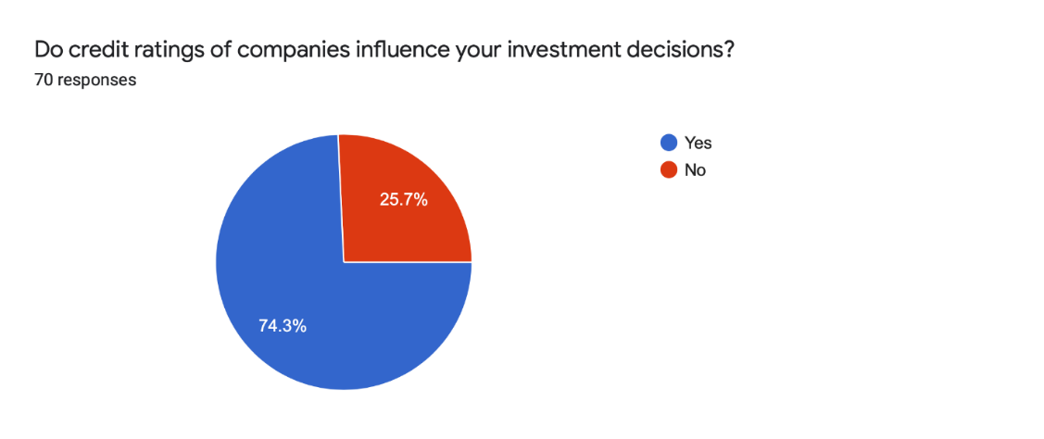

**Figure 9:** Does credit rating of companies influence your investment decisions?

**Data Interpretation:** The above data shows the use of credit rating amongst investors before investing. As shown in the above chart that investors are likely to consider the credit rating provided by various credit rating agencies. Majority of the investors i.e. 74% of the total sample size get influenced by the credit rating of the companies. Remaining 26% of the respondents are not influenced by the credit rating provided to companies by various agencies. Thus this implies that credit rating is a factor affecting investment decisions of majority of investors.

6.10. **Which sector did you prefer the most to invest in during the pandemic?**

a) Pharma

b) IT

c) Energy

d) Metal

e) Realty

f) FMCG

g) Others



**Figure 10:** Which sector did you prefer the most to invest in during the pandemic?

**Data Interpretation:** The above table illustrates that the 33% of the investors preferred investing in Pharma, 30% of the investors preferred investing in IT sector and 26% of the investors preferred investing in the FMCG sector. This is in direct correlation with the fact that the above industries were booming during the pandemic. Only 11% of the investors preferred investing in other industries.

1. **FINDINGS**

● Majority of the respondents are of age group between 18 years – 25 years. The least respondents are of age group above 60 years. This concludes that people of age 18-25 years are more likely to invest in stock market as compared to other age groups.

● Respondents have different qualifications. From the analysis we can conclude that majority of respondents qualified. Therefore, it can be concluded that the research analysis is not based on the responds of uneducated or unqualified people.

● Out of the total respondents, majority of respondents are students, salaried or professionals.

● With respect to per month income most of the investors are in the band of below 25,000.

● Majority of the investors are risk neutral in aversion.

● Many sources are used by investors, analysing company fundamentals being the one majorly used. Newspapers are not used by many investors.

● Advice from financial analyst is not taken by majority of investors.

● The time period of investment is less than 1 year for most of the investors.

● Company analysis and market volatility are major factors guiding investment decisions of investors in stock markets during the pandemic.

● Credit rating is considered by most of the investors.

1. **CONCLUSION**
   1. **Hypothesis Testing**

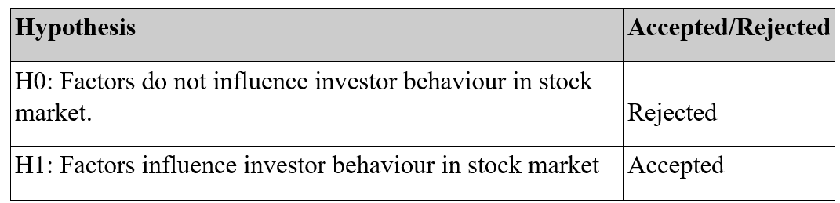

**Figure 11:** Hypothesis Testing

From the above table it can be seen that the hypothesis stating that factors do not influence investor behaviour is rejected after analysing the data collected by the respondents. Whereas the hypothesis stating that factors influence investor behaviour in stock market is accepted as it is proved from the data analysis that various factors such as liquidity, taxation, GDP growth rate etc. influenced the investor behaviour in stock markets during the pandemic.

The study shows how different factors and instruments have different risk-return and tax considerations while taking investment decisions and are of diverse nature. It is very difficult to come to any definite conclusions that how a particular market instrument is doing and how they will perform in the future, but still the study concludes to an extent that the particular instrument or product like equity or government security has performed well in the past, and supported with strong demands will perform well in the future. The study also draws an important conclusion from the study that the investors are keen to invest in short term and less risk products, much interested to earn good return on their investments. Investors are aware about the factor affecting their short term as well as long term investment plans and they do take advice from advisors, self-analysis by investors themselves and internet also. This intensive study will somehow help investors in deciding the correct investment for their savings.

The findings of this research study shows that economic and political stability are the most considerable factors for stock selection process. The results also show that market factors and personal factors are the most important factors influencing individual investor’s decisions. Furthermore, results of the study also show that during COVID-19 investors are carefully investing in the market by relaying on their own experience and broker advices. The results also showed that religious beliefs, social status, “getting rich quickly” and opinion of family members have not affected on equity decisions.

The analysis and interpretation very clearly shows that the investors have different views like investment pattern by market movement, factors influencing their decisions, frequency of investment, alternatives available and investment preferences truly influence their perception towards different products and services of the company.

1. **REFERENCES**
2. Baker, M., and Wurgler, J., (2006), Investor Sentiment and the Cross-Section of the Stock Returns, Journal of Finance, Vol. 61(4), pp 1645-1680
3. Barberis, N., A., Shleifer, and R., Vishny, (1998), A Model of Investor Sentiment, The Journal of Financial Economics, Vol. 49, Issue 3, pp. 307-343
4. Behaviour, the Business Systems and Economics, ISSN-2029-8234, Vol. 3(1), pp. 69-79
5. Bhatta, M., (2009), Behavioural Finance: A discussion on Individual Investor Biases, The Management Accountant – ICWAI Journal, Vol. 44(2), pp. 138-141
6. Bisen. V and Pandey. M(2013), Applying Behavioural Finance by Analysing Investor Behaviour in Lucknow City, Indian Journal of Applied Research, Vol. 3(6), ISSN 2249555X, pp 353-355