**"Navigating the Vaccine Approval Process in the European Union: A Guide to EMEA Regulations"**

Vidhya P*, Dr.K.Jaganathan, Dr.N.Senthil Kumar

The Tamilnadu Dr.M.G.R Medical University, Chennai.

Department of Pharmaceutical Regulatory Affairs, JKKMRF’s Annai JKK Sampoorani

Ammal College of Pharmacy, Komarapalayam, Nammakkal – 638183, Tamil Nadu, India

**ABSTRACT**

This study describes about the Vaccine Approval Process in EMEA of European Union. It briefly outlines the history of vaccines and the guidelines that must be followed throughout the development process, as well as the guidelines that must be followed for the development of the COVID – 19 vaccine. Scientists and researchers work together to develop a vaccine, and it may take several years of study before it is available to the general public. Clinical trial is a method that is used in many of these studies. It indicates that the vaccine is safe, pure, and potent, and that the manufacturing facility follows the requirements established to ensure that the vaccine product remains safe, pure, reliable, and non-inferior when given with concomitant vaccines. To receive a licence to manufacture vaccines, all vaccine manufacturers must submit the Marketing Authorization Application the European Medicines Agency. European Medicines Agency is responsible for approving all the vaccines produced in European Union. This study also discusses the COVID – 19 approval process in European Union.

**Keywords:** European Medicines Agency, Clinical trials, European Union, Vaccine Approval Process.

**\*Corresponding Author: Dr.K.Jaganathan, M.Pharm, Ph.D.**

**Email Id:** jaganjkkm2022@gmail.com

**INTRODUCTION**

A vaccine is a biological product that delivers energetic immunisation in opposition to a exact contagious disease. A vaccination normally comprises a representative that acquired looks like a disease-causation microbe and is formed from vulnerable or damaged bacteria, their toxic substances, or single of their surface proteins. The agent energises the body's immunisation system to find and kill the representative as a menace, as well as any associated microorganisms it might encounter in the future. Vaccines can be either prophylactic or preventive to fight a disease that has previously occurred, such as cancer. Vaccination is the process of administering vaccination. Vaccination is the most successful way to eradicate infectious diseases; it is mainly answerable for the global annihilation of smallpox and the restriction of diseases like polio, measles, and tetanus in much of the global. Vaccine efficacy has been extensively researched and tested; for instance, the influenza vaccine, the HPV vaccine, and the chicken pox vaccine have all been shown to be reliable. According to the (WHO), accepted vaccines are presently obtainable for twenty-five different diseases that can be avoided. Variolae vaccinae is the source of the word’s vaccine and vaccination. (cowpox), a word coined by Edward Jenner (who invented the first vaccine as well as the definition of vaccines) to describe cowpox. In 1798, he used the term for the long title of his Inquiry into the Variolae vaccinae Known as the Cow Pox, in which he explained cowpox's anti-smallpox effect. To respect Jenner, Louis Pasteur suggested that the expressions can be expanded to include new defensive inoculations that were being created at the time.

Vaccines are designed to be used in healthy people as a disease prevention tool, as opposed to traditional medications, which are used to treat an underlying illness. A vaccine's safety is important. Clinical studies for vaccines must be able to prove that a vaccination is both safe and effective in preventing disease. This means that vaccine clinical trials would involve a larger number of subjects than conventional drug trials. As a result, previously a vaccine is agreed and put on the marketplace, it goes through a lengthy and thorough development process, followed by years of testing. Vaccines are one of the greatest medical accomplishments of our time, eliminating infectious diseases and saving the lives of 2-3 million people worldwide each year. By preventing illness, reducing the burden on health care, and promoting healthier communities, vaccination plays a key role in maintaining the public health and well-being of European citizens.

**Methodology:**

To explore the vaccine approval process within the European Medicines Agency (EMA) of the European Union, it is crucial to study the comprehensive framework governing vaccine development. This includes understanding the EMA’s guidelines for developing new vaccines, specifically for COVID-19, and how regulatory pathways are structured to ensure safety and efficacy. Additionally, focusing on the EMA’s role in evaluating and authorizing vaccines in the EU will provide insights into the key stages of the vaccine lifecycle, from clinical trials to post-marketing surveillance.

**THE PROCESS OF VACCINE DEVELOPMENT:**

Vaccines are designed to be used in healthy people as a disease prevention tool, as opposed to traditional medications, which are used to treat an underlying illness. A vaccine's safety is important. Clinical studies for vaccines must be talented to prove that a vaccination is both safe and effective in preventing disease. This means that vaccine clinical trials would involve a larger number of subjects than conventional drug trials. As a result, previously a vaccine is accepted and put on the marketplace, it goes through a lengthy and thorough development process, followed by years of testing.

**NEW VACCINE RESEARCH AND DEVELOPMENT:**

**Induction and pre-clinical studies**

**One to ten years**

Understanding the disease, its pathogenesis, and the protective immune mechanisms. Identifying vaccine composition and assessing the effectiveness and safety profile of vaccine candidates using a variety of assays and models, including both in vitro and in vivo experiments.

**Non-clinical Safety Assessment**

**1-2 years**

According to regulatory guidelines, in-depth monitoring of the vaccine candidate's safety in laboratory and in vivo models.

**Clinical trials Phase 1**

**12 months to 18 months**

A limited number of healthy people (20-50) are tested to see if the candidate vaccine is safe and capable of eliciting an immune response in humans.

**Clinical trials phase 2**

**2 or more years**

To further validate the candidate vaccine's protection and immunogenicity, it is offered to a wider group of people (100-300). This step investigates the optimum dose in greater depth and can provide preliminary proof of the vaccine's ability to protect against the target infection.

**Clinical trials phase 3**

**3 to 5 years**

Thousands of people (3,000 to 5,000) are screened for the most successful vaccine candidate in order to gather definitive proof of its ability to protect against the target infection. Additional data on its protection and potential for causing rare side effects is being gathered, which has not been seen in smaller studies.

**Registration of the Vaccine in Europe 1 – 2 years**

Submission of documents, review, and approval by the European Medicines Agency or other appropriate National Competent Authorities for a licence to sell and distribute the vaccine in countries all over the world.

**HOW DOES A VACCINE GET APPROVED IN EUROPE?**

It takes a long time to produce a vaccine. Just a small percentage of the hundreds of vaccine candidates meet the criteria for international approval. Vaccines and other medications are regulated by the European Medicines Agency (EMA) and additional controllers in the European Union. The development of a vaccine usually takes 10 to 15 years. International leaders, on the other hand, say that a vaccine against Covid-19 could be ready in a year or two. There has never been a coronavirus vaccine created. Is this, then, a practical scenario? The measures that any future vaccine must take to be licenced for human use are outlined below.

**Step 1: Exploratory work**

Researchers need to grasp how a virus functions in order to combat it. It begins in the laboratory, where scientists seek to establish the virus's genetic sequence and understand how it affects human or animal cells. They'll look at the virus proteins' structures and see how they can use them to cause an immune response. A healthy vaccine should be able to imitate an infection without leaving you ill.

All of the studies done during the SARS and MERS global outbreaks aided this process in the case of SARS-COV-2. In January, China published the genetic sequence of the new coronavirus. This assisted in the production of test kits and potential therapies.

**Step 2: Pre – Clinical Development**

Until a vaccine is tested on humans, scientists must conduct extensive experiments to ensure that it is both safe and capable of eliciting an immunisation reaction. As a result, the vaccination applicant is verified in laboratories and on animals at this point. Many possible vaccines are unsuccessful, either because they are ineffective or because they are dangerous.

**VACCINE APPROVAL IN THE EUROPEAN UNION:**

Previously inoculation can be licenced in the EU, it must first go through extensive testing by the manufacturer and then be evaluated scientifically by controlling governing bodies. The European Medicines Agency (EMA) and additional controllers in EU/EEA countries are among them.

The efficacy of the vaccine is verified during testing:

• The purity of the product;

• The elements, including inactive elements or "excipients";

• The method by which it is produced. The vaccine's results are then tested by the vaccine developer. This entails both laboratory and animal studies. This is accompanied by a human clinical research programme. The vaccine is tested in three stages of clinical trials, with each phase involving a greater number of participants. This software must conform to the regulators' strict requirements, procedures, and protocols.

**APPROVAL OF VACCINES**

Vaccines are subjected to stringent regulatory approval processes in the United States (US) and the European Union (EU) to ensure their protection, effectiveness, and consistency. This procedure can take months or years, depending on the product, and any postponement in gain access to could endanger public strength. This is particularly significant and true in the case of vaccinations produced in answer to communicable disease eruptions or for highly contagious illnesses. The FDA is in charge of all drug approvals in the United States. If a corporation submits a Biologics License Application (BLA) for a vaccine, the Centres for Biologics Estimation and Testing (CBER) reviews the application (CBER). All biologics, like inoculations, must be licenced by the European Medicines Agency (EMA) in the EU. In the EU, there are three different ways to get a pharmaceutical product approved: centralised, decentralised, and reciprocal recognition. The unified route enables companies to apply a solo Marketing Authorization Application (MAA) to the European Medicines Agency (EMA), which leads to product endorsement in all EU countries. The Committee for Medicinal Products for Human Use reviews it after it is submitted (CHMP). During the study's time span, the centralised process was used to approve all merchandises accepted by together the FDA and the EMA. The decentralised pathway, on the other hand, enables corporations to apply for concurrent endorsement in added than one EU member state, however not everything, as lengthy as the merchandise for which endorsement is sought consumes non yet remained authorised for advertising in any EU country. One nation is chosen as the reference member state in this process, and it finishes initial evaluation. Marketing authorization would be given if the other nations agree with the reference state's valuation. Finally, the reciprocal recognition pathway enables a business to apply for endorsement in additional EU nations after their merchandise consumes been approved in single EU country. The goal states depend on the reference state's technical evaluation when determining whether or not to issue a marketing endorsement.

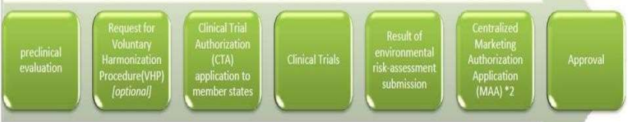

**Figure.1** Simplified regulatory pathway from preclinical to the marketing authorization.

**LABELING OF VACCINES:**

The request for endorsement requires comprehensive security and efficiency evidence gathered through the preliminary to clinical trials and scientific stages, as well as the corporation's proposed labelling, which is the approval process' final deliverable. Each agency assesses the vaccine's risk–benefit ratio based on this information. The completion of product labelling is one of the last stages in the merchandise endorsement process. Regulatory agencies collaborate with manufacturers to finalise draught language, confirming that it is necessary, adequate, and exact. There are dual categories of merchandise labels: one for health care practitioners (recommending info) and one for patients (info about the product) (patient info leaflets). Vaccine labelling for medicinal specialists are practical manuals used by doctors, chemists, and other trained medicinal staff to collect info about a vaccine's administration, precautions, protection, possible side effects, and effectiveness, and to decide if it is necessary to manage to a specific patient. Patients' labels, on the further hand, include more patientfriendly information about instructions, warnings, contraindications, side effects, and dosages, enabling patients to balance the hazards against the advantages and make an informed a choice.

**SAFETY, QUALITY AND STANDARDS:**

Every new vaccine must undergo thorough testing before it can be used. Only after a clinical review of the results of these tests to ensure the vaccine's efficacy, safety, and effectiveness can it be accepted for usage in the European Union (EU) and European Economic Area (EEA).

This assessment would demonstrate that the benefits of a vaccine in terms of disease protection outweigh any possible risks. Since vaccines are offered to healthy people, scientific experts reviewing vaccines carefully evaluate the benefits as well as any possible risks.

A vaccine can only be produced, sold, and used to protect people after it has been licenced. To ensure that the vaccine stays safe and reliable, it is constantly monitored. A vaccine, like any other drug, can cause side effects, but they are typically minor and short- lived. Mild fever, as well as discomfort or redness at the injection site, are possible symptoms. Significant side effects are exceedingly uncommon.

**BENEFITS OF VACCINATING:**

Vaccines protect people from illnesses that may cause severe health complications, lifelong disability, or even death if they were not prevented. Vaccines shield hundreds of millions of people around the world from dangerous diseases each year. For example, in 2018, approximately 86 percent of children universal received three dosages of the diphtheria, tetanus, and pertussis (DTP) vaccine, and 85 percent of children worldwide received three dosages of the polio vaccination. Vaccines are commonly administered to healthy people to keep them from becoming sick, rather than as a drug to cure an infection. As a result, the long-term effects of vaccination could not be readily apparent. Since many infectious diseases are still exceedingly rare as a result of vaccination, the harmful effects of these diseases are often ignored. Many of these diseases and outbreaks could resurface if people started getting vaccinated.

Example: measles

**MONITORING VACCINE SAFETY AND REPORTING SIDE EFFECTS:**

After a vaccine is agreed for use, the European Medicines Agency (EMA) and national authorities in the EU/EEA monitor side effects in publics who take conventional the vaccine. This means that any potential threats are identified and dealt with as quickly as possible.

The European Medicines Agency (EMA) monitors new information on the safety of all vaccines available in Europe. It examines a variety of data sources, including:

• Patient, parent, and healthcare professional reports;

• Clinical studies; and

• The scientific literature;

• Data exchanged with other regulators

**THE WORKINGS OF VACCINES:**

Each virus and bacterium elicit a distinct immune response involving T-cells, B-cells, and other immune cells create in the blood, bone marrow, and additional parts of the body. A vaccine activates the immune system and creates a "memory" in the body for a particular disease without actually triggering it. Most vaccines contain a severely weakened or inactivated (killed) form of the virus or bacteria that typically causes disease, or a small portion of the virus or bacteria. This is referred to as the antigen. The antigen is recognised as "foreign" by the immune system when a person receives the vaccine. This causes the immune system cells to become activated, allowing them to destroy the diseasecausing virus or bacterium and create antibodies against it. Antibodies are proteins that assist in the killing of viruses and bacteria.

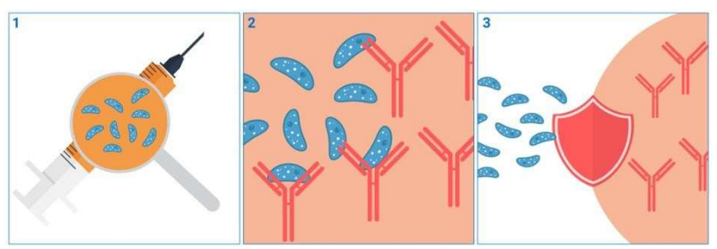

1. Antigen 2.Antibodies 3.Immune-response

Figure: 2 vaccine work

Instead of an antigen, some newer vaccines use a molecule called mRNA. This mRNA provides instructions for generating an antigen that is virtually identical to a portion of a real virus.

**DECISION ON VACCINES IN USE IN UNITED NATIONS OF EUROPE:**

Individual European countries decide the vaccinations should be included in their national vaccine programmes and the vaccinations should be compensated for through their health-care systems. This is determined by local circumstances, such as the prevalence of the disease and economic factors. Vaccines for up to twenty diseases are offered to citizens at particular ages in most national vaccination programmes in the EU/EEA. Vaccines to protect against particular diseases are also often prescribed for ‘high-risky' population, such as those with long-standing health problems or those who want to migrate to other parts of the world. Some vaccines only protect against one disease, while others protect against several diseases. To protect against multiple infectious diseases, more than one vaccine can be given at the same time. Vaccination in combination is well-established and supported by empirical evidence of its benefits and protection.

**GUIDELINES OF VACCINES:**

The European Medicines Agency's scientific vaccine guidelines assist medication developers in the preparation of marketing-authorization applications for human medicines.

* Adjuvants in vaccines for human use
* Clinical evaluation of new vaccines
* Development of vaccinia virus-based vaccines against smallpox
* Dossier structure and content for pandemic-influenza-vaccine marketing-authorisation application
* EMA considerations on COVID-19 vaccine approval
* Explanatory note on the withdrawal of the note for guidance on harmonisation of requirements for influenza vaccines
* Influenza vaccines - non-clinical and clinical module
* Influenza vaccines - quality module
* Influenza vaccines – submission and procedural requirements
* Influenza vaccines prepared from viruses with the potential to cause a pandemic and intended for use outside of the core dossier context
* Interim guidance on enhanced safety surveillance for seasonal influenza vaccines in the EU
* Quality aspects included in the product information for vaccines for human use
* Preclinical pharmacological and toxicological testing of vaccines

**DEVELOPMENT OF NEW VACCINES:**

Injection was initial introduced in Europe, and Europe has remained at the forefront of the worldwide injection industry ever since, playing a crucial role in vaccine study and growth. Emergent new technology and science, such as the usage of recombinant DNA, has led to promising new vaccine breakthroughs and possibilities. Many new vaccines are currently being researched and developed in our industry, including virus vector vaccines, non-replicating vectored vaccines, RNA vaccines, DNA plasmid technology, and immunotherapy. Vaccines are being developed for HIV/AIDS and other infectious diseases (such as cytomegalovirus, dengue fever, and ebola); cancer; Alzheimer's disease; rheumatic diseases; bacterial diseases (such as Clostridium difficile, chlamydia, and E. coli); and parasitic diseases (such as malaria, hookworm, and leishmaniasis), among others. Furthermore, some combination vaccines have functional benefits that can increase vaccine uptake and thereby improve public health. [21] Human phase I, II, and III trials follow the discovery, process engineering, toxicology, and animal studies phases of vaccine production. Dependent on the disease, the procedure can take up to ten years. The experiments on humans: 1. begin with small groups of people to determine safety; 2. move on to moderate-sized "target" populations (people of similar ages and other features to those for whom the vaccination aim) to determine together security and immune response stimulus; and 3. Move on to big goal populaces to determine if a vaccine really prevents a disease as intended (efficacy). The WHO Initiative for Vaccine Research (IVR) was founded in 2001 to bring together WHO and the Joint United Nations Programme on HIV/AIDS' various vaccine research and development projects (UNAIDS). IVR aims to accelerate the production of vaccines against major public health threats, expand existing immunisation skills, and assure that these advancements are complete obtainable to those who essential them utmost. IVR uses a three- pronged approach to accomplish these goals:

* accelerating progress for new and enhanced vaccines and technologies through managing expertise and offering advice and advocacy through effective partnerships;
* conducting implementation analysis and designing tools to promote evidence-based vaccine and technology recommendations, legislation, and strategies; and
* Supporting innovation and product development for WHO's priority new vaccines and technologies.

**Study design, study site, and outcomes:**

While phase I trials are typically open-tag and nonrandomized, randomised measured trials (RCTs) using a placebo or an injection against a different illness as a comparator are possible. A singleblinded or double-blinded analysis may be used to eliminate bias. In Phase I trials, the use of bedside formulations, in which the vaccine antigen and adjuvant are combined just before immunisation, is common. This allows the vaccine manufacturer to test several adjuvants with the same vaccine antigen without having to create a large number of vaccine formulations. A qualified pharmacist prepares the formulations in a laminar flow setting. Any changes to the formulation, on the other hand, would necessitate a novel Stage I trial. The Phase I study site should be located inside or close to a tertiary care hospital. The need for postimmunization day-care observation stems from the need to monitor adverse events. Tolerance and reactogenicity due to the vaccine or the vaccination protocol are the key safety outcomes measured in a Phase I trial. To ensure comparability of safety data inside and through clinical trials, a structured approach to data collection, analysis, and reporting is recommended. As standard guides for healthy volunteer vaccine trials, the USFDA's toxicity grading scales and the Brighton Collaboration's case descriptions for specific solicited events are recommended.

**COVID-19 VACCINES:**

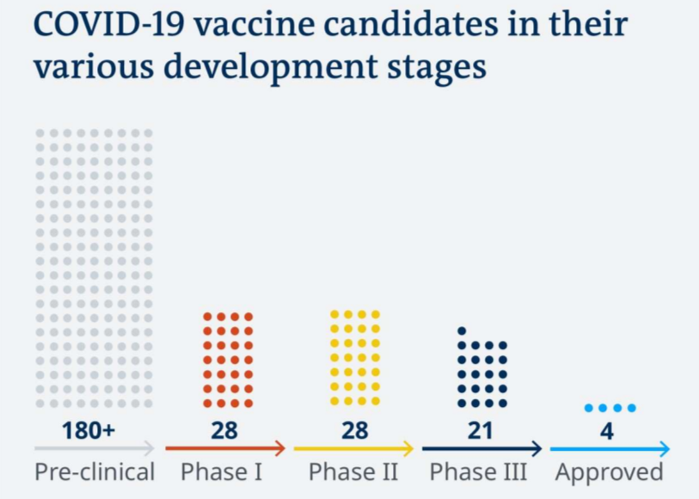

**DEVELOPMENT, EVALUATION, APPROVAL AND MONITORING**

COVID-19 inoculations are developed, scientifically evaluated, approved, and monitored in the European Union by the European Medicines Agency (EMA) (EU). COVID-19 vaccines are being industrialized, reviewed, and accepted in compliance with existing regulatory and lawful requirements.

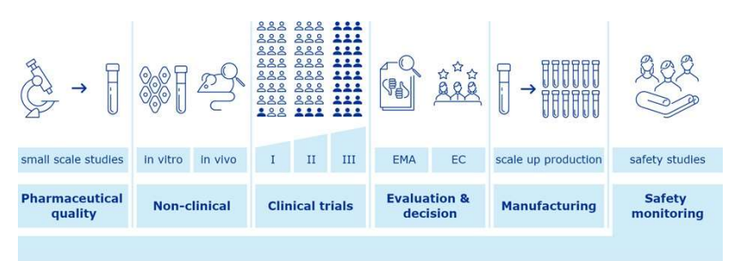

Figure: 3 Overview of vaccine development and approval stages

**DEVELOPMENT:**

COVID-19 vaccines, similar all drugs, are primary evaluated in the lab. The inoculations are then verified in clinical trials on humanoid volunteers. These tests are used to validate how vaccines function as well as to assess their protection and protecting effectiveness. Standard vaccine development Vaccine formulation is a lengthy process in which trials are carried out in stages. To characterise and optimise the manufacture procedure, corporations initial produce minor groups and conduct small-measure tests. They conduct research to find a preparation that will keep vaccination components safe until the finish of its shelf lifecycle. The corporation then chooses whether or not to continue developing and expanding manufacture. The organisation implements a suitable and appropriate quality management strategy to ensure that the inoculation achieves its expected value outline and meets controlling requirements.

Specific vaccine ingredients, the last preparation to be used, and the entire industrial procedure are all examined in depth in pharmaceutical quality studies. Towards illustrate how the vaccination causes a resistant reply and acts to avoid contamination, the inoculation creator performs further experiments in laboratory models, using in vitro trainings or animal models. Finally, the inoculation's inventor conducts three stages of clinical trials, each with a greater number of participants. Fast-track vaccine development in a public health emergency Vaccine production for COVID-19 vaccines is moving at a breakneck pace around the world. The manufacturing process is sped up by using the vast knowledge of vaccine production obtained from previous vaccines. Regulators can help speed up progress by providing early scientific advice.

The European Medicines Agency (EMA) provides unofficial discussion with its COVID-19 Group of Experts as well as fast technical guidance. COVID-19 inoculation designers can get immediate advice on the greatest approaches and study designs for generating reliable results. More details can be found at: Provision for drug and inoculation creators from the start COVID-19 drugs that have been approved by the European Medicines Agency Advising businesses on regulatory requirements ensures that quality, protection, and effectiveness criteria are established initial in the procedure and are not jeopardised by rapid growth.

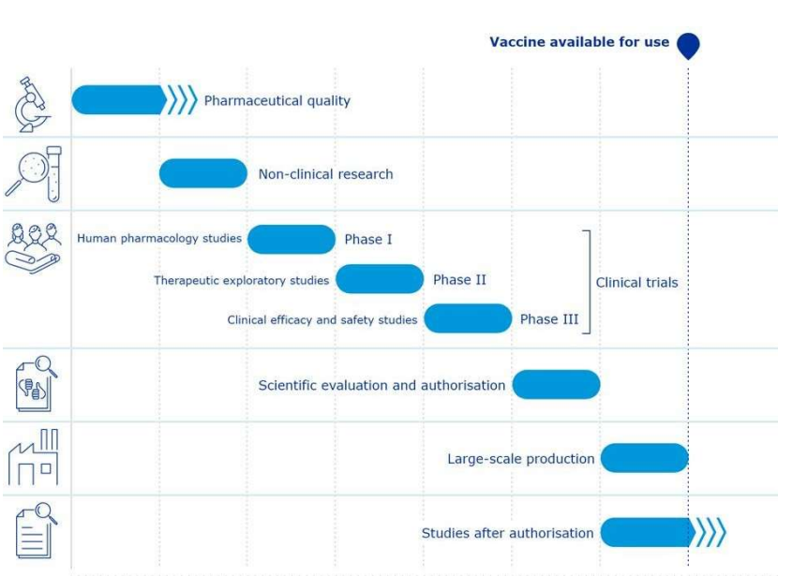

Figure: 4 Indicative timelines for COVID-19 vaccines compared with standard vaccine

Vaccine manufacturers and academics depend on well-proven manufacturing processes that have produced safe and successful vaccines in the past. Furthermore, they are still looking for new ways to produce and manufacture inoculations, and some of the developments made so far are being used to develop inoculations for COVID-19. Approximately COVID-19 inoculations are being produced using innovative approaches to growth production capacity and haste compared to other types of inoculations, boost merchandise constancy, and induce strong resistant replies. Additional inoculations are produced using techniques that have already been used to manufacture vaccines for other diseases, making it simpler to mass-produce COVID-19 vaccines than it is for novel inoculation categories.

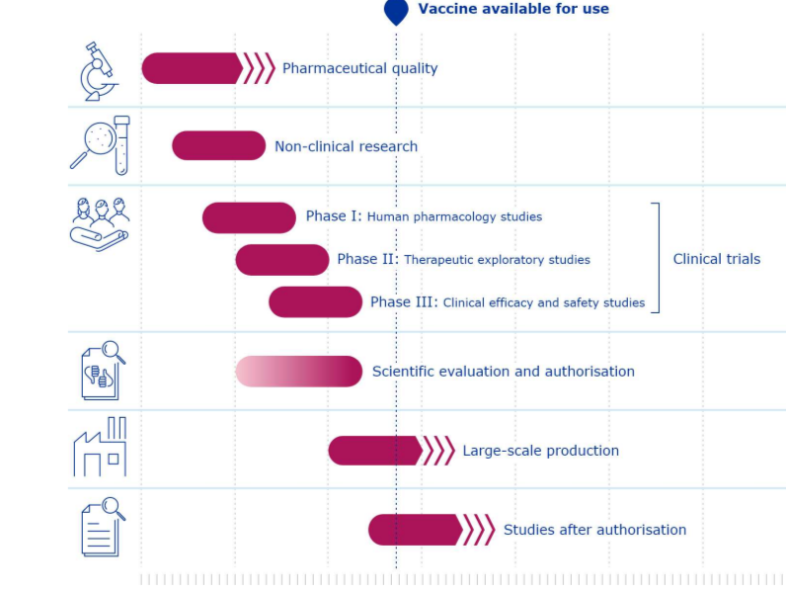

**Regulatory standards**

COVID-19 vaccines essential meet the same regulatory requirements as all other drugs in the EU.

**STANDARD**

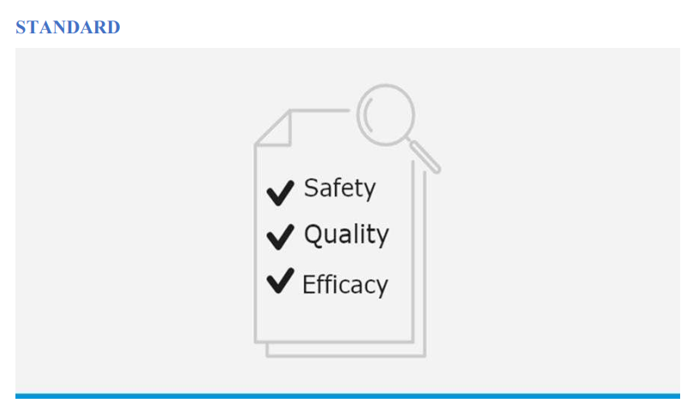

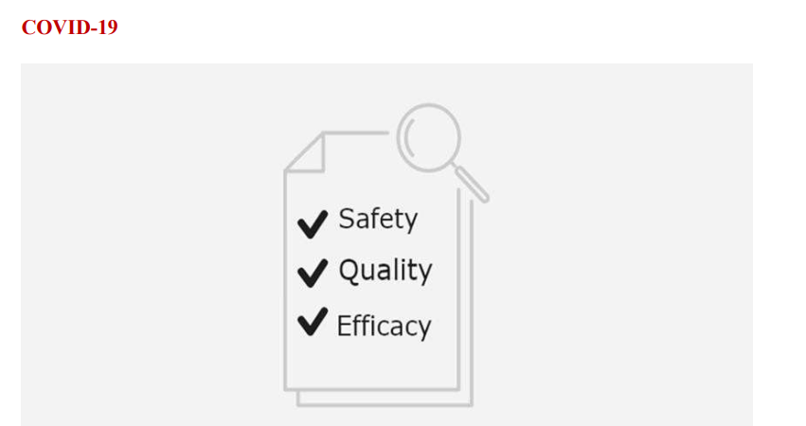

**Timelines**

COVID-19 vaccine production is sped up by using the most up-to-date vaccine development expertise.

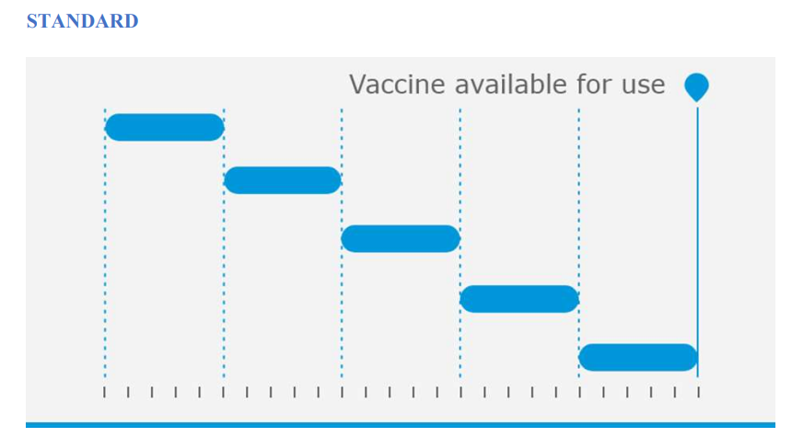

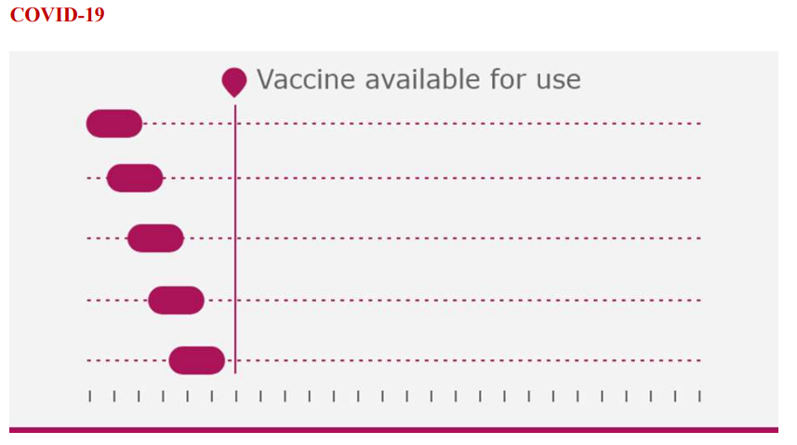

**Resource**

The advancement of the COVID-19 vaccine mobilises more capital at the same time.

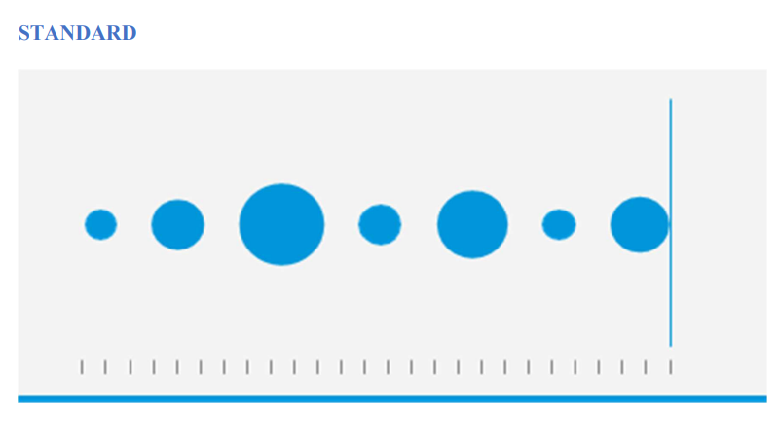

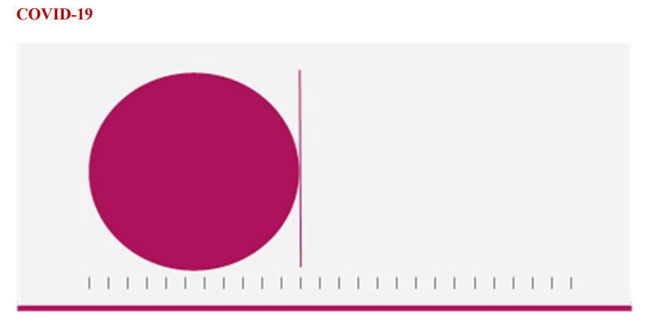

**Expert Task Force & continuous dialogue**

The creation of the COVID-19 vaccine is supported by primary and ongoing communication among creators and a dedicated community of controlling specialists. EMA (European Medicines Agency) Task Force COVID-19

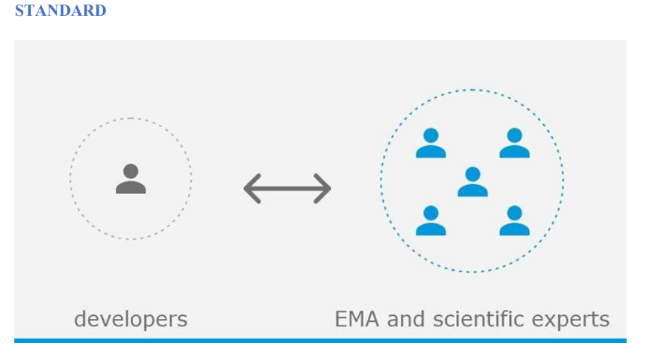

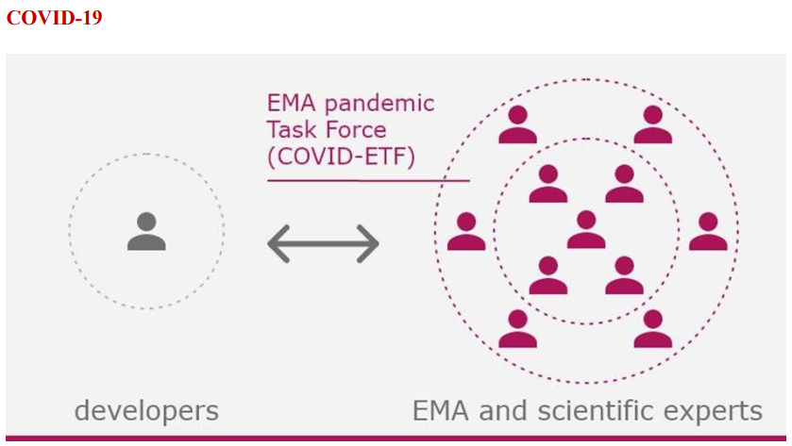

**Manufacturing**

To ensure effective vaccine deployment, companies are expanding their manufacturing and development capability.

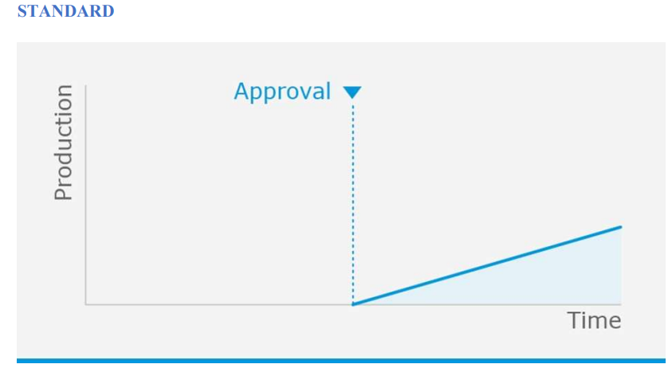

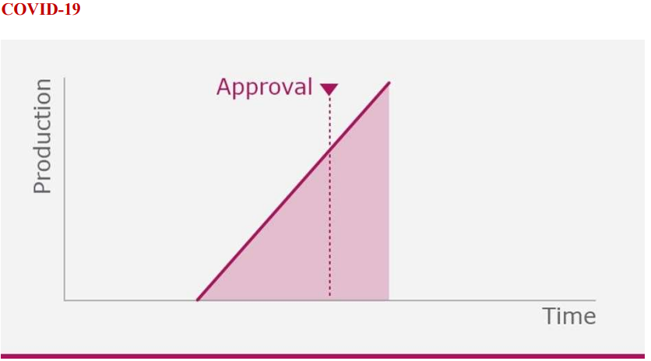

5.7.6 COVID-19 vaccines under assessment for approval by EMA

MRNA inoculations contain genetic directions (mRNA) for creation an immune reply compared to coronavirus.

• Pfizer-Biotech (BNT162b2)

• Modern (mRNA-1273)

Viral vectors usage altered inoffensive adenovirus to carry genetic advices for creation an immune reply compared to coronavirus.

• Astra Zeneca/Oxford (ChAdOx1-SARS-CoV-2)

• Janssen (Ad26.COV2.S) [27]

**CONCLUSION**

In European Union, vaccine preparation and monitoring are governed by a set of rules. The initial stages are meant to be exploratory. The amount of regulation and supervision increases as the vaccine progresses through the process. Vaccines in the European Union (EU) are based on a thorough regulatory approval procedures to ensure their safety, efficacy, and accuracy. Depending on the product, this process can take months or years. Centralised, decentralised, and mutual recognition are the three different approaches to get a pharmaceutical product licenced in the EU. The European Medicines Agency receives a single Marketing Authorization Application (MAA) from companies (EMA) for approval of the vaccines. Common Technical Document is a standardised electronic framework for new products. Europe was the first to implement injection, and it has been at the forefront of the global injection industry ever since, playing a critical role in vaccine research and development. After a vaccine is agreed for use, the European Medicines Agency (EMA) and national authorities in the EU/EEA monitor side effects in publics who take conventional the vaccine. Individual European countries determine if vaccines should be included in their national vaccine programmes and paid by their health- care systems. Most national vaccination programmes in the EU/EEA provide vaccines for up to twenty diseases to people of various ages. The European Medicines Agency (EMA) develops, scientifically evaluates, approves, and monitors COVID-19 inoculations in the European Union (EU). COVID-19 vaccines are being mass-produced, evaluated, and approved in accordance with current regulatory and legal requirements.

**REFERENCES**

1. Vaccine [online] Available at: <https://en.wikipedia.org/wiki/Vaccine>

2. Vaccines developed [online] Available at: <https://www.vaccineseurope.eu/about> vaccines/how-are-vaccines-developed

3. Vaccine [online] Available at: <https://www.vaccineseurope.eu/>

4. Yurim Seo⁎ and Eunjoo Pacifici Elements of Regulatory Dissonance: Examining FDA and EMA Product Labeling of New Vaccines (2006–2018)

5. Ole F. Olesen,⁎ Anna Lonnroth, and Bernard Mulligan Human vaccine research in the European Union

6. Vaccine history [online] Available at: <https://time.com/5835668/vaccine-history/>

7. Yoshikazu Nakayama and Atsushi Aruga* Comparison of Current Regulatory Status for Gene-Based Vaccines in the U.S., Europe and Japan.

8. Vaccine [online] Available at: <https://en.wikipedia.org/wiki/Vaccine>

9. Vaccine [online] Available at: <https://www.historyofvaccines.org/timeline#EVT_2>

10. A brief history of vaccination [online] Available at: <https://www.vaccinestoday.eu/stories/a-brief-history-of-vaccination/>

11. Vaccine development [online] Available at: https://www.vaccineseurope.eu/aboutvaccines/how-are-vaccines-developed

12. Vaccine approved in Europe [online] Available at: <https://www.euronews.com/2020/07/03/how-does-a-vaccine-get-approved-in-europe> the-process-explained

13. Approval of vaccines [online] Available at: <https://vaccination-info.eu/en/vaccine> facts/approval-vaccines-european-union

14. Vaccine facts [online] Available at: <https://vaccination-info.eu/en/vaccine-facts>

15. Vaccine effectiveness [online] Available at: <https://vaccination-info.eu/en/vaccine> facts/vaccine-effectiveness

16. Monitoring vaccine safety [online] Available at: <https://vaccination-info.eu/en/vaccine> facts/monitoring-vaccine-safety-and-reporting-side-effects

17. Vaccine effectiveness [online] Available at: <https://vaccination-info.eu/en/vaccine> facts/vaccine-effectiveness