**Investigation of Concrete Properties Using Waste Foundry Sand and Recycled PET Bottle Aggregates**

Prachi Dubey1, Afzal khan2

M.Tech Scholar1 , Assistant Professor2

MILLENNIUM INSTITUTE OF TECHNOLOGY,BHOPAL (M.P)

**Abstract:**  
Concrete is a major construction material composed of cement, sand, coarse aggregate, and water. The management and disposal of industrial by-products like waste foundry sand (WFS) and non-biodegradable materials such as PET bottles present environmental challenges. This research explores using waste foundry sand and recycled PET bottle aggregates in concrete to enhance properties like compressive, tensile, and flexural strength, while simultaneously addressing waste disposal issues. Experimental studies were conducted on M25 grade concrete, with partial replacements of fine aggregate using WFS and coarse aggregate using PET bottles. Results indicate improved strength characteristics, positioning this approach as a cost-effective and sustainable solution for the construction industry.

**Keywords:** Foundry Sand, PET Bottles, Recycled Aggregates, Concrete Strength, Sustainability

**1. Introduction**

Concrete’s versatility and high strength have led to its extensive use in construction, contributing to high demands on natural resources like river sand. Waste foundry sand (WFS) is an industrial by-product primarily used in mold-making in the metal casting industry. Disposing of WFS and plastic, especially PET bottles, represents a major environmental challenge. Thus, integrating these materials into concrete mixes could provide an efficient way to manage waste while producing an economically beneficial concrete with enhanced properties.

**2. Literature Review**

Several studies highlight the potential benefits of incorporating WFS and recycled PET into concrete. Previous research has shown that replacing natural aggregates with waste materials can improve various mechanical properties, including compressive, tensile, and flexural strengths. Studies by Maqbool (2019) and Schankoski (2019) support WFS’s role in eco-efficient construction, while researchers like Alsadey (2016) have demonstrated the effectiveness of PET fibers in enhancing concrete’s compressive strength.

**3. Problem Statement and Objectives**

Despite evidence of enhanced concrete properties using waste materials, comparative studies on the combined use of WFS and PET aggregates in concrete are limited. This study aims to:

* Investigate the properties of concrete with partial replacements of fine aggregates using WFS and coarse aggregates using PET.
* Evaluate the workability, compressive strength, tensile strength, and flexural strength of modified concrete.
* Assess the economic and environmental feasibility of using these waste materials in construction.

**4. Methodology**

Concrete mix designs were prepared in accordance with IS 10262-2009 for M25 grade concrete. Waste foundry sand replaced fine aggregate at 0%, 5%, 10%, 15%, 20%, and 25%, while recycled PET aggregates replaced coarse aggregates at 0% and 5%. Compressive, tensile, and flexural strength tests were conducted after curing specimens for 7, 14, and 28 days.

**4.1 Materials**

* **Cement**: Ordinary Portland Cement (OPC) of 43-grade.
* **Fine Aggregate**: Natural river sand (Zone II as per IS 383-1970).
* **Coarse Aggregate**: Crushed rock, maximum size 20 mm.
* **Waste Foundry Sand (WFS)**: High-quality silica sand used in metal casting, with specific gravity 2.55 and bulk density 1650 kg/m³.
* **Plastic Bottle Aggregate (PET)**: Shredded PET bottles with specific gravity 0.8.

**5. Experimental Results and Discussion**

The experimental results indicate that:

* **Compressive Strength**: Increased with the addition of WFS up to 20% and PET aggregates up to 5%. Beyond these limits, strength decreased due to excessive plastic content.

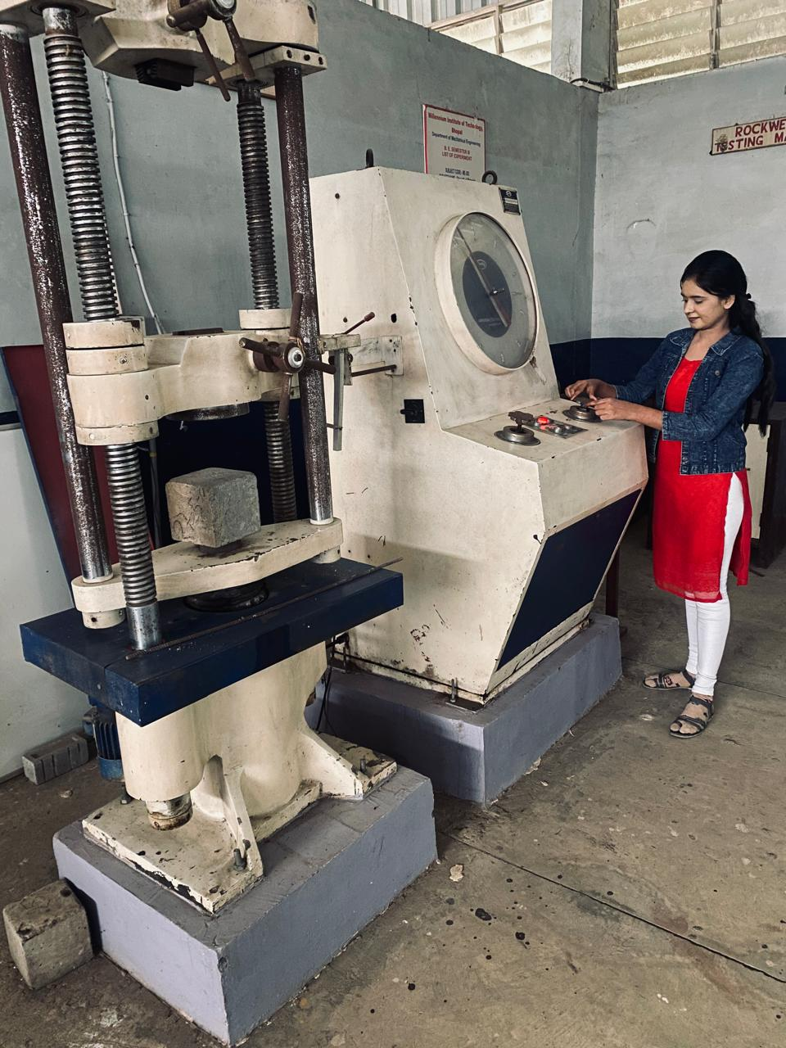

**Fig. 1 Compressive Strength test**

**Table 5.2 – Compressive Strength of M25 Grade concrete in N/mm2**

|  |  |  |  |  |  |
| --- | --- | --- | --- | --- | --- |
| **S.No.** | **Different % of waste used in concrete** | | **Compressive Strength of M-25grade concrete in N/mm2** | | |
| **% of waste foundry sand** | **% of waste Plastic bottle scrap** | **7 Days** | **14 Days** | **28 Days** |
| 1 | 0% | 0% | 18.92 | 22.25 | 28.19 |
| 2 | 5% | 5% | 19.27 | 23.8 | 28.81 |
| 3 | 10% | 5% | 19.62 | 25.35 | 29.43 |
| 4 | 15% | 5% | 20.2 | 25.63 | 29.65 |
| 5 | 20% | 5% | 20.42 | 25.92 | 29.88 |
| 6 | 25% | 5% | 19.75 | 25.20 | 28.61 |

**Fig. 2 Compressive Strength of M-25grade concrete in N/mm2**

* **Tensile Strength**: Enhanced with the combined use of WFS and PET, attributed to improved bond strength.

|  |  |  |  |  |  |
| --- | --- | --- | --- | --- | --- |
| **S.No.** | **Different % of waste used in concrete** | | **Split Tensile Strength for M25 Grade of Concrete in N/mm2** | | |
| **% of waste foundry sand** | **% of waste Plastic bottle scrap** | **7 Days** | **14 Days** | **28 Days** |
| 1 | 0% | 0% | 2.31 | 2.68 | 3.39 |
| 2 | 5% | 5% | 2.38 | 2.71 | 3.43 |
| 3 | 10% | 5% | 2.46 | 2.75 | 3.47 |
| 4 | 15% | 5% | 2.47 | 2.82 | 3.51 |
| 5 | 20% | 5% | 2.49 | 2.89 | 3.56 |
| 6 | 25% | 5% | 2.36 | 2.80 | 3.39 |

Fig. 3 **Split Tensile Strength in N/mm2**

* **Flexural Strength**: Showed a similar trend, with optimal strength achieved at 20% WFS and 5% PET replacement.

|  |  |  |  |  |  |
| --- | --- | --- | --- | --- | --- |
| **S.No.** | **Different % of waste used in concrete** | | **Flexural Strength of M-25grade concrete Beam in N/mm2** | | |
| **% of waste foundry sand** | **% of waste Plastic bottle scrap** | **7 Days** | **14 Days** | **28 Days** |
| 1 | 0% | 0% | 2.22 | 2.78 | 3.73 |
| 2 | 5% | 5% | 2.39 | 3.02 | 3.87 |
| 3 | 10% | 5% | 2.56 | 3.26 | 4.02 |
| 4 | 15% | 5% | 2.59 | 3.34 | 4.15 |
| 5 | 20% | 5% | 2.63 | 3.42 | 4.28 |
| 6 | 25% | 5% | 2.52 | 3.23 | 3.97 |

**fig .4 Flexural Strength of M-25grade concrete Beam in N/mm2**

**6. Conclusion and Future Scope**

The study concludes that WFS and PET aggregates can effectively enhance the mechanical properties of concrete, offering a sustainable alternative to traditional concrete materials. Future research should explore larger-scale applications, environmental impacts, and the long-term durability of concrete containing these waste materials.

**References**

1. Celik, T. and Marar, K., 1996. Effects of crushed stone dust on some properties of concrete. Cement and Concrete research, 26(7), pp.1121-1130.
2. Colombo, P., Brusatin, G., Bernardo, E. and Scarinci, G., 2003. Inertization and reuse of waste materials by vitrification and fabrication of glass-based products. Current Opinion in Solid State and Materials Science, 7(3), pp.225-239.
3. S.P. Oudhia, an Overview of Indian Foundry Industry, Metalworld. (2015) 3–4.
4. Sarita Chandrakanth and Ajay.A.Hamane, "Partial Replacement of Waste Foundry Sand and Recycled Aggregate in Concrete", International Journal for Research in Applied Science & Engineering Technology (IJRASET), Volume 4 Issue V, May 2016, 98 ISSN: 2321-9653
5. T.R. Naik, Foundry industry by-products utilization, (1989).
6. Today, F.I.R.S., 2004. Foundry sand facts for civil engineers. Federal Highway Administration Environmental Protection Agency Washington, DC.
7. Y. Aggarwal, R. Siddique, Microstructure and properties of concrete using bottom ash and waste foundry sand as partial replacement of fine aggregates, Constr. Build. Mater. 54 (2014) 210–223.