**A Review Paper On**

Secure Smart Parcel Receiving System

1Yash Kandelkar, 2Amay Baurashi, 3 Manav Gokhale, 4Om Deshmukh 5Anshuman

Deshmukh 6Sharvid Miskin

7Shri.R.M.Gharat 1,2,3,4,5,6Students, Electronics Engineering.

7HOD, Electronics Engineering,

Dr. Panjabrao Deshmukh Polytechnic, Amravati, Maharashtra, India.

***Abstract: -***

***A system called the Secure Smart Parcel Receiving System has been developed to enhance the safety and efficiency of package deliveries through the use of advanced technologies such as IoT and automated alerts. It ensures the secure acceptance and storage of parcels and enables users to keep track of deliveries, receive notifications when packages arrive, and employ secure retrieval methods to minimize theft and unauthorized entry. The primary objective of this system is to provide proof to users in both residential and commercial settings.***

# Keywords*—* Parcel receiver, Arduino, Secure, E-Commerce,

**INTRODUCTION**

As we know that the world is getting smarter in everything and busy with their work. So, the customer uses online shopping as compared to offline shopping, now customers mostly use e- commerce and online shopping but the person does not have any time to receive the parcel, so as we cannot take the delivery or due to other reason we can’t [1]. As we know that, most of the receiver facing the problem of the parcel which is, if the receiver cannot receive the parcel, parcels left unattended the parcel may be subject to theft or environmental damage, parcels re-delivery will be time consuming and costly which leads to dissatisfaction to the customer. Hence, the automation of receiving the parcel will lead a new revolution & easy receiving of parcel can be possible. This is the motive behind the proposal of an approach for automation of the parcel receiving. It is an electronic delivery box with advance locking system with a keypad and fingerprint sensor

. Due to this system your parcel will be secure in it. The major advantage of this system is it contains of GSM module, so where ever the receiver is present in the globe can receive the information of received parcel [1].

On the basis of survey, Amazon accounted for close to 3 million shipments per day, followed by Flipkart plus Myntra at around 2.5 million per day. All the other horizontals and verticals, including Meesho, ShopClues, and Snapdeal, accounted for about 2.5 million daily shipments.[8]

So, in this box we provided a locking system which will be control by the customer which ensures the security of the box and the parcel which is inside it. In earlier days when people used to put the simple box outside the house. The deliver may often refuse to leave parcel in this existing boxes as they do not offer true proof of delivery. Our smart parcel receiving box has the ability that issue multiple number of OTPs on each delivery. So, this can provide the proper proof of delivery [4].

Here’s how it works:

When you buy parcels online and no one at home for receiving parcel, the parcel can first be delivered to a trusted neighbor or to the front house door. However, if neither of these options is available, our system will implement. We will install a Smart Parcel Box outside the door of your house. This box will feature advanced security like a fingerprint scanner and an IoT interface. If you’re not home, the delivery person can securely place the parcel in the box. The box can only be unlocked using a PIN or OTP provided by the homeowner, ensuring that only authorized access is granted to the delivery person. This system guarantees the safety and contact-less delivery of your parcels even when you’re away.[6]



Fig a. Parcel being theft

# LITERATURE REVIEW

Recently, the RFID mailbox courier system was studied by Himalayee Saini, et al, each courier is attached with RFID tag and sends the identity number to receivers mobile. When the courier boy arrives, the RFID tag on the courier is read by RFID reader. When the tag matches, letter box is automatically opened using geared DC motor, then it sends message to receiver about arrival of the courier. When the receiver takes the courier from letter box, an acknowledgment is sent to courier officee.[1]

Another study about Future Parcel box was studied by Ahmad Syafiq Bin Masrilhisyam, et al, propose a solution of Future Parcel Box is a parcel collection unit which will receive the parcel from courier person safely. This smart system will save time as it avoids rescheduling of the parcel delivery. Customer can click and receive the parcel securely through their emails. The important use of this product which user can save so much time. Finally, the stolen parcels case can be avoided by this new parcel box.[2]

Similar approach was taken by Indrayani Rewatkar, et al, of a Design and Implementation of Smart Parcel Receiving System, A Box will be having a request key which will provide trigger to delivery driver. The delivery driver simply presses the key on the box. System is having GSM module which send the notification of new parcel to the owner’s smartphone. Owner will send the OTP in response to the notification message which will be received by the system in the parcel box. System will display the OTP for delivery person for confirmation. Further on validation the upper lid is opened and package is to be kept by the delivery person within stipulated time after which the lid is closed. Once the upper lid is closed another confirmation is made whether the package is placed by output of IR sensor placed inside compartment.[3]

Another project was done by Ahmad Anwar Zainuddin, et al on Simulating the Effectiveness of an IoT Parcel Alert System for Enhancing Delivery Efficiency and Safety During Covid-19. In which Information about parcel details will be sent to the recipient and the recipient needs to verify the parcel details. When the recipient wants to pick up the parcel, the recipient will show QR code and light sensors detect light and convert light energy to an electrical signal output. After detection of QR code is successful, the recipient will receive a One-Time

Password (OTP) to verify the authorized recipient only. Recipient needs to enter that password correctly to collect their parcel from the locker.[4]

Another study by R. ReddiRani on IoT Based Bank Locker System using Finger Print and OTP, the main aim of this project is to design and implement bank locker security system based on Finger print and OTP technology.[5] This can be organized in bank, offices and homes. In this system only the authenticate person recover the documents or money from the lockers. In this security system fingerprint and OTP is used.

Lee Jia Heng studied about A prototype of smart parcel box,[6] This project develops a prototype of a smart parcel box. This project will be developed by using Raspberry Pi and configured with a computer. This project will be able to solve the parcel receiving problem faced by the deliveryman and recipient. Besides, since this project is just a prototype product of a smart parcel box, therefore it is only limited to receiving one parcel at one time, and it is also limited to one deliveryman and one recipient. The prototype of the smart parcel box is not weather-proof.

Mohit Guptaa et al, proposed a project on Designing an Intelligent Parcel Management System using IoT & Machine Learning,[7] the aim is to save the time, detect impermissible objects inside the parcel and also to reduce human efforts. We have used RFID together with QR code so as to reduce the chances of missing a parcel when being scanned as the QR code needs to be facing the camera for being read and RFID can be read by a RFID reader irrespective of the orientation of the parcel moreover RFID is much secure than the QR code and even holds more data.

# PROPOSED METHODOLOGY

1. System Architecture:

The upper compartment is called the receiving compartment in which the delivery driver will drop the parcel. The lower compartment is called the safety compartment in which owner will collect it.

In the below flowchart, the delivery boy will come at box and open then the SMS will go on to the mobile number of the owner. As soon the OTP is received the delivery boy will unlock the box after typing the OTP. The box will detect if the Parcel is received if it does not detect the parcel the SMS will be sent on the owner’s number. If the box detects parcel, then the door will be locked and message will be sent on owner number.[3]

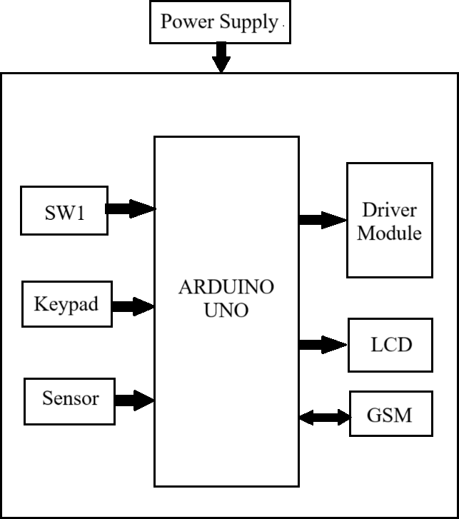

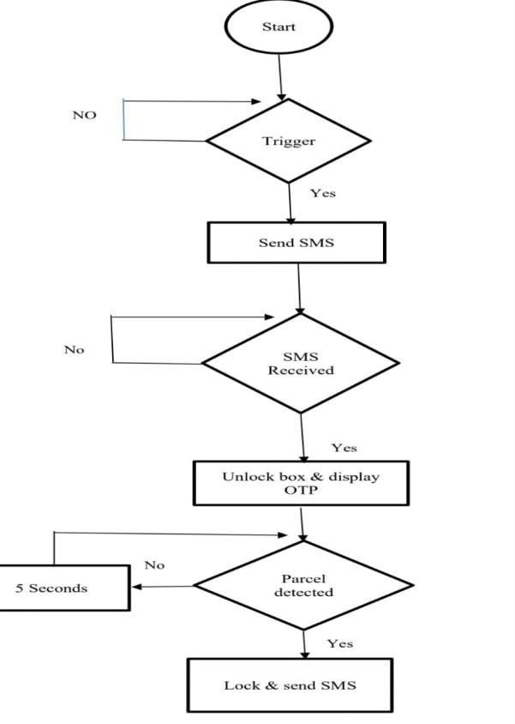Fig b. Flowchart of Receiving component

As shown in the below figure, When the owner will come at home to collect the parcel the safety compartment will take place**,** the owner will place his finger or password on the display screen if the password matched the door will open otherwise the door will remain close.

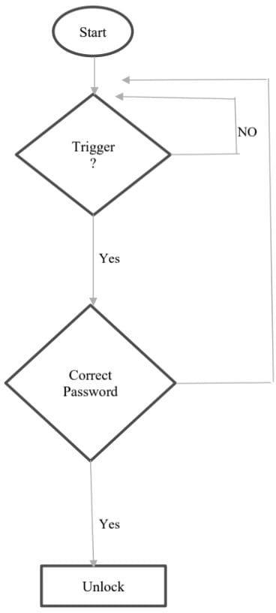

Fig c. Flowchart of safety compartment

Fig d. Block Diagram of Parcel receiver

The above block diagram consists of Smart Secure Parcel Receiver System which contains Arduino uno, in which all other components are connected as input output ports i.e. Switch/push-buttons, LCD display, GSM Modem, Fingerprint Sensor, Keypad, Driver module.

1. Description of Components
   1. Arduino Uno

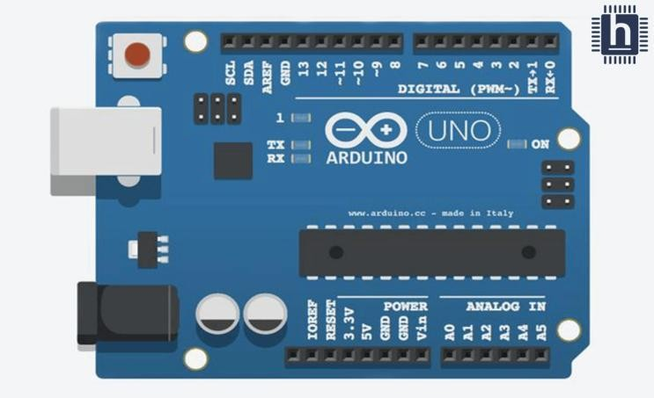

The Arduino Uno is one kind of microcontroller board based on ATmega328, and Uno is an Italian term which means one. Arduino Uno is named for marking the upcoming release of microcontroller board namely Arduino Uno Board 1.0. This board includes digital I/O pins-14, a power jack, analog I/ps-6, ceramic resonator-A16 MHz, a USB connection, an RST button, and an ICSP header. All these can support the microcontroller for further operation by connecting this board to the computer. The power supply of this board can be done with the

help of an AC to DC adapter, a USB cable, otherwise a battery. This article discusses what is an Arduino Uno microcontroller, pin configuration, Arduino Uno specifications or features, and applications.[7]

* 1. Pushbuttons

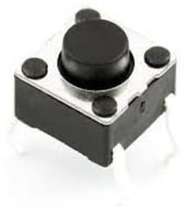

A push-button or simply button is a simple switch mechanism to control some aspect of a machine or a process. Buttons are typically made out of hard material, usually plastic or metal. The surface is usually flat or shaped to accommodate the human finger or hand, so as to be easily depressed or pushed. Buttons are most often biased switches, although many un-biased buttons (due to their physical nature) still require a spring to return to their un pushed state. Terms for the "pushing" of a button include pressing, depressing, mashing, slapping, hitting, and punching.[7]

* 1. GSM

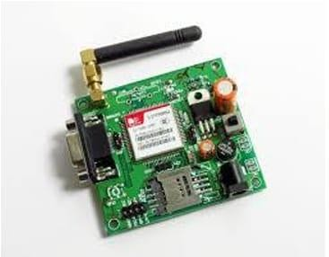

GSM is a mobile communication modem; it is stand for global system for mobile communication (GSM). A GSM digitizes and reduces the data, then sends it down through a channel with two different streams of client data, each in its own particular time slot. Basically, GSM was built to aid 2g connectivity in mobile phones. Earlier, the network incorporated a circuit switching network but with time and need, it had to collaborate with GPRS, implementing the packet switching

protocol. The frequency of operation of the GSM network falls within the range of 900-1800 MHz

* 1. LCD Display

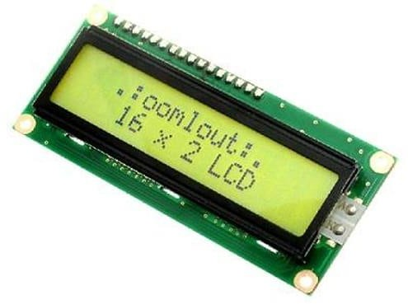

The LCD (Liquid Crystal Display) used in the Smart Parcel Receiving System is a 16x2 character display, which means it can show two rows of up to 16 characters each. This type of display is popular for its low power consumption and ease of use with microcontrollers like Arduino. It allows for the display of essential information, such as parcel delivery notifications and OTP codes for secure access.

* 1. Fingerprint Sensor

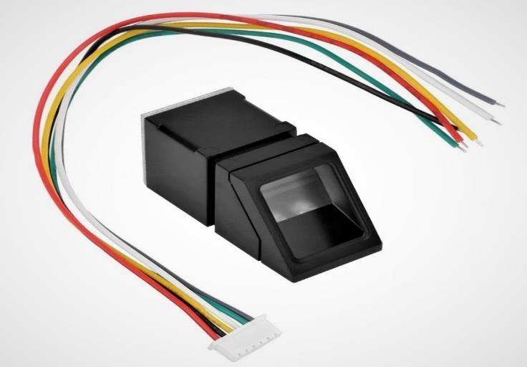

This is the fingerprint sensor MSF500 is used which will detect the owner’s fingerprint by scanning and will open the door.

As we become more advanced and IoT keeps growing, accurate data collection via sensors becomes more important. Smartphones are the best example on how sensors are quickly changing the way we go about our days. After all, it was only a few years ago that phones didn’t have touchscreen or fingerprint applications on them.

# CONCLUSIONS

This system ensures that parcels are securely stored until the recipient is available to collect them. This innovative approach addresses several key challenges in the current delivery system: Reduction of Missed Deliveries: The smart parcel locker allows delivery personnel to deposit packages without requiring the recipient's presence, to reduce and minimizing missed delivery attempts. Enhanced Security: With biometric access and secure locking mechanisms, the risk of theft or loss is greatly reduced. This is more effective in urban areas where package theft is common. Convenience and Flexibility: Recipients can access their parcels at their convenience, eliminating the need to rearrange their schedules around delivery windows. This flexible option IS FOR those with busy lifestyles. personnel from potential health risks associated with direct interactions. Automated Notifications and Access Control: The system provides real-time notifications to recipients when their parcels are delivered, along with OTP/PIN for secure delivery. This ensures that users are always informed and in control of their deliveries. In summary, the Smart Secure Parcel Locker System not only streamlines the parcel receiving process but also enhances security and convenience for users. As e-commerce continues to grow, such systems will play a crucial role in modern logistics and delivery solutions, making them an essential addition to any smart home ecosystem.

# REFERENCES

* + 1. Himalayee Saini, Anita Sharma, International Journal of Research in Engineering, Science and Management Volume-2, June-2019, pp.1-4
    2. Ahmad Syafiq Bin Masrilhisyam, Jabatan kejuruteraan elektrik,2022, pp. 9-12
    3. Indrayani, Rewatkar Samiksha Shankarpure, Sayma Shete, Mrunal Bhuskade, International Journal of Scientific and Research Publications 2021, pp. 5-31
    4. AhmadAnwarZainuddin, Hafizah Mansor1, Nurul Iffah Badrulhisham1, Nurul Nabilah Zulkifli1, Aisyah Afiqah Mohd Ridzal1, and Nasyitah Ghazalli, Malaysian Journal of Science and Advanced Technology,2021, pp. 30-33
    5. R.ReddiRani,Pavithra Neelam, Journal of Emerging Technologies and Innovative Research, 2021, pp.1-5
    6. Lee Jia Heng, Bachelor of Information Technology Communications and

Networking Faculty of Information and Communication Technology, UTAR, 2021, pp.5-32

* + 1. Mohit Gupta, Nitesh Garg, Jai Garg, Vansh Gupta, and Devraj Gautam,2024, pp.2-6
    2. [https://glginsights.com/articles/analyzing-the-](https://glginsights.com/articles/analyzing-the-indian-e-commerce-logistics-market/) [indian-e-commerce-logistics-market/](https://glginsights.com/articles/analyzing-the-indian-e-commerce-logistics-market/)
    3. [https://swiftlane.com/blog/package-theft-](https://swiftlane.com/blog/package-theft-prevention/) [prevention/](https://swiftlane.com/blog/package-theft-prevention/)