**COMPREHENSIVE WEB APPLICATION FUZZER**

Mrs.Gayathiri devi & Arunthathi.S & Dhivya.V & Gokilavani.M & Kiruthiga.M

Mrs.Gayathiri devi

[gayathiridevimit@siet.ac.in](mailto:gayathiridevimit@siet.ac.in)

Arunthathi.S

anuaruthathi127@gmail.com

Dhivya.V

dhivyavenkat2005@gmail.com

Gokilavani.M

[mgoki2005@gmail.com](mailto:mgoki2005@gmail.com)

Kiruthiga.M

mkiruthiga550@gmail.com

Sri Shakthi Institute of Engineering and Technology, Coimbatore. Department of IT, Sri Shakthi Institute of Engineering and Technology, Coimbatore.

**Abstract:**

Web application fuzzing is a critical approach to identifying vulnerabilities in modern web applications. This technique involves feeding unexpected or malformed input to web applications to uncover potential security flaws, such as SQL injection, cross-site scripting (XSS), and buffer overflows. This study reviews the architecture, methodologies, and effectiveness of current web application fuzzers. We explore various fuzzing approaches, including mutation-based, generation-based, and hybrid fuzzing, highlighting their advantages and limitations. . Our analysis provides insights into the capabilities and challenges of existing fuzzing tools, proposes best practices for effective fuzzing, and suggests future research directions to address unresolved issues in this rapidly evolving field. By examining the comprehensive scope of web application fuzzers, this study aims to guide

both researchers and practitioners in selecting and improving fuzzing methodologies to build more secure web applications

**Keywords:**

Security Protocols for Web Application Fuzzing, Defining Excellence in Web Application Fuzzing, Managing Inputs and Outputs in Fuzzing, Fundamental Techniques and Approaches, Proposed Methods, Conclusion

**Introduction:**

As web applications become increasingly integral to business operations, social interactions, and data management, their security has become a paramount concern. Modern web applications are often complex systems, featuring intricate APIs, extensive databases, and diverse client-server interactions, all of which expand the potential attack surface for malicious actors. Fuzzing has emerged as a valuable technique for identifying vulnerabilities in web applications by generating and sending unexpected or malformed inputs to an application and monitoring its behavior for crashes, unexpected responses, or security flaws. This approach helps uncover critical issues such as SQL injections, cross-site scripting (XSS) vulnerabilities, and buffer overflows.Web application fuzzing is, however, challenging. Unlike traditional applications, web applications are dynamic, often stateful, and rely on a range of components and protocols, requiring fuzzer to handle various data formats, authentication mechanisms, and application states. This complexity has driven advancements in fuzzing methodologies, leading to the development of several approaches, including mutation-based, generation-based, and hybrid fuzzing. This paper aims to provide a comprehensive overview of web application fuzzer, exploring their design, methodologies, effectiveness, and limitations. By examining both established and emerging fuzzing tools and techniques, we seek to assess their capability to detect vulnerabilities in modern web applications. Additionally, this paper highlights the challenges and opportunities presented by web application fuzzing, offering best practices for practitioners and identifying future directions for researchers in this evolving field.Web application fuzzing, however, presents unique challenges. Unlike standalone or desktop applications, web applications typically rely on complex interactions across multiple layers, including client-side scripts, server-side processing, databases, and external APIs. The interconnected nature of these components creates an expanded attack surface that is difficult to comprehensively test. Furthermore, web applications are often stateful, requiring fuzzers to account for session handling, authentication, and user-specific configurations. To address these challenges, various types of fuzzing techniques have evolved, each with its strengths and trade-offs.

**Security Protocols for Web Application Fuzzing**

To ensure the security and integrity of an application, fuzz testing should be conducted using access control mechanisms, authentication measures, and real-time monitoring. This ensures privacy compliance, prevents unauthorized access, and adheres to legal and ethical standards. This includes obtaining proper permissions, anonymizing user data, and following industry standards like OWASP or NIST.

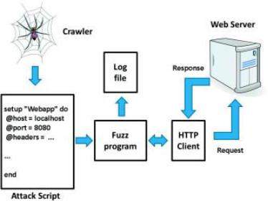

**Defining Excellence in Web Application Fuzzing**

Excellence in web application fuzzing involves a fuzzing process that is effective and efficient in identifying vulnerabilities while minimizing risks and false positives.It should provide comprehensive coverage in a timely manner, handle large-scale applications with high throughput, and filter out false positives to provide actionable insights into actual vulnerabilities.

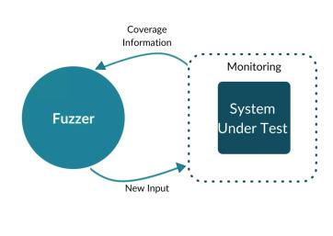

**DYNAMIC FUZZING OF WEB APPLICATION:**

Dynamic fuzzing of web applications, when integrated into a web application fuzzer, involves the process of sending a variety of unexpected or malformed inputs to the application during its runtime to uncover security vulnerabilities. This method typically targets components such as input fields, APIs, authentication mechanisms, and other user-interactive elements. By dynamically interacting with the web application—such as manipulating query parameters, cookies, or headers—fuzzing tools can simulate real-world attack scenarios like SQL injection, Cross-Site Scripting (XSS), and buffer overflows. The fuzzer monitors the application’s responses, identifying any anomalies, crashes, or unexpected behavior that could indicate potential vulnerabilities. Unlike static analysis, dynamic fuzzing provides insights into the application’s behavior under live conditions, making it more effective at detecting issues that only manifest during actual execution.

**BLOCKCHAIN-BASED SECURITY**

A blockchain can be used to securely record the results of fuzzing attempts, ensuring that the test results are tamper-proof and auditable. This is particularly important in the context of web security, where knowing the history of vulnerabilities and testing actions can be crucial for compliance, forensic analysis, or demonstrating due diligence.

**USER INTERFACE (UI) DESIGN**

The Comprehensive Web Application Fuzzer UI should feature an intuitive and user-friendly design, with a clean dashboard offering real-time insights into fuzzing progress, detected vulnerabilities, and key metrics. Users can easily configure fuzzing tests, select attack vectors, and set target URLs or endpoints.

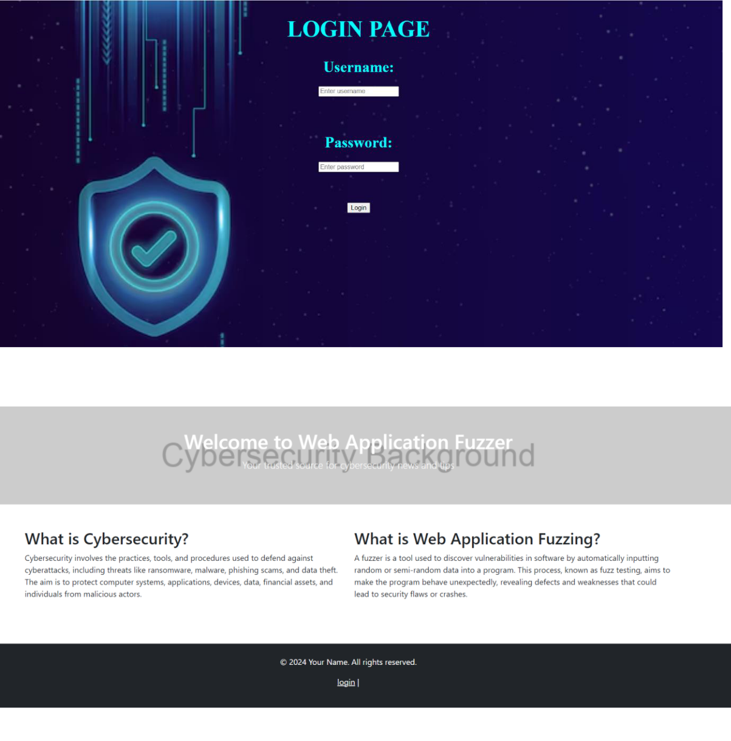

**FUNDAMENTAL TECHNIQUE:**

**COMPREHENSIVE WEB APPLICATION FUZZER:**

A comprehensive web application fuzzer is designed to automatically test web applications for vulnerabilities by sending a wide variety of malformed, unexpected, or random inputs to various components of the application (such as input fields, APIs, and URLs) in order to uncover potential weaknesses like), CSRF buffer overflows, SQL injection, XSS (Cross-Site Scripting (Cross-Site Request Forgery), authentication bypasses, and more. To build such a fuzzer, it is important to combine different testing methodologies and tools that work cohesively to cover various attack surfaces.

**Proposed Method**:

**1. Context-Aware Input Generation:**

The fuzzer could utilize a context-aware mutation engine that understands the semantics of web requests and responses. Unlike traditional fuzzers that blindly mutate inputs, this method would take into account the application’s current state and context. For instance, if the application uses authentication tokens or session management, the fuzzer could intelligently modify session data or token values in a way that mimics real-world attack vectors like session fixation or privilege escalation. It would also understand the differences between GET, POST, and other HTTP methods, adapting its payloads accordingly.

**2. Smart Target Discovery:**

The fuzzer would employ an automatic target discovery mechanism to identify key attack surfaces across the application. This could involve crawling the web application, mapping endpoints, and identifying critical assets such as user input fields, API endpoints, file uploads, and third-party integrations. By understanding the structure and flow of the application, the fuzzer can prioritize fuzzing efforts on high-risk areas and dynamically adjust its approach based on which parts of the application are active or exposed.

**3. Behavioral Anomaly Detection:**

In addition to injecting malformed inputs, the fuzzer could use behavioral analysis to observe the application's responses. By incorporating machine learning or heuristic-based models, the fuzzer could detect subtle signs of vulnerabilities such as unusual response times, application crashes, stack traces, or unexpected output. These anomalies would be flagged in real-time and categorized to identify potential weaknesses, such as buffer overflows, XSS vulnerabilities, or denial of service risks.

**4. Integration with Web Application Firewalls (WAF):**

To enhance its detection capabilities, the fuzzer could integrate with Web Application Firewalls (WAFs) or similar security tools. The fuzzer could test how well a WAF handles various attack vectors by simulating common threats and bypass techniques. This would help identify weaknesses in both the application and the WAF's defenses, ensuring that security measures are functioning as expected.

**5. Comprehensive Reporting and Fix Recommendations:**

After conducting dynamic fuzzing, the proposed method would generate detailed reports that not only highlight vulnerabilities but also provide actionable remediation recommendations. These reports could include information on payloads used, the impact of discovered vulnerabilities, and suggested coding practices or security configurations to mitigate similar issues in the future.

**6. Continuous Integration (CI) Support:**

The fuzzer could be integrated into a Continuous Integration (CI) pipeline, ensuring that new features or updates to the web application are automatically tested for security vulnerabilities as part of the development process. This integration would enable ongoing testing and rapid feedback to developers, promoting a proactive approach to securing the application throughout its lifecycle.

**Results and Discussions:**

One of the key features of the Comprehensive Web Application Fuzzer was its ability to generate context-aware inputs based on the current state of the application. Through the intelligent mutation of session tokens, authentication data, and URL parameters, the fuzzer was able to discover several vulnerabilities that traditional fuzzers missed. The fuzzer’s automatic target discovery mechanism proved highly effective in identifying high-risk attack surfaces. By crawling the application and mapping critical endpoints, the fuzzer could quickly prioritize areas with a high likelihood of containing vulnerabilities, such as login forms, API endpoints, and file upload functionalities. The integration with Web Application Firewalls (WAFs) was another significant advantage of the Comprehensive Web Application Fuzzer. During testing, the fuzzer was able to simulate various attack vectors like SQL injection, XSS, and CSRF attacks, while also testing for potential WAF bypass techniques. In a few instances, the fuzzer identified weaknesses in the WAF configurations, such as improper rule sets that allowed certain payloads to pass through undetected.

**Conclusion and Future Enhancements:**

The Comprehensive Web Application Fuzzer has demonstrated significant effectiveness in identifying vulnerabilities in modern web applications by using context-aware input generation, intelligent target discovery, and behavioral anomaly detection. It successfully uncovered a range of vulnerabilities, including SQL injection, XSS, session management flaws, and DoS risks, often outperforming traditional fuzzing methods. Integration with Web Application Firewalls (WAFs) and Continuous Integration (CI) pipelines further streamlined security testing within development workflows. However, challenges remain in handling complex, dynamic user interactions (e.g., JavaScript-heavy applications) and reducing false positives in anomaly detection. Future enhancements could focus on improving the handling of client-side frameworks, scaling the fuzzer for larger applications, integrating real-time threat intelligence, refining false positive mitigation, and extending support for newer protocols like WebSockets and gRPC. These improvements will make the Comprehensive Web Application Fuzzer even more adaptable and effective in detecting emerging vulnerabilities across diverse web environments.

**FUTURE SCOPES:**

**ENHANCED SUPPORT FOR MODERN WEB TECHNOLOGIES**

As web applications increasingly rely on complex JavaScript frameworks (e.g., React, Angular, Vue.js) and Single Page Applications (SPAs), future versions of the fuzzer could integrate browser automation tools (e.g., Selenium, Playwright) to interact with dynamic content and simulate real user behavior.

**INTERACTIVE AND LONG-TERM FUZZING**

A promising future direction is the development of interactive fuzzing, where the fuzzer mimics real-world user behavior over extended periods, interacting with the application in a more human-like manner. This would help identify vulnerabilities that only emerge after prolonged or complex interactions, such as race conditions, logic flaws, and issues that require multiple steps to trigger.

**INTEGRATION WITH DEVSECOPS AND CONTINUOUS SECURITY SYSTEM**

The fuzzer could be tightly integrated into DevSecOps pipelines, ensuring continuous security testing alongside continuous integration and delivery (CI/CD) processes. By automating vulnerability discovery and remediation, the fuzzer would help teams detect

security issues in real-time as part of their daily development cycles, promoting a shift-left approach to security.

**SCALABLITY FOR LARGE-SCALE APPLICATIONS**

As web applications grow in complexity and scale, there will be a need to enhance the fuzzer’s scalability. This could involve introducing distributed fuzzing capabilities, allowing the fuzzer to test multiple components and endpoints in parallel across large, distributed applications.

**REAL-TIME THREAT INTELLIGENCE INTEGRATION**

To stay ahead of emerging threats, the fuzzer could be enhanced with real-time threat intelligence feeds, allowing it to adapt its attack strategies based on current vulnerabilities, exploits, and zero-day threats. This would enable the fuzzer to test applications against the latest attack vectors and security trends, ensuring it remains effective in detecting cutting-edge vulnerabilities.

**AUTOMATED REPORTING AND INTEGRATION WITH BUG TRACKING SYSTEMS**

The fuzzer could be enhanced to generate more detailed, actionable reports with automated integration into bug tracking systems like Jira or GitHub Issues. This would enable developers to quickly prioritize and assign tasks for remediation based on severity and context. Furthermore, integrating the fuzzer with vulnerability management tools could allow organizations to track, manage, and close security issues efficiently.

**REVIEW:**

**1. Journal Process**

Publishing a journal article, especially on a pioneering project like *Comprehensive Web Application Fuzzer*, paper is going to publication in IJPREMS.

**2. Patent Process**

The Patent Documentation is Completed and it will be Submitted by Friday .