A Comparative Study AI Health Assistants vs. Human Health Assistants

Ariesha Shamsi Masters of Science in

Information Technology

K.C. College, HSNC University Mumbai 4000 020, India [arieshaaa00@gmail.com](mailto:arieshaaa00@gmail.com)

Saima Ansari Masters of Science in

Information Technology

K.C. College, HSNC University Mumbai 4000 020, India [saimaansariii003@gmail.co](mailto:saimaansariii003@gmail.com) [m](mailto:saimaansariii003@gmail.com)

Dr.Rakhi Gupta

Head of I.T. Department

K.C. College, HSNC University Mumbai 4000 020, India [rakhi.gupta@kccollege.edu.](mailto:rakhi.gupta@kccollege.edu) in

Miss.Nashrah Gowalker Asst. professor, I.T. Department

K.C. College, HSNC University Mumbai 4000 020, India Nashrah.gowalker@kccolle ge.edu.in

# Abstract— this study emphasizes the AI growth towards healthcare system. In this study, we compare the AI assistant and human assistant using AI tools that are freely available on all search engines that is haut.AI and Cody.AI both has their own specialization in different fields. We have done quantitative analysis on several factors that are time taken, error rates the accuracy and the overall patients experience by using both the options. This research will help us give an idea on people’s opinion over AI in healthcare system.

**Keywords— *Artificial Intelligence, Human Doctor, Health Assistant, AI Tools, Cold and Cough Diagnosis, Health Technology Integration, Comparative study.***

* 1. INTRODUCTION

Artificial intelligence is a technology that helps in problem solving decision making and can automate human task that consume less time compared to human. It enables computers and machines to behave like humans.

In the era of Artificial intelligence (AI), rapidly rising in multiple industries healthcare is one of the fields that is introducing new possibilities for patient care. Multiple AI tools are being utilized in various industries and field such as dermatology, general physician, Cancer treatment, eczema treatment and much more.

As the AI is growing, it is important to understand the effectiveness of these AI tools in health industry. This research paper explores the comparative study on AI health assistant versus human health assistant in two specific domains that is skin assessment and general cold & cough diagnosis through Case Study. The AI tools examined are HAUT.AI for skin assessment and Cody.AI for cold and cough assessment compared with human dermatologist and general physicians. The research focus on the comparison on the basis of Quantitative analysis on some key factors that are Time taken to complete task, accuracy level error rates, and patients experience based on service and feedbacks.

1. PURPOSE

The purpose of the research is to provide quantitative comparison between AI assistant and a human doctor . The study focuses to assess the accuracy and dependency of patients on AI based on their experience.

The main goal is to figure out which option between both AI and human is given more preference by patients

1. IMPORTANCE

The research provides a clear understanding of what is more considered by people nowadays through comparing the accuracy of AI and human doctor.

It is important to understand how patients perceive AI and whether they trust AI in future healthcare recommendations.

The study also proposes that is AI potential to replace human doctors completely in future and earn peoples trust over Physical doctors.

* 1. LITERATURE REVIEW

In 2024, we’re witnessing a surge in AI-powered applications that are fundamentally changing how we approach our skin’s well-being. From personalized product recommendations to advanced diagnostics, AI is poised to usher in a new era of proactive and data-driven skincare *in an article discussed by Ramakrishna R, CTO at Cure skin*

The COVID-19 pandemic could not but do significant damage to the beauty market. The demand for beauty products naturally drops when everybody stays in during lockdown. The need to wear masks accounted for a decline in demand for colored cosmetics. On the other hand, the need for skincare products increased — the lockdown stimulated a more conscious approach to consumption and motivated consumers to try more advanced self-care *in an article discussed by Kacey Culinary, L’Oréal.*

Numerous studies have highlighted the potential of AI in healthcare, demonstrating improved diagnostic capabilities and efficiency *in a paper discussed by Davenport & Kalakota, 2019).*

The diagnostic accuracy of AI tools has been validated in various contexts, including influenza diagnosis *in a paper discussed by Okiyama et al., 2022.*

However, concerns regarding empathy and trust persist, indicating that while AI can augment medical practice, human interaction remains invaluable. The literature underscores a need for empirical analysis comparing patient experiences with AI versus traditional healthcare models.

* 1. METHODOLOGY

# Case Study: Skin assessment (Haut.ai vs Human dermatologists)

For this case study we used Haut.AI based tools which will give us skin analysis by clicking a bare skin picture and uploading it, based on which it will generate a report on the skin conditions and recommend the skincare products for treatment.

The results will then be compared with assessment and treatment provided by dermatologists.

We conducted Research and Data Collection by creating a google form and circulating around expecting 20-30 response/outcomes

# Case Study 2: General Cold and Cough Assistance (Cody.ai vs General Physician)

In this study, Cody.ai, an AI-based tool, was compared with a general physician in diagnosing and recommending treatment for cold and cough symptoms.

We conducted Research and Data Collection by creating a google form and circulating around expecting 20-30 response/outcomes

1. TESTING:

# Case Study 1 Skin assessment (Haut.ai VS Human dermatologists)

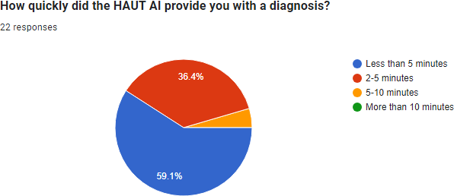

(Fig No 1.1)

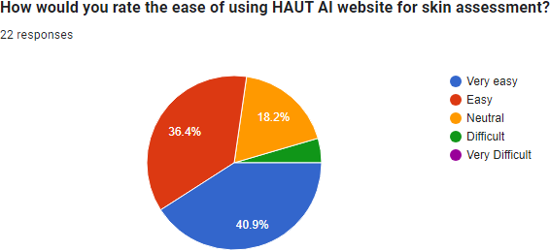

(Fig No 1.2)

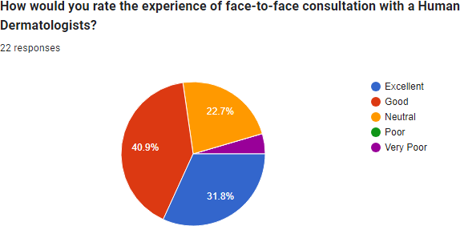

(Fig No 1.3)

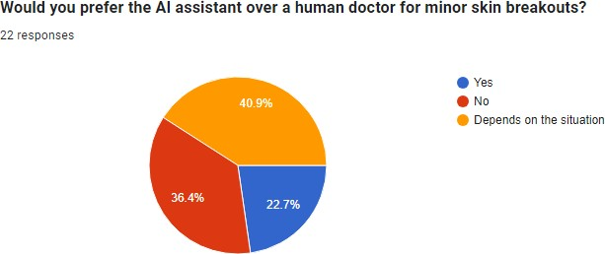

(Fig No 1.4)

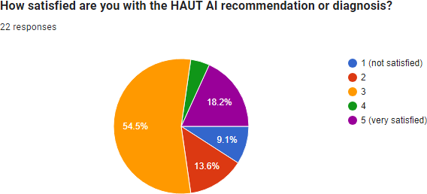

(Fig No 1.5)

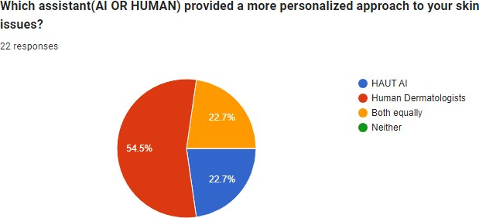

(Fig No 1.6)

# Metrics of Case Study 2: General Cold and Cough Assistance (Cody.ai VS General Physician)

(Fig No 2.1)

1. 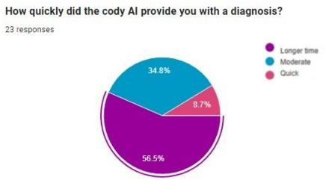ANALYSIS:

(Fig No 2.5)



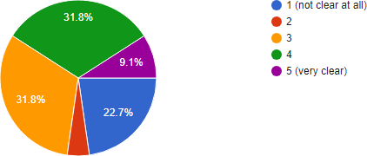

(Fig No 2.2)

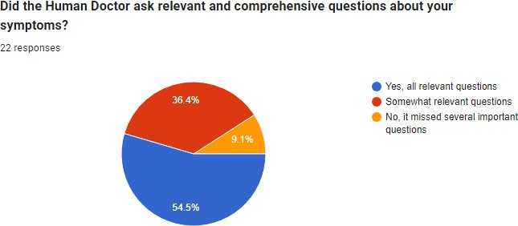

(Fig No 2.3)

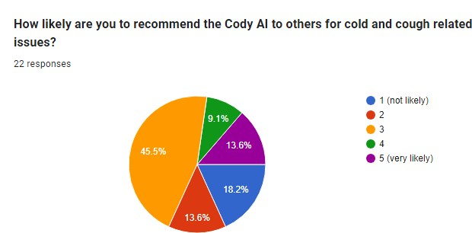

(Fig No 2.4)

# Metrics of Case Study 1: Skin assessment (Haut.ai VS Human dermatologists)

|  |  |  |
| --- | --- | --- |
| Metrics | Haut AI | Human  Dermatologists |
| Time taken | 59.1 % of users was diagnosed in less than 5  minutes | 40.9 % found it longer. |
| Accuracy and Ease of use | 40.9% rated as very easy but not too  accurate. | 30.8% rated face-to- face consultation as excellent |
| Surveys and  feedbacks on  Overall Patient experience | 45.5% both equally and AI. | 54.5% preferred human doctor. |

(Table No 1.1)

# Metrics of Case Study 2: General Cold and Cough Assistance

**(Cody.ai VS General Physician)**

|  |  |  |
| --- | --- | --- |
| Metrics | Cody AI | General Doctor |
| Time taken | 56.5% user  diagnosis took time. | 43.1% found it longer |
| Clarity and Satisfaction | 31.8% rated Cody AI very  clear. | 54.5% found it more relevant. |
| Surveys and  feedbacks on  Overall Patient experience | 22.7% rated AI  and 40.9% rated based on their situation. | 26.4% rated  human and  40.9% rated  based on their situation. |

(Table No 2.1)

* 1. RESULT AND DISCSSION

# Case Study 1: Skin Assessment

The result that we get from this case study is that users experienced HAUT AI diagnosis was done quite quick and efficient while in person consultation took longer time and hassle. Interface of the HAUT AI website was quite easy to use but users were not convinced by the result rate accuracy than in person visit to the dermatologist. Face-to-face consultation preferred by most users.

Users preferred human doctors over AI but found AI easy to use and less time consuming. In person visit to doctor would be time consuming but patient can interact and trust dermatologists more.

# Case Study 2: General Cold and Cough Assistance

Users experiences that their diagnosis took quite long but it was necessary for diagnosis so people with busy schedules found it convenient. In person visit could take a lot of time and appointment issues could rise while AI can be used from their phones anywhere and anytime.

Cody AI was similar in clarity compared to human as it asked relevant questions to provide solutions.

Users preferred human doctors over AI because of lack in human empathy. In person visit to doctor would be time consuming but patient can interact and trust them more

* 1. CONCLUSION AND RECOMMENDATION

On the basis of our case study and analysis it results that users found AI and Human both convenient based on their situation as people who have busy schedules cannot find the time to visit doctor for minor health issues so they prefer AI to give them solutions as it comes in handy while other users prefer human doctor to get the empathy, care, trust and reassurance that a human doctor can provide.

Thus the study concludes, AI cannot operate entire healthcare system independently, it will always need physical doctors. But although embedding AI technology along with human efficiency will improve the overall healthcare system and collaboratively it can result to more fast, accurate and efficient results with AI to improve the healthcare society.AI can provide more frequent outcome on the other hand human doctor can provide precise solution and fulfill empathy and trust that AI lacks.

* 1. LIMITATIONS

AI also lacks clinical or practical experience in real world, it cannot replace completely how human react to problems.

Human doctors can also make mistakes such as incorrect treatments due to their lack of information at times. They can also be biased as they can make judgements on the basis of their personal experience.

* 1. FUTURE SCOPE

A future scope is that by integrating AI with human in healthcare it can enhance the telemedicine by monitoring and collecting the data of the patients in real time quickly allowing for immediate support and suggestions regarding their health conditions.

* 1. REFERENCES

1. <https://haut.ai/>
2. <https://cody.md/>
3. [https://timestech.in/the-role-of-artificial-intelligence-in-](https://timestech.in/the-role-of-artificial-intelligence-in-the-skincare-industry/#%3A~%3Atext%3DTraditionally%2C%20skincare%20routines%20have%20relied%2Cto%20create%20truly%20customised%20regimens) [the-skincare-](https://timestech.in/the-role-of-artificial-intelligence-in-the-skincare-industry/#%3A~%3Atext%3DTraditionally%2C%20skincare%20routines%20have%20relied%2Cto%20create%20truly%20customised%20regimens) [industry/#:~:text=Traditionally%2C%20skincare%20ro](https://timestech.in/the-role-of-artificial-intelligence-in-the-skincare-industry/#%3A~%3Atext%3DTraditionally%2C%20skincare%20routines%20have%20relied%2Cto%20create%20truly%20customised%20regimens) [utines%20have%20relied,to%20create%20truly%20cus](https://timestech.in/the-role-of-artificial-intelligence-in-the-skincare-industry/#%3A~%3Atext%3DTraditionally%2C%20skincare%20routines%20have%20relied%2Cto%20create%20truly%20customised%20regimens) [tomised%20regimens.](https://timestech.in/the-role-of-artificial-intelligence-in-the-skincare-industry/#%3A~%3Atext%3DTraditionally%2C%20skincare%20routines%20have%20relied%2Cto%20create%20truly%20customised%20regimens)
4. [https://banuba.medium.com/ai-technology-in-skin-care-](https://banuba.medium.com/ai-technology-in-skin-care-21dc363b3cb5) [21dc363b3cb5](https://banuba.medium.com/ai-technology-in-skin-care-21dc363b3cb5)
5. <https://www.nature.com/articles/s41598-024-57830-4>
6. [https://www.mckinsey.com/~/media/McKinsey/Industri](https://www.mckinsey.com/~/media/McKinsey/Industries/Consumer%20Packaged%20Goods/Our%20Insights/How%20COVID%2019%20is%20changing%20the%20world%20of%20beauty/How-COVID-19-is-changing-the-world-of-beauty-vF.pdf) [es/Consumer%20Packaged%20Goods/Our%20Insights/](https://www.mckinsey.com/~/media/McKinsey/Industries/Consumer%20Packaged%20Goods/Our%20Insights/How%20COVID%2019%20is%20changing%20the%20world%20of%20beauty/How-COVID-19-is-changing-the-world-of-beauty-vF.pdf) [How%20COVID%2019%20is%20changing%20the%2](https://www.mckinsey.com/~/media/McKinsey/Industries/Consumer%20Packaged%20Goods/Our%20Insights/How%20COVID%2019%20is%20changing%20the%20world%20of%20beauty/How-COVID-19-is-changing-the-world-of-beauty-vF.pdf) [0world%20of%20beauty/How-COVID-19-is-changing-](https://www.mckinsey.com/~/media/McKinsey/Industries/Consumer%20Packaged%20Goods/Our%20Insights/How%20COVID%2019%20is%20changing%20the%20world%20of%20beauty/How-COVID-19-is-changing-the-world-of-beauty-vF.pdf) [the-world-of-beauty-vF.pdf](https://www.mckinsey.com/~/media/McKinsey/Industries/Consumer%20Packaged%20Goods/Our%20Insights/How%20COVID%2019%20is%20changing%20the%20world%20of%20beauty/How-COVID-19-is-changing-the-world-of-beauty-vF.pdf)
7. [https://www.cosmeticsdesign-](https://www.cosmeticsdesign-europe.com/Article/2021/02/19/L-Oreal-Active-Cosmetics-2020-success-underpinned-by-COVID-19-skin-health-trends) [europe.com/Article/2021/02/19/L-Oreal-Active-](https://www.cosmeticsdesign-europe.com/Article/2021/02/19/L-Oreal-Active-Cosmetics-2020-success-underpinned-by-COVID-19-skin-health-trends) [Cosmetics-2020-success-underpinned-by-COVID-19-](https://www.cosmeticsdesign-europe.com/Article/2021/02/19/L-Oreal-Active-Cosmetics-2020-success-underpinned-by-COVID-19-skin-health-trends) [skin-health-trends](https://www.cosmeticsdesign-europe.com/Article/2021/02/19/L-Oreal-Active-Cosmetics-2020-success-underpinned-by-COVID-19-skin-health-trends)
8. “Davenport T, Kalakota R. The potential for artificial intelligence in healthcare. Future Healthc J. 2019 Jun;6(2):94-98. doi: 10.7861/futurehosp.6-2-94. PMID: 31363513; PMCID: PMC6616181.”
9. Okiyama S, Fukuda M, Sode M, Takahashi W, Ikeda M, Kato H, Tsugawa Y, Iwagami M. Examining the Use of an Artificial Intelligence Model to Diagnose Influenza: Development and Validation Study. J Med Internet Res. 2022 Dec 23;24(12):e38751. doi: 10.2196/38751. PMID: 36374004; PMCID: PMC9823578.