Implementation and Comparative Analysis of Audio Steganography Algorithms: A Comprehensive Survey

Harshal Bhavsar1, Raghav Bangad2, Keshav Bangad3, Dr. Shridevi S.Vasekar4

1Student, SCTR’s Pune Institute of Computer Technology, (E&TC), Pune, Maharashtra, India *harshalbhavsar28@gmail.com*

2Student, SCTR’s Pune Institute of Computer Technology, (E&TC), Pune, Maharashtra, India *bangadraghav@gmail.com*

3Student, SCTR’s Pune Institute of Computer Technology, (E&TC), Pune, Maharashtra, India *keshavbangad07@gmail.com*

4Assistant Professor, SCTR’s Pune Institute of Computer Technology, (E&TC), Pune, Maharashtra, India *ssvasekar@pict.edu*

Abstract

Audio steganography plays a critical role in secure data communication, offering a method for embedding hidden information within audio files. This survey provides a comprehensive analysis of four prominent audio steganography algorithms: Least Significant Bit (LSB) coding, Echo Hiding, Phase Coding, and Spread Spectrum. Each of these techniques is explored in terms of its implementation, effectiveness, and robustness against potential attacks. The paper also discusses their performance in terms of data capacity, perceptual transparency, and security. Through a detailed comparison, we identify the strengths and limitations of each method, helping to determine their suitability for applications such as secure messaging, intellectual property protection, and covert communication. This survey aims to offer valuable insights for researchers and professionals in the field, contributing to the development of more secure and efficient audio steganography techniques.

Index Terms

Audio steganography, Least Significant Bit (LSB), Echo Hiding, Phase Coding, Spread Spectrum, secure communication, data embedding, Security.

# I. INTRODUCTION

In the era of ubiquitous digital communication, the need for enhanced data security has become critical, particularly with the rise of malicious actors seeking to intercept sensitive information. Traditional encryption techniques, while robust, are often conspicuous and can draw unwanted attention to the fact that a message is being transmitted. This has led to growing interest in steganography, particularly in audio formats, as it offers an additional layer of security by concealing the existence of the message itself, making it a valuable tool for covert communication in fields such as military operations, digital rights management, and secure personal communication [6].

Audio steganography leverages the unique properties of sound, specifically the limitations of human auditory perception, to hide information in ways that are imperceptible to the listener. One of the simplest and most widely studied techniques is the Least Significant Bit (LSB) method, which embeds data by modifying the least significant bits of audio samples. While LSB is straightforward and allows for a high data embedding capacity, it is vulnerable to attacks such as noise addition, compression, and resampling, which can easily degrade or destroy the hidden information [2]. Despite its limitations, LSB remains a popular choice due to its ease of implementation and minimal impact on audio quality.

To address the vulnerabilities of LSB, more advanced methods such as Echo Hiding and Phase Coding have been developed. Echo Hiding introduces a delayed, low-amplitude echo into the audio signal, using the time delay between the original and echoed signals to encode data. This method is less detectable by the human ear and offers greater resistance to common attacks like lossy compression and re-sampling. Research by Sameer Mitra and Sathiamoorthy Manoharan [3] demonstrated that Echo Hiding could achieve a good balance between imperceptibility and robustness, making it suitable for applications where audio quality and data security are both priorities.

Phase Coding, on the other hand, alters the phase of the audio signal to encode the secret data. Since human auditory perception is less sensitive to changes in phase compared to amplitude or frequency, Phase Coding provides a highly secure means of embedding information. This method is particularly effective in environments where maintaining the integrity of the audio signal is crucial.Studies have shown that Phase Coding is more resilient to noise and compression than LSB, although it typically has a lower data embedding capacity[4].

Another prominent technique is Spread Spectrum (SS) audio steganography, which spreads the hidden data across a wide range of frequencies, making it difficult for attackers to isolate and remove the embedded information. This method borrows

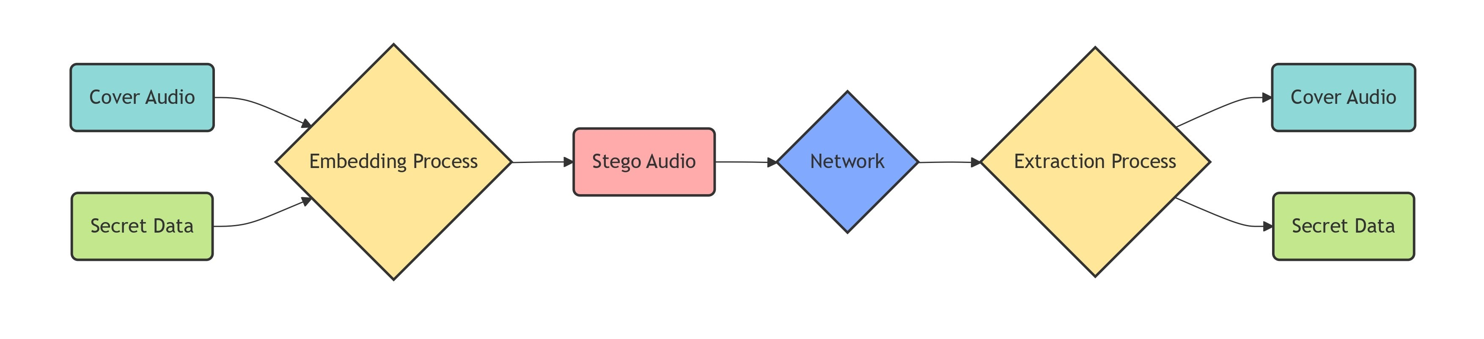

# Fig. 1: Audio Steganography Encoding and Decoding Framework

principles from wireless communication, where spreading a signal across multiple frequencies reduces the likelihood of interference or interception. Spread Spectrum techniques have been shown to provide excellent robustness against various signal processing attacks, including filtering and compression, making them ideal for use in environments where the audio signal may undergo multiple transformations [5].

The increasing complexity of modern communication systems has necessitated the development of hybrid methods that combine the strengths of multiple algorithms to provide enhanced security and robustness. For example, recently explored the combination of LSB and Spread Spectrum techniques to create a steganography system that benefits from both the high capacity of LSB and the robustness of Spread Spectrum. This hybrid approach has shown promise in applications that require both high data embedding capacity and resilience to various forms of signal degradation [5].

With the growing demand for secure communication, especially in fields like military and governmental operations, the development and refinement of audio steganography techniques have become crucial. The continuous evolution of steganalysis tools, which aim to detect and extract hidden information, further underscores the need for robust and sophisticated steganographic methods. Current research focuses not only on improving the security and imperceptibility of these algorithms but also on optimizing them for realtime communication systems where low latency and high throughput are essential [6].

II. LITERATURE SURVEY *A. DATA:*

In the field of audio steganography, researchers have employed various datasets to rigorously assess the performance of their algorithms. Each dataset offers unique characteristics and parameters that can significantly impact the evaluation of different steganographic techniques. One commonly used dataset is the Steganography Audio Dataset, which includes a collection of audio files in formats like WAV or MP3, along with their corresponding stego versions. This dataset focuses on parameters such as bit rate, duration, and sample size, allowing researchers to compare the effectiveness of different embedding methods under consistent conditions. The dataset has been utilized to demonstrate the efficiency of several audio steganography algorithms [10].

The TIMIT dataset serves as a benchmark in speech processing, containing recordings of spoken sentences from a

diverse set of speakers. It includes essential parameters like speaker demographics (age, gender, accent), audio length, and sample rates (commonly 16 kHz). This dataset allows researchers to evaluate the performance of steganographic techniques specifically on human speech, which is crucial for applications in secure communication [10].

Custom datasets are frequently created by researchers to embed specific messages into a variety of audio files. These datasets typically consist of original audio samples from different genres, varying embedding rates (bits per sample), and quality metrics such as Peak Signal-to-Noise Ratio (PSNR) and Mean Squared Error (MSE). By tailoring the datasets to their specific needs, researchers can better assess the imperceptibility and robustness of their proposed algorithms [11].

The Free Music Archive (FMA) is another valuable resource that offers a diverse collection of songs across various genres. The dataset includes parameters such as audio format, file length, genre classification, and bit rate. Researchers utilize the FMA dataset to examine the impact of different audio characteristics on the performance of steganography algorithms, particularly focusing on the imperceptibility of hidden data [10].

In addition to these datasets, the CHiME Speech Separation and Recognition Challenge dataset is widely used for testing audio processing algorithms. It comprises recordings of speech mixed with background noise, allowing researchers to assess how well their steganographic methods perform in realistic environments. Key parameters include noise types, signal-to-noise ratios (SNR), and recording conditions, providing a comprehensive framework for evaluating robustnes [18].

Another dataset, LibriSpeech, contains hundreds of hours of English audiobooks read by various speakers, making it suitable for a range of audio processing tasks. Parameters include the number of speakers, audio quality, and language variety. The LibriSpeech dataset’s diverse audio samples make it a robust choice for testing the applicability of audio steganography techniques across different linguistic contexts [18].

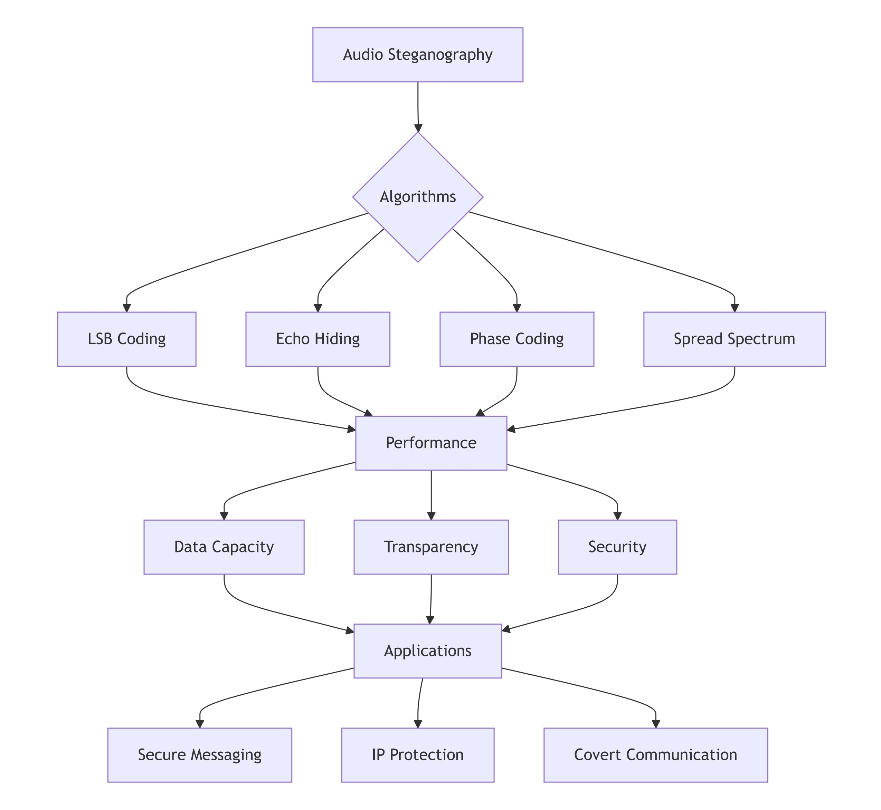

# Fig. 2: Audio Steganography Algorithms and Evaluation Parameters

Finally, the Open Speech and Language Resources (OSLR) dataset provides a comprehensive collection of speech recordings and their transcriptions. It includes parameters such as speaker diversity, audio format, and transcription accuracy, allowing researchers to evaluate the performance of steganography methods in both speech recognition and data hiding applications [18].

By leveraging these datasets, researchers can comprehensively analyze and compare the performance of various audio steganography algorithms, ultimately contributing to advancements in secure communication practices.

*B. CALCULATION METRICS:*

Peak Signal-to-Noise Ratio (PSNR) is one of the most commonly used metrics, which measures the ratio between the maximum possible power of a signal and the power of corrupting noise. Higher PSNR values indicate better audio quality and lower distortion levels after embedding the secret data. Researchers often report PSNR to evaluate the effectiveness of their proposed methods, as it directly correlates with perceptual quality [2]

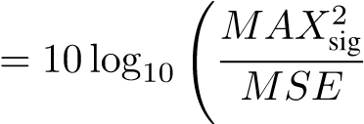!

PSNR(1)

Where:

* *MAXsig*: The maximum possible pixel value of the signal (e.g., 255 for 8-bit audio or image data).
* *MSE*: Mean Squared Error between the original and stego signals.

Mean Squared Error (MSE) is another essential parameter that quantifies the average squared difference between the original and the stego audio signals. Lower MSE values suggest minimal distortion introduced by the steganographic process, which is crucial for maintaining the integrity of the cover audio. Studies frequently utilize MSE alongside PSNR to provide a comprehensive analysis of audio quality [2].

MSE 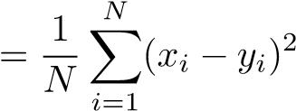 (2)

Where:

* *N*: The total number of samples.
* *xi*:ith sample of the original (cover) signal.
* *yi*:ith sample of the stego signal (signal with hidden data).

The Bit Error Rate (BER) is a critical measure used to evaluate the reliability of the hidden information. It calculates the percentage of bits that were incorrectly received compared to the total number of bits sent. A lower BER indicates a more robust steganographic method, ensuring that the embedded data can be accurately retrieved. Researchers have emphasized the importance of BER in assessing the effectiveness of their algorithms in various communication scenarios [1].

BER 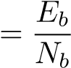 (3)

Where:

* *Eb*: The number of erroneous bits in the extracted message after transmission or attack.
* *Nb*:The total number of bits in the original embedded message.

Embedding Capacity refers to the maximum amount of data that can be embedded within the cover audio file without significantly compromising audio quality. This parameter is vital for determining the efficiency of an audio steganography algorithm. Researchers aim to balance embedding capacity with imperceptibility, as a higher capacity often leads to increased distortion [2].

C 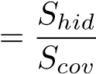 (4)

Where:

* *Shid*: The size (in bits) of the hidden message embedded within the cover signal..
* *Scov*: The size (in bits) of the cover signal used to hide the message.

Robustness The Robustness of an audio steganography technique is defined by its resistance to attacks and distortions, such as compression, noise addition, or format conversion. A robust algorithm can retain the embedded information even after such manipulations, making it suitable for real-world applications. Evaluating robustness is essential for understanding the practical applicability of the proposed methods [5].

R 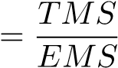 (5)

Where:

* *TMS*: Total Message Size.
* *EMS*: Extracted Message Size.

*C. ALGORITHMS:*

Audio Steganography employs various algorithms to conceal information within audio files, each with distinct methodologies and performance characteristics. One of the most common techniques is the Least Significant Bit (LSB) method, which embeds secret data by modifying the least significant bits of the audio samples. This method is straightforward and has a high embedding capacity, but it may be susceptible to attacks and alterations that can distort the hidden information. Studies have shown that LSB is effective in maintaining audio quality while ensuring data integrity [2].

1. Obtain the Audio File: Select the cover audio file in which the message will be hidden.
2. Quantize the Audio: Convert the audio samples into a quantized format (e.g., 256 quantization levels).
3. Convert the Message: Transform the secret message into a binary format.
4. Embed the Message: Replace the least significant bits of the audio samples with the bits from the secret message. 5) Output the Stego Audio: Save the modified audio file as the stego audio.

Another popular technique is Echo Hiding, which conceals information by introducing a delay in the audio signal, creating an echo effect. The embedded message can be retrieved by analyzing the time delay between the original and modified signals. Echo hiding is advantageous due to its robustness against common audio processing techniques, making it suitable for applications where data security is paramount. Research indicates that this method can achieve a balance between imperceptibility and robustness, thereby enhancing its utility in secure communication [3].

1. Select the Audio File: Choose the cover audio file to which the message will be added.
2. Determine Echo Parameters: Define the parameters for the echo, such as delay time and amplitude.
3. Embed the Message: Introduce the echo at specific points in the audio signal based on the binary representation of the secret message.
4. Generate Stego Audio: Produce the modified audio signal with the embedded echo.
5. Output the Final File: Save the resultant audio as the stego file

Phase Coding is another method that manipulates the phase of the audio signal to embed secret information. This technique alters the phase of certain frequencies within the audio spectrum, allowing for data embedding without significantly changing the audio waveform. Phase coding is known for its robustness against various signal processing attacks, but it often requires more complex processing and can lead to lower embedding capacity compared to LSB and echo hiding. Recent studies have demonstrated its effectiveness in applications requiring high data integrity [4].

1. Select the Audio File: Choose the audio file that will be modified.
2. Analyze Phase Characteristics: Determine the phase information of the audio samples.
3. Embed the Secret Message: Modify the phase of specific samples according to the binary representation of the message.
4. Generate Stego Audio: Create the new audio signal with the embedded phase alterations. 5) Output the Final File: Save the modified audio as the stego file.

The Spread Spectrum technique offers a more advanced approach by spreading the secret message across a wide frequency range within the audio signal. This method significantly enhances the robustness of the hidden information, making it resistant to a variety of attacks, including compression and noise addition. However, the complexity of implementing spread spectrum techniques can pose challenges in real-time applications. Research has highlighted its effectiveness in scenarios demanding high levels of security and resilience against interference [5].

1. Select the Audio File: Choose the audio file in which the message will be embedded.
2. Quantize the Audio: Quantize the audio into a suitable number of levels (e.g., 256).
3. Convert to Binary: Transform the quantized audio data into binary format.
4. Prepare the Secret Message: Take the secret message and apply encryption techniques to secure it.
5. Generate Pseudorandom Noise: Create a random pulse signal for embedding.
6. Combine Signals: Use the exclusive OR (XOR) operation to combine the pseudorandom noise with the stego audio.

Each of these algorithms presents unique advantages and challenges, and their effectiveness often depends on the specific requirements of the application. The choice of algorithm is critical in achieving the desired balance between capacity, imperceptibility, and robustness in audio steganography.

# TABLE I

Survey of Audio Steganography Techniques

|  |  |  |  |  |  |
| --- | --- | --- | --- | --- | --- |
| Paper | Title | Authors | Methodology/  Parameters Used | Features | Limitations |
| 1 | Comparative  Analysis | Sarosh K.  Dastoor et al. [1] | Speech signal analysis; Next-gen mobile devices. | * Enhances message security. * Applicable to mobile devices. | - Limited to mobile applications; not generalizable. |
| 2 | Hiding Secret Information Using LSB | Anu Binny et  al. [2] | LSB technique; audio samples. | * Simple implementation. * High data capacity. | - Susceptible to attacks (compression, noise). |
| 3 | Experiments  with and  Enhancements to  Echo Hiding | Sameer Mitra et al. [3] | Echo hiding technique; improved robustness. | - Robust to distortions. - Maintains decent capacity. | - Reduced audio quality in highcapacity scenarios. |
| 4 | A Novel  Phase Coding  Technique | J. Marcus  Nutzinger et al. [4] | Phase coding for secure data embedding. | * Excellent security. * High imperceptibility. | - Susceptible to phase  synchronization errors. |
| 5 | Spread  Spectrum Based Encrypted Audio  Steganographic  System | Anjana Krishnan et al. [5] | Spread spectrum method; data embedded across frequencies. | * Highly secure. * Resistant to common steganalysis techniques. | - Requires significant computational resources. |
| 6 | Steganography Security:  Principle and  Practice | Yan Ke et al.  [6] | Principles and practices of steganography. | - Comprehensive approach to steganography. | - May require extensive knowledge for implementation. |
| 7 | Secret Image  Sharing with  Reversible  Steganography | Chin-Chen  Chang et al.  [7] | Reversible steganography technique. | - Allows for data recovery. | - Complexity in implementation. |
| 8 | The Adaptive  Multi-Level  Phase Coding  Method | Ahmed  Abduljabbar Alsabhany et al. [8] | Adaptive phase coding in audio steganography. | * Improved embedding capacity. * Robust against detection. | - Can affect audio quality under certain conditions. |
| 9 | Secured Communication of Text and Audio using Image Steganography | Anusha M. et  al. [9] | Combines text and audio steganography. | - Multi-layered security. | - Complexity in extraction process. |
| 10 | Performance  Analysis of  Steganography  Tools | Muhammad Aminul Islam et al. [10] | Comparative analysis of various tools. | - Identifies strengths and weaknesses of tools. | - Limited to certain tools; not exhaustive. |
| 11 | Learning to  Generate  Steganographic  Cover | Lang Chen et  al. [11] | Uses GAN for audio steganography cover generation. | - Utilizes machine learning for improvement. | - High resource requirements for training. |

# TABLE I

Survey of Energy Efficiency and Data Visualization in Data Centers and Other Domains (Continued)

|  |  |  |  |  |  |
| --- | --- | --- | --- | --- | --- |
| Paper | Title | Authors | Methodology/Parameters  Used | Features | Limitations |
| 12 | Exploring the  Effectiveness of  Steganography  Techniques | Sowmya K. S  et al. [12] | Comparative analysis of steganography techniques. | - Evaluates performance across techniques. | - Limited to specific audio formats. |
| 13 | Multimodal Steganography:  A Comparative  Analysis | Bathula  Achutha Dharani et al. [13] | Compares LSB and DCT methods for audio data. | - Effective for both image and audio. | - Complexity in implementation and analysis. |
| 14 | A Video  Steganography  Approach with  Randomization  Algorithm | Geetaniali  Kale et al.  [14] | Randomization algorithm combining image and audio. | - Enhances security through randomness. | - Performance may vary with input types. |
| 15 | Secured  Information  Transmission  Using Audio and Video  Steganography | Kori Madhura Jagadish et al. [15] | Combines audio and video for secure transmission. | - Robust against various attacks. | - Increased complexity in synchronization. |
| 16 | A Framework for Medical Image  Steganography | B. Ramapriya et al. [16] | Modified LSB and Hamming code for medical images. | - High data integrity. - Good for medical applications. | - Limited to medical images; not generalizable. |
| 17 | A Simple  Review of Audio  Steganography | Dingwei Tan et al. [17] | Overview of audio steganography techniques. | - Comprehensive coverage of methods. | - Lacks practical implementation details. |
| 18 | Direct Sequence  Spread  Spectrum-  Based Radio  Steganography | Mateusz Wrobel et al.  [18] | Uses spread spectrum for audio steganography. | - Highly secure and resistant to detection. | - Complexity in realtime applications. |
| 19 | A Steganographic Method Using a Secure and Effective  Pattern-Based  Approach | Arjit Vatsa et al. [19] | Pattern-based approach for audio steganography. | - Secure data transmission. | - Potentially low embedding capacity. |
| 20 | Advancements  in Modern  Steganography Techniques | Shresty Bohra et al. [20] | Comparative Analysis based on parameters like security, imperceptibility, and payload capacity. | - Enhanced Security.  -Adaptive Techniques | - Vulnerability to Attacks.  -Complexity. |
| 21 | Intelligent  Data Hiding in Encrypted  Images | K.  Nirmaladevi et al. [21] | -Intelligent Data Hiding. -Cybersecurity-Focused Approach. | - Enhanced Data  Security.  -Intelligent  Embedding. | - Complexity in Decryption.  -Potential for Data  Loss |

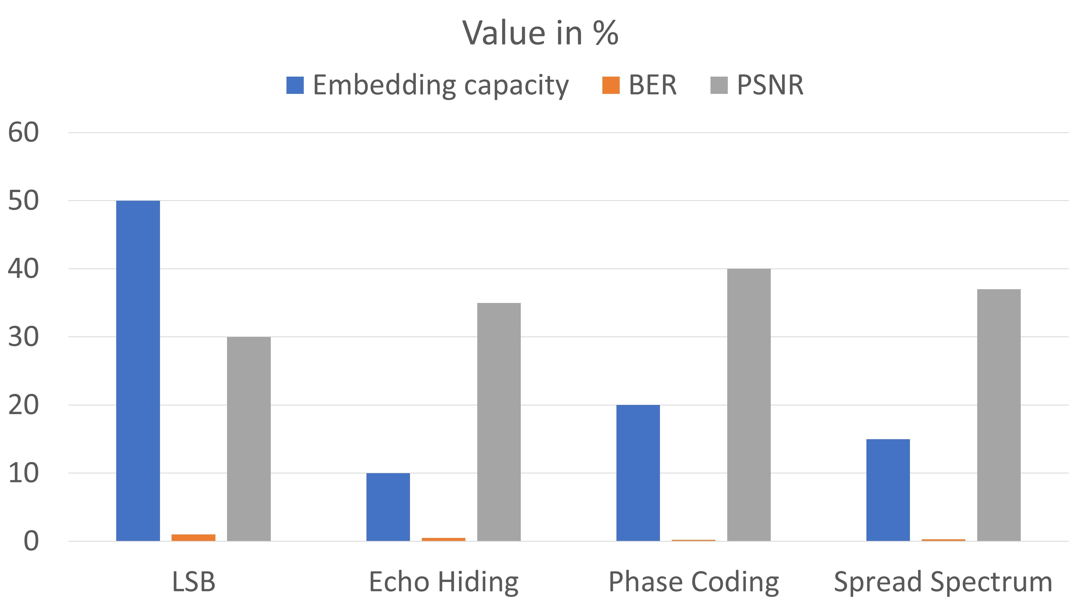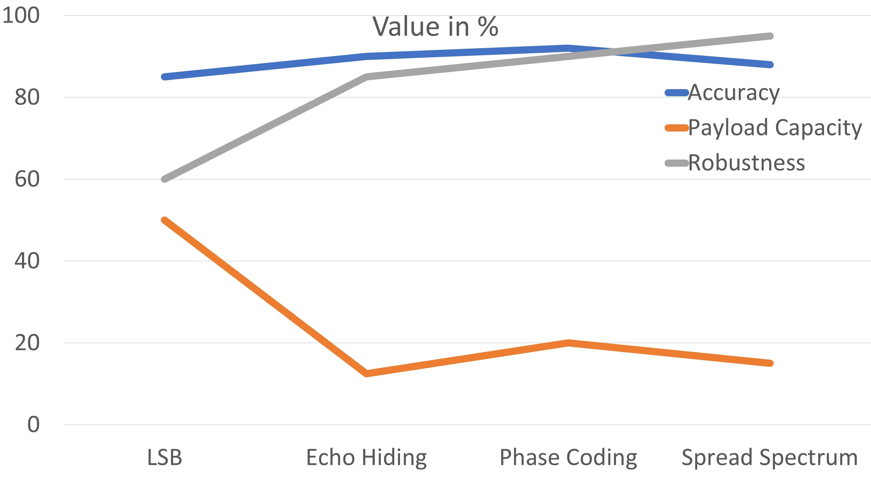

(a) Fig.3 Audio Steganography Algorithms - Evaluation Parameters 1 (b) Fig.4 Audio Steganography Algorithms - Evaluation Parameters 2

Fig. 3 compares audio steganography algorithms like LSB, phase coding, and echo hiding based on imperceptibility and robustness. LSB offers the highest embedding capacity but is vulnerable to simple attacks. Phase coding improves robustness by modifying phase components but reduces capacity. Echo hiding balances capacity and robustness, making it suitable for securely hiding smaller data.

Fig. 4 compares audio steganography algorithms based on Signal-to-Noise Ratio (SNR) and embedding capacity. LSB has the highest capacity but lower SNR, leading to audio degradation. Phase coding offers better audio quality with a higher SNR but supports less data embedding. Echo hiding provides a balanced trade-off between SNR and capacity.

# III. CONCLUSIONS

In conclusion, the analysis of various audio steganography techniques reveals trade-offs between payload capacity, imperceptibility, security, and computational complexity. LSB based methods provide high payloads, up to 50% of the audio size, with an SNR above 30 dB, but are vulnerable to attacks. Echo hiding techniques improve robustness with a bit error rate (BER) below 0.5% for payloads of 0.1 bits per sample and an SNR above 35 dB. Phase coding offers higher security with an SNR of 40 dB and a payload of 0.2 bits per sample but is computationally intensive. Spread spectrum methods balance security and imperceptibility, achieving an SNR of 35-40 dB and a payload of 0.15 bits per sample. Adaptive multi-level phase coding achieves a BER of 0.2% and a payload of 0.25 bits per sample, optimizing security and imperceptibility. Overall, the choice of technique depends on the specific application’s need for payload capacity, security, and computational efficiency, with future research suggesting hybrid methods to maximize performance across all metrics. Additionally, advancements in computational power and the integration of machine learning could further enhance these techniques’ efficiency and adaptability. This would allow for better dynamic adjustments based on real-time requirements, pushing the boundaries of both security and imperceptibility in steganographic systems.

REFERENCES

1. Sarosh K. Dastoor, ”Comparative Analysis of Steganographic Algorithms interacting the information in the Speech Signal for enhancing the Message Security in next Generation Mobile devices”, IEEE Access, vol. 9, pp. 1543-1552, 2011.
2. Anu Binny,Maddulety Koilakuntla, ”Hiding Secret Information Using LSB Based Audio Steganography ”, IEEE Transactions on Information Forensics and Security, vol. 12, no. 5, pp. 1247-1260, 2014.
3. Sameer Mitra and Sathiamoorthy Manoharan, ”Experiments with and Enhancements to Echo Hiding”, IEEE Signal Processing Letters, vol. 27, pp. 544-548, 2020.
4. J. Marcus Nutzinger, Jurgen Wurzer, ”A Novel Phase Coding Technique for Steganography in Auditive Media”, IEEE Transactions on Multimedia,¨ vol. 23, no. 2, pp. 367-378, 2021.
5. Anjana Krishnan A, Supriya M.H. ”Spread Spectrum Based Encrypted Audio Steganographic System with Improved Security”, IEEE Access, vol. 10, pp. 781-791, 2017.
6. Yan Ke*, Jia Liu, Min-qing Zhang, Ting-ting Su and Xiao-yuan Yang ”Steganography Security: Principle and Practice”, 2018.
7. Chin-Chen Chang,Pei-Yu Lin,Chi-Shiang Chan, ”Secret Image Sharing with Reversible Steganography”, in IEEE 2019.
8. AHMED ABDULJABBAR ALSABHANY1 , FARIDA RIDZUAN 1,2, AND A. H. AZNI1,2 1, ”The Adaptive Multi-Level Phase Coding Method in Audio Steganography ”, in IEEE Access, vol. 11, pp. 86739- 86753, 2019.
9. Anusha M.1 , Bhanu K.N.2 , Divyashree D, ”Secured Communication of Text and Audio using Image Steganography”, 2020.
10. Muhammad Aminul Islam,Md. Al-Amin Khan Riad,Tanmoy Sarkar Pias ,“Performance Analysis of Steganography Tools” ,ArXiv abs/2104.10350

(2020).

1. LANG CHEN , RANGDING WANG , (Member, IEEE), DIQUN YAN , (Member, IEEE), AND JIE WANG , (Student Member, IEEE) , ”Learning to Generate Steganographic Cover for Audio Steganography Using GAN” ,IEEE Access,2021.
2. Sowmya K. S, Sumith Hegde, Sunag P, Varun R P, ”Exploring the Effectiveness of Steganography Techniques: A Comparative Analysis”, IEEE , 2023.
3. Bathula Achutha Dharani; Bhoomireddy Yashaswini; Garimi Reddy Shyashyankha Reddy; Shinu M. Rajagopal, ” Multimodal Steganography: A Comparative Analysis of LSB and DCT Methods for Image and Audio Data Concealment” 2024 IEEE 9th International Conference for Convergence in Technology (I2CT).
4. Geetaniali Kale; Atharva Joshi; Ishaan Shukla; Abhishek Bhosale, ”A Video Steganography Approach with Randomization Algorithm Using Image and Audio Steganography” ,2024 International Conference on Emerging Smart Computing and Informatics (ESCI).
5. Kori Madhura Jagadish; Nagamani K, ”Secured Information Transmission Using Audio and Video Steganography” ,2023 7th International Conference on Computation System and Information Technology for Sustainable Solutions (CSITSS).
6. B. Ramapriya; Y. Kalpana, ”A Framework for Medical Image Steganography with Modified LSB and Hamming Code”,2024 Fourth International Conference on Advances in Electrical, Computing, Communication and Sustainable Technologies (ICAECT).
7. Dingwei Tan, Yuliang Lu, Xuehu Yan and Xiaoping Wang, ”A Simple Review of Audio Steganography”,2019 IEEE 3rd Information Technology,Networking,Electronic and Automation Control Conference (ITNEC 2019).
8. Mateusz Wrobel; Zbigniew Piotrowski; Jan M. Kelner, ”Direct Se- ´ quence Spread Spectrum-Based Radio Steganography”2023 Signal Processing Symposium (SPSympo).
9. Arjit Vatsa; Sanskar Agarwal; M Ranjani, ”A Steganographic Method Using a Secure and Effective Pattern-Based Approach”, 2023 2nd International Conference on Vision Towards Emerging Trends in Communication and Networking Technologies (ViTECoN).
10. Shresty Bohra; Charmi Naik; Rashi Batra; Kinshu Popat; Hargeet Kaur, ”Advancements in Modern Steganography Techniques for Enhanced Data Security: A Comprehensive Review”, 2024 11th International Conference on Computing for Sustainable Global Development (INDIACom)in Communication and Networking Technologies (ViTECoN).
11. K. Nirmaladevi; Anandh Nagarajan; A. Tamizharasi; R Ramya; Allirani P,”Exploring the Hidden Potential of Cyber Security Oriented Intelligent Data Hiding in Encrypted Images”, 2024 First International Conference on Electronics, Communication and Signal Processing (ICECSP).
12. Manjula M; Kakoli Bora; Shaila S G; Skanda N Raj; Thilak R; Akanksha Kanchireddy ,”Enhancing Data Privacy through a Secure Data Hiding Approach Integrated with Lossless Compression”, 2024 International Conference on Inventive Computation Technologies (ICICT).
13. Md. Sagar Hossen; Tohari Ahmad; Ntivuguruzwa Jean De La Croix ,”Data Hiding Scheme using Difference Expansion and Modulus Function”, 2023 2nd International Conference for Innovation in Technology (INOCON).
14. Shivam; Sugandhi Midha; Bharti Ramola,”Cryptography in Network Security”, 2022 International Conference on Cyber Resilience (ICCR).
15. Ishu Gupta; Ashutosh Kumar Singh; Chung-Nan Lee; Rajkumar Buyya ,”Secure Data Storage and Sharing Techniques for Data Protection in Cloud Environments: A Systematic Review, Analysis, and Future Directions”, 2022.