**Herbal vs. Synthetic: The Drug Comparison.**

**Rohan Chaudhari1, Sushant Bele2**

**1,Student, Genba Sopanrao Moze College of Pharmacy, Wagholi Pune.**

**2 Student Genba Sopanrao Moze College Of Pharmacy, Wagholi Pune**

**Abstract:-**

Herbal and synthetic drugs represent two distinct strategies in healthcare, each offering unique advantages and facing specific challenges. Herbal drugs, which have been utilized for centuries in various traditional medicine systems, provide a comprehensive approach to health by addressing multiple facets of a condition through a complex array of natural compounds. These compounds often work together synergistically, potentially resulting in fewer side effects compared to synthetic drugs. Despite this, issues such as variability in plant composition, potential contamination, and inconsistent dosing can impact their safety and effectiveness. Medicine is a substance that provides nutritive, curative, or preventive benefits, while "herbal" refers to a plant-based or botanical preparation. Therefore, "herbal medicine" describes plant-based substances with nutritive, curative, or preventive properties. Herbal medicine is an interdisciplinary field combining herbal practices and Ayurveda, encompassing areas such as botany, medicinal plant research, pharmacognosy, phytochemistry, phytotherapy, botanical medicine, Ayurveda, natural chemistry, agricultural science, Unani medicine, biotechnology, and biochemistry. An expert in medicinal herbs is called an herbalist. Herbal journals focus on the use of plants for treating diseases. [1]

* **Keywords:**Herbal drugs, Synthetic drugs, Mechanism

**1. Introduction:-**

The comparison between herbal and synthetic drugs has been a significant subject of discussion in medicine and healthcare for many years. Both types of drugs are essential for the treatment and prevention of various health conditions, yet they embody distinctly different approaches to health and wellness.

Herbal drugs also referred to as botanical or plant-based medicines have been utilized for millennia in traditional medical systems worldwide, including Ayurveda, Traditional Chinese Medicine, and Indigenous practices. These remedies are derived from natural plant sources and are often valued for their holistic approach, addressing not only the symptoms but also the underlying causes of illnesses. Due to their natural origins and complex chemical makeup, which tends to work in harmony within the body, they are generally believed to have fewer side effects.

In contrast, synthetic drugs are the product of modern pharmaceutical science, developed through meticulous research and chemical synthesis. These drugs are engineered to precisely target specific biological pathways, providing fast and effective symptom relief. They are subjected to extensive testing and regulatory processes to ensure consistent potency, safety, and effectiveness. However, the focused nature of synthetic drugs can lead to a higher likelihood of side effects and may only manage symptoms rather than addressing the root cause of a disease.

With the growing interest in integrative and alternative medicine, there is a heightened focus on understanding the benefits and drawbacks of both herbal and synthetic drugs. This exploration is vital for creating a more comprehensive healthcare strategy that combines the advantages of both natural and synthetic treatments. In this light, examining the distinctions and synergies between herbal and synthetic drugs is key to optimizing patient care and enhancing therapeutic outcomes.

**2. What are Herbal Drugs:**-

Herbal drugs also referred to as herbal or botanical medicine’s, are natural treatments derived from plants or their parts, such as leaves, flowers, roots, seeds, or bark, known for their therapeutic properties. These remedies are available in various forms, including teas, capsules, powders, extracts, tinctures, and ointments, and are used to treat or prevent diseases and support overall well-being.

Herbal therapy is a holistic approach that integrates emotional, mental, and spiritual aspects of well-being. Naturopathic treatments consider lifestyle, as well as emotional, mental, and spiritual factors. Unlike conventional drugs, the use of herbs typically does not result in "drug-like" actions or adverse effects. While medicinal plants are widely used and generally regarded as safe, they can still pose toxic risks. Cases of poisoning are often linked to the misidentification of plants, improper preparation, or incorrect administration by unqualified individuals. Some plant remedies have effects similar to pharmaceutical drugs, and herbalists incorporate these in treatment strategies. In countries like Britain, the availability of such plants is regulated by law. Digitalis is one example, though the number of such plants is relatively small. The precise mechanisms through which herbs exert their effects are not fully understood, but many medicinal plants are known for their antioxidant properties. This activity has been shown to be beneficial in various conditions such as cancer, memory loss, Alzheimer's, atherosclerosis, diabetes, and other cardiovascular diseases. The antioxidant properties of herbal medicines also help mitigate the toxic effects of harmful agents or other drugs.[2]

Unlike synthetic drugs, which are chemically engineered, herbal drugs consist of a diverse range of natural compounds that work together synergistically. This complexity allows them to target multiple aspects of a condition simultaneously. For instance, a single herb may possess anti-inflammatory, antioxidant, and immune-boosting qualities.

Herbal medicines have been utilized for thousands of years across traditional medicine systems worldwide, such as Traditional Chinese Medicine (TCM), Ayurveda from India, and Indigenous healing practices. Some widely recognized herbal drugs include:

1. Echinacea: Commonly used to strengthen the immune system and alleviate colds.

2. Ginkgo biloba: Often used to enhance memory and cognitive abilities.

3. Ginger: Mostly used for natural antiseptic.

4. Turmeric: Noted for its anti-inflammatory and antioxidant effects, often used to manage arthritis and other inflammatory conditions.

5. Garlic: Known for its cardiovascular benefits, blood pressure-lowering

**Fig 1: Steps involved in herbal extraction .**

Above fig.1 indicates whole procedure of Herbal Drugs is processed. Although herbal drugs are generally considered safer than synthetic medications, they can still cause side effects, interact with other medications, or be harmful if misused. Therefore, it is important to consult a qualified healthcare provider before using herbal remedies, especially for individuals with existing health conditions or those taking other medications.

**2.1**. **Origins and Composition:**

Herbal drugs are derived from natural sources, specifically plants, including various parts such as leaves, roots, flowers, seeds, and bark. The therapeutic effects of these drugs come from the diverse array of bioactive compounds found in the plants, which work together synergistically to produce a holistic effect.

Due to their natural origin, herbal drugs are often less processed than synthetic drugs. This minimal processing allows them to retain a wide range of chemical constituents, each contributing to the overall therapeutic effect. For example, a single herb may contain compounds that act as anti-inflammatories, antioxidants, and immune boosters.

However, this complexity can also be a drawback. The composition of herbal drugs can vary significantly depending on factors such as the plant’s growing conditions, harvesting time, and preparation methods. This variability can lead to inconsistent therapeutic outcomes. [13]

**2.2**. **Mechanism of Action:**

The mechanism of action of herbal drugs is often multifaceted, owing to their complex chemical composition. Herbal drugs tend to act on multiple pathways and systems within the body, offering a holistic approach to treatment. For example, an herb used to treat inflammation may also have antioxidant and immune-modulating properties, addressing both the symptoms and underlying causes of the condition.

This broad-spectrum action makes herbal drugs particularly suitable for chronic conditions and preventive care. However, the complexity of their effects can also make it challenging to pinpoint their exact mechanisms, leading to variability in effectiveness and a lack of clear understanding in some cases.

**2.3. Safety and Side Effect**:

Herbal drugs are generally perceived as safer than synthetic drugs due to their natural origin and the complexity of their chemical composition. The presence of multiple compounds working together can help to buffer against adverse effects. For instance, one compound in an herb might mitigate the side effects of another.

However, the safety of herbal drugs is not without challenges. The variability in plant quality, the potential for contamination with heavy metals, pesticides, or other harmful substances, and the lack of standardized dosages can all pose risks. Additionally, some herbal drugs may interact with prescription medications, leading to unintended consequences.

* Lower Toxicity: Generally, herbal drugs are associated with fewer and milder side effects compared to synthetic drugs. This is because they contain a variety of compounds that can modulate the effects of one another, often reducing the risk of toxicity. For example, herbal remedies like ginger or peppermint used for digestive issues typically have few side effects when taken in recommended doses.
* Variability and Inconsistency: One of the main safety challenges with herbal drugs is their lack of standardization. The same plant species can have different concentrations of active ingredients depending on where and how they are grown and harvested. Without strict regulations and standard dosages, it can be difficult to predict the potency or effectiveness of an herbal remedy. This inconsistency can lead to overdosing or underdosing, which may affect the safety and efficacy of the treatment.
* Contamination: Herbal products are at risk of contamination by pesticides, heavy metals, or microbes if not cultivated or processed under controlled conditions. This is a significant safety concern, particularly in regions where regulation of herbal products is lax.
* Drug Interactions: Herbal drugs can interact with prescription medications, sometimes in harmful ways. For example, St. John’s Wort, a popular remedy for depression, can reduce the effectiveness of antidepressants, birth control pills, and anticoagulants by speeding up the metabolism of these drugs in the liver. Ginkgo biloba, often used for cognitive enhancement, can increase the risk of bleeding when taken with blood-thinning medications like warfarin.
* Allergic Reactions: Some people may be allergic to certain herbal components. For example, echinacea, used to boost the immune system, can cause allergic reactions in individuals who are sensitive to plants in the daisy family. It's important to note that just because a substance is natural does not mean it is entirely free from risk. [8] [9]

**2.4. Efficacy and Treatment Scope:**

When comparing the efficacy of herbal and synthetic drugs, it is essential to consider the type of condition being treated, the expected speed of action, and the overall therapeutic goals. Both types of drugs serve different purposes, and their efficacy can vary based on these factors.

* Slow but Steady: Herbal drugs are often used for long-term treatment, focusing on balancing and supporting the body's natural processes rather than providing immediate relief. For instance, turmeric may take weeks to show its anti-inflammatory benefits in conditions like arthritis, but its lower risk of side effects makes it suitable for long-term use. Similarly, ginseng is used to boost energy and reduce stress over time rather than offering quick relief.
* Chronic Conditions: Herbal drugs are particularly useful for managing chronic conditions, such as digestive disorders, mild anxiety, or skin problems, where gradual improvement is acceptable. For example, peppermint oil is commonly used to manage symptoms of irritable bowel syndrome (IBS), while valerian root is used for managing mild insomnia over an extended period.
* Preventive Care: Herbal remedies are often used for preventive health and wellness, such as boosting immunity or improving overall well-being. Echinacea is a popular herb taken to reduce the duration and severity of colds and flu. Ashwagandha, an adaptogen, is used to help the body cope with stress and improve overall vitality.
* Limitations in Acute Conditions: One of the significant limitations of herbal drugs is their slow onset of action. In acute conditions requiring immediate relief, such as severe pain or infections, herbal remedies may not be effective. For example, while ginger may help reduce nausea over time, it is not suitable for rapidly stopping vomiting during a severe illness or surgical recovery. [5]

**2.5. Regulation and Standardization:**

Regulation of herbal drugs varies significantly across different regions. In some countries, herbal medicines are classified as dietary supplements and are not subject to the same rigorous testing and approval processes as pharmaceutical drugs. This lack of standardization can lead to inconsistencies in quality and efficacy

* Post-Market Surveillance: After a synthetic drug is approved and made available to the public, it continues to be monitored through post-market surveillance systems. Regulatory bodies like the FDA and EMA require drug manufacturers to report any adverse reactions or new side effects that were not evident during clinical trials. This ensures that any long-term risks associated with the drug can be identified and managed. For example, several synthetic drugs, such as rosiglitazone (used for diabetes), have been pulled from the market or had their usage restricted after post-market surveillance revealed serious cardiovascular risks.
* Consistency and Quality: Synthetic drugs are manufactured under strict conditions to ensure that each dose contains the same amount of the active ingredient. This level of precision ensures that patients receive predictable results. For example, when a patient takes acetaminophen (Tylenol), they can expect consistent pain relief because each pill has an exact dose, thoroughly tested for efficacy.
* Intellectual Property and Patents: One notable aspect of synthetic drug regulation is the patent system. Pharmaceutical companies can patent new drugs, giving them exclusive rights to manufacture and sell the drug for a certain number of years (usually 20 years). While this promotes innovation, it also drives up costs for consumers, as the lack of competition allows the patent holder to charge higher prices. Once the patent expires, generic versions of the drug become available, often at a fraction of the cost.

Global Standards: Regulatory bodies work to harmonize standards for drug approval across different countries, allowing for consistent safety and efficacy measures. The International Council for Harmonisation of Technical Requirements for Pharmaceuticals for Human Use (ICH) works toward aligning regulatory requirements to streamline drug approvals globally. This ensures that a drug approved in one country, such as the U.S., can meet the same safety and efficacy standards if introduced in Europe or Asia. [4] [5]

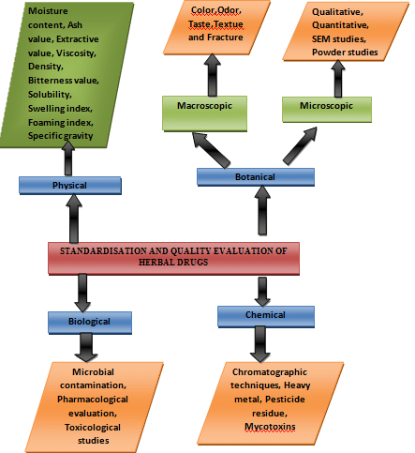

**Fig. 2 Method of herbal standardization**

**2.6. Cultural and Historical Context:**

Herbal drugs have deep roots in cultural and historical traditions, with many plants being used for medicinal purposes for centuries or even millennia. In systems like Ayurveda, Traditional Chinese Medicine, and Indigenous healing practices, herbs are considered essential components of holistic healthcare.

The cultural significance of herbal medicine often extends beyond its therapeutic use, encompassing spiritual and community practices. As such, herbal medicine remains an integral part of healthcare in many cultures, valued for its natural approach and connection to traditional knowledge.

**2.7. Manufacturing of Herbal drugs:**

The manufacturing of herbal drugs involves a series of processes to ensure quality, safety, and efficacy. Here's a simplified overview:

### 2.7.1. **Procurement of Raw Materials:**

* **Source Selection:** Careful selection of high-quality herbal plants from reputable suppliers.
* **Authentication:** Verification of the plant's identity and purity to prevent adulteration.
* **Cultivation or Wild-Harvesting:** Depending on the herb, it may be cultivated in controlled environments or harvested from the wild.

### 2.7.2. **Processing and Preparation:**

* **Cleaning and Drying:** Removing impurities and reducing moisture content to prevent spoilage.
* **Size Reduction:** Grinding or cutting the herbs into smaller particles for easier processing.
* **Extraction:** Using various methods (e.g., decoction, maceration, percolation) to extract the active from the plant material.

### 2.7.3. **Formulation:**

* **Blending:** Combining extracted herbal ingredients with other components (e.g., excipients, preservatives) to create the desired dosage form.
* **Standardization:** Ensuring consistent levels of active compounds in each batch.
* **Quality Control:** Implementing rigorous quality control measures to verify product safety and efficacy.

### 2.74. **Dosage Form Preparation:**

* **Tablets:** Compressing powdered or granulated materials into tablets.
* **Capsules:** Enclosing herbal extracts or powders in capsules.
* **Tinctures:** Preparing alcoholic extracts of herbs.
* **Syrups:** Creating sugar-based solutions containing herbal extracts.
* **Topical Preparations:** Formulating creams, ointments, or lotions for compounds external application.

### 2.7.5. **Packaging and Labeling:**

* **Packaging:** Sealing the product in appropriate containers to protect it from contamination.
* **Labeling:** Providing clear and accurate information about the product, including ingredients, dosage, and storage instructions.

### 2.7.6. **Quality Control Testing:**

* **Chemical Analysis:** Testing for the presence and quantity of active compounds.
* **Microbial Testing:** Ensuring the product is free from harmful microorganisms.
* **Stability Testing:** Evaluating the product's shelf life and stability under various conditions.

### 2.7.7. **Regulatory Compliance:**

* **Adhering to Regulations:** Complying with local, national, and international regulations governing herbal drug manufacturing.
* **Obtaining Licenses:** Obtaining necessary licenses and permits from regulatory authorities.

**Additional Considerations:**

* **Good Manufacturing Practices (GMP):** Adhering to GMP guidelines to ensure consistent quality and safety.
* **Traceability:** Maintaining records of the entire manufacturing process for traceability and accountability.
* **Sustainability:** Considering environmental and social sustainability in the sourcing and production of herbal drugs.
* **Traditional vs. Scientific knowledge**

|  |  |
| --- | --- |
| **Traditional Use of Herbs** | **Scientific Use of Herbs** |
| People around the word use various plants for different purposes often in the form of juices, decoctions, pills. | Plants are prepared using appropriate techniques for their medicinal properties. |
| Traditional herbal remedies often consist of mixtures of many different plants, believed to work together effectively. These products may not provide information about the specific chemical compounds or the extraction methods used. | Scientifically prepared herbal products are often purified and standardized to ensure consistent levels of active compounds, and they are used for treating symptoms, prevention, or treatment. |
| Traditional herbal medicines are generally thought to be safe and without any negative consequences. | Scientifically prepared herbal products can have potential side effects, may not be suitable for everyone, and may interact with other medications. |
| Traditional herbal remedies often rely on philosophical, religious, and cultural beliefs to understand the causes of illnesses and develop treatment plans. These approaches often consider the patient's personality and emotional state (a holistic approach). | Modern herbal medicine follows conventional medical practices for diagnosis and treatment. Its effectiveness is evaluated through scientific research. |

* **Market size of Herbal Drugs:**

The global market for herbal medicine, which includes both herbal products and raw materials, has been growing at an annual rate between 5% and 15%. This market is valued between USD 80 billion and USD 100 billion and is projected to reach USD 2,500 billion by 2010. In Western countries, the demand for herbal supplements has surged, with the global market exceeding USD 15 billion since 1999. This includes a USD 7 billion market in Europe, USD 2.4 billion in Japan, USD 2.7 billion in the rest of Asia, and a significant market in North America.

A nationwide survey from 1990 to 1997 indicated a notable increase in the use of alternative therapies, with out-of-pocket expenditures reaching USD 27 billion. In India, the trade value of botanicals is about USD 10 billion annually, with exports amounting to USD 1.1 billion. China’s herbal drug production is valued at USD 48 billion annually, with exports totalling USD 3.6 billion. The United States is the largest importer of Indian botanical products, accounting for about 50% of total exports. Major importers of Chinese herbal medicines include Japan, Hong Kong, Korea, and Singapore, which together account for 66% of China’s herbal drug exports.

The World Health Organization (WHO) supports the use of phytotherapy in its health programs and recommends procedures for validating plant-based drugs in developing countries. Eastern countries like China and India have established robust herbal medicine industries, while Latin American countries are investing in research and regulation of medicinal plants, following the example of European nations such as France and Germany. In Germany, 50% of phytomedicinal products are available by prescription and covered by health insurance. In North America, herbal products are often categorized as "health foods," but efforts are ongoing to provide better information on their efficacy and safety. As of 1997, the North American market for plant-based products was valued at USD 2 billion. [7]

**In India**

**Domestic Market:** The domestic market for Indian systems of medicine and homeopathy (ISM&H) is estimated to be around Rs 4000 crore (approximately $500 million).

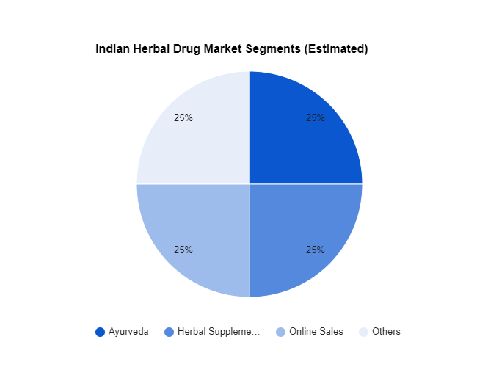

**Fig 3: Indian Herbal Market Segment**

**3. What are synthetic drugs**

Synthetic drugs are man-made substances developed in laboratories to replicate the effects of naturally occurring drugs or to produce new, unique effects. These drugs are created by combining various chemicals through sophisticated processes, resulting in compounds that can interact with the body’s biological systems. [12]

* There are two primary categories of synthetic drugs:

**3.1. Synthetic Prescription Drugs:**

These are drugs created by pharmaceutical companies for medical purposes, specifically designed to treat certain conditions or diseases. They undergo extensive testing and regulatory approval before becoming available on the market. Examples include:

* Aspirin: A synthetic drug used for pain relief and to reduce inflammation.
* Ibuprofen: A synthetic NSAID (nonsteroidal anti-inflammatory drug) that helps alleviate pain, fever, and inflammation.
* Prozac: A synthetic antidepressant commonly used to manage depression and anxiety disorders.[14][15][16]

**3.2. Synthetic Recreational Drugs:**

These are often illicit drugs designed to mimic the effects of natural substances like marijuana, cocaine, or opioids. Some synthetic drugs are formulated to evade drug laws by slightly altering the chemical structure of controlled substances. Examples include:

* Synthetic cannabinoids (e.g., Spice, K2): Created to simulate the effects of THC, the active compound in marijuana. [17]
* Synthetic cathinones (e.g., bath salts): Stimulants that imitate the effects of drugs like amphetamines and MDMA. [18]
* Fentanyl: A highly potent synthetic opioid, far stronger than morphine, frequently associated with overdose fatalities. [19]
* Key Features of Synthetic Drugs:
* Targeted Action: Synthetic drugs can be precisely engineered to target specific receptors or pathways in the body, making them highly effective for treating certain medical conditions.
* High Potency: Many synthetic drugs are more potent than their natural counterparts, which can enhance their effectiveness but also increase the risk of side effects.
* Significant Risks: Synthetic drugs, especially recreational ones, can lead to severe side effects, including addiction, overdose, and other serious health issues.

Further detail information is given below on Synthetic drugs.

**3.3.1**. **Origins and Composition:**

Synthetic drugs, in contrast, are man-made and are developed through meticulous chemical processes in laboratories. These drugs are designed to have a specific chemical composition that targets particular biological pathways or receptors in the body.

Unlike herbal drugs, synthetic drugs typically consist of a single active ingredient or a precisely defined combination of ingredients. This precision allows for more predictable and consistent effects, making synthetic drugs highly effective for treating specific conditions.

The controlled nature of synthetic drug production ensures uniformity and reduces variability, leading to more reliable therapeutic outcomes. However, the simplicity of their composition may also limit their scope of action, often focusing on one aspect of a disease rather than addressing multiple factors simultaneously. [11]

**3.3.2**. **Mechanism of Action:**

Synthetic drugs are designed with precision to target specific biological pathways, receptors, or enzymes. For example, a synthetic drug might bind to a particular receptor to block pain signals or inhibit an enzyme to reduce inflammation. This targeted approach allows synthetic drugs to provide rapid and effective relief from symptoms.

The specific and well-defined mechanisms of synthetic drugs make them highly predictable in their effects. However, their narrow focus on specific pathways can also lead to side effects if other physiological processes are inadvertently affected. Additionally, while synthetic drugs are effective at alleviating symptoms, they may not address the underlying causes of a disease as comprehensively as herbal remedies. [20]

**3.3.3. Safety and Side Effect**:

Synthetic drugs undergo rigorous testing in clinical trials to establish their safety, efficacy, and potential side effects before they are approved for use. This regulatory oversight ensures that synthetic drugs are produced to consistent standards, minimizing the risk of variability in their effects.

Despite their precision, synthetic drugs are often associated with more significant side effects, particularly because they target specific pathways with high potency. For example, while a synthetic drug might effectively reduce inflammation, it might also cause gastrointestinal upset or increase the risk of infections due to its impact on the immune system. [10]

* High Potency: The precise chemical structure of synthetic drugs allows for highly targeted action, but it also increases the likelihood of side effects. For instance, NSAIDs like ibuprofen are effective for reducing pain and inflammation but can cause gastrointestinal problems such as ulcers or bleeding when used long-term.
* Predictable Side Effects: Because synthetic drugs are rigorously tested in clinical trials before approval, their side effects are well-documented and predictable. This allows healthcare providers to weigh the risks and benefits of using these drugs more effectively. However, the very nature of their targeted action can sometimes lead to unintended consequences. For instance, statins, used to lower cholesterol, can sometimes cause muscle pain, liver damage, or increased blood sugar, leading to the onset of diabetes in some individuals
* Long-Term Use Risks: Many synthetic drugs are designed for short-term use, and prolonged exposure can lead to toxicity or organ damage. Opioid medications, for example, are highly effective for pain relief but can lead to dependency and addiction with long-term use, a problem that has fueled the opioid crisis in many countries.
* Strict Regulation: Synthetic drugs undergo rigorous regulatory review, ensuring that their manufacturing is consistent, their dosage is precise, and their side effects are well-understood. This is a key advantage over herbal medicines, which often lack such stringent oversight.
* Drug Interactions: Like herbal drugs, synthetic medications can interact with other drugs, potentially leading to harmful effects. For example, warfarin, a blood thinner, can interact with numerous medications and even certain foods, necessitating careful monitoring to prevent dangerous bleeding. [6]

**3.3.4. Efficacy and Treatment Scope:**

Synthetic drugs are generally more effective for treating acute conditions, infections, and diseases that require immediate intervention. Their precise targeting of biological pathways allows them to produce quick and reliable results, making them the treatment of choice in emergency situations and for conditions requiring immediate symptom relief.

The efficacy of synthetic drugs is well-documented through clinical trials, and their outcomes are predictable, making them a cornerstone of conventional medicine. However, their focus on symptom relief rather than addressing the root causes of a condition may limit their long-term benefits.

**3.3.5. Regulation and Standardization:**

Synthetic drugs are subject to stringent regulatory oversight by agencies such as the U.S. Food and Drug Administration (FDA), the European Medicines Agency (EMA), and other national regulatory bodies. These agencies require comprehensive testing for safety, efficacy, and quality before a synthetic drug can be approved for market.

The regulatory processes for synthetic drugs involve multiple phases of clinical trials, post-market surveillance, and strict manufacturing standards. This ensures that patients receive drugs that are not only effective but also safe and of high quality.

**3.3.6. Cultural and Historical Context.**

It represents the achievements of modern science and pharmaceutical innovation. Their development is closely linked to the advancement of chemistry, biology, and medicine, leading to the creation of life-saving treatments for conditions that were once considered untreatable.

The rise of synthetic drugs has transformed healthcare, providing solutions for a wide range of diseases, and improving overall life expectancy. However, this has also led to debates about the over-reliance on pharmaceuticals, especially in cases where lifestyle changes or natural remedies might be equally effective.

In conclusion, synthetic drugs are laboratory-made substances with carefully designed chemical structures, created for either medical or recreational purposes. While they offer therapeutic benefits, they can also pose serious health risks if not used properly.

**3.3.7. Manufacturing of Synthetic Drugs**

**Step 1: Design and Development**

* Identify the therapeutic target and desired pharmacological effect
* Design the molecular structure of the drug using computer-aided design (CAD) software
* Optimize the drug's pharmacokinetic and pharmacodynamics properties
* Conduct in silico simulations to predict drug behavior

**Step 2: Synthesis**

* Choose the starting materials and reagents
* Develop a synthetic route to build the drug molecule
* Conduct chemical reactions to synthesize the drug
* Use techniques like crystallization, distillation, and chromatography to isolate the drug

**Step 3: Purification**

* Remove impurities and byproducts using techniques like:
* Recrystallization
* Chromatography (HPLC, GC, etc.)
* Distillation
* Filtration
* Ensure the drug meets purity standards (e.g., 99%)

**Step 4: Characterization**

**Determine the drug's physical properties:**

* Melting point
* Boiling point
* Solubility

**Determine the drug's chemical properties:**

* Molecular weight
* Structure (NMR, IR, MS)
* Purity (HPLC, GC)
* Conduct stability testing to ensure shelf life

**Step 5: Formulation**

* Choose a suitable dosage form (tablets, capsules, injectable etc.)
* Develop a formulation recipe
* Conduct formulation optimization studies
* Ensure the formulation meets regulatory requirements

**Step 6: Quality Control**

**Conduct rigorous testing to ensure:**

* Identity
* Purity
* Potency
* Quality

**Use techniques like:**

* HPLC
* GC
* MS
* NMR

Ensure compliance with regulatory standards (e.g., USP, EP)

**Step 7: Packaging and Distribution**

* Package the drug in suitable containers (bottles, blisters, etc.)
* Label and serialize the packages
* Distribute the drug to pharmacies and healthcare providers
* Ensure compliance with regulatory requirement.
* **Market size of Synthetic drugs**

**The prevalence of synthetic drugs in India has increased dramatically in recent years.** These substances, often produced in clandestine laboratories, pose a significant threat to public health and safety. Factors such as the ease of accessing these drugs through online platforms, the relatively low cost of production, and the high potency of many synthetic substances have contributed to their rapid spread.

The impact of synthetic drug abuse in India is far-reaching, affecting individuals, families, and communities. It leads to increased rates of overdose deaths, addiction, and mental health issues. Additionally, the illegal trade of synthetic drugs can contribute to crime and violence.

To address this growing problem, India requires a comprehensive approach involving prevention, treatment, law enforcement, and policy reforms. Prevention efforts should focus on educating the public about the dangers of synthetic drugs and promoting healthy lifestyle choices. Treatment and rehabilitation programs should be expanded to provide support to individuals struggling with addiction. Law enforcement agencies should work to disrupt the production, distribution, and sale of synthetic drugs. Finally, policy reforms are needed to address the root causes of drug abuse and improve access to healthcare and social services.

**4. Mechanism of Action of Herbal Drugs-**

The mechanism of action of herbal drugs refers to the processes through which the active compounds in medicinal plants interact with the body to exert their therapeutic effects. Unlike synthetic drugs, which typically target a single receptor or pathway, herbal drugs are composed of a diverse array of bioactive compounds. These compounds can work together in a synergistic manner, interacting with multiple physiological systems to produce a range of therapeutic outcomes. This holistic approach is a key feature of herbal medicine, making it effective in addressing various aspects of a condition simultaneously.

* **Key Mechanisms of Action in Herbal Drugs:**
* Examples of Herbal Drug Mechanisms:
* Ginger: This herb contains gingerol, a compound with potent anti-inflammatory and antioxidant properties. Gingerol inhibits the synthesis of inflammatory prostaglandins and helps reduce nausea, making ginger effective for digestive health and pain relief. [21]
* Garlic: Rich in allicin, garlic has antimicrobial properties and supports cardiovascular health by lowering blood pressure, improving cholesterol levels, and preventing blood clots. [22]

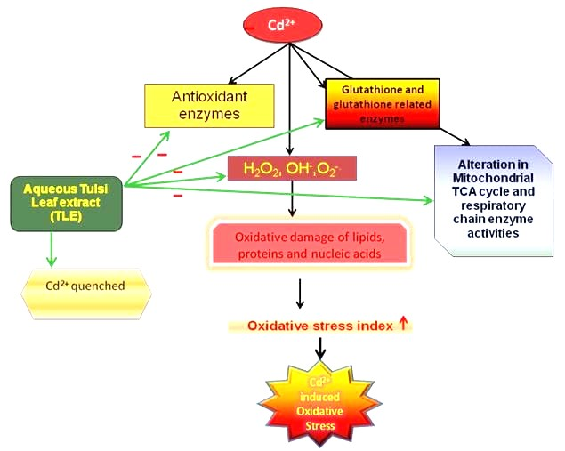

**Fig 4: Mechanism action of Tulsi in Antitussive agent.**

**5. Mechanism of Action of Synthetic Drugs-**

Synthetic drugs are chemically designed compounds crafted to interact with specific biological targets to produce therapeutic effects. These drugs exert their influence through precise interactions with various molecular structures in the body, such as receptors, enzymes, ion channels, and cellular pathways. The following outlines the key mechanisms by which synthetic drugs operate

**5.1. Receptor Binding:**

* Mechanism: Many synthetic drugs function by attaching to specific receptors on cell surfaces. These receptors, which are proteins, trigger a cellular response when activated or blocked by a drug.
* Example: Beta-blockers like propranolol bind to beta-adrenergic receptors to lower heart rate and blood pressure, effectively treating conditions like hypertension and angina. [23]

**5.2. Enzyme Inhibition:**

* Mechanism: Some synthetic drugs inhibit enzymes, blocking them from facilitating chemical reactions that contribute to disease. This inhibition can slow disease progression or reduce the production of harmful substances.
* Example: ACE inhibitors such as Lisinopril inhibit the angiotensin-converting enzyme (ACE), reducing angiotensin II production, which in turn lowers blood pressure. [24]

**5.3. Enzyme Activation:**

* Mechanism: Conversely, certain synthetic drugs activate enzymes, boosting their activity to achieve therapeutic results.

Example: Anticoagulants like warfarin inhibit the production of vitamin K-dependent clotting factors, lowering the risk of blood clot formation. [25]

**5.4. Ion Channel Modulation:**

* Mechanism: Synthetic drugs can alter ion channels in cell membranes, impacting the flow of ions like sodium, potassium, or calcium. This modulation can affect nerve signals and muscle contractions.
* Example: Calcium channel blockers such as amlodipine prevent calcium ions from entering cells, causing blood vessels to relax and reducing blood pressure. [26]

**5.5. Neurotransmitter Reuptake Inhibition:**

* Mechanism: Some synthetic drugs work by blocking the reuptake of neurotransmitters in the brain, increasing their availability in the synaptic space, which enhances mood and cognitive function.
* Example. Selective serotonin reuptake inhibitors (SSRIs) like fluoxetine increase serotonin levels by preventing its reabsorption, thereby helping to alleviate depression. [27]

**5.6. Competitive Antagonism:**

* Mechanism: Synthetic drugs can act as competitive antagonists by occupying the same receptor sites as natural substances, thus blocking their effects.
* Example: Naloxone is used to reverse opioid overdoses by binding to opioid receptors, displacing the opioid, and reversing its effects. [28]

**5.7. Non-competitive Antagonism:**

* Mechanism: Some drugs bind to a different site on a receptor than the natural ligand, altering the receptor's function and inhibiting its activity.
* Example: Certain antipsychotics act as non-competitive antagonists at dopamine and serotonin receptors, helping to manage symptoms of schizophrenia. [29]

**5.8. Hormone Modulation:**

* Mechanism: Synthetic drugs can influence hormone levels and actions within the body.
* Example: Oral contraceptives contain synthetic hormones that regulate the menstrual cycle and prevent ovulation, providing effective birth control. [30]

**5.9. Interference with Genetic and Cellular Pathways:**

* Mechanism: Some synthetic drugs target specific genetic and cellular pathways to influence gene expression or cellular functions, treating diseases at a molecular level.
* Example: Targeted cancer therapies like imatinib inhibit specific tyrosine kinases involved in cancer cell growth, providing more precise treatment with fewer side effects. [31]

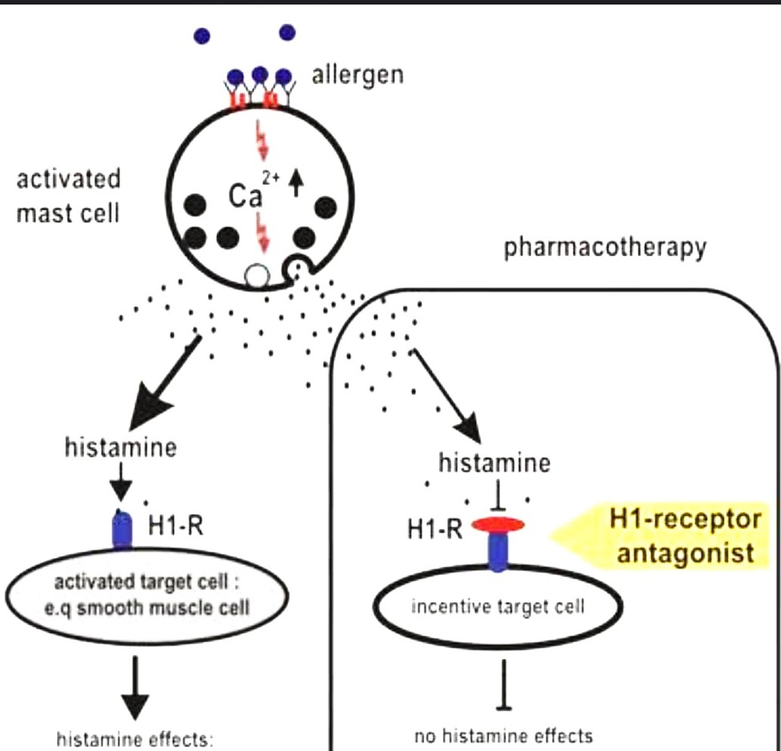

**Fig 5: Mechanism Action of Promethazine Drug.**

**6. Comparison between Herbal and Synthetic Drugs:[3]**

The comparison between herbal and synthetic drugs involves a thorough examination of their origins, composition, mechanisms of action, safety profiles, efficacy, regulation, and cultural significance. Both types of drugs have distinct advantages and challenges, making them suitable for different therapeutic purposes. Understanding these differences is essential for optimizing patient care and selecting the most appropriate treatment strategy.

|  |  |  |  |  |
| --- | --- | --- | --- | --- |
| **Herbal Drugs** | | | | |
|  | Curative medicine | Alternative medicine | Preventive measures |  |
| Medicine | Diagnostic Techniques | Supporting measures | Special treatment techniques | Surgery |
| **Synthetic Drugs** | | | | |

**Fig 2. Treatment methods .**

**Table 1 comparison between Herbal and Synthetic drugs.**

|  |  |  |
| --- | --- | --- |
|  | **Herbal Drugs** | **Synthetic Drugs** |
| Origin | Derived from plant extract, plant base compound. | Created in laboratories through chemical synthesis. |
| Composition | Complex mixture of different compound.  E.g. 1. Alkaloids  2. Glycosides  3. Terpenes | Single isolated chemical compound.  E.g. 1. small molecules  2. Biologics  3. Peptides |
| Mechanism of action | Multi-targeted, interacting with various biological pathway includes-   1. Anti-inflammatory 2. Immune modulation | Targeted to specific biological mechanism includes.   1. Enzyme inhibition 2. Receptor binding 3. Hormone regulation |
| Efficacy | Variable due to plant quality, preparation, and individual response | Generally, more potent, and consistent in effect. |
| Side effects | Safer with less side effects but includes   1. Allergic reaction 2. Interaction with other medication | Causes more side effects.   1. Organ toxicity 2. Dependance and withdrawal |
| Regulation | Less regulated with different quality control measures | Strictly regulated with various tastings and approval process |
| Cost | Lower research and development cost  Availability of raw material | High research and development cost.  Patent protection |
| Availability | Widely available which includes  Over the counter | Typical for prescription only  Over the counter for mild condition only |
| Interaction | Potential interaction with other medication or health condition | Potential interaction with other medication or health condition |
| Dosage | Dosage can be less precise due to availability in plant material | Precise dosing information due to standardized chemical composition. |
| Manufacturing | Traditional methods like drying, grinding and infusion. | High-tech process with strict control for purity and dosage. |
| Shelf life | May have shorter shelf due to natural ingredients. | Mostly has longer shelf life. |
| Pharmacokinetics | Variable absorption, distribution, metabolism, and excretion | Predictable pharmacokinetics due to standardized chemical composition |
| Pharmacodynamics | Complex interactions with multiple biological pathways | Targeted action on specific biological mechanisms |
| Toxicity | Generally considered safer, with lower toxicity | Can have higher toxicity due to targeted action |
| Withdrawal | Generally, not associated with withdrawal symptoms | Can be associated with withdrawal symptoms |
| Dependence | Generally, not associated with dependence | Can be associated with dependence |
| Allergic Reactions | Potential for allergic reactions due to plant material | Potential for allergic reactions due to chemical composition |
| Quality Control | Varying quality control measures, including GMP and labeling requirements | Strict quality control measures, including GMP, labeling requirements, and FDA/EMA approval |
| Research and Development | Often based on traditional knowledge and empirical evidence | Based on rigorous scientific research and clinical trials |
| Cultural acceptance | Widely accepted in various traditional cultures | Generally, accepted in modern medical practice |

**TABLE 2 Comparison of drugs of natural and synthetic origin**

|  |  |  |
| --- | --- | --- |
|  | Drugs of natural origin | Drugs of synthetic origin |
| Emergence of new drugs | Rare; would require discovery of new naturally occurring compounds; slow and limited | Chemical development; rapid by comparison and nearly unlimited |
| Inputs and materials | Crops or other natural inputs that require certain climates or environments; limited State control over growing areas; other related chemicals needed in processing | Precursor chemicals, some of which are controlled, at least in theory. Others can easily be masked or designed to circumvent controls |
| Scale and scope of production | Large, low-skilled labor supply dedicated to cultivating and harvesting large areas of illicit crops; geographically fixed production centers; extraction and refinement of alkaloids in rudimentary clandestine labs | Only requires a few individuals with knowledge of chemistry or means of carrying out chemical reactions in concealed and small locations; production can be mobile or easily relocated and scaled up or down as needed |
| Production time | Months. Some illicit crops are harvested only a few times a year, while some have staggered harvests; some plants may take years to reach maturity | Hours or days for reactions and processing |
| End products | Extracted/isolated and refined alkaloids (cocaine, morphine) or processed plant matter (cannabis, khat, kratom) | A wide array of psychoactive compounds can be produced using a range of precursor inputs |
| Trafficking | Often involves larger quantities of primary inputs and finished products transported over vast distances or through remote areas, sometimes crossing several borders, which enables the authorities to detect and seize such drugs | Can be manufactured close to end markets; small quantities can be posted to end buyers |
| Forms of administration | Most often injected, snorted or smoked, sometimes ingested | Can be smoked, snorted or injected, but a considerable share is tableted |
| Pharmacology | Largely understood | Not always known or predictable, even if the chemical structure is known; some new compounds may appeal to different user groups |

## **Herbal and synthetic medicines together?**

When using both herbal and synthetic medicines simultaneously, caution is essential, and it's generally recommended to avoid such combinations. Herbal medicines should also be avoided during pregnancy.

Combining herbal and synthetic medicines, also known as conventional or allopathic medicines, is a growing practice in integrative healthcare. While it can offer several benefits, it also raises important considerations regarding safety, efficacy, and interactions. Let’s explore this in more detail

* 1. **Potential Benefits of Combining Herbal and Synthetic Medicines**
* Holistic Approach: Herbal medicines often address the body’s overall balance, aiming to promote long-term wellness. Conventional drugs, on the other hand, target specific diseases or symptoms. Using both together can provide a more comprehensive treatment.
* Complementary Effects: Some herbal remedies may enhance the effects of synthetic drugs. For example, turmeric (curcumin) has anti-inflammatory properties that could complement non-steroidal anti-inflammatory drugs (NSAIDs).
* Fewer Side Effects: In some cases, combining lower doses of synthetic drugs with herbal remedies can reduce side effects while maintaining therapeutic efficacy. Herbal medicines are often perceived as gentler, although this isn't always the case.
* Chronic Conditions: For long-term management of chronic diseases like arthritis, diabetes, or hypertension, a combination approach can sometimes reduce dependency on synthetic drugs.
  1. **Risks and Challenges of Combining Herbal and Synthetic Medicines**
* Drug-Herb Interactions: One of the major concerns with combining the two types of treatments is the potential for interactions. Herbal products can affect how conventional drugs are absorbed, metabolized, or eliminated from the body. For example:
* St. John’s Wort: Known to reduce the effectiveness of oral contraceptives and some antidepressants by speeding up drug metabolism in the liver.Ginkgo Biloba: May increase the risk of bleeding when taken with blood thinners like warfarin.
* Lack of Standardization: Unlike synthetic drugs, which are tightly regulated for dosage and purity, herbal medicines can vary in potency, quality, and active ingredient concentrations. This variability can complicate their use alongside conventional drugs.
* Undisclosed Ingredients: Some herbal products contain undisclosed synthetic compounds or adulterants that can cause adverse reactions or drug interactions.
* Delayed Medical Care: Relying too much on herbal medicine may delay seeking conventional treatments for serious conditions.
  1. **Considerations for Safe Use**
* Consultation with Healthcare Providers: Always consult a healthcare professional (physician, pharmacist, or a qualified herbalist) before combining herbal and synthetic medicines. They can help monitor for potential interactions, adjust dosages, and ensure safety.
* Research Evidence: Look for evidence-based research on specific herbal supplements. Some herbs are well-studied, while others lack sufficient clinical trials to verify their safety and efficacy.
* Proper Dosing and Timing: The timing of when you take herbal and synthetic medicines can matter. Some herbs may interfere with drug absorption if taken simultaneously. Healthcare providers can advise on the correct timing.
* Regulatory Oversight: Choose herbal products that come from reputable manufacturers that follow good manufacturing practices (GMPs). Some countries have regulatory bodies like the FDA in the U.S. that offer certifications for herbal products. [32][33]

Many people are drawn to herbal remedies under the impression that they are free from side effects. While this belief is often mistaken, herbal medicines are generally considered safer than synthetic drugs. Approximately 100,000 deaths occur annually due to synthetic drug toxicity, whereas severe complications or deaths from herbal medicines are rare.Top of FormBottom of Form

**Conclusion-**

In conclusion, herbal and synthetic drugs represent two distinct approaches in medicine. Synthetic drugs excel in their precision and potency, targeting specific health issues with scientifically proven methods. In contrast, herbal drugs adopt a holistic approach, harnessing natural substances and traditional wisdom to foster overall well-being and balance. When choosing between herbal and synthetic drugs, individuals should consider their personal preferences, health status, and professional medical guidance. Consulting a healthcare provider ensures an informed decision that aligns with one's unique health needs and treatment objectives. Both approaches have their advantages and disadvantages, and the optimal choice often depends on the individual's specific health context and treatment requirements

.

**References:**

1. Sharma, Akanksha, Pooja Sabharwal, and Rima Dada. (2021) "Herbal medicine—An introduction to Its history." *Herbal Medicine in Andrology*. Academic Press. 1-8.
2. Karimi, Ali, Maedeh Majlesi, and Mahmoud Rafieian-Kopaei, (2015), "Herbal versus synthetic drugs; beliefs and facts." *Journal of nephropharmacology* 4.1: 27.
3. Nisar, B., Sultan, A., & Rubab, S. L. (2018). Comparison of medicinally important natural products versus synthetic drugs-a short commentary. *Nat. Prod. Chem. Res*, *6*(2), 308
4. Sahoo, Niharika, Padmavati Manchikanti, and Satyahari Dey. (2010), "Herbal drugs: standards and regulation." *Fitoterapia* 81.6: 462-471.
5. Choudhary, Neeraj, and Bhupinder Singh Sekhon. (2011), "An overview of advances in the standardization of herbal drugs." *Journal of Pharmaceutical Education and Research* 2.2: 55.
6. Bent, Stephen. (2008), "Herbal medicine in the United States: review of efficacy, safety, and regulation: grand rounds at University of California, San Francisco Medical Center." *Journal of general internal medicine* 23: 854-859.
7. Sharma, A., Shanker, C., Tyagi, L.K., Singh, M. and Rao, C.V., (2008). Herbal medicine for market potential in India: an overview. *Acad J Plant Sci*, *1*(2), pp.26-36.
8. Sharma A, Shanker C, Tyagi LK, Singh M, Rao CV. (2008)Herbal medicine for market potential in India: an overview. Acad J Plant Sci.;1(2):26-36.
9. Aronson, J.K. ed., (2008). *Meyler's side effects of herbal medicines*. Elsevier.
10. Palaian, S., Bista, D., Rajan, S., Shankar, P.R. and Mishra, P., (2006). Safety profile of herbal drugs: urgent need for monitoring. *Journal of Institute of Medicine Nepal*, *28*(2), pp.57-61.
11. Bade, R., Chan, H.F. and Reynisson, J., (2010). Characteristics of known drug space. Natural products, their derivatives and synthetic drugs. *European journal of medicinal chemistry*, *45*(12), pp.5646-5652.
12. Singh, R., (2002). *Synthetic drugs*. Mittal Publications.
13. Koul, I., & Taneja, S.C. (2004). "Plant-derived Antimicrobial Agents: A Review." *Current Trends in Medicinal Chemistry*, 4(9), 877-883.
14. Vane, J.R., & Botting, R.M. (1987). "Inhibition of Prostaglandin Synthesis as a Mechanism of Action for Aspirin-like Drugs." *Nature*, 325(6106), 250-252.
15. Moore, R.A., & Derry, S. (2015). "Ibuprofen and the Use of Nonsteroidal Anti-inflammatory Drugs." *British Journal of Clinical Pharmacology*, 80(3), 395-403.
16. Stoll, A.L., et al. (1991). "Fluoxetine in the Treatment of Major Depression." *The New England Journal of Medicine*, 325(13), 907-913.
17. Wiley, J.L., & Pacheco, M.A. (2014). "Synthetic Cannabinoids: The Newest Drugs of Abuse." *Journal of Psychoactive Drugs*, 46(1), 76-81.
18. Baler, R.D., & Volkow, N.D. (2016). "Prescription Drugs: Misuse and Abuse." *The Journal of Clinical Psychiatry*, 77(1), e115-11
19. Rudd, R.A., et al. (2016). "Increases in Drug and Opioid Overdose Deaths—United States, 2000–2014." *Morbidity and Mortality Weekly Report*, 64(50-51), 1378-1382.
20. Fabbri, A., et al. (2014). "Mechanisms of Action and Clinical Utility of Synthetic Drugs." *Frontiers in Pharmacology*, 5, 123.
21. Zang, J., et al. (2016). "Ginger (Zingiber officinale) Extracts Inhibit Inflammatory Responses via Suppression of NF-κB Pathway." *Phytotherapy Research*, 30(4), 635-642.
22. Ried, K., et al. (2016). "Garlic Reduces Blood Pressure in Hypertensive Individuals." *Journal of Nutrition*, 146(4), 748S-753S.
23. Dorsey, E.R., & Venkataraman, K. (2018). "Beta-Blockers in the Treatment of Hypertension." *American Journal of Hypertension*, 31(4), 421-426.
24. Buse, J.B., & Ginsberg, H.N. (2006). "Inhibition of the Renin-Angiotensin-Aldosterone System: A Review of ACE Inhibitors." *Journal of Clinical Hypertension*, 8(6), 415-422.
25. Hirsh, J., & Fuster, V. (2004). "The Role of Anticoagulants: Warfarin and Vitamin K." *Circulation*, 110(9), 1186-1191.
26. Heusch, G. (2015). "Calcium Channel Blockers in Cardiology." *European Heart Journal*, 36(1), 33-36.
27. Keller, J., & Schatzberg, A.F. (2002). "The Role of Selective Serotonin Reuptake Inhibitors in Depression." *Journal of Clinical Psychiatry*, 63(Suppl 6), 16-21.
28. Johnson, R.E., et al. (2013). "Naloxone: A New Paradigm for the Treatment of Opioid Overdose." *American Journal of Emergency Medicine*, 31(3), 586-591.
29. Muench, J., & Hamer, A.M. (2010). "The Role of Non-Competitive Antagonism in Antipsychotic Therapy." *Psychiatric Clinics of North America*, 33(1), 125-138.
30. Hatcher, R.A., et al. (2000). "The Effectiveness of Oral Contraceptives." *Contraception*, 61(1), 1-20.
31. Druker, B.J., et al. (2001). "Imatinib as a Selective Inhibitor of BCR-ABL." *Proceedings of the National Academy of Sciences*, 98(21), 12671-12676.
32. Izzo, A.A., & Ernst, E. (2009). "Interactions Between Herbal Medicines and Prescribed Drugs: A Systematic Review." *Drugs*, 69(13), 1777-1798.
33. World Health Organization (WHO). (2013). "WHO Traditional Medicine Strategy: 2014–2023."