**A STUDY ON A COMPREHENSIVE REVIEW ON ALZHEIMERS DISEASE**

**PRACTICE SCHOOLSUBMITTED TO THE JAWAHARLALNEHRU TECHNOLOGICAL UNIVERSITY ANANTAPUR.**



# SUBMITTED BY M.GOUSE

**22ER5R0003**

**Under the supervision of**

## Dr.M.SPHURTHY MITRA Associate Professor, DEPT OF PHARMACY PRACTICE Dr. KV.SUBBAREDDY INSTITUTE OF PHARMACY



**Dr. KV.SUBBAREDDY INSTITUTE OF PHARMACY DUPADU, KURNOOL 518001 NOVEMBER.**



**CERIFICATE BY SUPERVISIOR**

This is to certify that the work study on “A COMPREHENSIVE REVIEW ON ALZHEIMERS DISEASE” submitted by M. GOUSE{22ER5R0003} f or the award of the degree B .

PHARMACY t o the D R.K.V. SUBBA REDDY INSTITUTE OF PHARMACY i s a record of bonafide research works carried out by her under my supervision or guidance.

I considered that the thesis has reached the standards and fulfilling requirements of rules and regulations relating to the nature of degree. The contents embodied thesis have not been submitted for the award of any other degree or diploma in this or any other university.

**Date:**

**Place:**

# Dr.M.SPHURTHY MITRA



## Signature of the Principal



## CERTIFICATE BY HEAD OF THE INSTITUTE

This is to certify that the dissertation entitled **“A COMPHRENSIVE REVIEW ON**

**ALZHEIMERS DISEASE”** was done for the partial fulfillment for the award of degree of **B. PHARMACY** has been carried out by M.GOUSE **{22ER5R0003}** under the guidance and supervision of **DR.M. SPURTHY MITRA {PHARMACY PRACTICE}** at **Dr. K.V. Subba**

**Reddy Institute of Pharmacy,** Dupadu, Kurnool, during the period of 2024-2025. It is further certified that this work or any part of this has not been submitted in part or full for the award of any degree or fellowship.

**Date:**

**Place:**

**Signature of the principal**



**DECLARATION**

I certify that

1. The work contained in the thesis is original and has been done by myself under the supervision of my supervisor.
2. The work has not been submitted to any other Institute for any degree or diploma.
3. I have conformed to the norms and guidelines given in the Ethical Code of Conduct

of the Institute.

1. Whenever I have used materials (data, theoretical analysis, and text) from other sources, I have given due credit to them by citing them in the text of the thesis and giving their details in the references.
2. Whenever I have quoted written materials from other sources and due credit is given to the sources by citing them.
3. From the plagiarism test, it is found that the similarity index of whole thesis within

25% and single paper is less than 10 % as per the university guidelines.

**Date:**

**Place:**

**M.GOUSE**

**Reg.no:22ER5R0003**



**ACKNOWLEDEMENTS**

I would like to express my sincere gratitude to all those who contributed to the completion of this work on Ebola virus. I am especially grateful to the faculty and staff for their support, guidance, and the valuable resources provided during the course of this study.

Furthermore, I would like to the invaluable contributions of my peers and mentors in the field of pharmacy whose feedback and encouragement have been fundamental to the completion of this project.

Lastly, I am deeply grateful to my guide who guided for their continuous encouragement and support throughout this journey

### STUDENT NAME

**M. GOUSE**



#### ABSTRACT

Alzheimer’s complaint( announcement) is a complaint that causes degeneration of the cells in the brain and it's the main cause of madness, which is characterized by a decline in thinking and independence in particular diurnal conditioning. announcement is considered a multifactorial complaint two main suppositions were proposed as a cause for announcement, cholinergic and amyloid suppositions. also, several threat factors similar as adding age, inheritable factors, head injuries, vascular conditions, infections, and environmental factors play a part in the complaint. presently, there are only two classes of approved medicines to treat announcement, including impediments to cholinesterase enzyme and antagonists to N- methyl d- aspartate( NMDA), which are effective only in treating the symptoms of announcement, but do n't cure or help the complaint. currently, the exploration is fastening on understanding announcement pathology by targeting several mechanisms, similar as abnormal tau protein metabolism, β- amyloid, seditious response, and cholinergic and free radical damage, aiming to develop successful treatments that are able of stopping or modifying the course of announcement. This review discusses presently available medicines and unborn propositions for the development of new curatives for announcement, similar as complaint- modifying rectifiers( DMT), chaperones, and natural composites.



##### LIST OF ABBREVATIONS

|  |  |
| --- | --- |
| **ABBREVIATIONS** | **DESCRIPTION** |
| AD | Alzheimer's Disease |
| ADC | Alzheimer's Disease Center |
| APOE | Apolipoprotein E protein |
| BCAT | Brief Cognitive Assessment Tool |
| EOAD | Early oneset anouncement |
| DDS | Disease down syndrome |
| EEA | Exitatory amino acids |
| MOCA | Montreal congnitive assesment test |
| MMSE | Anti mini mental status |
| NFT | Neurofibiliary befudliments |
| NMDA | N methyl d aspartase |
| NCDS | Neurological and communicative disorder |
| NBM | Nexus basalis of meynert |
| PSEN 1 | Presenilin 1 |
| TBP | Traumatic brain injury |
| VILIP | Visinin such like protien |
| WHO | World health organistaion |



##### LIST OF SYMBOLS

|  |  |
| --- | --- |
| NAMES | SYMBOLS |
| Celicius | ° C |
| kilobyte | kb |
| Milligram | mg |
| centrigram | cn |
| milliliter | ml |
| nanometer | nm |
| nanogram | ng |



**LIST OF FIGURES**

FIGURE 1**:** A pic representing a alzheimers disease syndriome about forgot to lock door

FIGURE 2**:** Symptoms of alzeihmers

FIGURE 3**:** The inflammation hypothesis of late-onset alzheimer

FIGURE 4**:** Swellings and leakage as a trigger of senile plaque formation in patients with alzheimer disease.

|  |  |  |
| --- | --- | --- |
| Abnormal accumulation of | [tau](https://en.wikipedia.org/wiki/Tau_protein) [protein,](https://en.wikipedia.org/wiki/Tau_protein) | which constitutes neurofibrillary tangles, |

FIGURE 5**:**

|  |  |  |
| --- | --- | --- |
| in | [neuronal](https://en.wikipedia.org/wiki/Neuron) | cell bodies |

FIGURE 6**:** Causes and risk factors of alzheimers

FIGURE 7**:** Stages of brain disease occur during stages



##### CONTENTS

|  |  |
| --- | --- |
| **Contents details** | **Page No** |
| INTRODUCTION | 11 |
| PHYSICAL EXAMINATION | 11 TO 12 |
| RISK FACTORS | 12 TO 13 |
| SIGN AND SYMPTOMS | 13 |
| DIAGNOSIS | 14 |
| PATHOPHYSIOLOGY | 14 |
| NEUROPHATHOLOGY | 17 |
| ETIOLOGY | 19 |
| HISTOPATHOLOGY | 20 |
| STAGES OF ALZHEIMERS | 22 |
| PREVENTION | 24 |
| TREATMENT | 25 |
| MANAGEMENT  STRATEGIES IN INDIA | 27 |
| COMPLICATION | 28 |
| REFERENCES | 30 |

# COMPREHENSIVE REVIEW ON ALZHEIMER’S DISEASE



• INTRODUCTION

One of the most generally reported causes of madness in the senior is announcement, which is a habitual, unrecoverable neurological complaint. It's a degenerative, ineluctable, progressive neurological complaint and complex complaint that continually damages brain cells, leading to memory and cognitive chops loss and, ultimately, the incapability to carry out the most introductory conditioning. This condition causes cognitive deterioration, which ultimately leads to madness. In the environment of neurodegenerative madness, similar as announcement, the original stages are characterized by mild deterioration, which precipitously worsens over time. The opinion of announcement can not be made solely through a single test. rather, healthcare professionals gather comprehensive information on a case’s medical and internal health history, as well as their family background. also, they engage in consultations with cousins and conduct neurological and cognitive tests. To count other implicit causes of madness, actors suffer fresh.

.



Fig 1 : a pic representing a alzheimers disease syndriome about forgot to lock door

## • Physical Examination

A comprehensive physical test, including a detailed neurological test and internal status assessment, is essential to estimate the announcement stage and rule out other implicit conditions. A complete clinical assessment can give a reasonable position of individual delicacy for utmost cases. A detailed neurological examination is essential to rule out other implicit conditions. In announcement, the neurological test generally appears normal, except for anosmia. Anosmia is also in case with Parkinson complaint, madness with Lewy bodies, and traumatic brain injury( TBI) with or without madness, but not in individualities with vascular cognitive impairment( VCI) or depression. AMini-mental Status test( MMSE) or, rather, a Montreal Cognitive Assessment test( MOCA) should be performed and proved as part of the cognitive neurological test. The MOCA is more sensitive to assessing cases with mild cognitive impairment than the effective cognitive webbing test for primary care croakers

is the Min test, which involves a timepiece drawing test and 3- point recall. specially, the results of theMini-Cog are n't significantly told by the existent’s position of education. In the advanced stages of announcement, cases may parade further focal neurological signs, including apraxia and aphasia, anterior release signs, and primitive revulsions. Cases may come mute and unresponsive to verbal requests as the complaint progresses, leading to increased dependence on caregivers. They may ultimately come confined to bed and ultimately enter into a patient vegetative state. During a internal status examination, it's essential to assess colorful cognitive disciplines to estimate the extent of cognitive decline in announcement. These disciplines include attention, attention, recent and remote memory, language chops, visuospatial functioning, praxis, and administrative functioning. These assessments help to estimate the extent of cognitive decline. All follow- up visits for individualities with announcement should include a thorough internal status examination to assess complaint progression and the development of neuropsychiatric symptoms. Alzheimer's complaint is a progressive brain complaint that causes memory loss and cognitive decline. It was first described by Alois Alzheimer in 1906 after examining brain towel from a departed case. The complaint results from the figure up of beta- amyloid pillars and tau protein distraction in the brain, which damage and kill neurons. threat factors include age, family history, and inheritable factors. There's no cure for Alzheimer's, but specifics and caregiving can temporarily ease symptoms.

**Alzheimer’s Disease Risk Factors**

# Aging

The most important threat factor in announcement is growing. youngish individualities infrequently have this complaint, and utmost announcement cases have a late onset that starts after times of age Aging is a complex and unrecoverable process that occurs through multiple organs and cell systems with a reduction in the brain volume and weight, a loss of synapses, and ventricles’ blowup in specific areas accompanied by SP deposit and NFT. also, several conditions might crop during growing similar as glucose hypometabolism, cholesterol dyshomeostasis, mitochondria dysfunction, depression, and cognitive decline. These changes also appear in normal aging, which makes it delicate to distinguish the cases in early announcement. announcement can be divided grounded on age of onset into early- onset announcement( EOAD), the rare form with around 1 – 6 of cases, in which utmost of them are domestic announcement characterized by having further than one member in further than one generation with announcement, and ranges from 30 – 60 or 65 times. The alternate type is the late- onset announcement( cargo), which is more common with age of onset above 65 times. Both types may do in people who have a family with a positive history of announcement and families with a late- onset complaint • Genetics AD cases were related to inheritable factors most cases of EOAD are inherited in an autosomal dominant( APP), Presenilin- 1( PSEN- 1), Presenilin- 2 ( PSEN- 2), and apolipoprotein E( ApoE) are associate

## SIGNS & SYMPTOMS

### Memory Loss

Difficulty remembering recent events

Forgetting important dates or appointments

Trouble finding the right words to express thoughts **Challenges in Thinking and Reasoning:**

Difficulty concentrating

Trouble planning or solving problems

Poor judgment

**Language Difficulties:**

Trouble following conversations

Difficulty finding the right words

Repeating oneself

**Visual Spatial Difficulties**:

Problems recognizing familiar places

Misjudging distances

Difficulty with tasks requiring hand-eye coordination **Personality Changes:**

Mood swings

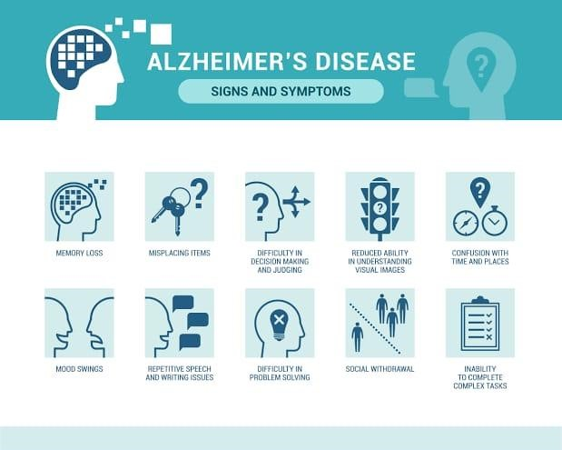

FIG 2 : Symptoms of alzeihmers

### Disease Diagnostic Criteria

The National Institute of Neurological and Communicative Disorders and Stroke (NINCDS) and the Alzheimer’s Disease and Related Disorders Association (ADRDA) formed a work group (NINCDS-ADRDA) to establish a clinical diagnostic’s criteria for Alzheimer’s disease.

This criteria includes: (1) probable Alzheimer’s disease, which can be diagnosed by dementia that is confirmed by neuropsychological tests, progressive memory loss, impaired daily-life activity, and other symptoms like aphasia (impairment of a language), apraxia (a motor skills disorder), and agnosia (a loss of perception). All of these symptoms can start from age 40–90, with the absence of any systemic or brain diseases, (2) possible Alzheimer’s disease can be applied in the absence of neurologic, psychiatric disorders, and the presence of another illness like systemic or brain disorder, but they are not the primary cause of dementia, and (3) definite Alzheimer’s disease, that is confirmed by histopathology confirmation obtained from a biopsy or autopsy Examination:

* mental status examination
* neuro physiological assessment
* laboratory test
* brain imaging
* CT scan
* MRI PET
* CSF examination electromyogram Inflammation hypothesis of AD

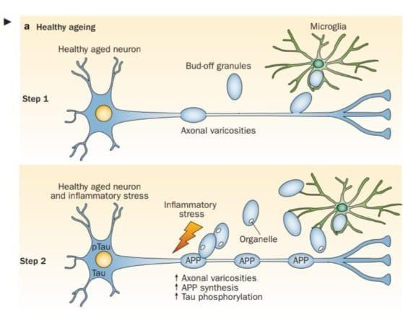

FIG 3: The inflammation hypothesis of late-onset Alzheimer

### Pathophysiology

Alzheimer complaint is characterized pathologically by an accumulation of abnormal neuritic pillars and neurofibrillary befuddlements in the brain. These pathological changes are accompanied by a loss of neurons, particularly cholinergic neurons in the rudimentary forebrain and the neocortex.

#### Cholinergic thesis

In the 1970s, neocortical and presynaptic cholinergic poverties were reported to be related to the enzyme choline acetyltransferase( converse), which is responsible for the conflation of acetylcholine( Ach). Due to the essential part of Ach in cognitive function, a cholinergic thesis of announcement was proposed. Ach is synthesized in the cytoplasm of cholinergic neurons from choline and acetyl- coenzyme A by the converse enzyme and transported to the synaptic vesicles by vesicular acetylcholine transporter( VAChT)( Figure 3). In the brain, Ach is involved in several physiological processes similar as memory, attention, sensitive information, literacy, and other critical functions. Degeneration of the cholinergic neurons was set up to take place in announcement and to beget alternation in cognitive function and memory loss. Β- amyloid is believed to affect cholinergic neurotransmission and to beget a reduction in the choline uptake and a release of Ach. Studies demonstrated that cholinergic synaptic loss and amyloid fibril conformation are related to Aβ oligomers’ neurotoxicity and to relations between pang and Aβ peptide. fresh factors also contribute to the progression of announcement, similar as a reduction in nicotinic and muscarinic( M2) Ach receptors, located on presynaptic cholinergic outstations, and the deficiency in excitatory amino acid( EAA) neurotransmission, where glutamate attention and D- aspartate uptake are significantly reduced in numerous cortical areas in announcement smarts. This is in addition to the use of cholinergic receptor antagonists similar as scopolamine, which was set up to induce amnesia. This effect can be reversed by using composites that spark acetylcholine conformation As a result, the cholinergic thesis is grounded on three generalities reduced presynaptic cholinergic labels in the cerebral cortex, severe neurodegeneration of nexus basalis of Meynert( NBM) in the rudimentary forebrain, which is the source of cortical cholinergic innervation, and the

part of cholinergic antagonists in memory decline compared to the agonists, which have the

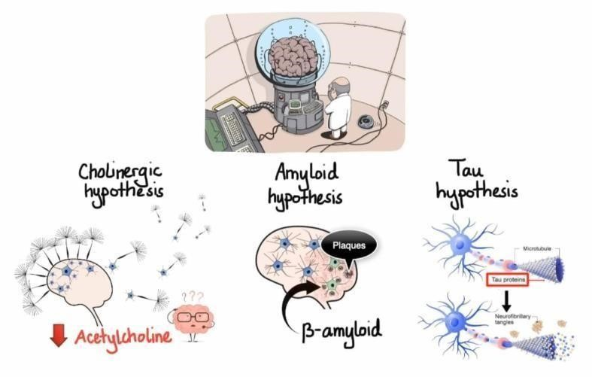

contrary effect

FIG 4 : swellings and leakage as a trigger of senile plaque formation in patients with Alzheimer disease.

#### Amyloid Hypothesis

For decades, it was honored that abnormal deposit of β- wastes in the central nervous system has a strong correlation with madness, which led to the conception of the amyloid thesis. still, it was set up that the amyloid pillars( AP) also deposit in normal healthy smarts with aging, which raised the question of whether AP deposit is responsible for announcement onset or not? thus, in the recent times, indispensable suppositions were proposed for thenon-inherited form of announcement( NIAD), but at present, the amyloid thesis remains the most accepted pathological medium for inherited announcement( IAD). The amyloid thesis suggests that the declination of Aβ, deduced from APP by β- and γsecretase, is dropped by age or pathological conditions, which leads to the accumulation of Aβ peptides( Aβ40 and Aβ42). adding the rate of Aβ42/ Aβ40 induces Aβ amyloid fibril conformation, performing in neurotoxicity and tau pathology induction, and accordingly, leading to neuronal cell death and neurodegeneration. announcement threat factors and mutations of several genes like APP, PSEN1, and PSEN2 were set up to affect Aβ catabolism and anabolism, which fleetly beget an accumulation a fast progression of neurodegeneration

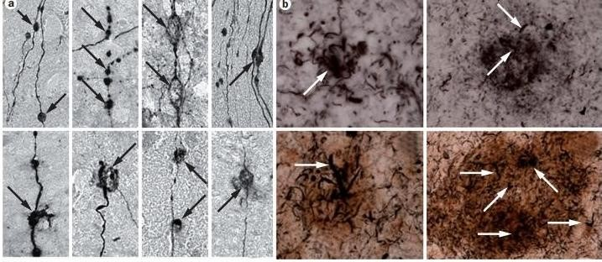

|  |  |  |
| --- | --- | --- |
| Abnormal accumulation of | [tau](https://en.wikipedia.org/wiki/Tau_protein) [protein](https://en.wikipedia.org/wiki/Tau_protein) | , which constitutes neurofibrillary tangles, |

FIG 5**:**

|  |  |  |
| --- | --- | --- |
| in | [neuronal](https://en.wikipedia.org/wiki/Neuron) | cell bodies |

### Neuropathology

There are two types of neuropathological changes in announcement which give substantiation about complaint progress and symptoms and include( 1) positive lesions( due to accumulation), which are characterized by the accumulation of neurofibrillary befuddlements, amyloid pillars, dystrophic neurites, neuropil vestments, and other deposits set up in the smarts of announcement cases. In addition to( 2) negative lesions( due to losses), that are characterized by large atrophy due to a neural, neuropil, and synaptic loss. either, other factors can beget neurodegeneration similar as neuroinflammation, oxidative stress, and injury of cholinergic neurons.

#### 1. Senile Pillars( SP)

The senile pillars are extracellular deposits of beta- amyloid protein( Aβ) with different morphological forms, including neurotic, verbose, thick- cored, or classic and compact type pillars. Proteolytic fractionalization enzymes similar as β- secretase and γ- secretase are responsible for the biosynthesis of Aβ deposits from the transmembrane amyloid precursor protein( APP**).**

**2. Neurofibrillary befuddlements( NFTs**) NFT are abnormal fibers of the hyperphosphorylated tau protein that in some stages can be twisted around each other to form paired spiral hair( PHF) and accumulate in neuralperikaryal cytoplasm, axons, and dendrites, which beget a loss of cytoskeletal microtubules and tubulinassociated proteins. The hyperphosphorylated tau protein is the major element of NFTs in the smarts of announcement cases, and its elaboration can reflect NFTs morphological stages, which include( 1) pretangle phase, one type of NFT, where phosphorylated tau proteins are accumulated in the somatodendritic cube without the conformation of PHF,( 2) mature NFTs, which are characterized by hair aggregation of tau protein with the relegation of the nexus to the fringe part of the soma, and( 3) the extracellular befuddlements, or the ghost NFTs stage, that results from a neuronal loss due to large quantities of filamentous tau protein with partial resistance to proteolysis

#### 3. Synaptic Loss

A synaptic damage in the neocortex and limbic system causes memory impairment and generally is observed at the early stages of announcement. Synaptic loss mechanisms involve blights in axonal transport, mitochondrial damage, oxidative stress, and other processes that can contribute to small fragments, like the accumulation of Aβ and tau at the synaptic spots. These processes ultimately lead to a loss of dendritic backbones,presynaptic outstations, and axonal dystrophy. Synaptic proteins serve as biomarkers for the discovery of synapses loss, and inflexibility, similar as neurogranin, a postsynaptic neuronal protein, visinin- such like protein- 1( VILIP- 1), and synaptotagmin- 1 These enzymes stick APP into several amino acid fractions 43, 45, 46, 48, 49, and 51 amino acids, which reach the final forms Aβ40 and Aβ42. There are several types of Aβ monomers, including large and undoable amyloid fibrils which can accumulate to form amyloid pillars and answerable oligomers that can spread throughout the brain. Aβ plays a major part in neurotoxicity and neural function, thus, accumulation of thick pillars in the hippocampus, amygdala, and cerebral cortex can beget stimulation of astrocytes and microglia, damage to axons, dendrites, and loss of synapses, in addition to cognitive impairments The most dependable individual system for announcement is presently grounded on pathological examination. Although several macroscopic characteristics of announcement can be linked, no single characteristic or combination of characteristics can definitively diagnose the complaint. still, certain features explosively indicate the presence of announcement.

In the mortal body and brain, the protein amyloid naturally develops. In announcement, normal amyloid groups suffer structural changes that disrupt their normal functioning. Abnormal amyloid groups can spark differences in near healthy amyloid groups, performing in the conformation of large clusters called pillars. These pillars, depicted as the brown, pallsuchlike substance in are associated with the conformation of brain lesions, which are a distinctive point of announcement and contribute to the degeneration of brain cells. The hippocampus, a brain region particularly susceptible to shrine conformation, plays a pivotal part in the processing of short term to long- term recollections. Damage to the hippocampus has been linked to the symptoms of announcement. Another protein naturally present in the mortal body and brain is tau. Its primary function in the brain is to maintain the stability of brain cell axons, which are tube- suchlike structures through which electrical impulses pass. In announcement, tau proteins suffer structural changes that lead to their aggregation with other tau filaments. This trap of tau proteins disrupts the stability of brain cell axons, performing in their degeneration and eventual death. hyperactive phosphorylation of tau disrupts its normal function in stabilizing microtubules, leading to the conformation of neurofibrillary befuddlements. These befuddlements contribute to neuronal dysfunction and eventually affect in cognitive decline and neurodegenerative conditions, similar as Alzheimer’s complaint. Understanding the part of tau hyperactive phosphorylation in complaint progression is pivotal for developing targeted curatives and interventions to alleviate its mischievous goods. The tau befuddlements, depicted in purple in intrude with the transmission of signals between neurons, thereby dismembering synaptic communication Tuted by 639 – 770 amino acids in humans, and largely expressed in the central nervous system where it exerts a variety of physiological functions Aβ- PP is originally adhered by α- secretase or β- secretase, generating answerable and carboxyterminal fractions( CTF). Α- secretase exertion leads to the conformation of sAβPPα and CTF83, whereas β- secretase generates sAβPPβ and CTF99. also, γ- secretase intervenes, further adhering CTF83 and CTF99, generating the intracellular peptide AICD/ AID( amyloid intracellular sphere) and a small p3 peptide from CTF83, and AICD/ AID and Aβ from CTF99. Grounded on this biochemical processing, the waterfall initiated by α- secretase has been considered neuroprotective when compared with the βsecretase fractionalization, leading to the amyloidogenic waterfall and the conformation of Aβ( 5). Grounded on the γ- secretase point of slice, different isoforms of Aβ can be generated, composed of 38 — 43 amino acids. Aβ40 is the predominant species, whereas Aβ42 is present at lower attention but has entered further attention in the announcement field due to its high propensity to form summations. still, in the brain of announcement cases, Aβ38 and abbreviated forms at Terminal region, i.e., Aβ15, Aβ16, and Aβ17, have been also detected( 6). Aβ is really the most studied protein in announcement and its apparent part in the pathogenesis of the complaint has acquainted medicine development and clinical trials for several decades

## ETIOLOGY

Alzheimer complaint is characterized by gradational and progressive neurodegeneration caused by neuronal cell death. The neurodegenerative process generally begins in the entorhinal cortex within the hippocampus. inheritable factors have been linked to contribute to both early and late- onset announcement. Trisomy 21, for illustration, is a threat factor associated with early- onset madness. announcement is a multifactorial condition associated with numerous known threat factors. The most significant factor is age, with advancing age being the primary contributor. The frequence of announcement roughly doubles with every 5 times increase in age starting from age 65. Cardiovascular conditions( CVD) are honored as significant threat factors for announcement. They increase the threat of developing announcement and contribute to the threat of madness caused by strokes or vascular madness. CVD is decreasingly honored as a adjustable threat factor for announcement. rotundity and diabetes are also important adjustable threat factors for announcement. rotundity can vitiate glucose forbearance and increase the threat of developing type II diabetes. habitual hyperglycemia can lead to cognitive impairment by promoting the accumulation of betaamyloid(A-beta) and neuroinflammation. rotundity farther amplifies the threat by driving the release ofpro-inflammatory cytokines and promoting insulin resistance. Other implicit threat factors for announcement include traumatic head injury, depression, cardiovascular and cerebrovascular complaint, advanced maternal age at birth, smoking, family history of madness, increased homocysteine situations, and the presence of the APOE e4 allele. Having a first- degree relative with announcement increases the threat of developing the complaint by 10 to 30. individualities with 2 or further siblings with late- onset announcement face a3-fold advanced threat than the general population Several factors have been linked that may potentially reduce the threat of developing announcement. These include advanced education, estrogen use in women,anti-inflammatory agents, rest conditioning similar as reading or playing musical instruments, maintaining a healthy diet, and regular aerobic exercise

### Genetic Base Of Alzheimers Deisease

Disease Down Syndrome, a inheritable condition caused by trisomy 21, is explosively linked to the amyloid thesis in the environment of announcement exploration. In Down Syndrome, individualities have an redundant dupe of chromosome 21, leading to an fresh dupe of the APP gene. Due to this inheritable duplication, individualities with Down Syndrome have advanced situations of APP, which increases the product of amyloid- beta( Aβ) peptides. As a result, individualities with Down Syndrome are at a significantly increased threat of developing announcement. It's estimated that roughly 40 to 80 of cases with Down Syndrome experience clinical announcement by the fifth to sixth decade of life, and nearly 100 of them parade announcement pathology, similar as amyloid pillars and neurofibrillary befuddlements. announcement can be inherited as an autosomal dominant complaint with nearly complete penetrance. This form of the complaint is linked to mutations in 3 genes the AAP gene on chromosome 21, Presenilin1( PSEN1) on chromosome 14, and Presenilin 2( PSEN2) on chromosome 1. APP mutations may lead to increased product and accumulation of Aβ. On the other hand, PSEN1 and PSEN2 mutations intrude with the processing of gamma- secretase, leading to the aggregation of Aβ in the brain. Although these mutations are fairly rare, counting for roughly 5 to 10 of all announcement cases, they're explosively associated with early- onset forms of the complaint. The PSEN1 mutation is the most common, counting for about 5 of all announcement cases. Apolipoprotein E( APOE) is a lipid metabolism controller with an affinity for beta- amyloid protein. There are 3 alleles for the Apolipoprotein E gene ε2, ε3, and ε4. The ε4 allele of the APOE gene has been linked as a significant inheritable threat factor for cargo. Heterozygous carriers of the ε4 allele have a 3 times increased threat, while homozygous carriers face 15 times increased threat of developing announcement. In cases with EOAD, the threat is indeed more pronounced in homozygous ε4 carriers and heterozygous ε4 carriers with a positive family history of announcement. The presence of the APOE e4 allele is considered one of the most pivotal threat factors for sporadic Alzheimer complaint.( 20) While the ε4 allele increases the threat of developing the complaint, it's essential to fete that not everyone with the ε4 allele will develop announcement, and numerous other factors play a part in the complex etiology of the complaint. Variants in the gene for the sortilin receptor, SORT1, which is essential for transporting APP from the cell face to the Golgi- endoplasmic reticulum complex, have been set up in domestic and sporadic forms of announcement

### Histopathology

The typical histopathology of announcement is characterized by the presence of 3 main elements

#### Neuritic Pillars

Neuritic pillars are globular bitsy lesions featuring a core of extracellular amyloid betapeptide( Aβ) girdled by enlarged axonal consummations. These Aβ grounds do around meningeal and cerebral vessels and within the cortical argentine matter in individualities with announcement. Gray matter deposits are multifocal and coalesce, forming milliary structures called pillars. still, in some cases, brain reviews have revealed the presence of amyloid pillars in some individualities without madness. In discrepancy, other cases with diagnosed madness who passed multiple brain reviews did n't show substantiation of pillars.

#### Neurofibrillary tangles

Neurofibrillary tangles are fibrillary intracytoplasmic structures that form inside neurons and are composed of a protein called tau. The primary function of the tau protein is to stabilize axonal microtubules. Microtubules run along neuronal axons and are essential for intracellular transport. Tau helps maintain the integrity of microtubules and aids in their assembly along neuronal axons. In announcement, the aggregation of extracellular beta- amyloid leads to hyperphosphorylation of tau. This abnormal phosphorylation causes tau to come misfolded and form summations within the neurons. These tau summations take the shape of crooked paired spiral fibers known as neurofibrillary befuddlements. Neurofibrillary befuddlements first appear in the hippocampus and latterly spread throughout the cerebral cortex. Tau- summations are deposited within the neurons.

#### Cortical Neuronal Degeneration

Among these degenerative changes, granulovacuolar degeneration of hippocampal pyramidal neurons is generally observed. Cognitive decline in announcement appears to be more nearly affiliated to a drop in the viscosity of presynaptic boutons from pyramidal neurons in specific layers of the cerebral cortex, particularly in lamellae III and IV. The reduction in their viscosity may have a more significant impact on cognitive function than the bare increase in the number of pillars characteristic of announcement.

#### Braak and Braak Carrying

A staging system known as the Braak and Braak staging has been developed to classify the topographical progression of neurofibrillary befuddlements into 6 stages. This staging system is extensively honored and is integral to the individual criteria for announcement handed by the National Institute on Aging and Reagan Institute. Neurofibrillary tangles have demonstrated a stronger correlation with announcement inflexibility than pillars. This means that the quantum of tau deposits in the smarts of cases with announcement correlates better with madness inflexibility than the quantum of amyloid deposits. still, amyloid is a moredefining pathology for announcement than other forms of madness. The relationship between amyloid and tau in the pathogenesis of announcement is frequently likened to a" detector and pellet" script. Amyloid is considered the detector that initiates the complaint process. At the same time, tau, in the form of neurofibrillary befuddlements, acts as the pellet that leads to neurodegeneration and cognitive decline. Accumulation of Aβ is a common point in announcement, with a advanced frequence of the further answerable Aβ40 than the Aβ42. In some announcement cases, Aβ accumulates in the intracranial blood vessels, leading to the pathology known as cerebral amyloid angiopathy( CAA). The presence of CAA in announcement has clinical counteraccusations , as it's associated with more significant cognitive impairment and conceivably briskly cognitive decline in affected individualities. On the other hand, vascular donation to the neurodegenerative process of announcement is n't yet completely understood. still, exploration suggests that subcortical infarcts can increase the threat of madness by4-fold. also, cerebrovascular complaint can exaggerate the inflexibility of madness and accelerate its progression

## Causes and Risk Factors ofAlzheimer’s Disease

Announcement has been considered a multifactorial complaint associated with several threat factor similar as adding age, inheritable factors, head injuries, vascular conditions, infections, and environmental factors( heavy essence, trace essence, and others). The underpinning cause of pathological changes in Alzheimer’s complaint( Aβ, NFTs, and synaptic loss) is still unknown. Several suppositions were proposed as a cause for announcement but two of them are believed to be the main cause some believe that an impairment in the cholinergic function is a critical threat factor for announcement, while others suggest that revision in amyloid β- protein product and processing is the main initiating factor. still, at present, there's no accepted proposition for explaining the announcement pathogenesis

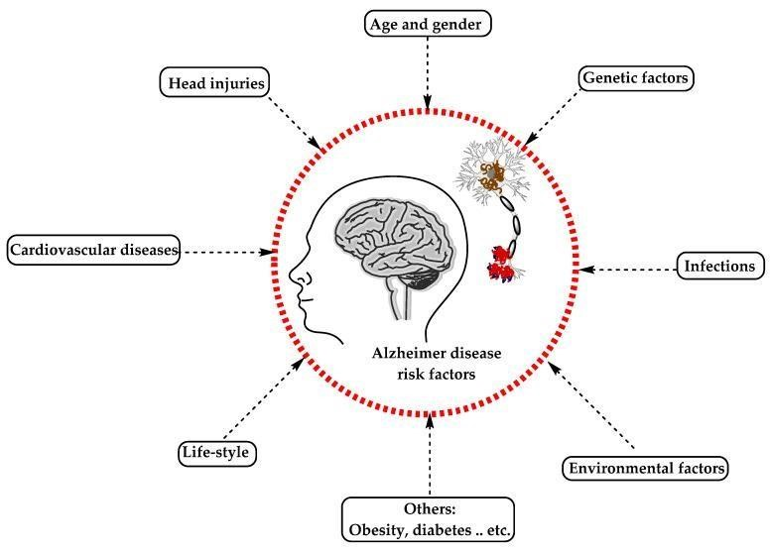

FIG 6 **:** causes and risk factors of alzheimers

### STAGES OFALZHEIMER’S DISEASE

The severity of Alzheimer's disease rangeMild Alzheimer’s disease:

**Mild Alzheimer’s Disease:**

Individuals with mild Alzheimer's disease may experience the following memory and cognitive difficulties:

requiring more time than usual to complete daily duties having trouble managing money or paying bills wandering and getting lost experiencing personality and behaviour changes, such as getting upset or angry more easily, hiding things, or pacing.

**Moderate Alzheimer’s Disease** brain regions responsible for language, senses, reasoning, and consciousness are damaged in moderate Alzheimer's disease. This can result in the subsequent symptoms:

Greater memory loss and confusion

Difficulty in recognising family and acquaintances.

Incapable of acquiring new knowledge

Difficulty completing multi-step tasks, such as getting dressed.

Difficulty adapting to new situations.

Impulsive behaviour

Hallucinations, delusions, or paranoia

#### Severe Alzheimer’s Disease

Plaques and tangles are present throughout the brain in severe Alzheimer's disease, causing the tissue to diminish significantly. This can result in: INABILITY to communicate dependent on others for care being bedridden for the majority of the time

Evaluation

From a primary care provider standpoint, when evaluating a patient suspected to be suffering from AD, the following tasks are essential:

Review and confirm the medical and family history.

Review the patient’s medication list for medications that may potentially cause or worsen cognition.

Perform a bedside cognitive assessment test, either an MMSE or MOCA, to evaluate the patient’s cognitive function.

Request blood tests to rule out any reversible causes of dementia

Routine laboratory tests do not reveal any specific abnormalities in AD. Complete blood count

(CBC), complete metabolic panel (CMP), thyroid-stimulating hormone (TSH), and vitamin B12 levels are commonly conducted to exclude other potential causes of cognitive impairment.

A brain computed tomography (CT) may reveal findings of cerebral atrophy and a widened third ventricle in individuals with AD. However, these findings are suggestive but not specific to AD, as they can also be present in other conditions and even in individuals experiencing normal age-related changes in the brain.

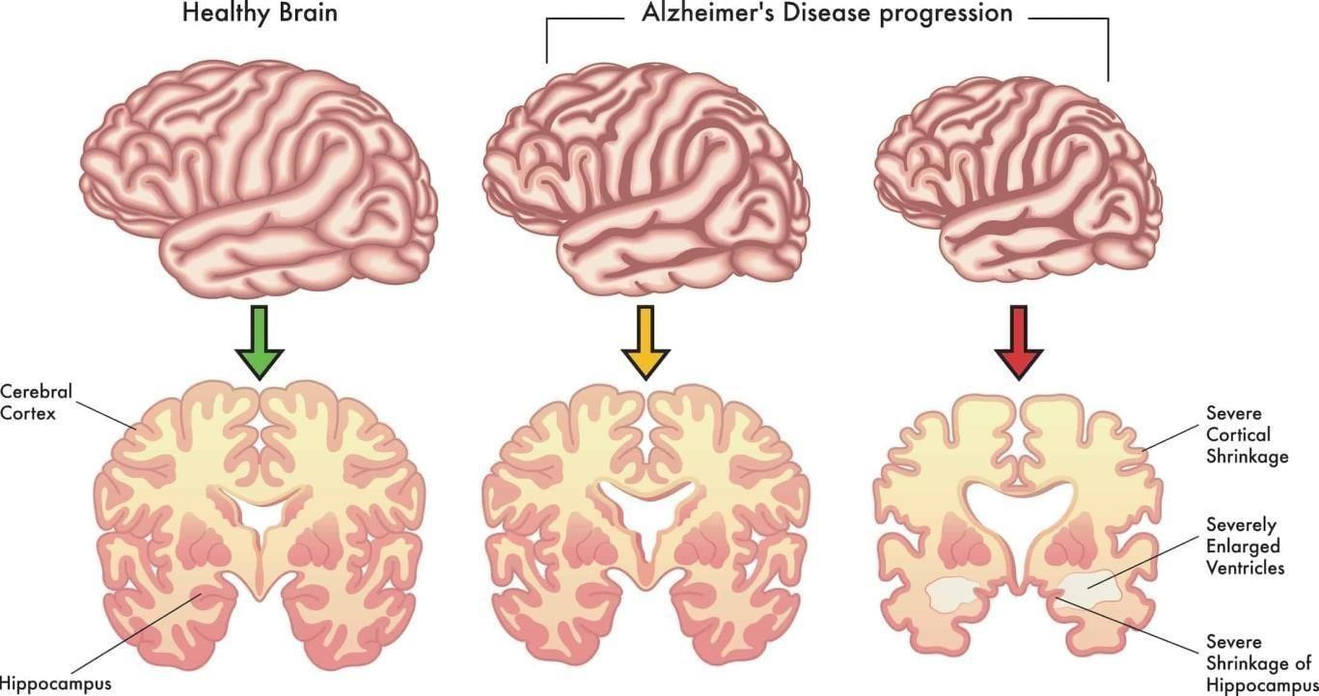

FIG 7**:** Stages of brain disease occur during stages

Magnetic Resonance Imaging (MRI) is a superior structural neuroimaging modality compared to CT when evaluating individuals with dementia, including those suspected of having AD. In AD cases, MRI can reveal specific features compatible with the diagnosis. These include atrophy of the entorhinal cortex, followed by atrophy of the medial temporal cortex or hippocampi (see Image. Normal Versus AD Brain).

While MRI, like CT, may not make or confirm the diagnosis of AD, it can be beneficial in identifying specific patterns indicative of other neurodegenerative disorders with dementia, such as frontotemporal lobar degeneration, or specific radiological signs of multisystem atrophy, Creutz Jacob disease, or progressive supranuclear palsy.

More recently, volumetric MRI has emerged as a valuable tool for precisely measuring changes in brain volume. In AD, volumetric MRI can reveal shrinkage in the medial temporal lobe, particularly the hippocampus. This hippocampal atrophy is considered a characteristic feature of AD and is associated with memory decline.

However, hippocampal atrophy is also linked to normal age-related memory decline, so the use of volumetric MRI for early detection of AD and distinguishing it from normal agingrelated changes is still a subject of debate and research. A definite role for volumetric MRI to aid the diagnosis of AD is not yet fully established.

Functional brain imaging techniques such as Positron Emission Tomography (PET), functional MRI (fMRI), and Single-Photon Emission Computed Tomography (SPECT) are becoming increasingly valuable in mapping patterns of dysfunction in smaller brain areas of the medial temporal and parietal lobes. While these functional brain imaging techniques hold promise for early detection and monitoring of the clinical progression of AD, their role in the definitive diagnosis of AD is not fully established yet.

Electroencephalogram (EEG) is generally not a helpful diagnostic tool for AD and other neurodegenerative disorders. The EEG findings in AD are typically normal. Sometimes, it may reveal a generalized slowing of brainwave activity with no focal features.

Neuropsychological testing is the most reliable method for detecting mild cognitive impairment (MCI) in its early stages clinically.

**PREVENTION :**

[Prevent](https://www.cdc.gov/high-blood-pressure/living-with/index.html) [and](https://www.cdc.gov/high-blood-pressure/living-with/index.html) [manage](https://www.cdc.gov/high-blood-pressure/living-with/index.html) [high](https://www.cdc.gov/high-blood-pressure/living-with/index.html) [blood](https://www.cdc.gov/high-blood-pressure/living-with/index.html) [pressure:](https://www.cdc.gov/high-blood-pressure/living-with/index.html) Tens of millions of American adults have high blood pressure, and many do not have it under control.

[Manage](https://www.cdc.gov/diabetes/treatment/) [blood](https://www.cdc.gov/diabetes/treatment/) [sugar:](https://www.cdc.gov/diabetes/treatment/) to manage your blood sugar if you have diabetes.

[Maintain](https://www.cdc.gov/healthyweight/index.html) [a](https://www.cdc.gov/healthyweight/index.html) [healthy](https://www.cdc.gov/healthyweight/index.html) [weight.](https://www.cdc.gov/healthyweight/index.html) [H](https://www.cdc.gov/healthyweight/index.html)ealthy eating and regular physical activity can help you maintain a healthy weight.

[Be](https://www.cdc.gov/physical-activity-basics/about/) [physically](https://www.cdc.gov/physical-activity-basics/about/) [active.:](https://www.cdc.gov/physical-activity-basics/about/) Physical activity can improve thinking, reduce risk of depression and anxiety, and help you sleep better.

Exercise regularly

Engage in social activities

Have a healthy diet

Get quality sleep

Manage stress effectively

Stop smoking

Maintain a healthy weight-height ratio

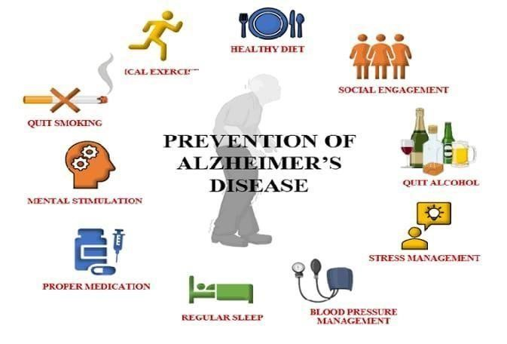

FIG 8 **:** Prevention and management of of alzheimers of disease

**TREATMENT**

**SYMPTOMATIC THERAPIES OFAD**

Traditionally, there has been no cure for ad, and symptomatic treatment remains the primary approach in everyday clinical practice.

Two categories of drugs are approved for treating ad: Cholinesterase inhibitors and partial nmethyl daspartate (nmda) antagonists.

CHOLINESTERASE INHIBITORS

**Donepezil :**

Medication of choice

Used in AD with mild dementia

Rapid and reversible inhibitor of acetylcholinesterase

Once-daily dosing in the evening

##### Brand name - Aricept

**DOSE -** donepezil 5 mg orally once a day, in the evening before going to bed.

RIVASTIGMINE **:**

Rivastigmine is used to treat mild to moderate dementia in Alzheimer’s disease, a progressive illness which gradually affects memory and thinking. It is also used to treat Parkinson’s disease. **Brand Names**: [Exelon](https://www.bing.com/ck/a?!&&p=0faa263d101a3b38JmltdHM9MTcyNjA5OTIwMCZpZ3VpZD0yMTE5YWU2Yi1lNTQ2LTZiNGYtMzU4OC1iYThhZTRkZDZhMjAmaW5zaWQ9NTUzNQ&ptn=3&ver=2&hsh=3&fclid=2119ae6b-e546-6b4f-3588-ba8ae4dd6a20&u=a1aHR0cHM6Ly93d3cuYmluZy5jb20vc2VhcmNoP0ZPUk09aGx0aGRyJnE9RXhlbG9u&ntb=1) [&](https://www.bing.com/ck/a?!&&p=abe771f00079be3fJmltdHM9MTcyNjA5OTIwMCZpZ3VpZD0yMTE5YWU2Yi1lNTQ2LTZiNGYtMzU4OC1iYThhZTRkZDZhMjAmaW5zaWQ9NTUzNw&ptn=3&ver=2&hsh=3&fclid=2119ae6b-e546-6b4f-3588-ba8ae4dd6a20&u=a1aHR0cHM6Ly93d3cuYmluZy5jb20vc2VhcmNoP0ZPUk09aGx0aGRyJnE9RXhlbG9uK1R0cw&ntb=1) [Exelon](https://www.bing.com/ck/a?!&&p=abe771f00079be3fJmltdHM9MTcyNjA5OTIwMCZpZ3VpZD0yMTE5YWU2Yi1lNTQ2LTZiNGYtMzU4OC1iYThhZTRkZDZhMjAmaW5zaWQ9NTUzNw&ptn=3&ver=2&hsh=3&fclid=2119ae6b-e546-6b4f-3588-ba8ae4dd6a20&u=a1aHR0cHM6Ly93d3cuYmluZy5jb20vc2VhcmNoP0ZPUk09aGx0aGRyJnE9RXhlbG9uK1R0cw&ntb=1) [Tts](https://www.bing.com/ck/a?!&&p=abe771f00079be3fJmltdHM9MTcyNjA5OTIwMCZpZ3VpZD0yMTE5YWU2Yi1lNTQ2LTZiNGYtMzU4OC1iYThhZTRkZDZhMjAmaW5zaWQ9NTUzNw&ptn=3&ver=2&hsh=3&fclid=2119ae6b-e546-6b4f-3588-ba8ae4dd6a20&u=a1aHR0cHM6Ly93d3cuYmluZy5jb20vc2VhcmNoP0ZPUk09aGx0aGRyJnE9RXhlbG9uK1R0cw&ntb=1)

##### SYMPTOMS

Such as nausea, vomiting, and diarrhea. Due to an increase in vagal tone, these medications can cause bradycardia, cardiac conduction defects, and syncope. They are contraindicated in patients with severe cardiac conduction abnormalities.

PARTIAL N-METHYL D-ASPARTATE (NMDA) MEMANTINE

Partial n-methyl d-aspartate (nmda) antagonist memantine blocks nmda receptors,

Slowing down intracellular calcium accumulation. The fda approves it for treating

Moderate to severe ad. Dizziness, body aches, headache, and constipation are common

**DOSE**

5 mg every week to a target dosage of 10 mg twice daily

**BRANDNAMES**

Namenda & Axura and Merz

**SIDEEFFECTS**

Memantine can be combined with cholinesterase inhibitors, such as donepezil, rivastigmine, or galantamine, especially in individuals with moderate to severe ad.

#### DISEASE MODIFYING THERAPIES OF ALZHEIMER’S DISEASE

In the past, the treatment of ad has primarily focused on managing the symptoms. By

The time a patient is diagnosed with ad, the pathological process in the brain has been present for over a

Decade. However, with advancements in our understanding of the pathophysiology of

Ad and improvements in diagnostic testing with imaging and biochemical markers, we can now detect preclinical and presymptomatic stages of the disease, even in individuals with mci.

New and specific disease-modifying therapies are being developed, and the fda has recently approved some

For example, aducanemab was approved by the fda in june 2020. The fda recently approved lecanemab. Donanemab is also expected to receive fda approval soon. These

Monoclonal antibodies act by removing amyloid from the brain as immunotherapy.

Remternetug is another one of these promising amyloid-targeting immunotherapy drugs in the pipeline.

Aducanemab received accelerated fda approval in june 2020. It was shown to reduce amyloidbeta plaque in the brain. However, it missed the primary phase iii trial endpoint of clinical improvement.

Lecanemab received accelerated fda approval in january 2023. It reduced the amyloidbeta burden in the brain. The phase iii trial showed a 27% slowing of disease progression.

Donanemab is expected to receive fda approval in 2023. It reduced the amyloid-beta burden in the brain and slowed cognitive decline by 35%.

Amyloid related imaging abnormalities (aria)

Aria is an immune-mediated response to amyloid-targeting therapies in the cerebral vascular

Walls resulting in capillary leakage into perivascular spaces and hemorrhages of cortical and leptomeningeal arteries. There are 2 radiological types of aria: Aria edema (aria-e) and aria hemorrhage (aria-h).

Aria is a known side effect associated with amyloid immunotherapies. Apolipoprotein

E4 allele and cerebral amyloid angiopathy findings in brain mri are the most substantial risk factors for developing aria in patients treated with amyloid immunotherapies.

In the aducanemab phase i/ii trials, aria-e and aria-h were present in 26.1% to 26.7% and

26.1% to 30.5% of the patients, respectively. Notably, the majority of these patients were asymptomatic.

### MANAGEMENT STRATEGIES IN AD

In managing ad, addressing accompanying symptoms such as anxiety, depression, and psychosis is essential, especially in the mid to late stages of the disease. It is advisable to avoid tricyclic antidepressants because of their anticholinergic activity, which

Can worsen cognitive impairment. Antipsychotic medications should be used cautiously for acute

Agitation when other interventions have been exhausted and the patient’s or caregiver’s safety is

At risk. Other medications are generally tried before consideration of antipsychotics. These generally include ssri antidepressants such as citalopram and anticholinesterase such as donepezil.

Second-generation antipsychotics are generally favored over first-generation antipsychotics

Because of their safety and less extrapyramidal side effects. Fda just approved

Brexpiprazole in may 2023 for treating agitation associated with dementia due to ad.[52] however, their limited benefits should be weighed against the small risks of stroke and increased mortality.

The general principle in using antipsychotics is to use the lowest dose that may help the patient’s agitation. Benzodiazepines should not be used because they may worsen delirium and agitation in these patients.

Simple strategies such as creating a familiar and safe environment, monitoring and addressing

Personal comfort needs, providing security objects, redirecting attention, removing potentially hazardous items like doorknobs, and avoiding confrontational situations can be highly beneficial in managing behavioral issues.

Addressing mild sleep disturbances is essential to minimize caregiver burden and improve the

Quality of life for individuals with ad. Several non-pharmacological strategies can be

Incorporated, such as exposure to sunlight, providing daytime exercise, and establishing a bedtime routine. These interventions can help regulate the sleep-wake cycle and promote better sleep patterns.

The expected benefits of these treatments are modest. Treatment should be stopped or modified if no significant benefits are seen or the patient experiences intolerable side effects.

Regular aerobic exercise has been shown to slow the progression of ad

### COMPLICATIONS

According to cdc’s national center for health statistics 2023, ad is the 6th leading cause of death, with nearly 120,000 deaths annually.Ad predominantly affects individuals over 65,

Putting them at higher risk of experiencing complications that can significantly impact their

Health and well-being. Complications associated with ad can be broadly categorized into mental/behavioral and physical challenges.

#### Mental/behavioral

Depression is a prevalent comorbidity among patients with ad, adding to the Complexity of

Managing their condition. Common symptoms of depression in patients with ad include mood changes, sleep disturbances, social withdrawal, and difficulty concentrating.

Agitation and delirium, including sundowning, are common occurrences in the more advanced stages of ad, posing challenges for patients and caregivers. Managing these symptoms is essential for ensuring the safety and comfort of individuals with ad. However, the use of antipsychotic medications to treat these issues has been associated with increased mortality and other adverse effects.

#### Physical

Fever and infections, particularly respiratory and urinary infections, are prevalent among

Elderly individuals with ad. Swallowing difficulties can lead to aspiration pneumonia, further complicating their health condition.

Dehydration and malnutrition

Falls

Bladder and bowel problems

Dementia, and specifically Alzheimer's disease, may be among the most costly diseases for societies worldwide. As populations age, these costs will probably increase and become an important social problem and economic burden Costs associated with AD include direct and indirect medical costs, which vary between countries depending on social care for a person with AD Direct costs include doctor visits, hospital care, medical treatments, nursing home care, specialized equipment, and household expenses. Indirect costs include the cost of informal care and the loss in productivity of informal caregivers.

Costs for those with more severe dementia or behavioral disturbances are higher and are related to the additional caregiving time to provide physical care.

### CONCLUSION

For the once two decades, the general supposition that the molecular medium underpinning the genetically determined form of announcement is identical to the one determining the late- onset variant of the complaint has redounded in an nearly exclusive focus of our experimental and translational exploration on Aβ species and its goods on neuronal integrity and functions. still, despite further than 66,000 publications, multitudinous clinical examinations, and innovative medicine developments, we remain unfit to indeed decelerate complaint progression. Reevaluation of our knowledge of the lateonset form of announcement, which accounts for the maturity of cases, is thus of loftiest precedence. In this composition, we've integrated multitudinous experimental findings with a focus beyond Aβ to propose a sequence of pathological events that might lead to development of late- onset announcement in humans. We suggest naming this intertwined view of how the neuropathology evolves over decades ‘ the inflammation thesis of announcement’, as inflammation convinced by infection, complaint, or agerelated changes could be the main cellular stressor after 80 or further times of life. In addition, traumatic head injury, microstrokes and other vascular dysfunctions associated with increased threat of announcement presumably spark the pathological waterfall described then via secondary neuroinflammatory responses. In summary, in late- onset announcement — in discrepancy to the domestic form of the complaint — habitual seditious conditions may represent a major detector of pathology by converting phosphotau- related cytoskeletal abnormalities and attendant impairments of axonal transport. These changes could lead to age-dependent conformation of axonal bumps, focal accumulation of mitochondria, and transport and declination of organelles. Membrane leakage at the spots of axonal bumps could serve as a seed for the conformation of senile pillars, thereby driving an ingrain vulnerable response of the brain. Axonal transport impairments would also affect the stability of distal synapses and grease the conformation of NFTs. Together with patient neuroinflammatory responses, these changes are anticipated to lead to prominent neurodegeneration and the spread of pathology. We argue, thus, that redundant cellular Aβ pillars appear from intracellular APP accumulations and are secondary to degeneration of neurons. Accordingly, remedial strategies to remove pillars using specific antibodies, or to help shrine conformation through inhibition of β- secretase or γsecretase, would have little if any — effect on complaint inauguration and presumably also progression. Eventually, we propose that the primary pathological event in announcement is inflammationinduced and stress- convinced mis- localization and hyperphosphorylation of tau, with posterior impairment of axonal transport. We're apprehensive that the experimental results and compliances reviewed then represent only a bit of all the published data on lateonset announcement, and that farther examinations are demanded to completely delineate the molecular mechanisms that initiate and drive the pathology in lateonset announcement. Hence, we truly hope that scientists and clinicians will add their data to confirm, upgrade, acclimate, and extend our proposed sequence of events. nonetheless, we explosively believe that the proposed model with its solid experimental backup provides a first step for the inauguration and support of new exploration directions in the announcement field beyond Aβ.

#### REFERENCES

1.Ahmad FB, Cisewski JA, Xu J, Anderson RN. Provisional Mortality Data – United States, 2022. MMWR Morb Mortal Wkly Rep. 2023 May 05;72(18):488-492. [PMC free article] [PubMed]

2.

Mendez MF. Early-Onset Alzheimer Disease. Neural Cline. 2017 May;35(2):263-281. [PMC free article] [PubMed] 3.

Zetterberg H, Bendlin BB. Biomarkers for Alzheimer’s disease-preparing for a new era of diseasemodifying therapies. Mol Psychiatry. 2021 Jan;26(1):296-308. [PMC free article] [PubMed]

4.

Porsteinsson AP, Isaacson RS, Knox S, Sabbagh MN, Rubino I. Diagnosis of Early

Alzheimer’s Disease: Clinical Practice in 2021. J Prev Alzheimers Dis. 2021;8(3):371-386. [PubMed]

5.

Therriault J, Zimmer ER, Benedet AL, Pascoal TA, Gauthier S, Rosa-Neto P. Staging of Alzheimer’s disease: past, present, and future perspectives. Trends Mol Med. 2022 Sep;28(9):726-741. [PubMed] 6.

Tang Y, Lutz MW, Xing Y. A systems-based model of Alzheimer’s disease. Alzheimers Dement. 2019 Jan;15(1):168-171. [PubMed]

7.

Zilberzwige-Tal S, Gazit E. Go with the Flow-Microfluidics Approaches for Amyloid Research. Chem Asian J. 2018 Nov 16;13(22):3437-3447. [PubMed]

8.

Maccioni RB, González A, Andrade V, Cortés N, Tapia JP, Guzmán-Martínez L. Alzheimer´s Disease in the Perspective of Neuroimmunology. Open Neurol J. 2018;12:50-

56. [PMC free article] [PubMed]

9.

Santos CY, Snyder PJ, Wu WC, Zhang M, Echeverria A, Alber J. Pathophysiologic relationship between Alzheimer’s disease, cerebrovascular disease, and cardiovascular risk: