**SMART AGRICULTURE WITH HELP OF IoT AND ARTIFICIAL INTELLIGENCE**

**Archita Mishra1 , Sanskar Singh2, and Shweta Sinha3**

1Student National Post Graduate College

2, Rana Pratap Marg, Hazratganj, Lucknow, Uttar Pradesh 226001

2Student National Post Graduate College

2, Rana Pratap Marg, Hazratganj, Lucknow, Uttar Pradesh 226001

3Assistant Professor, National Post Graduate College

2, Rana Pratap Marg, Hazratganj, Lucknow, Uttar Pradesh 226001

Emails: mishraarchita13@gmail.com *1 , sanskarsingh9140@gmail.com *2, sinha.shweta020776@gmail.com *3.

**ABSTRACT**

When it comes to economies either it global level or national level, agriculture plays a fundamental role in both sector by engaging approximately 40% of the world population and in India, around 50% to 60% population is involved in agriculture which means 600 to 700 million people from 1.4 billion populations are indulge in the agriculture.

The traditional farming methods still struggle to fulfil modern demands. Due to the integration of Internet of Things(IoT) technology into agriculture presents a transformative approach to modernize and enhance farming practices and also address the challenges faced by farmers, particularly in countries like India.

The proposed systems leverage sensor networks to monitor critical environmental parameters such as soil moisture, temperature, rainfall and light intensity, which are essential for optimizing crop management and irrigation. Data which collected from these sensors is transmitted to the cloud for real time analysis and visualization using platforms like ThingSpeak and MATLAB, this enable farmers to make decisions based on predictive analytics.

Many systems provide smart irrigation management remote monitoring via mobile and web applications.

The result of using IoT is to improve crop productivity and sustainability by automating process, reducing resource wastage and offering real-time data for better decision making.

**Keywords** : Artificial Intelligence, IoT, Agriculture,Farming,Soil Monitoring

**INTRODUCTION**

Agriculture is an important pillar of human civilization which is now degrading due to rapid global population growth, shifting climate patterns, and the pressing need for enhanced productivity.

The demand for food is increasing which underscores the necessity for innovative advancements in agriculture practices to ensure sustainable and efficient crop management.

The arrival of IoT technology offers a transformative opportunity due to which revolutionize agricultural practices.

Our proposed model includes sensors like for monitoring temperature, humidity and atmospheric pressure the BME280 is used; for measuring soil moisture the Adafruit STEMMA is used and for addressing light intensity TEMT 6000 is used. These sensors are interfaced with an Arduino Uno microcontroller, which facilitates seamless data collection and transmission. [1] This data then transmitted to the ThingSpeak IoT platform via Wi-Fi. Then by using MATLAB’s robust analytics tools where all this is visualized and analyzed. [3][2]

This model contains real-time data visualization as well as incorporates predictive analytics to forecast environmental conditions and automate irrigation processes. [5]

When we integrate Arduino with the relay module, the system can intelligently activate or deactivate a water pump based on soil moisture levels, this optimize the usage of water and enhancing crop management efficiency. The system’s capability to monitor critical environmental parameters and perform predictive analysis represents a significant advancement over traditional methods.

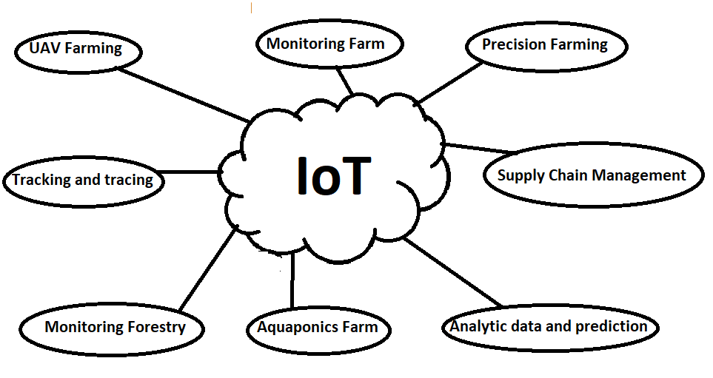

Figure1. IoT enabled smart agriculture

**Related Works**

The proposed smart agriculture model utilizes IoT technology to monitor key soil and environmental parameters such as temperature, humidity, and moisture, alongside crop yield through SMS-based alerts. By integrating a pH meter for soil acidity assessments and leveraging an IoT sensor network, the system securely transmits data to the cloud via ThingSpeak, utilizing MQTT and secure HTTP protocols to ensure high data security and real-time access from various devices. The system facilitates remote control of field operations and automates responses to environmental conditions, such as activating the water sprinklers when necessary. This integration not only enhances flexibility and efficiency but also reduces labor costs, water wastage, and human interaction, ultimately helping farmers to monitor and improve crop yield and overall production. [1][2][3][4].

**Literature Survey**

**1.Smart Agriculture Monitoring System Using IoT**

D. Betteena Sheryl Fernando's project, "Smart Agriculture Monitoring System Using IoT," presents an innovative approach to enhance crop yield through real-time monitoring and remote operations. This system measures environmental parameters like temperature, moisture, and humidity, critical factors for crop health and productivity. The system employs IoT technology to track these parameters and sends alerts via SMS, allowing farmers to monitor their fields remotely. Additionally, it supports remote operations, which can be managed through a mobile app or web application, making it more accessible and user-friendly. By giving farmers real-time data and control over field conditions, this model helps optimize crop yields by enabling timely responses to environmental changes, ultimately promoting more sustainable and productive farming practices.[4]

2. **Design and Development of Precision Agriculture System Using Wireless Sensor Network**

S. R. Nandurkar, V. R. Thool and R. C. Thool, “Design and Development of Precision Agriculture System Using Wireless Sensor Network” did a research about the use of a wireless sensor network to gather data about the soil moisture and temperature that will help to take decision regarding irrigation of the field. The model uses LM-35DZ sensor for temperature measurement, a designed resistive sensor to sense moisture level in the soil and a microcontroller that takes analog sensor value and convert them to digital value. The values received determines whether the microcontroller should turn on the water supply through a relay module to maintain the moisture level.[9]

**3. A Novel Approach to IoT Based Plant Health Monitoring System**

Srinidhi Siddagangaiah has done a similar research to monitor plant health using IoT technology . The model uses various sensors such as DHT11 sensor to measure temperature and humidity, YL-38+YL-69 to measure soil moisture and TEMT6000 to measure light intensity that the plant is receiving. It uses Arduino board as the microcontroller and relies on Ubidots which is an IoT platform which builds chart for the representation of the data collected through the sensors. The data can be accessed remotely and the user can know if there are any changes in the different parameters for which the sensors are placed.[1]

**4. A Model for Smart agriculture using IOT**

Prof K.A.Patil,N.R.Kale proposes about a model for Smart Agriculture using IOT.The proposed system addresses the issues of shifts in weather patterns, soil conditions, and outbreaks of pest and diseases by sensing local agricultural parameters, pinpointing sensor locations, and transferring ddata related to crop fields and monitoring. The farmers will get updated information so that they can adapt to changes more effectively. By access to real-time and historic environmental data, it will be easy to enhance resource management.[8]

**Existing Models**

Table 1.

|  |  |
| --- | --- |
| Description | Devices/Components Used |
| **Field Monitoring with Sensors and Manual/Automatic Mode Control**: Sensors like temperature, humidity, and moisture are deployed in the field. The microcontroller checks values against thresholds. Alerts are sent via a message to the farmer, and values are displayed on a web page. Manual mode allows users to control the system via an Android app, while automatic mode turns the system on/off based on thresholds. | -TemperatureSensor -HumiditySensor -MoistureSensor -Microcontroller -Wi-FiModule -WaterLevelSensor -Bell/Alarm - Android App |
| **IoT Sensor Network for Monitoring and Predictive Analysis**: Environmental parameters like temperature, moisture, rainfall, and light are monitored. Data is sent to the cloud via IoT protocols (MQTT) for real-time visualization and predictive analysis using machine learning (MATLAB). The system is secure, supports remote monitoring, and uses bandwidth-compatible protocols. | -TemperatureSensor -MoistureSensor -RainfallSensor -LightSensor -IoTHub(Thingspeak) -MQTTProtocol -Wi-FiModule - Mobile/PC/Tablet (for monitoring) |
| **IoT-Based Monitoring with Real-Time Control**: Focuses on real-time monitoring of environmental parameters in an agriculture field. Utilizes lightweight communication protocols like MQTT. Commands are sent to control field operations via the MQTT protocol, and the data is visualized on platforms like Thingspeak. The system is compatible with 4G, ensuring high-speed, low-latency operation. | -TemperatureSensor -MoistureSensor -RainfallSensor -LightSensor -IoTGateway(Thingspeak) -MQTTProtocol -Wi-FiModule -Relay for irrigation control - Mobile/Tablet/PC |
| **Real-Time Agricultural Monitoring with pH Sensing**: Monitors soil properties (temperature, humidity, moisture, pH) and sends SMS alerts to farmers. Remote control of field operations is possible via mobile/web apps. The system is IoT-based and reduces labor costs, automating operations based on sensor data. A 3-in-1 soil meter provides insights for optimal crop conditions. | -TemperatureSensor -HumiditySensor -MoistureSensor -pHSensor(ATMEGA8AMicrocontroller) -3-in-1SoilMeter -4-in-1pHSoilMeter -IoTNetwork -Mobile/WebApplication - SMS Module (for Alerts) |

**PROPOSED MODEL**

In the agricultural field various sensors will be placed to collect data regarding various parameters that help in monitoring the soil and plant health. The sensors will be connected to a microcontroller that will send the data to an IoT platform where the data can be visualized and we can apply predictive algorithms to the data.Also there will be a relay module to turn on and off a water pump to irrigate the field whenever the moisture level of the soil are down below a threshold value.The proposed model consists of various sensors, hardware and software modules which are shown in the figure 2.

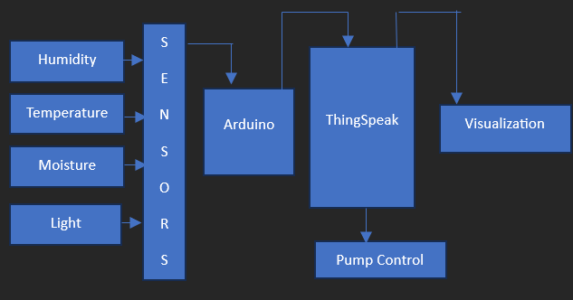

Figure 2

**Hardware Used:**

**BME280**

The BME280 is a highly versatile sensor used to measure humidity, temperature, and atmospheric pressure, making it ideal for monitoring environmental conditions in agricultural, horticultural, and greenhouse settings. Using this sensor, we can precisely measure the humidity, temperature, and atmospheric pressure in the environment where plants are grown, enabling optimized growth conditions. The BME280 uses a digital I2C or SPI output, allowing easy communication with microcontrollers such as Arduino or Raspberry Pi, making it adaptable for various IoT applications. This sensor has a temperature range of -40°C to 85°C, a humidity range of 0% to 100% RH, and an atmospheric pressure range of 300 to 1100 hPa, covering a wide array of environmental conditions. With a rapid response time of less than one second, it is suitable for real-time monitoring applications. The sensor’s low power consumption, typically less than 1 mA, makes it highly energy-efficient and suitable for battery-powered devices, adding convenience for remote or portable projects. Additionally, the BME280 offers high accuracy, with a temperature accuracy of ±1°C, humidity accuracy of ±3% RH, and pressure accuracy of ±1 hPa, ensuring reliable data for environmental assessment and control. Its compact design further allows for easy integration into compact systems, adding to its flexibility across various domains such as weather stations, smart farming, and automated environmental monitoring systems.[12]

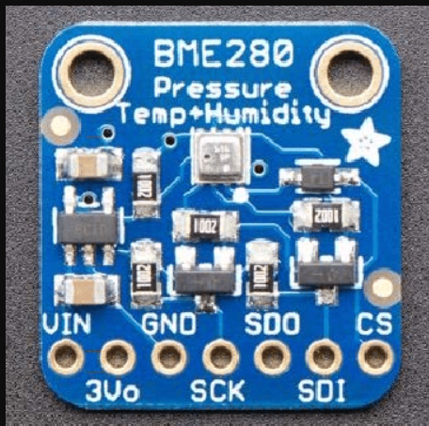

Figure 3. BME280 sensor [10]

**Adafruit STEMMA**

The Adafruit STEMMA Soil Sensor is a capacitive sensor designed to measure soil moisture by detecting changes in capacitance, which varies with the moisture content in the soil. This non-contact measurement approach allows it to effectively gauge soil humidity levels without exposing metal parts to soil, thereby reducing corrosion and extending its lifespan. Using this sensor, we can determine whether irrigation is needed based on the real-time moisture levels in the soil, making it an ideal solution for automated watering systems and precision agriculture. The capacitive nature of the Adafruit STEMMA Soil Sensor enhances its accuracy by minimizing the impact of soil conductivity and salinity on readings, which can affect other types of moisture sensors. With a response time of just a few seconds, it provides timely data for moisture-based irrigation decisions. The sensor supports both I2C and analog outputs, allowing seamless integration with a range of microcontrollers, including Arduino and Raspberry Pi, which enhances its versatility for different project requirements. Its low power consumption further makes it suitable for long-term use in outdoor environments or battery-powered applications, such as remote plant monitoring systems. Additionally, the compact and lightweight design enables easy deployment in various soil-based projects, from small home gardens to large-scale agricultural systems.

**TEMT6000**

The TEMT6000 is a highly sensitive light sensor, also known as a phototransistor, designed to measure ambient light levels in various environments. Using this sensor, we can accurately determine the amount of light that a plant is receiving, which is crucial for assessing the plant's growth conditions and optimizing its care. The TEMT6000 operates by altering its electrical resistance in response to changes in light intensity, allowing it to provide a direct correlation between the amount of light detected and the electrical output signal. With an illumination range of 1 to 1000 Lux, it can measure light levels across a wide spectrum, from low-light environments to well-lit areas, making it suitable for both indoor and outdoor plant monitoring applications. The sensor requires a supply voltage between 3.3V and 5V, which makes it compatible with a variety of microcontrollers, including Arduino, Raspberry Pi, and other development platforms. Due to its analog output, it provides continuous data that can be processed for tasks such as determining the optimal light exposure for plants, automating lighting systems, or controlling greenhouse environments. Additionally, the compact design and low power consumption of the TEMT6000 make it an ideal choice for energy-efficient and portable systems that require precise light monitoring.

**Arduino Uno**

Arduino Uno is an open-source microcontroller which was released in 2010. It provided an inexpensive and easy way to create devices that can communicate with their surroundings using various sensors and actuators. It is among the most popular and commonly used microcontrollers. The Arduino Uno is equipped with various digital and analog input and output pins that can be interfaced to various other circuits. Arduino board is used to read input and turn it into an output. We can program the Arduino using the Arduino programming language. Arduino Uno uses Wi-Fi shields using which we can send and receive data. [6]

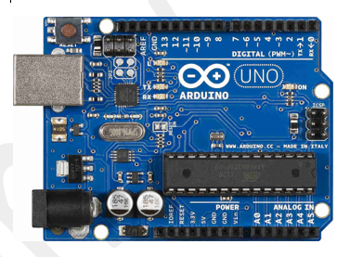

Figure 4 . Arduino Uno [11]

**Software Used:**

**ThingSpeak**

ThingSpeak is an IoT platform that enables its users to collect, visualize, and analyze real-time data and perform actions accordingly. ThingSpeak is an open-source application where data can be collected through REST API or MQTT (Message Queuing Telemetry transport) and analyzed using MATLAB (Matrix Laboratory) analytics. With the help of MATLAB we can apply mathematical functions, statistical methods and machine learning algorithms to analyze data collected from various sensors within the platform. Using MATLAB, we can run complex data analysis and predictive algorithms directly within the platform. We can perform various actions using the apps that are provided by the platform such as integration with web services, social networks etc. [7]

**WORKING**

The system consists of sensors like BME280, TEMT600 and Adafruit STEMMA connected with Arduino Uno. Arduino Uno is connected to ThingSpeak which is an IoT platform using Wi-Fi which will allow user to create an account and analyze the data.

The BME280 will monitor temperature, humidity and atmospheric pressure, TEMT6000 will measure light and Adafruit STEMMA will measure soil humidity. All the data gathered by these sensors will be sent to Arduino dev board from where it will be sent to ThingSpeak using Wi-Fi. Using ThingSpeak’s MATLAB analysis feature we will implement predictive analysis using linear regression. To automate the water pump, we will integrate a relay module with the Arduino which will check the soil moisture periodically. If the moisture level falls below the threshold value, the relay will be activated to turn on the water pump and deactivate after the moisture level reaches to a normal level.

**Comparison Between Proposed Model and Existing Model**

|  |  |  |  |  |  |
| --- | --- | --- | --- | --- | --- |
| **Aspect** | **Proposed Model** | **Model 1 [4]**  **(Smart Agriculture Monitoring System Using IoT)**  **[2020]** | **Model 2 [9]**  **(Design and Development of Precision Agriculture System Using Wireless Sensor Network)**  **[2014]** | **Model 3[1]**  **(A Novel Approach to IoT Based Plant Health Monitoring System)**  **[2016]** | **Model 4 [2]**  **(A Model for Smart agriculture using IOT)**  **[2019]** |
| **Sensors/Devices** | -**BME280** (Temperature, Humidity, Pressure) - **Adafruit STEMMA** (Soil Moisture) - **TEMT6000** (Light) | Temperature Sensor - Humidity Sensor - Water Level Sensor | Temperature Sensor - Humidity Sensor - Moisture Sensor | Temperature Sensor - Moisture Sensor - Rainfall Sensor - Light Sensor | **pH Sensor** (for acidity/alkalinity) - **ATmega 8A** Microcontroller |
| **Communication** | - **Wi-Fi** communication to send data to **ThingSpeak IoT** platform for analysis | - **Wi-Fi Module** used for web-based monitoring and **SMS-based alerts** | - **MQTT** and **HTTP** for secure communication with the cloud platform | **MQTT protocol** to connect to an IoT gateway for remote monitoring and control | **SMS-based communication** |
| **Data Analysis** | - **MATLAB-based predictive analysis** using data from sensors - Predictive irrigation based on moisture data | - Basic data monitoring and **alerts** sent to the farmer - Manual mode for user intervention | - **MATLAB-based predictive analysis** in the cloud - Predictive algorithms help guide irrigation decisions | Real-time data monitoring with visualization on Thingspeak - Simple predictive analysis for irrigation | **Soil pH analysis** for nutrient control - Limited data analytics |
| **Automation** | Automated irrigation system integrated with a relay and water pump based on soil moisture readings | Partial automation: farmers receive alerts but must manually adjust water flow or other actions | - Automated control for irrigation and real-time decision-making based on data | - Real-time irrigation control through remote commands via MQTT | No automatic irrigation control - Only alerts are generated for soil pH |
| **Power Source** | Low power consumption due to efficient sensors like BME280 and Adafruit STEMMA | No specific mention of power efficiency | No specific mention of power efficiency | - No specific mention of power efficiency | Low power consumption due to **ATmega 8A** microcontroller |
| **Type of Sensors** | - **Advanced sensors** for multiple environmental parameters (e.g., temperature, humidity, soil moisture, light intensity) | - Basic sensors primarily focusing on temperature, humidity, and water level. | **Moisture and temperature sensors** with a focus on cloud data collection and analysis. | Covers additional parameters like **rainfall** and **light**, suitable for outdoor environmental monitoring. | **pH sensor** focuses on soil acidity/alkalinity, does not monitor humidity or light |
| **Target Application** | Comprehensive **real-time agricultural monitoring** for multiple environmental parameters | Designed for farmers who need **basic alerts** on crop conditions and **manual intervention** | Targets farms with **secure IoT-based communication** for **real-time data** and **cloud-based predictive analysis** | For farmers needing **real-time irrigation control** through **remote monitoring** via MQTT | Targets farms focusing on **soil quality monitoring** and **pH balancing** |
| **Cost/Complexity** | **Moderate to high complexity** due to multiple Comprehensive **real-time agricultural monitoring** for multiple environmental parameters sensors and integration with MATLAB for predictive analysis | **Low complexity**: simple sensors and Wi-Fi/SMS-based communication, mostly manual control | **Moderate complexity**: advanced IoT protocols like MQTT, MATLAB-based predictive analysis | **Moderate complexity**: includes real-time control and **multiple sensors**, no predictive analysis | **Low complexity**: simple **pH sensor** and SMS-based alerts, not reliant on cloud or advanced automation |
| **Real-time Monitoring** | - **Yes**, using ThingSpeak for data visualization and MATLAB for predictive analysis | **Partial real-time monitoring**: alerts and basic data sent through the webpage and SMS | **Yes**, data sent securely in real-time to cloud for monitoring and analysis | **Yes**, real-time data monitoring and remote control of irrigation | No real-time monitoring, alerts sent based on pH readings |
| **Control Systems** | **Automated control** over the irrigation system based on soil moisture levels, reducing manual labour. | **Partial control**: only sends alerts, no automatic control over irrigation or field conditions | **Automated control** using predictive data analysis to manage irrigation | **Remote control** over irrigation via MQTT | No control system; only sends alerts to users |
| **Customization** | Can be **customized for any agricultural field** with varying soil types and environmental conditions | Suitable for farms needing basic alerts and real-time data visualization | Best suited for farms requiring **cloud-based analysis** and **remote monitoring**, adaptable to different crops | - Suitable for **outdoor monitoring** where factors like rainfall and light are critical | Can be customized for **soil pH analysis** in different types of soil, but limited to soil quality monitoring |
| **Flexibility** | - **Highly flexible**: supports indoor/outdoor farming and adaptable to different environments | Flexible but mostly for **basic outdoor monitoring** | Suitable for **outdoor farms** with more complex IoT systems | Suitable for **outdoor farms** with more complex IoT systems | Suitable for **soil quality monitoring** in various environments |

**CONCLUSION AND FUTURE WORK**

Agriculture is an important sector for any country. With the growing population the food demands will rise, and due to global warming, it is becoming difficult to predict the weather conditions. Improvement of crop productivity is a major challenge in the world. Integration of technology can improve crop productivity, with the proposed model user can monitor various parameters which play a major role in the growth of crop. Not only it will show the current state but also offers predictive analysis of the future state of the environment, so that user can make appropriate decision. By using the sensors with a higher accuracy and range we can get a more accurate result. The proposed model can further be improved by incorporating more efficient predictive algorithms.

**REFERENCES**

[1] Srinidhi Siddagangaiah.A Novel Approach to IoT Based Plant Health Monitoring System. IRJET, 2016.

[2] A. Anusha, A. Guptha, G. Sivanageswar Rao, Ravi Kumar Tenali. A Model for Smart Agriculture Using IOT, 2019.

[3] Shruti A Jaishetty1, Rekha Patil2 IOT SENSOR NETWORK BASED APPROACH FOR AGRICULTURAL FIELD MONITORING AND CONTROL, 2016.

[4] Assistant Professor D. Betteena Sheryl Fernando, UG Students M. Sabarishwaran, R. Ramya Priya, S. Santhoshini Smart Agriculture Monitoring System Using IoT, 2020.

[5] Jiber, Y.; Harroud, H.; Karmouch, A, "Precision agriculture monitoring framework based on WSN," Wireless Communications and Mobile Computing Conference (IWCMC), 2011 7th International, vol., no.pp.2015, 2020, 4-8 July 2011.

[6]. Leo Louis. Working Principles of Arduino and using it as a tool for study and research. International Journal of Control, Automation, Communication and Systems (IJCACS), Vol.1, No.2, April 2016.

[7] Vítor Viegas, J. M. Dias Pereira, Pedro Girão , Octavian Postolache. Study of latencies in ThingSpeak. Advances in Science, Technology and Engineering Systems Journal Vol. 6, No. 1, 342-348 (2021).

[8] K. A. Patil and N. R. Kale, "A model for smart agriculture using IoT," 2016 International Conference on Global Trends in Signal Processing, Information Computing and Communication (ICGTSPICC), Jalgaon, India, 2016, pp. 543-545, doi: 10.1109/ICGTSPICC.2016.7955360.

[9] S. R. Nandurkar, V. R. Thool and R. C. Thool, "Design and development of precision agriculture system using wireless sensor network," 2014 First International Conference on Automation, Control, Energy and Systems (ACES), Adisaptagram, India, 2014, pp. 1-6, doi: 10.1109/ACES.2014.6808017.

[10] A Low-Cost Microcontroller Based Air Temperature, Humidity and Pressure Datalogger System Design for Agriculture - Scientific Figure on ResearchGate. Available from: https://www.researchgate.net/figure/The-BME-280-sensor-module_fig4_340314082 [accessed 11 Nov 2024]

[11] Malav, Vaibhav. (2019). Research Paper On Home Automation Using Arduino.

[12] Djordjevic, Milos & Dankovic, Danijel. (2019). A smart weather station based on sensor technology. Facta universitatis - series: Electronics and Energetics. 32. 195-210. 10.2298/FUEE1902195D