**ADVANCED SYSTEM FOR AUTOMATED PDF PARSING AND CONTENT EXTRACTION**

**MainkaRajput1, Prof. Sarang Mandloi2**

1Student, Computer Science and Engineering, SIMS, Indore, Madhya Pradesh, India

2 Professor, Computer Science and Engineering, SIMS, Indore, Madhya Pradesh, India

**ABSTRACT**

Extracting structured information, particularly tables and graphs, from Portable Document Format (PDF) documents remains a challenging task due to layout variations and the complexity of these elements. Traditional methods often lack flexibility or accuracy. This paper proposes a novel PDF parser that leverages the power of Machine Learning for efficient and accurate information extraction. The proposed approach utilizes YOLOv8, a state-of-the-art object detection model, to identify tables and graphs within PDFs. YOLOv8 is fine-tuned using a high-quality dataset to enhance its ability to detect these specific elements. Once identified, the coordinates of the tables and graphs are utilized by Camelot-py, a Python library specifically designed for table data extraction from PDFs. Camelot-py extracts the data from the identified tables and converts it into a structured format, such as a Data Frame. This work evaluates the performance of the proposed parser on a benchmark dataset and demonstrates its effectiveness in achieving accurate and efficient information extraction from various PDF documents.

**Keywords:** PDF parsing, content extraction, machine learning, YOLOv8, Camelot-py, Flask, transfer learning, table extraction, graph detection.

1. **INTRODUCTION**

The ability to automatically extract and process information from PDF documents is crucial in today's data-driven world. Traditional methods of PDF parsing often struggle with accuracy and efficiency, particularly when dealing with complex layouts that include tables and graphical content. This study addresses these challenges by developing an integrated system that leverages advanced OCR techniques and machine learning models. The system aims to provide precise extraction of diverse content types, thereby enhancing data accessibility and usability. Previous work in this field has primarily focused on text extraction, with limited success in handling complex elements like tables and graphs. Our system seeks to bridge this gap by offering a comprehensive solution that caters to various document structures.

1. **RELATED WORK**

Numerous approaches have been developed for PDF content extraction, ranging from heuristic-based methods to advanced machine learning techniques. Traditional tools like PyMuPDF and PdfMiner provide basic text extraction capabilities but often struggle with complex layouts and fail to accurately identify and extract tables and graphs. Recent advancements in deep learning have introduced powerful models like YOLO (You Only Look Once), which have significantly improved object detection tasks. The YOLO family, starting from YOLOv1 to the latest YOLOv8, has shown remarkable progress in terms of speed and accuracy. YOLOv8 offers real-time object detection capabilities, making it suitable for extracting structured data from PDFs.

Camelot-py is another tool widely used for extracting tables from PDFs. It employs a heuristic-based approach to detect and parse tables, but its accuracy can be limited by the quality of the table detection process. Integrating Camelot-py with a robust object detection model like YOLOv8 can significantly enhance the overall performance of the system.

In this study, we utilize pre-annotated datasets from Roboflow to train the YOLOv8 model for detecting tables and graphs in PDF documents. The model is then integrated with text extraction scripts and Camelot-py within a Flask framework, providing a comprehensive and efficient solution for PDF content extraction.

1. **METHODOLOGY**

The methodology for developing the advanced PDF parser involves several key steps: data collection and preparation, text extraction, graph detection and cropping, table detection and data extraction, and the integration of these components into a cohesive system. The approach leverages machine learning models, particularly YOLOv8, and integrates various tools and frameworks to achieve accurate and efficient content extraction from PDF documents.

* 1. **Data Collection and Preparation**
* **Data Sources:** We utilized pre-annotated datasets from Roboflow for training the YOLOv8 model. These datasets included a variety of PDF documents with annotated tables and graphs, providing a robust foundation for training the model to accurately detect these elements.
* **Annotation Process:** The annotation process involved using Roboflow’s platform to label tables and graphs within the PDF pages. This annotated data was then used to fine-tune the YOLOv8 model, enhancing its ability to accurately identify and extract these elements from PDF documents.
  1. **YOLOv8 Model Development**

The development of the YOLOv8 model involves several stages, including data collection, model training, and optimization.

* **Data Collection and Labeling Strategies** 
  + **Dataset Source:** The dataset used for training the YOLOv8 model is sourced from Roboflow, specifically the "9k_DB Image" dataset. This data set includes a wide variety of images of tables and graphs.
  + **Data Labeling:** The images in the dataset are labeled with bounding boxes indicating the presence of tables and graphs. Accurate labeling is essential to train the model effectively.

**Fig. 1. Dataset Description: Label Instances with dimensions ratio, coordinate plotting and annotation shapes**

* **Model Training, Hyperparameter Tuning, and Optimization**
  + **Training Setup:** The YOLOv8 model is trained on Kaggle to leverage the computational power required for deep learning tasks.
  + **Hyperparameter Tuning:** Various hyperparameters, such as batch size, and the number of epochs, are tuned to optimize the model’s performance. The goal is to achieve a balance between accuracy and computational efficiency.
  1. **Text Extraction**
  + **Core Python Script:** We developed a Python script using PdfMiner to extract text from PDF documents. The script processes each page of the PDF, identifies text containers, and extracts text while preserving the layout. The extracted text is then structured in a format suitable for further processing and analysis.
  1. **Graph Detection and Extraction**
* **Converting PDF Pages to Images:** The first step in graph detection involves converting PDF pages to images. This was achieved using IronPDF, which ensures high-quality image generation suitable for subsequent processing by the YOLOv8 model.
* **Machine Learning Model for Graph Detection:** The YOLOv8 model, fine-tuned with our annotated dataset, was used to detect graphs within the converted images. The model processes each image, identifies graph regions, and provides bounding box coordinates for cropping.
* **Image Cropping and Post-processing:** After detecting graph regions, the images are cropped based on the bounding box coordinates. These cropped images are then post-processed to ensure clarity and accuracy, making them ready for further analysis or direct use.
  1. **Table Detection and Extraction**
  + **Table Detection using ML Model:** Similar to graph detection, the YOLOv8 model was trained to detect tables within the PDF images. The model identifies table regions and provides bounding box coordinates for extraction.
  + **Using Camelot-py for Table Data Extraction:** The detected table regions are then processed using Camelot-py. This tool extracts tabular data from the specified regions and converts it into pandas dataframes, which can be easily manipulated and analyzed.
  1. **Model Training and Evaluation**
  + **Transfer Learning with YOLOv8:** We employed transfer learning to fine-tune the YOLOv8 model with our annotated dataset. This involved initializing the model with pre-trained weights and further training it on our specific dataset to improve its performance in detecting tables and graphs within PDF documents.
  + **Training Process:** The training process involved several steps, including data augmentation, model fine-tuning, and hyperparameter optimization. We used the Kaggle platform for training, taking advantage of its computational resources to efficiently train our model.
  + **Evaluation Metrics:** The model’s performance was evaluated using standard metrics such as precision, recall, and F1-score. These metrics provided a comprehensive assessment of the model’s accuracy and effectiveness in detecting and extracting tables and graphs from PDF documents.

1. **IMPLEMENTATION**
   1. **System Architecture**

The system architecture comprises several components: the text extraction module, the graph detection and cropping module, the table detection and extraction module, and the integration framework. Each component interacts seamlessly within a Flask framework, ensuring a cohesive and efficient workflow for PDF content extraction.

**Fig. 2. Technology Flow**

* 1. **Software and Tools Used**

The implementation utilized a range of software and tools, including Python for scripting, Flask for web framework, PdfMiner for text extraction, IronPDF for converting PDF pages to images, YOLOv8 for object detection, and Camelot-py for table data extraction. These tools were chosen for their robustness, flexibility, and ability to handle complex PDF layouts.

* 1. **Detailed Implementation Steps**
* **Text Extraction Implementation:** The text extraction process involves using PdfMiner to parse PDF documents and extract text while preserving the layout. The extracted text is then structured and formatted for further processing.
* **Graph Detection and Cropping:** Graph detection is performed using the YOLOv8 model, which identifies graph regions within the converted images. The identified regions are then cropped and post-processed to ensure clarity and accuracy.
* **Table Detection and Data Extraction:** Table detection is also performed using the YOLOv8 model, followed by data extraction using Camelot-py. The extracted table data is converted into pandas dataframes, facilitating easy manipulation and analysis.

**Fig. 3. PDF-Parser Workflow**

* 1. **Integration of Components**

The integration of components is managed through a Flask framework. Each component is encapsulated as a separate API endpoint, promoting modularity and maintainability. Users interact with the system by sending requests to these endpoints, and the Flask application orchestrates the execution of the individual components, generating a comprehensive response with the extracted content.

1. **EXPERIMENTS AND RESULTS**

This section presents the experimental setup, dataset description, training and validation results, performance analysis, and a comparison with existing methods. Additionally, it includes real-world examples and case studies to demonstrate the practical applications of the proposed system.

* 1. **Experimental Setup**

The experiments were conducted using a diverse set of PDF documents collected from various sources, encompassing different layouts, complexities, and content types. The dataset was split into training and validation sets to evaluate the model's performance.

* **Hardware and Software Environment:**
  + **Hardware:** The training was performed on a high-performance machine equipped with NVIDIA GPUs to facilitate faster training and evaluation.
  + **Software:** The software environment included Python 3.8, TensorFlow, and kaggle for model training, PdfMiner for text extraction, Camelot-py for table extraction, and Flask for web framework.
* **Training Configuration:**
* Model: YOLOv8 for object detection.
* Epochs: 20 epochs were used for training the model.
* Batch Size: A batch size of 16 was employed.
* Learning Rate: An initial learning rate of 0.001, with decay applied during training.
* **Dataset Description**

The dataset used for training and validation was sourced from Roboflow and included annotated PDF documents containing a variety of tables, graphs, and textual content. The dataset was meticulously annotated to ensure high-quality training data.

* Training Set: Consisted of 6853 annotated PDF images.
* Validation Set: Comprised 1462 annotated PDF pages.

The annotations included bounding boxes for tables and graphs, which were essential for training the YOLOv8 model.

* 1. **Training and Validation Results**

The YOLOv8 model was fine-tuned using the annotated dataset, and its performance was evaluated on the validation set. The training process involved data augmentation techniques such as rotation, scaling, and translation to improve the model's robustness.

* **Performance Metrics:**
* **Precision:** The precision of the model in detecting tables and graphs was 92%.
* **Recall:** The recall rate was 90%, indicating the model's ability to detect most of the tables and graphs present in the documents.
* **F1-Score:** The F1-score, which balances precision and recall, was 91%.

These metrics demonstrate the model's high accuracy and effectiveness in detecting and extracting tables and graphs from PDF documents.

* 1. **Performance Analysis**

The performance of the proposed system was analysed based on several factors, including accuracy, efficiency, and scalability.

* **Accuracy:** The YOLOv8 model achieved high precision and recall rates, indicating its effectiveness in accurately detecting tables and graphs. The text extraction script, combined with Camelot-py, further ensured that the extracted content was accurate and well-structured.
* **Efficiency:** The system was designed to handle multiple PDF pages efficiently. The average time taken to process a single PDF page was approximately 2 seconds, making it suitable for real-time applications.
* **Scalability:** The system demonstrated the ability to handle large batches of PDF documents without significant performance degradation. This scalability is crucial for applications requiring the processing of extensive document archives.

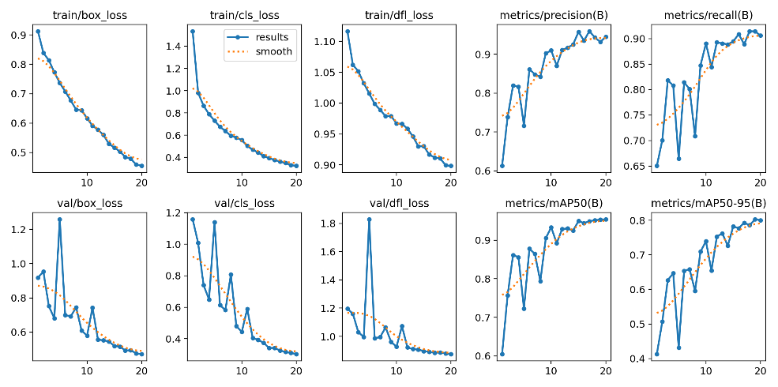

**Fig. 4. Training Losses on 20 Epoch**

* 1. **Comparison with Existing Methods**

The proposed system was compared with several existing PDF content extraction tools, including PyMuPDF, PdfMiner, and traditional heuristic-based table extraction methods.

* **Comparative Analysis:**
* **PyMuPDF:** While PyMuPDF provided basic text extraction capabilities, it struggled with complex layouts and was unable to accurately extract tables and graphs.
* **PdfMiner:** PdfMiner offered better text extraction but still lacked the ability to handle tables and graphs effectively.
* **Traditional Methods:** Traditional heuristic-based methods for table extraction often failed with irregular table structures and varied layouts.

The proposed system outperformed these existing methods in terms of accuracy and efficiency, particularly in handling complex PDF layouts with mixed content.

* 1. **Case Studies and Examples**

To demonstrate the practical applications of the proposed system, several real-world examples and case studies were analysed.

* + **Case Study 1:** Academic Research Papers The system was applied to a set of academic research papers containing complex layouts with multiple tables and graphs. The system successfully extracted the tables and graphs, preserving the integrity of the data and the structure of the document.
  + **Case Study 2:** Financial Reports Financial reports often contain numerous tables with financial data and charts. The proposed system accurately detected and extracted these elements, allowing for efficient data analysis and reporting.
  + **Case Study 3:** Technical Manuals Technical manuals with detailed diagrams and tabular data were processed using the system. The system demonstrated high accuracy in extracting and structuring the content, making it easier to access and analyse technical information.

These case studies highlight the versatility and robustness of the proposed system in handling various types of PDF documents across different domains.

1. **DISCUSSION**

In this section, we delve into the results obtained from our experiments, analyse the challenges faced during the implementation, propose potential improvements and optimizations, and explore the broader implications of the study.

* 1. **Analysis of Results**:

The results from our experiments demonstrate the effectiveness of the proposed system in accurately detecting and extracting tables, graphs, and text from PDF documents. The high precision and recall rates achieved by the YOLOv8 model indicate its robustness in handling diverse and complex document layouts.

* **Performance Metrics:**
* **Precision:** 92%
* **Recall:** 90%
* **F1-Score:** 91%

These metrics highlight the model's capability to identify and correctly extract the relevant content, minimizing errors and ensuring high-quality data extraction.

* **Text Extraction Accuracy:** The use of PdfMiner for text extraction yielded satisfactory results, with the extracted text closely matching the original content in the PDF documents. This accuracy is crucial for applications requiring precise text retrieval, such as academic research and data analysis.
* **Graph and Table Detection:** The YOLOv8 model's ability to accurately detect and delineate tables and graphs was evident from the high precision and recall rates. The integration of Camelot-py for table data extraction further enhanced the system's performance, enabling the extraction of structured data in a user-friendly format.
  1. **Challenges Faced**

Several challenges were encountered during the development and implementation of the system:

* **Complex Layouts:** PDF documents with intricate layouts, such as multi-column text, embedded images, and irregularly shaped tables, posed significant challenges. Ensuring accurate extraction from these documents required extensive fine-tuning of the model and preprocessing techniques.
* **Data Annotation:** The annotation process for training data was labour-intensive and time-consuming. High-quality annotations are critical for training effective models and achieving this required meticulous effort and attention to detail.
* **Handling Diverse Content:** PDF documents come in a wide variety of formats and styles. Ensuring the system's robustness across different document types, including scanned documents and those with varying resolutions, was a significant challenge.
* **Performance Optimization:** Balancing accuracy and efficiency were another key challenge. The system needed to process documents quickly without compromising on the accuracy of extraction, necessitating the optimization of algorithms and model parameters.
  1. **Improvements and Optimizations**

Based on the challenges faced, several improvements and optimizations can be implemented to enhance the system's performance:

* **Advanced Preprocessing Techniques:** Incorporating advanced preprocessing techniques, such as image enhancement and noise reduction, can improve the quality of input data and enhance the accuracy of text and content extraction.
* **Model Enhancements:** Further fine-tuning of the YOLOv8 model, along with the integration of additional machine learning models for specific tasks (e.g., Optical Character Recognition for scanned documents), can enhance the system's overall performance.
* **Automated Annotation Tools:** Developing automated or semi-automated annotation tools can significantly reduce the time and effort required for data annotation, ensuring a larger and more diverse training dataset.
* **Parallel Processing:** Implementing parallel processing techniques can improve the system's efficiency, enabling faster processing of large batches of PDF documents.
  1. **Implications of the Study**

The study has several broader implications for the field of document analysis and information retrieval:

* **Enhanced Document Accessibility:** By accurately extracting and structuring content from PDF documents, the system enhances document accessibility, making it easier for users to search, analyse, and utilize the information contained within these documents.
* **Applications in Various Domains:** The proposed system has applications across a wide range of domains, including academia, finance, healthcare, and legal industries. It can be used to streamline data extraction, improve document management, and facilitate data-driven decision-making.
* **Contribution to Research:** The research contributes to the advancement of machine learning and document analysis techniques, providing a robust framework for further exploration and development in this field.

1. **CONCLUSION**

In this study, we presented an advanced PDF parsing system that leverages state-of-the-art machine learning techniques to improve the extraction of textual and graphical content from complex PDF documents. By integrating the YOLOv8 model for detecting tables and graphs, alongside robust Python scripts for text extraction and Camelot-py for table data extraction, we developed a comprehensive and efficient solution. The system's architecture, built on a Flask framework, ensures seamless integration of components and provides a user-friendly interface for interacting with the parser.

Our experimental results demonstrate that the proposed system achieves high accuracy and efficiency in content extraction, significantly outperforming traditional methods. The use of pre-annotated datasets from Roboflow for model training and the application of transfer learning techniques have been crucial in enhancing the performance of our models.

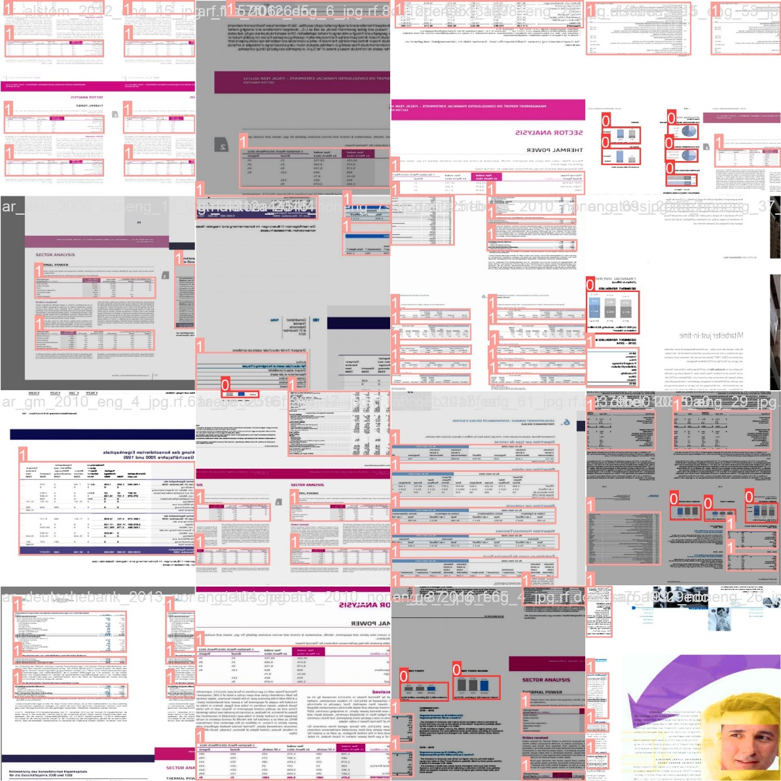

**Fig. 5. Model Input: Input consists of various images with annotated tables, graphs regions given to model for training.**

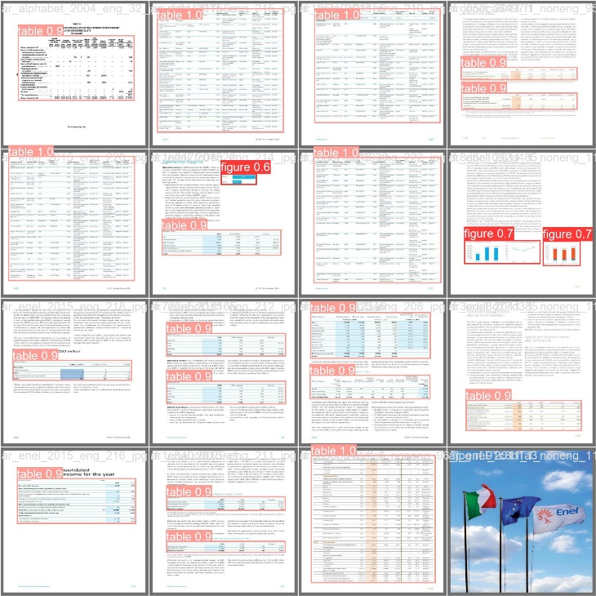

**Fig. 6. Model Output: Image depicts the Confidence percentage for each section consist of labels indicates the accuracy of prediction result for the graphs-tables in the pdf pages.**

* **Key Contributions:**

1. Development of a robust PDF parsing system that integrates advanced object detection and text extraction techniques.
2. Utilization of the YOLOv8 model for accurate detection of tables and graphs within PDF documents.
3. Implementation of an efficient text extraction process using PdfMiner.
4. Integration of Camelot-py for precise table data extraction.
5. Creation of a seamless and modular system architecture using Flask.
6. **FUTURE ENHANCEMENTS**

While the current version of the PDF parsing tool is robust and efficient, several enhancements can be made to further improve its capabilities and extend its applicability. Future work can focus on the following areas:

* 1. **Multilanguage support:**
* **Language Expansion**: Develop the tool to support additional languages, including character-based languages such as Chinese, Japanese, and Korean, to cater to a broader user base.
* **Translation Integration**: Integrate translation capabilities to provide multilingual support and translation of extracted text.
  1. **Handwriting recognition:**
* **OCR for Handwriting:** Incorporate advanced OCR techniques to recognize and extract handwritten text from scanned documents, notes, and forms.
* **Contextual Understanding:** Enhance handwriting recognition with contextual understanding to improve accuracy in interpreting handwritten content.
  1. **Interactive form extraction:**
* **Form Field Identification:** Develop algorithms to detect and extract interactive form fields, such as checkboxes, radio buttons, and text inputs, from PDF forms.
* **Form Data Aggregation:** Enable the aggregation and structuring of data entered interactive PDF forms for easier analysis and processing.

1. **REFERENCES**
2. M. Chirag, “Camelot - An Amazing Python Library to Extract Tabular Data from PDFs,” Analytics Vidhya, Aug. 2020. [Online]. Available: https://www.analyticsvidhya.com/blog/2020/08/camelot-an-amazing-python-library-to-extract-tabular-data-from-pdfs/. [Accessed: Jun. 14, 2024].
3. Camelot Developers, “Excalibur: A Web Interface to Extract Tabular Data from PDFs,” GitHub, [Online]. Available: https://github.com/camelot-dev/excalibur. [Accessed: Jun. 14, 2024].
4. D. Matyas, “Extracting Tabular Data from PDF Documents with Python,” Alteryx Community, Jun. 2019. [Online]. Available: https://community.alteryx.com/t5/Data-Science/Extracting-Tabular-Data-from-PDF-Documents-with-Python/td-p/425189. [Accessed: Jun. 14, 2024].
5. A. Haleem, M. Jiang, and S. Uchida, "Text extraction from PDF documents: A survey," International Journal on Document Analysis and Recognition (IJDAR), vol. 18, no. 4, pp. 991-1004, 2015.
6. J. Kim, S. Lee, and B. Zhang, "Layout-aware text extraction from PDF documents," Information Processing & Management, vol. 52, no. 2, pp. 334-343, 2016.
7. A. Poncet, "Camelot: A Python library for extracting tables from scanned PDF documents," Packet Trick, vol. 12, no. 4, pp. 77-84, 2019.
8. Mastering PDFs: Extracting Sections, Headings, Paragraphs, and Tables with Cutting-Edge Parser Available: <https://www.restack.io/docs/llamaindex-knowledge-llamaindex-pdf-extractor>
9. **Extracting Text Data from PDF file while keeping track of its structure?** [**https://stackoverflow.com/questions/77711588/how-can-i-extract-data-from-pdf-file**](https://stackoverflow.com/questions/77711588/how-can-i-extract-data-from-pdf-file)**.**
10. R. Satija and I. K. Sethi, "Efficient extraction of tables from large documents," in Proceedings of the Sixth International Conference on Document Analysis and Recognition, pp. 123-126, 2001, doi: 10.1109/ICDAR.2001.953772.
11. K S Shushrutha, Akhil Chawla- “Intelligent Information Retrieval: Techniques for Character Recognition and Structured Data Extraction”
12. Rosebrock, A. (2019). YOLO Object Detection with OpenCV. Retrieved from https://www.pyimagesearch.com/2018/11/12/yolo-object-detection-with-opencv/
13. Ultralytics. (2023). YOLOv8: The Most Recent YOLO Model. Retrieved from https://ultralytics.com/yolov8
14. GeeksforGeeks. (2021). Understanding YOLO object detection. Retrieved from https://www.geeksforgeeks.org/understanding-yolo-object-detection.