**EFFECTIVENESS OF A CHILD SAFETY DEVICE IN PREVENTING FORGOTTEN CHILDREN INCIDENTS IN VEHICLES**

**Noor Azlyn Ab Ghafar1, Norfadhilah bt Hasan2, Nor Hasnati bt Abdull Patas3**

1,2,3Department of Electrical Engineering, Politeknik Sultan Mizan Zainal Abidin, 23000 Dungun Terengganu, Malaysia

**ABSTRACT**

Leaving children unattended in vehicles, even briefly, poses significant risks, potentially leading to tragic outcomes such as hyperthermia and suffocation. This study evaluates the effectiveness of a newly developed “Child Safety Device” (CSD) aimed at preventing “forgotten baby syndrome” by detecting movement or sound within the vehicle. Designed to activate when a parent exits the car, the device alerts parents if it detects any movement or sound from a child, sending an immediate notification to their handphone. This feature is intended to mitigate the risk of children being accidentally left behind in vehicles, reducing incidents of forgotten baby syndrome. The CSD utilizes key components, including an Arduino UNO, GSM module, OLED display, LED, PIR motion sensor, and sound sensor, to detect the child’s presence and initiate alerts. A demonstration video was used to simulate the device’s operation, followed by a survey conducted among 80 participants in the Dungun area to gather feedback. The findings indicate that the CSD has significant potential to address this major safety issue, as indicated by respondents' overwhelmingly favorable response, which emphasized the device's functionality and effectiveness.

**Keywords:** Child safety device, forgotten baby syndrome, Arduino UNO

1. **INTRODUCTION**

Child safety in vehicles is an increasingly pressing issue, with numerous cases reported globally each year of children unintentionally left in cars [1]. Tragically, such incidents can lead to severe injury or even death, primarily due to heatstroke (hyperthermia), suffocation, or other environmental hazards posed by the confined space of a vehicle [2]. Known as "forgotten baby syndrome," this phenomenon is a result of memory failure rather than intentional negligence, with even the most vigilant parents susceptible to such lapses [3][4]. Studies in neuroscience reveal that when caregivers experience high levels of stress, fatigue, or abrupt changes in routine, their brain's memory system can override cues that would otherwise remind them of a child’s presence in the back seat. Such lapses in memory are understood to be related to the interplay between the brain's "habit memory" and "prospective memory" systems, which can disrupt typical routines, leading to potentially dangerous oversights[5].

The risk associated with these memory lapses has garnered significant attention, especially given the alarming statistics on vehicular heatstroke-related deaths. Between 1998 and 2024, an average of 37 children per year have died from vehicular heatstroke in the United States alone, with similar trends observed globally [6]. This emphasizes the urgent need for reliable preventative measures to protect children from being accidentally left in vehicles. Numerous technologies have been developed to mitigate these risks, including car seat sensors, smartphone reminder applications, and other notification systems designed to alert caregivers. However, while these systems represent meaningful advancements, they also have inherent limitations. For example, some devices rely solely on in-car reminders, which may fail to engage caregivers once they have exited the vehicle, while others depend on connectivity or app notifications, which can sometimes go unnoticed in busy, noisy environments.

The challenge, therefore, lies in developing a solution that not only captures a caregiver’s attention in real time but also remains effective in various environmental and situational contexts. Recognizing these limitations, this project introduces an innovative Child Safety Device (CSD) tailored to reduce the risk of forgotten children in vehicles through a robust, multi-layered alert system. This device, unlike many existing solutions, is designed to be both user-friendly and comprehensive in its safety approach, making it practical for caregivers of all types.

The Child Safety Device integrates several key components: an Arduino UNO microcontroller, a GSM module for communication, an OLED display, LED, a PIR (Passive Infrared) motion sensor, and a sound sensor. Figure 1 shows the CSD. The Arduino UNO, a reliable and widely used microcontroller, serves as the central processing unit, coordinating inputs from both the motion and sound sensors to detect a child’s presence in the vehicle. The GSM module is utilized to send notifications directly to a caregiver’s smartphone through a call alert, immediately alerting them if a child is detected. The OLED display is designed to be visible from outside the vehicle, displaying warning messages and illuminating a LED that alerts passersby, providing an external layer of security that encourages intervention by nearby individuals if a child is left unattended.

Figure 1: View of the device

This device operates automatically, activating as soon as the caregiver closes the car door. Figure 2 show the device location. When either movement or sound is detected, the system immediately triggers an alert sequence, sending a call to the caregiver’s smartphone. The dual-alert design of this system serves a twofold purpose: to notify the caregiver directly and to create a visual alert that passersby can notice, increasing the likelihood of intervention. By addressing the issue from both internal and external perspectives, the device is uniquely positioned to prevent cases of "forgotten baby syndrome" more effectively than single-layer alert systems.

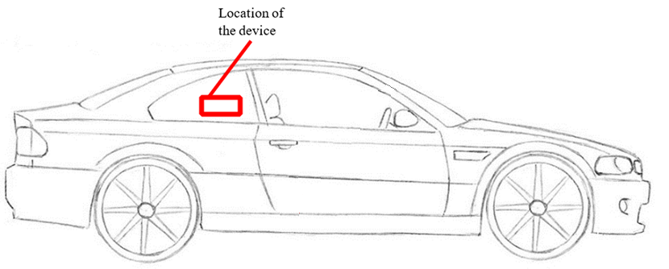

Figure 2 : Device location

The research conducted in this study focuses on assessing the perceived effectiveness, usability, and practical implications of the CSD through direct feedback from potential users. Since testing a device of this nature under real conditions is ethically challenging and logistically complex, a demonstration video was created to simulate the device's functions. This video provides an overview of the device’s capabilities, illustrating how it would operate in a real-world scenario where a child might be unintentionally left behind in a vehicle. Following the video demonstration, participants were invited to complete a self-developed survey aimed at gathering in-depth insights into the device’s perceived ability to address the problem, its impact on enhancing user security, and its potential for benefiting the community.

The survey, while self-developed, was specifically designed to capture feedback relevant to the device’s intended functionality and impact. However, its self-developed nature presents limitations in terms of external validity, which this study acknowledges and explores as part of its analysis. Despite these limitations, the survey provided valuable insights into user perspectives, highlighting areas where the device performs well and potential aspects for improvement in future iterations.

This study seeks to answer key research questions related to the device’s perceived effectiveness, including how well users believe it addresses the issue of forgotten children, the extent to which it enhances their sense of security, and its potential impact on public awareness and intervention. Additionally, the study aims to evaluate the validity of the survey as a reliable tool for gathering targeted user feedback. By understanding user perceptions and identifying areas for enhancement, this research contributes to the development of more effective, accessible child safety solutions within the automotive sector. The findings from this study may guide future improvements to the CSD, helping to ensure that it meets the practical needs of caregivers and achieves its intended goal of preventing tragic, avoidable incidents related to forgotten children in vehicles.

1. **METHODOLOGY**

Due to the challenge of authentically recreating conditions under which users might unintentionally forget a child, the device’s operation was demonstrated through a video. This video simulated the device’s automatic activation upon door closure and showcased scenarios where the device detects movement or sound from a child, subsequently alerting the parent and displaying visual signals on the OLED display. The simulation thus provided a controlled yet comprehensive view of the device’s function, covering various alert mechanisms and hypothetical responses.

After presenting the demonstration video of the CSD, a survey was distributed to 80 members of the Dungun community to gather valuable feedback on the device’s effectiveness and impact. Participants were asked to address three critical questions that focused on different aspects of the device's utility and potential benefits. First, they were prompted to consider whether the device effectively addresses the problem of children being forgotten in vehicles, a significant concern that the CSD aims to mitigate. Next, participants were asked if the device enhances their sense of security when leaving the vehicle, highlighting the psychological reassurance the device provides to parents and guardians. Finally, they were questioned about whether they believe the device will be beneficial to the wider community, emphasizing the potential societal impact of such a safety innovation. The survey was carefully designed to focus on key areas related to the device’s usability, practicality, and overall perceived effectiveness. Although the survey was self-developed and comes with inherent limitations, particularly the lack of real-life testing, the use of a comprehensive video demonstration provided respondents with a foundational understanding of the device's capabilities, enabling them to give informed feedback based on their observations and impressions.

* 1. **Survey Validity and Limitations**

The survey’s self-developed nature presents some limitations concerning validity, as it lacks standardized validation through established instruments. While the survey effectively captured user feedback, its reliability could be enhanced with validated metrics or pilot testing. The simulated video also poses a limitation in fully capturing user perceptions in real-life settings. Consequently, participant responses might differ if they interacted with the device under authentic conditions, where psychological responses to real-time alerts might be more pronounced. To enhance validity, future studies could consider using standardized satisfaction or effectiveness scales alongside targeted questions. Incorporating real-life trials would also provide a more accurate assessment of device reliability and user responses, offering greater insight into the device’s effectiveness in preventing forgotten child incidents.

* 1. **Study Limitations**

This study is limited by the absence of real-life trials and the reliance on a video demonstration. Replicating real-world scenarios where a child might be left unattended is challenging but would offer invaluable insights into the device's effectiveness and user responses. Conducting trials in naturalistic settings—such as with parents using the device for an extended period—would yield richer data on trust and satisfaction.

1. **FINDINGS AND DISCUSSION**

The findings from the user survey provide valuable insights into the perceived effectiveness and practical implications of the Child Safety Device (CSD) in preventing incidents of children being unintentionally left in vehicles. The survey responses enable a thorough analysis of the device’s strengths and areas for improvement, particularly regarding usability and reliability in real-world conditions. These insights lay the groundwork for a detailed discussion of the device’s potential, limitations, and community impact, as well as guidance on areas for future enhancement.

* 1. **Does the device solve the identified problem?**

According to the survey results depicted in Graph 1, a significant 73.75% of users strongly agree that the device effectively addresses the risk of children being left behind in vehicles. Many respondents noted that the device’s ability to provide immediate alerts greatly reduces the likelihood of forgetting a child in the car. Positive feedback frequently emphasized the dual-layer alert system, which provides both internal notifications to the caregiver and external alerts visible to bystanders. This layered approach was viewed as crucial for attracting the attention of passersby, especially if there is a delayed response from the caregiver.

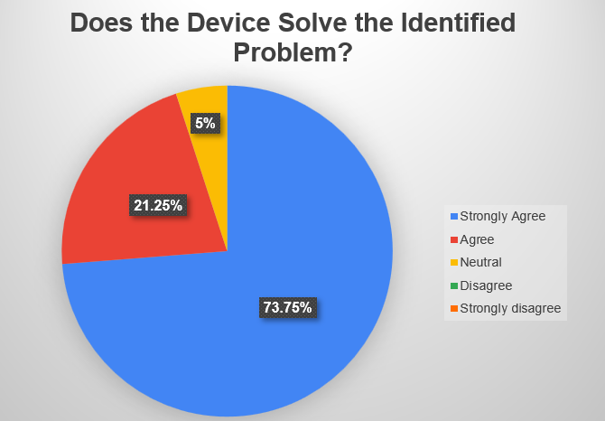

Graph 1

Graph 1 also shows that 21.25% of respondents agree that while the device is effective, certain factors could affect its performance in real-world settings. Some users raised questions about the device’s sensitivity, particularly in detecting minimal movements or faint sounds from infants. Others pointed out operational challenges, such as battery life and signal strength, which may impact the device's reliability. These insights indicate that, while the device holds promise, further refinement in technical specifications could enhance its functionality. Future iterations might incorporate more advanced sensors capable of detecting even subtle movements or physiological signs, such as breathing. Additionally, improving battery durability and expanding notification options could help address concerns about consistency and reliability. Only 5% of respondents were neutral, indicating that the majority found the device beneficial in addressing the issue at hand.

* 1. **Does the device enhance users' sense of security?**

From the data presented in Graph 2, it is evident that the CSD has had a highly positive impact on participants' sense of security when leaving their vehicle. Specifically, 65% of respondents strongly agreed, and an additional 28% agreed that the device significantly enhances their feeling of safety. A key factor contributing to this sense of reassurance is the automatic notification system, which users felt effectively reduces anxiety by providing immediate phone call alerts if the device detects movement or sound from a child. The immediacy of these notifications was particularly praised, as participants considered them far more effective than traditional passive reminders, which may not demand as much attention.

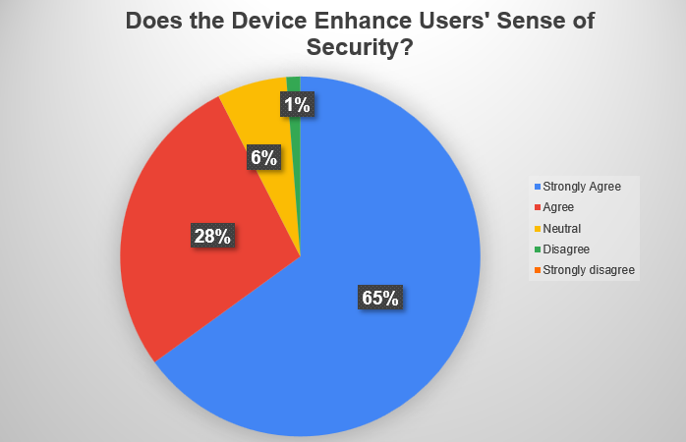

Graph 2

Additionally, many users valued the design feature where the device activates as soon as the car door is closed. This automatic activation reassures parents that the system is consistently engaged, reducing the likelihood of a child being unintentionally forgotten in the vehicle. Only 6% of respondents were neutral, and a mere 1% disagreed that the product enhanced their sense of security. These minority responses could potentially be attributed to a lack of hands-on experience with the device or the inability to test it in real-life scenarios, as the study only used a video demonstration. Nevertheless, the low percentage of neutral or negative feedback indicates a strong overall confidence in the device. Conducting long-term trials and real-world testing could provide more in-depth insights, particularly into how sustained use of the device influences users' long-term sense of security and overall trust in the product’s reliability.

* 1. **Does the product benefit the community?**

The survey results reveal an overwhelming consensus on the device’s potential to enhance public awareness and safety, with 96.25% of respondents recognizing its community benefits (refer graph 3). Participants emphasized that the prominent OLED alert serves not only as an additional safety feature but also as a catalyst for increased vigilance among bystanders, potentially nurturing a culture of communal responsibility. By drawing attention to a potentially dangerous situation, the alert empowers the public to intervene or notify authorities if they see a child left alone in a vehicle. This community involvement underlines the device’s social impact, demonstrating its role in promoting both individual and collective safety.

Moreover, this support highlights the broader implications of integrating safety technology into everyday life. Although 0% of respondents stated that the product had no community impact, 3.75% suggested it had room for improvement to maximize its effectiveness. This feedback points to opportunities for future enhancements, perhaps by refining the alert features or exploring additional safety mechanisms. Future research could delve deeper into the influence of the OLED alert in simulated environments, assessing how effectively it motivates bystander intervention and contributes to child safety. Such studies would provide quantifiable data to strengthen understanding of the device’s impact in real-world settings.

Graph 3

1. **CONCLUSION**

The findings from this study demonstrate that the child safety device is highly effective and provides significant benefits to the community. All respondents agreed that the device successfully addresses the critical problem of forgotten children in vehicles, enhances users' sense of security, and delivers substantial value by promoting public safety. The strong positive response indicates that the device not only meets individual safety needs but also fosters community awareness and encourages proactive intervention during emergencies. Despite the limitations of using a video demonstration, the device has clearly proven its potential to make a meaningful impact.

To maximize the device’s real-world effectiveness and further validate its benefits, future research should include comprehensive real-world trials and a refined survey design using validated instruments. These steps would provide deeper insights into user experiences and help identify opportunities for further enhancements. Overall, the child safety device stands out as a highly promising solution to a pressing child safety issue. With continued research and development, it has the potential to transform community safety practices, offering both individual protection and a collective commitment to preventing tragic incidents.

**ACKNOWLEDGEMENTS**

The authors thank the Department of Electrical Engineering at Politeknik Sultan Mizan Zainal Abidin for their support.

1. **REFERENCES**
2. Frank Ngeni, Judith Mwakalonge, Gurcan Comert, Saidi Siuhi, Tumlumbe Juliana Chengula, Cuthbert Ruseruka,The role of socioeconomic and environmental factors on pediatric vehicular heatstroke (PVH) deaths and sentiment analysis: An investigation,Transportation Research Interdisciplinary Perspectives, Volume 23,2024,101012, ISSN: 2590-1982, https://doi.org/10.1016/j.trip.2023.101012.
3. Epstein Y, Yanovich R. Heatstroke. N Engl J Med. 2019 Jun 20;380(25):2449-2459. doi: 10.1056/NEJMra1810762. PMID: 31216400.
4. Nur Suriya Mohamad; Ravenraj Mogan (2022). The Development of a Child Alert and Notification System for Forgotten Baby Syndrome, , e-Proceeding of 12th National Conference in Technical Education and Vocational Training 2022; (CiE-TVET 2022), pg 66-74.
5. Breitfeld, E. (2020). Hot-car deaths and forgotten-baby syndrome: A case against prosecution. Berkeley

Journal of Criminal Law, 25, 72. Retrieved from http://lawcat.berkeley.edu/record/1163936

1. Null, Jan. “No Heat Stroke.” No Heat Stroke, 8 Nov. 2024, [www.noheatstroke.org/](http://www.noheatstroke.org/).
2. Krackow, E., & Elias, H. (2024). Public Perceptions of Memory Failures in Infant ‘Hot Car’ Deaths. Imagination, Cognition and Personality, 44(1), 86-103. <https://doi.org/10.1177/02762366241268173>