**An Innovative Approach for Drug Targeting against Huntingtin protein in Huntington’s disease: The search for an Effective therapeutic strategy**

**Naysa Srivastava1; Aparajita Chakraborty2; Shreosee Ghosh2; Kunal Vora2; Rupak Roy2\***

**1Adlai E Stevenson High School, Lincolnshire, Illinois,United States.**

**2SHRM Biotechnologies Pvt. Ltd., Kolkata, West Bengal, India**

**Corresponding Author’s Email id:** [rupak@shrmbio.com](mailto:rupak@shrmbio.com)

**Abstract**

Huntington’s disease is a neurodegenerative disorder which is characterised by loss of striatal neurons and a decline in motor activity. It is marked by progressive increased levels of Huntingtin protein, which is caused by mutations in Huntingtin gene (Htt) which encodes it. Thus, in our study we aimed to establish the structure of Huntingtin protein using Homology modelling in SWISS-MODEL and Phyre2 and performing its respective docking with three target drug molecules as ligands, namely Benzamide, Pridopidine and Tetrabenazine, the structures of which are retrieved from PubChem database using Autodock Vina. The respective protein-ligand interactions were visualised in PyMol and LigPlot respectively. Amongst the three, pridopidine was found to be the potential drug candidate with the lowest binding energy and thus assumed to be the best candidate in targeting Huntingtin protein and more effective in treating Huntington’s disease. The potency of this drug is further yet to be established using clinical trials in wet lab experimental methods.

**Keywords**: Huntington’s disease, Huntingtin protein, structure, drug, Molecular Docking

**Introduction**

Huntington’s disease (HD) is an inherited disorder that causes brain cells to slowly lose their function and gradually die. In other words, it causes nerve cells to gradually decay with time. It is a type of neurodegenerative disorder which affects those areas of the brain responsible for causing controlling voluntary movements which are intentional and other areas as well [1-3]. People suffering from HD develop certain symptoms such as dance-like movements (chorea) and abnormal body postures such as problems with behaviour, emotions, thinking and personalities.

HD is primarily caused due to a cytosine-guanine-adenine) CAG repeat expansion in the huntingtin gene which codes for a protein called Huntingtin protein (HTT) [4, 5]. The involvement of glutamine and poly-q tracts in the mHTT (mutant HTT gene) that contributes to this disease is important to note, as those inherited in Huntington’s completely alter the structure and functionality of the protein [5,6]. This protein is required mainly for human development and the normal brain function. In case of HD, which is an autosomal dominant neurodegenerative disorder, a long expansion of CAG codon repeat in Huntingtin gene leads in an abnormally long glutamine tract within the N-terminus of the Huntingtin protein, since CAG codes for glutamine [6-8]. Mutated HTT is the main cause of HD and has long been explored for its involvement in long-term memory storage.

HD has been linked to many dysfunctional pathways, most of them which has been caused mainly due to abnormal HTT interactions with other cell proteins characterised previously by Yeast-2-Hybrid (Y2H) and tandem mass purification techniques followed by mass spectrometric procedures [9,10]. The identification and structural characterisation of this protein thus helped to determine its interacting partners and hence explore the pathogenesis of this disease at proteomic level. The mechanism underlying HD lead to the development of rational measures towards developing drugs which started in 1993 with the cloning of HD gene [11-13]. Although patients have long been treated with drugs which can work on ameliorating the symptoms of HD, none so far has been so effective so as to modify the progress or onset or its ultimate fatality. In our study, we thus used computational docking approaches to study the interactions of three target drugs namely Pridopidine, Benzamide and Tetrabenazine with Huntingtin protein which has been characterised by its structure. Pridopidine is responsible for amelioration of Endoplasmic Reticulum (ER) stress induced by HTT, in HD by modulation of the Sigma-1 receptor [14-16]. Benzamide, on the other hand, is known to block dopamine D2 receptors and thus reduces chorea, associated with HD. It mainly interacts with the N-terminal of Huntingtin protein and helps in reducing protein aggregation and even toxic peptide formation. It plays a role in the disruption of the translation of the mutated Huntingtin protein. It is most closely related to the Huntingtin protein in its functioning among the ones in this study. Other benzamide derivatives have shown success with reducing aggregation of the Huntingtin protein, moving more towards the protection of neurons and glial cells in the brain and other areas [17-20]. Tetrabenazine is another drug used to treat chorea caused by Huntingtin. It mainly functions in the central nervous system (CNS) and prevents the absorption of certain chemicals such as dopamine and serotonin [21, 22]. Though each of these drug molecules hold specific roles against the disorder, yet we explore the binding affinities of each one to see which one can be considered a potential or ideal drug candidate. In our study, though we use some computational approaches to determine specific drug-protein interactions but the validation of such studies is yet to be performed in drug screening procedures which involve a series of clinical trials for each drug to be approved by FDA before getting approval in the industry. More approaches in drug designing are being implemented for potential screening of ideal drug candidates in upcoming future research.

**Material and Methods**

1. **Sequence and Local Alignment of Huntingtin Protein**

The FASTA sequence of the Huntingtin protein was obtained from the UniProt Database. The local alignment of Huntingtin protein was primarily studied using NCBI BLAST ([Protein BLAST: search protein databases using a protein query](https://blast.ncbi.nlm.nih.gov/Blast.cgi?PROGRAM=blastp&PAGE_TYPE=BlastSearch&LINK_LOC=blasthome)) and observed for its maximum identity, it’s E-value, its phylogenetic relationship with any related organisms [23].

1. **Structural Analysis and Physicochemical Characterisation**

The secondary structure prediction tools namely GOR4 ([Prediction of the Secondary Structure by GOR (ocha.ac.jp)](http://cib.cf.ocha.ac.jp/bitool/GOR/), and SOPMA ([NPS@: SOPMA secondary structure prediction (ibcp.fr)](https://npsa-prabi.ibcp.fr/cgi-bin/npsa_automat.pl?page=/NPSA/npsa_sopma.html) were used to predict the 2D structure of Huntingtin protein [24,25].

The physiochemical analysis of Huntingtin was performed using Expasy Protparam ([ExPASy - ProtParam tool](https://web.expasy.org/protparam/)) [26]. ProtParam allows the computation of certain parameters such as calculation of molecular weight, theoretical isoelectric point, amino acid composition, atomic composition, estimated half-life, and hydropathicity index, among others.

1. **Determination of 3-dimensional structure of the Huntingtin protein**

The prediction of the 3D (3-dimensional structure) of Huntingtin protein was done by SWISS-MODEL ([SWISS-MODEL (expasy.org)](https://swissmodel.expasy.org/)) and the structure with a greater Q-mean Z score and maximum sequence identity with the target sequence was selected as the model. Furthermore, the 3-D structure was visualized in RasMol ([RasMol and OpenRasMol](http://www.openrasmol.org/)) [27] and UCSF Chimera and finally validated by its corresponding ERRAT score, Ramachandran plot using SAVES [28, 29].

1. **Retrieval of Drugs from PubChem Database**

We used three different drugs as ligands for studying their respective interactions with Huntingtin protein i.e. benzamide, pridopidine, and tetrabenazine. The structures of the three drugs are retrieved from PubChem and are checked for their respective physical and chemical properties from ADMET Lab 2.0 [30, 31]. Then their respective binding sites were observed using LigPlot [32].

1. **Protein-Ligand Docking using Autodock Vina and visualization of results**

After the preparation of the target protein Huntingtin and its respective ligands, docking of the respective inhibitor drugs with the desired protein was performed using Autodock Vina and UCSF Chimera [33, 34]. The dockings performed were done on the basis of the selection of the potential drug targets which had a greater efficiency of interacting with Huntingtin protein.

The output files obtained were ranked as per their binding energies from the highest to the lowest energy per molecule.

The obtained docked molecules were visualized for their interactive sites, distances, and conformational changes that occurred in the Huntingtin protein and the ligand molecules, by UCSF Chimera and LigPlot.

**Results and Discussion**

1. **Sequence and Local Alignment of Huntingtin Protein**

The FASTA sequence of Huntingtin protein, which is composed of 3142 amino acids, has been retrieved from UniProt and was used to determine the local alignment from NCBI BLAST. The aligned sequence of Huntingtin obtained was determined to be the best match owing to its maximum score which was found to be 6453 (Table 1) with maximum identity and query cover of 100% and zero E-value thereby describing it as the best-fitted sequence.

**Table 1**. Analysis of maximum identities of NCBI BLAST

|  |  |  |  |  |
| --- | --- | --- | --- | --- |
| **Name of Protein** | **Max. Score** | **Query Cover** | **E- value** | **% Identity** |
| Huntingtin | 6453 | 100% | 0.0 | 100.00 |

We also retrieved the phylogenetic tree from NCBI BLAST; the root of the tree denotes the common ancestor while Huntingtin forms a clade with its respective isoforms X1 thereby describing their close evolutionary relationship. On the other hand, Huntingtin from Carlito syrichta forms a clade with primates and thus signifies their close evolutionary relationship (Fig 1).

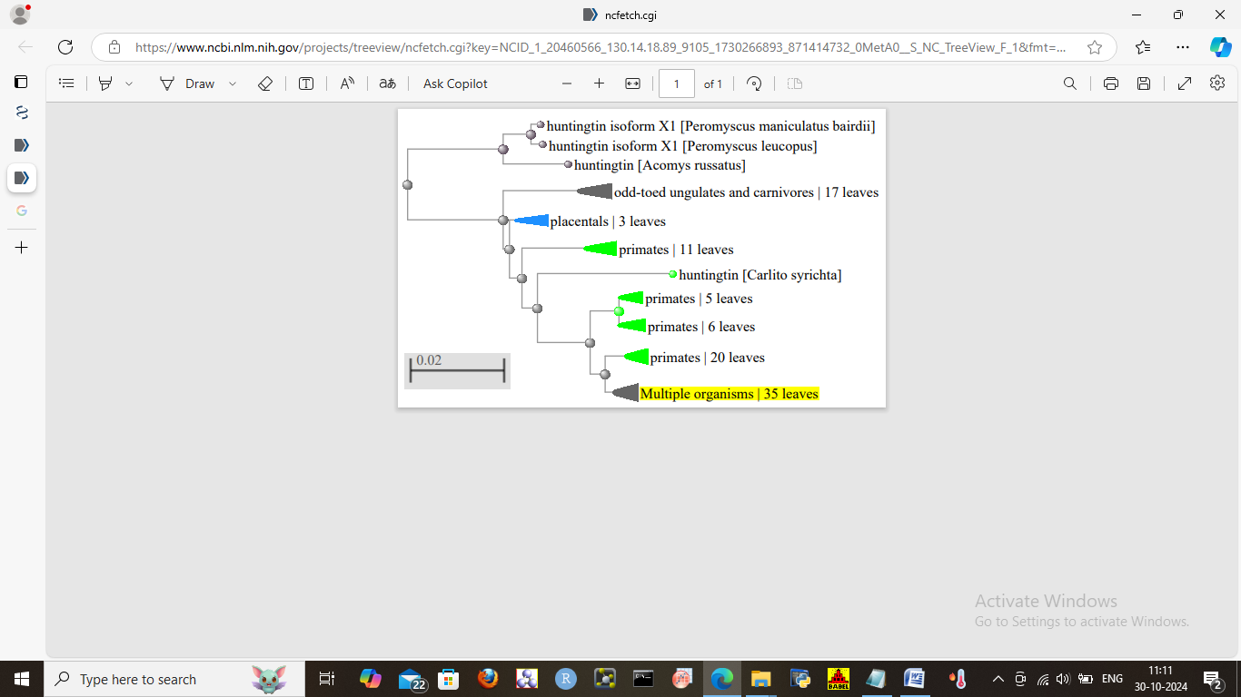

**Fig 1**. Phylogenetic tree depicting the close relationship of Huntingtin with other organisms.

The evolutionary relationship of Huntingtin shows its conservation across primates, placentals, and mammals [35-37]. Its association with a protein named HAP40, encoded by a single–exon gene in amniotes and a multiple-exon gene in other organisms may provide valuable information concerning the evolutionary relationships between the species at the genetic level, which thus signifies its conservation across vertebrates.

1. **Structural Analysis and Physicochemical Characterisation**

The Huntingtin protein was analyzed by the arrangement of sequences of alpha-helices, β-pleated sheets, and coils, in its secondary structure analyses by GOR 4 and SOPMA respectively (Table 2). The presence of alpha helix was found to be predominant, as compared to the others which thus determined its stable structure and mechanical strength and its ability to fold in a proper conformation. Recent studies performed on huntingtin protein described the presence of alpha-helices, and polyproline helix as predominant structures using X-ray crystallography which therefore justified our findings [38, 39]. Htt protein was found to possess a pathogenic poly-Q expansion which increased random coils, as we can see from Table 2, which is termed responsible for promoting aggregation and facilitation of abnormal interactions with proteins of other cells.

**Table 2**. Secondary structure analyses of Huntingtin Protein

|  |  |  |  |  |  |  |
| --- | --- | --- | --- | --- | --- | --- |
| **Name of Protein** | **GOR 4** | | | **SOPMA** | | |
| Huntingtin | Alpha helix (%) | Extended Strand (%) | Random Coil (%) | Alpha helix (%) | Extended Strand (%) | Random Coil (%) |
| 41.66 | 14.16 | 44.18 | 58.91 | 2.20 | 38.89 |

The Huntingtin protein had an instability index of 56.17 thereby indicating it to be an unstable protein, with a GRAVY score of less than about -0.066 which is less than 1 (Table 3). It may lead to establish the fact that this protein is a misfolded protein having long cytosine-adenine-guanine (CAG) repeats of more than 36 which leads to the formation of an abnormal, unstable protein in Huntington’s disease [40,41]. A greater instability index would thus lead to infer that mutations in Huntingtin would lead to the dysregulation of neuronal and glial functions of the mammalian system.

**Table 3.** Physicochemical parameters of Huntingtin protein

|  |  |  |  |  |  |  |
| --- | --- | --- | --- | --- | --- | --- |
| **Name of protein** | **Molecular weight** | **Theoretical pI** | **Extinction coefficient** | **Instability Index** | **Aliphatic Index** | **Grand Average of Hydropathicity** |
| Huntingtin | 347603.03 | 5.83 | 0.785 | 56.17 | 99.30 | -0.066 |

1. **Determination of 3- dimensional structure of Huntingtin protein**

The three-dimensional structure of Huntingtin protein was established by homology modeling using a template (PDB ID: 6x9o) using SWISS-MODEL and Phyre2. According to the predicted tertiary structure by both SWISS-MODEL and Phyre2, 2425 residues (77% of the sequence) have been modeled with 100% confidence, along with 77% identity, by the highest scoring template and visualized in RasMol and UCSF Chimera (Fig 2). The three-dimensional structure had been obtained from cryo-EM studies. The predicted model has been validated further from the ERRAT score, Z-score, and the Ramachandran plot (Fig 3). The ERRAT score was found to be 92.4205 which could thus lead to the development that our model obtained is of a good quality model, while the Z-score was found to be <1 which is suggestive of a good quality model, which is agreement with previous studies describing the tertiary structure, describing it as possessing many alpha-helices and it remaining in a complex with HTT-associated protein 40 (HAP40) which is verified from our result [41, 42]. The validation of the model has been observed from the Ramachandran plot which shows nearly 86.5% allowed regions and 0.7% disallowed regions (Table 4) which is also indicative of the fact that our predicted model is fine and of a superior quality.

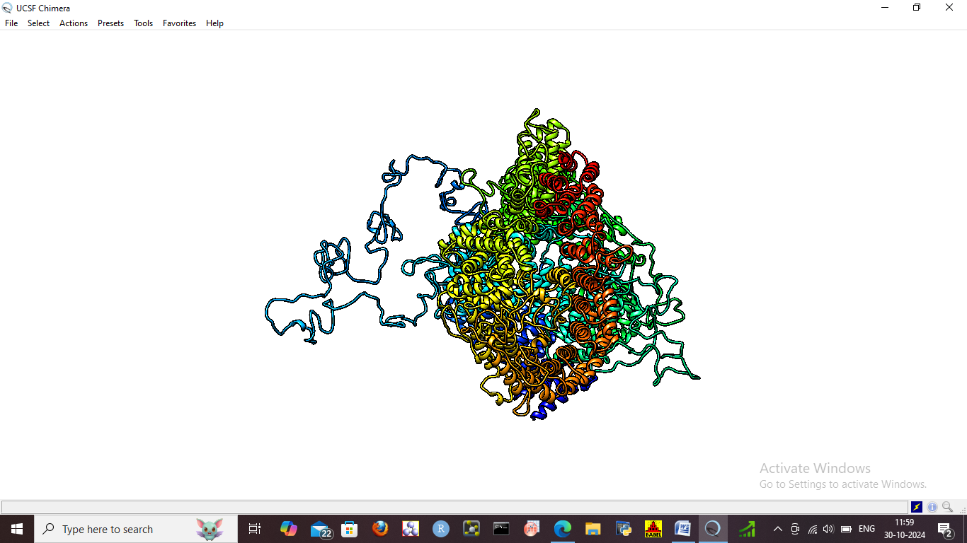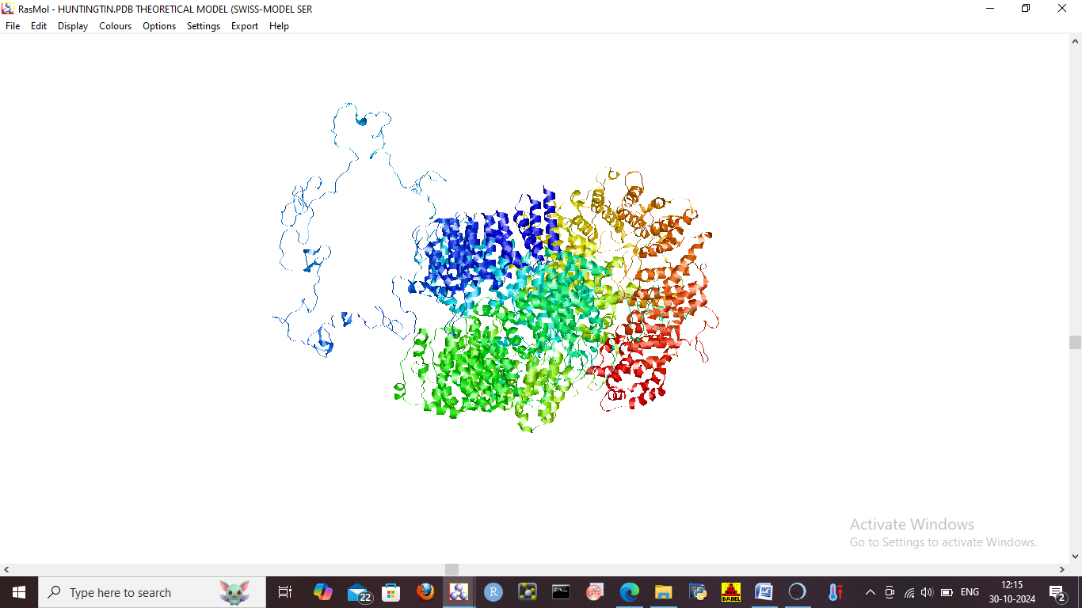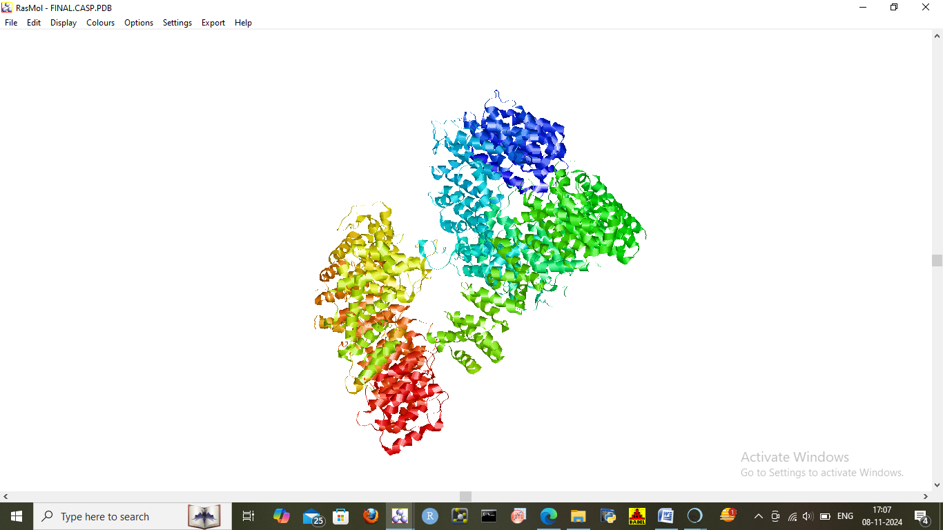

**Fig 2**. The tertiary structure of Huntingtin (from SWISS-MODEL) is viewed in A. UCSF Chimera B. RasMol C. Phyre2 server and visualised in RasMol

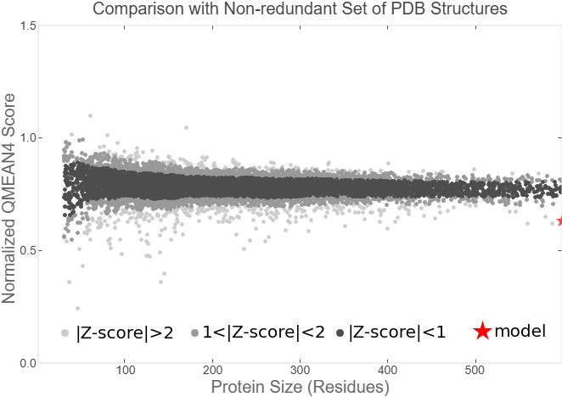

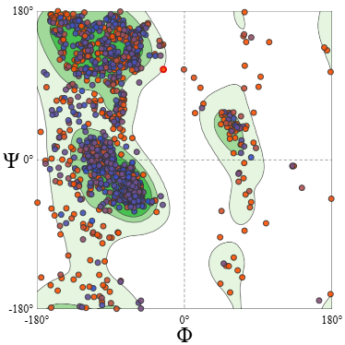

**Fig 3**. A. Qmean Z-score of Huntingtin protein B. Ramachandran Plot

**Table 4**. ERRAT scores and Ramachandran Plot values obtained from SAVES

|  |  |  |  |  |
| --- | --- | --- | --- | --- |
| **Name of Protein** | **ERRAT Score** | **Ramachandran Plot** | | |
| Huntingtin | 92.4205 | Core (%) | Allowed (%) | Disallowed (%) |
|  |  | 86.5 | 1.3 | 0.7 |

1. **Retrieval of Drugs from PubChem Database**

The three-drug molecules i.e. Benzamide, Pridopidine, and Tetrabenazine are used as ligands and retrieved from PubChem (Fig 4) and checked for their respective physicochemical properties from ADMET Lab 3.0 (Table 5). An analysis of the ADMET profiles (absorption, distribution, metabolism, excretion, and toxicity) of each drug describes each one with potential rates of absorption (TPSA) as molecules with TPSA (20-100 Å) have better absorption capacities. Their distribution coefficients (logD) range nearly between 1-2, both in aqueous and lipophilic environments, which state their moderate distribution rates. The intestinal permeabilities (Caco2) are also the same, thus describing their moderate metabolism and permeability rates (0.1-0.5), a comparatively high permeability across the intestine (MDCK) for pridopidine, low rates of potential to cross the blood-brain barrier (excretion rate) and relatively low toxicity rates (carcinogenicity) for each. Therefore these drugs are suitable to be explored further for our study.

Pridopidine is highly selective and has been termed a potent sigma-1 receptor (S1R) agonist with a safety profile that has been established beforehand. It is a common drug used and has been designated as a novel agent in the dopidine class which is believed to have ‘state-dependent’ effects at certain dopamine receptors thereby showing promising treatment in voluntary movement disorders. Benzamide, on the other hand, was shown to have a hand in the treatment of chorea, a movement disorder associated with tardive dyskinesia and other behavioral disorders, while Tetrabenazine has by far been the most-approved FDA drug for the treatment of chorea in Huntington’s disease [21, 43]. Thus, we take these three drugs for our study because no previous study had used Benzamide or any drug in computational approaches and we aim to establish the potency of each drug as to which one is a suitable candidate amongst the three for targeting Huntingtin protein.

**Table 5**. ADMET profiles for each drug molecule retrieved from ADMET lab 3.0

|  |  |  |  |  |  |  |  |
| --- | --- | --- | --- | --- | --- | --- | --- |
| **Name of Drug** | **Molecular weight** | **TPSA** | **LogD** | **Caco-2** | **MDCK** | **BBB** | **Carcinogenicity** |
| Pridopidine | 281.14 | 37.38 | 2.101 | 0.116 | 0.736 | 0.2027 | 0.9942 |
| Benzamide | 121.05 | 43.09 | 1.159 | 0.3717 | 0.057 | 0.113 | 0.531 |
| Tetrabenazine | 317.2 | 38.77 | 2.39 | 0.906 | 0.047 | 0.997 | 0.575 |

|  |
| --- |
|  |
|  |
|  |
| **Fig 4**. Respective drug molecule structures retrieved from PubChem Database A. Pridopidine B. Benzamide C. Tetrabenazine |

1. **Protein-Ligand Docking using Autodock Vina and visualization of results**

The docking of the Huntingtin protein with three drug molecules, benzamide, pridopidine, and Tetrabenazine was performed and analyzed. The respective protein-ligand interactions were visualized in PyMol along and in LigPlot. The binding energies for each drug were calculated post-docking operations; Pridopidine showed the lowest binding energy of 6.3 kcal/mol among the three drugs that were taken, thereby showing a greater binding affinity and more potency as a promising drug candidate (Table 6). The number of interacting residues was higher i.e. two whereas the other ones showed interaction with one particular residue for each. Thus, it may be in accordance with previous studies that pridopidine holds a vital role in the treatment of Huntington’s disease in the reduction of motor impairments associated with the disease [44, 45]. Though it is yet to be established further by the FDA in clinical trials, our first assumption might lead to establishing the fact that pridopidine is a potent drug candidate and holds a greater chance in the industry if targeted in the particular disease.

**Table 6.** Binding energy for each drug and Interacting residues of Huntingtin protein with each drug molecule

|  |  |  |  |  |
| --- | --- | --- | --- | --- |
| **Name of drug** | **Interacting residues of protein** | **Bond lengths (Å)** | **Binding Energy (ΔG)** | **Binding affinity** |
| Benzamide | Arg 708 | 2.79, 3.08 | -5.3 | Less affinity |
| Pridopidine | Ser 2593, His 2594 | 3.17,3.05 | -6.2 | Highest affinity |
| Tetrabenazine | Ser 881 | 2.96 | -5.1 | High affinity |

The residues taking part in interaction with Benzamide is Arg 708, while Ser 593 and His 2594 are responsible for interaction with pridopidine and Ser 2233 takes part in the interaction in case of reaction with Tetrabenazine (Table 6, Fig 5). This may be due to the fact that these residues are primarily responsible for facilitating protein interactions with other metal ions owing to the respective guanidinium group of arginine and the imidazole group of histidine, which are efficient interacting molecules [45, 46].

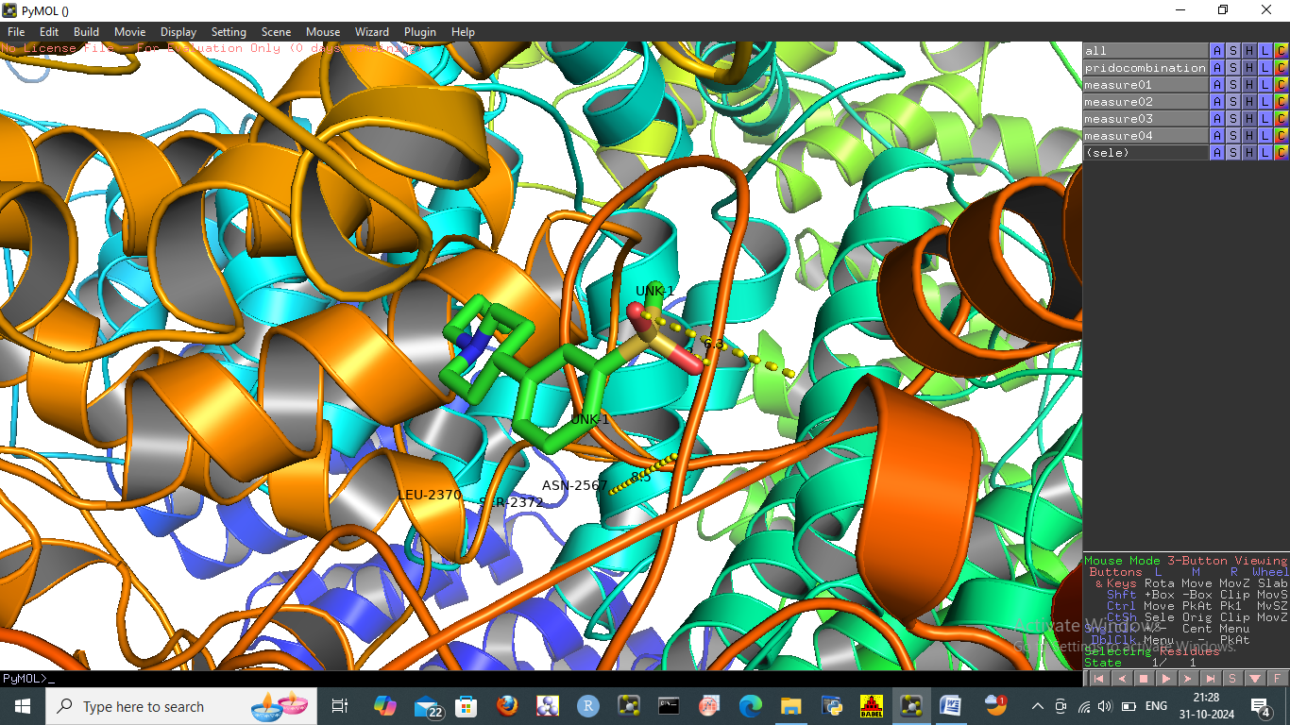

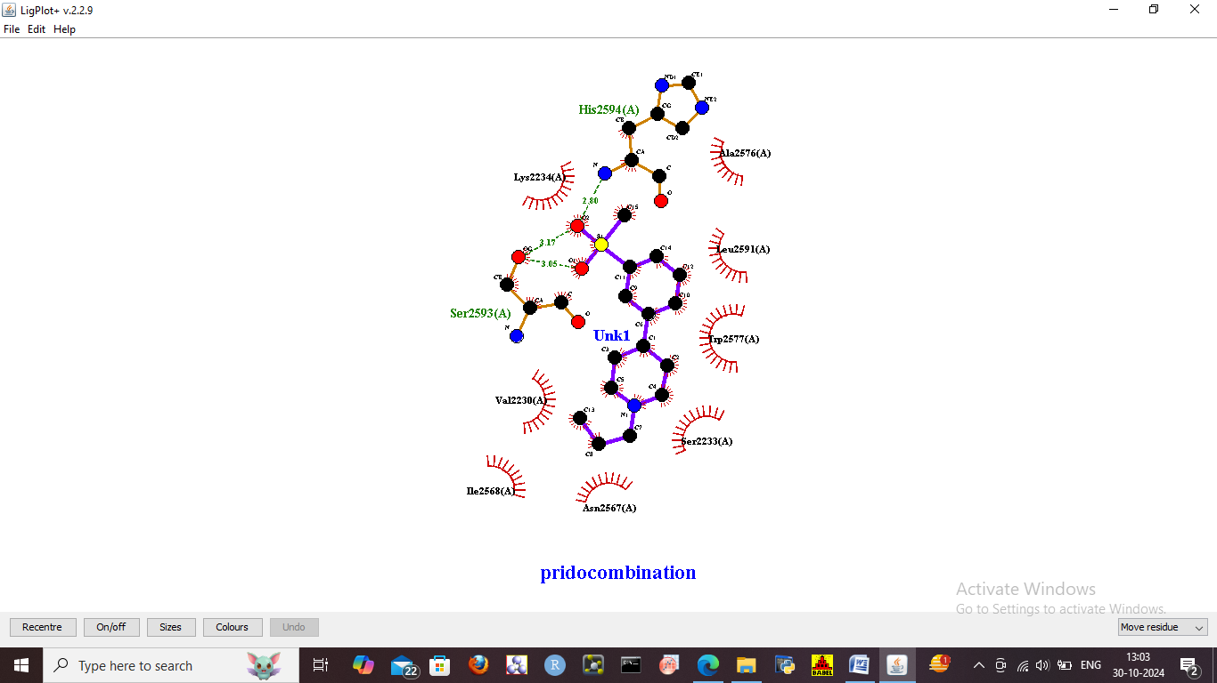

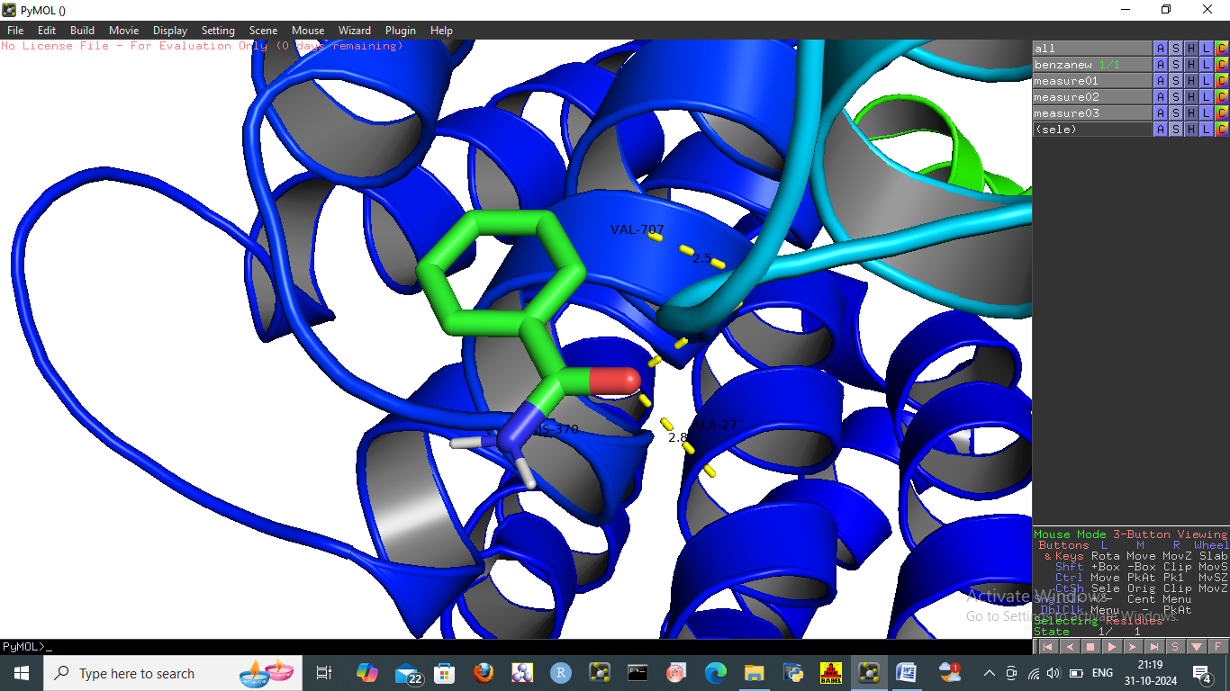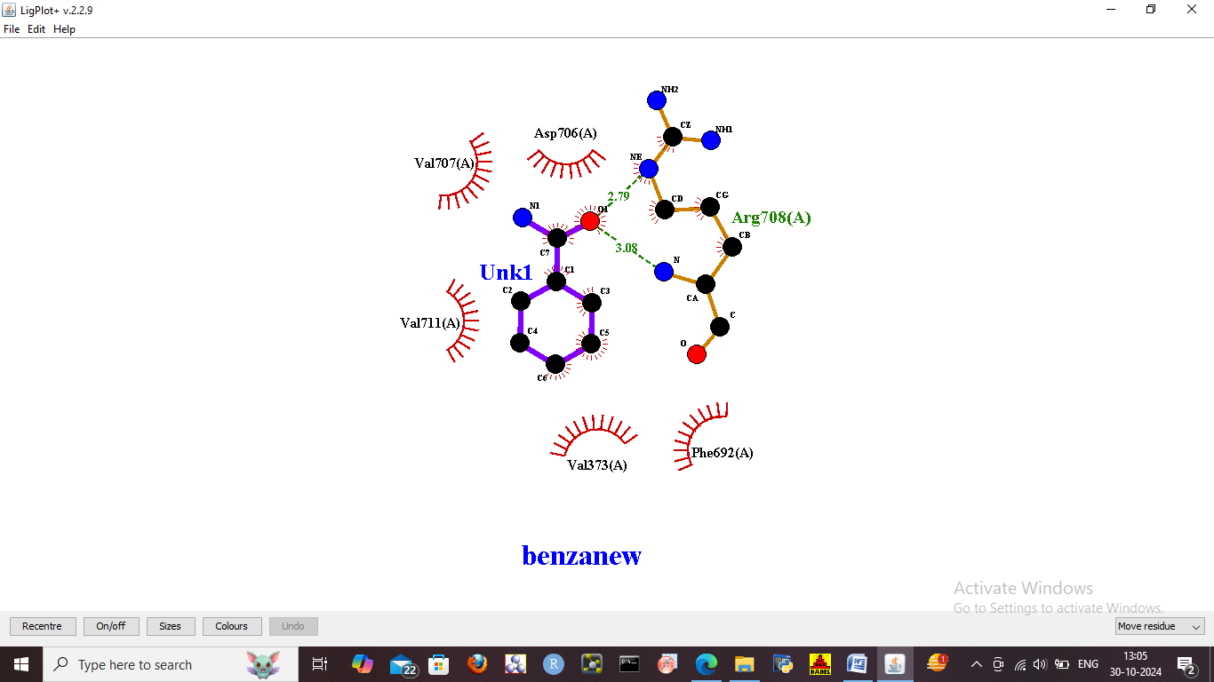

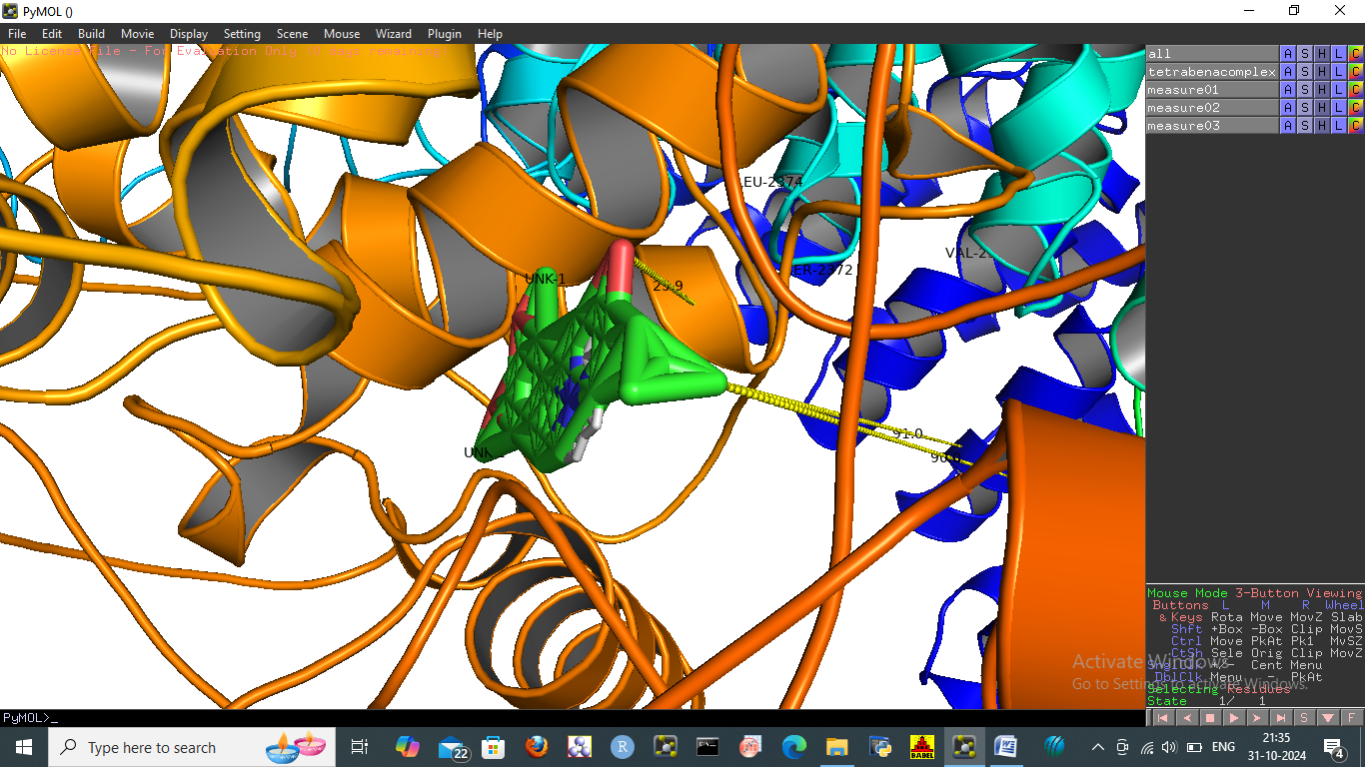

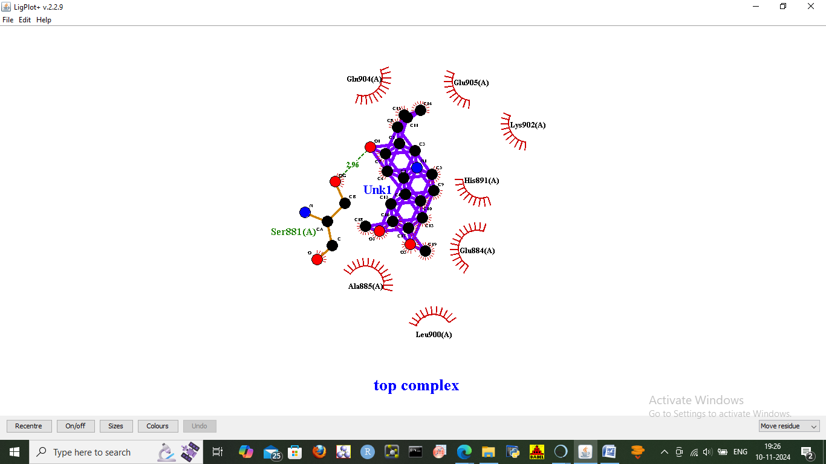

**Fig 5**. Interaction of Huntingtin with the three targeted drugs, highlighting the residues taking part in interaction A. Pridopidine B. Benzamide C. Tetrabenazine

**Conclusion**

Three target drugs are taken for studying interactions with the protein Huntingtin which plays a vital role in Huntington’s disease. Amongst the three drugs, Pridopidine was found to possess the lowest binding energy amongst all the three drugs and thus the highest binding affinity which thus signifies it to be a possible ideal drug candidate and thus hold a significant role in the amelioration of HD. Though it is just a probable hypothetical assumption, further validation is required in clinical trials for these drug molecules for necessary approval in the drug industry. Computational approaches on drug screening will hold a vital role in upcoming modern research.

**References**

1. Walker, Francis O. "Huntington's disease." *The Lancet* 369, no. 9557 (2007): 218-228.
2. Ross, Christopher A., and Sarah J. Tabrizi. "Huntington's disease: from molecular pathogenesis to clinical treatment." *The Lancet Neurology* 10, no. 1 (2011): 83-98.
3. Vonsattel, Jean-Paul, Richard H. Myers, Thomas J. Stevens, Robert J. Ferrante, Edward D. Bird, and Edward P. Richardson Jr. "Neuropathological classification of Huntington's disease." *Journal of Neuropathology & Experimental Neurology* 44, no. 6 (1985): 559-577.
4. Duan, Wenzhen, Ece Urani, and Mark P. Mattson. "The potential of gene editing for Huntington’s disease." *Trends in neurosciences* 46, no. 5 (2023): 365-376.
5. Ganesh, Sowmiyalakshmi, Thillai Chithambaram, Nadesh Ramu Krishnan, Durai Raj Vincent, Jayakumar Kaliappan, and Kathiravan Srinivasan. "Exploring huntington’s disease diagnosis via artificial intelligence models: a comprehensive review." *Diagnostics* 13, no. 23 (2023): 3592.
6. Li, Shi-Hua, and Xiao-Jiang Li. "Huntingtin–protein interactions and the pathogenesis of Huntington's disease." *TRENDS in Genetics* 20, no. 3 (2004): 146-154.
7. Zheng, Zhiqiang, and Marc I. Diamond. "Huntington disease and the huntingtin protein." *Progress in molecular biology and translational science* 107 (2012): 189-214.
8. Jerom, Jenat Pazheparambil, Sooryalekshmi Madhukumar, Raveendran Harikumaran Nair, and Sunilkumar Puthenpurackal Narayanan. "Anti-amyloid potential of some phytochemicals against Aβ-peptide and α-synuclein, tau, prion, and Huntingtin protein." *Drug discovery today* 28, no. 12 (2023): 103802.
9. Liu, Li, Huichun Tong, Yize Sun, Xingxing Chen, Tianqi Yang, Gongke Zhou, Xiao-Jiang Li, and Shihua Li. "Huntingtin Interacting Proteins and Pathological Implications." *International Journal of Molecular Sciences* 24, no. 17 (2023): 13060.
10. Sun, Xiao, Lu Liu, Chao Wu, Xueying Li, Jinzhen Guo, Junqiu Zhang, Junhong Guan et al. "Mutant huntingtin protein induces MLH1 degradation, DNA hyperexcision, and cGAS–STING-dependent apoptosis." *Proceedings of the National Academy of Sciences* 121, no. 13 (2024): e2313652121.
11. Wu, Yongjiang, Yanfei Wang, Yunchi Lu, Junguo Yan, Hongjun Zhao, Riyun Yang, and Jingying Pan. "Research advances in huntingtin-associated protein 1 and its application prospects in diseases." *Frontiers in Neuroscience* 18 (2024): 1402996.
12. Ramos, Eduardo Silva, Todd M. Greco, Ileana M. Cristea, and Erich E. Wanker. "Huntingtin protein–protein interactions: From biology to therapeutic targets." In *Huntington's Disease*, pp. 159-186. Academic Press, 2024.
13. Parkin, Georgia M., Jody Corey-Bloom, Chase Snell, Haileigh Smith, Angela Laurenza, Manuel Daldin, Alberto Bresciani, and Elizabeth A. Thomas. "Salivary Huntingtin protein is uniquely associated with clinical features of Huntington’s disease." *Scientific reports* 13, no. 1 (2023): 1034.
14. Shenkman, Marina, Michal Geva, Noga Gershoni‐Emek, Michael R. Hayden, and Gerardo Z. Lederkremer. "Pridopidine reduces mutant huntingtin‐induced endoplasmic reticulum stress by modulation of the Sigma‐1 receptor." *Journal of Neurochemistry* 158, no. 2 (2021): 467-481.
15. Jabłońska, Magdalena, Klaudyna Grzelakowska, Bartłomiej Wiśniewski, Ewelina Mazur, Kamil Leis, and Przemysław Gałązka. "Pridopidine in the treatment of Huntington’s disease." *Reviews in the Neurosciences* 31, no. 4 (2020): 441-451.
16. Naia, Luana, Philip Ly, Sandra I. Mota, Carla Lopes, Carina Maranga, Patrícia Coelho, Noga Gershoni-Emek et al. "The sigma-1 receptor mediates pridopidine rescue of mitochondrial function in Huntington disease models." *Neurotherapeutics* 18 (2021): 1017-1038.
17. Ahamad, Shakir, and Shahnawaz A. Bhat. "The emerging landscape of small-molecule therapeutics for the treatment of Huntington’s disease." *Journal of medicinal chemistry* 65, no. 24 (2022): 15993-16032.
18. Murphy, Ryan E., Pingyuan Wang, Saghir Ali, Hudson R. Smith, Daniel E. Felsing, Haiying Chen, Jia Zhou, and John A. Allen. "Discovery of 3-((4-Benzylpyridin-2-yl) amino) benzamides as Potent GPR52 G Protein-Biased Agonists." *Journal of Medicinal Chemistry* (2024).
19. Cai, Erli, Yage Chen, Jing Zhang, Haozheng Li, Yiran Li, Shuai Yan, Zhiyong He, Quan Yuan, and Ping Wang. "Imaging specific proteins in living cells with small unnatural amino acid attached Raman reporters." *Analyst* (2024).
20. Jiang, Dongfang, Tingting Li, Caixia Guo, Tie-Shan Tang, and Hongmei Liu. "Small molecule modulators of chromatin remodeling: from neurodevelopment to neurodegeneration." *Cell & Bioscience* 13, no. 1 (2023): 10.
21. Vadlamani, Nandini, Sabina Ibrahimli, Farees Ahmad Khan, Jason A. Castillo, Kavya Sai Satya Amaravadi, Poornachandra Nalisetty, Safeera Khan, Nandini S. Vadlamani, and Kavya Amaravadi. "Efficacy and Safety of Tetrabenazine in Reducing Chorea and Improving Motor Function in Individuals With Huntington's Disease: A Systematic Review." *Cureus* 16, no. 10 (2024).
22. Ruyi, W. A. N. G., F. A. N. Jingjing, L. I. Honglin, and W. A. N. G. Rui. "Mechanism of Tetrabenazine Regulating TH and Synaptic Vesicle Transport to Improve HD." *Journal of East China University of Science and Technology* 49, no. 2 (2023): 211-219.
23. Zaru, Rossana, Sandra Orchard, and UniProt Consortium. "UniProt tools: BLAST, align, peptide search, and ID mapping." *Current protocols* 3, no. 3 (2023): e697.
24. Peter, Swathik Clarancia, Valarmathi Ramanathan, G. Hemaprabha, and Chinnaswamy Appunu. "Isolation and characterization of drought responsive Aldehyde dehydrogenase (ALDH) gene from drought tolerant wild relative of sugarcane, Erianthus arundinaceus." *Journal of Sugarcane Research* 11, no. 2 (2023): 180-190.
25. Zhang, Runhua, Baozhong Zhu, Tengsheng Jiang, Zhiming Cui, and Hongjie Wu. "Enhancing Drug-Target Binding Affinity Prediction through Deep Learning and Protein Secondary Structure Integration." *Current Bioinformatics* 19, no. 10 (2024): 943-952.
26. Azimi, Reza, Mustafa Ozgul, Maria Cristina Kenney, and Baruch D. Kuppermann. "Bioinformatic Analysis of Small Humanin Like Peptides using AlfaFold-2 and Expasy ProtParam." *Investigative Ophthalmology & Visual Science* 65, no. 7 (2024): 1320-1320.
27. Huang, Yan, Hui Luo, Yihui Jin, Yuheng Ma, Yan Zhao, Xin Gao, Yuting Zhao et al. "Design of the artificial N-peptides with coiled-coil trimer structure against HIV-1 based on the SWISS MODEL and HDOCK-aided strategy." *Organic & Biomolecular Chemistry* (2024).
28. Verma, Surbhi, and Pravir Kumar. "Computational Approach for Prediction of NMDA antagonist in Huntingtin’s Disease." In *2024 OPJU International Technology Conference (OTCON) on Smart Computing for Innovation and Advancement in Industry 4.0*, pp. 1-6. IEEE, 2024.
29. Khan, Muneeza Qayyum, Hira Mubeen, Zohaira Qayyum Khan, Ammara Masood, Asma Zafar, Javed Iqbal Wattoo, and Alim Un Nisa. "Computational insights into missense mutations in HTT gene causing Huntington’s disease and its interactome networks." *Irish Journal of Medical Science (1971-)* 192, no. 3 (2023): 1435-1445.
30. Azad, Iqbal. "Molecular docking in the study of ligand-protein recognition: an overview." *Molecular Docking-Recent Advances* (2023).
31. Liang, Fuqiang, Yumeng Shi, Jiayi Shi, and WeiWei Cao. "Exploring the binding mechanism of pumpkin seed protein and apigenin: Spectroscopic analysis, molecular docking and molecular dynamics simulation." *Food Hydrocolloids* 137 (2023): 108318.
32. Zhang, Qun, Wei Fan, Yan Shi, Zongcai Tu, Yueming Hu, and Jing Zhang. "Interaction between soy protein isolate/whey protein isolate and sucrose ester during microencapsulation: Multi-spectroscopy and molecular docking." *LWT* 188 (2023): 115363.
33. Basu, Anamika, Anasua Sarkar, and Ujjwal Maulik. "Molecular docking study of potential phytochemicals and their effects on the complex of SARS-CoV2 spike protein and human ACE2." *Scientific reports* 10, no. 1 (2020): 17699.
34. Zhang, Qun, Wei Fan, Yan Shi, Zongcai Tu, Yueming Hu, and Jing Zhang. "Interaction between soy protein isolate/whey protein isolate and sucrose ester during microencapsulation: Multi-spectroscopy and molecular docking." *LWT* 188 (2023): 115363.
35. Hall, Barry G., and Jeremiah Nisbet. "Building phylogenetic trees from genome sequences With kSNP4." *Molecular Biology and Evolution* 40, no. 11 (2023): msad235.
36. Grigoriadis, Kristiana, Ariana Huebner, Abigail Bunkum, Emma Colliver, Alexander M. Frankell, Mark S. Hill, Kerstin Thol et al. "CONIPHER: a computational framework for scalable phylogenetic reconstruction with error correction." *Nature Protocols* 19, no. 1 (2024): 159-183.
37. Mahfudhah, Nariswari. "PHYLOGENETIC TREE FORMATION ANALYSIS OF SARS-COV-2 ORF3A PROTEIN USING NEIGHBOR-JOINING." *Eduvest: Journal Of Universal Studies* 3, no. 11 (2023).
38. Martin-Solana, Eva, Laura Casado-Zueras, Teobaldo E. Torres, Gerardo F. Goya, Maria-Rosario Fernandez-Fernandez, and Jose-Jesus Fernandez. "Disruption of the mitochondrial network in a mouse model of Huntington's disease visualized by in-tissue multiscale 3D electron microscopy." *Acta Neuropathologica Communications* 12, no. 1 (2024): 88.
39. Ethirajulu, Ajith Kumar, Vineesh Sriramoju, Amruta Gajanan Bhat, and Murali Ramanathan. "Evaluating AlphaFold for Clinical Pharmacology and Pharmacogenetics: A Case-Study of Huntingtin Variants Linked to Huntington’s Disease." *The AAPS Journal* 26, no. 6 (2024): 1-10.
40. Lobato, Amanda G., Natalie Ortiz-Vega, Yi Zhu, Deepa Neupane, Katlyn K. Meier, and R. Grace Zhai. "Copper enhances aggregational toxicity of mutant huntingtin in a Drosophila model of Huntington's Disease." *Biochimica et Biophysica Acta (BBA)-Molecular Basis of Disease* 1870, no. 1 (2024): 166928.
41. Lin, T-C., Orion Shih, T-Y. Tsai, Y-Q. Yeh, K-F. Liao, Bradley W. Mansel, Y-J. Shiu et al. "Binding structures of SERF1a with NT17-polyQ peptides of huntingtin exon 1 revealed by SEC-SWAXS, NMR and molecular simulation." *IUCrJ* 11, no. 5 (2024).
42. Stoebner, Zachary A., Kilian Hett, Ilwoo Lyu, Hans Johnson, Jane S. Paulsen, Jeffrey D. Long, and Ipek Oguz. "Comprehensive shape analysis of the cortex in Huntington's disease." *Human brain mapping* 44, no. 4 (2023): 1417-1431.
43. Ferguson, Ross, Robert Goold, Lucy Coupland, Michael Flower, and Sarah J. Tabrizi. "Therapeutic validation of MMR-associated genetic modifiers in a human ex vivo model of Huntington disease." *The American Journal of Human Genetics* 111, no. 6 (2024): 1165-1183.
44. Kim, Sunghwan, and Evan E. Bolton. "PubChem: A Large‐Scale Public Chemical Database for Drug Discovery." *Open Access Databases and Datasets for Drug Discovery* (2024): 39-66.
45. Rudrapal, Mithun, Kevser Kübra Kirboga, Mohnad Abdalla, and Siddhartha Maji. "Explainable artificial intelligence-assisted virtual screening and bioinformatics approaches for effective bioactivity prediction of phenolic cyclooxygenase-2 (COX-2) inhibitors using PubChem molecular fingerprints." *Molecular Diversity* (2024): 1-20.
46. Stanzione, Francesca, Ilenia Giangreco, and Jason C. Cole. "Use of molecular docking computational tools in drug discovery." *Progress in medicinal chemistry* 60 (2021): 273-343.