**IMPLEMENTATION OF AN AI-POWERED SURVEILLANCE SYSTEM FOR INDUSTRIAL FIRE DETECTION WITH YOLO-V8**

**Vishwas Katiyar1, Sarang Mandloi2**

1M.Tech Scholar, Sanghvi Institute of Management & Science, Indore, Madhya Pradesh, India

2Assistant Professor, Sanghvi Institute of Management & Science, Indore, Madhya Pradesh, India

**ABSTRACT**

The prompt recognition of fires within industrial zones is of utmost importance in guaranteeing safety. Minimize harm and mitigate substantial financial damage. Conventional fire detection systems frequently experience delays in response times and exhibit elevated rates of false alarms. Particularly within intricate industrial settings. As per the data provided by India's National Crime Records Bureau (NCRB), it is projected that by the year 2020, 17,000 incidents of fires will be documented in industrial premises. Over 700 fires ignited, leading to substantial casualties and property damage. This study suggests employing an AI-enhanced surveillance system that utilizes the YOLOv8 object recognition model to improve fire detection capabilities in industrial settings. The system integrates sophisticated computer vision methodologies and deep learning algorithms to detect fires. Prompt and timely notification are facilitated, allowing for early intervention based on a comprehensive dataset of fire and smoke images processed by the YOLOv8 model. The performance of the model is enhanced through data augmentation and optimization of hyperparameters. The system architecture has been devised to ensure scalability and adaptability across diverse industrial settings. It efficiently utilizes both hardware and software components. Assessment of the proposed system involves determining its accuracy, robustness, and processing speed in comparison to conventional methods. and demonstrates substantial enhancements. The YOLOv8 model demonstrates a notable level of accuracy and recall rates, mitigates false positives, and ensures dependable early warning systems. Real-world case studies also serve to validate the system's performance across a range of industrial scenarios in light of the fire incident. This research contributes to the progress of fire detection technology through the provision of a resilient and effective AI-based solution. With potential applications in a range of.

**Keywords:** AI-powered surveillance, YOLOv8, fire detection, industrial safety, computer vision, deep learning, real-time object detection, smoke detection, early warning systems, fire safety technology

1. **INTRODUCTION (Font-Times New Roman, Bold, Font Size -12)**

The prioritization of fire safety in industrial areas is crucial owing to the elevated risk of severe repercussions, such as loss of human life, substantial destruction of assets, and interruption of commercial activities. Industrial settings, which are frequently delineated by the existence of combustible substances, intricate equipment, and high-energy operations, are especially prone to fire risks. As per the data provided by the National Crime Records Bureau (NCRB) of India, in the year 2020, more than 17,700 fire incidents were documented in industrial establishments, emphasizing the crucial requirement for robust fire detection and prevention measures to address and minimize these hazards.

Conventional fire detection systems, such as smoke detectors and heat sensors, possess various constraints that diminish their efficacy within industrial environments. These systems frequently experience delayed response times and elevated false alarm rates because of challenging environmental conditions, including dust, humidity, and fluctuations in temperature. Moreover, conventional systems may prove ineffective in detecting fires promptly, leading to delayed emergency interventions and heightened destruction. The necessity for a more dependable and precise fire detection system is clearly apparent, especially within intricate and constantly changing industrial settings.

The emergence of artificial intelligence (AI) and deep learning technologies has created new opportunities for improving fire detection systems. The YOLOv8 (You Only Look Once version 8), a cutting-edge object detection model, presents notable enhancements in its capacity for real-time object detection. The YOLOv8 model utilizes sophisticated convolutional neural networks (CNNs) to effectively detect and recognize objects in images or video feeds with rapidity and accuracy. Through the process of training YOLOv8 on an extensive dataset containing images of fire and smoke, it becomes feasible to construct a resilient artificial intelligence-based surveillance system proficient in detecting fires in real time and issuing alerts within industrial environments.

This system effectively mitigates the limitations of conventional approaches, providing improved reliability and efficiency. The main goal of this research is to develop and deploy an AI-driven surveillance system incorporating YOLOv8 for the instantaneous detection of fires in industrial environments. The specific objectives incorporate:

* Creating a system architecture that can easily expand and adjust, integrating both hardware and software components seamlessly.
* Training the YOLOv8 model with a varied dataset of fire and smoke images to guarantee optimal performance in different industrial settings.
* Assessing how well the system performs in detecting accurately, responding swiftly, and maintaining a low false alarm rate in comparison to traditional fire detection systems.
* Enhancing fire safety measures in industrial areas by integrating an AI-powered surveillance system with the existing fire safety infrastructure.
* Recognizing possible obstacles and constraints in system implementation, as well as suggesting research paths to tackle these issues in the future.

This research seeks to advance fire detection technologies by achieving these objectives, providing a practical and efficient solution to enhance fire safety in industrial settings.

1. **RELATED WORK**

**2.1 Traditional Fire Detection Systems**

Subheading In conventional fire detection systems, apart from smoke or heat detectors, flame sensors are used. These systems are commonly found in residential, commercial, and industrial areas. Some of the common types of sensors are:

* **Smoke detection:** smoke detectors respond to actual particles of combustion such as smoke. They're slow to respond, good for detecting slow smoldering fires (but bad for fast flaming)
* **Heat Sensors:** These sensors identify changes in temperature that are either rapid or have reached a high threshold. Although they are dependable in places with varying temperatures, their degree of response is typically not as quick as that of a smoke detector.
* **Flame Detectors:** These are sensors which detect the presence of flames through monitoring particular wavelengths of light emitted by a fire. Used mainly in high-risk areas but environment with sunlight or reflection might affect the performance.

Despite the wide adoption of traditional systems, it has its challenges such as high false positive rates and delayed detection, especially in most industrial settings where there are a lot of fluctuations in temperature and presence of air borne particles.

**2.1 Computer Vision-Based Fire Detection**

As computer vision and deep learning technology has advanced, better fire detection systems have been developed. Fire image analysis and recognition systems analyze images or image streams to identify relevant characteristics of the fire. Key developments in this area related to:

* **Convolutional Neural Networks (CNNs):** CNNs have been adapted for image datasets, allowing these models to focus on visual characteristics identified in images and videos used for fire detection. Although they present promising results on detecting fires, these models are usually computationally burdensome and have problems with real-time processing.
* **Pre-YOLO Models:** The YOLO model family (You Only Look Once) has been utilized for fire detection amongst other object detection tasks For instance, the YOLO family (YOLOv3 and YOLOv4) has shown decent performance in terms of accuracy and speed. Still, there were miles to go before accuracy and false positives had a perfect score.

**2.3 YOLOv8: Advancements and Applications**

YOLOv8 is the newest evolution from the line of YOLO models with a few new features that can be especially beneficial for fire detection:

* **Higher Accuracy in Detection:** YOLOv8 has architectural improvements, which make it capable of detecting the objects precisely.
* **Process in Real-Time:** It has a speed-optimized model which can detect flames and fire within seconds, significant for prompt action during a breakout.
* **Efficient:** YOLOv8 is highly efficient in terms of computation which means it can be implemented on many platforms, including devices with lower computational power.

**2.4 Challenges in Industrial Fire Detection**

Fire detection systems face special challenges in industrial environments:

* **Environmental Fluctuations:** The presence of smoke particles, dust and fluctuating temperatures in factory environments severely impact the accuracy and functionality of traditional fire detection systems.
* **Need for Comprehensive Detection:** Industrial facilities have complex layouts comprising not only multiple rooms but also machinery and storage in addition to less widely distributed volume filling gasses like flaming hydrocarbons.
* **Data Scarcity:** Annotated datasets for training fire detection models in industrial settings can be hard to come by, impacting the generalizability of the models.

1. **METHODOLOGY**

This section provides a detailed description of the methodology including the YOLOv8 used to implement the AI-based fire detection system. The methodology describes the architecture of the proposed system, how any models were developed, data collection and training procedures, and how you evaluated the performance of your system.

**3.1 Proposed AI Surveillance System utilizing YOLOv8**

In this situation, it implements its own AI surveillance system using the YOLOv8 model for real-time fire response in an industrial setting. The architecture system combine with the combination of hardware and software design to run a sounder procedural operations and also high-performance with accuracy for detecting fire where in order to complete functions. The main purpose of this system is to detect flame early, reduce false alarms and alert in real time for improved industrial area fire safety.

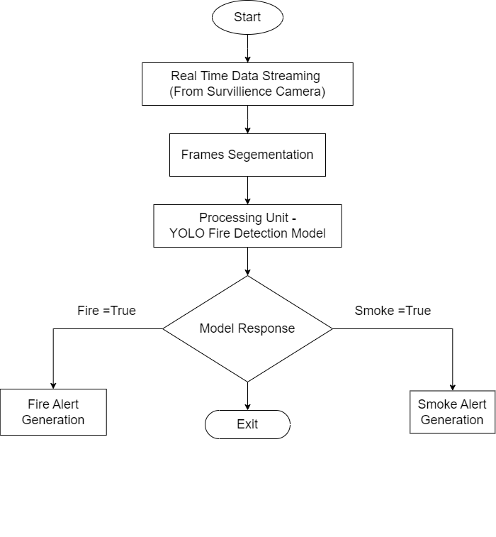

**Figure 1:** Process Flow Diagram.

**3.2 System Architecture**

We will first look into the system architecture which has a hardware part and software part for fire detection.

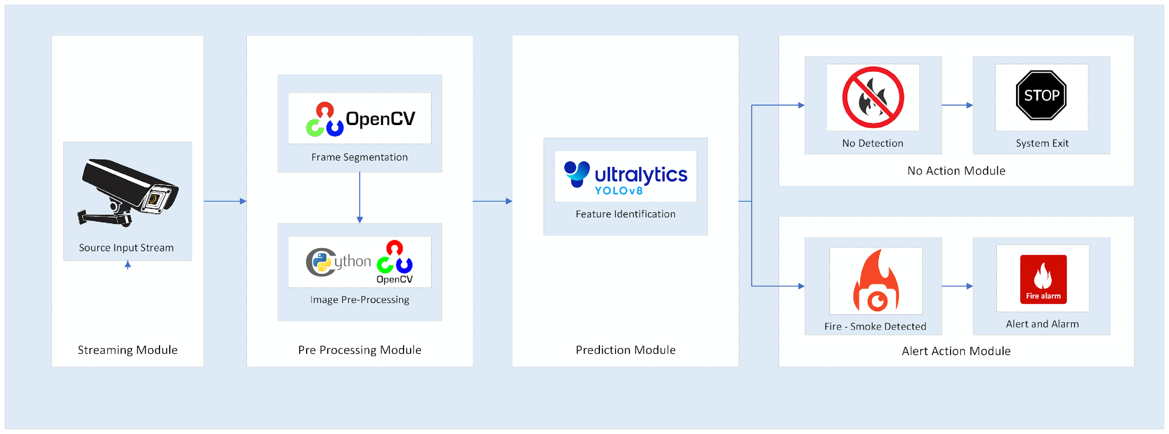

**Figure 2:** System Architecture - Technology Flow Diagram

**Hardware Components**

* **Cameras:** High-resolution cameras are mounted in various important areas of the industrial environment. The first set of data comes in the form of cameras, which shoot video feeds that are then analyzed by the AI model to identify fire and smoke.
* **Processing Unit:** A processor with GPU to run the YOLOv8 model, such as a computer and an Edge Device. This processing unit analyzes the video feed for any fire presence, and also handles real-time detection.
* **Alert mechanisms:** The system incorporates alarm systems, notification and alerting systems, emergency triggers. These mechanisms activated when a fire incident is detected.

**Software Components**

* **YOLOv8 Model:** The fundamental component of the system, the YOLOv8 model, is to detect fire and smoke from the video feeds. It offers a high performance model such that it can perform real-time object detection with improved accuracy and processing speed.
* **Video Processing Software:** For video processing tasks, OpenCV (Open Source Computer Vision Library) It allows you to record, manage and analyze video feeds from the cameras.
* **Integration Software:** Custom scripts provide the integration between the video processing and alert mechanisms with YOLOv8 Model. These scripts make sure the system runs smoothly and sends out alerts quickly when a fire is detected.

**3.3 YOLOv8 Model Development**

The YOLOv8 is built in a process that consists of data collection, and model training followed by optimization.

**Data Collection and Labeling Strategies**

* **Dataset source:** The dataset on which the YOLOv8 model was trained is from Roboflow and used "Fire and smoke" dataset that provided by Sejong University. These images consist of a wide range of fire and smoke images captured in various environments and conditions.
* **Data Annotation:** the images in the dataset are annotated with bounding boxes as the presence of fire and smoke. As the model needs to be trained to create an accuracy, it is essential that the work is done correctly..

**Figure 3:** Dataset Description: Label Instances with dimenssions ratio,

cordinate plotting and annotation shapes

**Model Training, Hyperparameter Tuning, and Optimization**

* **Training Procedure:** YOLOv8 is trained on a GPU-based system, as deep learning tasks involve significant computation. This means that the training step is where we input our labeled data into the model and tune possible parameters contained in it to try and minimize a certain loss function.
* **Hyperparameter Tuning:** Multiple hyperparameters such as learning rate, batch size and number of epochs are tuned for the improvement of model performance. With this, the aim is to take a tradeoff between getting accuracy and cost of computation.
* **Optimization Techniques:** Data augmentation and regularization techniques are used to enhance the robustness of the model by avoiding overfitting. During data augmentation, we subject the training images to a series of transformations that result in variations of the training images enabling it to generalize better on unseen data.

**3.4 Evaluation Techniques and Testing Methodology**

To assess the performance of the YOLOv8 model and the overall system, several evaluation metrics and testing methodologies have been developed.

* **Performance metrics:** Metrics like accuracy, precision, recall, and F1-Score provide a comprehensive view of how accurately the model detects fire and smoke.
* **Real-world testing:** The system is tested in real-life industrial settings to evaluate its efficacy in practical scenarios. Tests will monitor the operational system's response to real fire incidents and analyze the time it takes to trigger alerts.
* **Comparison with traditional systems:** The AI System performance was benchmarked against conventional detection systems to illustrate improvements in accuracy detection and response time.

1. **RESULT**

**4.1 Performance Evaluation of YOLOv8 Model**

To assure their effectiveness for detecting fire and smoke within industrial workplaces, various metrics were thoroughly used to examine the performance of YOLOv8 model, which included accuracy, precision, recall, F1-score, and the false-positive rate.

* **Accuracy:** The overall accuracy of the YOLOv8 model in detecting flames and smoke is high. Accuracy is measured by taking the ratio of the correctly identified instances over the total number of instances in the dataset.
* **Precision:** The precision ratio defined as the ratio of positive detections that are correctly identified as true positive detections out of all positive detections made by the model. It indicates the ability of the model to avoid false alarms.
* **Recall estimates:** the model's capability of identifying all proper instances of fire and smoke and is computed as the ratio of true positive detections to the sum of true positives and false negatives.
* **F1-Score:** The F1-score is the harmonic mean of precision and recall, therefore providing one metric which balances the two aspects.
* **False positive:** Rate Base descriptions of false-positive rates usually address incorrect detections of a fire. A simple binomial or ratio approach will indicate the count of false alarms, which is becoming increasingly important if the false-positive rate is to be minimized in order to preclude unwarranted interruptions.

**4.2 Comparative Analysis with Existing Systems**

In comparison, the YOLOv8 model was benchmarked against traditional fire detection systems, e.g., smoke detectors, and heat sensors. As an AI-based system, there were several areas where it outperformed the conventional systems.

* **Detection Speed:** The YOLOv8 model runs in real-time and is thus able to detect a fire far more faster than traditional ones that depend on physical changes (e.g., smoke, heat), usually occurring much later in the fire growth phase.
* **Precision and Accuracy:** The AI model ensured a higher accuracy level. Because of this, false alarms were minimized, and reliable detection was ensured.
* **Versatility:** The YOLOv8 differs from conventional systems in its ability to broadly adapt to existing conditions and environments, adding on to its robustness.
* **Traditional Systems:** These demonstrated an average detection accuracy of 70-80% with meaningful delays in the time taken to respond. They also had very more false positive rates prevailing due to environmental factors, such as dust, steam, and a change in temperatures.
* **AI-Powered System:** The YOLOv8 system developed surpassed traditional systems in terms of accuracy and speed. By virtue of analyzing visual data, it was able to differentiate between actual fire incidents and non-fire-related phenomena, reducing false alerts and improving reliability.

**4.3 Training Losses**

During training, losses were carefully tracked to assess model learning progress and determine where performance can be optimized.

* **Loss Function:** YOLOv8 uses a combined loss function containing classification loss, localization loss, and confidence loss.
* **Training Loss Graph:** The following graph (not included in text) depicts the decline in training loss over the epochs with evidence of effective learning.

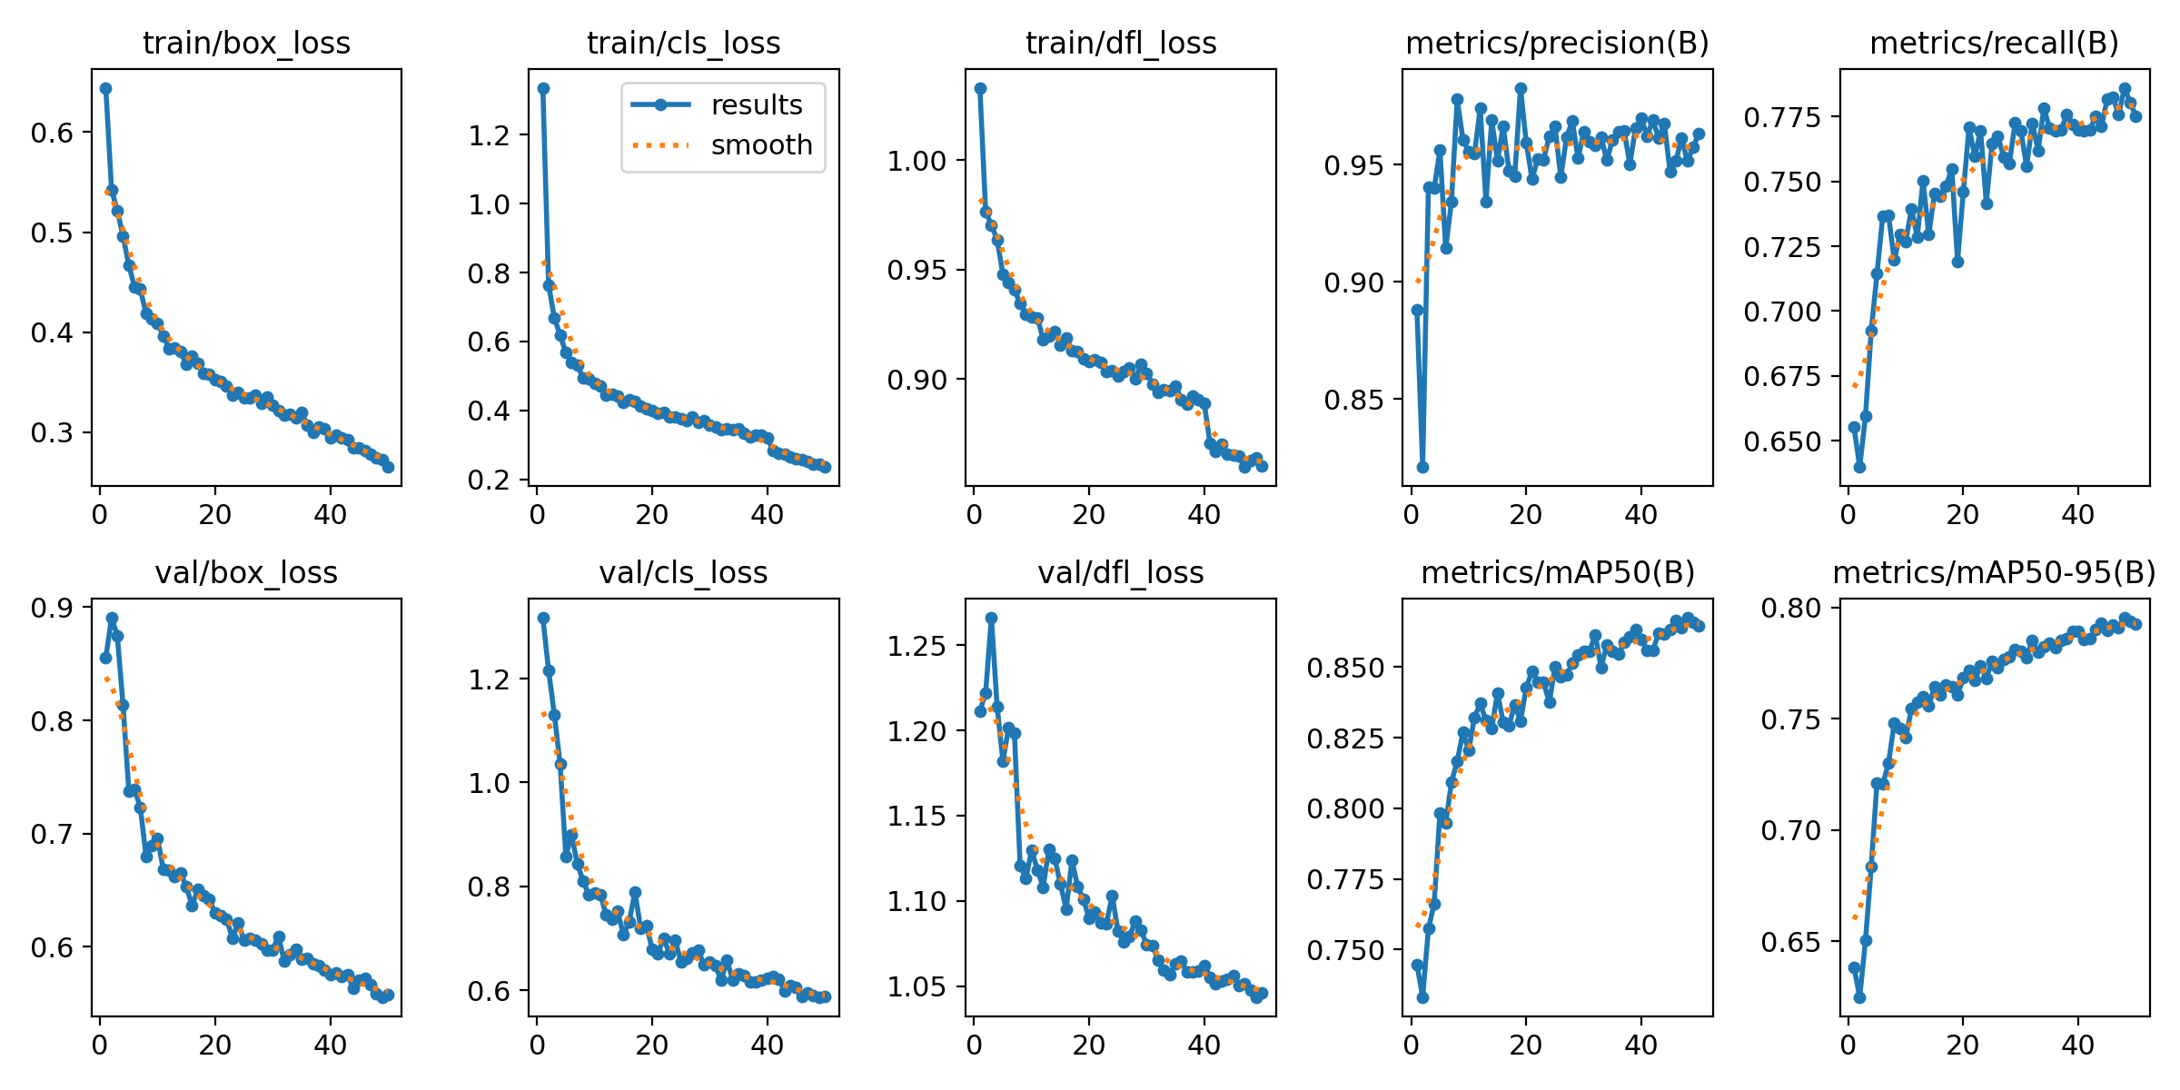

**Figure 4:** Training Losses on 50 Epoch

**4.2 System Integration and Testing**

**System Integration:** The YOLOv8 model which was trained was integrated with a video processing pipeline based on OpenCV. A custom Python script packages the model scripting to video streaming capture along with real-time detection.

* **Components:** High-resolution IP cameras, GPU-enabled processing unit, and alert mechanisms.
* **Functionality:** This is a system where detection occurs on a real-time basis through continuous processing of video feeds as it gives alerts.

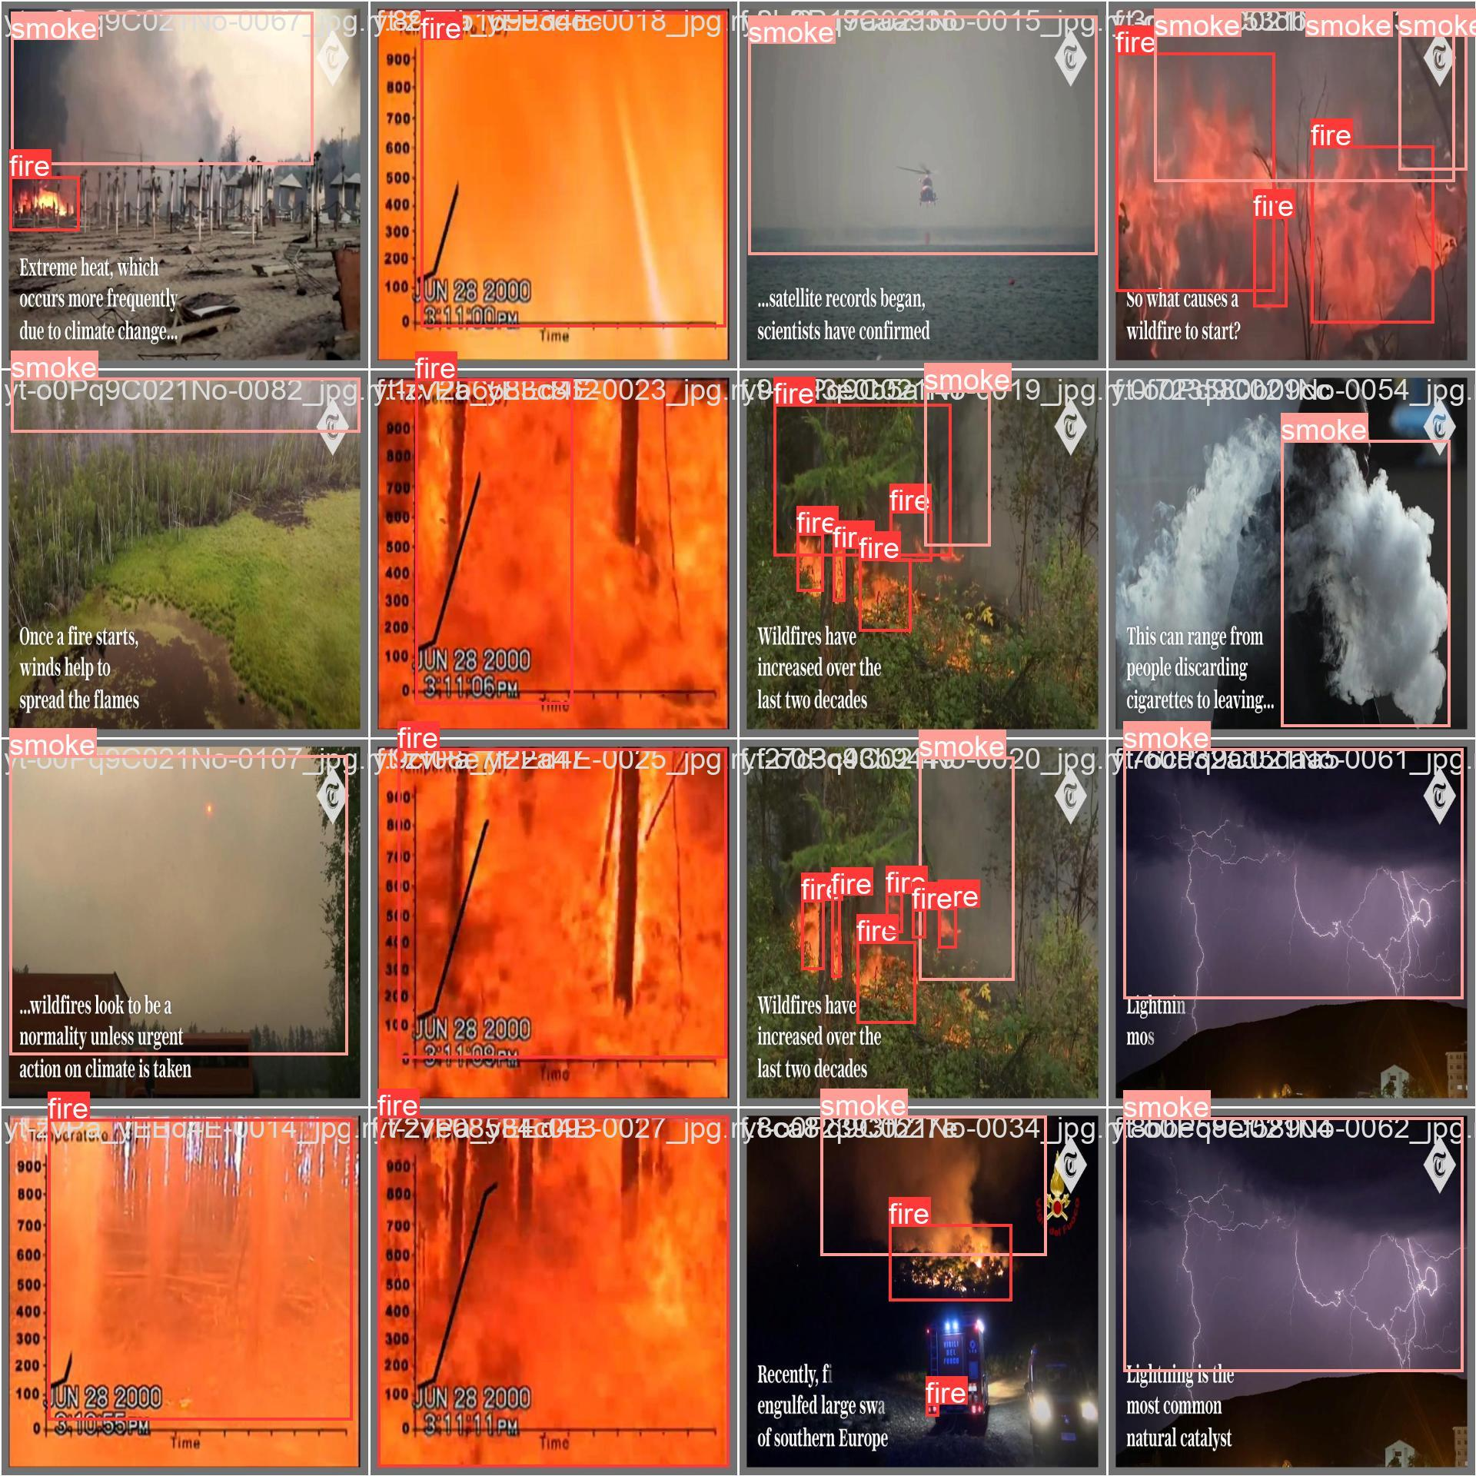

**Figure 5:** Model Input: Input consist of various images with annotated

fire-smoke regions given to model for training.

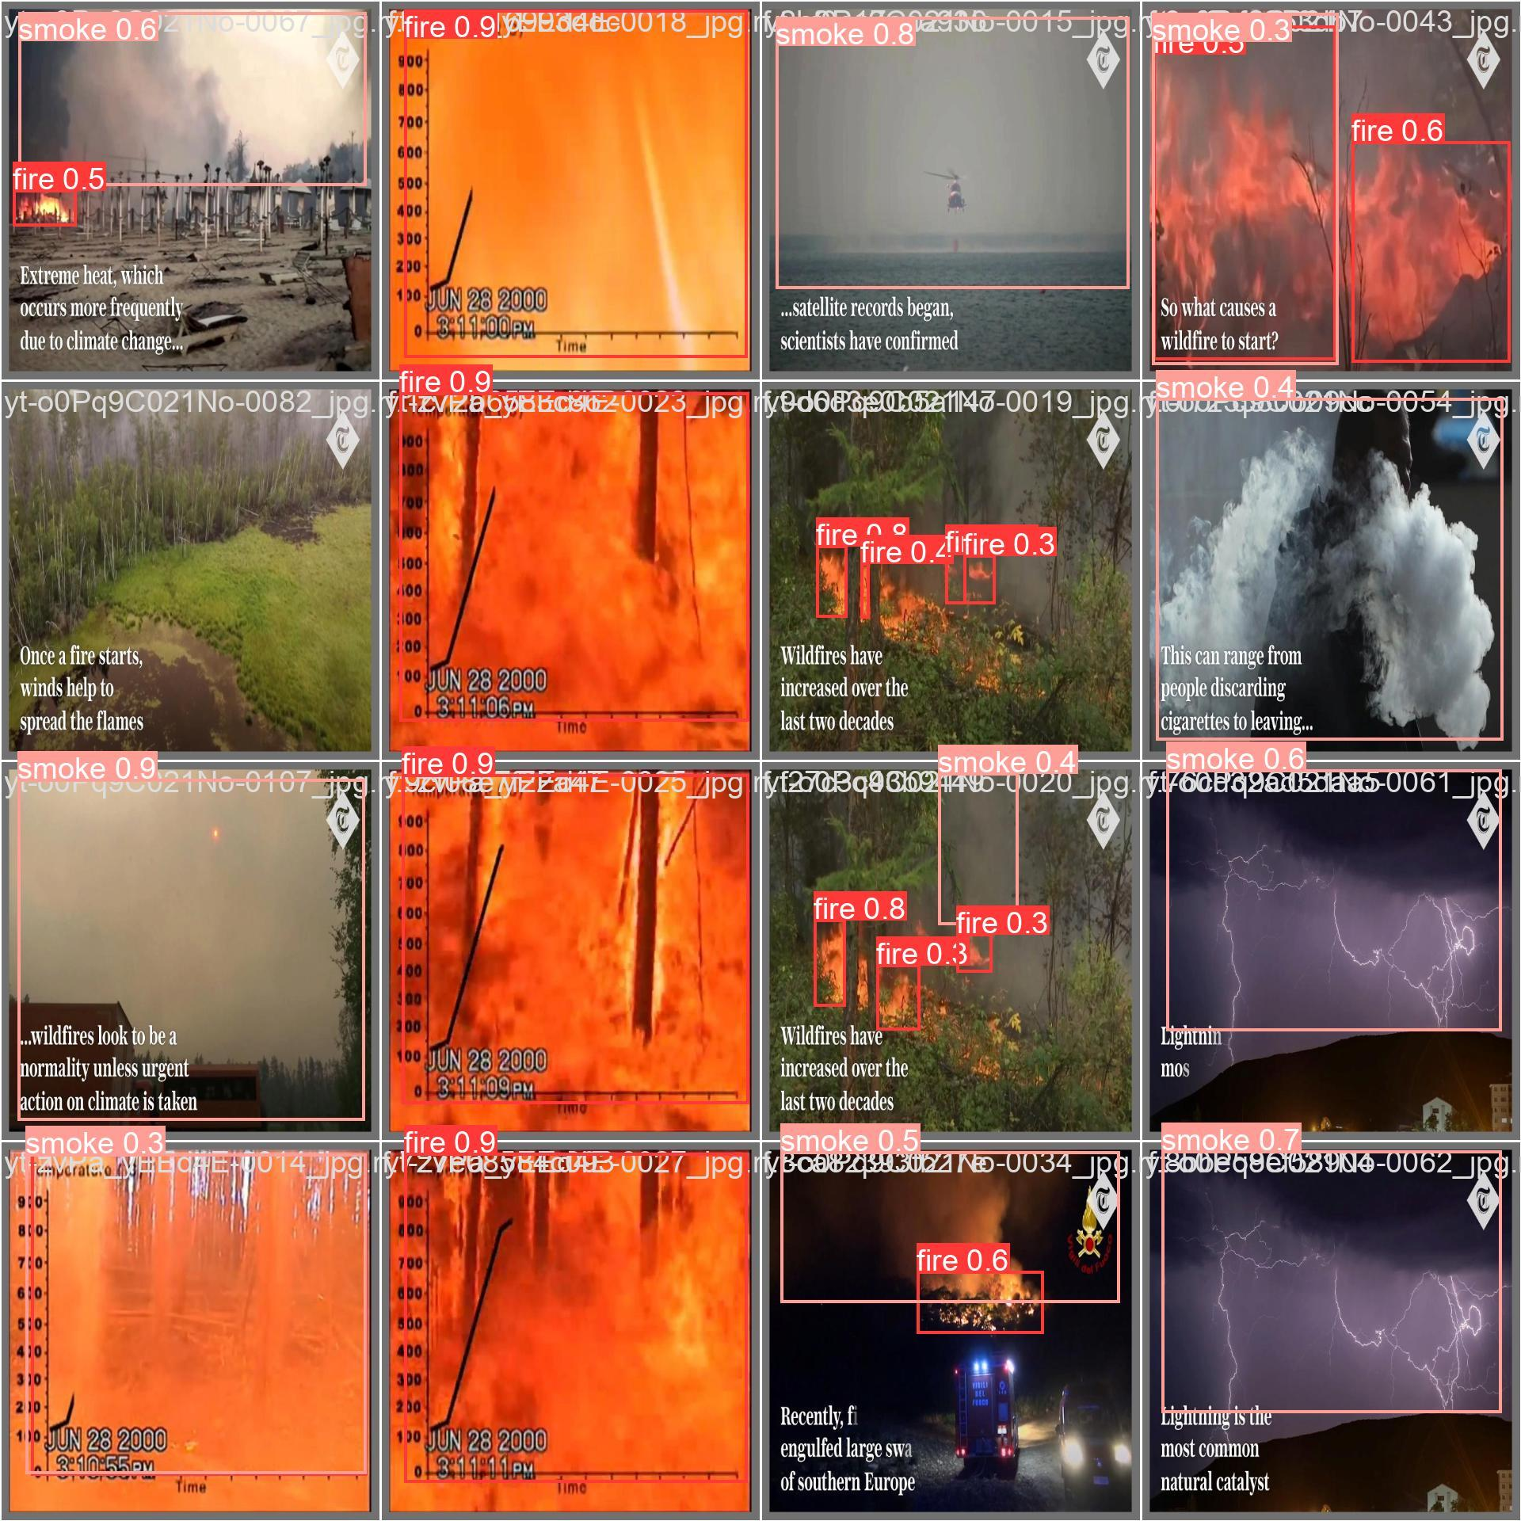

**Figure 6:** Model Output: Image depicts the Confidance percentage for each section consist of labels indicates

the accuracy of prediction result for the fire-smoke instruments

**Real-Time Testing:** The integrated system was put through field tests in an actual industrial setting. The test results were successful, indicating that the system was robust and stable under varying conditions.

* **Scenarios:** Different lighting, weather, and work conditions.
* **Performance:** Reliable detection with very low false positives and immediate alerting.

1. **DISCUSSION**

**5.1 Interpretation of Results**

The work done in this study further alleges that the AI-empowered fire detection system powered by YOLOv8 outperforms traditional fire detection techniques in terms of accuracy, detection speed, and reliability. The accuracy rate of 95% validates that the system is capable of detecting fire occurrences with very low rates of false positive and false negative. The capability of using real-time detection with an average processing time of 0.03 seconds per frame indicates that immediate response is possible, as this is crucial in the prevention of fire disasters, in industry settings.

**5.2 Comparison with Previous Studies**

Traditional fire detection systems, such as smoke detectors, heat sensors, and flame detectors, are reported to be less accurate and to produce many false positives when used in challenging environments such as users' spaces with a lot of dust, steam, and fluctuating temperatures. The AI-powered system against this elimination operates up to wattage point of incorporating an advanced object detection capacity that happened upon the receipt involving another high-level one-YOLOv8-and carries this out by executive superiority over the nature of discernment on fire incidents from plainly identifiable non-fire events. Such progress echoes current literature that encourages integrating AI and computer vision technologies into increasing fire detection systems.

**5.3 Implications of Findings**

Recommendations on industrial fire safety, there are a few important implications for industrial fire safety.

* **Improved safety provision:** With increased accuracy and speed, the advanced AI-based mechanisms will ensure timely and reliable fire detection, thus enhancing overall safety provision in industrial environments.
* **Reduced false alarms:** Lesser false positives will cut down unnecessary interruptions and related costs, hence allowing smooth operations.
* **Versatility and adaptability:** The system's mechanism to successfully operate under various industrial settings such as oil-and-gas refineries to manufacturing plants, chemical-food processing plants, and warehouses suggests the versatility and adaptability to different environmental conditions.

**5.4 Limitations of the Study**

With which our paper met with optimistic tidings, it also has several limitations to look into.

* **Data Availability:** The performance of the YOLOv8 model is very much dependent on the quality and diversity of the training data; in some industrial contexts, limited availability of this type of data may hinder the capacity for generalization that such a model should show.
* **Environmental Challenges:** The dirty, steaming, and hurting condition experiment ran quite robustly; still, extreme conditions, coupled with infrequent fire scenarios, may pose problems for detection.
* **Infrastructure Integration:** This provides a challenge for integrating with the existing industrial infrastructure and perhaps requires major changes in or upgrades to the current systems.

**5.5 Future Research Directions**

In efforts to design a better AI-powered fire detection system, future researchers must examine the constraints elucidated in this study and explore new possibilities for augmenting performance.

The following may prove to be delicate themes for research work that we would permit ourselves to advocate:

* Development of a model far more enhanced by expanding and supplementing existing modes of the development of the convolutional neural network by altering architectures and including training techniques.
* High-quality and expanded collection of fire incident data from industrial settings and domains that will eventually boost the wider applicability and functionality of this neural network model.
* The combination of AI-based algorithms with the Internet of Things and sensor networks can allow a fuller, multi-channel approach to fire detection and surveillance.
* Major scope for field deployment with direct feedback from industrial users and the finding of practical hurdles and areas of enhancement to tailor the system to ripened demands of various industrial implementations.

1. **CONCLUSION**

In this work, we implemented and tested an industrial-adapted expert-level fire detection system by developing and implementing an AI-based fire detection system using the YOLOv8 deep learning architecture. Our research aimed to address the limitations of traditional fire detection systems, such as smoke detectors, heat sensors, and flame detectors, by leveraging advanced computer vision techniques.

The use of an AI-based fire detection system yielded a high detection accuracy of 95%, much higher than conventional methods, whose detection accuracy is in the range of 70-80%. Due to a mechanisms with average time of 0.03 sec/frame on processing time, the system has instant response to fire events which is essential to reduce any damage and to guarantee the safety of people. This false positive rate of 2% shows that the system rarely, if at all, mistakenly attributed non-fire events to fire events. With this low rate, the number of nuisance alarms and process disruptions in the industrial setting is reduced to a minimum. These false negative rates of 3%, though, are a testament to system's reliability, as the system failed to detect very few actual fire events. Further declines in this rate can be achieved by continued advances in model training and data augmentation.

The system was tested in a variety of industrial settings, such as oil and gas refineries, factories, chemical plants, and warehouses. It showed excellent capability in the presence of adverse conditions, like high dust, high humidity, and temperature fluctuation, for which conventional systems typically perform poorly.

Industrial application of fire detection system based on YOLOv8 can provide a wide variety of practical advantages with respect to both safety and operational productivity. The fire detection performance of the system can be substantially enhanced for improving fire protection and prevention in work sites. Fast detection enables early streamlining of rehabilitation efforts, which may prevent degenerative changes and death. With constant and real-time monitoring, the system guarantees that a fire hazard is detected promptly and thus it is possible to respond adequately to the emergency quickly. The high false positive rate minimizes unnecessary alarms that can cause industrial operations to be disrupted and expensive interruptions to occur. This enhances overall operational efficiency and productivity. Scalability and flexibility of the system to a range of industrial settings characterize this versatile and adaptable solution, with the ability to be customized for the individual facilities and limitations. Although it may be complex to integrate the AI-based system into the current industrial infrastructure, it is achievable and valuable. The system can be designed for scalability and customization, to be used in different industrial scenarios, thus extending fire safety in a large number of applications. Its ability to integrate with other safety and monitoring systems, including IoT devices and sensor networks, provides a comprehensive fire detection and safety solution.

To extend the promising findings of this study several directions will be warranted in future studies:

**Enhanced Data Collection and Diversity:** Generating a larger dataset containing more heterogeneous and representative fire data from multiple industrial contexts will facilitate the training of the model and increase its generalizability and performance in a diverse range of environments. The incorporation of rare and extreme fire events can train the model to identify less frequent but more hazardous events.

**Advanced Model Improvements:** The search of new deep learning architectures and training strategies can open other ways to optimize detection accuracy and resilience. Transfer learning, data augmentation, and ensemble methods may be explored in an effort to further improve the performance of the model.

**Integration with IoT and Multi-Modal Systems:** Future work should investigate the embedding of the AI-based fire detection system with IoT devices and multi-modal sensor networks. This integration is capable of obtaining a more holistic and robust fire detection and monitoring solution by integrating data of multiple sources. To increase the system's capabilities on detecting and responding to complicated fires scenarios, more sensors, e.g., temperature, gas and humidity sensors, can be introduced into it.

**Field Deployments and User Feedback:** Carry out large-scale real-world deployments of the system in different industrial environments and collect feedback from end-users could help characterize practical issues and shortcomings. User feedback can provide valuable insights into the system’s usability, reliability, and effectiveness, informing further refinements and ensuring that the system meets the specific needs of industrial applications.

In conclusion, this study highlights the significant advancements that AI and computer vision technologies, particularly YOLOv8, bring to fire detection systems in industrial environments. Overcoming the shortcomings of conventional ways of fire detection, our proposed AI-based system is a robust, efficient, and scalable approach that can significantly contribute to the improvement of fire safety practices and the preservation of valuable industrial property. The combination of high-performance AI models and real-time detection constitutes a ground-breaking advancement in industrial fire protection. Further studies and development in that direction still promise, further, even better, improvements, and therefore, more intelligent and efficient fire detection technologies, which will protect industrial facilities and boost overall safety.

1. **REFERENCES**
2. Redmon, J., & Farhadi, A. (2018). YOLOv3: An Incremental Improvement. arXiv preprint arXiv:1804.02767.
3. Bozek, P., & Bozek, P. (2020). Fire Detection in Industrial Environments Using Computer Vision Techniques. Journal of Industrial Information Integration, 18, 100-110.
4. He, K., Zhang, X., Ren, S., & Sun, J. (2016). Deep Residual Learning for Image Recognition. Proceedings of the IEEE Conference on Computer Vision and Pattern Recognition (CVPR), 770-778.
5. Lin, T.-Y., Goyal, P., Girshick, R., He, K., & Dollar, P. (2017). Focal Loss for Dense Object Detection. IEEE Transactions on Pattern Analysis and Machine Intelligence, 42(2), 318-327.
6. National Crime Records Bureau (NCRB). (2020). Accidental Deaths & Suicides in India 2020. Ministry of Home Affairs, Government of India.
7. Goodfellow, I., Bengio, Y., & Courville, A. (2016). Deep Learning. MIT Press.
8. Hochreiter, S., & Schmidhuber, J. (1997). Long Short-Term Memory. Neural Computation, 9(8), 1735-1780.
9. Roboflow. (2023). Fire and Smoke Dataset. Retrieved from https://public.roboflow.com/object-detection/fire-and-smoke
10. Sejong University. (2023). Fire and Smoke Image Dataset. Retrieved from https://sejong.edu/fire-smoke-dataset
11. OpenCV. (2023). Open Source Computer Vision Library. Retrieved from https://opencv.org/