# OPTIMIZING DRUG INVENTORY MANAGEMENT AND SUPPLY CHAIN TRACKING SYSTEM

**Mr.B.Varun Kumar , P.Brindhaa , M.Harini , G. Abinayasri**

**Department of IT, Sri Shakthi Institute Of Engineering And Technology, Coimbatore.**

Mr.B.Varun Kumar

[varunkumarb@siet.ac.in](mailto:varunkumarb@siet.ac.in)

P.Brindhaa

[brindhaapooja@gamil.com](mailto:brindhaapooja@gamil.com)

M.Harini

[harinidhanam05@gmail.com](mailto:harinidhanam05@gmail.com)

G.Abinayasri

[abinayasrig@gmail.com](mailto:abinayasrig@gmail.com)

**ABSTRACT:**

The contemporary pharmaceutical supply chain is a complicated process wherein research is conducted to create medications, which are then manufactured in accordance with the findings and sent from the producer to pharmacies. Numerous parties are involved in this process, including the producer, distributor, wholesaler, pharmacies, and, lastly, the patient who are the end consumers. Pharmaceutical product demand must guide inventory management at every level. An inventory management system is essential since having too much inventory could be expensive for the pharmacy. It is also more complicated because it must keep track of medication lot numbers and expiration dates. The pharmaceutical supply chain has a number of challenges, including inventory management, lack of visibility in transportation and storage, medicine shortages, and temperature control of drugs.

**KEYWORDS:**

Drug inventory control-Stock tracking -Supply chain -Real time monitoring-Replenishment-Tracking system -Logistics management -Future scopes -(RFID)stands for Radio Frequency Identification.

**INTRODUCTION:**

Effective drug inventory management and supply chain tracking are essential in the ever-changing healthcare industry to guarantee on-time medication delivery, reduce stockouts and overstocking, and preserve overall operational effectiveness. Optimising pharmaceutical supply chains has never been more crucial due to the growing complexity of these supply chains, which is being driven by the worldwide need for medications, vaccines, and medical supplies.



**LOGIN PAGE:**

Authorised users, such as chemists, inventory managers, and supply chain administrators, can manage crucial activities from a centralised, secure entry point provided by a pharmacy login page tailored for drug inventory management and supply chain tracking. Tools for processing batch records, managing expiration dates, keeping an eye on stock replenishments, and tracking inventory levels are accessible through this login page. With role-based access added, it guarantees that users only see information and features pertinent to their responsibilities, safeguarding private data while promoting effective workflows.



**REGISTER PAGE:**

For the purpose of securing and streamlining operations, a pharmacy's registration system that is tailored for medicine inventory management and supply chain tracking is essential. Authorised people, including pharmacists, inventory managers, and supply chain coordinators, are given access to vital tools and data required for inventory management and supply chain supervision through a restricted registration process. Role-based permissions are commonly included in the registration system to guarantee that each user's access corresponds with their duties, whether those duties involve managing stock replenishments, keeping an eye on expiration dates, maintaining inventory levels, or supervising batch and shipping records

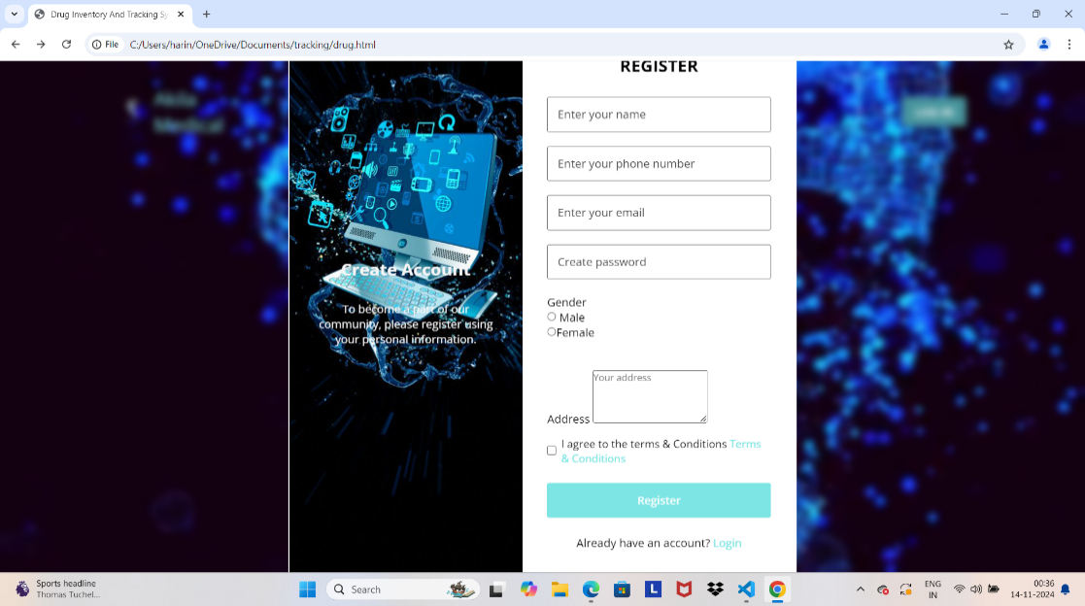Top of Form

**HOME PAGE:**

The home page of a pharmacy system designed for supply chain tracking and drug inventory management acts as a primary dashboard, providing users with instant access to key features and information for supply chain monitoring and inventory management. The main page, which is intended for administrators, stock managers, and chemists, offers real-time information on stock levels, notifications of low or expired stock, and updates on incoming shipments.

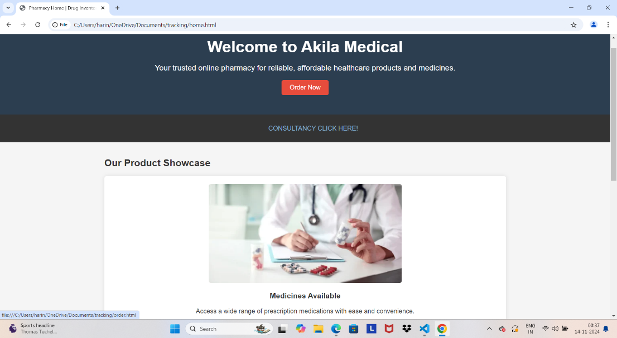

**BROWSE PAGE:**

Users can effectively search, display, and filter vital inventory and supply chain data on the browse page of a pharmacy system designed for drug inventory management and supply chain tracking. Pharmacists, inventory managers, and supply chain coordinators can quickly find specific medications, verify stock levels, monitor batch and expiration dates, and evaluate supplier details using this interface. The explore page, which is enhanced with search filters including medicine category, supplier, stock status, and expiration term, makes it easy to locate and examine inventory based on up-to-date information.

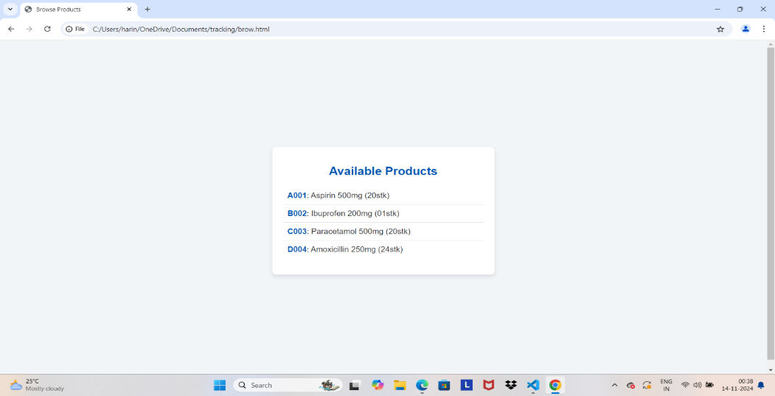

**VIEW PAGE:**

In a pharmacy system designed for supply chain tracking and drug inventory management, the View Products page gives users thorough, up-to-date information on available stock and product data. Pharmacists, inventory managers, and supply chain staff may examine vital information about each product, including batch numbers, expiration dates, supplier information, and the quantity on hand, in one convenient location. Users may easily find certain products by categories, such as medication kind, stock status, or supplier, thanks to advanced filtering and sorting tools, which aid in effective inventory management.

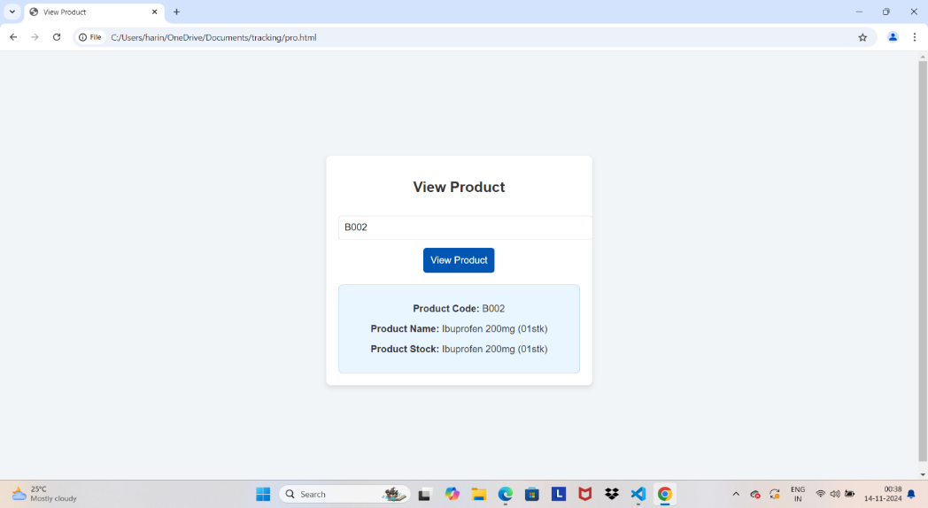

**CONSULTANCY PAGE:**

Pharmacies and healthcare facilities can increase overall efficiency, cut expenses, and streamline operations with the help of a consulting service tailored for drug inventory management and supply chain tracking. From precise demand forecasts and stock replenishment plans to controlling expiration dates and cutting down on waste, this service offers professional advice on putting best practices for managing medicine inventory into effect. To enhance stock control, consultants evaluate the present inventory procedures, pinpoint problems, and provide customised solutions like real-time analytics and automated inventory tracking.



**ORDER NOW PAGE:**

Are you prepared to improve your supply chain tracking system and manage your medicine inventory more effectively? Purchase today to take advantage of a smooth, data-driven solution that can optimise your pharmacy's operations, cut expenses, and guarantee the prompt delivery of prescription drugs. Our technology gives your team the ability to effectively manage stock levels, expiration dates, and shipments by offering real-time inventory tracking, precise demand forecasts, and end-to-end supply chain insight.

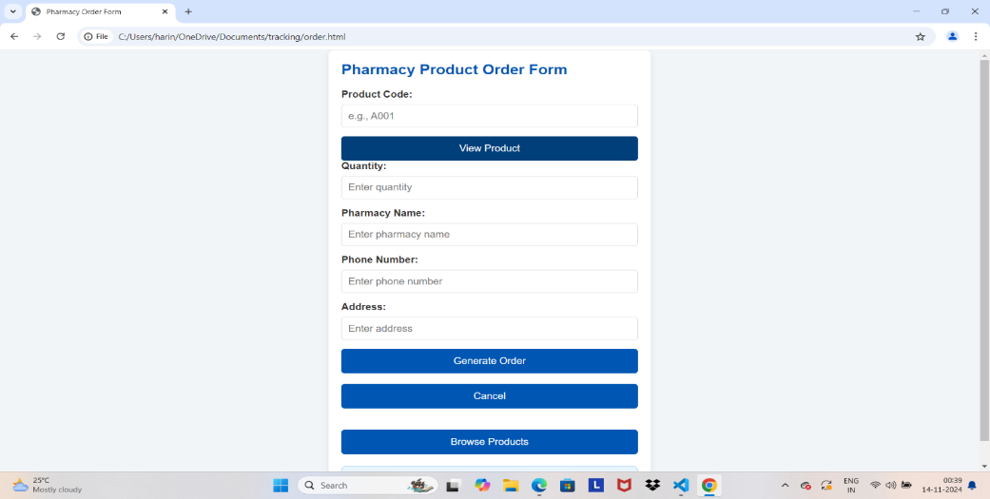

**ABOUT US PAGE:**

Pharmacies and healthcare facilities can increase overall efficiency, cut expenses, and streamline operations with the help of a consulting service tailored for drug inventory management and supply chain tracking. From precise demand forecasts and stock replenishment plans to controlling expiration dates and cutting down on waste, this service offers professional advice on putting best practices for managing medicine inventory into effect.

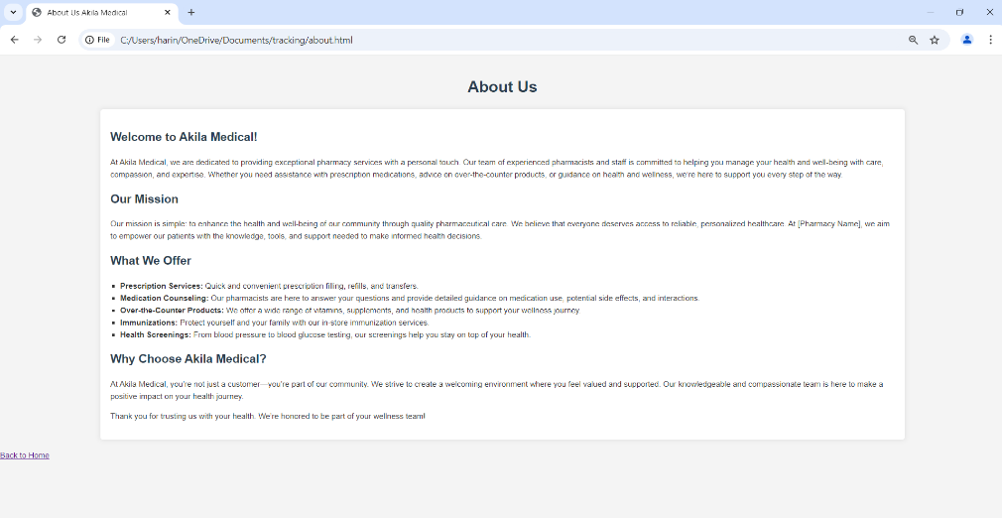

**CONTACT US PAGE:**

Please get in touch with us if you have any questions about improving supply chain tracking and managing medicine inventories. Our team of professionals is prepared to talk about how we can help your pharmacy run more efficiently, save money, and increase the supply of medications. We offer customised solutions that fit in well with your workflow, whether your interests are in demand forecasting, real-time inventory tracking, or end-to-end supply chain transparency.

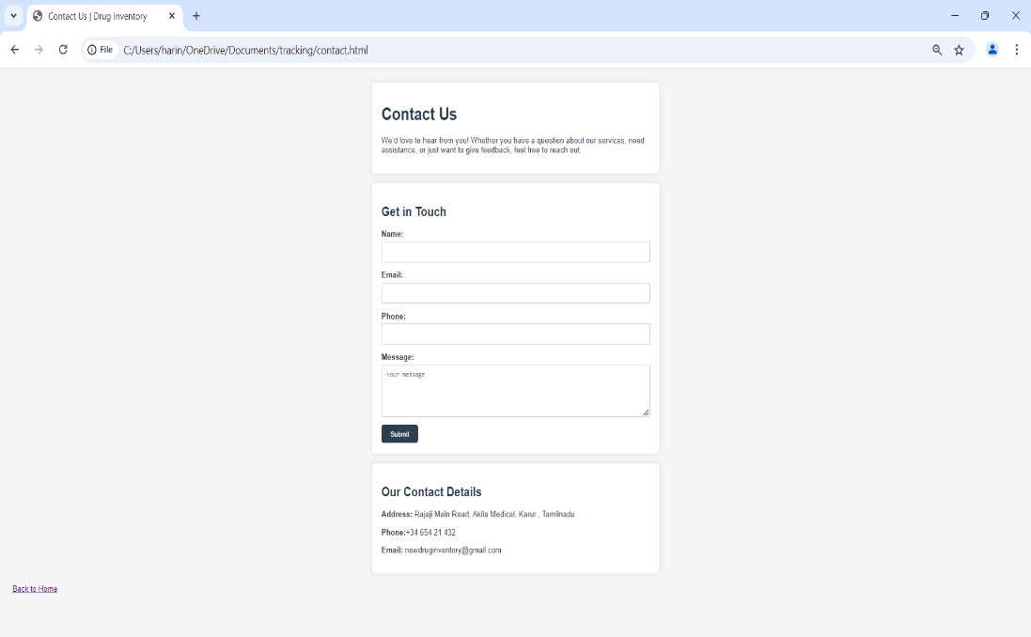

**FEEDBACK PAGE:**

As we continue to improve our supply chain tracking and drug inventory management systems, we appreciate your feedback. In order for us to better serve your requirements and enhance pharmacy operations, your input is essential. We invite you to share your experience with us, whether you have questions, comments, or recommendations regarding our services

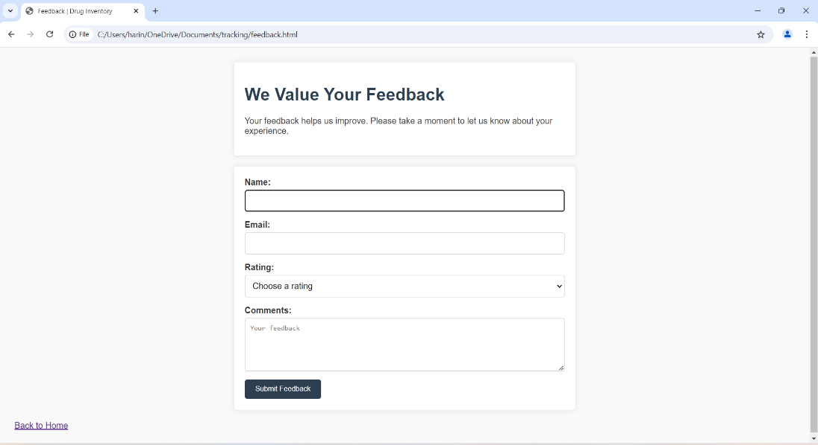

**PROPOSED METHOD:**

1. **Implementation of Automated Inventory Management Systems:** Track medications in real time from suppliers to shelves using RFID or barcode scanning technology. This guarantees precise monitoring of batch numbers, expiration dates, and stock levels. By integrating with pharmacy management software, manual errors can be avoided and automated updates can be provided.

**2. Demand Forecasting and Predictive Analytics:** Use sophisticated forecasting methods that examine past data and present patterns to better accurately predict the demand for medications.

**3**. **Supply Chain Visibility from Start to Finish:** Create an integrated supply chain system that allows visibility from the pharmacy's shelves to the supplier's warehouse. Effective replenishment planning will be aided by real-time updates on shipment tracking, order status, and delivery schedules, which will reduce delays. With the help of cloud-based technologies, suppliers, distributors, and pharmacy management can work together to ensure openness and seamless communication.

**4.** **Automated Stock Alerts and Reordering:** Install reordering mechanisms that are automatically triggered when stock levels drop below specified levels. This guarantees timely medication replenishment and constant inventory optimisation. In order to minimise waste and enhance inventory turnover, alerts for slow-moving medications or expired goods can also be created. Making Decisions Based on Data. Use real-time data analytics to acquire knowledge.

**CONCLUSION:**

For pharmacies and healthcare facilities to guarantee the availability, security, and effectiveness of their pharmaceutical supply, drug inventory management and supply chain tracking must be optimised. Pharmacies may cut expenses, cut waste, and avoid stockouts by implementing automated systems, real-time tracking, predictive analytics, and improved supply chain transparency. Putting these tactics into practice also increases data accuracy, promotes improved decision-making, and improves adherence to healthcare rules. Additionally, by connecting these systems with enterprise resource planning (ERP) and pharmacy management software, a smooth information flow is produced that helps pharmacy employees effectively manage demand, track shipments, and keep an eye on stock levels.

**FUTURE SCOPE:**

**1. Incorporation of Artificial Intelligence (AI) tools:** Predictive analytics and AI-driven demand forecasting may continuously improve inventory management by examining trends and patterns, increasing stock prediction accuracy, and lowering shortages and surpluses. By learning from past data and adjusting to seasonal demands or abrupt changes in pharmaceutical requirements, machine learning algorithms can optimise reordering procedures.

**2. Real-time tracking and IoT:** Smart sensors that detect the temperature, humidity, and location of critical medications in real time across the supply chain can be made possible by Internet of Things (IoT) technology. This will guarantee ideal storage circumstances and improve compliance with safety standards.

**3. Blockchain for transparent supply chains:** A safe, decentralised method for monitoring the flow of drugs from production to distribution is provided by blockchain technology. Transparency, authenticity, and traceability are guaranteed, which can improve patient safety, strengthen regulatory compliance, and stop counterfeiting. Additionally, blockchain can simplify regulatory reporting by streamlining record-keeping and producing an unchangeable audit trail Robotic Process.

**4. Automation (RPA) and Automation:** Particularly in high-volume pharmacies and distribution centres, robotic process automation and automated storage and retrieval systems (AS/RS) can further streamline the selection, replenishment, and stock handling procedures. Inventory data management Repetitive chores can be handled by RPA, which lowers manual error rates and frees up employees for more important work. Business intelligence and advanced analytics as big data becomes more prevalent, complex analytics can give pharmacies even more insight.

**REFERENCE:**

1. **Real-Time Inventory Tracking:** To guarantee precise, current inventory management, put in place automated systems that offer real-time updates on stock levels, expiration dates, and batch numbers.
2. **Demand Forecasting:** To precisely predict medicine demand and prevent stockouts and overstocking while maintaining medication supply, use predictive analytics and historical data.
3. **Supply Chain Transparency:** To guarantee on-time delivery and promptly detect supply chain interruptions integrate end-to-end tracking from suppliers to drugstore shelves.
4. **Data-Driven Decision Making:** Pharmacy teams can watch sales patterns, optimize purchasing schedules, and find cost-saving opportunities by integrating data analytics technologies.
5. **Compliance and regulatory tracking:** verify that systems adhere to healthcare laws and keep correct records, especially for controlled substances, to make sure that all legal and regulatory obligations are fulfilled.
6. **Automation and Integration:** To save manual labour and streamline operations, use automated ordering systems and connect inventory management with enterprise resource planning (ERP) or pharmacy management systems (PMS).