**SUPPLY CHAIN MANAGEMENT**

Department of Information Technology

Batchelor of Technology

Sri Shakthi Institute of Engineering and Technology (Autonomous) Coimbatore-641062

­­­­­­­­­­­­­­­­­­­­ **ABSTRACT**

The Supply Chain Management (SCM) system is designed to enhance the efficiency, transparency, and resilience of supply chain operations. This project integrates advanced data analytics, machine learning, and real-time tracking to overcome the limitations of traditional SCM systems, such as demand volatility, inventory imbalances, and poor response to disruptions. By utilizing diverse data sources—including historical demand, market trends, and consumer insights.

The system provides accurate demand forecasting and optimal inventory management. Key features include real-time visibility across the supply chain, predictive analytics for proactive decision-making, and a responsive structure that mitigates risks such as stockouts and overstocking. The system’s modular design supports scalability, enabling businesses to adapt quickly to market changes, streamline operations, and ultimately improve customer satisfaction and profitability­­­­­­­­­­­­­­­­­­­­___________________________________________________________________________

**INTRODUCTION**

Supply Chain Management (SCM) is the strategic coordination of business processes to efficiently manage the flow of goods, information, and finances from raw material suppliers to the end customer. SCM encompasses every aspect of production, from sourcing materials to manufacturing, warehousing, and distribution. It aims to streamline operations, minimize costs, and maximize product availability and customer satisfaction. Effective SCM enables companies to respond swiftly to market demands, reduce waste, and build strong relationships with suppliers and distributors. As businesses become more global, SCM plays a critical role in maintaining competitiveness and ensuring sustainability.

***Keywords****:*  Supply Chain Optimization, Inventory Management, Demand Forecasting, Logistics and Distribution , Real-time Tracking, Data Analytics , Machine Learning Predictive Analytics, Risk Mitigation , Supplier Management.

# OBJECTIVE:

1. Facilitate a seamless transition from traditional manual processes to a digital SCM platform, improving the efficiency and transparency of supply chain operations.

2. Implement strong data security and access control measures to protect sensitive information and maintain the integrity of transactions across the supply chain.

3. Develop a scalable infrastructure that accommodates fluctuating demand and varied user loads, ensuring smooth operations even during peak periods or disruptions.

4. Design a user-centric interface tailored for suppliers, managers, and logistics personnel, making the platform intuitive, easy to navigate, and adaptable for diverse roles.

5. Leverage advanced analytics to gain insights into demand patterns, inventory levels, and supplier performance, empowering decision-makers with data-driven insights for strategic planning.

6. Incorporate cutting-edge technologies such as AI-driven demand forecasting, machine learning algorithms, and IoT-enabled tracking to enhance visibility, efficiency, and agility throughout the supply chain.

**LITERATURE SURVEY**

The literature survey for supply chain management (SCM) explores a wide range of studies, articles, and academic publications to understand the historical development, technological advancements, and existing challenges in this field. This research aims to capture the evolution of SCM from traditional, manual processes to the implementation of advanced digital and automated solutions. It highlights how technology—particularly artificial intelligence, IoT, and blockchain—has transformed traditional SCM practices, enhancing efficiency, accuracy, and adaptability across industries.

The review investigates current SCM practices, strategies, and technologies, including real-time data tracking, predictive analytics, and automated inventory management. It examines the strengths and limitations of existing SCM systems in terms of security, scalability, and their ability to respond to dynamic market demands and disruptions. The survey aims to identify recurring themes, innovative solutions, and areas for improvement in SCM practices, with a focus on agility and resilience.

By assessing various scholarly sources, this literature review provides insights into how supply chain management can further leverage technology to enhance transparency, efficiency, and responsiveness. It also identifies gaps within existing literature, offering direction for future SCM system enhancements that are user-focused, sustainable, and adaptable to evolving market needs. The goal is to contribute to the academic understanding of supply chain management and support ongoing advancements in digital SCM solutions.

# METHODOLOGY

The development of a supply chain management (SCM) platform follows a structured approach to meet the demands of inventory tracking, demand forecasting, and real-time data integration. The process begins with a thorough analysis of requirements, engaging key stakeholders to identify the essential features, including inventory management, order processing, and supplier coordination. Once the requirements are clear, the system’s architecture is designed using a technology stack that ensures scalability and security, such as React for the frontend, Node.js for backend logic, and MongoDB for data management. Cloud services like AWS or Azure are chosen to enable reliable access and scaling capabilities.

The UI/UX design focuses on creating intuitive interfaces tailored for different users, emphasizing dashboards and reports that offer clear, actionable insights. Backend development integrates critical functions, including inventory tracking, supplier coordination, and demand forecasting, with real-time data feeds and third-party APIs for up-to-date information. Security measures, such as HTTPS protocols and access controls, protect data integrity and ensure user privacy. The database is structured to handle high data volumes efficiently, supporting real-time access to critical supply chain data. Rigorous testing—encompassing functional, performance, and security aspects—ensures that the platform operates reliably and securely.

Deployment takes place in a cloud-based environment, with Docker used for containerization to facilitate updates and scalability. CI/CD pipelines automate deployment, enabling smooth feature rollouts and updates. User documentation, including detailed manuals and FAQs, supports platform onboarding, while training sessions prepare users to fully utilize the platform’s functionalities. Post-deployment, continuous monitoring ensures optimal performance, and user feedback is systematically gathered to inform iterative improvements. This methodical approach results in a robust, adaptable SCM platform that supports efficient, real-time supply chain management.

## **EXISTING SYSTEM**

The current supply chain management (SCM) systems primarily rely on traditional approaches, combined with basic digital tools, to handle inventory, order processing, and demand forecasting. These systems use historical data and standard statistical methods to predict demand, which often results in limited accuracy when responding to sudden changes in the market. Many existing SCM solutions operate with disparate information silos, making it challenging to achieve seamless coordination between suppliers, distributors, and customers. Additionally, these systems frequently lack real-time tracking and data integration, which can hinder visibility across the supply chain. Although some systems incorporate basic enterprise resource planning (ERP) tools, they are often unable to fully address the complexities of modern supply chain dynamics, such as fluctuating customer demands, supply disruptions, and rapid changes in market conditions. Consequently, traditional SCM systems may experience inefficiencies, such as delayed response times, stock imbalances, and missed optimization opportunities.

**Disadvantages:**

* Existing systems often lack real-time tracking, reducing supply chain visibility and slowing response times to disruptions.
* Forecasting relies heavily on historical data and basic statistical models, leading to inaccuracies in demand predictions and inefficient inventory management.
* Many traditional SCM solutions operate in isolated silos, causing fragmented data and hindering seamless communication across suppliers, manufacturers, and distributors.
* Older systems are vulnerable to security risks due to outdated encryption and cybersecurity practices, increasing the likelihood of data breaches.
* These systems are generally rigid, making it difficult to incorporate new data sources or adapt to dynamic market conditions.
* Limited data integration hampers effective decision-making, often resulting in stockouts or overstocking due to poor demand visibility.

**PROPOSED SYSTEM**

The proposed system for supply chain management (SCM) integrates advanced data analytics, real-time tracking, and predictive algorithms to enhance decision-making and operational efficiency. By using a centralized data platform, this system ensures seamless communication and data sharing across suppliers, manufacturers, distributors, and retailers, breaking down information silos. Real-time tracking and IoT sensors provide up-to-the-minute data on inventory levels, transit status, and demand changes, improving responsiveness to market fluctuations. Machine learning and AI-driven algorithms are applied to enhance demand forecasting, inventory optimization, and automated replenishment, reducing the risk of stockouts and overstocking. The proposed system also includes a robust security framework with modern encryption, access control, and regular audits to protect sensitive information. Furthermore, this system is designed with modular architecture, allowing for easy integration of additional data sources and third-party tools, ensuring adaptability to evolving market conditions and technological advancements.

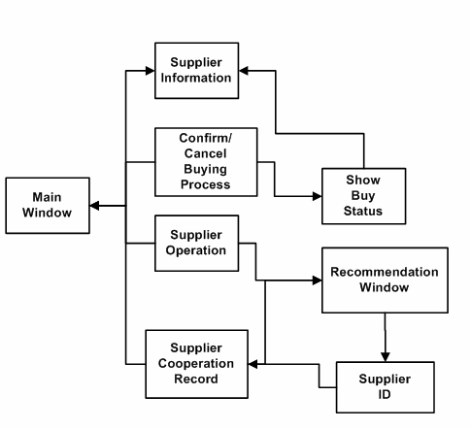

# SYSTEM REQUIREMENTS

**HARDWARE REQUIREMENTS:**

* Devices.
* Intel Core i5 processor or equivalent.
* Minimum 2 GB RAM for smooth operation.
* 100 MB of free storage space for the app and data.
* Internet Connection.

**SOFTWARE REQUIREMENTS:**

* **Front-end technologies:** HTML, CSS, JavaScript, and Bootstrap.
* **Backend Technologies**: Use Node.js and Express.js for server-side programming.
* One database that enables scalable and adaptable data management is MongoDB (NoSQL).
* Docker for container management, Git for version control, and RESTful APIs for integration are examples of additional tools.

# MODULE DESCRIPTION:

**1. The module for user authentication**

* With role-based access control and JWT authentication, it offers a secure login for various user categories (such as managers and suppliers).
* Safeguards user information and limits access according to role permissions.

**2. Inventory Management Module**

* Provides alerts for reorder points and real-time inventory level tracking.
* Reduces stockouts and surplus inventory by assisting in the maintenance of ideal stock levels.

**3. Order Management Module**

* Enables efficient order monitoring and processing from creation to completion.
* Prevents both overordering and understocking by synchronizing with inventory.

**4. Module for Demand Forecasting**

* Forecasts demand using machine learning and historical trends.
* Aims in keeping inventory levels at the proper levels to satisfy anticipated demand.

**5. Module for Supplier and Vendor Management**

* Keeps thorough records for suppliers, including past contracts and ratings.
* Helps with procurement procedures and keeps an eye on supplier performance.

**6. Logistics and Shipping Module**

* In order to provide real-time shipment tracking, it integrates with logistics partners.
* Updates users on the status of deliveries and any delays.

**7. Data Analytics and Reporting Module**

* Generates customizable reports for inventory, supplier performance, and order statistics.
* Provides insights for data-driven decision-making.

**8. Quality Assurance and Compliance Module**

* Records compliance and quality checks for suppliers and shipments.
* Helps ensure regulatory compliance through integrated quality assessments.

**9. User Dashboard Module**

* Provides a user-friendly interface customized for different roles.
* Displays real-time data on inventory, orders, and supply chain metrics.

**10. Supplier Collaboration Module**

* Facilitates direct communication and document sharing with suppliers.
* Tracks order status and sends timely notifications to stakeholders.

**11. Feedback and Customer Service Module**

* To increase customer happiness, it keeps track of service requests and feedback.
* Provides information about places where services could be improved.

**DASHBOARD**

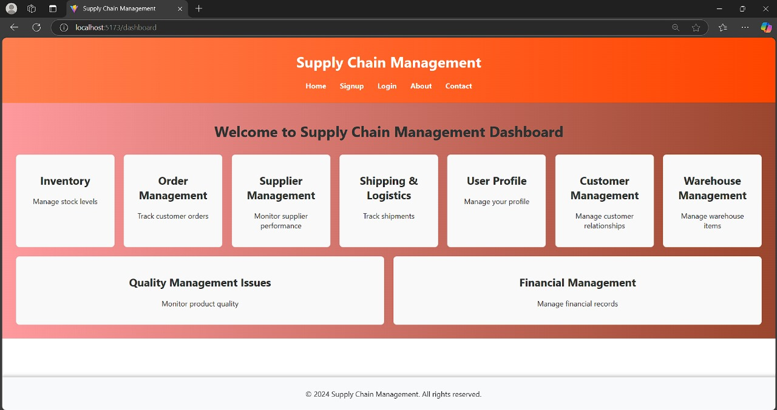

**INVENTORY MANAGEMENT**

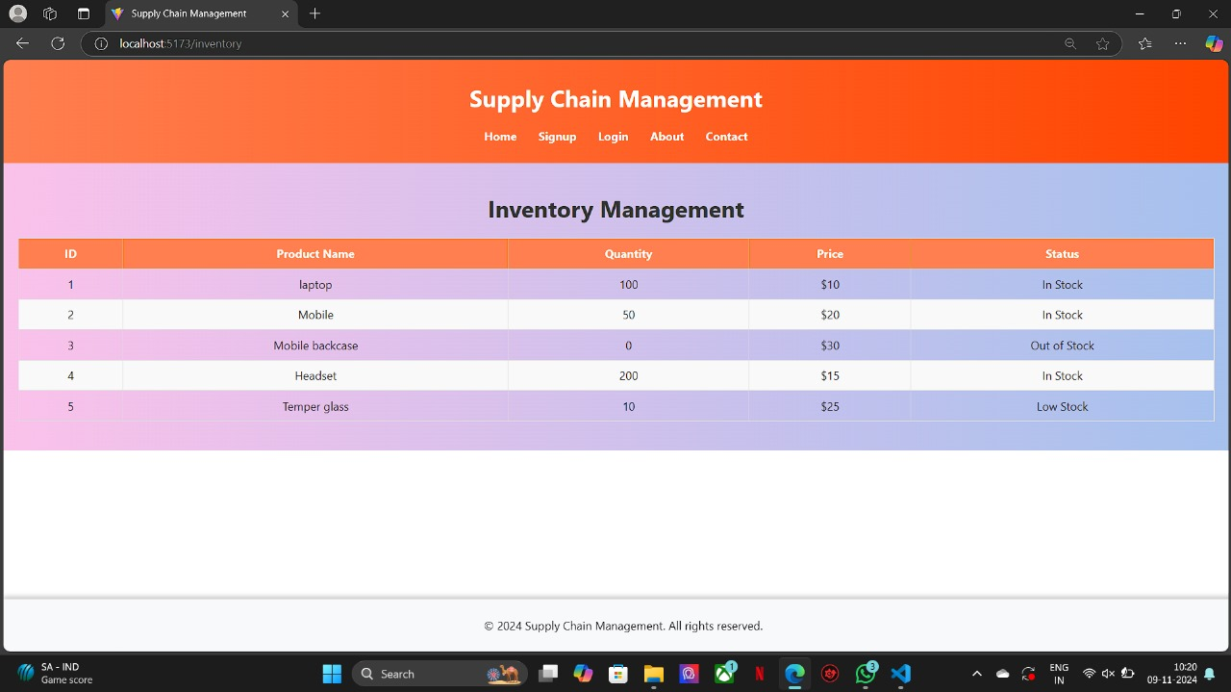

**CONCLUSION**

The implementation of a robust Supply Chain Management (SCM) system provides businesses with a comprehensive solution to streamline their supply chain processes, improve inventory management, and enhance order fulfillment efficiency. By integrating advanced data analytics, machine learning, and real-time tracking, this system enables businesses to respond proactively to market demands and disruptions. The SCM system not only optimizes resource allocation and minimizes stock imbalances but also increases visibility across the supply chain, fostering better supplier and customer relationships. This results in more agile, resilient, and customer-focused supply chains that drive profitability and competitive advantage.

**REFERENCES**

[1] Meindl, P., and S. Chopra (2015). The sixth edition of Supply Chain Management: Strategy, Planning, and Operation. Pearson Learning.

[2] Kaminsky, P., Simchi-Levi, E., and Simchi-Levi, D. (2008). Supply Chain Design and Management: Theories, Plans, and Examples (3rd ed.). M. Christopher, McGraw-Hill/Irwin, 2016

[3]. Fifth Edition of Logistics & Supply Chain Management. Pearson.

[4] Keebler, J. S., Soonhong, M., DeWitt, W., & Mentzer, J. T. (2001). Supply chain management definition. Business Logistics Journal, 22(2), 1–25.

[5] Tsipoulanidis, A., Ivanov, D., & Schönberger, J. (2017). Global Operations and Supply Chain Management. Springer.

[6] C. S. Tang (2006). strong methods for reducing supply chain interruptions. Journal of International Logistics, 9(1), 33–45.H. Stadtler (2005)

[7]. The fundamentals, overview, and difficulties of supply chain management and advanced planning. 163(3),575-588 of the European Journal of Operational Research

[8] Ketchen, D. J., and G. T. M. Hult (2007). Organization theory and supply chain management are connected by the example of best value supplier networks. Journal of Operations Management, 25(2), 573–580. Fisher, M. (1997)

[9]. Which supply chain is best for your product? 105–116 in Harvard Business Review, 75(2).

[10] Tang, C. S., and M. S. Sodhi (2012). control of supply chain risk. Operations Research & Management Science InternationalSeries, 172.