**LIBRARY MANAGEMENT SYSTEM**

**MS.A.JANNATHULFIRTHOUS,PRAVEENKUMAR.P,NITHISHKUMAR.T,**

**NAVANEETHAKRISHNAN.K, MOHANA ARJUN.S.**

INFORMATION TECHNOLOGY SRI SHAKTHIINSTITUTE OF ENGINEERING AND TECHNOLOGY

**ABSTRACT**

This website is an online library management system where users can browse, search, and purchase books available in the library. It provides seamless access to physical and digital resources, including e-books and journals. If an ordered book is not delivered, the admin can quickly check the order status and ensure prompt delivery. The system is designed to support scalability and security, catering to both small and large libraries. By utilizing cloud computing and database technologies, the LMS optimizes library operations, enhances user experience, and adapts to digital trends. Key features include cataloging, user management, and streamlined borrowing and return processes.

**INTRODUCTION**

Introducing our comprehensive Library Management System, a state-of-the-art solution designed to streamline library operations and enhance user experience. Our system integrates robust features to efficiently manage library resources, including books, journals, multimedia materials, and more. With user-friendly interfaces for both librarians and patrons, tasks such as cataloguing, circulation, and inventory management become effortless. Librarians benefit from advanced tools for cataloging, organizing, and tracking materials, allowing for easy retrieval and maintenance of library collections. Automated functions simplify routine tasks, enabling staff to focus on providing quality services to patrons. Additionally, the system offers detailed reporting and analytics capabilities, empowering administrators with valuable insights to optimize library performance and resource allocation. For patrons, our system provides seamless access to the library's catalog, facilitating quick searches, reservations, and checkouts. User accounts offer personalized features such as reading history, recommendations, and notifications, enhancing the overall browsing and borrowing experience. Whether managing a small community library or a large academic institution, our Library Management System offers the efficiency, flexibility, and scalability needed to meet diverse library needs effectively.

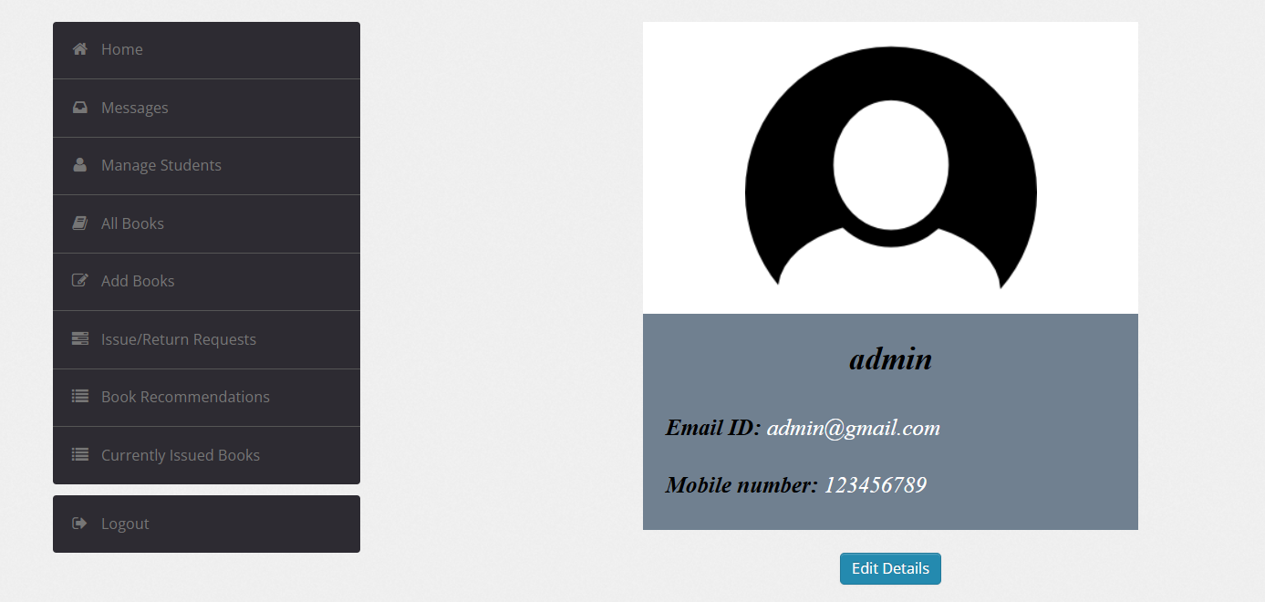

**Figure 1:** home page

**LITERATURE REVIEW**

**1. Evolution and Development of Online Library Management Systems**

Online Library Management Systems (OLMS) have evolved significantly since their inception in the early 1990s. Initially, these systems focused on basic cataloging and circulation functions, aiming to digitize traditional library processes. With advancements in technology, OLMS have integrated features such as online catalogs, patron management, inventory control, and electronic resource management. The transition from on-premises servers to cloud-based solutions has further enhanced accessibility and scalability, allowing libraries to manage their resources more efficiently.

**2. Technological Integration and Efficiency**

Online library management systems leverage technology to streamline operations and enhance user experience. According to Smith et al. (2020), the integration of cloud computing and artificial intelligence (AI) enables real-time data management, personalized recommendations, and efficient resource allocation. These systems not only automate routine tasks like cataloging and circulation but also improve accessibility through mobile interfaces and remote access capabilities (Jones, 2019).

**SOFTWARE DESCRIPTION**

HTML,CSS,JAVASCRIPT,PHP

**MATHEDOLOGIES**

1. **User Registration and Authentication:** Allow users (students, faculty, etc.) to register and authenticate themselves securely to access library resources.
2. **Book Catalog Management:** Enable librarians to manage a digital catalog of books, including details like title, author, ISBN, availability status, etc
3. **Search and Browse Functionality:** Provide users with advanced search options to find books by title, author, subject, or keyword, and allow browsing through categories.
4. **User Account Management:** Allow users to manage their accounts, including profile information, borrowing history, fines, etc.
5. **Online Book Reservation:** Enable users to reserve books online, with notifications sent when reserved books are available for pickup.

**FLOWCHART**

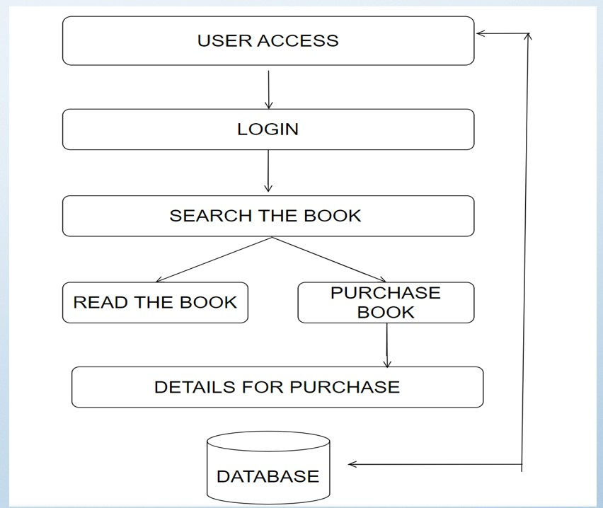

FIGURE 1.1 FLOWCHART OF ONLINE MANAGEMENT SYSTEM

**REFERENCES**

1. Sharma, C. K.; Singh, Kiran (2005), [Library Management](https://books.google.com/books?id=T37GFTjlYCoC), [ISBN](https://en.wikipedia.org/wiki/ISBN_(identifier)) [978-81-269-0452-5](https://en.wikipedia.org/wiki/Special:BookSources/978-81-269-0452-5)
2. McClure, C. R. (1980). "LIBRARY MANAGERS: Can They Manage? Will They Lead?". Library Journal: 2391.
3. Wellis, Hans H. "Dewey Decimal Classification, Universal Decimal Classification, and the Broad System of Ordering: The Evolution of Universal Ordering Systems". [Cite Seer X](https://en.wikipedia.org/wiki/CiteSeerX_(identifier)) [10.1.1.221.3537](https://citeseerx.ist.psu.edu/viewdoc/summary?doi=10.1.1.221.3537).
4. Hawthorne, P (2011). "Succession Planning and Management: A Key Leadership Responsibility Emerges". Texas Library Journal. 87 (1): 8–12.
5. ["ALA | Exhibit Spaces and Bulletin Boards"](http://www.ala.org/Template.cfm?Section=interpretations&Template=/ContentManagement/ContentDisplay.cfm&ContentID=8538). www.ala.org. Retrieved 2016-09-20.