**EDUCATIONAL SUPPPORT AND GUIDLINESS**

**M. Buvana, K.S. Rethina Prakash, R. Sabarikirivasan, M. Sagar**

**ABSTRACT**

This study examines the complex issue of student dropout in education, investigating the various factors contributing to students leaving school before completion, including academic challenges, socioeconomic disadvantages, family dynamics, peer influences, and school climate, while also exploring potential interventions and preventative strategies to mitigate dropout rates and promote improved educational attainment for all students

Keywords : absenteeism, risk factors, socioeconomic status, poverty, family background, mental health

1. **INTRODUCTION**

A "dropout" refers to a student who prematurely leaves an educational program before completing their studies, often signifying a significant issue within education systems where individuals abandon school due to various factors like academic struggles, personal challenges, socioeconomic difficulties, or lack of motivation, ultimately limiting their future opportunities and contributing to societal disparities; understanding the causes and developing effective interventions to prevent dropouts is crucial for promoting equitable access to quality education.

1. **METHODOLOGY**

 Identifying at-risk students through data analysis, implementing personalized learning plans with flexible providing targeted support like tutoring and counseling, and engaging families and community partners to address underlying social and economic factors contributing to dropout risk; focusing on early intervention and holistic approaches to re-engage students in education.

1. Data Analysis for Identifying At-Risk Students

* Collecting and analyzing data such as attendance, grades, behavior, and socio-economic background.

### 2. **Personalized Learning Plans**

* Assessing individual learning needs and challenges.
* Designing customized academic plans to cater to diverse learning paces and styles.

1. **MODELING AND ANALYSIS**

The process of using statistical and machine learning techniques to identify patterns and predict student dropout rates based on various factors like academic performance, demographic data, socioeconomic background, and engagement levels, allowing educational institutions to proactively intervene and support at-risk students to prevent them from dropping out.



**Figure 1:** Front page



**Figure 2:** Registration Info

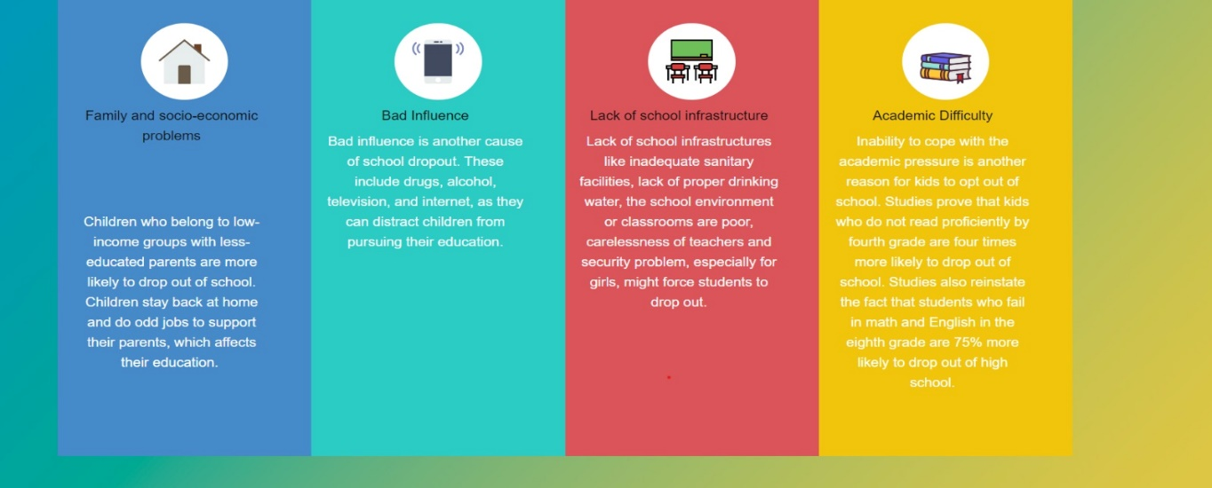

1. **RESULTS AND DISCUSSION**

* Discuss how the findings align with or deviate from previous research.
  + Example: "The significant improvement in academic performance is consistent with studies highlighting the efficacy of personalized learning plans."
* Explain the real-world applications and significance of the findings.
  + Example: "This study provides evidence that early intervention strategies can reduce dropout rates and improve student retention."

1. **CONCLUSION**

This study highlights the critical role of a comprehensive, data-driven approach in identifying and supporting at-risk students. By combining personalized learning plans, targeted interventions, and community engagement, significant improvements were observed in academic performance, attendance, and overall student well-being. The findings demonstrate that addressing social and economic barriers alongside academic challenges is essential for reducing dropout rates and fostering student success.

1. **REFERENCES**

1• Bowers, A. J., Sprott, R., & Taff, S. A. (2013**). Do we know who will drop out? A review of the predictors of dropping out of high school: Precision, sensitivity, and specificity.** The High School Journal, 96(2), 77-100.

2• Finn, J. D., & Zimmer, K. S. (2012**). Student engagement: What is it? Why does it matter?** Handbook of Research on Student Engagement, 97–131.

3• Christenson, S. L., Reschly, A. L., & Wylie, C. (2012). **Handbook of research on student engagement.** Springer.