Face Recognition Systems

# Mr. Prof Chinni krishnaiah, Ganesh, Sai kumar , Manvitha, Anusha, Vsishnavi, Guide: Prof. Mairaj Unisa Begum

***Abstract: Face recognition systems have become increasingly popular and important in recent years due to their various applications in security, surveillance, and human-computer interaction. These systems use algorithms to detect and recognize human faces in images or videos, and can be trained to identify individuals with high accuracy.***

## INTRODUCTION

Face recognition is a biometric technology that has attracted significant attention in recent years. This technology involves the identification of an individual based on their facial features. Face recognition systems have become increasingly popular in various applications such as security systems, access control, and authentication systems. In this paper, we will discuss the basics of face recognition systems, their various types, and their applications. We will also implement a face recognition system in Python using OpenCV and Python libraries.

## BASICS OF FACE RECOGNITION SYSTEMS

Face recognition systems are built on the principle of biometric authentication. This technology uses various algorithms and techniques to recognize and match the unique features of an individual's face.

1. *Face Detection:* This is the first step in face recognition systems, where the system detects The face detection process uses various algorithms and techniques to identify the facial features of an individual, such as eyes, nose, mouth, and eyebrows.
2. *Feature Extraction:* The next step in the face recognition process involves extracting the unique features of an individual's face. The feature extraction process involves capturing the facial features of an individual, such as the shape of the face, the position of the eyes, nose, and mouth, and the skin texture.
3. *Face Matching:* The final step in the face recognition process is face matching, where the extracted features of an individual's face are compared with a database of known faces to identify the person.

## TYPES OF FACE RECOGNITION SYSTEMS

There are two types of face recognition systems: 2D face recognition and 3D face recognition.

1. *2D Face Recognition:* This type of face recognition system uses images or videos to recognize faces. The system extracts the facial features of an individual and matches them with a database of known faces.
2. *3D Face Recognition:* This type of face recognition system uses 3D models to recognize faces. The system captures the 3D shape of an individual's face and matches it with a database of known 3D models.

*A. Working of Face Recognition Systems*

The working of face recognition systems involves three steps: face detection, feature extraction, and face matching. In the first step, the system detects the face in the input image or video. Then in the second step, it extracts the features such as the shape, size, and position of the facial features, and creates a unique representation of the face. In the final step, the system compares the extracted features with the stored features in the database and produces the output as the identity of the person.

## ALGORITHMS USED IN FACE RECOGNITION SYSTEMS

There are various algorithms used in face recognition systems such as Eigenfaces, Fisherfaces, Local Binary Patterns Histograms (LBPH), and Convolutional Neural Networks (CNN). Eigenfaces is one of the earliest algorithms used in face recognition, which uses Principal Component Analysis (PCA) to extract features. Fisherfaces is an extension of Eigenfaces that uses Linear Discriminant Analysis (LDA) to improve recognition accuracy. LBPH is a texture-based algorithm that extracts features from the texture of the face. CNN is a deep learning algorithm that uses neural networks to learn the features from the input images .

## APPLICATIONS OF FACE RECOGNITION SYSTEMS

Face recognition systems are widely used in security systems, access control, attendance management, and marketing. In the security system, face recognition is used to identify criminals and to provide access control. In attendance management, it is used to mark attendance in schools and offices. In marketing, it is used to analyse customer behaviour and preferences.

*A. Applications of Face Recognition Systems*

Face recognition systems have numerous applications in various industries. Some of the major applications of face recognition systems are as follows:

1. *Security Systems:* Face recognition systems are widely used in security systems to control access to secure areas. These systems can be used in airports, government offices, and other high-security locations.
2. *Law Enforcement:* Face recognition systems are used by law enforcement agencies to identify criminals and suspects. The system can match the faces of criminals with a database of known criminals.
3. *Marketing:* Face recognition systems are used in marketing to identify the age, gender, and ethnicity of customers. This data can be used to target specific customers with specific marketing campaigns.

Flow Chart

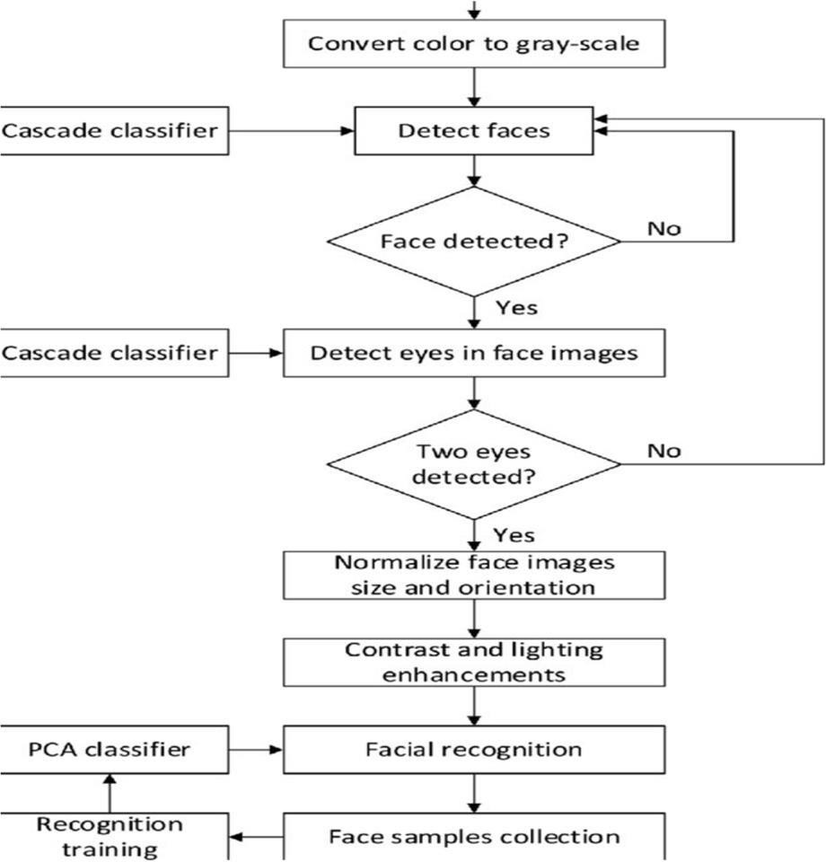

## CONCLUSION

Face recognition systems are a rapidly developing technology with numerous applications in various industries. The technology uses feature-based and template-based techniques to capture, process, and match facial images. The use of facial recognition systems has raised concerns over privacy and civil liberties, and its accuracy has been questioned, especially in cases of misidentification. It is crucial to consider the ethical implications of facial recognition systems and ensure that their use is regulated to protect people's rights and prevent misuse.

## REFERENCES

1. https:[//www.researchgate.net/publication/224698290_Face_Recognition_System_using_Artificial_Neural_Networks_Approach](http://www.researchgate.net/publication/224698290_Face_Recognition_System_using_Artificial_Neural_Networks_Approach)
2. https:[//www.geeksforgeeks.org/opencv-python-program-face-detection/](http://www.geeksforgeeks.org/opencv-python-program-face-detection/)
3. https:[//www.javatpoint.com/face-recognition-and-face-detection-using-opencv](http://www.javatpoint.com/face-recognition-and-face-detection-using-opencv)