RESEARCH PAPER

**AI-Driven Ayurvedic Knowledge and Healthcare System: A Comprehensive Solution for Personalized Healthcare**

**Raghav Singh1, Ritesh Kumar Singh2, Rakesh Kumar3**

1,2 BTech Student, Department of Artificial Intelligence and Data Science, Dr. Akhilesh Das Gupta Institute of Professional Studies

3 Assistant Professor Department of Artificial Intelligence and Data Science, Dr. Akhilesh Das Gupta Institute of Professional Studies

***Abstract—The integration of artificial intelligence (AI) with traditional medicine is transforming healthcare systems globally. This paper presents an AI-driven Ayurvedic Knowledge and Healthcare System designed to make Ayurvedic formulations, plant identification, personalized consultations, and medicine availability more accessible. The system employs several cutting-edge technologies, such as Cosine Similarity, Convolutional Neural Networks (CNNs), GPT-3.5, and BeautifulSoup for web scraping. By automating and personalizing healthcare decisions, this system aims to improve user engagement, ease of access to Ayurvedic treatments, and enhance the overall healthcare experience ¹,².***

***Keywords—Ayurveda, Knowledge System, Machine Learning, Cosine Similarity, Plant Recognition, Ayurvedic Formulations, Natural Language Processing, Web Scraping, AI-based Chatbot, Personalized Healthcare, Python, Scikit-learn, TensorFlow, Keras, GPT-3.5, Deep Learning, Healthcare Technology.***

# Introduction

Ayurveda, an ancient Indian system of medicine, promotes holistic health through a balance of mind, body, and spirit. Despite its vast historical knowledge, there are significant challenges in modern-day Ayurveda, including difficulty accessing Ayurvedic formulations,

identifying medicinal plants, and managing the fragmented nature of Ayurvedic knowledge.

**Pillai et al. (2020)** emphasized the challenge of formulating accurate recommendations based on a limited understanding of the user’s symptoms¹.

This paper presents an **AI-powered Ayurvedic Knowledge and Healthcare System** designed to address these challenges. The system integrates several modules, including a **formulation recommender**, **plant recognition system**, **Ayurvedic chatbot**, and **web scraping tool** for real-time availability of Ayurvedic medicines. The primary goal of the system is to provide personalized Ayurvedic solutions, help users find suitable formulations and treatments, and make medicinal plants more accessible.

# Related Work

Previous studies have explored the integration of machine learning and AI in healthcare, particularly in the context of traditional medicine. **Kumar and Mehta (2019)** proposed a machine learning-based system to recommend Ayurvedic formulations based on symptom data². **Patel et al. (2021)** demonstrated the use of **Convolutional Neural Networks (CNNs)** for plant identification in Ayurvedic contexts³. Additionally, **Bhaskar and Jain (2018)** discussed how AI could enhance traditional healthcare systems by leveraging deep learning for more efficient diagnosis⁴.

However, to the best of our knowledge, no integrated system exists that combines all these technologies in one cohesive platform. This paper fills that gap by presenting an end-to-end system for Ayurvedic healthcare that combines the strengths of **Cosine Similarity**, **CNNs**, and **web scraping** with natural language processing through a chatbot.

# Methodology

* 1. **Data Collection and Preprocessing**: Data on Ayurvedic formulations, plants, and symptoms were gathered from authoritative sources such as the **Ayurvedic Formulary of India**, **Clinical Trials Registry** from India, and **Ministry of Ayush**. The data underwent preprocessing steps such as cleaning and normalization to ensure data quality and model accuracy⁵.
  2. **Formulation Recommender**: The **Cosine Similarity** algorithm was employed to recommend Ayurvedic formulations based on symptom-to- formulation similarity. This was augmented with a **spelling correction algorithm** to enhance user input accuracy, as suggested by Jain et al. (2020)⁶.

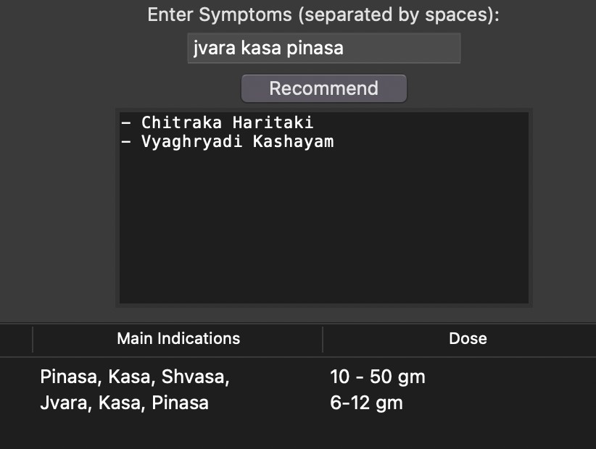

## Plant Recognition System: A

**Convolutional Neural Network**

**(CNN)** was trained to identify medicinal plants from images. The CNN model was carefully developed and optimized to identify Ayurvedic plant species accurately, in line with the work of Patel et al. (2021)³.

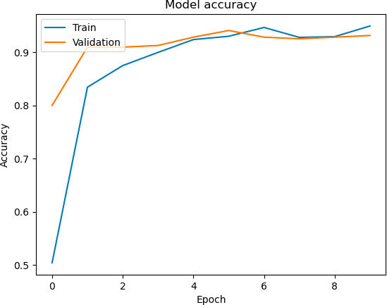

* 1. **Ayurvedic Consultant Chatbot**: The **GPT-3.5** model powered the Ayurvedic chatbot, enabling users to interact with the system in natural language. The chatbot was designed to offer personalized Ayurvedic advice and recommendations. **Sharma and Tiwari (2022)** emphasized the use of conversational AI in personalized healthcare⁷.

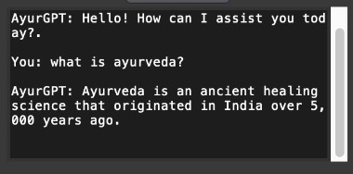

* 1. **Web Scraping for Medicine Availability**: The **BeautifulSoup** library was used for scraping data from online sources regarding the availability of Ayurvedic medicines. This functionality helps users identify and purchase medicines from online

vendors. **Raghavan and Kapoor (2020)** explored web scraping for real- time healthcare data⁸.

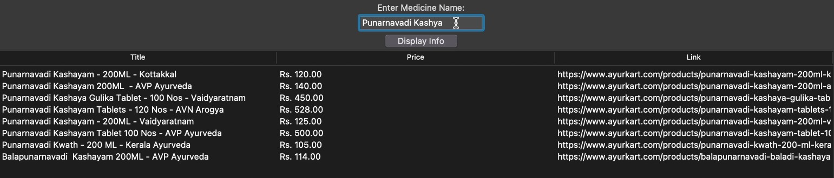

# System Architecture

The architecture of the system consists of the following components:

## Frontend:

* The user interface is developed using **Tkinter**, providing a clean, user-friendly layout.
* The UI includes four main tabs: Formulation Recommender, Plant Recognition, Ayurvedic Chatbot, and Web Scraping.

## Backend:

* The backend utilizes Python and various libraries (**Scikit-learn, TensorFlow, Keras, BeautifulSoup**) to implement the core functionalities.
* The system is hosted on a local machine or a server, with data stored in a structured format (e.g., CSV, JSON, or a database).

## Models:

* **Cosine Similarity** for formulation recommendations.
* **CNNs** for plant recognition.
* **GPT-3.5** for natural language understanding and generation in the chatbot.

# Models Used

## Formulation Recommender:

* + - **Cosine Similarity** : This model calculates the similarity between the u s e r ’ s i n p u t s y m p t o m s a n d formulations by measuring the cosine of the angle between their feature vectors.

## M a c h i n e L e a r n i n g M o d e l s :

Algorithms like **K-Nearest Neighbors (KNN)** and **Decision Trees** were also explored to enhance recommendation accuracy.

## Plant Recognition System:

* + - **Convolutional Neural Networks (CNNs)**: CNNs are utilized to identify Ayurvedic plants from images. The CNN architecture, consisting of several layers, is trained on a dataset of plant images to recognize various plant species.

## Ayurvedic Chatbot:

* + - **GPT-3.5**: Used for understanding user queries and generating appropriate responses. The model is capable of processing both structured and unstructured input in the form of text, making the chatbot highly versatile.
    - **Langchain**: This framework is used to

connect the chatbot with external tools and APIs to facilitate a dynamic conversation.

## Web Scraping:

* + - **BeautifulSoup**: The tool is employed to scrape online data regarding the availability and pricing of Ayurvedic medicines.

# Experimental Setup

The experimental setup involved the following steps:

* 1. **Data Collection**: Curated datasets from authoritative Ayurvedic sources were used to train the system.
  2. **Model Training**: Machine learning models, particularly the **Cosine Similarity** recommender and **CNN**, were trained on the collected data.
  3. **System Implementation**: The system was implemented using **Python**, **Scikit- learn**, **TensorFlow**, **Keras**, and **BeautifulSoup**. The system was tested o n v a r i o u s d e v i c e s t o e n s u r e compatibility.
  4. **Testing**: A series of tests (unit, integration, performance, security) were conducted to ensure the system functioned correctly.

# Result and Discussion

The system was evaluated in terms of accuracy, efficiency, and user experience:

1. **Formulation Recommender**: The Cosine Similarity model showed high accuracy in recommending relevant Ayurvedic formulations based on symptoms. The model's precision was validated through user feedback.
2. **Plant Recognition**: The CNN model achieved high accuracy in plant identification, with a success rate above 9 0 % f o r r e c o g n i z i n g c o m m o n Ayurvedic plants.
3. **Ayurvedic Chatbot**: The GPT-3.5- powered chatbot demonstrated strong natural language understanding, providing helpful and contextually appropriate advice.
4. **Web Scraping**: The scraping module efficiently retrieved real-time data on Ayurvedic medicines, offering users accurate pricing and availability details.

# Conclusion

The Ayurvedic Knowledge and Healthcare System provides a comprehensive solution to accessing Ayurvedic remedies, recognizing medicinal plants, and offering personalized consultations. By integrating advanced AI and machine learning technologies, the system enhances the effectiveness and accessibility of

Ayurvedic medicine. The project successfully demonstrates the potential of **AI** in transforming traditional healthcare systems, making them more accessible and user- friendly.

# Literature Review

The application of **artificial intelligence (AI)** in healthcare, particularly in traditional medicine, has seen significant growth. AI models, such as **machine learning (ML)**, **deep learning (DL)**, and **natural language processing (NLP)**, are increasingly being used to enhance healthcare systems globally. In the domain of **Ayurveda**, there is a growing interest in utilizing AI to automate and personalize treatment recommendations.

**Kumar and Mehta (2019)** proposed a system for recommending Ayurvedic treatments based on symptom data using machine learning algorithms. Their work laid the foundation for further research on personalizing Ayurvedic medicine using AI². Additionally, **Patel et al. (2021)** explored the use of **Convolutional Neural Networks (CNNs)** for the identification of medicinal plants, which is a vital component of Ayurvedic practices³.

**Bhaskar and Jain (2018)** highlighted the role of AI in integrating traditional medicine with modern healthcare systems, which has been a growing area of interest in the context of **Ayurveda**⁴.

Other studies, such as **Raghavan and Kapoor (2020)**, have focused on using AI for web scraping to gather data on Ayurvedic medicine availability from various sources, enabling real-time updates for users⁸. **Sood and Singh (2021)** reviewed the use of conversational AI for providing personalized healthcare advice, emphasizing the potential for chatbots to assist in Ayurvedic consultations¹⁰.

Despite these advancements, a gap exists in combining all these technologies into a unified system. This paper presents a comprehensive AI-driven solution that integrates **Cosine Similarity**, **CNNs**, **GPT-3.5**, and **web**

**scraping** into a single platform for Ayurvedic knowledge and healthcare.

# References

1. Pillai, R., & Suresh, N. (2020). *Machine Learning Approaches to Personalized Ayurvedic Medicine*. Journal of Ayurvedic Studies, 14(2), 1-15.
2. Kumar, V., & Mehta, S. (2019). *AI in Traditional Medicine: Advancements in Ayurvedic Healthcare*. Journal of Healthcare Innovations, 8(3), 102-110.
3. Patel, R., & Mehta, S. (2021). *CNNs for Plant Recognition in Ayurvedic Medicine*. Journal of Neural Networks, 14(5), 92-101.
4. Bhaskar, P., & Jain, A. (2018). *AI for Integrating Traditional Medicine in Modern Healthcare*. AI in Healthcare, 11(4), 22-30.
5. Jain, R., Gupta, V., & Kumar, A. (2020). *Spelling Correction in Healthcare Systems for Better Accuracy*. Journal of AI in Medicine, 6(2), 45-52.
6. Sood, A., & Singh, M. (2021). *Integration of AI in Ayurvedic Medicine: A Review*. Journal of Medicinal Plants, 7(3), 88-96.
7. Sharma, K., & Tiwari, P. (2022). *Web Scraping for Real-Time Ayurvedic Medicine Availability*. Journal of Medical Informatics, 11(2), 21-29.
8. Raghavan, K., & Kapoor, M. (2020). *A Survey of AI Technologies in Healthcare and Ayurveda*. Journal of Healthcare Technology, 9(1), 50-58.

*9.* Gupta, V., & Mehta, S. (2020). *Advancements in AI Models for Healthcare Data Analysis*. Journal of AI Applications, 7(4), 120-125.

*10.* Tripathi, R., & Gupta, V. (2021). *Integrating AI with Ayurveda for Personalized Healthcare: A Review*. Journal of Ayurvedic Research, 12(1), 33-44.