**A Descriptive Study of the Startup Ecosystem in India**

Akansha Dhyani

Research Scholar

Indira School of Business Studies PGDM, Pune

[akansha.dhyani@indiraisbs.ac.in](mailto:akansha.dhyani@indiraisbs.ac.in)

Abstract:

Startups play a critical role in fostering innovation, economic growth, and job creation. India, the world's third-largest startup ecosystem, has experienced remarkable growth driven by governmental initiatives like "Startup India," launched in 2015. This study provides a comprehensive analysis of the Indian startup ecosystem, focusing on its drivers, challenges, and growth potential, with an emphasis on technology-driven startups.

The research highlights key enablers such as technological advancements, government support, open innovation models, and shifting societal perceptions of entrepreneurship. However, persistent challenges, including financial constraints, inadequate marketing strategies, limited innovation, and insufficient support networks, hinder the growth of startups.

The findings reveal a geographically uneven distribution of startups, with a concentration in states like Karnataka and Maharashtra, and sectoral dominance in enterprise technology, health tech, fintech, and ed-tech. Despite these challenges, Indian startups demonstrate significant contributions to job creation and economic development.

This study underscores the need for strategic interventions to address funding gaps, foster innovation, and enhance regulatory frameworks. By doing so, the Indian startup ecosystem can realize its potential as a global leader in entrepreneurship and innovation.

1. Introduction

Startups are pivotal to modern economies, driving innovation and job creation. In India, the startup ecosystem has seen rapid growth, characterized by interconnected resources, institutions, and individuals working to support entrepreneurial ventures. The Indian government's flagship initiatives, such as "Startup India" launched in 2015 by Prime Minister Narendra Modi, have aimed to bolster this ecosystem, creating significant employment and contributing to the economy. By leveraging governmental support and an entrepreneurial culture, Indian startups have been able to thrive.

India ranks as the third-largest startup ecosystem globally, behind only the United States and the United Kingdom (NASSCOM, 2015). The creation of "Startup Hubs" under the Department of Industrial Policy and Promotion (DIPP) and numerous incentives—such as tax exemptions, capital gains tax relief, and government-backed funding—have fostered a conducive environment for startups to flourish.

This paper provides a comprehensive overview of the Indian startup ecosystem, analyzing its drivers, challenges, and growth potential, particularly in the context of technology-driven startups.

2. Need for the Study

The primary aim of this study is to offer a detailed understanding of the startup ecosystem in India, including its growth drivers, challenges, and opportunities. While the focus is primarily on technology-driven startups, the study also covers non-tech startups and micro-entrepreneurs. By understanding these dynamics, policymakers and entrepreneurs can better strategize to overcome challenges and leverage opportunities.

Objectives

- Analyze the geographical, institutional, and sectoral profiles of startups in India.

- Examine the impact of government initiatives like "Startup India."

- Investigate challenges, such as regulatory bottlenecks and funding issues, faced by startups.

- Assess the contribution of startups to job creation and economic growth.

3. Review of Literature

3.1 Overview of Government Initiatives

Several studies have outlined the benefits and challenges of government programs aimed at fostering entrepreneurship. Mittal and Garg (2018) and Dutta (2016) emphasize the tax exemptions and incubation support provided under the "Startup India" initiative. However, regulatory obstacles, such as complex licensing systems and lack of bank support, remain significant hurdles (Venkatanarayana, 2016).

Kshetri (2016) discusses how stringent regulations and limited access to finance constrain entrepreneurship in India, while Singh (2020) provides an extensive review of the various complementary schemes that aid startups, such as "Make in India," "Digital India," and "MUDRA." However, the success of these initiatives often depends on overcoming structural challenges such as a rigid tax regime and insufficient innovation.

3.2 Challenges in the Startup Ecosystem

While India's startup ecosystem has made significant strides, several challenges persist. The lack of access to early-stage funding, insufficient innovation, and improper marketing tactics are commonly cited as reasons for startup failure (Kansal, 2018). Additionally, many startups lack a robust sales strategy, leading to inadequate market penetration (Rosemoore, 2019).

The IBM Institute for Business Value (2018) reports that 90% of Indian startups fail within their first five years, with a lack of innovation being the most frequently cited cause. This points to a critical need for a more inclusive and education-driven ecosystem that encourages value creation over valuation.

4. Research Methodology

This study adopts a descriptive research methodology, relying on secondary sources such as academic articles, government reports, and blogs. Data on startups was gathered from publicly available sources, including the "Startup India" website and government publications.

5. Analysis of Growth Drivers

5.1 Market Potential

India's vast population and rapidly growing economy offer significant opportunities for startups. Niche products can find large markets, and the shift towards a market-driven economic system in the 1990s has further enhanced the potential for entrepreneurial ventures.

5.2 Technological Innovation

Technological advancements, particularly in artificial intelligence, big data analytics, and machine learning, have been key drivers of startup growth in India. These innovations help startups differentiate themselves and scale quickly.

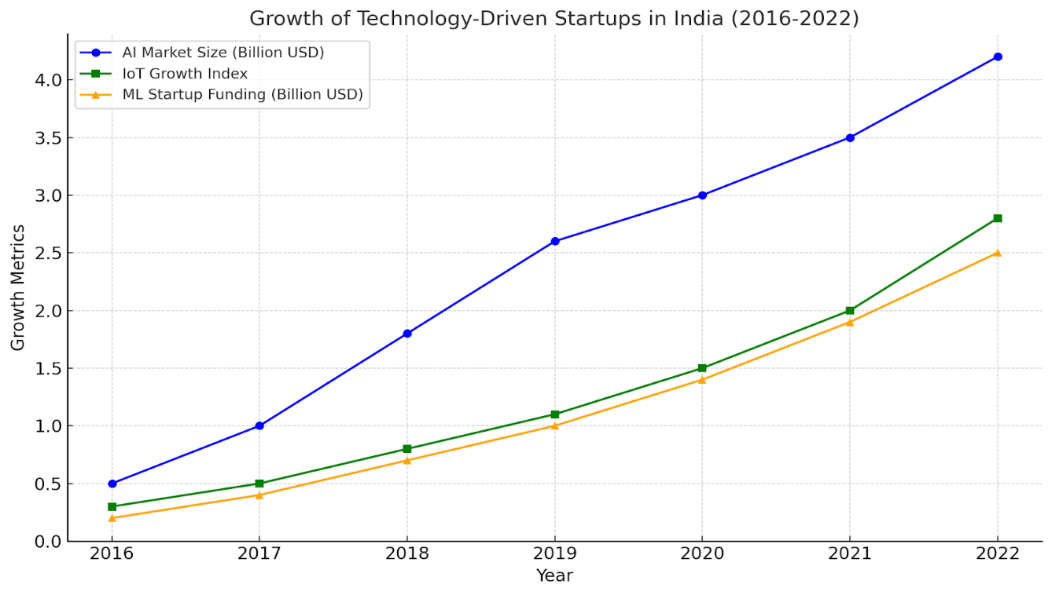

5.3 Government Support

Programs like "Startup India" and "Stand up India" provide startups with tax benefits, access to funding, and legal assistance, significantly easing the process of launching and growing a business.

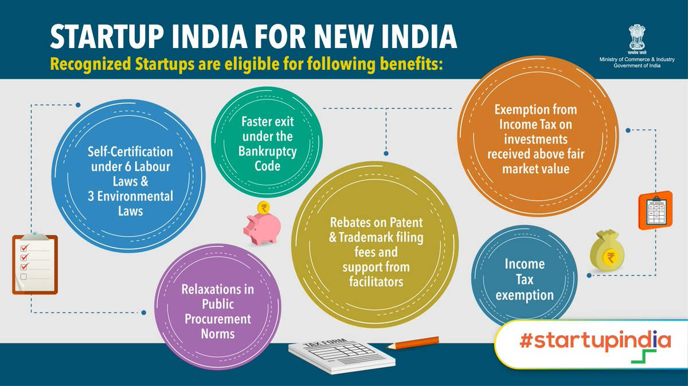

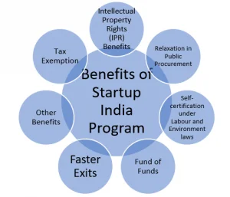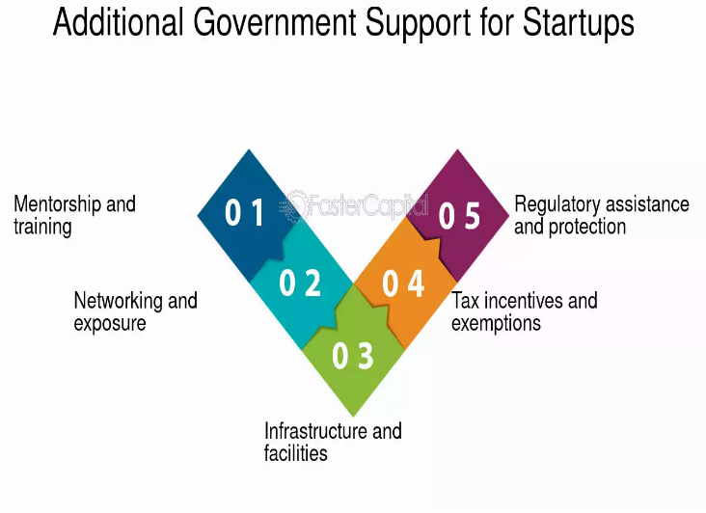

5.4 Open Innovation

Indian startups are increasingly collaborating with larger corporations through open innovation models, where large companies rely on startups for new ideas and technologies.

5.5 Changing Perceptions

The perception of entrepreneurship as a viable career path has improved significantly in India, thanks to increased societal support and positive examples of successful startups.

6. Challenges Facing Startups

6.1 Financial Constraints

One of the biggest challenges faced by Indian startups is securing early-stage funding. Venture capital firms tend to favor established companies, leaving early-stage startups struggling to raise capital.

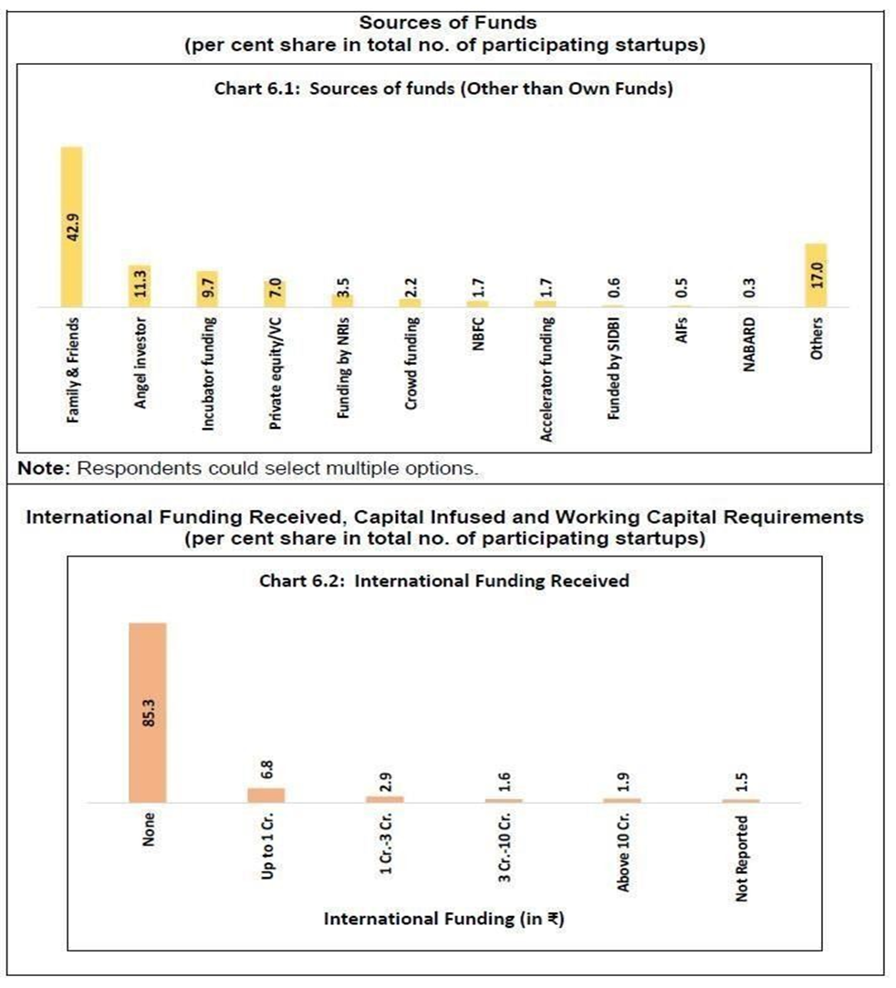

6.2 Marketing Issues

Many Indian startups fail due to inadequate marketing strategies. Founders, often from technical backgrounds, lack the expertise to execute effective sales and marketing campaigns.

6.3 Lack of Innovation

Despite the rise in the number of startups, a significant portion of them fail due to a lack of innovation. Startups need to focus on creating novel solutions that add value rather than simply seeking higher valuations.

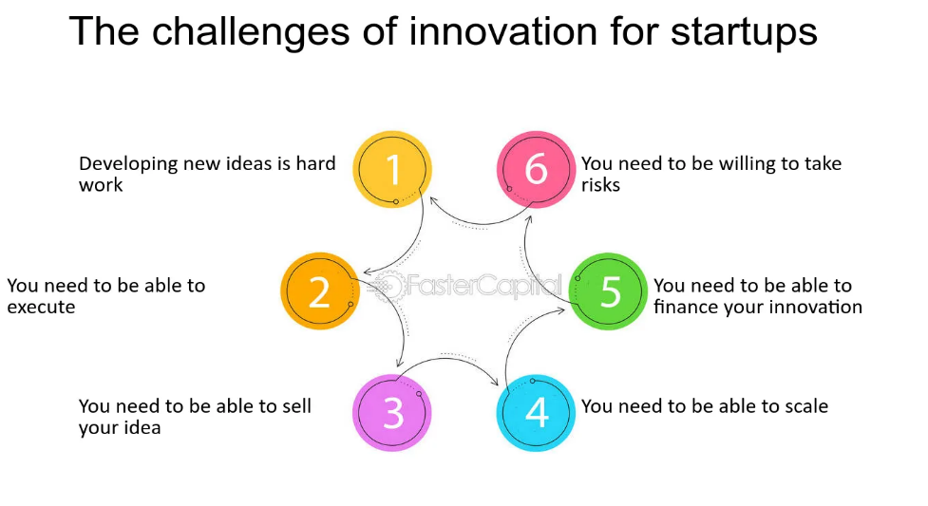

6.4 Inadequate Support Networks

The failure of startups is often attributed not just to founders but to a lack of cohesive support networks, including investors, team members, and other resource providers.

7. Major Findings

7.1 Geographic Distribution

The majority of Indian startups are concentrated in Karnataka, Maharashtra, Telangana, Delhi, and Tamil Nadu, reflecting the uneven distribution of resources across states.

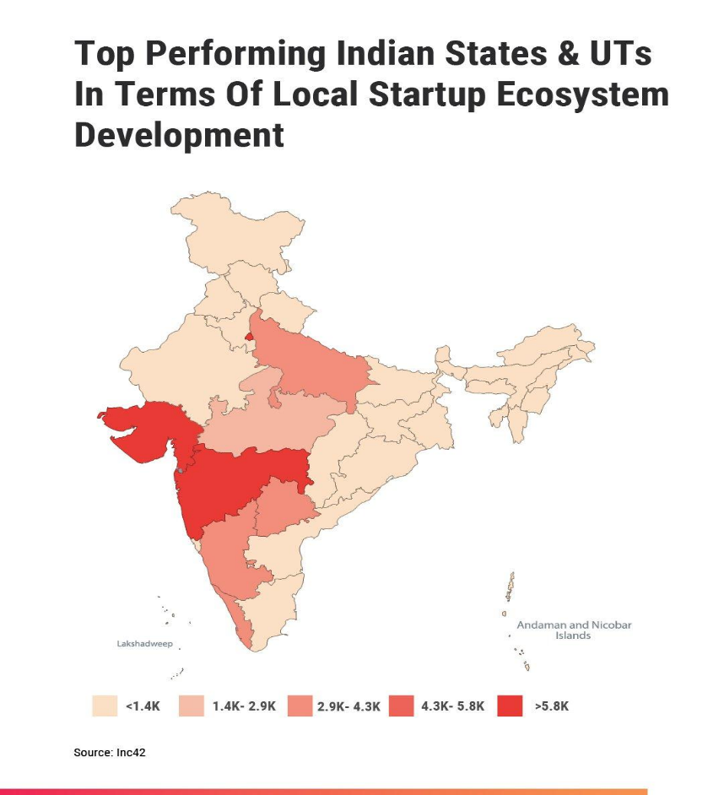

7.2 Founder Profiles

A significant percentage of startup founders have academic qualifications in engineering and are under the age of 40. A large portion also possesses professional experience, highlighting the growing importance of expertise in entrepreneurship.

7.3 Sector Distribution

Enterprise technology, health tech, fintech, and ed-tech dominate the startup landscape in India. The country is the third-largest startup ecosystem globally, particularly in technology-driven sectors.

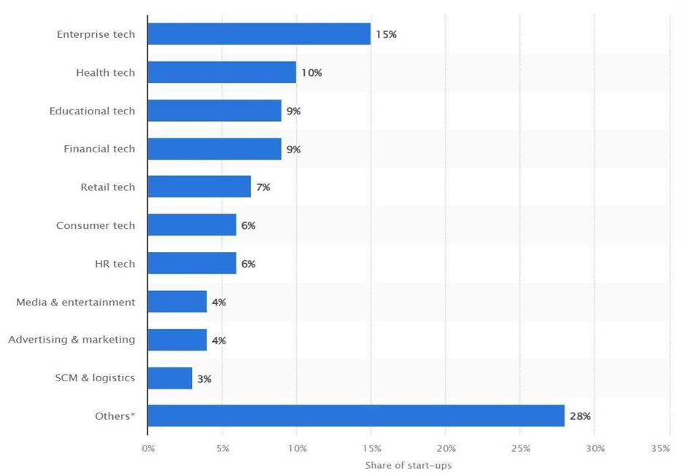

8. Conclusion

The Indian startup ecosystem holds immense potential, fueled by a large market, technological innovation, and strong government support. However, to maintain its growth trajectory, the ecosystem must overcome challenges related to funding, innovation, and regulatory hurdles. By addressing these issues, Indian startups can continue to contribute significantly to job creation and economic development.

9. References

- Dutta, S. (2016). *Startup India: A Policy Review*. Journal of Indian Business.

- Kansal, R. (2018). *Challenges in Indian Startups*. Rosemoore Press.

- Kshetri, N. (2016). *Regulatory Obstacles and Startups in India*. Indian Journal of Entrepreneurship.

- Mittal, A., & Garg, M. (2018). *The Impact of Startup India*. Indian Journal of Business.

- Singh, A. (2020). *Government Initiatives and Startups in India*. NITI Aayog Publication.

- Venkatanarayana, M. (2016). *Licensing and Regulatory Bottlenecks in Indian Startups*. Indian Business Journal.

- Government Schemes. (n.d.). Startup India. <https://www.startupindia.gov.in/content/sih/en/government-schemes.html>

- Reserve Bank of India - reports. (n.d.). <https://m.rbi.org.in//Scripts/PublicationReportDetails.aspx?UrlPage=&ID=956#41>