**Lead Development, Service Pitching, and Client Needs Recognition for HR Services**

Vaishnavi Vasudev Vaidya

Research Scholar

Indira School of Business Studies PGDM, Pune

vaishnavi.vaidya@indiraisbs.ac.in

**Abstract**

This research focuses on the strategic elements of lead generation, service pitching, and need identification within the HR consultancy sector, with a specific focus on Talent Corner HR Services. The project aims to enhance the firm's ability to attract potential clients, effectively communicate the value of HR services, and identify client-specific needs, thereby improving customer acquisition and retention strategies.

The study involved an in-depth analysis of Talent Corner’s current practices, including digital tools for lead generation, personalized approaches for service pitching, and consultative methods for understanding client requirements. Key findings highlighted the significance of structured lead qualification processes, tailored service pitches incorporating success stories, and active client engagement to foster trust and build long-term relationships.

The research proposes actionable recommendations such as implementing a robust CRM system, enhancing online marketing efforts, and training sales teams in consultative selling. These insights aim to empower HR consultancy firms to refine their customer engagement strategies, improve business outcomes, and maintain a competitive edge in a dynamic market.

**Introduction**

The success of HR consultancy firms hinges on their ability to attract and engage potential clients effectively, communicate the value of their services, and address client-specific needs with tailored solutions. This research focuses on exploring the strategic dimensions of lead generation, service pitching, and need identification within the HR consultancy sector. These interconnected processes play a crucial role in building lasting client relationships and driving business growth in a competitive market. By examining these aspects, the study aims to uncover actionable insights that enhance the customer acquisition and retention strategies of HR consultancy firms.

The research primarily targets HR consultancy firms operating in the Pune region, delving into their use of various lead generation channels such as digital marketing, networking events, and referrals. It also investigates effective service pitching techniques, including personalized presentations, case studies, and testimonials, which resonate with clients and build trust. Additionally, the study emphasizes the importance of accurately identifying client needs to deliver solutions that address their specific challenges and goals.

Ultimately, this research aims to provide HR consultancy firms with a structured framework to refine their approach to lead generation, improve service pitching effectiveness, and enhance need identification practices. By bridging the gap between current practices and client expectations, the study seeks to empower these firms to achieve sustained growth, foster strong client relationships, and remain competitive in the evolving HR services industry.

**Literature Review**

Despite the efforts of well-intentioned HR professionals, talent management remains a silo-driven, disjointed endeavour that rarely meets the human capital needs of today's organizations. This failing, which calls into question the strategic value of HR, stems from both organization-oriented shortcomings, such as poor strategy, lackluster processes, and immature management, as well as more contextual issues that speak to the heart of senior leader bias. For years, professional sales organizations have navigated a complex process that virtually mirrors strategic talent management. By incorporating a common business development tool called the sales funnel, talent leaders can learn to navigate their most valuable human resources through the employee life cycle while positively shifting the performance curve for all employees. (Toterhi, T., & Recardo, R. J. (2013))

The pursuit of leadership bench strength is not a racfor talent. It is a steady, ongoing labor that requires discipline, decisiveness and responsible risk-taking. The solution to the gap in leadership bench depth is a clear and pervasive leadership-development agenda, managed over time, by executive teams at the top of the corporation and at the top of each of its major operating units.( Kesler, G. C. (2002))

Service employees are crucial for a service firm's success as they represent the company in the customer's eyes, deliver brand promises, generate sales, drive productivity, and contribute to customer loyalty. However, frontline employees face challenges such as organizational/client conflicts, person/role conflicts, inter-client conflicts, and emotional stress. The Cycles of Failure, Mediocrity, and Success describe how firms can be set up for failure, mediocrity, and success. Successful firms operate in the Cycle of Success, where employees are satisfied with their jobs and productive, leading to customer satisfaction and loyalty.  
The Service Talent Cycle is a framework for successful human resources strategies in service firms, guiding them into the Cycle of Success. It involves hiring the right people, enabling frontline employees, motivating and energize them, and having a leadership team that supports the frontline. Competing for talent requires attracting, selecting, and hiring the right people, enabling frontline employees, and using internal communications to reinforce the firm's service culture. Empowering the frontline allows them to respond with flexibility to customer needs and non-routine encounters.

(Wirtz, J., & Lovelock, C. (2017))

This research, gathered between December and April 2002, reveals the rapid changes in the financial market, including the collapse of share prices, the fall of Enron and Global Crossing, and the SEC probe of investment banks' research-broking links. This has led to financial institutions shifting their strategies from product to customer-centric, driven by the cyclical nature of the market and competition to attract high net worth individuals. The study examines how a financial services firm introduces fundamental changes to respond to market pressures, analyzing strategy alignment and service delivery changes from the perspectives of clients, advisors, and associates.

(Wirtz, J., & Lovelock, C. (2017))

The paradigm shift in managing the living assets of organizations has witnessed a revolution in the past three decades. Human-Resources (HR) professionals now strive for corroborating the decisive capabilities driving business excellence. This trend signals a transformation in the way HR contributes to organizational objectives. This instrumental change points out an integration of the new with the old. This paper traces the evolution and genesis of HR outsourcing and its variation overtime. Further it enumerates factors which compel organizations to opt for outsourcing the HR function, implications it has on facets of business. Lastly it illustrates successful HRO deals worldwide.( Malhotra, S. (2013))

The paradigm shift in managing the living assets of organizations has witnessed a revolution in the past three decades. Human-Resources (HR) professionals now strive for corroborating the decisive capabilities driving business excellence. This trend signals a transformation in the way HR contributes to organizational objectives. This instrumental change points out an integration of the new with the old. This paper traces the evolution and genesis of HR outsourcing and its variation overtime. Further it enumerates factors which compel organizations to opt for outsourcing the HR function, implications it has on facets of business. Lastly it illustrates successful HRO deals worldwide.( Sigamani, P., & Malhotra, S. (2013))

The intersection of the COVID-19 pandemic and the acceleration of digital transformation has decisively reshaped the higher education system, enacting an extensive paradigm shift in its operational and pedagogical realms. Educational institutions were propelled to swiftly transition to remote and hybrid learning models, navigating through the complexities of implementing digital platforms and evolving traditional teaching methodologies to suit virtual contexts. This digital shift illuminated not only the imperative nature of technological integration in ensuring educational continuity and enabling innovative assessment and accreditation methods but also unveiled stark disparities in technological access among students, thus highlighting a pervasive digital divide. Additionally, the conventional student experience was reimagined, as virtual campus interactions, online orientations, and digital networking opportunities became ubiquitous, embedding a new normal within the higher educational journey.( Giovannetti, M., Cardinali, S., Kulaga, B., & Amadio, G. (2021))

The [higher availability](https://www.sciencedirect.com/topics/computer-science/high-availability) of software usage data and the influence of the Lean Startup led to the rise of experimentation in [software engineering](https://www.sciencedirect.com/topics/computer-science/software-engineering), a new approach for development based on experiments to understand the user needs. In the models proposed to guide this approach, the first step is generally to identify, prioritize, and specify the hypotheses that will be tested through experimentation. However, although practitioners have proposed several techniques to handle hypotheses, the scientific literature is still scarce.( Melegati, J., Guerra, E., & Wang, X. (2021))

**Objective**

1. To attract and engage potential clients for Talent Corner HR Services through lead generation strategies.
2. To design a system for understanding and addressing the unique needs of potential customers.
3. To drive lead generation efforts for Talent Corner HR Services by reaching out to prospective clients.
4. To discover and refine service pitching techniques that successfully connect with potential clients.
5. To build a structured approach to identifying and fulfilling the specific requirements of potential customers.

**Project DetailsBottom of Form**

1. **Summary of the Intern's Work**

The intern's main responsibility was to create a thorough plan to find potential clients for Talent Corner HR Services and develop ways to effectively present services to those clients. The tasks included:

* **Lead Generation:** The intern researched potential clients using platforms like LinkedIn and Naukri, identified key contacts, reached out to companies, and assessed if these companies were a good fit for Talent Corner’s services.
* **Service Pitching:** The intern created persuasive pitches that highlighted the unique benefits of Talent Corner HR Services, addressed client challenges, and adapted the pitch to different communication channels.
* **Follow-Up:** A structured process was implemented to keep in touch with potential clients, respond to their questions, and provide additional information when needed.

1. **Process Overview for Lead Generation, Service Pitching, and Follow-Up**

**Lead Generation:**

**Identify Potential Clients**

**Gather Contact Information**

**Initiate Contact**

**Qualify Leads**

**Create Lead Database**

**Service Pitching**

**Develop Pitch**

**Tailor Pitch**

v

**Deliver Pitch**

**Address Questions and Concerns**

**Follow-Up:**

**Immediate Follow-Up**

**Consistent Follow-Up**

**Address Objections**

**Provide Value**

1. **Output generated at the end of each task**.

**Lead Generation**

|  |  |
| --- | --- |
| Particulars | Value |
| Collected Data of Prospects | 500 |
| Email Campaigns Sent | 500 |
| Emails Responded | 88 |
| Interested Leads | 60 |
| Hot Leads | 40 |
| Warm Leads | 15 |
| Cold Leads | 5 |

**Table no. 1**

**Sales pitching**

|  |  |  |  |
| --- | --- | --- | --- |
| Particulars | Existing Clients | Prospects | Total |
| Ongoing Communication | 4 | 25 | 29 |
| Relationships Built | 4 | 25 | 29 |
| Feedback Collected | 3 | 0 | 3 |

**Table no. 2**

**Sales / Follow up**

|  |  |
| --- | --- |
| Particulars | Value |
| Meetings Scheduled | 18 |
| Presentations Delivered | 18 |
| Contracts Signed | 10 |

**Table no. 3**

1. **Data/Format/Structures Created for Each Task**
2. **Lead Database:** A comprehensive list of potential clients, including their contact information, company details, and specific needs.

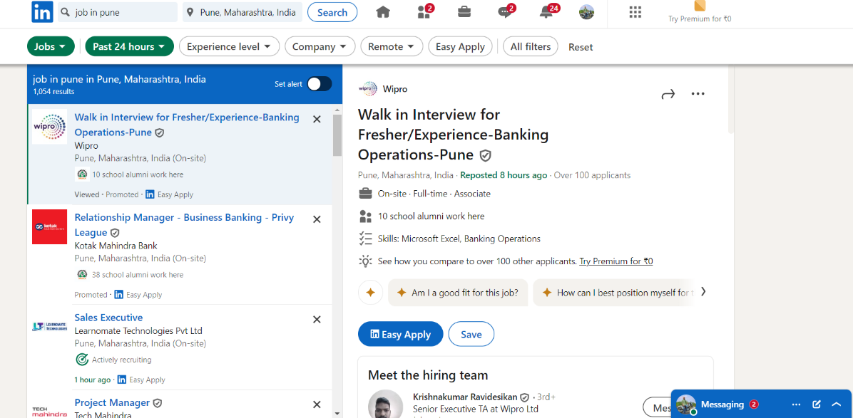

1. **Pitch Deck:** A polished presentation outlining the value proposition of Talent Corner HR Services, key benefits, and success stories.
2. 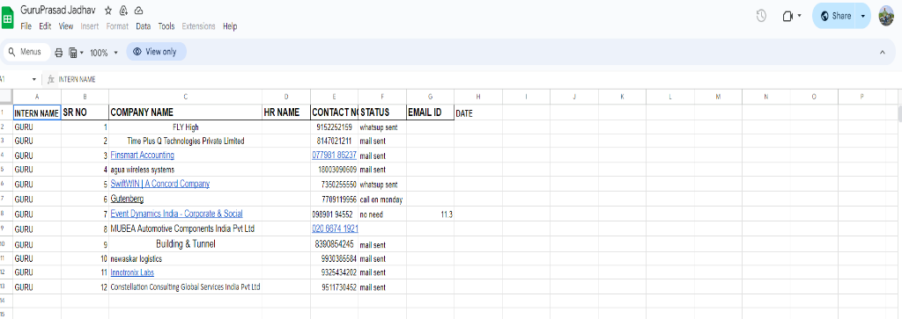**Follow-Up Templates:** Standardized email and phone scripts for various stages of the follow-up process.

1. **Lead Segmentation:** A categorization of leads into "hot," "warm," and "cold" based on their level of interest and potential.

**Challenges**

1. **Unclear Target Audience:**

It's challenging to precisely define the ideal customer, including their industry, company size, and specific HR needs. o Effect: Having a vague target audience can result in inefficient lead generation efforts and lower conversion rates.

1. **Getting Past Gatekeepers:**

It can be hard to reach key decision-makers in companies, especially larger ones, due to gatekeepers like administrative assistants. o Effect: Gatekeepers can delay the sales process by preventing direct communication with potential clients.

1. **Standing Out in the Market:**

In a crowded HR services industry, it can be tough to differentiate Talent Corner from its competitors. o Effect: Without clear differentiation, convincing potential clients of Talent Corner's unique value can be difficult.

1. **Dealing with Budget Limitations:**

Many companies have tight HR budgets, making it hard to justify spending on external HR services. o Effect: Potential clients may hesitate to invest in Talent Corner's services if they see them as too expensive.

1. **Showing Value and ROI:**

Proving the return on investment (ROI) of HR services can be challenging, especially in the short term. o Effect: Clients may be hesitant to commit to long-term partnerships if they don't clearly see the value and benefits of Talent Corner's services.

**Limitations**

1. **Access to Decision-Makers:** Even if lead generation identifies potential clients, getting in touch with key decision-makers within companies can be tough, especially in large organizations with many layers and gatekeepers.
2. **Industry Knowledge Gaps:** Talent Corner might have a broad understanding of various industries, but a deeper dive into specific sectors is often necessary. Without this detailed knowledge, tailoring service pitches to address specific industry needs can be challenging.
3. **Time Constraints:** Lead generation and crafting effective service pitches take a lot of time. Limited resources and tight deadlines can prevent thorough research and personalized follow-ups, affecting the efficiency and success of the sales process.
4. **Competitive Market:** The HR services market is crowded, with many competitors offering similar services. Standing out and convincing potential clients of what makes Talent Corner unique requires a strong grasp of market dynamics and clear communication of competitive advantages.
5. **Economic Changes:** Fluctuations in the economy can impact hiring practices and demand for HR services. During economic downturns, there may be fewer leads, reduced customer acquisition, and potential revenue loss.
6. **Technological Challenges:** Technology is crucial for lead generation and pitching, but limitations such as outdated CRM systems or ineffective lead scoring can reduce efficiency and the quality of leads and follow-ups.

Top of Form

Bottom of Form

**Recommendations**

* 1. **Deepen Industry Expertise and Focus on Niche Markets**

**Recommendation:**  
HR consultancy firms should enhance their industry-specific expertise and focus on niche markets where they can establish a competitive advantage.

**Implementation Guidelines:**

* **Conduct In-Depth Industry Research:** Identify industries with high demand for HR services and align with Talent Corner’s core strengths.
* **Develop Industry-Specific Case Studies:** Showcase successful projects in targeted industries to build credibility and trust among potential clients.
* **Hire or Train Industry Experts:** Invest in recruiting or training staff with specialized knowledge of key industries to improve client interactions and service delivery.
* **Create Tailored Marketing Materials:** Design content that addresses the unique challenges and requirements of each targeted industry.

**Expected Outcomes:**

* Improved credibility and recognition as a trusted expert in targeted industries.
* Enhanced lead quality by attracting prospects with specific needs.
* Delivery of more effective and customized solutions, leading to better client satisfaction.
* A stronger competitive position through differentiation from generalist competitors.

**Scope for Future Work:**

* Continuously identify and explore emerging industries with growth potential.
* Foster partnerships with industry groups or complementary service providers.
* Offer specialized training programs to clients, increasing their HR capabilities.

**2. Leverage Technology for Operational Efficiency and Scalability**

**Recommendation:**  
Adopt advanced technology solutions to streamline processes, improve lead management, and enhance overall efficiency.

**Implementation Guidelines:**

* **Invest in a Robust CRM System:** Utilize a CRM platform to track and manage leads, ensuring efficient customer relationship management.
* **Utilize Automation Tools:** Automate repetitive tasks like email campaigns and appointment scheduling to optimize time and resources.
* **Explore AI-Powered Tools:** Use AI for lead scoring, personalized recommendations, and predictive insights to prioritize high-potential clients.
* **Integrate Social Media Platforms:** Engage with prospects, build brand awareness, and foster relationships using targeted social media campaigns.

**Expected Outcomes:**

* Increased efficiency by reducing manual workloads and streamlining operations.
* Enhanced lead conversion rates by focusing on high-quality leads.
* Improved customer experience through personalized and timely interactions.
* Data-driven decision-making supported by actionable analytics.

**Scope for Future Work:**

* Keep pace with advancements in AI and automation to remain competitive.
* Continuously optimize the technology stack to address evolving business needs.
* Train staff to leverage technology effectively in sales and client management.

**3. Strengthen Sales Team Capabilities**

**Recommendation:**  
Develop the sales team’s skills and create a collaborative culture to drive better client acquisition and retention outcomes.

**Implementation Guidelines:**

* **Provide Ongoing Sales Training:** Conduct regular training sessions on advanced sales techniques and product knowledge.
* **Implement Performance Metrics:** Establish KPIs to monitor and improve sales team performance.
* **Offer Incentives and Rewards:** Motivate the team through performance-based rewards and recognition.
* **Foster a Positive Sales Culture:** Encourage collaboration, support, and a sense of shared purpose within the sales team.

**Expected Outcomes:**

* Improved sales performance through enhanced skillsets and strategies.
* Increased customer satisfaction and loyalty due to better service delivery.
* Higher employee morale and engagement, resulting in reduced turnover.
* A skilled and motivated sales force capable of meeting business objectives.

1. **Scope for Future Work:**

* Explore sales enablement tools to improve content delivery and training.
* Implement personalized coaching programs to address individual skill gaps.
* Evaluate and adjust the sales team structure to align with strategic goals.

**Conclusion**

This study explored the strategic elements of lead generation, service pitching, and need identification within the HR consultancy sector, specifically focusing on Talent Corner HR Services. The findings underscored the importance of structured approaches and tailored strategies to improve customer acquisition and retention. By leveraging digital tools, adopting a consultative approach, and personalizing service pitches, HR consultancy firms can effectively build trust, foster long-term relationships, and enhance business outcomes.

The recommendations proposed—such as deepening industry expertise, leveraging advanced technology, and strengthening sales team capabilities—offer actionable solutions to address identified challenges and capitalize on opportunities. These strategies are expected to streamline processes, improve client interactions, and position HR firms as trusted partners in meeting diverse organizational needs.

By implementing these strategies, HR consultancy firms can not only refine their service delivery but also adapt to evolving market dynamics, ensuring sustained growth and a competitive edge in the industry. This research contributes valuable insights for HR consultancy firms looking to enhance their operational efficiency, build stronger client relationships, and achieve long-term success.

**Bibliography**

**1. Books**

* Kotler, P., & Keller, K. L. (2016). *Marketing Management* (15th ed.). Pearson Education.
* Spiro, R. L., & Weitz, B. A. (1990). *Adaptive Selling: Conceptualization, Measurement, and Nomological Validity*. Journal of Marketing Research, 27(1), 61-69.

**2. Journal Articles**

Giovannetti, M., Cardinali, S., Kulaga, B., & Amadio, G. (2021). State of Art of HEI Sales Education in Digital Age: A Literature Review. Fostering digital skills and competencies in Higher education, 1-33.

Halaby, B., & Li, Q. (2002). Introducing fundamental changes to a service delivery model:" lessons from a financial advisory organization".

Kesler, G. C. (2002). Why the leadership bench never gets deeper: Ten insights about executive talent development. Human Resource Planning, 25(1), 32-45.

Malhotra, S. (2013). Challenges and Emerging Trends in Human Resource Management. International Journal of Business Anthropology, 4(2).

Melegati, J., Guerra, E., & Wang, X. (2021). Understanding hypotheses engineering in software startups through a gray literature review. Information and Software Technology, 133, 106465.

Sigamani, P., & Malhotra, S. (2013). Challenges and emerging trends in human resource management. International Journal of Business Anthropology, 4(2).

Toterhi, T., & Recardo, R. J. (2013). The talent funnel: How to surface key human resources. Global Business and Organizational Excellence, 32(5), 22-44.

Wirtz, J., & Lovelock, C. (2017). Managing People for Service Advantage. World Scientific.