**Iot Driven Innovation in smart parking-A Review**

S Sai Baba

Computer Science and Engineering

GMR Institute of Technology, Rajam

ssbaba9692777797@gmail.com

9692777797

**Abstract:**

Good parking management solutions are in demand, and this has been taken a step further by rapid urbanization and increased vehicle ownership. Classic parking usually creates long searches, increases traffic congestion and consequently high emissions that lead to inefficiency in urban creation. This paper therefore proposes a detailed IoT-based smart parking system, premised on real-time data and advanced communication technologies, to effectively cure these problems. The system integrates IoT-powered sensors to constantly look out and ascertain the status of parking space occupying. All of this information is transmitted from these parking areas to a cloud-based management platform for further processing and analysis after which the results are communicated in real-time to the drivers through mobile applications. The app not only leads the driver to the nearest available parking lot but also assists in the automated reservation of parking and contactless payment process, which almost eliminates the whole process of parking. Furthermore, this system suggests useful analytics for city planners to understand parking patterns, optimally using space, and enhancing traffic flow. The proposed system reduces the parking searching time and, as a result, reduces congestion, thereby lowering carbon emissions on the whole, hence increasing the efficiency of urban transportation systems. This smart parking infrastructure in symbiosis with IoT is a great leap toward smarter and more sustainable cities.

**Key Words:**

Smart Parking, IoT, Realtime Monitoring, Urban Mobility, Digital Systems Integration

**1.Introduction:**

Urbanization has immensely increased the number of road users, thereby making challenges attached to managing minimal parking spaces much worse. Users spend a lot of their time in towns in search of parking opportunities. Such frustration causes detours of traffic flow, wastage of more fuel, and an increase in emissions from such vehicles. Traditional parking systems are not able to keep up with growing parking needs in very populated cities.

IoT, therefore, presents a transformative solution to this growing problem. It is possible with the help of IoT to collect and communicate data in real time among devices that are rumored to enable the construction of smarter, more efficient urban infrastructure. In the context of parking, systems based on IoT can change the way monitored and managed space is utilized in the parking environment. They should be able to deploy IoT sensors in their parking lots and along streets so that cities are permitted to track dynamically the availability of parking spots and provide real-time inputs to drivers, hence reducing the time spent searching for parking in greatmagnitude.

So, the IoT-parking management system can be deployed with automated payment and reservation systems to make a parking process more convenient and user-friendly. In fact, these smart parking systems could, on one side, contribute to the improvement of a better overall user experience but, on another side, offer considerable support in the solution of the following pressing issues of modern city life: traffic congestion, carbon emission, and creating a more sustainable and smart city.

**2.Literature Survey:**

With the rapid growth of urbanization and vehicle ownership, parking management has become a critical challenge in modern cities. Traditional parking systems often result in long search times, traffic congestion, and increased carbon emissions. To address these challenges, researchers have extensively explored smart parking solutions powered by Internet of Things (IoT) technologies.

Jabbar et al. (2024) proposed a LoRaWAN-based IoT parking system that demonstrated enhanced efficiency in data communication over long distances, making it ideal for large parking facilities. Their study highlighted the system's ability to integrate seamlessly with smart city infrastructure. Similarly, Thakre et al. (2021) utilized RFID technology to automate vehicle entry and exit, significantly reducing manual intervention and enhancing user convenience.

Kadir et al. (2020) implemented IR sensors for vehicle detection, emphasizing their low cost and high reliability. Their IoT-based system provided accurate real-time updates on parking availability. Meanwhile, Madhavi et al. (2020) explored the use of IoT in combination with mobile applications to create a user-friendly interface for parking reservations, showcasing the potential of digital integration.

Another notable contribution is from Kabir et al. (2021), who designed a system that leverages mobile and web applications for real-time monitoring of underutilized parking spaces. This approach not only increased the efficiency of space utilization but also introduced contactless payments to streamline the parking process. Honrao and Rane (2024) further investigated the role of IoT in creating smart parking systems, focusing on data-driven decision-making and user experience improvement.

In addition to IoT-based approaches, machine learning and AI-driven methods have also been explored. Ali et al. (2020) integrated deep learning algorithms for vehicle detection using Long Short-Term Memory (LSTM) networks. Their system exhibited high accuracy in identifying vacant parking spots, showcasing the power of AI in smart parking solutions. Zahid et al. (2023) introduced an RFID-based detection system with inkjet-printed tags, which was highly scalable and cost-effective.

Lastly, Sulistyawan et al. (2023) implemented ultrasonic sensors with NodeMCU for parking tracking, offering a simple yet effective solution for small-scale parking systems. Their system demonstrated the importance of low-cost components in achieving a balance between affordability and functionality.

From these studies, it is evident that IoT-driven parking systems are revolutionizing urban mobility by providing efficient, scalable, and user-centric solutions. However, integrating these systems with AI, blockchain, and augmented reality (AR) presents exciting opportunities for future enhancements, enabling smarter, greener, and more sustainable urban environments.

**3.Dataset:**

* **Vehicle Images:** Images or videos of parking areas to test object detection algorithms.
* **Occupancy Data:** Real-time or historical data indicating when spaces are occupied or free.
* **Sensor Data:** Information from IoT sensors that track vehicle presence, parking duration, and space availability.

**4.Methodologies:**

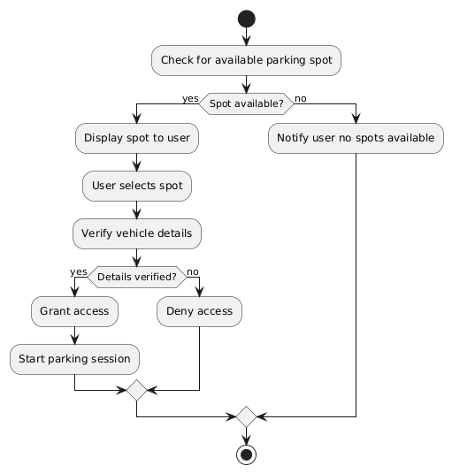**4.1 Event-Triggered algorithm:**

Figure 1 Event-Triggered

Input:

* **Sensors (Ultrasonic, RFID, IR)**: Detect vehicle presence or absence in parking spots.
* **Event Trigger**: Activated when a vehicle enters (occupied) or leaves (vacant) a spot.

Process:

* **Event Detection**: Sensor identifies a change (e.g., car enters or leaves).
* **Data Transmission**: Sends the event data (spot ID, status, timestamp) to the server via communication protocols (Wi-Fi)
* **Processing**: The central server updates the parking spot's status in the database and triggers additional logic (e.g., notifications or payment).

Output:

* **Real-Time Updates**: Displays updated parking spot status (occupied or vacant) on the mobile/web app.
* **Notifications**: Alerts users of parking availability changes.

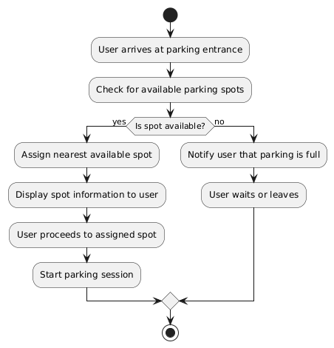**4.2 FCFS(first come first serve) algorithm:**

Figure 2 FCFS

Input:

* **User Request Queue**: Users are added to the queue based on arrival time.
* **Parking Spot Data**: Real-time availability status of all parking spots.

Process:

* **Check Queue**: The system prioritizes the earliest request in the queue.
* **Assign Spot**: If a spot is available, it is assigned to the first user in the queue.
* **Update Queue and Availability**: Removes the assigned user from the queue and marks the spot as occupied.

Output:

* **Spot Assignment**: Confirms assigned parking spot to the first user in line.
* **System Update**: Adjusts parking spot status and updates the queue for the next request.

**4.3 Greedy algorithm:**

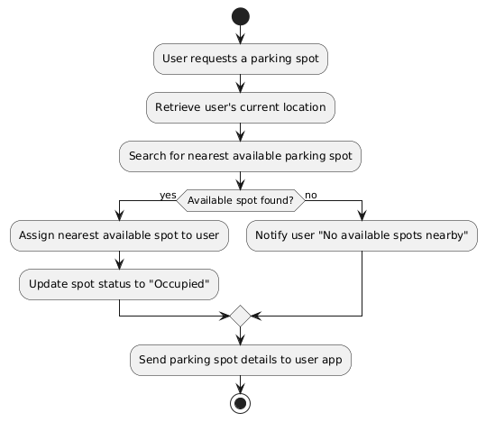

Figure 3 Greedy

**Input:**

* **User Request**: Searches for available parking.
* **Parking Spot Data**: Real-time availability and location of spots.

**Process:**

* **Identify Available Spots:** Finds vacant spots based on location or user preference.
* **Greedy Selection:** Assigns the best spot (e.g., closest or first-available)
* **Update:** Marks spot as reserved or occupied.

**Output:**

* **Assignment**: Notifies user of assigned spot.
* **System Update**: Marks spot as occupied for all users.

**4.4 State-Monitoring Algorithm:**

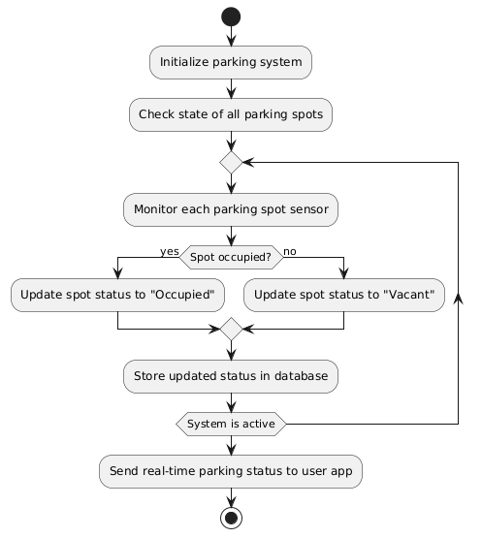

Figure 4 State- monitoring

Input

* **Sensor Data**: Real-time input from sensors detecting occupancy or availability.
* **Parking System Database**: Current state of all parking spots.

Process:

* **Monitor Status**: Continuously checks sensor data for status changes (e.g., occupied or vacant).
* **Update Database**: Updates the central system with new status information when changes are detected.

Output:

* **Real-Time Updates**: Displays updated spot status on user platforms.
* **Alerts/Notifications**: Sends alerts if specific spots become available or occupied.

**4.5 YOLO algorithm:**

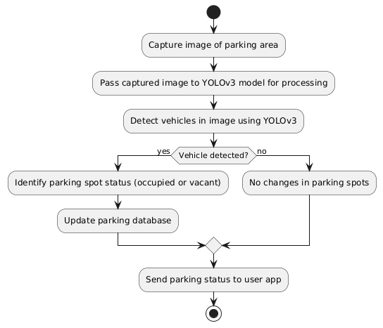

Figure 5 YOLO

**Input:**

* **Image Frame**: The input image/frame that needs object detection.

**Process:**

* **Divide Image into Grid**: YOLO divides the image into an S×S grid (e.g., 13x13).
* **Bounding Box Prediction**: Each grid cell predicts bounding boxes and confidence scores for objects within its cell.
* **Class Probability Prediction**: Each bounding box includes probabilities for specific object classes (e.g., car, person, bicycle).
* **Non-Maximum Suppression**: Filters overlapping boxes to keep the most accurate bounding boxes for each detected object.

**Output:**

* **Detected Objects**: Outputs a list of objects with bounding boxes, class labels, and confidence scores.
* **Visual Representation**: The algorithm can draw bounding boxes around detected objects in the image frame.

**5.Results:**

|  |  |  |  |  |
| --- | --- | --- | --- | --- |
| **Method** | **Detection Accuracy** | **Space Utilization** | **Response Time** | **User Satisfaction** |
| **Event-Triggered algorithm[8]** | 90% | 85% | 92% | 88% |
| **Greedy algorithm[1]** | 87% | 80% | 88% | 84% |
| **FCFS algorithm[12][14]** | 82% | 78% | 80% | 79% |
| **Priority based algorithm[9]** | 88% | 83% | 85% | 86% |
| **YOLO algorithm[5]** | 95% | NA(detection only) | 93% | 92% |
| **RFID-based System[2][10]** | 89% | 84% | 90% | 87% |

**Graphical Representation:**

**6. Discussions:**

Analyzing the performance of different algorithms emphasizes their role in supporting an IoT-based smart parking solution. Due to the vehicle recognition capabilities it possesses, the YOLO method clocked the highest in terms of detection accuracy (95%) of all other methods with the Event-Triggered method taking the second position as it guarantees timely information updates that are very accurate and improves user satisfaction. Concerning space efficiency, it is also the case that the Event-Triggered method performs better as it directs the drivers to the closest available space ensuring effective use of parking lot. On the other hand, although FCFS is less reactive and efficient, it is however acceptable in places with low demand. Response time-wise on the other hand, YOLO takes the lead as it offers fast and reliable updates which are crucial in busy urban settings.

**7. Conclusion:**

This paper presents an IoT-based smart parking system that addresses challenges of urban congestion, inefficient space utilization, and high emissions resulting from traditional parking systems. By employing algorithms like YOLO and the Event-Triggered approach, the system accurately detects vehicles and provides real-time updates, reducing parking search times and optimizing space allocation. The proposed solution significantly lowers traffic congestion and carbon emissions, supporting sustainable urban mobility. Additionally, real-time feedback enhances the user experience, making parking more convenient and efficient. Future enhancements, such as predictive analytics for peak demand and blockchain for secure transactions, could further improve system reliability and user trust. Overall, this IoT-enabled smart parking infrastructure contributes to smarter, more sustainable cities, showcasing the potential of IoT in transforming urban environments and improving the quality of life for city residents.

**REFERENCES:**

1. Jabbar, W. A., Tiew, L. Y., & Shah, N. Y. A. (2024). Internet of things enabled parking management system using long range wide area network for smart city. *Internet of Things and Cyber-Physical Systems*, *4*, 82-98.
2. Thakre, M. P., Borse, P. S., Matale, N. P., & Sharma, P. (2021, January). IOT based smart vehicle parking system using RFID. In *2021 International Conference on Computer Communication and Informatics (ICCCI)* (pp. 1-5). IEEE.
3. Abd Kadir, M. M., Osman, M. N., Othman, N. A., & Sedek, K. A. (2020). IoT based car parking management system using IR sensor. *Journal of Computing Research and Innovation*, *5*(2), 75-84.
4. Madhavi, K., Kandulu, N., Rao, R. M., Vandrasi, S. M., & Swamy, G. K. Smart Parking System Using IoT.2020
5. Kabir, A. T., Saha, P. K., Hasan, M. S., Pramanik, M., Ta-Sin, A. J., Johura, F. T., & Hossain, A. M. (2021, June). An IoT based intelligent parking system for the unutilized parking area with real-time monitoring using mobile and web application. In *2021 International Conference on Intelligent Technologies .*IEEE.
6. Honrao, Y., & Rane, R. (2024). Smart Parking System using IOT. *Grenze International Journal of Engineering & Technology (GIJET)*, *10*(1).
7. Alam, M. R., Saha, S., Bostami, M. B., Islam, M. S., Aadeeb, M. S., & Islam, A. M. (2023).IoT Driven Smart Parking Management System: Approaches, Limitations and Future Research Agenda. *IEEE Access*.
8. Murugan, M. B., Rajagopal, M. K., Kannan, T. R., & Kathiresan, G. (2021, November). A modest IoT based smart parking system with business analytics integration. In *Journal of Physics: Conference Series* (Vol. 2115, No. 1, p. 012018). IOP Publishing.
9. Ali, G., Ali, T., Irfan, M., Draz, U., Sohail, M., Glowacz, A., ... & Martis, C. (2020). IoT based smart parking system using deep long short memory network. *Electronics*, *9*(10), 1696.
10. Zahid, A., Mufti, N., Ullah, S., Nawaz, M. W., Sharif, A., Imran, M. A., & Abbasi, Q. H. (2023). IoT-enabled vacant parking slot detection system using inkjet-printed RFID tags. *IEEE Sensors Journal*, *23*(7), 7828-7835.
11. Saleem, Y., Sotres, P., Fricker, S., de La Torre, C. L., Crespi, N., Lee, G. M., ... & Sanchez, L. (2020). IoTRec: The IoT recommender for smart parking system. *IEEE Transactions on Emerging Topics in Computing*, *10*(1), 280-296.
12. Sulistyawan, V. N., Salim, N. A., Abas, F. G., & Aulia, N. (2023, June). Parking tracking system using ultrasonic sensor HC-SR04 and NODEMCU ESP8266 based IoT. In *IOP Conference Series: Earth and Environmental Science* (Vol. 1203, No. 1, p. 012028). IOP Publishing.
13. Marshoodulla, S. Z., & Saha, G. (2024). SDIoTPark: A Data Analytics Framework for Smart Parking Using SDN Based IoT. *IEEE Internet of Things Journal*.
14. Krishna, G. M., & Narendhar, G. (2019). Smart Parking Management System using IoT. *IJRTE*, *8*(4), 3862-3867.
15. Mackey, A., Spachos, P., & Plataniotis, K. N. (2020). Smart parking system based on bluetooth low energy beacons with particle filtering. *IEEE Systems Journal*, *14*(3), 3371-3382.
16. Elakya, R., Seth, J., Ashritha, P., & Namith, R. (2019). Smart parking system using IoT. *Int. J. Eng. Adv. Technol*, *9*(1), 6091-6095.