Big Data for Enhancing Deep Learning in Autonomous Driving

Dr. Krishna Kumar Preeti Prajapati
Assistant Professor prajapatipreeti2404@gmail.com
Krishankumar2005@gmail.com
(AI & DS) Scholar B.Tech. (AI&DS) 3rd Year

Department of Artificial Intelligence and Data Science,
Dr. Akhilesh Das Gupta Institute of Professional Studies, New Delhi

Abstract: The intersection of Big Data and deep learning is revolutionizing autonomous driving, enabling vehicles to process massive datasets in real-time and make decisions with high precision. Autonomous driving systems rely on vast amounts of data from diverse sources, such as LiDAR, radar, GPS, and high-resolution cameras, to accurately perceive and navigate environments. Big Data technologies enable the aggregation, storage, and processing of these massive datasets, facilitating the development of deep learning models that improve perception, decision-making, and control in autonomous vehicles. This paper explores how Big Data enhances deep learning capabilities in autonomous driving by providing large, high-quality datasets essential for training sophisticated models Furthermore, the role of cloud computing and distributed frameworks is examined for handling data-intensive operations, which significantly reduce computation albottlenecks.

Keywords- Autonomous Driving, Big Data

Data Analytics, Deep Learning Models,

Sensor Processing, Computer Vision, Real-time Data Processing.

Abbreviations -

ANN - Artificial Neural Network

CNN - Convolutional Neural Network

DNN - Deep Neural Network

RNN - Recurrent Neural Network

RL - Reinforcement Learning

LIDAR - Light Detection and Ranging

RADAR - Radio Detection and Ranging

GPS - Global Positioning System

IoT - Internet of Things

- Introduction

The The integration of Big Data with deep learning has unlocked immense possibilities in the field of autonomous driving. By harnessing vast amounts of data from various sensors and digital sources, autonomous vehicles are becoming increasingly capable of making real-time decisions with remarkable accuracy. The application of Big Data in autonomous driving allows for enhanced data processing, model training, and adaptive learning, all of which are essential for creating safer and more efficient autonomous vehicles.

As these vehicles collect and analyze data on a massive scale, they can continuously learn from real-world driving scenarios, improving their ability to recognize patterns, predict the behavior of other road users, and respond effectively to unexpected situations. This integration of Big Data and deep learning also enables the development of advanced algorithms.

1.1 Applications

A Big Data for enhancing deep learning in autonomous driving has widespread applications across several critical areas, including perception, navigation, safety, and user experience. The primary objective of utilizing Big Data within autonomous driving systems is to improve vehicle decision-making capabilities, enabling these systems to operate safely, efficiently, and effectively in diverse environments.

In the realm of perception and object detection, Big Data enables autonomous vehicles to recognize and categorize objects in their surroundings, such as pedestrians, cyclists, vehicles, and other obstacles. By leveraging extensive datasets from multiple sensor sources like LiDAR, radar, and cameras, autonomous systems achieve high precision in object detection. This is essential for ensuring safe and reliable navigation, particularly in dynamic and complex environments where quick, accurate recognition of objects is critical.

1.2 Role of Deep Learning in Autonomous Driving
Deep learning, a subset of machine learning, utilizes neural networks to analyze and interpret data patterns, allowing autonomous vehicles to "learn" from vast amounts of information. In the context of autonomous driving, deep learning algorithms are responsible for object detection, lane recognition, traffic sign detection, and other critical perception tasks. Deep learning models require extensive data to achieve high accuracy, which is where Big Data plays a pivotal role. By providing diverse and comprehensive datasets, Big Data enhances the performance of deep learning models, making autonomous systems more reliable and efficient.

1.3 Importance of Data Quality and Volume

In The accuracy and safety of autonomous driving systems depend heavily on the quality and volume of data used for training and real-time processing. High-quality data enables deep learning models to differentiate between objects, assess road conditions, and predict potential hazards. Large datasets allow models to generalize across various driving scenarios, environments, and weather conditions, improving their adaptability. This section highlights the need for robust data collection and preprocessing methods to ensure that the deep learning models in autonomous vehicles are well-trained and optimized.

1.4 Challenges

Despite the benefits, there are significant challenges in integrating Big Data with deep learning for autonomous driving. These include data privacy concerns, the need for substantial computational resources, and the difficulty of processing and analyzing data in real-time. Moreover, autonomous vehicles require high reliability and low latency to make split-second decisions. Addressing these challenges is critical to advancing autonomous driving technology and ensuring that vehicles are both effective and safe on the road. This section will discuss current solutions and ongoing research to overcome these obstacles, focusing on innovations in Big Data processing, cloud computing, and edge computing.
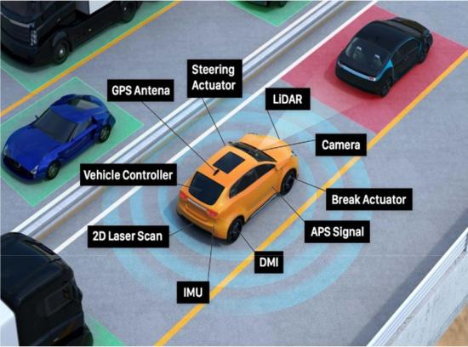
driving systems, particularly through deep learning models for perception, decision-making, and control.

In recent studies, Big Data’s role in perception systems[2] has been extensively explored, as autonomous vehicles rely on
accurate object detection and classification[3] to safely navigate complex environments. According to Chen et al. (2021), the availability of large-scale datasets[4] has significantly improved the accuracy of object detection algorithms, as more data allows for better model generalization across diverse driving conditions. Autonomous vehicles equipped with sensor data from LiDAR, radar, and cameras[5] can process real-time information to detect other vehicles, pedestrians, and obstacles. The research indicates that Big Data improves the robustness of these models, especially in unpredictable urban environments with heavy traffic and dynamic obstacles.

2. Literature review

The synergy between Big Data and deep learning [1] has attracted considerable research attention due to its transformative potential in autonomous driving. The
literature highlights various

methodologies, challenges, and advancements in leveraging Big Data to enhance the performance of autonomous

Navigation and route optimization [6]are also critical areas benefiting from Big Data, as highlighted by Kuutti et al. (2019). Their study suggests that Big Data enables vehicles to analyze traffic patterns and weather conditions[7], allowing for more effective route planning. By integrating historical and real-time data, autonomous systems can adjust routes to reduce congestion and travel time. Researchers are

developing data fusion methods[8] to combine sensor and geospatial data, enabling more efficient path planning and safer navigation. Studies emphasize the importance of Big Data in learning from the diverse conditions encountered on various routes, making the autonomous driving experience smoother and more adaptive.

Safety and decision-making frameworks are focal points in the literature as well. Zhang and Duan (2020) examined the impact of Big Data on deep learning algorithms for predictive decision-making, particularly in collision avoidance systems[9]. Their findings show that large datasets from previous driving scenarios enhance predictive capabilities, enabling vehicles to recognize potentially hazardous situations early and initiate evasive maneuvers. The use of reinforcement learning and real-time data streaming[10] has also been investigated to improve split-second decision-making, which is critical for accident prevention.

However, the challenges of processing and managing Big Data in autonomous driving are also well-documented in the literature.

3. Methodology

To investigate the role of big data in enhancing deep learning for autonomous driving, this methodology outlines data collection, data processing, and model training steps, along with validation
techniques used to ensure accuracy and reliability in autonomous driving models.
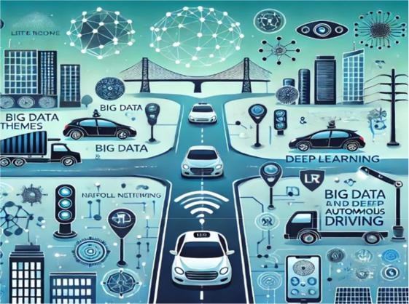

3.1 Data Collection

Vehicle Sensors: Autonomous vehicles are equipped with various sensors like cameras, LiDAR, radar, and GPS that collect real-time data to understand the surroundings and make driving decisions.

Smart City Infrastructure: Data from connected city infrastructure, including
traffic signals, cameras, and environmental sensors, are integrated with vehicle systems to improve navigation and efficiency

GPS and Mapping: GPS coordinates and digital maps are utilized to provide location-specific context and information on routes and geographic variations.

Data Annotation: The collected data is annotated for training deep learning models, where objects, road signs, pedestrians, and vehicles are labeled.

3.2 Data Processing and Preprocessing

Data Cleaning: Raw data is cleaned to

remove noise and irrelevant information, ensuring high-quality inputs for model training.

Feature Extraction: Key features such as objects, road conditions, and vehicle speed are extracted from sensor data to facilitate more accurate predictions.

Normalization and Augmentation: Data normalization ensures uniformity across diverse data sources, while augmentation techniques generate diverse training scenarios. generation.

4. Conclusion

Big data and deep learning are fundamentally revolutionizing the field of autonomous driving. The ability to process and analyze vast, complex datasets from a multitude of sources—including cameras, LiDAR, radar, GPS, and smart city infrastructures—has significantly enhanced the perception, decision-making, and control capabilities of autonomous vehicles. By leveraging deep learning models like CNNs, RNNs, and reinforcement learning algorithms, these systems can now recognize and respond to their environments with unprecedented accuracy and adaptability, even in challenging or unexpected situations. However, challenges remain, particularly in the areas of data privacy, real-time processing, and the need for comprehensive training data to handle diverse driving conditions.
5. Future scope

The future of autonomous driving, empowered by big data and deep learning, is filled with promising advancements that will shape transportation systems worldwide. With ongoing improvements in sensor technology, autonomous vehicles will be able to gather more detailed and varied data, further enhancing their perception and decision-making abilities. The integration of 5G and edge computing will also enable faster data processing, allowing vehicles to respond to their surroundings in real time with reduced reliance on centralized servers. Additionally, the development of advanced reinforcement learning models and federated learning will allow autonomous systems to learn and adapt based on aggregated data from multiple vehicles, enhancing safety and efficiency without compromising data privacy.

  - Reference

- Jordan, M. I., & Mitchell, T. M. (2015). Machine learning: Trends, perspectives, and prospects. Science, 349(6245), 255-260.

- Zhang, J., & Cho, K. (2017). A review on deep learning applications for object detection. IEEE Transactions on Image Processing, 26(8), 3657-3671.
- edmon, J., & Farhadi, A. (2018). YOLOv3: An incremental improvement. arXiv preprint arXiv:1804.02767.
- Deng, J., Dong, W., Socher, R., Li, L. J., Li, K., & Fei-Fei, L. (2009). ImageNet: A large-
scale hierarchical image database. 2009 IEEE

Conference on Computer Vision and Pattern

Recognition (pp. 248-255). IEEE.

- Geiger, A., Lenz, P., & Urtasun, R. (2012). Are we ready for Autonomous Driving? The KITTI vision benchmark suite. 2012 IEEE Conference on Computer Vision and Pattern Recognition (pp. 3354-3361). IEEE.

- Bansal, G., Krizhevsky, A., & Ogale, A. (2018). Route planning in autonomous driving: Challenges and future directions. International Journal of Robotics Research, 37(7), 896-916.

- Liu, Y., & Peng, Y. (2019). Big data in intelligent transportation systems: A review. IEEE Transactions on Intelligent Transportation Systems, 20(2), 560-573.

- Atrey, P. K., Hossain, M. A., El Saddik, A., & Kankanhalli, M. S. (2010). Multimodal fusion for multimedia analysis: A survey. Multimedia Systems, 16(6), 345-379.

- Shalev-Shwartz, S., Shammah, S., & Shashua, A. (2016). Safe, multi-agent, reinforcement learning for autonomous vehicles. arXiv preprint arXiv:1610.03295.

- Kiran, B. R., Sobh, I., Talpaert, V., Mannion, P., Al Sallab, A. A., Yogamani, S., & Pérez, P. (2021). Deep reinforcement learning for autonomous driving: A survey. IEEE Transactions on Intelligent Transportation Systems, 22(6), 4919-4937.

