**MENTAL HEALTH EDUCATION, AWARENESS AND STIGMA REGARDING MENTAL ILLNESS AMONG COLLEGE STUDENTS**

Abstract

**Objective**: The present study examined whether psychoeducational tools are beneficial in improving awareness and reducing stigma regarding mental health. This study aims to increase mental health awareness and reduce the stigma associated with mental illness.

**Methods**: The study is quantitative research. In this study, 147 students registered in the Abnormal Psychology course, which focuses on mental illness, were recruited. Students signed informed consent and participated in the study voluntarily. Students completed the demographic questions, Beliefs Toward Mental Illness Scale (BTMI), and Stig-9 questionnaire (stig-9).

**Results:** Our findings revealed a significant difference in beliefs and awareness about mental health and a decrease in stigma after students completed the Abnormal Psychology course. The statistical analysis revealed that students believe mental health is more curable and less embarrassing after taking mental health education. Finally, our findings demonstrated a direct impact of the educational experience on student attitudes toward mental health.

**Conclusion:** Our finding indicates that mental health education is a promising tool to raise awareness and understanding and reduce the stigma regarding mental health. Providing students with mental health education and training enabled students to learn and understand issues with mental illness. This study demonstrated a direct impact on the educational experience on student attitudes toward mental health.

Introduction

Mental illnesses are common, and many adults with mental health problems in the United States do not receive mental health care, even though treatments are available1. Globally, almost two-thirds of the population with mental illness do not receive treatment from medical professionals2. As a result, many people with mental illness remain untreated or poorly treated3. Researchers are increasingly emphasizing the importance of mental health awareness as many college students suffer from mental health issues and these challenges affect their lives4-6 and their academic performance7. Unfortunately, many college students report having mental health concerns8, and only about one-third of students with psychological disorders receive mental health treatment8. Among college students, a lack of knowledge and awareness of on-campus mental health resources is a significant barrier to seeking mental health help9. In addition, about one-third of college students do not know that counseling services and support are available on campus9,10. While counseling centers have been utilized in recent years than in the past, college students report poor mental health, and they receive very little treatment11,12. Lack of awareness of services makes it difficult for students to seek help.

It is vital to raise awareness of mental health and identify students who may be at risk for mental health-related problems5,6. Mental health awareness campaigns at higher education institutions have raised awareness of mental health issues and effectively changed student attitudes towards mental health4. Mental health prevention and awareness-raising can normalize seeking help and motivate individuals to take action when they need support6. In a previous study conducted on a university campus, almost half of the respondents did not know where to look during a mental health crisis, and only a quarter of students knew about student services4. Awareness campaigns can be a great initiative to reduce mental health stigma. Most universities host Mental Health Awareness weeks yearly to promote mental health education. Segal13 demonstrated that a lack of stigma and mental health education is responsible for underutilizing mental health services. Improving awareness of available mental health services and reducing stigma should be addressed through mental health awareness campaigns on campuses14. Studies have shown that the prejudice towards mental illness and lack of consciousness associated with mental illness is a barrier to the behavior of college students seeking help7. Kessler15 also stated that perceived discrimination shows associations between disadvantaged social status and mental health.

Henderson2 argued that lack of help-seeking was associated with a lack of knowledge about mental illness, prejudice against people with mental illness, and stigma associated with mental illness. Funkhouser16 found that mental health awareness campaigns show the potential to reduce college student stigma and increase help-seeking behavior. In addition, stigma attitudes most improved among those who actively participated in educational events16. Many studies have negatively predicted high-level public stigma associated with mental illness for help-seeking attitudes and showed that higher-level stigma is associated with lower-level help-seeking behavior17-19. Another study found that participants puzzled by mental health treatment were less likely to seek mental health services20. Mental health-related stigma is a critical factor interfering with mental health services21. Sirey22 pointed out that perceived stigma was a predictor of treatment discontinuation among young people. Especially among male college students, stigma and low mental health literacy are significant barriers to help-seeking for mental health23. Gulliver7 stated that the embarrassing experience of perceived stigma and mental illness is a consistent barrier to help-seeking behavior. Overcoming these barriers is essential for helping students with mental health on college campuses.

Corrigan24 found that persons who hide their mental health experiences suffer from internal shame and are afraid of "societal scorn." Furthermore, society suffers fears and misinformation based on stigma and myth24,25. Corrigan26 argued that changes to the public view of mental health are essential to overcoming the structural stigma and promoting mental health care. In addition, the media's misrepresentation of individuals with mental illness has reduced their seeking for help25,27. More accurate representations in media are a necessary part of changing the public view and helping to reduce stigma. Research also indicates that many adults felt shameful about mental illness and did not trust mental health treatment13. By increasing accurate information regarding mental illness and raising awareness regarding mental health, a reduction in personal stigma is possible, as well as promoting help-seeking behaviors for those in need of service2. Researchers consistently indicated that stigma is a significant barrier to seeking mental health. Those who view the pursuit of mental health as a stigmatized experience may be afraid of potential discrimination because they believe that society has a negative perception of mental illness25. Individuals who believe pursuing mental health is stigmatized are less likely to seek help with their mental health needs28,29. Reducing the barriers to seeking help is essential for college students, as many mental illnesses first appear during college years30. Reducing prejudice about mental illness and using mental health services is an important goal of mental health education21. Segal13 also stated that stigma and lack of education are the causes of the underutilization of mental health services. Gulliver7 examined perceived barriers and intermediaries to seeking mental health help, showing that perceived stigma is the most significant barrier to seeking mental health help. Studies show that increased knowledge and awareness and reduced stigma about mental illness promote early detection of mental illness, improve mental health outcomes, and improve mental health services25,31.

A recent study investigated the relationship between college students' familiarity with active minds, mental health education, and awareness32. In this study, students familiar with active-mind learning were associated with increased knowledge and decreased mental health stigma over time. Dealing with public stigma may reduce the likelihood of personal stigma for service users and make it easier to seek help and engage in mental health care2. Snyder14 demonstrated that a mental health awareness campaign and communication could address the lack of awareness of services and awareness of stigma. Mental health awareness campaigns have successfully raised awareness and effectively changed attitudes about mental health issues14. Mental health interventions and awareness campaigns can motivate individuals to seek counseling, and those who were encouraged to seek help observed more optimistic expectations for mental health outcome33. Many researchers argue that mental health education and campaigns are following steps to raise awareness of campus services, reduce prejudice, and lead to the normalization of seeking help25,10. Mental health education and intervention have successfully encouraged seeking psychological help among college students. For example, campus-wide interventions provide insights into seeking help among students who suffer from depression and positively impact suicide prevention among college students34. Raising awareness, reducing prejudice, and exposure to campus mental health services can promote the use of mental health help-seeking13. Mental health problems at a young age are associated with academic and health disadvantages35,36, and timely psychological treatment can have long-term benefits15,37.

Another study found that increasing knowledge regarding mental health helps improve mental health literacy for male college students38. Much evidence shows that understanding and knowledge about mental illness is crucial for promoting mental health39. Sharp39 found that students who received mental health education showed significant improvement in attitudes toward seeking psychological help and their perception of mental illness. Other researchers also reported that knowledge about mental illness is critical to increasing help-seeking and changing attitudes toward individuals with a mental disorder40,41. In addition, Rickwood, et al42. showed that mental health education had a substantial impact on increasing knowledge and a moderate impact on reducing stigma and improving attitudes toward people with mental illness. These findings suggest that the mental health education program is a promising method to improve help-seeking attitudes and reduce the negative view of mental illness. Increasing awareness, reducing stigma, and providing education to university campuses can increase the use of psychological services and improve the optimistic view of mental health in university students4,39,43. However, the impact of specific mental health education on mental health awareness and stigma is not well studied.

This current study calls for mental health awareness and help-seeking behavior through mental health education on college campuses. The study aimed to find ways to raise students' awareness and knowledge of mental health to help students in need on college campuses. In addition, our research aims to identify the value and importance of mental health resources, including education, as a powerful support tool for raising student awareness and reducing perceived stigma. Finally, our study investigated the relationship between mental health education and changes in the level of consciousness and stigma surrounding mental illness. This study's resource for mental health education was the Abnormal Psychology course, PSYC 2400. This course involved comprehensive education on mental health, including various names/descriptions of mental illness, the specific symptoms based on the DSM 5, and the various causes and the dynamics of treatments for mental illness. This research aims to increase mental health awareness, reduce the stigma associated with mental illness, and foster supportive and educational programs for students who struggle with mental health concerns.

Hypotheses

In order to assess how mental health education influences the level of awareness and attitude toward stigma, we set out to test the following hypotheses

1. Students who receive mental health education by taking an Abnormal Psychology course would show increased levels of mental health awareness.
2. Students who receive mental health education by taking an Abnormal Psychology course would show a decreased attitude toward stigma.
3. Higher levels of mental health awareness would be associated with a lower perceived stigma among college students.
4. Demographic differences would exist regarding sex, gender, years of education, and experiences with mental health in the level of awareness and stigma attitude.

Method

**Participants and Procedures**

Before recruitment began for this study, approval was sought and received from the Internal Review Board at Georgia Gwinnett College for using human subjects. Students who took the Abnormal Psychology course were recruited voluntarily, and 128 students participated in the study. We analyzed 82 students who completed both pre-test and post-test among total numbers. Students enrolled in the Abnormal Psychology course learned about the history of mental illness, studied various mental disorders (symptoms, causes, treatments), and learned about numerous models for understanding the nature of mental illness. In addition, students took three questionnaires twice, one at the beginning and one at the end of the semester. We compared scores from two results and examined whether mental health education improves levels of awareness and reduces perceived stigma among college students.

Measurements

The instruments used in this study are the Beliefs toward Mental Illness Scale (BTMI)44,45 and the Stig-9 questionnaire (Stig-9)46, and the Demographic Questionnaire. The Beliefs towards Mental Illness Scale (BTMI) assesses the negative perception of mental health and how that may affect whether individuals seek psychological help44,45. The BTMI has gained attention among researchers interested in measuring stigma toward psychological disorders13. In addition, BTMI assessed cross-cultural differences in beliefs related to mental illness.

The BTMI questionnaire consisted of 24 statements, and individuals indicated how much they agreed with the statements based on a 6-point Likert scale ranging from (0) "completely disagree" to (5) "completely agree." Total scores were indicative of beliefs about mental illness, with higher scores indicating negative beliefs. BTMI Scales used a four-factor model using the parallel analysis engine. Four subscales are created based on factor analysis. That is dangerousness, poor social and interpersonal skills, and incurability. The social skills scale incorporates beliefs that those with mental illness are untrustworthy13. The BTMI aimed to assess stigmatizing views of mental illness. That includes the beliefs that mental illness is not curable, it is shameful to suffer from it, people who have mental illness are dangerous, and individuals who are not trustworthy. Of the four areas related to beliefs studied, the following categories were considered most valid: dangerousness, poor social skills, and incurability. Research demonstrates that the BTMI scale is psychometrically sound and sufficient for analyzing the beliefs about mental illnesses47.

We also used the Stig-9 questionnaire to measure mental health and mental illness stigma. Stig-9 is short, comprehensive, and popular with patients with mental illness. Psychological assessments of Stig-9 showed a one-factor structure, high internal consistency, and reasonable internal validity46. Stig-9 consists of nine items that assess the cognitive, behavioral, and emotional aspects of perceived stigma related to mental health. Higher scores indicate higher expectations for negative social beliefs, feelings, and behaviors towards the "mentally ill." Confirmatory factor analysis revealed a one-factor structure. In addition, the scale showed high internal consistency: male gender, social disability, and psychopathology correspond to higher STIG-9 scores. STIG-9 is a new, theory-based, patient-focused, psychometrically promising self-reporting measure of perceived stigma related to mental health. It is short, comprehensive, and popular with patients with mental illness46. Participants also completed a demographic questionnaire.

Results

Paired samples t test was performed to determine whether there are significant differences between pre-test and post-test for the sample of size N=82 who took the psychology course. Table 1 shows the result of paired samples t test between pre-test and post-test for Beliefs Toward Mental Illness Scales (BTMI), Stigma 9 questionnaires (STIG-9), and 4 subfactors of the BTMI. The BTMI has four subfactors and they are Dangerousness/harm, Social Dysfunction, Incurability, and Embarrassment. The first two rows of the table 1 show a significant difference at É=0.05 level between pre-test and post-test for BTMI (p-value=0.041) and STIG-9 (p-value=0.036). It suggests that students show improvement on belief and awareness about mental health and decrease of stigma level related to mental health after the mental health education. The t value of the difference between pre-test and post-test is 2.077 (BTMI), and 2.127 (STIG-9), respectively, meaning that the mean BTMI scores and the mean STIG-9 scores were decreased after the mental health education. In the questionnaire of the BTMI and the STIG-9, low BTMI scores represents high mental health awareness, and low STIG-9 scores represents low stigmatic attitudes. In addition, paired samples t test was performed to determine whether there is significant difference between pre-test and post-test for 4 subfactors. Among the four BTMI subfactors, incurability (F3) and embarrassment (F4) factors show significant improvement between pre-test and post-test at É=0.1 (p-value=0.090) and É=0.05 level (p-value=0.019), respectively, meaning that students believe that mental health is more curable and less embarrassing after the mental health education.

The Pearson correlation coefficients were computed to understand the relationship between the pre-test and post-test of BTMI and STIG-9 (Table 2). The correlation coefficient between BTMI pre-test and post-test is 0.707, and correlation between STIG-9 pre-test and post-test gives a value of 0.658, which shows a moderate to strong correlation. The correlation between BTMI and STIG-9 ranges from 0.242 to .329, which shows a weak correlation. Notice that the correlation between BTMI pre-test and STIG-9 pre-test is .295, however, the correlation between BTMI post-test and STIG-9 post-test is .329, which shows that the correlation between BTMI and STIG-9 was slightly increased after taking the psychology course. In other words, the strength of a linear correlation between BTMI and STIG-9 was increased after the mental health education. Furthermore, the BTMI scores positively correlate with the STIG-9 scores, meaning that high BTMI scores correlates with high STIG-9 scores. In the questionnaire BTMI and STIG-9, high BTMI scores represent low mental health awareness, and high STI0G-9 scores represent high stigmatic attitudes. Therefore, students with low level of mental health awareness and beliefs have higher level of stigmatic attitudes toward mental health.

**Table 1:** Paired Samples Test for BTMI, STIG-9, and 4 subfactors

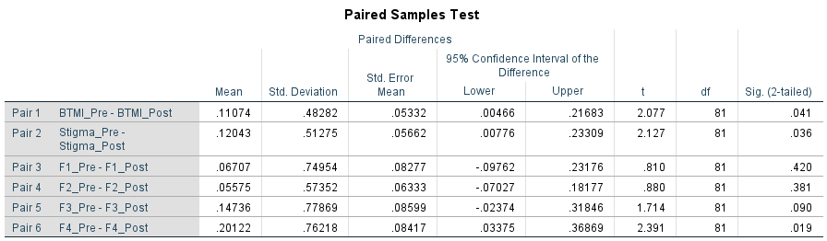

F1: Dangerousness/harm, F2: Social Dysfunction, F3: Incurability, F4: Embarrassment.

**Table 2:** Correlation Coefficients between BTMI and STIG-9

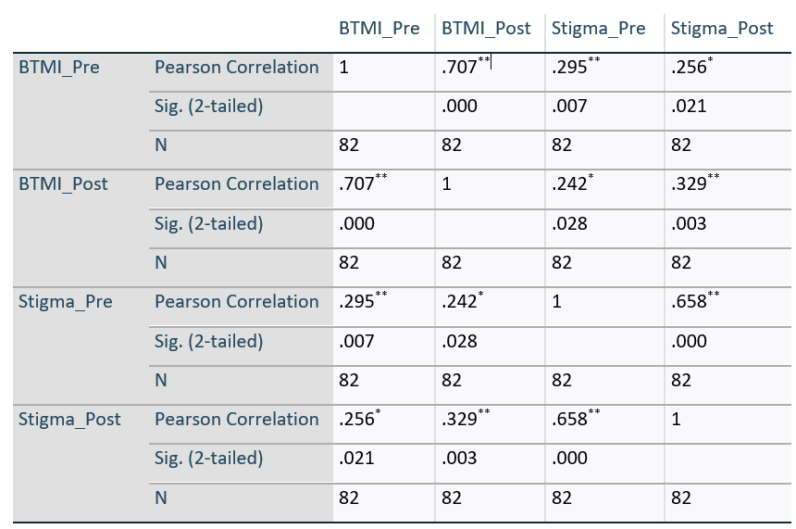

**. Correlation is significant at É=0.01 level (2-tailed).

*. Correlation is significant at É=0.05 level (2-tailed).

A paired samples t-test was performed for each demographic factor, such as ethnic group, age, gender, employment status, major, and experience with mental health issues between the BTMI and the STIG-9 pre-test and post-test. As a result, among ethnic groups, only Asians and Hispanic tend to show significant differences in BTMI scores at É=0.1 level. (p-value=0.095, p-value=0.083, respectively) (Table 3). Our data showed that the students who expressed no direct or indirect mental health-related experience and the group whose family and friends have mental health-related issues show significant differences in BTMI and STIG-9. The data also showed that psychology major students show a statistically significant difference in STIG-9 at É=0.1. Interestingly, the results showed only female students significantly differ in BTMI and STIG-9.

**Table 3:** Paired Sample Test for Ethnic Group

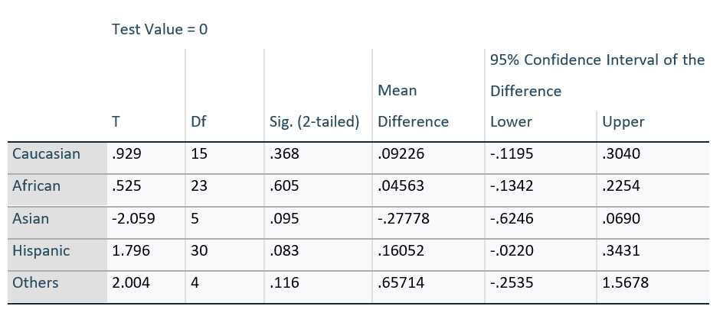

Discussion

This study examined how mental health education influences the level of awareness about mental illness and the attitudes toward stigma related to mental illness. The results of this study were consistent with the four hypotheses explored. Our findings demonstrated a significant difference in beliefs and awareness about mental health as well as a decrease in stigma related to mental health after students completed the Abnormal Psychology course. The statistical improvements demonstrated in our pre-test/post-test assessment show that after experiencing mental health education, students believe that mental health is more curable and less embarrassing. The findings indicated an increase in the linear correlation between higher levels of mental health awareness and lower levels of stigma – students’ learning throughout the course helped lower their stigmatic attitudes regarding mental illness. The findings also demonstrated a correlation in students with low levels of mental health awareness/beliefs and higher levels of stigmatic attitudes toward mental health.

This study explored the demographic dynamics associated with mental health awareness and stigma. Findings included demographic factors such as ethnicity, family history, educational major and part-time status, gender, and age, all impacted mental health awareness and stigma levels. For example, Asians and Hispanic students showed significant differences in BTMI scores, demonstrating that they significantly improved mental health awareness and belief after taking the Abnormal Psychology course. Furthermore, students with mental health-related experiences compared to non-experienced showed improved awareness and decreased stigma about mental illness after the education. In addition, the study showed that female students improved their awareness and offered a less stigmatic attitude after taking an Abnormal Psychology course. The current study showed limited results regarding the ethnic minorities' awareness and attitude. A more extensive study needs to examine ethnic differences, the benefits of the program, and mental health education for ethnic minorities.

These findings support the existing literature that documents the challenges associated with the lack of awareness regarding mental illness and its impact on attitudes of stigma about mental illness7, as well as the numerous studies indicating the importance and the benefits of increasing awareness of mental health as a way of decreasing stigma around it5, 6, 21, 39. In addition, the findings of this study support the existing literature regarding the effectiveness of mental health education as a tool for normalizing help-seeking behavior as a way of supporting mental health issues, as well as increasing outcomes for those needing support5,25,31,39.

This study adds to the available literature because our methodological rigor provides outstanding support for the importance and value of educating college students to help raise awareness about mental illness and directly reduce the stigma associated with their existing attitudes regarding mental illness. In addition, most of the literature focused more on the dynamics of stigma or the elements of mental health prevention, and our findings demonstrated a direct impact of the educational experience on student attitudes.

The present sample may not represent the overall population of college students. One limitation of our study is that we used students who enrolled in the Abnormal Psychology course. This course is often chose by students who are psychology majors, nursing majors, and criminal justice majors. It would have limited to generalizing our study that we used students who enrolled in the Abnormal Psychology course. Future research on mental health education to raise awareness and reduce stigmata attitudes should explore other mental health education opportunities and possible interventions, as well as educating students across all degree programs and majors.

Despite its limitations, our research is a pioneering study demonstrating the vital role of the specific mental health education, Abnormal Psychology course, in improving awareness and reducing stigma related to mental health. The present study highlights that mental health awareness increases and stigma associated with psychological disorders decrease through mental health education. Using specific mental health education, such as Abnormal Psychology, opens further research and applications in developing various mental health education fields. Furthermore, our findings could add to the existing mental health education methods and the current mental health campaign. Increased mental health education opportunities at the college campus have raised mental health knowledge and awareness. Furthermore, Abnormal psychology students demonstrated decreased stigma toward mental health issues.

Conclusion

The present study highlights that mental health awareness increases and stigma associated with psychological disorders decrease through mental health education. Using specific mental health education, such as Abnormal Psychology, opens further research and applications in developing various mental health education fields. Our findings could add to the existing mental health education methods and the current mental health campaign. Increased mental health education opportunities at the college campus have raised mental health knowledge and awareness.

Our finding indicates that mental health education is a promising tool to raise awareness and understanding regarding mental health. Providing students with mental health education and training enabled students to learn and understand issues with mental illness. There is a critical need for sufficient mental health education on a college campus. This study suggests that colleges must address the benefits of mental health education and campaign to support students' mental health. College campuses need to consider offering accessible mental health education and programs for students. Developing and implementing a specific education program for mental health students must be studied further at the college campus.

There are several implications of this study in mental health research. First, the findings suggest that education should be considered as a part of campus mental health campaigns on college campuses. Second, multi-methods, psychological education programs and interventions need to be adopted in the mental health education program. Third, considering that intervention influences changing attitudes and knowledge about mental health, colleges may consider how programs might develop to support students' mental health. Fourth, the study results facilitate further development and implement mental health education and programs on a college campus. Finally, we suggest more research needs for mental health education options and training for college students in the future.

Ethics Declaration

The present study was approved by the ethics committee of the Georgia Gwinnett College Institution Review Board. The participants signed the informed consent before start to questionnaires. Personal information and data obtained from the subjects were kept confidential.

Transparency Declaration

The authors declare that they have to known competing financial interests or personal relationships that could have appeared to influence the work reported in this paper. The authors declare no conflict of interest.

Funding

The present study was supported by the Georgia Gwinnett College, Georgia, Seed Research Grant. The content is solely the responsibility of the authors.

References

1. ‘Mental Illness’. *National Institute of Mental Health (NIMH)*. 2020. [http://www.nimh.nih.gov/health/statistics/mental-illness -index.shtml](http://www.nimh.nih.gov/health/statistics/mental-illness%20-index.shtml)
2. Henderson C, Evans-Lacko C, Thornicroft G. ‘Mental Illness Stigma, Help Seeking, and Public Health Programs’. *American journal of public health*. 2013; 103(5): 777–780. <https://doi.org/10.2105/ajph.2012.301056>.
3. Wang P, Lane M, Olfson M, et al. ‘Twelve-Month Use of Mental Health Services in the United States: Results from the National Comorbidity Survey Replication’. *Archives of general psychiatry*. 2005; 62(6): 629–640. <https://doi.org/10.1001/archpsyc.62.6.629>.
4. Giroux D, Geiss E. ‘Evaluating a student-led mental health awareness campaign’. *Psi Chi journal of psychological research*. 2019; 24(1): 61–66. https://doi.org/10.24839/2325-7342.jn24.1.61.
5. Kelly C, Jorm A, Wright A. ‘Improving Mental Health Literacy as a Strategy to Facilitate Early Intervention for Mental Disorders’. *The Medical journal of Australia*. 2007; 187(S7): S26-30. https://doi.org/10.5694/j.1326-5377.2007.tb01332.x.
6. Kutcher S, Bagnell A, Yifeng W. ‘Mental Health Literacy in Secondary Schools: A Canadian Approach’. *Child and adolescent psychiatric clinics of North America*. 2015; 24(2): 233–244. https://doi.org/10.1016/j.chc.2014.11.007.
7. Gulliver A, Griffiths K, Christensen H. ‘Perceived Barriers and Facilitators to Mental Health Help-Seeking in Young People: A Systematic Review’. *BMC psychiatry*. 2010; 10(1) 113. <https://doi.org/10.1186/1471-244x-10-113>.
8. Eisenberg D, Hunt J, Speer N, et al. ‘Mental Health Service Utilization among College Students in the United States’. *The journal of nervous and mental disease*. 2011; 199(5): 301–308.
9. Eisenberg D, Golberstein E, Gollust S. ‘Help-Seeking and Access to Mental Health Care in a University Student Population’. *Medical care*. 2007; 45(7): 594–601. <https://doi.org/10.1097/mlr.0b013e31803bb4c1>.
10. Yorgason J, Deanna L, Zitzman B. ‘Mental Health among College Students: Do Those Who Need Services Know about and Use Them?’ *Journal of American college health: J of ACH*. 2008; 57(2): 173–181. Web.
11. Eisenberg D, Hunt J, Speer N. ‘Help Seeking for Mental Health on College Campuses: Review of Evidence and next Steps for Research and Practice’. *Harvard review of psychiatry*. 2012; 20(4): 222–232.
12. Lipson S, Gaddis SM, Heinze J, et al. ‘Variations in student mental health and treatment utilization across US colleges and universities.’ *Journal of American College Health*. 2015; 63(6): 388–396.
13. Segal DL, Coolidge FL, Mincic M, et al. ‘Beliefs about Mental Illness and Willingness to Seek Help: A Cross-Sectional Study’. *Aging & mental health*. 2005; 9(4): 363–367. https://doi.org/10.1080/13607860500131047.
14. Snyder M. ‘Changing the Tide: Stigma, School Youth, and Mental Illness’. *NASN school nurse*. 2015; 30(2): 130–132. <https://doi.org/10.1177/1942602X14553307>.
15. Kessler RC, Mickelson KD, Williams DR. ‘The Prevalence, Distribution, and Mental Health Correlates of Perceived Discrimination in the United States’. *Journal of health and social behavior*. 1999; 40(3): 208–230. Web.
16. Funkhouser C, Zakriski A, Spoltore JD. ‘Evaluating peer-peer depression outreach: College students helping peers approach and respond to students in crisis’. *Psi Chi journal of psychological research*. 2017; 22(1): 19–28. <https://doi.org/10.24839/2325-7342.jn22.1.19>.
17. Barney L, Griffiths K, Jorm A, et al. ‘Stigma about Depression and Its Impact on Help-Seeking Intentions’. *The Australian and New Zealand journal of psychiatry*. 2006; 40(1): 51–54. <https://doi.org/10.1080/j.1440-1614.2006.01741.x>.
18. Cooper A, Corrigan P, Watson A. ‘Mental Illness Stigma and Care Seeking’. *The journal of nervous and mental disease*. 2003; 191(5): 339–341. <https://doi.org/10.1097/01.nmd.0000066157.47101.22>.
19. Phelan JoC, Link BG, Stueve A, et al. ‘Public conceptions of mental illness in 1950 and 1996: What is mental illness and is it to be feared?’ *Journal of health and social behavior*. 2000; 41(2): 188-207.
20. Mojtabai R, Olfson M, Mechanic D. ‘Perceived Need and Help-Seeking in Adults with Mood, Anxiety, or Substance Use Disorders’. *Archives of general psychiatry*. 2002; 59(1): 77–84. <https://doi.org/10.1001/archpsyc.59.1.77>.
21. Hogan MF. ‘New Freedom Commission Report: The President’s New Freedom Commission: Recommendations to Transform Mental Health Care in America’. *Psychiatric services (Washington, D.C.)*. 2003; 54(11): 1467–1474. <https://doi.org/10.1176/appi.ps.54.11.1467>.
22. Sirey JA, Bruce ML, Alexopoulos G, et al. ‘Perceived Stigma as a Predictor of Treatment Discontinuation in Young and Older Outpatients with Depression’. *The American journal of psychiatry*. 2001; 158(3): 479–481. <https://doi.org/10.1176/appi.ajp.158.3.479>.
23. DeBate RD, Gatto A, Rafal G. ‘The Effects of Stigma on Determinants of Mental Health Help-Seeking Behaviors among Male College Students: An Application of the Information-Motivation-Behavioral Skills Model’. *American journal of men’s health*. 2018; 12(5): 1286–1296. https://doi.org/10.1177/1557988318773656.
24. Corrigan P. ‘The Impact of Stigma on Severe Mental Illness’. *Cognitive and behavioral practice*. 1998; 5(2): 201–222. <https://doi.org/10.1016/s1077-7229(98)80006-0>.
25. Corrigan P. ‘How Stigma Interferes with Mental Health Care’. *The American psychologist*. 2004; 59(7): 614–625. <https://doi.org/10.1037/0003-066x.59.7.614>.
26. Corrigan P, Benjamin GD, Perlick D. ‘The Impact of Mental Illness Stigma on Seeking and Participating in Mental Health Care’. *Psychological science in the public interest: a journal of the American Psychological Society*. 2014; 15(2): 37–70.
27. Stuart H. ‘Media Portrayal of Mental Illness and Its Treatments’. *CNS drugs*. 2006; 20(2): 99–106. <https://doi.org/10.2165/00023210-200620020-00002>.
28. Eisenberg D, Downs, MF, Golberstein E, et al. ‘Stigma and Help Seeking for Mental Health among College Students’. *Medical care research and review: MCRR*. 2009; 66(5): 522–541. <https://doi.org/10.1177/1077558709335173>.
29. Loya F, Reddy R, Hinshaw S. ‘Mental illness stigma as a mediator of differences in Caucasian and South Asian college students’ attitudes toward psychological counseling’. *Journal of counseling psychology*. 2010; 57(4): 484–490. <https://doi.org/10.1037/a0021113>.
30. Kessler R, Demler O, Frank R, et al. ‘Prevalence and Treatment of Mental Disorders, 1990 to 2003’. *The New England journal of medicine*. 2005; 352(24): 2515–2523. <https://doi.org/10.1056/nejmsa043266>.
31. Rüsch N, Evans-Lacko S, Thornicroft G. ‘Knowledge and attitudes as predictors of intentions to seek help and disclose a mental illness’. *Psychiatrische Praxis.*2011; *38 (S.01)*. https://doi.org/10.1055/s-0031-1277794.
32. Sontag-Padilla L, Dunbar MS, Ye F, et al. ‘Strengthening College Students’ Mental Health Knowledge, Awareness, and Helping Behaviors: The Impact of Active Minds, a Peer Mental Health Organization’. *Journal of the American Academy of Child and Adolescent Psychiatry*. 2018; 57(7): 500–507.
33. Vogel D, Wade N, Wester S, et al. ‘Seeking Help from a Mental Health Professional: The Influence of One’s Social Network’. *Journal of clinical psychology*. 2007; 63(3): 233–245. <https://doi.org/10.1002/jclp.20345>.
34. Garlow S, Rosenberg J, Moore JD, et al. ‘Depression, Desperation, and Suicidal Ideation in College Students: Results from the American Foundation for Suicide Prevention College Screening Project at Emory University’. *Depression and anxiety*. 2008; 25(6): 482–488. <https://doi.org/10.1002/da.20321>.
35. Breslau J, Lane M, Sampson N, et al. ‘Mental Disorders and Subsequent Educational Attainment in a US National Sample’. *Journal of psychiatric research*. 2008; 42(9): 708–716. <https://doi.org/10.1016/j.jpsychires.2008.01.016>.
36. Ettner S, Frank R, Kessler R. *The impact of psychiatric disorders on labor market outcomes*. Cambridge, MA: National Bureau of Economic Research. 1997. <https://doi.org/10.3386/w5989>.
37. Reavley N, Jorm A. ‘Recognition of Mental Disorders and Beliefs about Treatment and Outcome: Findings from an Australian National Survey of Mental Health Literacy and Stigma’. *The Australian and New Zealand journal of psychiatry*. 2011; 45(11): 947–956. <https://doi.org/10.3109/00048674.2011.621060>.
38. Rafal G, Gatto A, DeBate R. ‘Mental Health Literacy, Stigma, and Help-Seeking Behaviors among Male College Students’. *Journal of American college health: J of ACH*. 2018; 66(4): 284–291. DOI: [1080/07448481.2018.1434780](https://doi.org/10.1080/07448481.2018.1434780).
39. Sharp W, Hargrove DS, Deal WP, et al. ‘Mental health education: An evaluation of a classroom based strategy to modify help seeking for mental health problems’. *Journal of college student development*. 2006; 47(4): 419–438. DOI:[1353/csd.2006.0051](https://doi.org/10.1353/csd.2006.0051)
40. Jyothi NU, Bollu M, Ali F, et al. ‘Questionnaire survey on student’s attitudes towards individuals with mental illness’. *Pharm. Sci. Res*. 2015; 7(7): 393–396.
41. Wei Y, Hayden JA, Kutcher S, et al. ‘The Effectiveness of School Mental Health Literacy Programs to Address Knowledge, Attitudes and Help Seeking among Youth’. *Early intervention in psychiatry*. 2013; 7(2): 109–121. DOI:10.1111/eip.12010
42. Rickwood D, Cavanagh S, Curtis L, et al. ‘Educating young people about mental health and mental illness: evaluating a school-based programme’. *International Journal of Mental Health Promotion*. 2004; 6(4): 23–32.
43. Jorm A, Barney LJ, Christensen H. ‘Research on mental health literacy: what we know and what we still need to know Australian and’. *New Zealand Journal of Psychiatry*. 2006; 40: 3–5. <https://doi.org/10.1080/14623730.2004.9721941>
44. Hirai M, Clum G. ‘Beliefs toward mental illness scale’. *PsycTESTS Dataset*. 2018: 10. https://doi.org/10.1037/t67468-000
45. Hirai M, Clum G. ‘Development, reliability, and validity of the beliefs toward mental Illness Scale’. *Journal of psychopathology and Behavioral Assessment*. 2000; 22(3): 221–236.
46. Gierk B, Löwe B, Murray A, et al. ‘Assessment of Perceived Mental Health-Related Stigma: The Stigma-9 Questionnaire (STIG-9)’. *Psychiatry research*. 2018: 270; 822–830. <https://doi.org/10.1016/j.psychres.2018.10.026>.
47. Royal K, Thompson J. ‘A Psychometric Validation of the Beliefs toward Mental Illness Scale’. *Journal of nursing measurement*. 2013; 21(3): 516–524. https://doi.org/10.1891/1061-3749.21.3.516.

Supplementary

**Table 4:** Paired Sample Test for Mental Health Experience

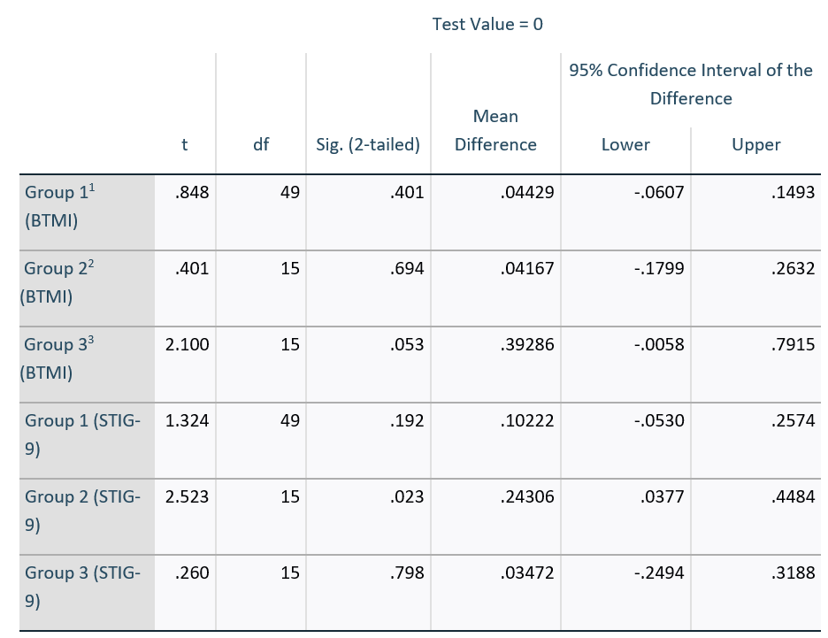

1Group 1 represents students who experienced mental health related issue.

2Group 2 represents students whose family and friends have mental health related issue.

3Group 3 represents students who doesn’t have direct or indirect mental health related experience.

**Table 5:** Paired Sample Test for Psychology Major

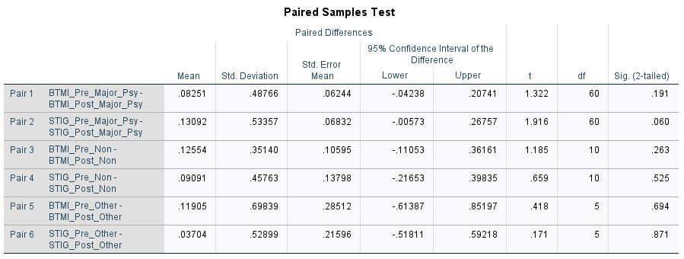

**Table 6:** Paired Sample Test for Gender

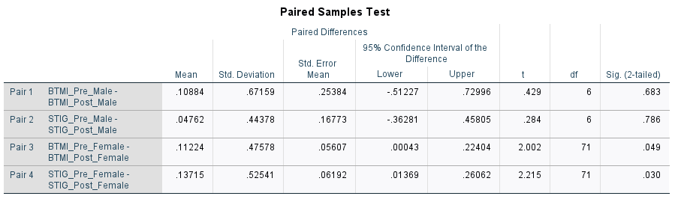

**Table 7:** Paired Sample Test for Age

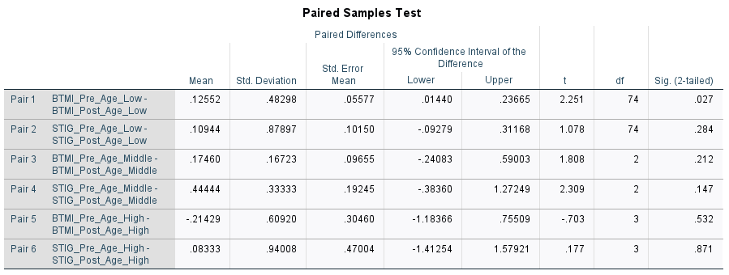

**Table 8:** Paired Sample Test for Employment Status

