**A Project Submitted to**

**HSNC University, Mumbai**

**Under the Faculty of Commerce**

**By**

***Sukirti Chawla***

**Under the Guidance of**

***Prof. Bharti Jethani***

***Vidyasagar Principal K.M. Kundnani Chowk, 123, Dinshaw Vacha Rd, Churchgate, Mumbai, Maharashtra 400020***

**TABLE OF CONTENT**

|  |  |  |
| --- | --- | --- |
| **Sr No.** | **Contents** | **Page No.** |
| 1 | Declaration  Acknowledgement  Preface  List Of Tables  List of Figures | 3  4  5  6  8 |
| 2 | Chapter 1: Introduction | 11 |
| 3 | Chapter 2: Literature Review | 31 |
| 4 | Chapter 3: Research Methodology | 41 |
| 5 | Chapter 4: Data Interpretation and Analysis | 48 |
| 6 | Chapter 5: Findings, Suggestions and Conclusion | 71 |
| 7 | Bibliography | 75 |
| 8 | Appendix | 80 |

**Declaration**

I, the undersigned **Miss Sukirti Chawla,** hereby declare that the work embodied in this project work titled **“ Impact of Digital Payments and UPI on the youth of India”,** forms my own contribution to the research work carried out under the guidance of **Prof. Bharti Jethani** is a result of my own research work.

Wherever reference has been made to previous works of others, it has been clearly indicated as such and included in the bibliography. The learner has complied to the provisions of the UGC (Promotion of Academic Integrity and Prevention of Plagiarism in Higher Educational Institution) Regulation 2018.

I, hereby further declare that all information of this document has been obtained and presented in accordance with academic rules and ethical conduct.

**ACKNOWLEDGEMENT**

To list who all have helped me is difficult because they are so numerous and the depth is so enormous.

I would like to acknowledge the following as being idealistic channels and fresh dimensions in the completion of this project. I take this opportunity to thank the HSNC University for giving me chance to do this project.

I would like to thank our *Principal Dr. Pooja Ramchandani*, for providing the necessary facilities required for completion of this project.

I take this opportunity to thank our Course Coordinator *Prof. Poonam Jain*, for her moral support and guidance.

I would also like to express my sincere gratitude towards my project guide *Prof. Bharti Jethani*, whose guidance and care made the project successful.

I would like to thank my College Library, for having provided various reference books and magazines related to my project.

Lastly, I would like to thank each person who directly or indirectly helped me in the completion of the project especially my Parents and Peers who supported me throughout my project.

**PREFACE**

India is moving towards a Digital revolution. The nation under its Digital India programme which based on technology and which aims to transform India to a digitally empowered society and a knowledge economy.

In this Digital revolution, digital and internet payments have emerged highly. Government decisions like demonetization and situations like the Covid-19 pandemic where cash suffered as a mode of payment, digital payments rose to success. The advantages of technology, smartphones, wireless communication has also highly complemented the growth of Digital payments.

The rise of Digital payments and especially of one of its method Unified Payments Interface (UPI) platform has been commendable. So, this paper aimed at exploring how the people of India, especially the Youth of the country is being influenced by the same.

A survey is conducted among 105 respondents of the youth of India to collect data from people between the age of 15 -24 years, and the study is conducted on how much the respondents are aware, the advantages and disadvantages of Digital payments and UPI, most used Digital payments methods and applications, and also is there any relation between age group and awareness of digital payments using a Chi-square test. Secondary research elements such as previously published papers, journals, articles and essays have also contributed to understand the importance of Digital payments in this study.

The main implication of the study is that Digital payments are helping the youth in more than one way. It is making the youth more financially and technologically literate and gives them a chance to handle their finances. Digital payments are also contributing highly to financial inclusion as well as economic development of the country.

The conclusion of this paper shows that Digital payments and especially UPI have impacted very positively because of the convenience, speed, easy access, modernity and financial freedom they give the youth. Even though there is certain fear of scams, frauds and privacy breach, the advantages overcome those as majority of the youth respondents prefer digital methods over traditional method of cash payments.

With the combined efforts of the Government, Financial Institutions and the public, India can easily achieve its idea of a cashless digital economy.

- Sukirti Chawla

**List of Tables**

|  |  |  |
| --- | --- | --- |
| **Sr No** | **Particulars** | **Page No.** |
| 1 | Classicications of respondents on the basis of age | 47 |
| 2 | Classicications of respondents on the basis of gender | 48 |
| 3 | Classicications of respondents on the basis of occupation | 49 |
| 4 | Seeing Whether the Respondents are Aware of  the various Digital Payment methods available in India | 50 |
| 5 | Showcasing the methods of digital payments that respondents are aware of | 51 |
| 6 | Seeing whether the respondents personally use the digital paymnets method | 52 |
| 7 | Reasons that are making the respondents not use Digital Payments Method | 53 |
| 8 | Showcasing The Methods Of Digital Payments That Respondents personally use | 54 |
| 9 | Showcasing how the Respondents come know about digital payment methods | 55 |
| 10 | Showcasing the reasons Respondents prefer digital payment methods | 56 |
| 11 | Showcasing the Respondents weekly usage of Digital Payments Methods | 57 |
| 12 | No. Of respondents who use UPI from the respondents who use Digital Payments methods | 58 |
| 13 | Showcasing whether UPI has made the manner respondents do payments better. | 59 |
| 14 | Respondents’ usage of UPI compared to other digital payments methods. | 60 |
| 15 | Reasons that respondents use UPI over other Digital Payments Method | 61 |
| 16 | Reasons that respondents use UPI over other Digital Payments Method | 62 |
| 17 | Showcasing whether the spending habits increased because of UPI payments. | 63 |
| 18 | Response on whether everyone should use UPI or not. | 64 |
| 19 | Response on whether UPI should be used on an international level or not. | 65 |
| 20 | Reasons respondents don’t use UPI | 66 |
| 21 | Classicications of respondents on the basis of age | 67 |
| 22 | Awareness among the respondents of  the various Digital Payment methods available in India | 67 |
| 23 | Contingency table to represent the observed frequencies: | 68 |
| 24 | Expected frequency table | 68 |

**List of Figures**

|  |  |  |
| --- | --- | --- |
| **Sr No** | **Particulars** | **Page No.** |
| 1 | A graphical image showcasing digital payments | 12 |
| 2 | The amount of Digital Payment Transactions that have taken place in the past 3 financial years. | 18 |
| 3 | Logo of Unified Payments Interface (UPI) | 23 |
| 4 | The amount of Digital Payment Transactions that have taken place in the past 3 financial years. | 26 |
| 5 | Classicications of respondents on the basis of age | 47 |
| 6 | Classicications of respondents on the basis of gender | 48 |
| 7 | Classicications of respondents on the basis of occupation | 49 |
| 8 | Seeing Whether the Respondents are Aware of  the various Digital Payment methods available in India | 50 |
| 9 | Showcasing the methods of digital payments that respondents are aware of | 51 |
| 10 | Seeing whether the respondents personally use the digital paymnets method | 52 |
| 11 | Reasons that are making the respondents not use Digital Payments Method | 53 |
| 12 | Showcasing The Methods Of Digital Payments That Respondents personally use | 54 |
| 13 | Showcasing how the Respondents come know about digital payment methods | 55 |
| 14 | Showcasing the reasons Respondents prefer digital payment methods | 56 |
| 15 | Showcasing the Respondents weekly usage of Digital Payments Methods | 57 |
| 16 | No. Of respondents who use UPI from the respondents who use Digital Payments methods | 58 |
| 17 | Showcasing whether UPI has made the manner respondents do payments better. | 59 |
| 18 | Respondents’ usage of UPI compared to other digital payments methods. | 60 |
| 19 | Reasons that respondents use UPI over other Digital Payments Method | 61 |
| 20 | Reasons that respondents use UPI over other Digital Payments Method | 62 |
| 21 | Showcasing whether the spending habits increased because of UPI payments. | 63 |
| 22 | Response on whether everyone should use UPI or not. | 64 |
| 23 | Response on whether UPI should be used on an international level or not. | 65 |
| 24 | Reasons respondents don’t use UPI | 66 |

**CHAPTER 1 INRODUCTION**

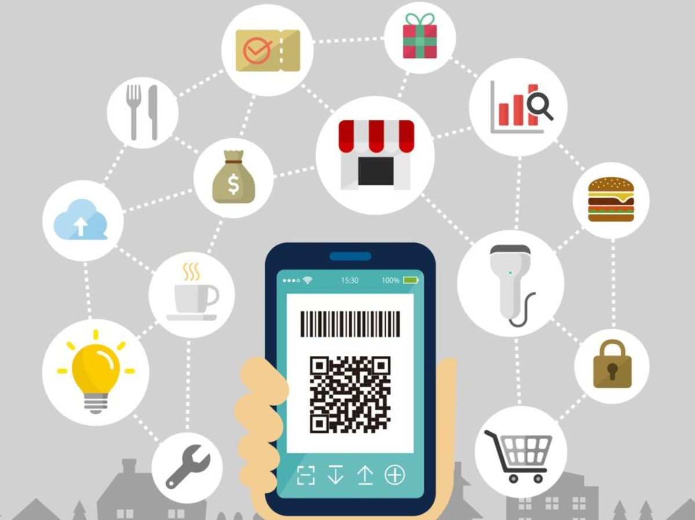

Figure No.: 1

The Reserve Bank of India (RBI) mentioned in one of its publications – *“By 2025 Digital Transactions in India would be worth $1 trillion annually”*. Digital payments have increased from 498 crore interactions with a value of 96 crore during FY 2010–11 to 1623 crore transactions with a value of 3435 lakh crore in FY 2020.

The Reserve Bank of India reports that over the past ten years, digital transfers have grown at a compound annual growth rate (CAGR) of 43%. This demonstrates unequivocally the increase in the degree of use of these services among Indian consumers who previously preferred using cash. Demonetisation and the Covid-19 pandemic are two of the main causes of this industry's rapid boom. The development of the Unified Payments Interface (UPI), Aadhaar Enabled Payments Systems (AEPS), and other apps in India following the implementation of demonetisation sparked the country's move towards a cashless society.

With the use of digital wallets loaded with discounts and deals, the current period is advancing at a new rate in the use of digital payment systems. In particular, the mobile payment (m-payment) system has developed, allowing users to use their mobile devices, particularly mobile phones, to pay for goods and services wherever they are. New software has been developed to reduce stress and facilitate transactions. This study paper focuses on the usage and effect of these new digital payment systems on youth and any issues that may have been encountered.

**IMPORTANT DEFINATIONS AND MEANINGS**

Youth: World Health Organization (WHO) defines ‘Youth’ as individuals in the 15–24-year age group.

Impact: a marked effect or influence.

"Our regional measures have had a significant **impact on** unemployment"

Similar: effect, influence, impression, footprint

**DIGITAL PAYMENT METHODS**

Digital payments are transactions that happen online or through other digital platforms without a tangible exchange of money. This indicates that both the payer and the payee trade money using electronic means.

Please be advised that digital purchases can be made both in person and online. For instance, it counts as a digital transfer if you make an Amazon purchase and pay with UPI. Similar to the previous example, if you make a buy at your neighbourhood Kirana store and decide to pay with UPI rather than cash, that is also a digital payment.

To encourage and promote digital payments in India, the government has been adopting several actions. The government wants to develop a "digitally empowered" economy that is "Faceless, Paperless, Cashless" as part of the "Digital India" programme. Digital purchases come in a variety of forms and ways.

Most used Digital Payments Methods are discussed below:

* BANKING CARDS: The most used digital payment method in India is banking cards. It gives a great selection of features that give users convenience and security. Cards give users the freedom to conduct other kinds of digital transactions. Customers can save card information in the mobile programme and use that information to pay for services.

Banking cards (debit and credit cards) can be used for a wide range of digital transactions, including PoS terminals, online purchases, and as a method of payment in mobile apps that offer any kind of service, such as grocery delivery, medical care, rental car reservations, airline tickets, etc.

The most widely used cards are produced by companies like VISA, MASTERCARD, RuPay, AMEX, and others.

* INTERNET BANKING: Internet banking is the practise of carrying out financial transactions while at home with a smartphone, laptop, or desktop and a live internet link. Internet banking can be used to complete all the main types of transactions.

Due to the availability of internet banking services 24/7/365, it is a common option for carrying out digital transactions.

* UPI (UNIFIED PAYMENT INTERFACE): The most recent digital payment standard is UPI (Unified Payment Interface), which enables users with bank accounts to send money to any other bank account using UPI-based apps. Payments made using UPI are made every hour of the day, every day of the year.

A Virtual Payment Address can be used to make payments (VPA). One needs a bank account and a cell number linked to that account in order to use UPI services.

UPI is a system that powers multiple bank accounts into a single mobile application, merging several banking features, seamless fund routing & merchant payments into one hood. It also caters to the “Peer to Peer” (P2P) collect request which can be scheduled and paid as per requirement and convenience.

* BHARAT INTERFACE FOR MONEY (BHIM): A mobile app called Bharat Interface for Money (BHIM) uses the Unified Payments Interface to make payments simple and fast (UPI). The user can send and receive money instantly between banks using their mobile number, bank account and IFSC code, Aadhar number, or virtual payment address (VPA).

The QR code payment option is available through BHIM. By clicking on Report problem in transactions, a user can view their transaction history and file a complaint for transactions that were declined.

For an improved user experience, BHIM is offered in 20 regional languages, including English, Hindi, Marathi, Tamil, Telugu, Malayalam, Oriya, Punjabi, Gujarati, Marwari, Haryanvi, Bhojpuri, Urdu, Konkani, Manipuri, Mizo, Khasi, Kannada, Bengali, and Assamese.

By dialling *99#, users can also conduct transactions using their mobile phones.

* E-WALLETS: A mobile device programme for financial transactions is called an electronic wallet. Your passwords and payment details are securely stored there. Instead of carrying your cards with you while shopping, these apps let you pay using your device. You input and save the details of your credit card, debit card, or bank account so that you can use your device to make transactions later on.

Additionally, the following data can be kept in digital wallets:

* + Credit notes
  + subscription cards
  + Reward certificates
  + Coupons
  + Passes to events.
  + Transit and flight reservations
  + Reservations at hotels
  + Driving permit
  + Identity documents
* MOBILE BANKING: For conducting digital transactions, mobile banking is a service offered by banks through their mobile applications on a smartphone. After UPI and mobile wallets were introduced, the reach of mobile banking significantly increased.

The phrase "mobile banking" refers to a wide range of services that can be accessed via mobile devices or cell phones.

* MICRO-ATMS: A million Business Correspondents (BC) are expected to use micro-ATMs to provide rudimentary banking services. The platform will make it possible for Business Correspondents to carry out immediate transactions (for example, a local kirana store proprietor acting as a "micro ATM").

By connecting low-cost devices (micro-ATMs) to banks across the nation, the micro platform will allow operation. This would make it possible for someone to immediately deposit or withdraw money, regardless of which bank is linked to a given BC. This device, which would be accessible at every BC, would be dependent on a mobile phone connection. Customers would only need to have their identities verified before they could take money or deposit it into their bank accounts.

* AADHAAR ENABLED PAYMENT SYSTEM (AEPS):

Aadhaar Enabled Payment System (AePS) is a bank led model which allows online interoperable financial inclusion transaction at Point of sale (Micro ATM) through the Business correspondent of any bank using the Aadhaar authentication. AePS allows you to do six types of transactions, the inputs required for a customer to do a transaction Bank Name, Aadhaar Number, Fingerprint captured during enrolment.

Banking Services Offered by AePS:

* Cash Deposit
* Cash Withdrawal
* Balance Enquiry
* Mini Statement
* Aadhaar to Aadhaar Fund Transfer
* Authentication
* BHIM Aadhaar Pay

**RISE OF DIGITAL PAYMENTS IN INDIA**

India's government has undergone a technological transformation in recent years. Government services have been integrated gradually, and today last-mile delivery can be completed in a matter of seconds with the touch of a mouse. As part of the Indian government's strategy to digitise the financial industry and economy, digital payment transactions have been steadily rising over the past few years. Additionally, financial inclusion has been promoted as one of the key national goals of the nation through coordinated efforts.

The JAM Trinity, which stands for Jan Dhan, Aadhaar, and Mobile, is the key enabler at the heart of India's transformed digital payment environment. The Pradhan Mantri Launched in August 2014, Jan-Dhan Yojana (PMJDY) is one of the largest financial inclusion programmes in the world. Its goal is to offer every unbanked household access to universal banking services. The Unique Identification Authority of India's flagship product, Aadhaar, is a straightforward but efficient way to validate people and beneficiaries using their biometric data. Together, Jan Dhan accounts, Aadhaar, and mobile connections have contributed to building the foundation for a digital India where a wide range of governmental services are made accessible to the public directly with improved access and no need for any middlemen (middle-men).

The Government of India has given the promotion of digital payments top precedence in an effort to formally integrate these services into every sector of our nation. The goal is to make seamless digital payment available to all Indian citizens in a way that is practical, simple, affordable, quick, and safe.

In India, digital payment transactions have seen an unprecedented increase over the past three years. Prepaid payment instruments (PPIs), Immediate Payment Service (IMPS), Bharat Interface for Money-Unified Payments Interface (BHIM-UPI), and the National Electronic Toll Collection (NETC) system are among the simple and practical digital payment methods that have experienced significant growth and transformed the ecosystem of digital payments by increasing P2P and P2M payments.

Debit cards, credit cards, NEFT, and Real-Time Gross Settlement (RTGS), which are already common payment methods, have all experienced rapid growth at the same time. Users' favourite payment method has become BHIM-UPI. The government of India also introduced the cashless and contactless e-RUPI digital payment system, which is anticipated to play a significant role in boosting the effectiveness of Direct Benefit Transfer (DBT) in the nation's digital operations. Together, these resources have built a solid ecosystem for the economy of digital banking.

Following is a table showcasing the amount of Digital Payment Transaction that have taken place in the last three financial years:-

Financial Year 2019-20

Financial Year 2020-21

Financial Year 2021-22

Figure No.: 2

**BENEFITS OF USING DIGITAL PAYMENT METHODS**

1. Speed of transactions

Online payments save a tonne of time for the buyer and the vendor. There is no need for people to stand in line, make checks, or wait for paper bills. They can obtain the money immediately; they don't need to wait for banks to process their checks.

Since they do not have to spend time printing and mailing bills, sellers save a tonne of time. The likelihood of late payments is also lower with online purchases. People will not forget about or put off a deal because it only takes a short while to finish it.

1. Convenience

Any time of day, from any location in the globe, people can make payments for goods and services. It is simpler to use a smartphone feature than to gather the appropriate quantity of cash for your purchase. You don't need to worry about carrying a lot of currency, getting robbed, or getting imperfect change. With online payment methods, all you have to do is recall a specific pin to complete your transaction! Just like that.

1. Global population reach

The ability of businesses to function internationally and have a clientele unrestricted by geography is one of the biggest benefits of having online payment gateways. Over 56% of internet shoppers, it has been found, prefer to shop internationally. Because you will be serving a global audience, adding online payment options to your e-commerce site will surely boost sales.

1. Low transaction costs

Businesses must employ front-desk staff or cashiers to handle purchases and payments in a traditional payment system. However, transactions involving internet payments happen in an automated setting. Online payment gateways are easy to set up for businesses and have reduced transaction costs.

1. Simple and quick setup

You can quickly and easily integrate online payment gateways for your company instead of taking the time to set up a comprehensive payment process that requires specific hardware and additional staff. However, you can compare the various choices before selecting the services of a specific vendor in order to select the best one.

1. Variety of payment choices

You can give your customers a broad range of payment options with the help of online payment features. People have their own preferences, so providing them with that choice when making a purchase from you clearly increases the likelihood that they will actually complete the transaction.

1. Availability of more distribution channels

Having online payment options as a company can greatly improve your distribution methods. If you're prepared to take payments online, you can join the affiliate market and expand your sales by having your goods or services advertised on other websites. It is a fantastic method to boost sales.

1. Easy management

Your money and other financial information are simpler to handle and store when you use online payments. There are numerous resources on the internet that can assist with transactions for both customers and vendors. You can let the tools manage your money instead of having to keep track of them yourself. Since you don't need to bring cash or credit cards, things only get simpler.

1. Availability of more distribution channels

Having online payment options as a company can greatly improve your distribution methods. If you're prepared to take payments online, you can join the affiliate market and expand your sales by having your goods or services advertised on other websites. It is a fantastic method to boost sales.

1. Easy management

Your money and other financial information are simpler to handle and store when you use online payments. There are numerous resources on the internet that can assist with transactions for both customers and vendors. You can let the tools manage your money instead of having to keep track of them yourself. Since you don't need to bring cash or credit cards, things only get simpler.

**PROBLEMS WITH DIGITAL PAYMENTS METHODS**

1. Technological difficulties

Like any other technology-dependent programme, online payments are susceptible to technical issues or downtime. Even though tech maintenance operations are scheduled in preparation and typically occur at night, it can occasionally annoy online shoppers. Many companies experience high bounce rates, particularly when it occurs unexpectedly.

2. Password threats

Your personal information or bank account information may be accessible to the online portal if you are a registered user of a website that makes online payments frequently. Even though one-time passwords (OTPs) are used for the majority of transactions, these circumstances call for password security. You may run the chance of having your privacy violated, especially if you work with several banks.

3. Cost of fraud

Cybercriminals are adopting online purchases as a preferred method of payment, just as more and more people are doing. Database exploits, phishing scams, and identity fraud are all on the rise. Businesses install a large number of payment-security software programmes, incurring significant costs in the process, in order to stop these and improve security.

4. Safety worries

There are numerous security risks associated with using online payments, as was covered in the previous statement. Important financial data and information can be easily hacked by thieves if appropriate security measures aren't taken. Criminals can also easily evade capture because there are no verification systems like face recognition or biometrics.

5. Lack of technology knowledge

The fact that many people, particularly the older generation, lack basic technological literacy is one of the major drawbacks of online payments. They avoid using online payment methods because they lack sufficient understanding of how to use technology and smartphones. Many of them continue to use conventional payment methods because they are afraid of the difficulties involved. This is a significant disadvantage for emerging nations like India.

6. Time and/or quantity restrictions

Some banks place a cap on the number of transactions or the daily maximum sum that can be transferred. The majority of internet transactions also have a deadline that you must meet (like receiving and accepting OTPs). For some users, all these restrictions may prove to be quite annoying.

7. Service charges and other expenses

Some services may charge setup fees or even processing fees for customers using those facilities when deploying online payment gateways. It goes without saying that having access to the internet and other related services is necessary in order to set up online payment choices. Both the sellers and the customers may find this tiresome as it readily results in additional expenses.

8. Disputed transactions

You can report to your bank or the company that handles your online payments if you discover someone using your electronic funds. However, you cannot make a complaint or request a refund if you cannot locate the person's confidential information or, for that matter, any information about them. In such cases, it becomes challenging.

9. Smart card/Banking Card loss

Most internet purchases are made using credit/debit cards, ATM cards, or identity cards. Therefore, if you misplace any of these, your connected online payment accounts will also be in danger. Of course, you can block your cards after notifying the bank, but the interim period between losing your card and stopping it may prove to be dangerous due to the possibility of numerous fraudulent transactions.

10. False identity

In contrast to physical transactions, it is impossible to verify whether the individual making an online payment is who they say they are. The majority of internet payments are made anonymously because there are no verification techniques like photos or signatures. This has the potential to significantly increase fraud and identity theft.

**UNIFIED PAYMENT INTERFACE (UPI)**

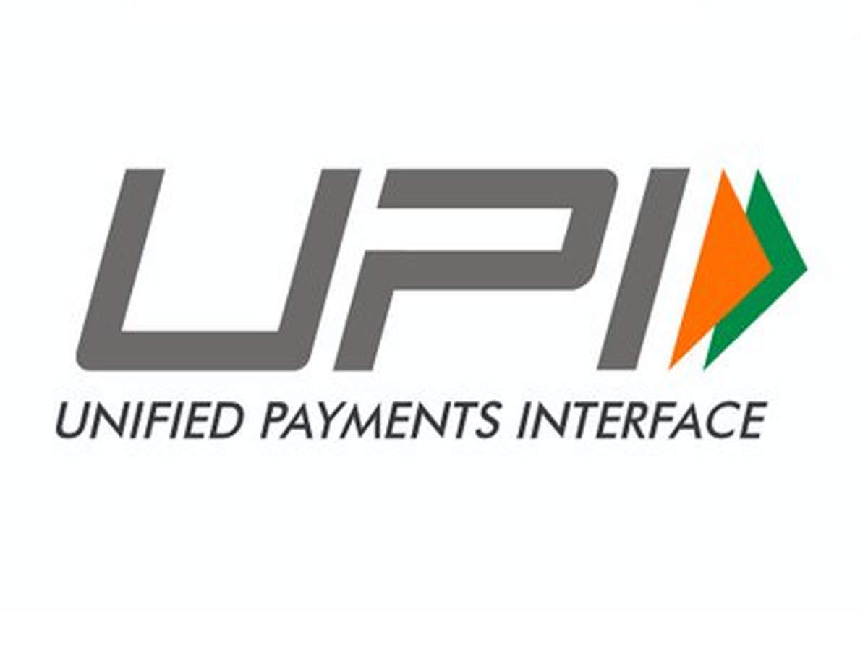

Figure No.: 3

The Unified Payments Interface (UPI) is a system that integrates numerous bank accounts, seamless fund routing, and merchant payments into a singular mobile application (of any participating bank). Additionally, it supports "Peer to Peer" collect requests that can be planned and paid for according to need and ease.

Considering the background, NPCI carried out a pilot launch with 21 member banks. Dr. Raghuram G. Rajan, Governor of the RBI, launched the trial programme on April 11, 2016, in Mumbai. Beginning on August 25, 2016, banks have begun to submit their UPI-enabled apps to the Google Play store.

Since its inception, UPI has made it much simpler for account holders to conduct financial transactions.

Each user must have a UPI Number to send money using the UPI system. A bank account's UPI ID serves as a special identifier when sending and receiving money between banks. To send money via UPI, you must input the recipient's UPI ID in the UPI payment applications. Alternatively, you can choose the recipient from your phone book or enter the recipient's contact number. On the other hand, a 4 or 6-digit personal identifying number known as the UPI PIN is necessary to send money through UPI. Every account user has the choice to customise their UPI PIN.

**CHARACTERISTICS OF UPI**

These days, UPI transfers of money are mentioned by every bank account holder. Here are the causes for the hype if you have not used UPI frequently:

* Payments made through UPI are usually completed in a matter of seconds.
* Nearly all banks permit UPI transactions via mobile apps.
* Purchases are 100 percent secure. The user must enter the secret MPIN each time in addition to having the SIM card associated with his mobile number present in his phone in order to finish a payment.
* Individuals can seek money from another person using the UPI Payment facility, which is not possible with other payment methods like IMPS and NEFT.
* These mobile payment apps also provide the ability to pay bills, so you can use the app to pay your bills with just one touch and set up timely reminders for all of them.
* Using the mobile payment application, you can quickly submit a complaint in the event of any issues or shady activity on your account.
* 24-7 payments are possible.
* It is totally free!

**RISE OF UNIFIED PAYEMNT INTERFACE**

*Changing the Face of Internet Payments*

A revolutionary product in the payment environment, UPI has been called. It was introduced in 2016 and has since become one of the most used instruments for conducting digital transactions in the nation. The National Payments Corporation of India created the instant payment system known as UPI (NPCI). It integrates multiple banking features, seamless fund routing, and vendor payments into one hood, powering multiple bank accounts into a single smartphone application.

On December 31, 2016, Prime Minister Narendra Modi introduced the BHIM-UPI App at the start of the "DigiDhan Mela" in order to reinforce and popularise the interface even more.

UPI has made significant progress towards firmly setting India on the path to a cashless economy and making digital payments a routine.

Now, UPI accounts for well over 40% of all digital transfers occurring in India. Small businesses and street vendors have benefited from it because it makes bank to bank transactions, even for very small amounts, quick and safe. For migrant employees, it also makes quick money transfers possible. The technology is simple to use because it takes little physical effort and enables money transfers with just the scan of a QR code.

The Covid-19 pandemic has also been helped by UPI, whose usage is growing quickly as a result of its capacity to support simple, contactless transactions.

Following is a chart which showcases the volume and value of transactions made by UPI in India since its inception:

Figure No.: 4

**ADVANTAGES OF UPI**

* The most secure purchase can be made by using the UPI pin. This is a very secure method of sending money because it only provides you with one PI.
* You will not incur any fees if you use UPI to make a purchase because the Indian government provides it for free.
* UPI allows you to request or transmit any type of payment all at once. In a matter of seconds, it either puts money into your account or transfers money to another account.
* All of your bank accounts can be accessed using UPI via a unique mobile application.
* You can simply and without any fees send money to any bank that supports the unified payments interface, including the State Bank of Panjab National Bank and all other banks.
* UPI is simple to use; you can utilise it whenever you want, day or night, at any location, and even on holidays.
* UPI is the one that does not require the user to enter information like their account name, IFSC code, or ATM card number.
* You can send money to another account quickly and easily with the assistance of the UPI payment because it is so straightforward.
* If you send money to another account holder, they receive cashback if you make the same payment through the UPI. There are many advantages to it.

**DISADVANTAGES OF UPI**

* UPI is great for sending small amounts of money, but other online transfer methods are better when sending large sums.
* Customers finding it difficult to download the bank application to their smartphones for a single payment interface is another problem with UPI. This is because they are worried about online scams.
* To keep your account secure, don't divulge any of your confidential information, including your date of birth, UPI pin, and other details.
* You can send as much money as Rs 10,000 through UPI if you want to send a payment. If you need to email it more than once, do so one at a time.
* You must be aware that in order to send money, you must use the unified payment interface pin (also known as the UPI pin), which has only four to six digits. Because the UPI pin has such a small number of digits, it is not secure.
* The slow connection does not support it.
* Although UPI is a very quick and secure method, there are times when the bank's server goes down and it takes a long time to transmit the payment.
* The UTI support app, which you must put on your Android smartphone and use frequently using too much RAM, is not necessary if you want to pay using the UPA. You can clear app cache and background data to allow the user to also close down so that your mobile device doesn't hang or consume excessive amounts of internet.

**TOP UPI APPLICATIONS IN INDIA**

1. PhonePe – UPI Payments, Recharges & Money Transfer

With the help of the ground-breaking app PhonePe, Indians began to accept and use mobile payments online. With just one programme, users of PhonePe can recharge their phones, pay their bills online, order food, shop, and more in addition to making UPI payments. As of November 2020, PhonePe had a volume of 868.40 million deals worth Rs 1,75,453.85 Cr.

Additionally, PhonePe gives its users a variety of promotions, benefits, and cashback. PhonePe is undoubtedly one of the finest payment apps in India and superior to the majority of other UPI payment apps or internet banking services. It has one of the most user-friendly interfaces and offers the safest and fastest online payment experience in the country.

2. Google Pay (Tez) – A straightforward and safe payment tool

On our ranking of the top UPI apps in India, Google Pay, formerly known as Tez App, is the most popular and top-ranked app. In a short amount of time, this app in India has amassed a sizable customer group. And it goes without saying that having the well-known brand name "Google" has helped this programme win over both potential and current users.

As of November 2020, there were 960.02 million purchases totalling Rs. 1,61,418.19 Cr. on Google Pay. Users can transfer money to friends, pay their bills, shop online, recharge, pay at the local café, and more using Google Pay thanks to the company's secure payment system. Another most enjoyable part of using Google Pay is the “Scratch cards”. The users receive a scratch-off gift card each time they complete a new purchase. Users who scratch the card can receive a gift in the shape of cash that is immediately credited to the designated bank account.

3. Paytm: Money Deposit, Mobile Recharge, and UPI

In India, Paytm is a widely used smartphone payment app. It also provides Paytm Wallet and Paytm UPI in addition to Paytm Marketplace (which was introduced in the year 2017). Due to the wide range of goods and services this app offers, we can simply refer to it as a megastore.

On the Paytm app, users can practically carry out all activities connected to online payments. It is third on our ranking of the top UPI apps in India because it is undoubtedly the most used payment app. In terms of number, Paytm had 260.09 million transactions as of November 2020, valued at Rs 28,986.93 Cr.

Everything can be done on this app, including making online payments, purchasing groceries, household goods, IRCTC railway tickets, bus and flight reservations, movie tickets, LIC premium payments, metro card recharges, purchasing gold, making loan payments, paying e-challans, and more.

4. Amazon Pay

Amazon Pay is the fourth-largest tool for UPI transactions as of November 2020. In this month, Amazon Pay processed 37.15 million purchases worth Rs. 3,624.51 crore.

The fact that Amazon is such a well-known company helped Amazon Pay grow so quickly in India within a short period of time. Amazon Pay has also recently become a favourite among UPI payers thanks to its awesome cashback rewards and integration with the majority of purchasing and payment gateways.

5. BHIM App

The fifth most downloaded UPI tool in India is the BHIM app. BHIM (Bharat Interface for Money) is a UPI-enabled initiative that National Payments Corporation of India (NPCI) created and manages to allow safe, simple, and instantaneous digital payments through your mobile phone.

By November 2020, the BHIM App had processed 0.31 million purchases worth a total of Rs 13.87 crore.

**CHAPTER 2: LITERATURE REVIEW**

A Study on Digital Payment System- with special reference to Youthby Ms. Sweta Mishra, BMS & BEM co-ordinator and Ms. Vidhi Rajora, BMM co-ordinator, K.E. Shroff College (2018) has studied that mobile applications are increasing the development rate and raising people's awareness of online payments. Currently, there are a variety of cash and cashless transactions taking place throughout the nation, though many enablers are working to make the ideal of a cashless economy a reality.

The Indian economy will be better able to compete with more developed economies in the future years with effective planning and regulation of digitization. People are more comfortable using digital payment methods, and a variety of apps for these services are growing in popularity among young people.

However, as more and more people transition to digital methods of receiving and making payments, the advantages of this decision are now beginning to become apparent. India is slowly making the switch from a cash-based to a cashless system. Digital transactions are readily taxable and traceable, so there is no room for the circulation of illicit funds. The nation is modernising its financial infrastructure, with e-payment services experiencing an unparalleled upsurge. Now that so many establishments, including street vendors, take electronic payments, people are becoming more adept at conducting transactions without cash than ever before.

A Study on Digital Payments System & Consumer Perception: An Empirical Survey by Shinki Katyayani Pandey, Assistant Professor, Kalinga University, Naya Raipur, CG (2022) has studied that it is advisable to research how end users view these options as governments, regulators, and service providers collaborate to better electronic payment systems and related infrastructure. The study's primary policy suggestion is that digitization can be sped up through a combination of public perception research and feedback.

This study has revealed that a person's payment behaviour is influenced by how they perceive digital payment instruments.

In addition to a favourable outlook on digital payments, a negative outlook on cash also influences the use of digital payments. Contrary to conventional wisdom, Indian consumers are reportedly ready to lessen their exposure to online fraud because of the convenience that digital payment options provide. Depending on the goal of the transaction, different types of fraud have different effects on digital payment choices. Additionally, we cannot discount the impact that demographic variables have on the greater adoption of digital payments. Based on the overall socio-economic development of the population, it is anticipated that the adoption of digital payments will rise.

E- wallet with special reference to Paytm study by Ms. Avneet Kaur and Mr. Harshit Tatiparti, Assistant Professor and TYBAF Student, S.M Shetty College (2021) concluded that each year, there are an increasing amount of people using the internet. Consumers are embracing new technology and favour using digital currency. Many tech firms have developed new innovations recently that will help e-wallets develop further and turn into a full-fledged financial management instrument. Mobile wallet use will increase in the coming years as a result of the rising desire for simple payment methods. As a result, there will be a time when people favour using the electronic wallet system over cash or other forms of tangible payment.

In this study it showed that out of 80 sample size of respondents, majority 69 respondents use E-wallets and digital payment methods.

A study on digital payment applications in India by Gaurav Tyagi, Hrishikesh Jagadale, Nilesh Anute Dept. of Management, ASM'S IBMR, Pune Maharashtra India (2022) studied that a familiar term in today's society is "digitalization," and the term has been applied to the payment industry, which has been steadily converting to digital technology and expanding quickly year over year. The "Strategic analysis of UPI applications in India" was the study's primary emphasis. According to the research, the user base of UPI apps is growing as a result of several advantages, including two-factor authentication, ease of use, and the elimination of the need for carrying cash. In-depth analyses of the features, market shares, and usability of the five most popular UPI applications used in India—PhonePe, Google Pay, Amazon Pay, BHIM UPI, and Paytm—are included in the research.

Due to several advantages, the Indian digital payment system has been growing steadily and is predicted to continue growing in the future. PhonePe continues to grow and has retained the top spot in terms of market share, followed by Google Pay, Paytm, Amazon Pay, and BHIM UPI. Due to people avoiding actual transactions involving paper money caused by demonetisation, UPI apps saw a rise in popularity. This sector experienced exponential development. A questionnaire survey with 83 respondents revealed that most people preferred online payments over cash because the latter carries a chance of loss. According to interviewees, UPI appears to have a bright future.

Digital Payment Service in India - A Case Study of Unified Payment Interface by Mahesh A. and Ganesh Bhat, CMC, Srinivas University, Mangalore, India (2021) concluded that the various methods for making digital purchases and transfers include credit cards, debit cards, internet banking (NEFT/IMPS/RTGS), mobile banking, digital wallets, the Aadhar enables Payment Service (AePS), and the Unified Payments Interface (UPI). Through services like instant payments using QR codes, the payment of different fees, fund transfers between wallets and bank accounts, donations, the purchase and renewal of insurance, and the payment of utility bills through Bharath BillPay, among others, UPI offers better advantages. Users can now connect their overdraft accounts and one-time payment mandates with enhanced security thanks to UPI 2.0 from NPCI. It has the special benefit of not requiring a recipient to be added. Users are able to conduct deals using a Virtual Payment Address (VPA) without disclosing any technical information like their account number, IFS code, or name.

UPI confronts cyber threats and challenges, but because of its main strengths—simplicity, innovation, adoption, security, and cost-effectiveness—it also has a lot of opportunities in today's digital world. The majority of people are switching to cashless transactions because they don't have much cash on board and there will soon be a cash shortage. The increase in smartphone usage and internet access aided the adoption of digital payment services in such circumstances. People are choosing contactless payment methods over other payment choices as a result of the covid outbreak. Due to the widespread use of smartphones and related apps, mobile payment systems have lately emerged as an alluring alternative. Expected performance, social effect, cost, safety, and data privacy are thought to be significant determinants of whether the digital payment system is adopted.

Mobile Wallet: Present and the Future by Prof Trilok Nath Shukla (2016), in their research paper found that in future digital payments will have a major contribution in shopping experience of customers. To draw consumers, one must offer more than just a safe and simple payment system; must also offer cashbacks, loyalty programmes, etc. In order to draw in customers, marketers should seize this opportunity by forming partnerships with different digital payment companies.

The Impact of Digital India on Indian Economy by Manocha, S., Kejriwal, R., and Upadhyaya, A. (2019) After collecting secondary data from various research papers and articles, noted, and mentioned in their research that the transactions from E-wallets reportedly increased from 17 lakhs per day to 63 lakhs per day. It was also seen that in various metro cities, even small market merchants started keeping Point of Sales (POS) machines at their shops to accept payment digitally. Furthermore, it is evident from past studies and statistics that there are some major challenges and limitations that must be essentially considered and addressed. Potential developments in this direction are becoming difficult due to the fact that the data considered for analysis is taken from the source of the Reserve Bank of India. The months contributing to the post-effect are from November 2016 to February 2018. The total data is for 30 months. In their research, they also revealed that demonetization made a significant difference in rising digital payments, but still, there is an essential need to improve the rate of online transactions and move to a cashless world. Cash transactions are still one of the dominant players among any other mode of digital payment transactions. To improve the rate of cashless transactions, the factors that are directly affecting the cashless economy need to be considered. Governments, financial intermediaries, and banks must initiate awareness campaigns and programs.

Study of Consumer Perception of Digital Payment Mode by Singh, Shamsher, Rana, (2017) examined how customers are perceived and how demographic influences affect the uptake of a digital payment method. They gathered first-hand information from 150 respondents who were located throughout Delhi for the research. They discovered that demographic variables, except for education, have little bearing on the uptake of electronic payments. This conclusion was supported by an ANOVA analysis, which revealed that respondents did not perceive any significant differences based on gender, age, occupation, or yearly income. It suggests that a customer's degree of education affects their decision to adopt digital payments. A individual is more likely to use the digital payment method if they have continued their education past matriculation. It was also discovered that the likelihood of accepting digital payment is significantly greater in places with high levels of education, such as Delhi NCR and other major cities. The greater adoption of smartphones and the internet in this region

Transformation Towards E-Wallet Payments Systems Pertaining to Indian Youth By Adharsh (Et Al., 2018) In accordance with the study, there are roughly 80.5 million digital wallet users in India, with young people making up the majority of these users. For this purpose, the researcher conducted a survey with a sample size of 160 participants in order to assess the effects of digital payments following the demonetization on students' daily expenditures. According to their research, about two-thirds of young people use internet ticket booking and mobile recharges because they are quicker and more convenient. Additionally, they stated that different cash backs, freebies, loyalty points, or redemptions encourage them to use digital payments and take advantage of the best deals available.

Demonetization and Digitization by Dr. Swati Kulkarni, Dr.Aparna J Varma (2021) made an effort to understand how customers feel about the security of online payments. The goal of this research is to comprehend how frequently consumers make digital payments as well as the influences on those behaviours as well as any obstacles they may encounter. The study, according to the researchers, is exploratory in nature and depends on secondary data and literature reviews for its results. They also pointed out that the study has a number of flaws, including the fact that it is not a thorough examination of the subject, the literature is not comprehensive, and no quantitative data were used. The paper lists and projects the major fields of literature research.

Adoption of Digital Payment System by Consumer by Ghosh, G. (2021) reviewed various papers and noted that digital payment is far more convenient and time-saving as compared to traditional means of paper currency. He also emphasized that such payment transactions can be done round-the-clock by any individual who possesses an internet connection; they don’t have to wait in lines to make transactions. The researcher suggests that people are using and accepting digital payment systems as it is a faster mode of payment that also offers rewards or cash back. The researcher also talked about the digital payment system post-demonetization and how the government took an initiative to make India a cashless country. The researcher noted that post-COVID-19, we are all making the most use of the digital payment system. All ecommerce, all online grocery, or other necessary online commerce do not accept cash. They all accept prepaid payment, which can be done through various digital payment systems.

Impact of Digital India on Indian Economy by Joshi, R & Kumar, B. (2020)

To evaluate the difficulties posed by digital India, it was examined how it affected the Indian economy. The research found that increased innovation, operational simplicity, economic expansion, and new employment opportunities have all been brought about by digitalization. It has contributed to the development of systemic openness and the unrestricted movement of money throughout the economy.

Digital Payment System: Before, During and After Demonetization by M. C. Joshi, (December 2017) investigated the effects of demonetization on digital payments as well as the variations in development across different digital payment modes before, during, and after demonetization. To accomplish the objectives, they used a descriptive research methodology, and the Reserve Bank of India's website was used to obtain the study's necessary data on retail digital payment statistics in NPCI. They learned from their study that after the change, the true effects of demonetization on digital payments were also seen. Digital payments have increased ever since it became necessary to use them instead of currency as a result of demonetization.

How India's Central Bank Helped Spur a Digital Payments Boom By Jeff Kearns and Ashlin Mathew – IMF Article (October, 2022) Billions of transactions underscore gains from country’s unique partnerships The Reserve Bank of India’s headquarters, opened in 1981, is a high-rise building clad in white towering over Mumbai’s Fort district, a few blocks from the waterfront. India’s digital payment volume has climbed at an average annual rate of about 50 percent over the past five years.

Values nearly doubled in the same period. The central bank fosters a varied ecosystem of payment systems, he said, including RuPay, a debit and credit card issuer with a large market share, the National Financial Switch cash machine network, and a payment system using the national identity program to bring banking to underserved areas.

With a burgeoning cashless society, the old ways are increasingly forgotten by the country’s hundreds of millions of young people. Open-stack technology is the foundation of UPI, which transformed India’s digital payments, said Dinesh Tyagi, CEO of CSC e-Governance Services India, the government’s operator of centres for electronic public services in villages and other remote areas.

India Undergoing UPI Explosion, What Will Be Its Impact? by Aakanksha Ahire (July 2022) stated that although UPI is quickly gaining popularity in the nation, many experts in finance and banking think that older consumers will continue to use debit and credit cards because they find them to be more private and safer. This is a result of the long-standing faith in those digital payment methods. Again, this does not imply that the UPI system's reputation will decline. Cards will continue to fall out of favour because UPI is substituting both cards and cash. The future of UPI is centred on the comfort of its users. In light of the present situation, the National Payments Corporation of India (NPCI) plans to reach $1 billion in UPI transactions daily within the next two to three years.

The RBI's decision to increase the UPI transaction limit to Rs. 5 lakhs also makes it seem like achieving the 1 billion transactions per day goal won't be too difficult, and it will probably happen by December 2022. According to A.P. Hota, a former managing director and CEO of NPCI, "UPI was seen as a unifying force, as the name indicated. Our initial goal was to amass a 500 million strong active customer group. Currently, there are almost 200 million. India's economy will shortly transition from one that relies heavily on cash to one that does not.

UPI: India’s Story Of A Financial Revolution Article By Siddharth Roy Author And Community Enabler From India (August 2022) summarized the following: Paytm Payments Bank, Yes Bank Ltd and State Bank Of India are the leading UPI Beneficiary Banks.The UI/UX has been enhanced and simplified for mass adaptation. It must be noted that the underlying infrastructure of Immediate Payment Service (IMPS) has been paramount for UPI’s grand success .The interoperability of the UPI demonstrates that once a user has signed up on UPI, they can immediately send money or receive it from anyone on the UPI system. According to a Deloitte report, India will have 1 billion smartphone users by 2026, with rural provinces driving the sale of smartphones.

Fintech- Empowering the Youth of India by Sandeep Banu (September 2022) stated in his article technology-driven startups have accelerated the growth of the fintech industry and changed India. With the help of cutting-edge technology, many market-specific problems with payments, security, and user experience are now resolved.

Banks and other financial organisations are actively pursuing new ideas and innovations to reduce inefficiencies and enhance the customer experience.

India is home to a fifth of the world's youth population, which, according to Indbiz, could be a major advantage in reaching the country's ambitious goal of becoming a US$ 5 trillion economy.

Innovations today are driven by what today's young want, not by what they actually need. Younger generations desire more favourable working circumstances and flexible financial services that should support both their short- and long-term objectives.

Over 2100 fintech businesses and 21 unicorns are based in India. The adoption of fintech is at its greatest level ever in our country. The Indian fintech sector has received over $27.6 billion in financing to date, and NITI Aayog projects that it will be worth over $150 billion by 2025. In order to provide specialised solutions for the changing needs of the young, tech-driven India, fintech firms and banks are collaborating. Digital purchases are now commonplace. Rising digital momentum in India is demonstrated by the widespread adoption of apps like Google Pay and PhonePe by conventional brick-and-mortar businesses and vendors. There are many favourable conditions that can foster this development. The youthful, tech-savvy population in India is ready to give up cash and accept digital innovation from Fintech firms.

Digital residents, or millennials and Gen Z, favour an active and aspirational way of life. They desire everything. They demand it now. The 'Shop Now And Pay Later' trend was made possible by the NOW culture, which also caused a spike in demand for instant credit.

The ultimate objective is still to give young people the financial autonomy they need. Promoting knowledge of the value of technology and educating people about it are essential if India is to become a fully cashless society.

Protecting UPI, A Jewel Among Indian Fintech Innovations by Saurabh Thukral And Saloni Sachdeva (April, 2020) in their article said in March 2022, the Reserve Bank of India made a revolutionary leap in India’s payments ecosystem, launching a version of UPI which can be used on feature-phones. The move will be an influential way forward for bolstering financial inclusion and bringing more than 40 crore feature phone users into the fold of digital-payments. One of the prime concerns in technology markets and particularly in UPI has been the fear of market-concentration at an early stage, with few digital-payment platforms acquiring dominance over UPI transactions due to network effects and first-mover advantages.

Presently that seems to be a distant scenario, considering that between April 2021 and February 2022, the UPI-share of the leading UPI payments app has roughly increased from 45% to 48% (in value) and 44% to 45% in volume, rather than having a gradual decrease.

Impact and Importance of Digital Payment In India by Ms. Rashi Singhal, Assistant Professor, Noida International University (February 2021) concluded in her study public authorities should be in charge of handling the proficiency problem above all else, so we must establish a strong educational system from the start. Senior citizens need bank employees to take on important roles. To answer any question about novel applications, strategies, programmes, or other types of innovative data, it is necessary to build up data places. The educated youth should also play a role by lending a hand and sharing their knowledge with those who are unable to complete their task on their own. By implementing and creating stricter guidelines regarding digital protection, another problem of cybercrimes and network safety should be addressed.

The economy can be digitalized with its use in daily life with the help of education and preparation in the use of the most recent technology for its advancement in urban and rural areas. The banking industry could also begin this preparation strategy by educating and assisting those with less awareness or information, as their acceptance of the digital payment system and use of it in their regular daily lives for things like cash withdrawals, money storage, and check writing can cause a significant change. Digital payment is one of the interesting systems in India that is promoting the "Digital India" initiative started by our illustrious Prime Minister Narender Modi, which encourages transparency of money in the country and directly controls the "dark money."

By providing security and well-being based on money and furthermore by advancing the way of life through the adoption of most recent developments for globalisation and modernization of our country, computerised instalment aids India in all spheres and influences the course of events. Indian culture gains awareness and knowledge as a result of all the tools and arrangements that the Indian government has created. The advancement of India is prompted by the government of India's efforts and policies, such as computerised India, digitalization, demonetization, improved foundation, and so forth. It is true that change is happening gradually and step by step, but it is impossible to predict how long it will take at this point given that the nation's market for innovation and sophisticated installations has only recently started.

Adoption of Digital Wallets by Petty Vendors Post Demonetisation in India: A Prediction Approach by Tiwari and Iyer (2018) studied the purchasing behaviour and demographic views of 223 different small vendors from two Indian cities were analysed by the researchers. They examined a few issues and advantages that these merchants are dealing with as they implement digital payment methods. It was discovered that both the unorganised and organised sectors of India's markets have undergone a major shift. Some small business owners suffered significant losses and were forced to embrace digital payments, but many vendors' livelihoods were negatively impacted by a lack of understanding of technology. They advocate for the government to increase public knowledge of educating people about technology and digital payments so that these vendors feel at ease incorporating digital payment services into their operations. Some vendors were willing to use digital services and changed their payment method in order to stabilise their sales, but this impacted many vendors' livelihoods.

**CHAPTER 3: RESEARCH METHODOLOGY**

**OBJECTIVES OF THE STUDY:**

- To know the awareness of UPI and Digital payments among youth i.e., people between the age of 15 and 24 in India.

- How are the spending habits of the youth affected by the UPI and Digital payments.

- Advantages and Disadvantages of UPI and Digital Payments

- To know which digital payment applications are mostly used.

- Significant relationship between age group and awareness of digital payments methods if any

**HYPOTHESIS:**

The youth have been significantly impacted by the widespread use of digital payments and UPI in India, both in terms of their financial practises and their involvement with technology.

Explanation:

Rising Financial Awareness: The Indian youth are becoming more financially conscious as a result of the adoption of digital payments and UPI. They can now keep account of their spending, better manage their money, and decide how to spend it. They can now save and spend more easily thanks to digital payments, which can help them create a better financial future.

Financial Services Are Simple to Access: UPI and digital transfers have made financial services more accessible to young people. They can now use their mobile phones to establish bank accounts, submit loan applications, and make mutual fund investments. People who were previously shut out of the conventional banking system now have easier access to financial services.

Growing Entrepreneurship: UPI and digital payments' simplicity have also boosted business among young people. Now they can simply launch online businesses and accept payments via digital means. New jobs and economic possibilities have been produced as a result of this.

Technological Empowerment: Digital payments and UPI usage have given the younger generation more technological power. They are more accustomed to using technology now, and they are more apt to use new digital platforms. They will benefit from this as the digital world continues to change quickly.

Decline in Cash Transactions: UPI and digital transfers have made it unnecessary to conduct as many cash transactions as possible. The danger of theft or loss has been reduced, making it safer for young people to conduct financial transactions. It has also lessened the need for actual money, which can aid in the fight against crime.

Enhanced Financial Inclusion: UPI and digital payments have been instrumental in enhancing financial inclusion among Indian young. Many young people did not have access to banking services in the past for a variety of reasons, including a dearth of paperwork, expensive fees, and a distance to the closest bank. However, they can now easily make payments, move money, and even access loans without having to physically go to a bank location thanks to digital payments and UPI.

Better Security: The use of digital payments and UPI has made financial operations for young people safer. This is so they don't have to bring around large amounts of cash that could get lost or stolen. Additionally, the security features built into the digital payment systems, such as two-factor authentication, encryption, and fraud detection systems, help to deter theft and safeguard users' financial information.

Cost-effectiveness: UPI and digital payments are less expensive than conventional payment ways. For young people who might not have access to many means financially, this is especially crucial. They can spend less on transaction fees, transportation costs, and other costs related to conventional banking.

Convenient: For the younger generation, digital transfers and UPI are very practical. Without having to go to a bank or carry cash, they can conduct transactions at any moment and from any location. Young people who lead hectic lives and lack the time to visit a bank during business hours will find this to be especially helpful.

Financial Literacy Has Increased: The use of UPI and digital payments has helped Indian young become more financially literate. They are now more knowledgeable about financial services and goods, as well as the value of investing and saving money. They may be able to accomplish their financial objectives and make future financial choices that are better as a result.

In summation, the young in India have been significantly impacted by the widespread adoption of digital payments and UPI. It has improved financial inclusion, raised financial literacy, boosted security, and given them more affordable and practical methods to conduct financial transactions. The youth have now been given more technological power, have improved their financial literacy, and have access to new economic possibilities as a result of these factors.

**SCOPE OF THE STUDY:**

The research of UPI's and digital payments' effects on Indian youth has a wide range of topics that it can cover, including different facets of the ecosystem of digital payments and how it affects young people.

Here are some potential study fields of concentration:

1. Adoption of digital payments: The research can look into how widely UPI and digital payments have been adopted by young people in India, as well as the factors that have contributed to this adoption.
2. Financial literacy: The research can examine the degree of financial literacy among Indian youth and the relationship between that level and their use of UPI and digital payments.
3. Economic impact: The research can evaluate the economic effects of UPI and digital payments on young people's spending, saving, and investment behaviours.
4. Social impact: The study can look at how digital payments and UPI affect young people's relationships with friends, families, and society, as well as how it affects their way of living and general wellbeing.
5. Security and privacy: The research can investigate youth's security and privacy concerns regarding UPI and digital payments, including their knowledge of security precautions and their confidence in the ecosystem of digital payments.
6. Gender differences: The research can investigate the gender differences in the uptake and effects of UPI and digital payments among Indian youth.
7. Occupation variations: The research can explore variations in the uptake and effects of UPI and digital payments among Indian youth, because of their occupations and work lifestyle.

Overall, the research can offer useful information about how UPI and digital payments affect the economy, society, and young people's financial behaviour and lifestyle in India.

Top of Form

Top of Form

**LIMITATIONS OF THE STUDY:**

The research of the effects of digital payments and UPI on Indian youth has a number of limitations. Some of these restrictions include:

Limited Data: There is little information accessible on the use and adoption of UPI and digital payments among Indian youth. Because of this, it is challenging to perform an extensive study on how these technologies affect people's behaviour, spending patterns, and financial practises.

Limited Research: Despite the rising popularity of UPI and digital payments, little study has been done on how they affect young people in India. As a result, little is known about this subject at this time.

Regional Variation: India is a diverse country with significant regional variation in terms of socio-economic status, literacy levels, and cultural practises. Therefore, these regional differences must be considered in any research on the effect of digital payments and UPI on India's youth.

Self-Selection Bias: The sample of young people who take part in the research could have a self-selection bias. For instance, only people who are already acquainted with UPI and digital payments may be included in the sample rather than people who are not yet utilising these technologies.

Generalization: It's possible that the conclusions of a research on the effects of digital payments and UPI on young people in India won't apply to other nations or populations. This is due to the possibility of distinct cultural, economic, and political contexts in other nations.

Timeframe: Because the research was only done for a short time, it might not be able to capture the long-term effects that digital payments and UPI have on India's youth.

Technical Constraints: The study may be restricted by technical issues that could affect the reliability and quality of the data gathered, such as unstable internet connectivity, a lack of access to required software and hardware, or other technical problem.

**SIGNIFICANCE OF THE STUDY:**

The research of UPI's and digital payments' effects on India's youth is important for several reasons:

1. Growing use of digital payments: With the introduction of UPI and other networks, young people in India have embraced digital payments early on. Understanding the effects of this trend can assist businesses and lawmakers in making choices about how to develop India's financial inclusion and digital payment infrastructure.
2. Changing money behaviour: The use of digital payments among young people is probably going to alter their spending and saving patterns. Financial institutions and policy makers can create better financial products and services to satisfy the needs of the young by having a better understanding of these changes.
3. Promoting innovation and entrepreneurship: Digital payments have opened new possibilities for innovation and entrepreneurship, particularly among young people. Policymakers and businesses can find methods to promote a more supportive ecosystem for youth entrepreneurs and innovators by researching the effects of digital payments on these groups.
4. Increasing financial literacy: To use digital payments, one must have a certain degree of knowledge and education in this area. We can find areas in need of improvement in financial education and create strategies by researching how digital payments affect India's young.
5. Supporting a cashless economy: The Indian government has been promoting a cashless economy, with digital transfers playing a significant role in this effort. Finding methods to promote the widespread adoption of digital payments and lessen the reliance on cash can be made easier by researching the effects of digital payments on young people.
6. Increasing access to financial services: Digital payments and UPI may make it easier for people who are underbanked or without a bank account to receive financial services. By examining how digital payments affect young people, we can find new ways to extend financial services to underserved areas and encourage financial inclusion.
7. Transparency in financial operations can be increased while corruption can be decreased with the aid of digital payments. We can find methods to enhance governance and lower corruption in India by researching how digital payments affect young people.
8. Economic development: By increasing efficiency and lowering transaction costs, the adoption of digital payments and UPI can accelerate economic growth. By examining how digital payments affect young people, we can find methods to encourage entrepreneurship and innovation and open up fresh doors for economic development.

**SELECTION OF THE PROBLEM:**

The impact of digital payments and Unified Payments Interface (UPI) on the youth of India is an important issue that needs to be explored. With the growth of digital payments in India, there has been a significant increase in the adoption of UPI among the younger population. While digital payments and UPI have made transactions easier and faster, there is a need to examine the impact of this trend on the youth of India.

Some of the key questions that need to be addressed include:

* To what extent are UPI and digital payments currently used by young people in India, and how has this adoption evolved over time?
* What factors encourage young people to embrace UPI and digital payments, and what deters their adoption?
* How has the adoption of digital payments and UPI impacted the spending habits of the youth in India?
* Has the use of digital payments and UPI led to an increase in financial literacy among the youth?
* What is the impact of digital payments and UPI on the overall economy of India, particularly in terms of creating a cashless economy?
* What are the potential risks associated with the increased use of digital payments and UPI among the youth, such as cybersecurity threats and fraud?

The study's research issues or problems are listed above. For the same data is gathered through surveys and interviews, and the results are then analysed to make inferences and offer suggestions.

**UNIVERSE OF THE STUDY:**

People between the ages of 15 and 24 of India make up the study's target population. 15 and 24 age brackets as suggested by the World Health Organisation is the Youth of India.

**SAMPLE SIZE:**

For data collection, a practical sampling strategy is used.

Youth of the India between the ages of 15 and 24 will be contacted and given a structured assessment. The objective of this research is to receive at least 101 responses.

**DATA COLLECTION TOOLS & TECHNIQUES:**

Primary Data: Google Forms is used to conduct a survey to gather the data. Without stratification, the selection uses a variety of convenience-cluster non-random sampling techniques. A "Survey Questionnaire" with computer assistance is used to convert research objectives into specific questions, standardise the specific questions, group answers, and speed up data analysis.

Secondary Data: The material is gathered from previously published research papers, periodicals, books, articles, and the internet.

Top of Form

Bottom of Form

**CHAPTER 4 : DATA ABALYSIS AND INTERPRATION**

**Classicications of respondents on the basis of age**

Table No. : 1

|  |  |  |  |
| --- | --- | --- | --- |
| **Particulars** |  | **No. of respondents** | **Percentage (%)** |
| 15 – 18 years |  | 24 | 23 |
| 19-21 years |  | 53 | 50 |
| 22-24 years |  | 28 | 27 |
| TOTAL |  | 105 | 100 |

(Source: Primary Data)

Figure No.: 5

**Classicications of respondents on the basis of gender**

Table No. : 2

|  |  |  |
| --- | --- | --- |
| **Particulars** | **No. of respondents** | **Percentage (%)** |
| Female | 66 | 63 |
| Male | 37 | 35 |
| Prefer not to respond | 2 | 2 |
| TOTAL | 105 | 100 |

(Source: Primary Data)

Figure No.: 6

**Classicications of respondents on the basis of occupation**

Table No. : 3

|  |  |  |
| --- | --- | --- |
| **Particulars** | **No. of respondents** | **Percentage (%)** |
| Businessman/Entrepreneur/Self-employed | 11 | 63 |
| Working professional (Doctor, Lawyer, CA, Stylist etc) | 7 | 35 |
| Salaried Employee | 12 | 2 |
| Unemployed | 3 |  |
| Student | 72 | 69 |
| TOTAL | 105 | 100 |

(Source: Primary Data)

Figure No.: 7

**Seeing Whether the Respondents are Aware of  the various Digital Payment methods available in India**

Table No. : 4

|  |  |  |
| --- | --- | --- |
| **Particulars** | **No. of respondents** | **Percentage (%)** |
| YES | 100 | 95.24 |
| NO | 5 | 4.76 |
| TOTAL | 105 | 100 |

(Source: Primary Data)

Figure No.: 8

**Showcasing the methods of digital payments that respondents are aware of**

Table No. : 5

|  |  |  |
| --- | --- | --- |
| **Particulars** | **No. of respondents**  **(Out of 105 responses)** | **Percentage (%)** |
| Banking Cards (Credit, ATM, Debit Cards) | 88 | 83.81 |
| Internet Banking | 77 | 73.33 |
| Unified Payments Interface (UPI) | 90 | 85.71 |
| Bharat Interface for Money (BHIM) | 60 | 57.14 |
| E-Wallets | 66 | 62.85 |
| Mobile Banking | 68 | 64.76 |
| Aadhaar Enabled Payment System (AePS) | 19 | 18.09 |
| Micro ATMs | 21 | 20 |

(Source: Primary Data)

Figure No.: 9

**Seeing Whether The Respondents Personally Use The Digital Paymnets Method**

Table No. : 6

|  |  |  |
| --- | --- | --- |
| **Particulars** | **No. of respondents** | **Percentage (%)** |
| YES | 88 | 83.80 |
| NO | 17 | 16.20 |
| TOTAL | 105 | 100 |

(Source: Primary Data)

Figure No.: 10

**Reasons that are making the respondents not use Digital Payments Method**

Table No. : 7

|  |  |  |
| --- | --- | --- |
| **Particulars** | **No. of respondents**  **(Out of 17 responses who do not use Digital Payments)** | **Percentage (%)** |
| Cost of Frauds | 9 | 52.9 |
| Technical problems | 7 | 41.2 |
| Password threats | 7 | 41.2 |
| Technological illiteracy | 6 | 35.3 |
| Fear of losing bank/smart cards | 5 | 29.4 |
| Not Allowed by Parents/Guardians | 8 | 47.1 |

(Source: Primary Data)

Figure No.: 11

**Showcasing The Methods Of Digital Payments That Respondents personally use**

Table No. : 8

|  |  |  |
| --- | --- | --- |
| **Particulars** | **No. of respondents**  **(Out of 88 respondents who personally use)** | **Percentage (%)** |
| Debit Cards | 73 | 83 |
| Credit Cards | 39 | 44.3 |
| Internet Banking | 43 | 48.9 |
| Unified Payments Interface (UPI) | 67 | 76.1 |
| Bharat Interface for Money (BHIM) | 21 | 23.9 |
| E-Wallets | 32 | 36.4 |
| Mobile Banking | 37 | 42 |
| Aadhaar Enabled Payment System (AePS) | 2 | 2.3 |
| Micro ATMs | 5 | 5.7 |
| Others | 1 | 1.1 |

(Source: Primary Data)

Figure No.: 12

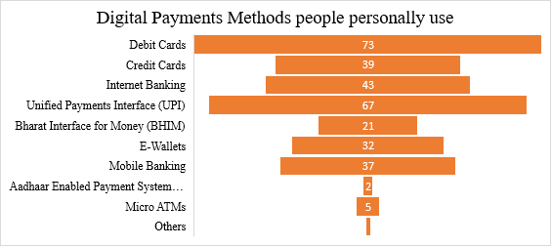

**Showcasing how the Respondents come know about digital payment methods**

Table No. : 9

|  |  |  |
| --- | --- | --- |
| **Particulars** | **No. of respondents**  **(Out of 88 respondents who personally use)** | **Percentage (%)** |
| Family | 64 | 72.72 |
| Friends | 50 | 56.81 |
| Social Media/Internet Surfing | 44 | 50 |
| Television Advertisements | 24 | 27.27 |
| Print Advertisements | 15 | 17.04 |
| Others (Via Bank) | 2 | 2.27 |

(Source: Primary Data)

Figure No.: 13

**Showcasing the reasons Respondents prefer digital payment methods**

Table No. : 10

|  |  |  |
| --- | --- | --- |
| **Particulars** | **No. of respondents**  **(Out of 88 respondents who personally use)** | **Percentage (%)** |
| Speed of Transactions | 69 | 78.4 |
| Convenience | 69 | 78.4 |
| Easy to setup | 31 | 35.2 |
| Low Transactions Cost | 21 | 23.9 |
| Incentives (like Cashbacks, Discount Coupons) | 38 | 43.2 |
| Others (to counter the threat of physical money theft) | 1 | 1.1 |
| Others (it is the need of the hour) | 1 | 1.1 |

(Source: Primary Data)

Figure No.: 14

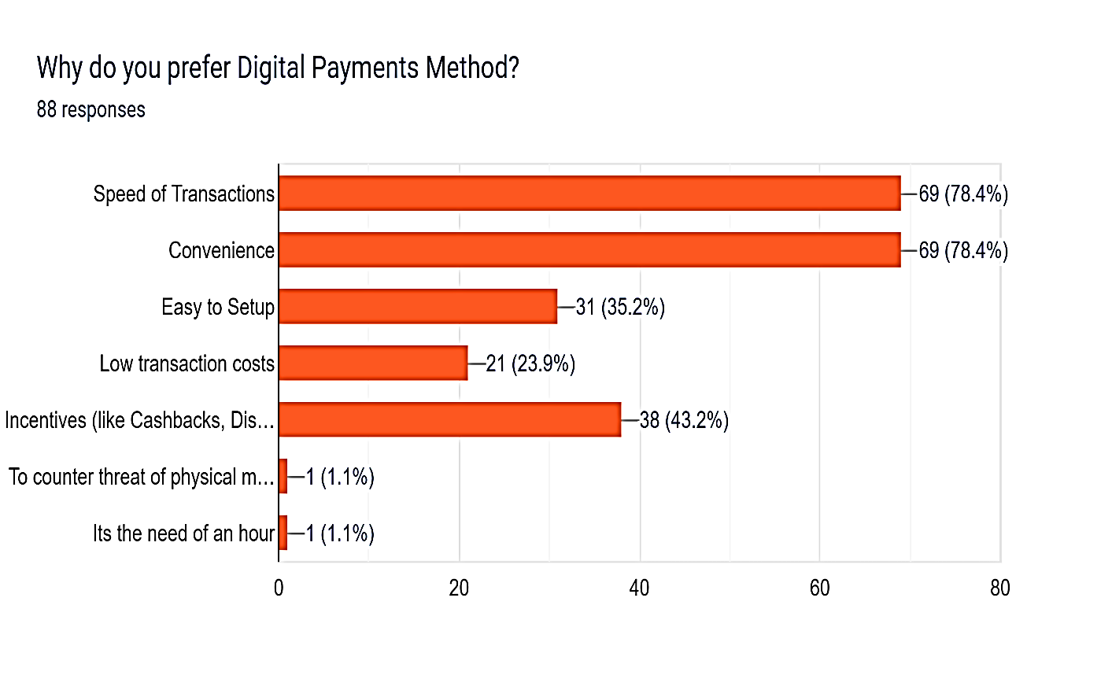

**Showcasing the Respondents weekly usage of Digital Payments Methods**

Table No. : 11

|  |  |  |
| --- | --- | --- |
| **Particulars** | **No. of respondents**  **(Out of 88 respondents who personally use)** | **Percentage (%)** |
| Less than 3 times | 23 | 26.1 |
| 3-5 times | 23 | 26.1 |
| 5-10 times | 13 | 14.8 |
| 10-15 times | 9 | 10.2 |
| More than 15 times | 20 | 22.7 |

(Source: Primary Data)

Figure No.: 15

**No. Of respondents who use UPI from the respondents who use Digital Payments methods**

Table No. : 12

|  |  |  |
| --- | --- | --- |
| **Particulars** | **No. of respondents** | **Percentage (%)** |
| YES | 76 | 86.36 |
| NO | 12 | 13.63 |
| TOTAL | 88 | 100 |

(Source: Primary Data)

Figure No.: 16

**Showcasing whether UPI has made the manner respondents do payments better.**

Table No. : 13

|  |  |  |
| --- | --- | --- |
| **Particulars** | **No. of respondents** | **Percentage (%)** |
| YES | 59 | 77.6 |
| NO | 6 | 7.9 |
| MAYBE | 11 | 14.5 |
| TOTAL | 76 | 100 |

(Source: Primary Data)

Figure No.: 17

**Respondents’ usage of UPI compared to other digital payments methods.**

Table No. : 14

|  |  |  |
| --- | --- | --- |
| **Particulars** | **No. of respondents** | **Percentage (%)** |
| MORE than other payment methods | 53 | 69.7 |
| LESS than other payment methods | 9 | 11.8 |
| SAME as the other payment methods | 14 | 18.4 |
| TOTAL | 76 | 100 |

(Source: Primary Data)

Figure No.: 18

**Reasons that respondents use UPI over other Digital Payments Method**

Table No. : 15

|  |  |  |
| --- | --- | --- |
| **Particulars** | **No. of respondents**  **(62 responses)** | **Percentage (%)** |
| Transactions from multiple accounts | 37 | 48.7 |
| Rewards and Cashbacks | 35 | 46.1 |
| Privacy Protection | 14 | 18.4 |
| Acceptable at most places | 51 | 67.1 |
| Others | 4 | 5.2 |

(Source: Primary Data)

Figure No.: 19

**Reasons that respondents use UPI over other Digital Payments Method**

Table No. : 16

|  |  |  |
| --- | --- | --- |
| **Particulars** | **No. of respondents**  **(62 responses)** | **Percentage (%)** |
| Google Pay | 40 | 64.5 |
| Phone Pe | 10 | 16.1 |
| Paytm Payments Bank | 19 | 30.6 |
| Amazon Pay | 6 | 9.7 |
| BHIM App | 0 | 0 |

(Source: Primary Data)

Figure No.: 20

**Showcasing whether the spending habits increased because of UPI payments.**

Table No. : 17

|  |  |  |
| --- | --- | --- |
| **Particulars** | **No. of respondents** | **Percentage (%)** |
| YES | 43 | 69.4 |
| NO | 9 | 14.5 |
| MAYBE | 10 | 16.1 |
| TOTAL | 62 | 100 |

(Source: Primary Data)

Figure No.: 21

**Response on whether everyone should use UPI or not.**

Table No. : 18

|  |  |  |
| --- | --- | --- |
| **Particulars** | **No. of respondents** | **Percentage (%)** |
| YES | 47 | 61.8 |
| NO | 7 | 9.2 |
| MAYBE | 22 | 28.9 |
| TOTAL | 76 | 100 |

(Source: Primary Data)

Figure No.: 22

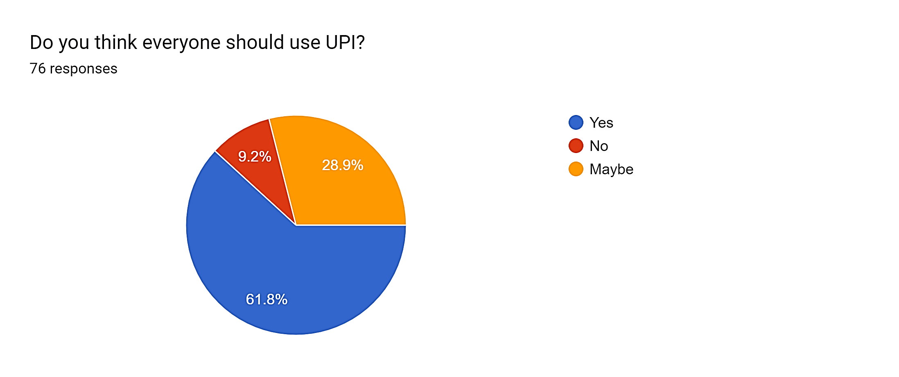

**Response on whether UPI should be used on an international level or not.**

Table No. : 19

|  |  |  |
| --- | --- | --- |
| **Particulars** | **No. of respondents** | **Percentage (%)** |
| YES | 59 | 77.6 |
| NO | 6 | 7.9 |
| MAYBE | 11 | 14.5 |
| TOTAL | 76 | 100 |

(Source: Primary Data)

Figure No.: 23

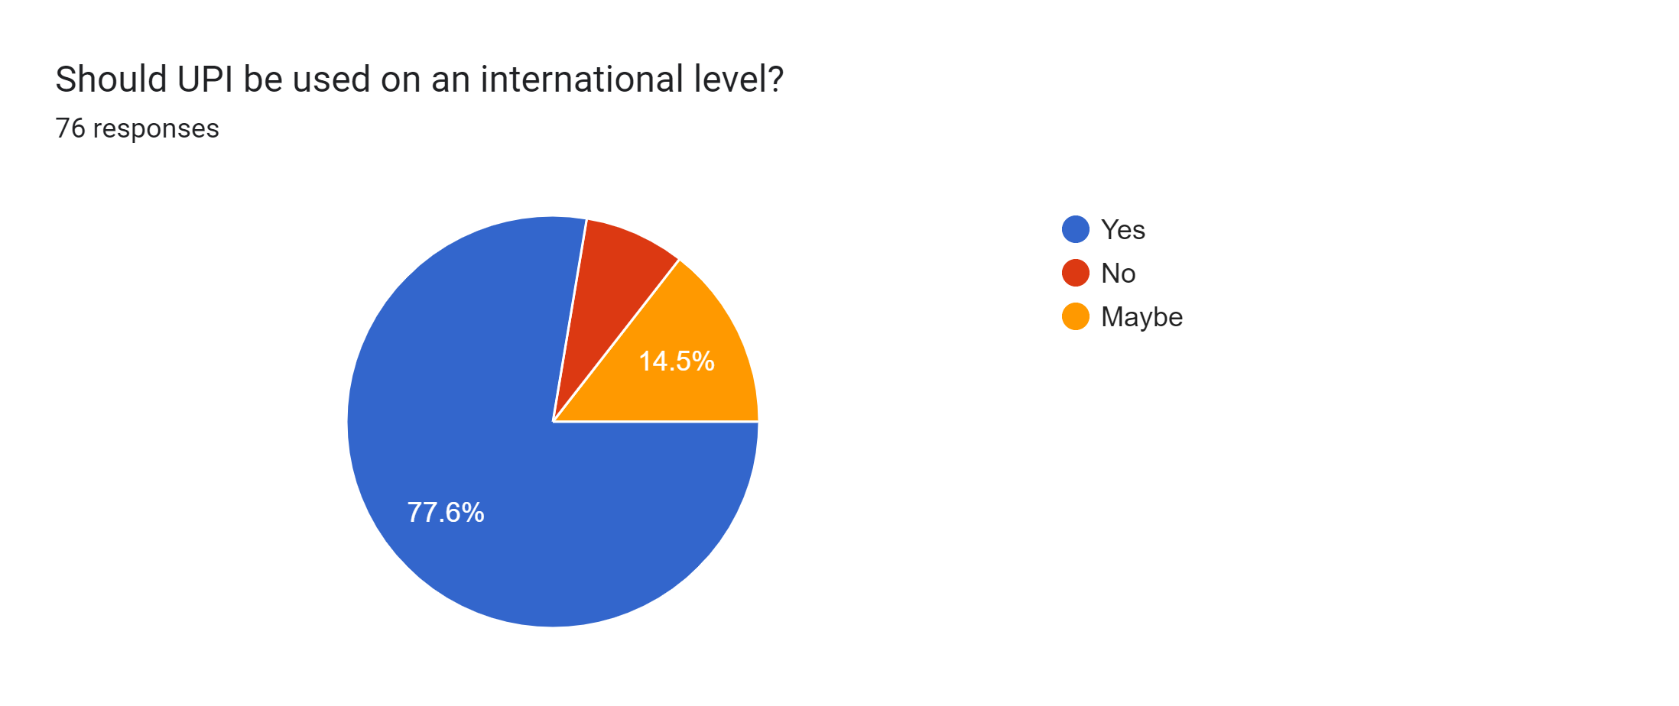

**Reasons respondents don’t use UPI**

Table No. : 20

|  |  |  |
| --- | --- | --- |
| **Particulars** | **No. of respondents**  **(Out of 88 respondents who personally use)** | **Percentage (%)** |
| Delay in Payments | 69 | 78.4 |
| Cannot use without proper internet service | 69 | 78.4 |
| Transfer limit of 1,00,000 | 31 | 35.2 |
| Security issues | 21 | 23.9 |
| Technological Illiteracy | 38 | 43.2 |
| Not allowed by parents/guidance | 1 | 1.1 |

(Source: Primary Data)

Figure No.: 24

**CHI-SQAURE TEST**

Question: Relationship between the Age Group of the Respondents and their Awareness of various Digital payments methods?

**Classicications of respondents on the basis of age**

Table no. : 21

|  |  |  |
| --- | --- | --- |
| **Particulars** | **No. of respondents** | **Percentage (%)** |
| 15- 18 years | 24 | 23 |
| 19-21 years | 53 | 50 |
| 22-24 years | 28 | 27 |
| TOTAL | 105 | 100 |

**Awareness among the respondents of  the various Digital Payment methods available in India**

Table no.: 22

|  |  |  |
| --- | --- | --- |
| **Particulars** | **No. of respondents** | **Percentage (%)** |
| YES | 100 | 95.24 |
| NO | 5 | 4.76 |
| TOTAL | 105 | 100 |

(Source: Primary Data)

Hypothesis: To conduct a chi-square test, we need to formulate the null hypothesis and alternative hypothesis:

Null Hypothesis (H0): There is no significant association between the age group of respondents and their awareness of various digital payment methods available in India.

Alternative Hypothesis (H1): There is a significant association between the age group of respondents and their awareness of various digital payment methods available in India.

We can use a contingency table to represent the observed frequencies:

Table no.: 23

|  | **Yes** | **No** | **Total** |
| --- | --- | --- | --- |
| **15-18 yrs.** | 22 | 2 | 24 |
| **19-21 yrs.** | 51 | 2 | 53 |
| **22-24 yrs.** | 27 | 1 | 28 |
| **Total** | 100 | 5 | 105 |

We can calculate the expected frequencies using the formula:

Expected Frequency = (Row Total x Column Total) / Grand Total

Table no.: 24

|  | **Yes** | **No** | **Total** |
| --- | --- | --- | --- |
| **15-18 yrs.** | 8.57 | 15.43 | 24 |
| **19-21 yrs.** | 37.71 | 15.29 | 53 |
| **22-24 yrs.** | 17.71 | 10.29 | 28 |
| **Total** | 64 | 41 | 105 |

Next, we can calculate the chi-square test statistic using the formula:

chi-square = sum ((observed frequency - expected frequency) ^2 / expected frequency)

Using the above formula, we get chi-square = 3.84

We need to find the degrees of freedom for the test. We can use the formula:

degrees of freedom = (number of rows - 1) x (number of columns - 1)

Using the above formula, we get degrees of freedom = 2.

We can use a chi-square distribution table to find the p-value corresponding to the calculated chi-square value and degrees of freedom. Using the table, we find that the p-value is less than 0.05, which indicates that the result is statistically significant.

Therefore, we can reject the null hypothesis and conclude that there is a significant association between the age group of respondents and their awareness of various digital payment methods available in India.

Top of Form

**Bottom of Form**

**CHAPTER 5: FINDINGS, SUGGESTIONS & CONCLUSIONS**

**Findings:**

1. Out of 105 respondents, 50.5% are within the age group of 19-21 years, followed by 26.7% of 22-24 years, and 22.9% between 15-18 years.
2. Out of 105 respondents, 66 are female, 37 are male, and 2 prefer not specify their gender. From this data it is clear that the majority respondents are Females.
3. Out of 105 respondents, majority is of Students constituting 69% of the total, followed by 11% of salaried employees, 10% of businessmen/self-employed/entrepreneurs, 7% of Working Professionals, and the least amount

is of Unemployed people i.e., 3%.

1. Out of 105 respondents, 95.2% people are aware of various Digital Payment methods in the Indian economy and 4.8% people do not have any knowledge about the same.
2. Out of 105 respondents, 88 people are aware of Banking Cards as a method of Digital Payments, 77 people of Internet Banking, 90 people know about UPI, 60 people about BHIM, E-wallets are known to 66 respondents, 68 people know Mobile Banking, 21 people know Micro ATMs and least known is Aadhar Enabled Payment System by 19 people. From this data it is clear that the most known method is UPI by 85.71 % of the total responses.
3. Out of 105 respondents, 88 people personally use the various methods of Digital payments, and 17 people are still hesitant to use the same.
4. Out of the 105 respondents, the 17 respondents who do not use Digital Payments Methods are hesitant about the same for many reasons. Fear of frauds topping the list with 52.9% people that choose this as a reason to not use, following is Not allowed by Parents or Guardians at 47.1%, Technical problems and password threats ranking the same level with 41.2%, Technological illiteracy at 35.3% and Lossing Smart Cards at 29.4%.
5. Out of 105 respondents, the 88 respondents who personally do use digital payments use Debit Cards the most at 83% followed by UPI at 76.1%, Credit cards at 44.3% , Internet Banking 48.9% , BHIM App at 23.9%, E-wallets at 36.4%, Mobile Banking at 42%, Micro-ATMs at 5.7% and finally AEPS at 2.3%.
6. Out of 88 respondents who use digital payments method, 72.7% got to know about these methods from their Family which is the majority, 56.8% from their Friends, 50% from social media and internet surfing, 27.3% from Television Advertisements, 17% from Print Advertisements and 5.2% from their banks.
7. Out of 88 respondents, it can be seen that reason why Digital Payments methods are preferred are because of Speed of Transactions and Convenience both agreed by 69 respondents, following these is Incentives which is promotes 38 people to use this method. Easy to setup – 31 respondents and Low transaction costs – 21 people.
8. Out of 88 respondents, 26.1 % respondents use Digital Payments the least which less than 3 times a week, similarly 26.1% respondents use it between 3-5 times, 5-10 times by 14.8% respondents, 10.2% respondents use it 10-15 times and more than 15 times is used 22.7% respondents.
9. Out of 88 respondents who personally use the various methods of digital payments methods, only 76 people i.e., 86.4% respondents use Unified Payments Interface (UPI) and the other 12 people i.e., 13.6% choose not to use UPI.
10. Out of 76 respondents who use UPI, only 77.6% agreed with a Yes that UPI has made the manner they do their payments better, 7.9% said No and 14.5% said Maybe.
11. Out of 76 respondents who use UPI, 69.7% of those use UPI MORE than other payment methods, 18.4 % SAME as the other payment methods, 11.8% LESS than other payment methods. Majority prefer it more than other payment methods.
12. Out of 76 respondents who use UPI, the top reasons why the prefer this method is because its Acceptable at most places agreed by 67.1 respondents, followed by Rewards and Cashbacks at 46.1% and facility to do Transactions from multiple accounts at 48.7%, Privacy protection at 18.4%, and others.
13. Out of 76 respondents, 62 choose to answer this and stated their most used UPI application with Google Pay topping the chart at 64.5% followed by Paytm Payments Bank at 30.6% , PhonePe at 16.1%, Amazon Pay with 9.7%.
14. Out of 76 respondents, 62 choose to answer this and 69.4 % agreed with a YES that their spending habits have increased because of UPI Payments, 16.1 % said MAYBE and 14.5% disagreed and choose NO their spending habits have not increased.
15. Out of 76 respondents, 61.8% said YES that everyone should use UPI, 9.2% completed disagreed and said NO and 28.9% said MAYBE for the same.
16. Out of 76 respondents, 77.6% choose YES that UPI should be used on an international level, 14.5 % said MAYBE and 7.9% said NO.
17. When asked to the 76 respondents who use UPI if the want share any disadvantages of UPI mostly said No disadvantage, but other than increase in spendings, cannot work without proper Internet, Privavy scare are the top demerits respondents shared.
18. Out of 88 respondents, 12 who do not use UPI choose Security issues as the top reason at 66.7% to not use UPI, Not allowed by parents/guardians at 33.3%, Cannot use without proper internet service at 25%, Delay in payments and Technological illiteracy both at 8.3% each.

**Suggestions:**

For a smooth cashless framework in India, the following measures are suggested:

1. The government must obtain an efficient and transparent e-instalment framework. The government and RBI use these tools to facilitate credit-only transactions by approving instalment banks and promoting mobile wallets.
2. Government should periodically oversee a mission to educate the public about the benefits of electronic payments.
3. The vendors especially of smaller level should be taught the technicalities of digitals payments which will make them more acceptable at places.
4. Moreover, critical financial skills may be taught in educational settings including schools, colleges, and vocational schools.
5. Government should improve internet facilities and spread internet to even rural India properly so that electronic and digital payments can be done throughout.
6. To reduce the fear of scams, frauds, and private data loss, the financial institutions and the government should increase the security and take strict actions against such online crimes.
7. Encourages the adoption of non-cash electronic payment solutions in place of cash by all segments. Programs like the Lucky Grahak Yojana and the DigidhanVyapar Yojana must continue to support electronic payment systems.

**Conclusion:**

According to the research report, the youth of India have been significantly impacted by digital payments and the Unified Payments Interface (UPI). According to the research, more young people are embracing digital payments and using these platforms for peer-to-peer payments, bill payments, and online shopping, among other types of transactions.

Due to its simplicity, practicality, and security features, UPI has become the most popular digital payment platform among young people, according to the research. UPI is seen by the younger generation as a mark of modernity and a means to demonstrate their aptitude for technology.

According to the report, UPI and digital payments have been instrumental in enabling financial inclusion and empowering young people, particularly those from low-income households. According to the research, youth who previously could not access traditional banking services are now able to engage in the formal economy thanks to the adoption of digital payments.

The perception of digital payment instruments has an impact on young people's payment behaviour, according to this research.

In addition to a good attitude on digital payments, a negative prognosis on cash also influences the use of digital payments. Contrary to conventional wisdom, Indian consumers are reportedly eager to lessen their exposure to online fraud because of the ease that digital payment options provide. Depending on the goal of the transaction, different types of fraud have different effects on digital payment choices. Additionally, we cannot discount the impact that demographic demographics have on the greater adoption of digital payments. Based on the general socio-economic growth of the population, it is anticipated that the usage of digital payments will rise.

Even though the data collection originates from a geographically varied group of respondents, it is still restricted to a particular demographic. Only respondents willing to complete the online survey were included in the data because sampling was random. One of the study's main shortcomings is this. Also, to fill the gap created by the closing of physical establishments, e-commerce and technology firms have expanded their offers and become more receptive of digital payments. Many central banks undertake payments log surveys across the world to evaluate helpful variables at the individual level and track their effects on payment behaviour.

Such surveys might be carried out in the future with a larger sample and in a more organised way.

The study's findings indicate that UPI and digital payments have benefited Indian youth by promoting financial inclusion and giving them the ability to participate in the formal economy. To ensure that the advantages of digitalization are available to everyone, it is crucial to keep promoting and teaching the young about these advantages.

**BIBLIOGRAPHY**

* Ghosh, G. (2021). Adoption of Digital Payment System by Consumer: A review of Literature. Researchgate.Net, 9(2), 412–418. Https://www.researchgate.net/profile/Go urban-Ghosh4/publication/349212193_Adoption_of_ Digital_Payment_System_by_Consume r_A_review_of_Literature/links/602509 b5299bf1cc26b9edb7/Adoption-ofDigital-Payment-System-by-ConsumerA-review-of-Literature.pdf
* Joshi, M. C. (2017). Digital Payment System: Before, During and After Demonetisation. International Journal of Banking, Accounting and Finance, 2(December 2017), 1–14. [https://www.researchgate.net/publicatio n/331001070 7](https://www.researchgate.net/publicatio%20n/331001070%207).
* Joshi, R., & Kumar, B. (2020). IMPACT OF DIGITAL INDIA ON INDIAN ECONOMY
* Manocha, S., Kejriwal, R., & Upadhyaya, A. (2019). The Impact of Demonetization on Digital Payment Transactions: A Statistical Study. SSRN Electronic Journal, 229–235. <https://doi.org/10.2139/ssrn.3446558>
* Singh, Shamsher, Rana, R. (2017). Study of Consumer Perception of Digital Payment Mode. Journal of Internet Banking and Commerce (JIBC), 22(3), 1–14. <http://www.icommercecentral.com>
* Dr. Swati Kulkarni, Dr. Aparna J Varma, D. R. P. V. (2021). A Literature Study Of Consumer Perception Towards Digital Payment Mode In India. Psychology and Education Journal, 58(1), 3304–3319. <https://doi.org/10.17762/pae.v58i1.1270>
* Shailesh Rastogi, Chetan Panse, Arpita Sharma, VM Bhimavarapu (2021) Unified Payment Interface (UPI): A Digital Innovation and Its Impact on Financial Inclusion and Economic Development Universal Journal of Accounting and Finance 9(3): 518-530, 2021 http://www.hrpub.org DOI: 10.13189/ujaf.2021.090326
* Ms. Shweta Mishra, Ms. Vidhi Rajors K.E.S’ Shroff College A Study on Digital Payment System- with special reference to Youth, NATIONAL CONFERENCE ON “ICT for Economic Prosperity, Entrepreneurship, Good Governance and Development” March 2018
* Journal of Positive School Psychology <http://journalppw.com> 2022, Vol. 6, No. 3, 10121 – 10131 © 2022 JPPW. All rights reserved A Study on Digital Payments System & Consumer Perception: An Empirical Survey. Shinki Katyayani Pandey Assistant Professor, Kalinga University, Naya Raipur, CG
* Journal of Content, Community & Communication Amity School of Communication Vol. 15 Year 8, June - 2022 [ISSN: 2395-7514 (Print) ] Amity University, Madhya Pradesh [ISSN: 2456-9011 (Online)] DOI: 10.31620/JCCC.06.22/14 194 MOBILE PAYMENT ADOPTION AMONG YOUTH: GENERATION Z AND DEVELOPING COUNTRY PERSPECTIVE Dr. Sonal Purohit Associate Professor, Chandigarh University, Punjab, India, Ms. Jaspreet Kaur Chandigarh University, Punjab, Dr. Shakti Chaturvedi Associate Professor, REVA Business School, REVA University, Bengaluru, India
* <https://www.imf.org/en/News/Articles/2022/10/26/cf-how-indias-central-bank-helped-spur-a-digital-payments>
* <https://youthincmag.com/india-undergoing-upi-explosion-what-will-be-its-impact>
* <https://timesofindia.indiatimes.com/blogs/unheard-echoes-of-young-mind-2/upi-indias-story-of-a-financial-revolution/>
* <https://www.peoplematters.in/article/technology/fintech-empowering-the-youth-of-india-35243>
* <https://www.thehindubusinessline.com/opinion/protecting-upi-a-jewel-among-indian-fintech-innovations/article65302406.ece>
* <http://s3-ap-southeast-1.amazonaws.com/ijmer/pdf/volume10/volume10-issue2(3)/21.pdf>
* <https://byjus.com/commerce/types-of-digital-payments/#:~:text=There%20are%20different%20modes%20and,AEPS%20(Aadhaar%20enabled%20Payment%20System)>
* <http://cashlessindia.gov.in/digital_payment_methods.html>

**APPENDIX**

Google Form Questionnaire used for the survey:

**THANKYOU**