**A STUDY ON MECHANICAL PROPERTIES AND BEHAVIOUR OF ALUMINUM 6061 ALLOY**

**G. Sasidhar1, M. Vivekananda2, P. Tharun kumar3, P. Gopidev4, P. Ashishvarma5, T. Raj Kumar6**

1Assistant Professor, Mechanical Dept., GMR Institute of Technology, Rajam, Andhra Pradesh, India

2,3,4,5,6 UG Scholar, Mechanical Dept., GMR Institute of Technology, Rajam, Andhra Pradesh, India

**ABSTRACT**

**Gaining insight into material properties is fundamental to engineering and design, as it enables the creation of reliable and efficient structures and components. Aluminum 6061, a widely used alloy in industries like aerospace, automotive, and construction, is valued for its strength-to-weight ratio and corrosion resistance. To ensure its suitability for various applications, determining its mechanical properties, particularly the ultimate tensile strength, is essential. A tensile test conducted using a universal testing machine (UTM) provides precise measurements of this property by subjecting the material to uniaxial tension until failure. This data is critical for predicting performance under operational loads, optimizing material usage, and ensuring safety in engineering design. The ultimate tensile strength of the specimen is 204.89 MPa at a mesh element size of 2mm. Thus, tensile testing of Aluminum 6061 plays a vital role in advancing material science and its applications.**

**Keywords:** Ultimate tensile strength, universal testing machine, Aluminum 6061, CNC machine

1. **INTRODUCTION**

Aluminium 6061 is a widely used alloy known for its versatility and balance of mechanical properties, including good strength, corrosion resistance, and weldability. The "6061" designation is part of the Aluminium Association system, where the first digit (6) indicates that it belongs to the magnesium and silicon series, the second digit (0) represents modifications of the original alloy, and the last two digits (61) differentiate it from other alloys in the same series. This alloy is highly valued in industries such as aerospace, automotive, and construction, where a combination of light weight and durability is essential for performance. This paper begins by describing the material selection and then experimental procedure used to evaluate the tensile strength of Aluminum 6061, including specimen preparation and testing using a universal testing machine (UTM). It then progresses to analyzing the mechanical behavior of the tested specimen, focusing on the stress-strain characteristics and ultimate tensile strength. The final section discusses the implications of the findings for practical applications, highlighting the role of tensile testing in material selection and engineering design.

1. **METHODOLOGY AND EXPERIMENTAL SET UP**

In this section it starts with the material section, then performing certain machining operations and tensile test were performed in order know the properties of the material [1] such as the ultimate tensile strength, elongation of the material under tensile axial loading [2]. The temperature of the material is considered as the room temperature in the simulation [3] [7].

* 1. **Material selection**

In regard of the project aluminum 6061 alloy is taken as the material due to its widespread use in engineering applications [5] where a balance between strength, weight, and corrosion resistance is essential.

* 1. **Cutting of raw material**

Hacksaws are used to cut large sizes of metals. Therefore, hacksaws have been developed to carry out the difficult and time-consuming work. The ‘arm’ moves backwards and forwards, cutting on the backwards stroke [6] Figure **1(a)** shows the metal bars that are cut by holding it in a machine vice which is an integral part of the base. Turning the handle tightens or loosens the vice. The vice is very powerful and locks the metal in position.

* 1. **Machining of the specimen**

The round bars are converted to the shape of the specimen used in both tensile and with the help of CNC (Computer Numeric Control) machine by performing operations such as drilling in order to hold the specimen in CNC and turning operation is performed to reduce the diameter of 15mm to the required dimensions of the specimen s shown in Figure 1(b)(c). The dimensions of the specimen is described in the figure 2 where The specimen is in a dog-bone shape where the grip section is of length 65cm each on both side of the gauge section with diameter 12mm. The gauge section is of length 72.65mm with diameter 8mm and the transition section where the radius is of 30mm which will useful to distribute the stress uniformly without any stress concentrations, so that the failure can be observed in the gauge section.

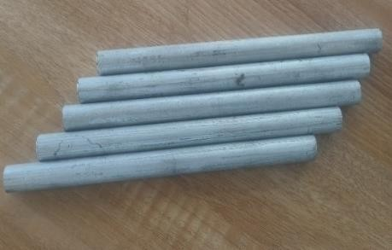 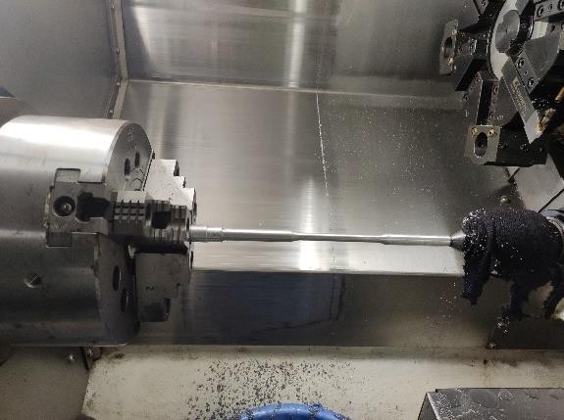 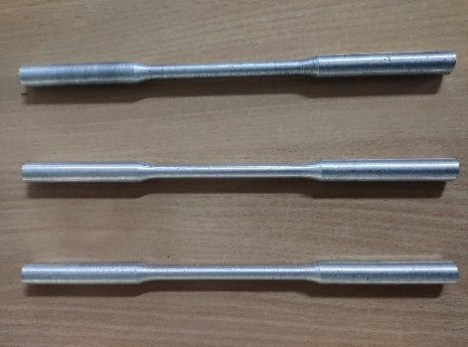

(a) (b) (c)

**Fig 1 (a)** aluminum round bar **(b)**Machining of the specimen **(c)** specimens with desired dimensions



**Fig.2 2D Model of the specimen**

1. **EXPERIMENTATION**
   1. **Tensile test**

The test is performed on two specimens with the help of UTM (Universal Testing Machine) as shown in Fig 3(a) in order to find the ultimate strength of the material and the average value in the above two is considered as the ultimate tensile strength of the material here it is aluminum 6061 alloy [10]. The specimen is clamped in the UTM and an axial tensile load was applied at a constant strain rate [4]. The test continued until the specimen fractured as shown in Figure 3(b).

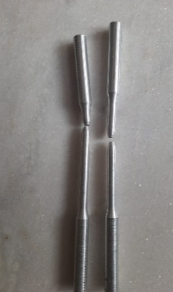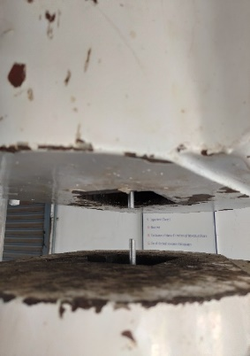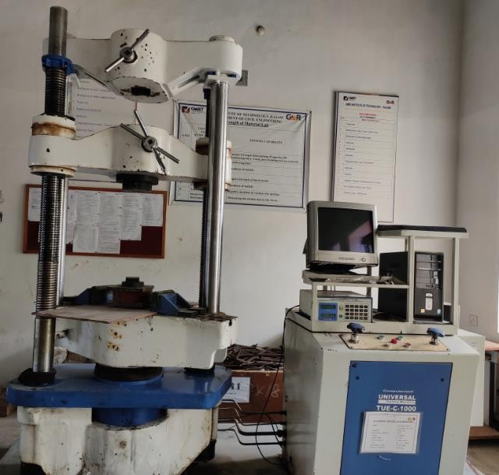

**(a) (b) (c)**

**Fig 3(a) Universal testing machine (b) specimen breakage (c) specimens after testing**

Load vs. elongation data were collected throughout the test. The fracture load and total elongation were recorded by the machine. The stress-strain curve was plotted using the recorded data to identify key properties like yield strength, ultimate tensile strength, and elongation at break. The specimens after the testing are shown in Figure 3(c). Same as the specimen one the second specimen is tested and the readings and the graph are recorded from the computer.

1. **MODELING AND ANALYSIS**
   1. **Modeling of the specimen**

The geometric model of the specimen is drawn by using the CAD modeling software as shown in Figure 3(a) [8] .After modeling the specimen generate a mesh which varies with each section such as 5mm for grip, 3mm for transition and 2mm for the gauge section as shown in Figure 3(b) [9] .In compare to all sections the gauge section which is also called as test section having less element size in order to get the accurate results at this section where the damage can first observed.

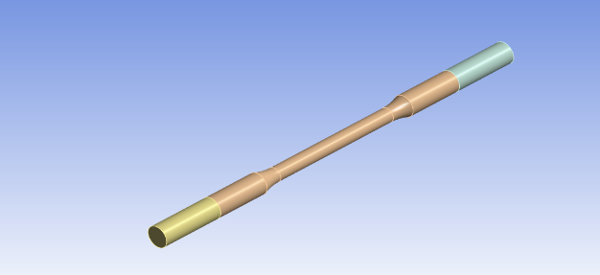 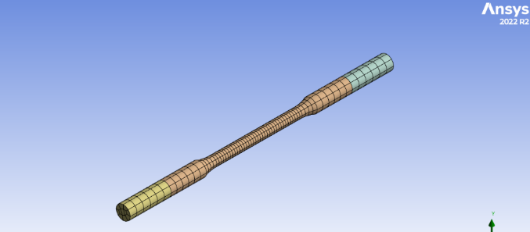

**(a) (b)**

**Fig 3 (a) geometric model (b) generating mesh**

* 1. **Applying boundary conditions**

After generating the mesh apply the boundary condition such as fixed support at one end and tensile force is applied at the other end and click on solve to get the results which will be discussed further in the results section.

1. **RESULTS AND DISCUSSION**
   1. **Stress – Strain graph for tensile test**

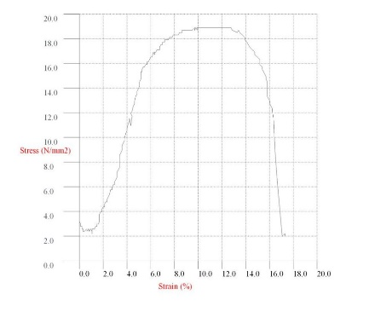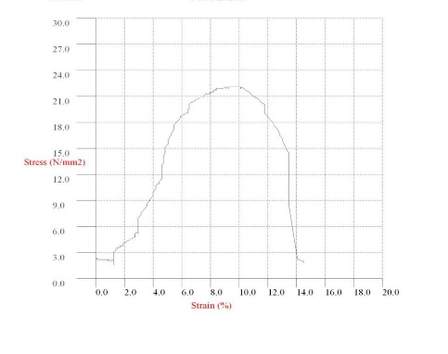

**(a) (b)**

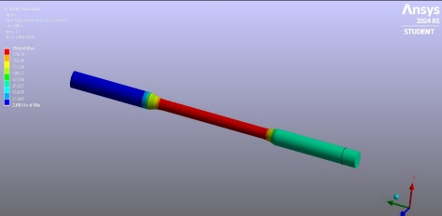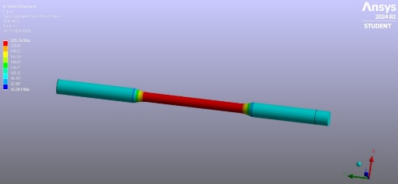

**(c) (d)**

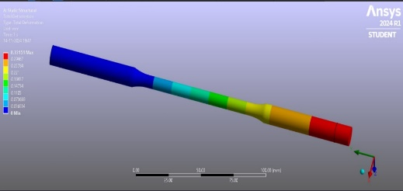 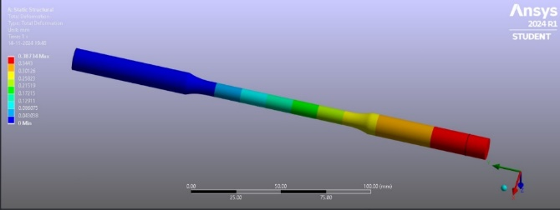

**(e) (f)**

**Fig 4 (a) graph at peak load 9.5 kN (b) graph at peak load 11.1 kN (c) analysis at load 9.5 kN**

**(d) Load 11.1 kN (e) deformation at 9.5 kN (f)deformation at 11.1 kN**

In the Figure 4(a) (b) the x-axis represents the strain in percentage and the y-axis represents stress of units N/mm2 by increasing the load, the strain gets increased up to the yield point of 145MPa and 195 MPa for the two specimens after this point the specimen gets plastic deformation with minimal increase of stress and at the stress 189 MPa ,220.8 MPa it reaches

Table 1 yield and ultimate tensile strength for both experimental and analysis

|  |  |  |  |  |
| --- | --- | --- | --- | --- |
| S.NO | Yield strength (Experimental) MPa | Yield strength (Analysis) MPa | Ultimate tensile strength (Experimental) MPa | Ultimate tensile strength (Analysis) MPa |
| 1. | 145 | 156.75 | 189 | 196.64 |
| 2. | 195 | 204.82 | 220.8 | 229.76 |

ultimate tensile strength an average of 204.9MPa is considered and after it breaks. Figure 4(c)(d) Depicts the simulation of the tensile test where the stress developed is uniform throughout the test section which is similar to the experimental values i.e. 213.2 MPa. The deformation for both the specimens is 0.33151mm and 0.09655 mm are shown in the Figure 4(e) (f). The results are shown in the Table1 where the experimental and analysis values are Similar to each other . The ultimate strength of the specimen can be considered as the average of the two values i.e. 204.9MPa.

1. **CONCLUSION**

The results highlight the alloy capability to withstand significant loads while maintaining its structural integrity, making it a reliable choice for critical applications in aerospace, automotive, and structural engineering.

* This study comprehensively investigated the properties, machining, and of aluminum alloy 6061, highlighting its versatility for engineering applications.
* The ultimate strength of the specimen of experimental value 204.9 MPa.
* The ultimate strength of the specimen of analysis value 213.2 MPa
* The element size of the mesh is 2mm which gives optimum results.

1. **REFERENCES**

[1] Singh, R., & Sharma, A. (2021). Friction stir processing of AA6061 with reinforcement particles for tensile strength enhancement. Materials Today Proceedings, 44, 1345–1352. <https://doi.org/10.1016/j.matpr.2020.11.063>

[2] Mishra, R., & Gupta, S. (2020). Effect of aging treatments on the tensile properties of AA6061 alloy. Journal of Manufacturing Processes, 55, 22–30. <https://doi.org/10.1016/j.jmapro.2020.03.001>

[3] Ali, M., Khan, F., & Shah, M. A. (2020). Effect of heat treatment on mechanical properties of AA6061 aluminum alloy. Materials Science and Engineering A, 792, 139790. <https://doi.org/10.1016/j.msea.2020.139790>

[4] Lee, J., & Kim, Y. (2019). High-strain-rate tensile behavior of AA6061-T6 alloy. Materials Science and Engineering A, 755, 139756. <https://doi.org/10.1016/j.msea.2019.139756>

[5] Chen, X., & Lin, Z. (2019). Microstructure and mechanical properties of friction stir welded AA6061-T6 alloy joints. Journal of Materials Research and Technology, 8(6), 5280–5290. <https://doi.org/10.1016/j.jmrt.2019.09.028>

[6] Elangovan, K., & Balasubramanian, M. (2018). Microstructural evolution during ECAP processing of AA6061 aluminum alloy. Journal of Alloys and Compounds, 748, 1096–1104. <https://doi.org/10.1016/j.jallcom.2018.03.081>

[7] Ram, G. D. J., & Pal, T. K. (2018). Role of post-weld heat treatment in enhancing the mechanical properties of AA6061 joints. Welding Journal, 97(5), 149–155. <https://doi.org/10.1002/weldj.0007>

[8] Park, J., & Rhee, C. (2018). Ductile fracture prediction in AA6061-T6 aluminum alloy sheets. International Journal of Plasticity, 103, 70–87. <https://doi.org/10.1016/j.ijplas.2018.01.002>

[9] Zhang, S., & Wu, J. (2017). Mechanical properties and failure analysis of AA6061 under uniaxial tensile loading. Engineering Fracture Mechanics, 187, 316–329. <https://doi.org/10.1016/j.engfracmech.2017.06.019>

[10] Kumar, A., & Jain, P. (2017). Experimental analysis of tensile properties of AA6061 composite materials. Procedia Materials Science, 9, 229–236. <https://doi.org/10.1016/j.promfg.2017.03.013>