**INTERNATIONAL ECONOMICS PROJECT**

**NAME -Shantanu Kadam**

**CLASS - M.COM**

**PROJECT TOPIC - INDIA'S CONTRIBUTION IN SAARC**

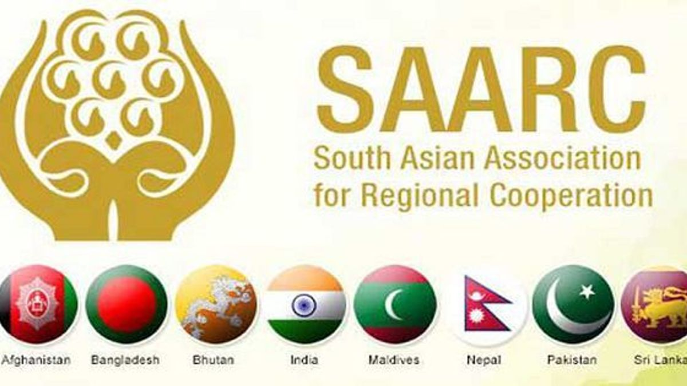

**SAARC (South Asian Association for Regional Cooperation)**

The **South Asian Association for Regional Cooperation (SAARC)** is an intergovernmental organization aimed at promoting economic and regional integration among the countries of South Asia. Below is a detailed overview of SAARC, its origins, objectives, member countries, structure, and its importance.

**1. History and Formation**

* **Established:** December 8, 1985
* **Headquarters:** Kathmandu, Nepal
* **Founder Countries:** The idea of SAARC was first proposed by the then President of Bangladesh, **Ziaur Rahman**, in the late 1970s, but the organization was formally established in 1985.
* **First Summit:** The first SAARC Summit was held in Dhaka, Bangladesh, where the member nations adopted the SAARC Charter, emphasizing the importance of cooperation among South Asian nations.

**2. Member Countries**

SAARC has **eight full members**, which are:

1. **Afghanistan** (joined in 2007)
2. **Bangladesh** (founding member)
3. **Bhutan** (founding member)
4. **India** (founding member)
5. **Maldives** (founding member)
6. **Nepal** (founding member)
7. **Pakistan** (founding member)
8. **Sri Lanka** (founding member)

In addition to full members, **9 observer countries** include:

* **Australia**
* **China**
* **European Union (EU)**
* **Iran**
* **Japan**
* **Mauritius**
* **Myanmar**
* **South Korea**
* **United States**

**3. Objectives of SAARC**

The primary objectives of SAARC, as outlined in its charter, include:

1. **Promotion of welfare**: To improve the quality of life and well-being of the peoples of South Asia.
2. **Economic cooperation**: To accelerate economic growth, social progress, and cultural development.
3. **Collective self-reliance**: To promote and strengthen collective self-reliance among the member nations.
4. **Collaboration in regional areas**: To promote cooperation in various fields including agriculture, rural development, science and technology, culture, health, population, education, and environment.
5. **Mutual trust and understanding**: To encourage the strengthening of mutual trust, peace, and security.
6. **Joint efforts in international forums**: To collaborate on international issues of common interest and coordinate positions at global platforms.

**4. Organizational Structure**

The SAARC structure includes several layers of governance:

1. **SAARC Summit:**
   * The highest decision-making body of SAARC.
   * Heads of State or Government of member countries meet biennially to set policies and discuss key regional issues.
   * The last summit was held in 2014 in Nepal. (Due to tensions between India and Pakistan, subsequent summits were delayed.)
2. **Council of Ministers:**
   * Comprised of the foreign ministers of the member countries.
   * They oversee the implementation of decisions made at the summit and handle policy formulation.
3. **Standing Committee:**
   * Includes the foreign secretaries of member states, responsible for reviewing and coordinating policies and programs.
4. **Technical Committees:**
   * These are created to implement programs and projects in various sectors like agriculture, education, health, rural development, and energy.
5. **SAARC Secretariat:**
   * Located in Kathmandu, Nepal.
   * It facilitates the implementation of SAARC activities and coordinates between the member states.
6. **Specialized Bodies:**
   * **SAARC Development Fund (SDF):** Based in Thimphu, Bhutan, it finances regional projects.
   * **SAARC Arbitration Council (SARCO):** Located in Islamabad, Pakistan, it settles disputes in the region.

**5. Key Achievements and Challenges**

**Achievements**

1. **Trade and Economic Cooperation**:
   * SAARC introduced the **South Asian Free Trade Area (SAFTA)** in 2006, aiming to reduce tariffs among member states, fostering regional trade and integration.
   * Development of **SAARC Development Fund (SDF)**, which promotes projects across poverty alleviation, social welfare, and infrastructure development.
2. **Social Development Initiatives**:
   * SAARC has taken initiatives in education, health, and poverty reduction through collaborative programs.
   * Promotion of **SAARC Youth Awards** and **SAARC Literary Awards** to encourage contributions in arts, culture, and humanitarian fields.
3. **Disaster Management and Climate Change**:
   * SAARC has emphasized disaster management and climate change adaptation through joint action plans and specialized programs, especially in the context of vulnerable island nations like Maldives.
4. **Cultural Exchange and People-to-People Contacts**:
   * It has supported regional cooperation in tourism, sports, and cultural exchanges, strengthening social ties among the nations.

**Challenges**

1. **India-Pakistan Relations**:
   * Persistent political tensions, particularly over the Kashmir issue, have hampered the effectiveness of SAARC in recent years. SAARC summits have often been delayed or postponed due to these bilateral disputes.
2. **Intra-Regional Trade**:
   * Despite initiatives like SAFTA, intra-regional trade within SAARC remains low (around 5% of total trade). Political barriers, lack of infrastructure, and protectionist policies have stunted economic cooperation.
3. **Poor Implementation of Agreements**:
   * Many agreements and declarations signed at SAARC summits have been slow to be implemented due to lack of political will, bureaucratic hurdles, and limited resources.
4. **Role of Smaller Nations**:
   * Some smaller member countries, like Bhutan, Maldives, and Nepal, feel overshadowed by larger countries like India and Pakistan, leading to an imbalance in regional influence.

**6. Future Prospects**

SAARC has immense potential to drive economic integration, poverty alleviation, and peace-building in the region, but it faces significant challenges due to political tensions, especially between India and Pakistan.

**Key Areas for Improvement:**

* **Political Will**: Resolving bilateral disputes (especially India-Pakistan) would be crucial for SAARC to function effectively.
* **Strengthening Economic Ties**: Boosting intra-regional trade by improving trade agreements and regional connectivity would be vital.
* **Environmental Cooperation**: With South Asia being highly vulnerable to climate change, collective action on climate adaptation and disaster management can become a major focus.
* **People-to-People Contacts**: Enhancing cultural, educational, and tourism exchanges to promote regional identity and cooperation.

**2. SAARC SPECIALIZED BODIES**

**SAARC Development Fund (SDF)**

* **Location**: Thimphu, Bhutan
* **Established**: 2010
* **Objective**: To promote the welfare of the people of South Asia and improve their quality of life. The fund finances regional projects in social, economic, and infrastructure sectors.

The SDF operates under three windows:

* + **Social Window**: Supports projects aimed at poverty alleviation, social development, education, and healthcare.
  + **Economic Window**: Funds projects that focus on trade, economic development, and regional integration.
  + **Infrastructure Window**: Supports large-scale infrastructure projects that enhance regional connectivity.

**SAARC SUMMITS**

**1. First SAARC Summit**

* **Date**: December 7-8, 1985
* **Location**: Dhaka, Bangladesh
* **Key Outcomes**:
  + The **SAARC Charter** was formally adopted, officially establishing SAARC.
  + Focus on cooperation in various fields like agriculture, rural development, and science and technology.
  + Stress on maintaining mutual trust and respect between member nations.

**2. Second SAARC Summit**

* **Date**: November 16-17, 1986
* **Location**: Bangalore, India
* **Key Outcomes**:
  + Discussion on strengthening cooperation in **agriculture and rural development**.
  + Emphasis on cooperation in meteorology and the environment.

Here’s a detailed look at the **SAARC Summits**:

**8. Eighth SAARC Summit**

* **Date**: May 2-4, 1995
* **Location**: New Delhi, India
* **Key Outcomes**:
  + **SAFTA (South Asian Free Trade Area)** discussions began, aiming to boost regional trade.
  + Emphasis on **poverty alleviation** and infrastructure development.

**18. Eighteenth SAARC Summit**

* **Date**: November 26-27, 2014
* **Location**: Kathmandu, Nepal
* **Key Outcomes**:
  + Focus on **regional connectivity** and the importance of implementing past agreements.
  + Emphasis on creating a **South Asian Economic Union** to facilitate trade and investment.

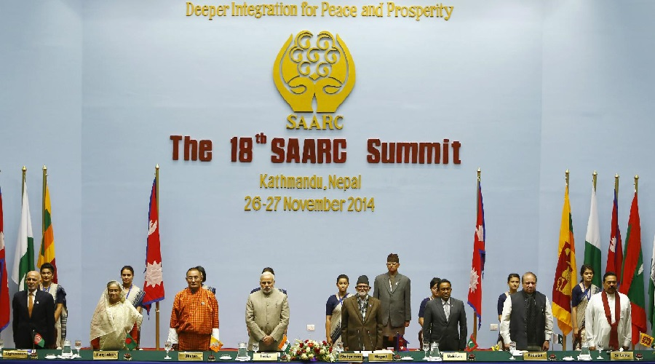

**INDIA’S CONTRIBUTION IN THE SAARC**

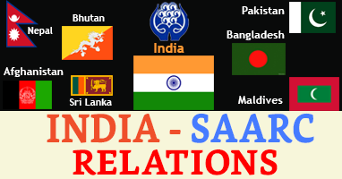

India plays a **pivotal role** in the **South Asian Association for Regional Cooperation (SAARC)** due to its geographical, political, and economic prominence within the region. As the largest country in South Asia in terms of population, economy, and land area, India’s involvement in SAARC has a significant impact on the association's activities and regional dynamics.

Here’s a detailed analysis of India’s role in SAARC:

**1. Founding Member and Driving Force**

* **India is a founding member of SAARC**, having played a key role in its establishment in 1985. As the largest and most populous country in the region, India's participation was critical for SAARC's formation. Despite initial hesitancy, India joined the initiative after it became clear that the organization would focus on economic and cultural cooperation rather than sensitive political issues.
* India’s participation gave legitimacy and stature to SAARC, and its involvement has been crucial for SAARC’s overall progress and implementation of its agenda.

**2. Economic Leadership**

* **Economic Powerhouse**: India is the largest economy in the SAARC region, accounting for over **70% of the region’s GDP**. As such, India has the potential to play a key role in regional economic integration and development.
* **South Asian Free Trade Area (SAFTA)**: India has been a strong advocate for promoting intra-regional trade within SAARC. SAFTA, which came into force in 2006, aimed to reduce tariffs and boost trade within the region. India has granted **unilateral trade concessions** to Least Developed Countries (LDCs) within SAARC (such as Nepal, Bhutan, and Bangladesh), removing tariffs on many goods imported from these countries.
* **Investment and Aid**: India has been a major investor in regional infrastructure projects. It provides economic aid, technical assistance, and developmental support to smaller SAARC nations like Bhutan, Nepal, Afghanistan, and the Maldives. This helps to foster goodwill and strengthen regional ties.

**3. Regional Security and Cooperation**

* **Security Concerns**: India has consistently emphasized regional security issues in SAARC, including terrorism, narcotics trafficking, and cross-border insurgency. India’s security concerns have often influenced its approach to SAARC, particularly its stance towards Pakistan, which it views as a major source of terrorism in the region.
* **SAARC Terrorism Convention**: India has been instrumental in pushing for a joint commitment against terrorism. The **SAARC Regional Convention on Suppression of Terrorism** was adopted in 1987, with India playing a key role in its formulation. However, India’s efforts in this regard have been limited by ongoing tensions with Pakistan.

**4. Promoter of Regional Connectivity**

India has promoted the **improvement of regional connectivity** within SAARC. As a transit hub for many of the smaller member states, India has advocated for regional projects in transport, energy, and telecommunications. Key initiatives include:

* **South Asian University (SAU)**: India hosts the **SAARC South Asian University** in New Delhi, promoting higher education and research among member countries.
* **Infrastructure Development**: India has invested in building road and rail links with neighboring countries like Nepal, Bangladesh, and Bhutan. It has promoted transnational energy cooperation, such as electricity sharing with Bhutan, Bangladesh, and Nepal.

**5. Diplomatic and Political Influence**

* **Regional Leader**: India, as the largest and most influential country in South Asia, is often seen as the de facto leader of SAARC. India’s foreign policy within SAARC is based on maintaining regional peace, stability, and economic cooperation. It uses SAARC as a platform for **soft power diplomacy**, promoting cultural ties and people-to-people exchanges.
* **Balancing Relations**: India has maintained close relations with almost all SAARC countries, except Pakistan. India’s diplomatic engagement with countries like Nepal, Bhutan, Maldives, and Sri Lanka has been characterized by both bilateral aid and regional cooperation. However, India’s relations with Pakistan have often obstructed progress on key SAARC initiatives.

**6. Challenges and Criticisms**

**Tensions with Pakistan**

* **India-Pakistan Rivalry**: One of the biggest challenges to SAARC’s effectiveness is the ongoing political and military tensions between India and Pakistan. The **Kashmir dispute** and cross-border terrorism have frequently led to diplomatic deadlocks between the two countries, preventing SAARC from functioning effectively.
* **Summit Delays**: Due to the tension, SAARC summits have often been postponed or canceled. The last SAARC summit was supposed to be held in Islamabad in 2016, but it was boycotted by India following the Uri terrorist attack, which India blamed on Pakistan-based militants. Other SAARC countries, including Afghanistan, Bangladesh, and Bhutan, also backed India, leading to the summit’s cancellation.

**Criticism of Over-Dominance**

* **Concerns from Smaller Nations**: India’s economic and political dominance has sometimes led to friction with smaller SAARC nations. Some member states have expressed concern over India’s influence, fearing it could overshadow their interests. This has occasionally pushed smaller countries to align more closely with China (which is an observer in SAARC) to counterbalance India’s power.

**Perception of SAARC’s Ineffectiveness**

* **Shift in Focus to BIMSTEC**: India has increasingly shifted its focus from SAARC to other regional groupings, such as **BIMSTEC (Bay of Bengal Initiative for Multi-Sectoral Technical and Economic Cooperation)**. This is partly due to SAARC’s inability to resolve regional political issues, especially India-Pakistan tensions. BIMSTEC excludes Pakistan and includes countries from both South and Southeast Asia, allowing India to foster regional cooperation without the political obstacles that arise in SAARC.

**7. India’s Future Role in SAARC**

India’s future role in SAARC will depend on various factors, including:

* **Resolution of India-Pakistan Issues**: India’s active engagement with SAARC will be influenced by its relations with Pakistan. If India and Pakistan can resolve their bilateral issues, SAARC can potentially be revitalized as a platform for regional cooperation.
* **Economic Integration**: India can continue to be a driving force for economic integration within SAARC, promoting trade, investment, and infrastructure development. It is likely to keep playing a leadership role in economic projects and extending support to smaller countries in the region.
* **Strategic Balancing**: India will need to balance its dominance in SAARC with the interests of smaller nations. Ensuring mutual benefits and reducing perceptions of unilateralism will be important for regional cooperation.

**INDIA-SAARC & COVID-19**

**India-SAARC & COVID-19: A Regional Response**

During the COVID-19 pandemic, **India** took a leading role in **SAARC** (South Asian Association for Regional Cooperation) by coordinating a **regional response** to mitigate the health and economic impacts of the pandemic in South Asia. As a founding and prominent member of SAARC, India's initiatives aimed to foster solidarity and cooperation among SAARC countries, helping to manage the crisis collectively.

Here’s a detailed breakdown of **India’s role in SAARC during COVID-19**:

**1. Virtual SAARC Leaders’ Summit on COVID-19**

* **Date**: March 15, 2020
* **Event**: **Prime Minister Narendra Modi** initiated a video conference with SAARC leaders to discuss the pandemic's impact on the region. This summit was the first SAARC-level meeting in years, demonstrating India’s willingness to revive regional cooperation, especially in crisis times.
* **Outcomes**:
  + India proposed a **joint strategy** to combat COVID-19, emphasizing collective efforts in sharing resources, knowledge, and strategies.
  + Modi suggested the creation of a **SAARC COVID-19 Emergency Fund**, with India pledging an initial **USD 10 million**.

**CONCLUSION**

SAARC has played an important role in fostering dialogue, cooperation, and integration among South Asian countries. Although it has achieved success in areas such as trade, health, and cultural exchanges, political differences and economic imbalances have limited its potential. To remain relevant in the future, SAARC must evolve by focusing on sustainable development, regional security, and building stronger economic and political ties among member nations.

India has played a **crucial and multifaceted role** in SAARC, from being a founding member to promoting economic cooperation, regional security, and connectivity. However, **India’s relations with Pakistan** have significantly influenced its role and the overall functioning of SAARC. While India remains committed to the idea of regional cooperation, ongoing political challenges, particularly with Pakistan, have hindered SAARC’s full potential.

**REFERENCES**

<https://www.orfonline.org/>

<http://www.ipcs.org/>

<https://www.mea.gov.in/FSDA>

<https://www.brookings.edu/>